Home safely – drink walking
Teachers should choose materials and activities that meet the needs of their students and local school context.

Life Ready outcomes
1.1 Assess personal strengths and skills to achieve positive outcomes in a range of challenging and changing situations.
4.2 Propose, apply and evaluate solutions to take action to lead and contribute to health, safe and meaningful lives.
5.1 Critically analyse situations attitudes and behaviours that influence independence, health, safety and wellbeing in different contexts.
5.2 Recognise and respond appropriately to situations which may be limiting or harmful to self and others.
7.3 Apply skills to take personal responsibility for their actions to protect and enhance the independence, health, safety and wellbeing of others.

What do we want students to know, understand or be able to do?
- Acknowledge that their safe road use behaviours will reduce the risk of injury to self and others.
- Know and demonstrate safe road use behaviours as pedestrians.
- Demonstrate assertiveness skills to protect themselves and others.
- Actively seek help in conflict situations.

Suggested content
Learning context | Content
Safe Travel  Focus: Travelling safely locally and overseas  Focus: Safe road use to protect each other | Safe travel  • planning for safe travel  • protective behaviours  • strategies to minimise harm to self and others  • seeking help  Responsible behaviour for road users  • drink/drug walking  • road user distraction  Making safe decisions as road and transport users  • making decisions and solving problems in real life situations  • planning strategically for at risk situations, e.g. at night, social events, breakdowns and drink/drug walking  • minimising distractions when driving, walking and as a passenger  Looking out for others  • planning for safe travel with others  • supporting yourself and others  • calling for help

Teaching notes

Creating a safe and supportive learning environment
Students should be aware of drink walking as a personal safety issue and devise protective strategies to keep themselves safe. The activities are designed for group or class discussion, to encourage the development of safe behaviours students can adopt to protect themselves and assist others.
Safety suggestions include:
- have a friend who is not drunk/drugged (like a designated driver)
- follow the road rules, e.g. use the pedestrian crossings
- stay off the road
- use a light of some kind, (e.g. torch on a mobile phone)
- wear bright coloured clothing
- organise a lift.

It is important for staff to choose materials and activities that meet the needs of their students and local school context.
Note: Drink walking is an emerging personal safety issue. Discussions should not encourage students to drink and drive as an alternative to drink walking. Drink driving remains one of three key risk factors in road trauma for young drivers. Discuss alternatives to drinking and travelling.
This activity needs to take a strengths based approach
- most young people do the right thing
- not all young people drink
It is about having empathy to others who may put themselves in danger

Activity one – Drink walking

Students view and share their reactions to the clip Drunk walking with style (length 2.49 minutes) http://www.snotr.com/video/8446/Drunk_Walking_With_Style

Invite students, in groups, to discuss and record comments to the following, on the Drink walking handout:
  - the obvious dangers to the drink walker
  - how drinking alcohol impairs physical and mental functioning
  - how this man’s situation could have been improved
  - their reaction to the camera person’s enjoyment of the drink walker’s demise
  - how responsible the camera person should feel if the drink walker had been injured or assaulted
  - how the camera person could have rendered assistance to the drink walker
  - suggestions and strategies for drink walkers to keep safe.
  - what if the person was someone they knew?
  - reflect how often have you laughed at someone who could put themselves in potential danger

Activity two – Peer influence on drink walking
Teacher note; the images referred to, are in the appendix. They are samples only, choose from these or other images that suit you students’ needs or social settings. If not appropriate staff need to choose what is appropriate.
- Students identify reasons why some young people may drink walk in their community. Note the reasons on butcher’s paper/whiteboard or online space and tell students they’ll be referring to this again later on. Acknowledging not all young people do this.
- Display large images of teenagers drink walking. Pose the question ‘Are friends the solution or part of the problem in our community?’

Conduct a think, pair, share activity for students to discuss this question.
Facilitate a whole group discussion on what students think.
Images are used to promote discussion and reinforce empathy, negotiations and communication skills and looking out for others.
Possible discussion points:
Friends as the solution | Friends as the problem
- provide protection (emotional, physical) when confronted by situations when friends are incapable of protecting themselves  - listen and share concerns about possible upcoming conflict situations  - help clarify and plan strategies in potentially harmful situations  - share fears and understanding  - assist in identifying and suggesting avenues of help/support outside the friendship circle  - know the best ways to communicate to a message. | - can encourage harmful, uninformed or stupid responses  - inflame situations to suit individuals needs rather than staying safe  - reinforce expectations of risky behaviour to fit a harmful stereotype  - power and relationship issues  - can provide mixed messages.

- Prompt students to imagine they are in a drink walking situation that is turning bad, placing a friend at risk of harm. Ask them to think about what strengths they could draw on to be a friend or support person who is part of the solution.

- Display several A3 sized copies of the ‘I am’ positive adjectives list. (refer to appendix). Students personally reflect upon their personality by identifying, selecting and recording 15 adjectives that describe the strengths they bring to relationships.
- Display several A3 sized copies of the ‘I can’ scripts. (refer to appendix) Students again personally reflect upon how they can think when faced with a challenging drink walking situation.

  - Use their adjective list and the ‘I can’ script prompts to generate and write five of their own personal positive self-talk statements, e.g. ‘I can control my nerves when things get out of hand and I can speak up if I’m scared because I’m sensible and responsible’.
  - Students share their dialogue by practising the positive self-talk out loud, in small groups. Encourage students to be a positive peer influence by standing up for themselves in a challenging or negative situation.

Activity 3: Standing tall

Being able to speak assertively in a conflict situation, when feeling personally uncomfortable or unsafe is a skill. Providing opportunities in a safe environment to practise assertiveness will assist students to be proactive in managing their wellbeing and that of others.
NOTE:
Protection of role - Sometimes young people feel more comfortable to be given a range of advice if they are ‘playing a role’ or talking about a fictitious situation. In presenting their own personal view they may be constrained by their social role, peer expectations or may fear ridicule or stigma.
Managing interactive activities - When students are preparing role plays move around the classroom to check in with each group and provide encouragement or assistance. Tell students how much time you will allocate to the task, i.e. 30 seconds to brainstorm ideas with a partner, five minutes to discuss a scenario and 10 minutes to develop a scene.
- Demonstrate, or use students to demonstrate, the 3 different ways a person can respond in a drink walking conflict situation: aggressively, assertively or submissively.
  - Use one of the 10 sample situations provided, or a situation familiar to your local area, to show the difference between each type of response.
  - Discuss what causes conflict between people in these situations.
  - Ask students to identify which response is most appropriate and works best when there is conflict. Provide reasons to explain why.

- Distribute several copies of ‘Being assertive prompt cards’ to each student and explain how a person can be proactive about their safety by using the 3 steps of ‘I feel….’ ‘when…..’ ‘and so…..’ strategy.
  - Ask students to reflect on a personal situation where they experienced conflict or they felt unsafe. If that situation was to happen again, ask students to record:
  - how they would feel in that situation
  - how could they reframe their thoughts to change their actions
  - what would they want to change in their response.

Alternatively, students can use one of the 10 sample situations provided or devise their own, e.g. I get stressed about your safety when you get really drunk and think it’s OK to walk home on the road in the dark. I want you to get a taxi home instead.
In pairs students practice the dialogue in an assertive manner. Have students repeat their assertive statements to the point they are saying them naturally and easily.
Students prepare and roleplay other sample drink walking situations to practice communicating and regulating their emotions. Reinforce the use of assertive words, tone and non-verbal actions when speaking.

Activity 4: Getting help

- As a group, discuss the concerns and fears that stop people from seeking help in conflict drink walking situations.

- Identify local people, services and resources who are available to help students when they need assistance in a conflict drink walking situation, e.g. parent, police officer, taxi company, club bouncer/security, venue manager, local shopkeeper, service station attendant. These people will be identified as ‘helpers’ for the following activity.

- Students work in small groups. Allocate a different ‘helper’ role to each group.
  - Students choose a person from their small group to sit on a chat show panel, to represent their allocated role.
  - Each small group works with their representative to identify ways they would respond in the scenarios from activity 2.

‘Helper’ representatives join together to form a panel at the front of the room
Nominate a chat show host to read out for a scenario. The host interviews each ‘helper’ representative to advocate how and why they would be a useful support to access in the drink walking situation, by asking the following questions:
  - Why should (scenario character) come to you for help?
  - What kind of support and advice can you offer?
  - What fears or apprehensions might (scenario character) have about asking you for help?
  - What makes you think you provide the best option for them?

After each helper has been interviewed, ask students who they would go to for support and why they’ve made this decision.
Repeat for each scenario.

Activity 5: Reducing drink walking in their community

- Refer back to activity 2 and the reasons why young people drink walk in their community.

- Students identify ways to make drink walking in their community more safe and produce resources promoting these strategies.

- Promote and display the safe drink walking resources at the places people gather to drink, (e.g. local pub, friend’s house, after sport, via the local radio station or in the local newspaper).

Activity 1: Drink walking (page 1)
APPENDIX
The obvious dangers to the drink walker are:

The camera person could have rendered assistance to the drink walker by:

The drink walker’s situation could have been improved by:

How responsible should the camera person feel if the drink walker had been injured or assaulted:

Our reactions to the camera person’s enjoyment of the drink walker’s demise are:

If this drink walker was 15-20 years old how would your responses/expectations for assistance change?
Activity 1: Drink walking (page 2)
APPENDIX

How do you even know this person is drunk?
If this drink walker was a member of your family how would your responses/expectations for assistance change?

If this drink walker was female how would your responses/expectations for assistance change?

Suggestions and ideas for drink walkers to keep safe.

Activity 2 - Cards

http://www.telegraph.co.uk/news/health/news/7038315/Drunk-young-women-stripped-of-dignity-by-alcohol-binges-says-police-chief.html

Dangers of drink walking rms.nsw.gov.au
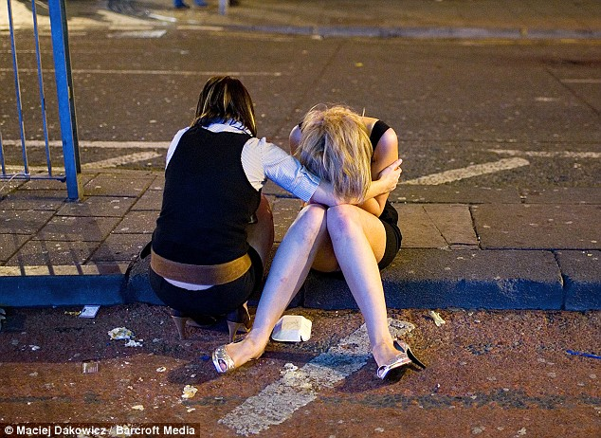
Maciej Dakowicz/Barcroft Media, Daily Mail UK, 2009

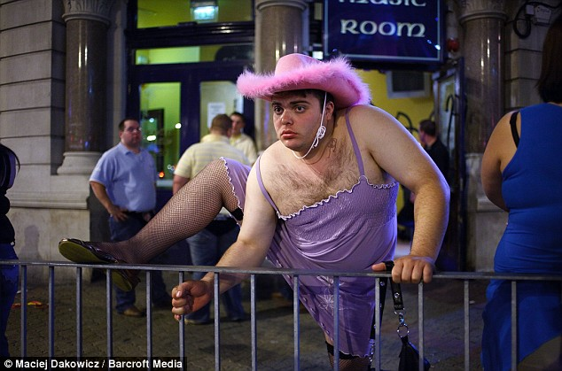
Maciej Dakowicz/Barcroft Media, Daily Mail UK, 2009

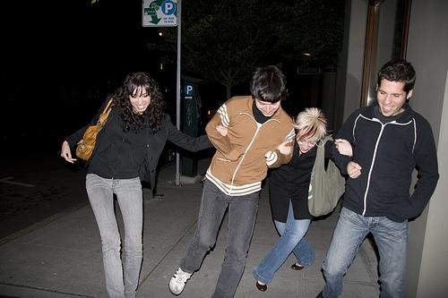
http://a2.ec-images.myspacecdn.com/images01/35/ab755f1e8c5db72d5cfa72d7b0c941ad/l.jpg
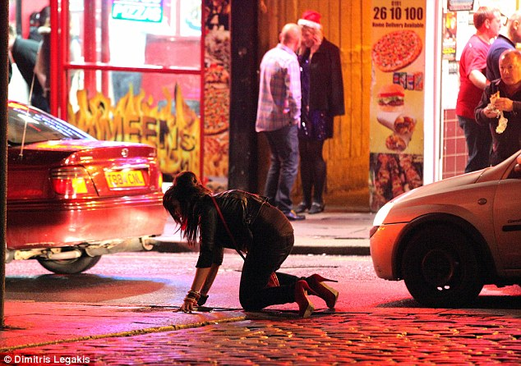

Dimitris Legakis, Daily Mail UK

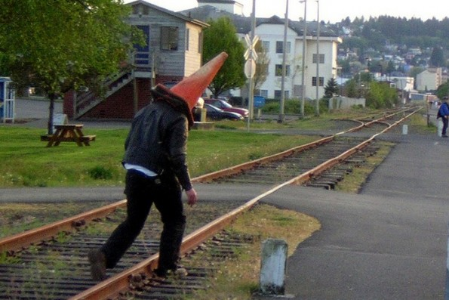
theadventuresofhobobob.blogspot

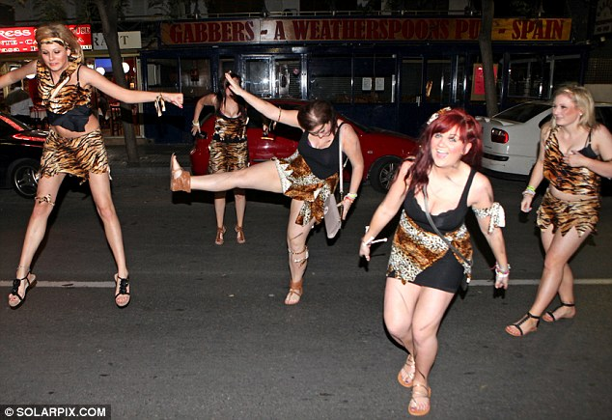

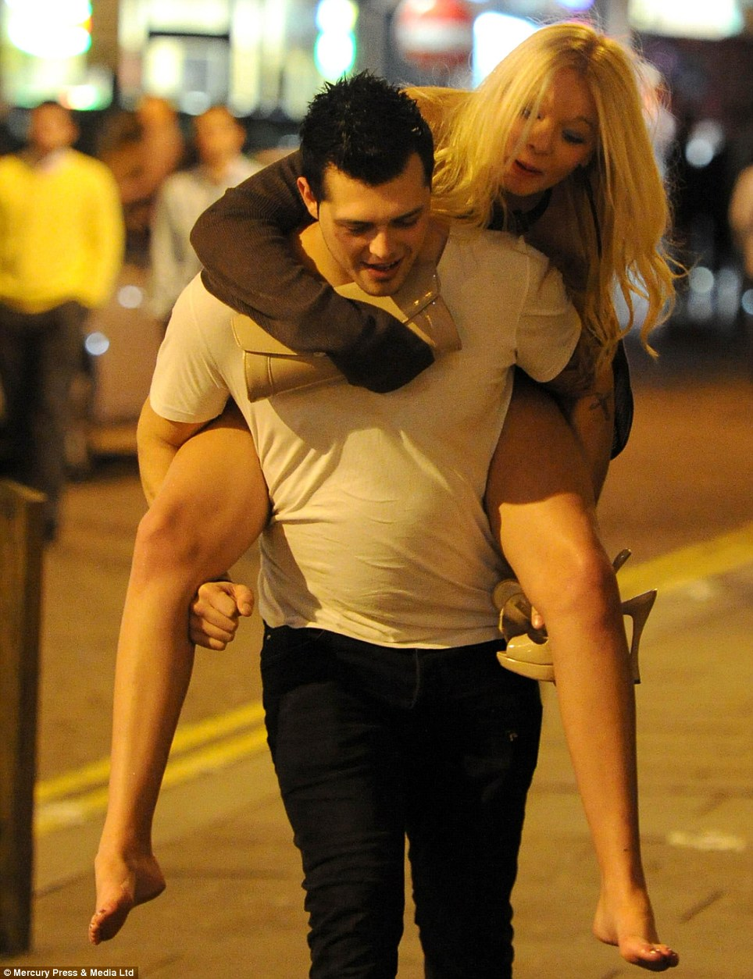
© SWNS dailymail.co.uk

© SWNS dailymail.co.uk

Activity 2
I am, or in the past there are times when I have been
Use these scripts as part of your positive self-talk
1. Organised | 2. Generous | 3. Interested | 4. Strong
5. Thoughtful | 6. Determined | 7. Outspoken | 8. Unaffected
9.Helpful | 10. Hard-working | 11. Proactive | 12. Aware
13. Flexible | 14. Honest | 15. Stable | 16. Bright
17. Anxious | 18. Loyal | 19. Tactful | 20. Dedicated
21. Funny | 22. Patient | 23. Well-behaved | 24. Far-sighted
25. Caring | 26. Courageous | 27. Articulate | 28. Objective
29. Accepting | 30. Respectful | 31. Broad-minded | 32. Realistic
33. Fair | 34. Affectionate | 35. Definite | 36. Cheerful
37. Persistent | 38. Appreciative | 39. Idealistic | 40. Cool-headed
41. Encouraging | 42. Approachable | 43. Out-going | 44. Logical
45. Witty | 46. Brave | 47. Tolerant | 48. Motivated
49. Calm | 50. Adventurous | 51. Practical | 52. Playful
53. Cheerful | 54. Compassionate | 55. Neat | 56. Resourceful
57. Creative | 58. Dependable | 59. Kind | 60. Amusing
61. Self-disciplined | 62. Sympathetic | 63. Polite | 64. Reliable
65. Careful | 66. Friendly | 67. Gentle | 68. Sensible
69. Intelligent | 70. Inventive | 71. Deep | 72. Warm-hearted
73. Joyful | 74. Loving | 75. Supportive | 76. Easy-going
77. Sensitive | 78. Open-minded | 79. Trustworthy | 80. Independent
81. Optimistic | 82. Perceptive | 83. Energetic | 84. Entertaining
85. Resourceful | 86. Punctual | 87. Understanding | 88. Fun-loving
89. Reasonable | 90. Empathetic | 91. | 92.

Activity 2
‘I CAN’

Use these script prompts as part of your positive self-talk
I can take responsibility when leadership is needed | I can speak up even if I am scared
I can learn from my mistakes | I can use what I have been taught
I can apologise when I did the wrong thing | I can draw on preparation that I did
I can stick at it | I can keep going even if I get stuck
I can turn up even if I don't feel like it | I can try a different strategy if the first one doesn’t work
I can control my nerves | I can work out how to manage my time
I can plan for my own safety and wellbeing | I can do the right thing even when my friends don’t
I can keep my promises | I can show friendship even if no one else does
I can handle being ordinary, I don’t have to be the best | I can stay positive even if people around me are getting upset
I can handle being different, it is OK to be who I am | I can control myself even when I feel really angry
I can get over it even if someone wronged me | I can own up even when I don’t want to take the blame
I can stick with my plan even if other people are being distracting | I can smile and be friendly even when I am nervous
I can think through how my actions  might affect other people | I can go out of my way to help even if I don’t know if it will be accepted
I can stick at it even when I am not sure if I will make it | I can take on a new challenge even if I am not sure how I will manage it
I can ask for help when I need it | I can explain what I need
I can speak up when I know something is wrong | I can identify when change is needed

Activity 3 - Be Assertive Prompts
I feel… | When…
............................................................................. | .............................................................................
(say how you feel) | (state the action or happening)
when… | I feel…
............................................................................. | .............................................................................
(state the action or happening) | (say how you feel)
and so… | and so…
............................................................................ | .............................................................................
(Make your request here)  Reference: Building resilience: Social and emotional l Reference: Building resilience: Social and emotional learning materials, Youth Research Centre, Melbourne Graduate School of Education, University of Melbourne  earning materials, Youth Research Centre, Melbourne Graduate School of Education, University of Melbourne | (Make your request here)

Sample situations

It’s Christmas time and the boss has offered to host a small celebration after the end of your shift at your part time job. You want to join in so stay around. The boss opens the esky to reveal the only drinks available are alcoholic. You’re on your red P’s and you drove to work.

The pub has closed and everyone is hanging around outside deciding how to get home. Lachlan wants to walk home even though he’s unsteady on his feet. He oversteps onto the road.

Pedro has just started his early morning shift at a fast food chain. Two very drunk customers enter and order some food. Rather than sit and eat Pedro notes they are about to head out the door.

Every Sunday the Khan family invites family and friends for a lunchtime feast. The Khan family don’t drink alcohol but their good friends, the Morsen’s do. One Sunday Mr Morsen seems a bit wobbly on his feet despite him drinking no more alcohol than usual. You find out that he’s on prescription medication for a chest infection. He decides that as it’s a lovely afternoon they should all go for a walk together.

Ajay got permission to go to a party to be held at a friend’s house after the year 12 formal. He thought they would all look out for each other and he would be quite safe but found himself surrounded by a group of drunks who had gate-crashed the party. His friends are nowhere to be seen and he wants to leave.

The Papadakis family is hosting a large reception for the oldest child’s wedding. There are 150 people having a good time. Alcoholic drinks are off limits to minors however it’s an open bar for everyone else. It’s getting close to the end of the party and people are working out how to get home. Joey, a 19 year old, decides the younger people should walk as taxis won’t be available for at least an hour. It’s cold and dark outside and some of the group are having trouble walking.

Thanh is going to his friend’s 18th birthday party at the beach and knows that most people will drink heavily. He doesn’t want to get drink. Nor does he want to be looking after others who are drunk but he’s in the mood for celebrating, and also values their friendship. He expects that the party will move from the beach to another venue as the night gets cooler.

The end of year 12 celebrations at the local club is winding up. There are no more taxis
available. Ronnie is swinging her high heeled shoes around in the air and singing merrily. She tries to flag down a passing car, and then heads off walking down the road calling for everyone else to join her.

Your team has just won the grand final. A few celebratory drinks are passed around. You join in the comradery by drinking a few. The team captain offers to host further celebrations at their house but there are not enough cars. You and two others decide to walk the 2 kms in the dark along the unlit road.

Dylan, Raj, Hana, Brian and Cho are on the train on their way home from the afternoon session at the movies. As they leave the railway station they come across Yuen and Rory, victorious after winning their grandfinal but both clearly influenced by alcohol.

