Foot scooter and skateboard rider templates for schools to use:

Foot scooter and skateboard rider safety guidelines

Foot scooter and skateboard rider safety agreement

How to use these templates:
The foot scooter and skateboard safety guidelines and agreement were developed to assist schools with managing their duty of care
Both documents are optional for implementation
Insert your school specific information
Clearly outline entry and exit procedures to suit the needs of your community
Schools are encouraged to reword/omit information not relevant to their school.
This document could be adapted to include rollerblade riders if necessary.

XYZ Public School foot scooter and skateboard rider safety guidelines
Our school encourages all students and their families to be safe active travellers. This guide lists our expectations for students as foot scooter and skateboard riders when travelling to and from school.
Transport for NSW advises:
- primary school-aged children and younger should be supervised by an adult while riding their foot scooter or skateboard
- primary school-aged children and younger should not use their foot scooter or skateboard on the road
- foot scooter and skateboard riders should wear a helmet and protective gear such as knee pads, wrist guards and elbow pads
- foot scooter and skateboard riders must obey the rules. https://www.transport.nsw.gov.au/roadsafety/pedestrians/skateboards-scooters-rollerblades
Personal e-scooters are illegal on NSW roads and road-related areas, including footpaths, shared paths and bicycle lanes. You can only use these on private property.
Parents and carers are responsible for:
- how their child travels to and from school
- maintaining their child’s foot scooter or skateboard
- ensuring their child wears adequate protective gear, including an Australian Standards approved helmet, knee pads, wrist guards and elbow guards
- teaching their child the foot scooter and skateboard rider rules
- completing the Parent/carer and child foot scooter and skateboard rider safety agreement.
Students who ride foot scooters and skateboards to school are responsible for:
- completing the Parent/carer and child foot scooter and skateboard rider safety agreement
- dismounting before entering school grounds
- using the school entry and exit points via xxxxxx Street pedestrian entrance or via the side pedestrian entrance in xxxxx Road
- walking foot scooters and skateboards on school grounds
- storing foot scooters and skateboards in the bicycle rack/xxx.
Foot scooters, skateboards and helmets are brought and stored at school at the owner’s risk.
Parents and carers will be notified if their child does not follow the conditions of the school’s foot scooter and skateboard rider safety guidelines and agreement.
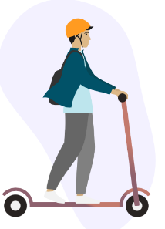
Students may be banned from bringing their foot scooter or skateboard onto school grounds if they breach school rules.

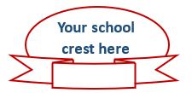
Xxxxxx Xxxxxx
Principal
Xxxxxx Xxxxxx
P&C President

XYZ Public School foot scooter and skateboard rider safety agreement

Child agreement
I, ________________________________________ of class ________
- have read and discussed the school foot scooter and skateboard rider safety guidelines and agreement with my parents or carers
- understand the information provided
- will wear my helmet and protective gear correctly when riding my foot scooter or skateboard to and from school
- will give way to all pedestrians on footpaths, crossings, and cycle paths
- will walk my foot scooter or skateboard across the road at safe places and pedestrian/traffic crossings
- will walk my foot scooter or skateboard on school grounds
- will store my foot scooter or skateboard in the bicycle rack/xxx
- understand that the principal may stop me from bringing my foot scooter or skateboard to school if I do not follow the rules
- bring my foot scooter or skateboard and helmet to and from school at my own risk.

Student signature: _____________________________
Parent/carer signature: _____________________________
Date: _____________________________

-----------------------------------------------------------------------------------------------------------------------------------

Parent/carer agreement
I approve my child (name) __________________________________ of class _______ riding his/her foot scooter or skateboard to and from school.
- I have read and discussed the school’s foot scooter and skateboard rider safety guidelines and agreement with my child rider.
- My child will correctly wear an Australian Standards approved helmet when riding a foot scooter or skateboard to and from school.
- I have reviewed the Guide to foot scooter and skateboard maintenance and understand that it is my responsibility to keep the foot scooter or skateboard maintained and roadworthy.
- I have reviewed the Guide to correctly fitting a helmet and understand that it is my responsibility that my child wears their helmet correctly.
- I understand the principal may ban my child from bringing their foot scooter or skateboard onto school grounds if the school’s rules are not followed.
- I understand that foot scooters, skateboards and helmets are brought to school at the owner’s risk.
Parent/carer signature: _____________________________
Parent/carer name: _____________________________
Date: _____________________________

Please complete and return to school

Guide to foot scooter maintenance
Feature | What are you checking for? | Maintained | Needs fixing
Wheels | - firm, round wheels  - no bulges, cuts or flat spots
Alignment | - front wheel is straight and in line with the steering column  - clamp on steering column is tight  - quick release lever is tight
Brakes | - brake engages with rear wheel when pressure is applied
Scooter size | - correct size for rider
Nuts and bolts | - tight wheel bolts  Note: Scooters won’t go faster with loose nuts. Wheels can fall off.

Guide to skateboard maintenance
Feature | What are you checking for? | Maintained | Needs fixing
Wheels | - firm, round wheels  - no bulges, cuts or flat spots
Bearings | - clean and lubricated
Deck | - clean deck  - grip tape intact and effective
Nuts and bolts | - tight wheel bolts  Note: Skateboards won’t go faster with loose nuts. Wheels can fall off.

Guide to correctly fitting a helmet
Always wear a helmet when you ride or skate
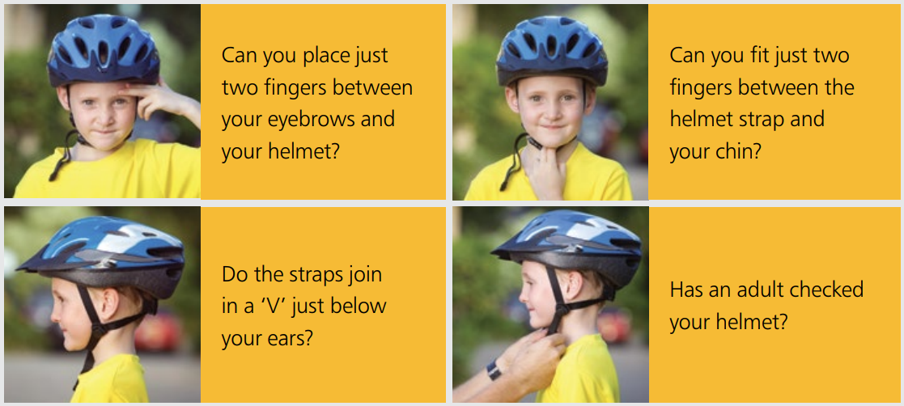
Source: NSW Centre for Road Safety, Transport for NSW
More information is available from:
Department of Education
- Riding to and from school https://education.nsw.gov.au/teaching-and-learning/curriculum/road-safety-education/safe-travel/riding
- Vulnerabilities of children as road users https://education.nsw.gov.au/teaching-and-learning/curriculum/road-safety-education/teaching-and-learning/road-safety-resources0/vulnerabilities-of-children-and-young-people
Transport for NSW
- Information for parents and carers about safety on wheels – The law and safety advice for bicycles, foot scooters, skateboards and rollerblades (pdf)
- Information, tools and tips for safe foot scooter and skateboard riding https://www.transport.nsw.gov.au/roadsafety/pedestrians/skateboards-scooters-rollerblades
- Helmets and equipment https://www.transport.nsw.gov.au/roadsafety/bicycle-riders/road-rules-for-bicycle-riders#Helmets_and_equipment_:~:text=Helmets%20and%20equipment-,Helmets,-Bicycle%20riders%20must
- For Families | Safety Town - helmets

