Bicycle rider templates for schools to use:

Bicycle rider safety guidelines

Bicycle rider safety agreement

How to use these resources:
The bicycle rider safety guidelines and agreement were developed to assist schools with managing their duty of care.
Both documents are optional for implementation.
Insert your school specific information.
Clearly outline entry and exit procedures to suit the needs of your community.
Schools are encouraged to reword/omit information not relevant to their school.

XYZ Public School bicycle rider safety guidelines
Our school encourages all students and their families to be safe active travellers. This guide lists our expectations for students as bicycle riders when travelling to and from school.
Transport for NSW advises:
- children under 10 years of age should be actively supervised by an adult when riding a bicycle
- children under 12 years of age should cycle in a safe place off the road, such as a footpath or bicycle path, and away from vehicles
- any person under 16 years of age can cycle on footpaths, as well as people over 16 if they are supervising bike riders under 12 years of age.
- children cycle away from busy roads
- bicycle riders must obey the bicycle road rules. https://roadsafety.transport.nsw.gov.au/stayingsafe/bicycle-riders/laws.html
Parents and carers are responsible for:
- how their child travels to and from school
- maintaining their child’s bicycle. Bicycles must be safe and in working order, and by law must be fitted with a working brake and a bell.
- ensuring their child correctly wears an Australian Standards approved helmet when riding
- teaching their child the bicycle road rules
- completing and returning the Parent/carer and child bicycle rider safety agreement.
Students who ride bicycles to and from school are responsible for:
- completing the Parent/carer and child bicycle rider safety agreement, issued by our school
- dismounting their bicycle before entering school grounds
- using the school bicycle entry and exit points via xxxxxx Street pedestrian entrance or via the side pedestrian entrance on xxxxx Road
- walking bicycles on school grounds
- storing the bicycle in the bicycle rack. Bicycles must be locked with a chain and padlock supplied by the bicycle owner.

Bicycles and helmets are brought and stored at school at the owner’s risk.
Parents and carers will be notified if their child does not follow the conditions of the school’s Bicycle rider safety guidelines and agreement.
Students may be banned from bringing their bicycles onto school grounds if they breach school rules.
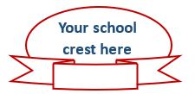
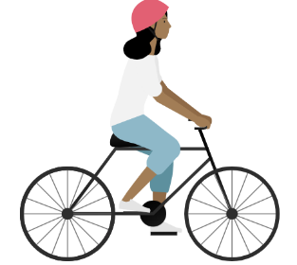
Xxxxxx Xxxxxx
Principal
Xxxxxx Xxxxxx
P&C President

XYZ Public School bicycle rider safety agreement

Child agreement

I, ________________________________________ of class ________

- have read and discussed the school Bicycle rider safety guidelines and agreement with my parents or carers
- understand the information provided
- will wear my helmet correctly when riding my bicycle to and from school
- will keep my bicycle well maintained
- will give way to all pedestrians on footpaths, crossings, and cycle paths
- will walk my bicycle across the road at safe places and pedestrian/traffic crossings
- will walk my bicycle on school grounds
- will secure my bicycle with a lock and chain in the bicycle rack
- understand that the principal may stop me from bringing my bicycle to school if I do not follow the rules
- bring my bicycle and helmet to and from school at my own risk.

Student signature: _____________________________
Parent/carer signature: _____________________________
Date: _____________________________

-----------------------------------------------------------------------------------------------------------------------------------

Parent/carer agreement
I approve my child (name) __________________________________ of class _______ riding his/her bicycle to and from school.
- I have read and discussed the school’s Bicycle rider safety guidelines and agreement with my child rider.
- My child will correctly wear an Australian Standards approved helmet when riding a bicycle to and from school.
- I have reviewed the Guide to bicycle maintenance and understand that it is my responsibility to keep the bicycle well maintained and roadworthy.
- I have reviewed the Guide to correctly fitting a helmet and understand that it is my responsibility that my child wears their helmet correctly.
- I understand the principal may ban my child from bringing their bicycle onto school grounds if the school’s rules are not followed.
- I understand that bicycles and helmets are brought to school at the owner’s risk.

Parent/carer signature: _____________________________
Parent/carer name: _____________________________
Date: _____________________________

Please complete and return to school

Guide to bicycle maintenance: Eight-point safety-check
Feature | What are you checking for? | Maintained | Needs fixing
Bell or horn | - rings or sounds clearly and loudly
Brakes | - when brakes are applied, bike wheel does not rotate
Brake pads | - pads are not worn down
Chain | - be well oiled and not sag
White front reflector | - is secure and clean
Red rear reflector | - is secure and clean
Tyres | - firm tyres  - tread not worn and no canvas showing  - no bulges or cuts
Yellow wheel and pedal reflectors | - is secure and clean
Source: Adapted from Safety Town
What is the right size of bicycle?
The right sized bicycle:
- is comfortable for the rider
- allows for the arms to be slightly bent as the body leans slightly forward holding the handlebars
- has controls within reach
- allows the rider’s feet to just touch the ground when the rider is sitting on the seat
- allows the rider to straddle the crossbar with both feet flat on the ground. There should be about 3 cm between the bicycle and the rider’s crutch for a light or medium weight road bicycle. For a BMX or mountain bike there should be a 10 cm gap. If there is no crossbar, make the test from where the crossbar would be.
- has a level seat.
What is required by law?
A bicycle must be fitted with:
- a working horn or bell
- at least one working brake
- and display a flashing or steady white light on the front, a flashing or steady red rear light, and a red rear reflector if ridden at night or during hazardous weather conditions.

Guide to correctly fitting a helmet
Always wear a helmet when you ride
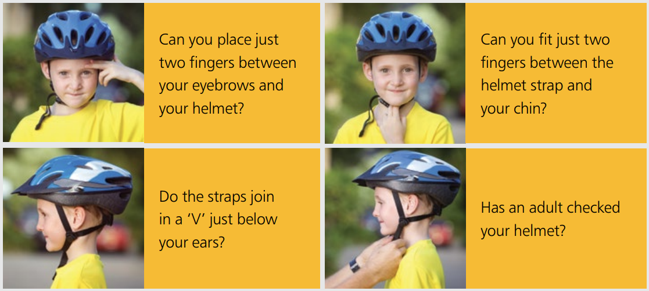
Source: NSW Centre for Road Safety, Transport for NSW
More information is available from:
Department of Education
- Riding to and from school https://education.nsw.gov.au/teaching-and-learning/curriculum/road-safety-education/safe-travel/riding
- Vulnerabilities of children as road users https://education.nsw.gov.au/teaching-and-learning/curriculum/road-safety-education/safe-travel#Vulnerabilities1
Transport for NSW
- Information for parents and carers about safety on wheels – The law and safety advice for bicycles, foot scooters, skateboards and rollerblades (pdf)
- Helmets and safety gear https://roadsafety.transport.nsw.gov.au/stayingsafe/bicycle-riders/helmets-gear.html
- NSW road rules, bicycle laws and penalties in NSW https://roadsafety.transport.nsw.gov.au/stayingsafe/bicycle-riders/laws.html
- Safe riding https://roadsafety.transport.nsw.gov.au/stayingsafe/bicycle-riders/safe-riding.html

