Curriculum implementation planning template
Purpose: This template assists leaders to plan and address key priorities and activities to meet the needs of staff and students during each phase of curriculum implementation. The template can be used as a source of evidence for implementation and progress monitoring. The questions and suggestions in Table 1 guide the contextual planning process for schools.
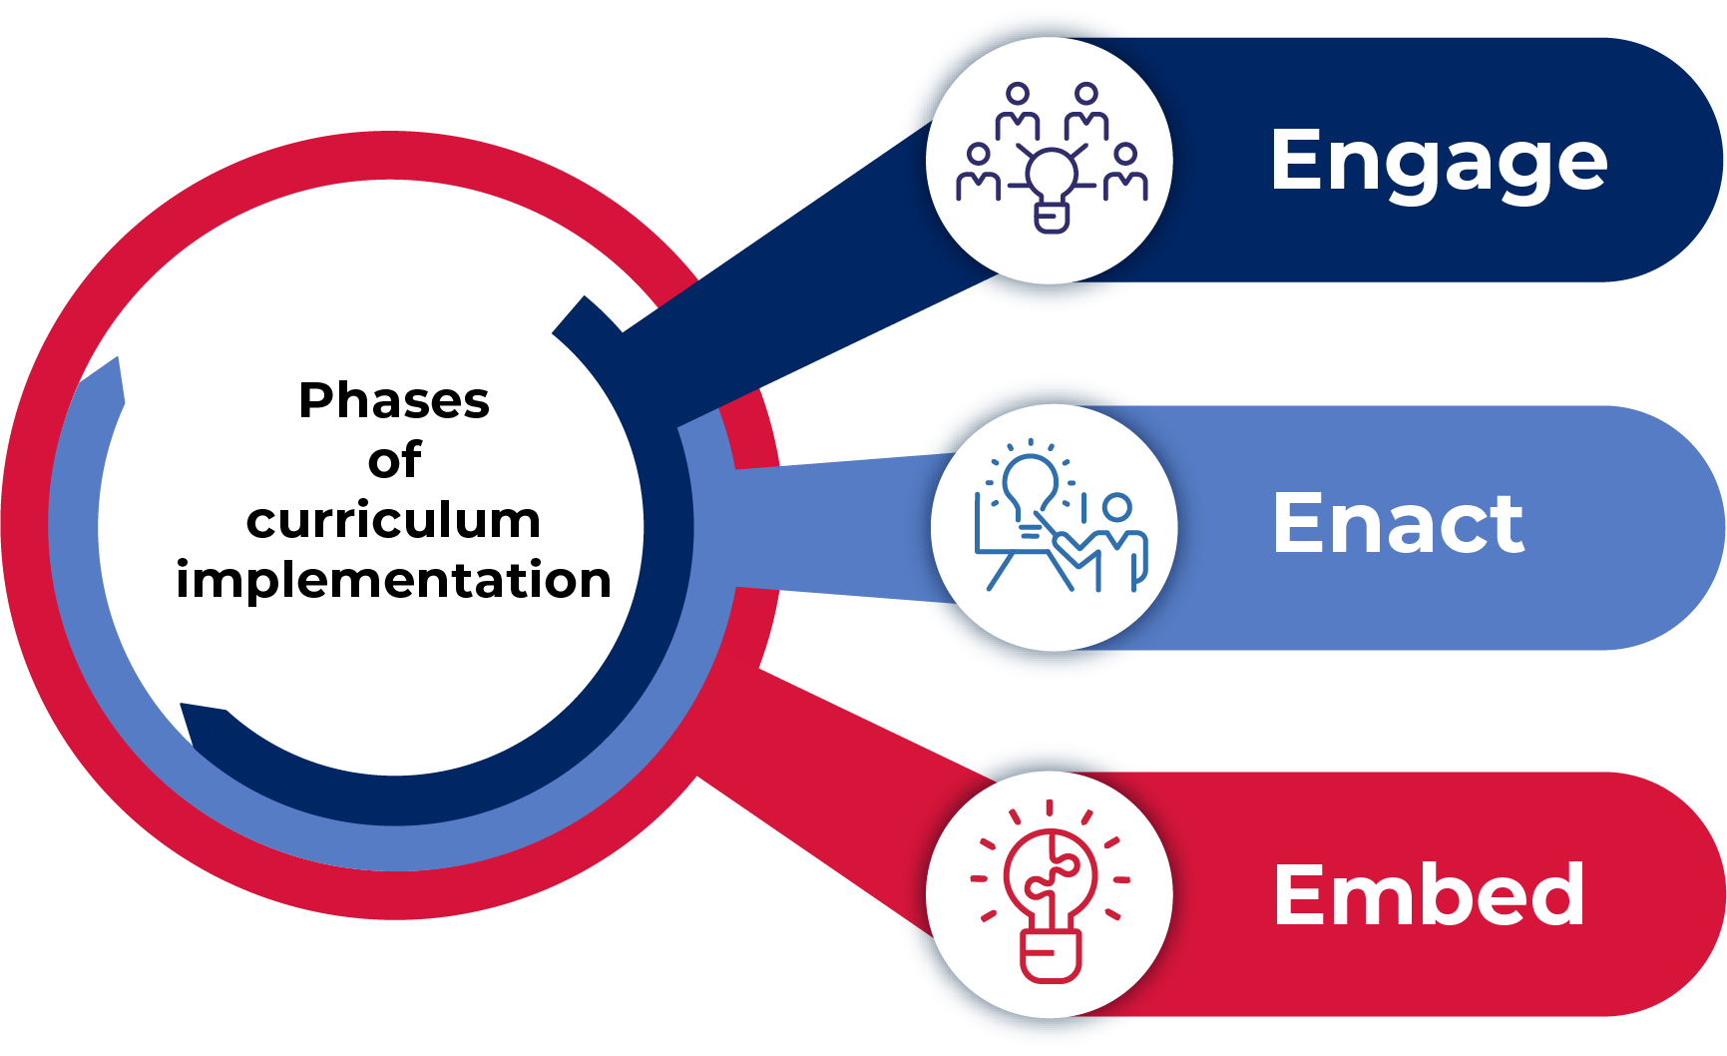

Engage phase
Explore new aspects and identify changes in practice required for effective syllabus implementation.
Table 1 – Planning for the Engage phase
What activities are our priority? | Why is this a focus for our school? | What resources can help us? | How do we contextualise resources to meet the needs of staff and students? | What evaluation processes will we undertake? (QDAI)
Consider activities already undertaken and the current needs of staff. | Identify changes that need to occur for effective implementation. | Use the curriculum implementation journeys to identify relevant NESA, DoE resources and professional learning. | Evaluate, select, create and adapt resources. | Use the reflective questions to guide the collection and analysis of data to inform next steps.

Enact phase
Teach, assess and report using the new syllabus and evaluate to refine practices and systems.
Table 2 – Planning for the Enact phase
What activities are our priority? | Why is this a focus for our school? | What resources can help us? | How do we contextualise resources to meet the needs of staff and students? | What evaluation processes will we undertake? (QDAI)

Embed phase
Strengthen and scale to ensure sustainable practices and systems.
Table 3 – Planning for the Embed phase
What activities are our priority? | Why is this a focus for our school? | What resources can help us? | How do we contextualise resources to meet the needs of staff and students? | What evaluation processes will we undertake? (QDAI)

