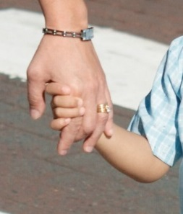
IMPORTANT ROAD SAFETY REMINDER FOR
PARENTS AND CARERS THESE HOLIDAYS

As the school holidays approach, it is important to remember when walking near roads, on footpaths, near driveways and in car parks always:
- hold your child’s hand. Until they are at least 8 years old children need to hold an adult's hand. Until they at least 10, children should be closely supervised by an adult and hold hands when crossing the road.
- talk to your child about road safety. Talk about how to be safe when near roads. Be a good role model.
- point out road safety dangers and differences in new environments. This is especially important when on holidays in different surroundings. Roads, footpaths and pedestrian facilities may look different in holiday areas.
The best way to keep your child safe on or near the road is to hold their hand.
Talk with your child daily about road safety.
Remind other adults and carers about this too.
You can find out more at Transport for NSW.
http://roadsafety.transport.nsw.gov.au/stayingsafe/children/pedestriansafety.html

Have a safe holiday break!

