Learning and Teaching Curriculum Network Project 2019

Executive Summary

Norma Petrocco and Deborah Santucci
Principals in Residence

Curriculum Network Project
Principals in Residence Executive Summary

Inquiry Question

How can the NSW Department of Education better support and measure the impact of effective curriculum networks to enhance quality curriculum support to become more sustainable and accessible across New South Wales?

Overarching Questions

  - Do networks work effectively for supporting syllabus implementation/new syllabus?
  - Are networks utilising support in the system that is currently available?
  - What is the current support for networks?
  - Is there a way we can structure support to align with networks and therefore extend our reach across NSW?
  - Is there a shared resourcing piece we can explore to assist networks?
  - What are the characteristics of quality, sustainable network practice/good examples of practice?
  - What conditions need to be present for networks to thrive and survive?

Curriculum Networks across NSW - Heat Maps

30 curriculum networks were identified by Educational Services personnel, DELs and PEOs. These curriculum networks are representative of the broad range of networks across NSW.

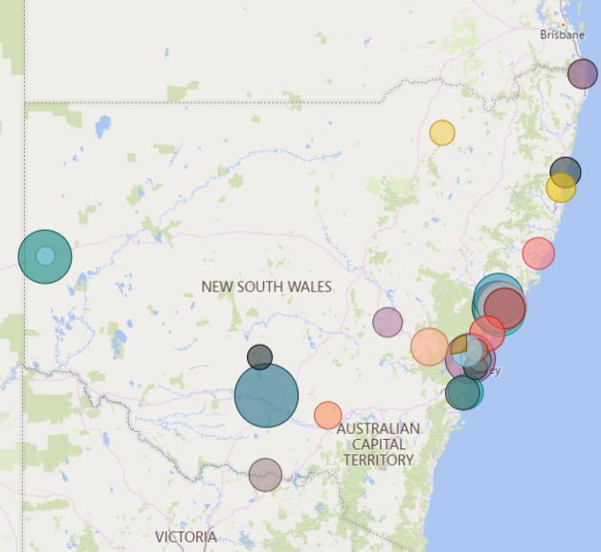
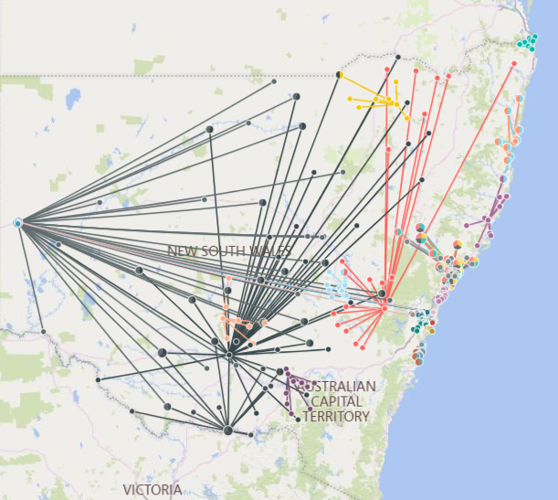

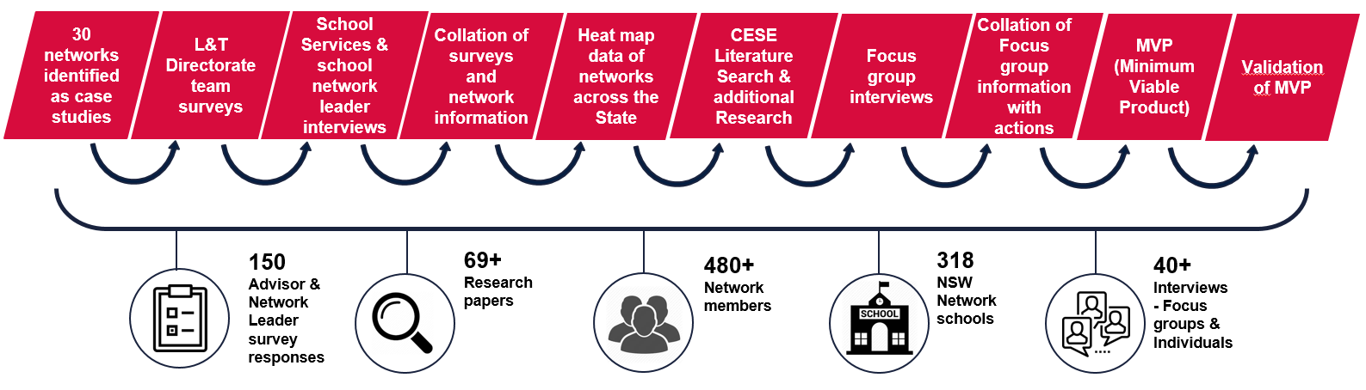
Process:

Key Findings - Focus Groups and Individual Interviews

Educational Services Support – What is important to networks:
  - Clarity and consistency of the curriculum roles, structures and support available to networks by L&T Directorate and School Services.
  - Awareness and up to date communication of the personnel, resources and support available in L&T Directorate.
  - Reliable and current directory of contact names and details with role statements.
  - Building relationships and trust to work collegially with Curriculum Advisors who have a knowledge of their context and needs.
  - Consistency of messaging and maintaining the integrity of syllabuses and Key Learning Areas.
  - Value KLA specific and credible curriculum expertise K-6, 7-10 and 11-12 compared to generalist support.

Professional Learning and Funding – What is important to networks:
  - Awareness and communication of the professional learning and resources available.
  - Funding to release staff to attend quality professional learning and access to casual teachers to enable this.
  - Face to face professional learning is the preferred model delivered with context in mind as opposed to generalist delivery.
  - Online learning acknowledged as a means to support the delivery of professional learning but is not the preferred model.
  - Quality professional learning is seen as a means of building relationships, trust and collegiality amongst colleagues as well as opportunities to share professional practice with expert curriculum leads.
  - Value ongoing support and professional learning with trusted, specialised and credible Curriculum Advisors.

Website – What is important to networks:
  - Awareness and communication that the L&T website exists.
  - Consistent ‘time poor’ message was communicated:
  - One stop shop, including course registration links.
  - Easy to find, access and navigate.
  - Current and up to date with notifications of new resources uploaded.
  - Quality and complete resources with exemplars that can be easily adapted for particular contexts.

Other Key Findings:
  - Consistently across all focus groups, Accreditation is not seen as a driver for the sharing of practice within networks.
  - Networks provide leadership opportunities to support building capacity, succession planning and career advancement.
  - Consistently, networks were originally established to provide the curriculum support lacking at that time.
  - Consistently, measuring impact does not feature highly in networks. Anecdotal evidence was provided, however there is no formalised measure of impact.
  - The intention of networks has always been to collegially support each other and to share practice and resources.
  - Consistently, secondary networks accessed NESA and KLA specific associations for resources and support, in the first instance.

Characteristics of Effective Curriculum Networks

Governance
Vision, values and culture
- Clear vision statement
- Vision statement agreed upon and communicated
- Transparency in decision making
- Strong collegial professional relationships built on trust
- Sharing of success and challenges

Structures, procedures and systems
- Clear governance guidelines, including a constitution
- Clearly defined roles and responsibilities
- Action plan that aligns with the network’s vision
- Clear induction processes for new members
- Support of principals and leadership teams across the schools
- Accountability structures

Sustainability
- Leadership opportunities embedded in network practice
- Mentoring opportunities embedded in network practice
- Structured nomination process
- Succession planning in place for leadership roles

Measuring impact
- Curriculum Network Self-Assessment Tool (aligned to SEF and supporting EV) (hyperlink to tool) used by network to measure impact and inform future directions

Quality professional learning
- Tailored and based on needs of the network
- Held consistently with purpose and aligned to the network’s vision
- Participants provide feedback
- Registered on MyPL
- Informs practice and is evidenced to improve student learning
- DoE curriculum personnel engage with and support the network
- DoE curriculum resources sourced and used to support the work of the network
- Curriculum expertise and practice is shared within the network
- Development and sharing of high-quality resources across the network

Benefits of Participating in a Curriculum Network

Individual surveys of network leaders as well as focus group interviews with Educational Services network leaders, school network leaders and participants of networks highlighted that curriculum networks provided a safe environment where educational practitioners could come together to work collaboratively and collegially to share best practice.

A ‘ground up’ approach with strong school leader support was the most effective and productive model as it is the autonomy coupled with a shared purpose and vision that these curriculum networks were most able to provide authentic opportunities for mentoring and capacity building.

A curriculum network provides a collaborative and supportive environment for:
  - Curriculum leadership to develop expertise and capacity building within a Key Learning Area.
  - Explicit and contextually tailored quality professional learning driving evidence-based practice aimed at creating collective efficacy.
  - Sharing of high-quality informed practice and teaching resources reflective of NSW syllabuses focusing on improving student outcomes.

How the DoE can support curriculum networks

As a result of the key findings and the research undertaken throughout this project, it is concluded that the following recommendations of support are provided to schools across NSW to review existing curriculum networks to make them more effective and sustainable or to establish a new curriculum network.

  - DoE L&T Directorate Curriculum Network Project Fact Sheet (add to appendix)
  - Curriculum Networks DoE Website (insert Home page PowerPoint slide)
  - Curriculum Network Resources (add sample templates in appendix – agenda, action plan, curriculum network leader checklist, EOI etc)
  - Self-Assessment Tool (aligned to the SEF and supporting EV – add self-assessment tool in appendix)

Research

Reference to School Curriculum Network Literature Search undertaken by CESE (July 2019)

Challenge: Solidarity with solidity: The case for collaborative professionalism (Andy Hargreaves and Michael O’Connor 2018)
- the most successful and sustainable efforts are characterized by both solidity and solidarity, meaning that they draw on both expert knowledge and strong collegial relationships, creating what the authors call collaborative professionalism

Making progress possible: a conversation with Michael Fullan (Thiers 2017)
- fostering collaborative professionalism in schools, external and internal accountability, and educational leadership that make progress possible
- we need to infuse collaborative professionalism throughout schools with a focus on deep learning for all students.

Theoretical Framework Development (H Timperley, Guskey, M Fullan & J Quinn, F Whalan, J Wiley & Sons, A Hargreaves 2017)
- There needs to be a transfer of learning into practice
- Relational Trust – This is central to achieving productive collaborative relationships focused on school improvement
- Teachers with a strong sense of collective efficacy believe that they can collectively make a difference in the learning and success of their students
- Highly successful organisations learned from the success of others but never tried to imitate what others do
- Leaders from the middle (LFTM) is a powerful strategy

Teacher Professional Learning and Development (H Timperley, A Wilson, H Barrar and I Fung 2008)
- Seven elements in the professional learning context were identified in the core studies as important for promoting professional learning in ways that impacted positively and substantively on a range of student outcomes:
    - providing sufficient time for extended opportunities to learn and using the time effectively;
    - engaging external expertise;
    - focusing on engaging teachers in the learning process rather than being concerned about whether they volunteered or not;
    - challenging problematic discourses;
    - providing opportunities to interact in a community of professionals;
    - ensuring content was consistent with wider policy trends;
    - and, in school-based initiatives, having leaders actively leading the professional learning opportunities.

The Elements of Effective Professional Development (CESE 2014)
    - Curriculum-focused professional development programs that emphasised content, how to teach specific content and how students learn, generated a more positive effect on student outcomes (effect size: 0.56) than programs that focus on pedagogy only (effect size: 0.07)

Appendix
  - DoE L&T Directorate Curriculum Network Project Fact Sheet
  - Curriculum Networks DoE Website Home Page
  - Curriculum Network Leader Resources
    - Curriculum Network Action Plan Template
    - Curriculum Network Agenda Template
    - Curriculum Network Constitution Template
    - Curriculum Network EOI Template
    - Curriculum Network Leader Checklist
  - Self-Assessment Tool and
    - Evidence Set Template 1
    - Evidence Set Template 2
    - Evidence Set Template 3
  - CESE Literature Search July 2019

Appendix A: DoE L&T Directorate Curriculum Network Project Fact Sheet
DoE L&T Directorate Curriculum Network Project – Fact Sheet

Purpose

To better understand the characteristics of quality, sustainable curriculum networks that develop leadership capacity, cultivate curriculum content expertise and improve teaching practice, leading to improved student learning outcomes.

Aim

To identify quality networking practices to facilitate ground up support by sharing and/or upscaling existing curriculum-based networks and supporting the growth of new ones.

Background

Curriculum networks operate within and across NSW public schools in a wide range of configurations and across multiple contexts. Networks sometimes arise to support the local implementation of a new syllabus and may operate for a limited duration. Other networks operate on a more sustained, self-managed model with ongoing collaboration and communication between participants.

30 networks were identified across the State (both metropolitan, regional, rural and remote) to be part of this project (hyperlink to network names).

Project Overview
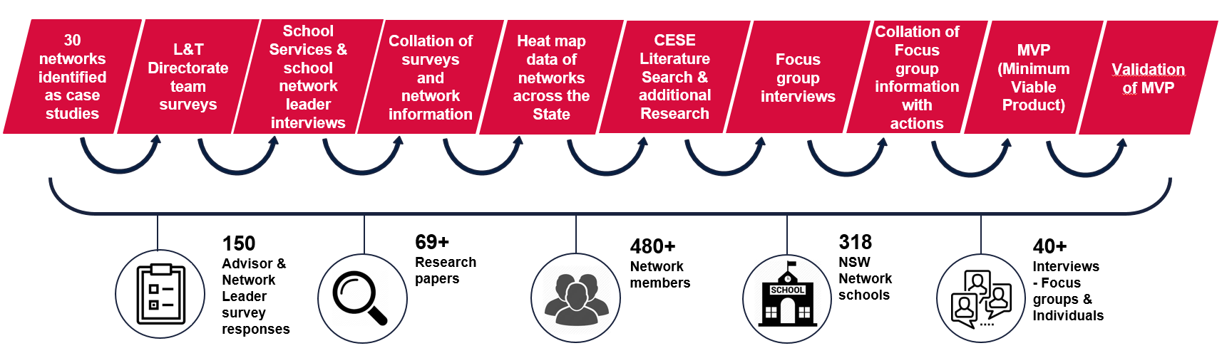

Characteristics of Effective Curriculum Networks

Governance
Vision, values and culture
- Clear vision statement
- Vision statement agreed upon and communicated
- Transparency in decision making
- Strong collegial professional relationships built on trust
- Sharing of success and challenges
Structures, procedures and systems
- Clear governance guidelines, including a constitution
- Clearly defined roles and responsibilities
- Action plan that aligns with the network’s vision
- Clear induction processes for new members
- Support of principals and leadership teams across the schools
- Accountability structures
Sustainability
- Leadership opportunities embedded in network practice
- Mentoring opportunities embedded in network practice
- Structured nomination process
- Succession planning in place for leadership roles
Measuring impact
- Curriculum Network Self-Assessment Tool (aligned to SEF and supporting EV) used by network to measure impact and inform future directions
Quality professional learning
- Tailored and based on needs of the network
- Held consistently with purpose and aligned to the network’s vision
- Participants provide feedback
- Registered on MyPL
- Informs practice and is evidenced to improve student learning
- DoE curriculum personnel engage with and support the network
- DoE curriculum resources sourced and used to support the work of the network
- Curriculum expertise and practice is shared within the network
- Development and sharing of high quality resources across the network

Benefits of participating in a network

A curriculum network provides a collaborative and supportive environment for:
- Curriculum leadership to develop expertise and capacity building within a Key Learning Area
- Explicit and contextually tailored quality professional learning driving evidence-based practice aimed at creating collective efficacy
- Sharing of high quality informed practice and teaching resources reflective of NSW syllabuses focusing on improving student outcomes

How the DoE can support curriculum networks

Models of Curriculum Networks and other useful Links
Professional Learning Communities (PLCs)

Action Research

Instructional Rounds

Learning Sprints

Dylan Wiliam

Helen Timperley

Appendix B: DoE Website Curriculum Network Home Page
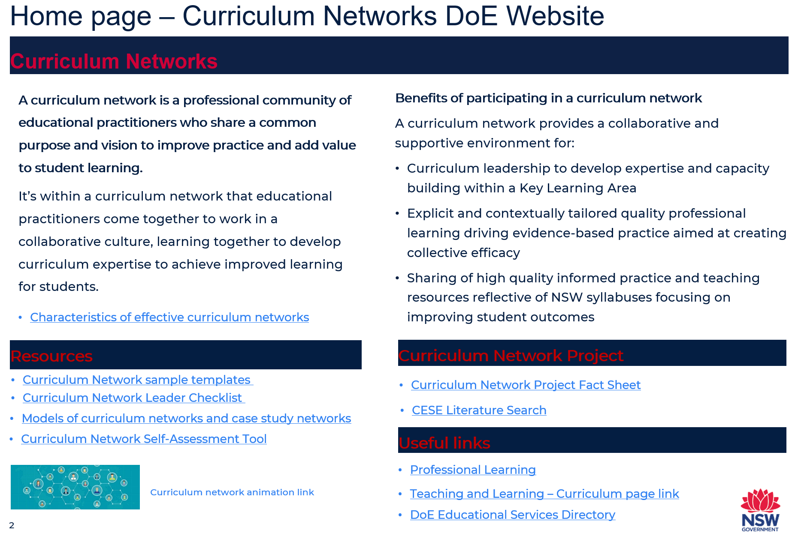
Appendix C.1: Curriculum Network Action Plan Template
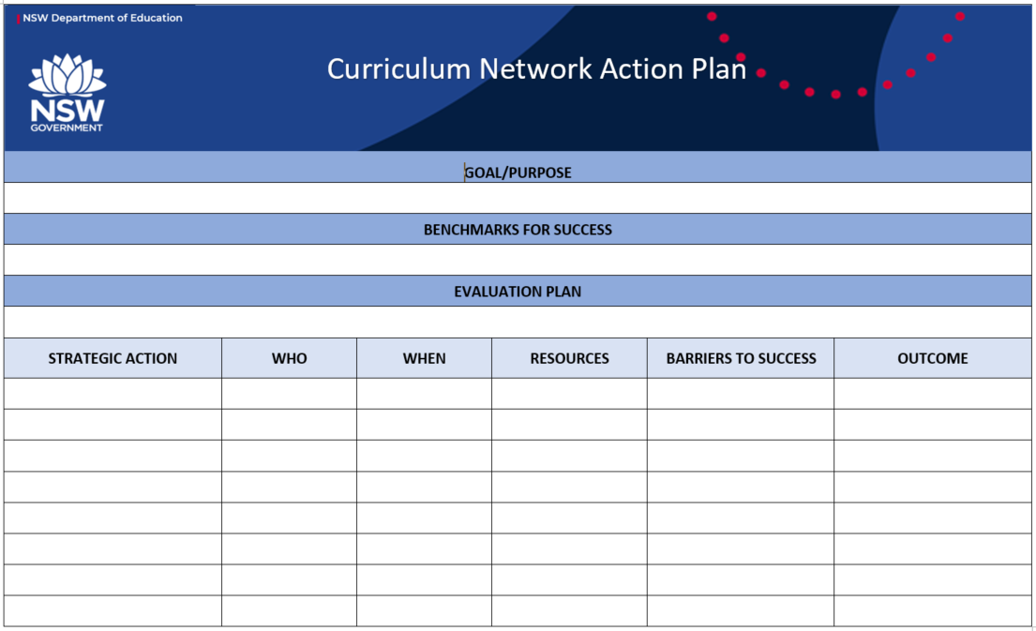

Appendix C.2: Curriculum Network Agenda Template

Appendix C.3: Curriculum Network Constitution Template

Appendix C.4: Curriculum Network EOI Template

Appendix C.5: Curriculum Network Leader Checklist
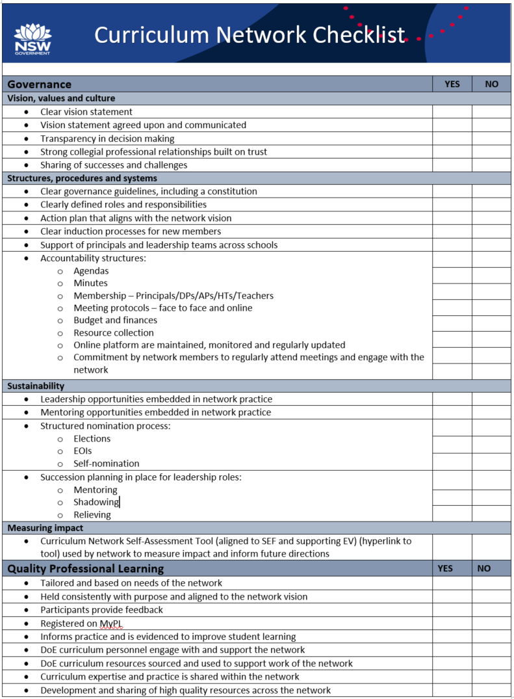

Appendix D: Self-Assessment Tool
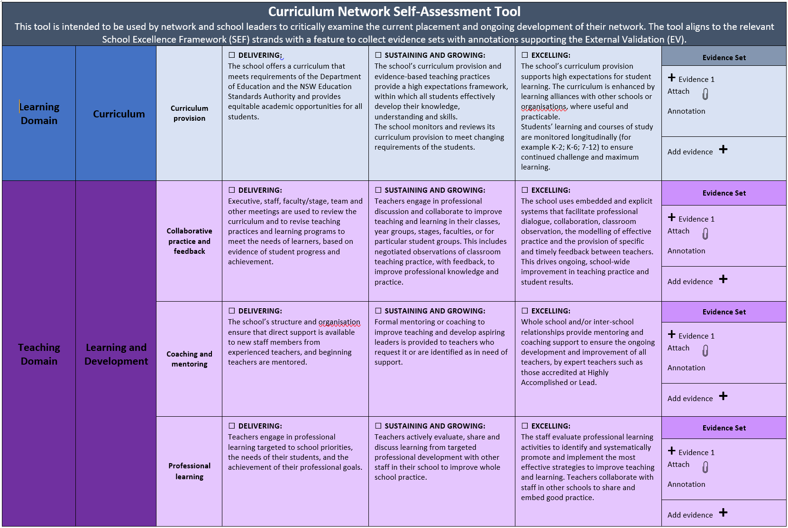

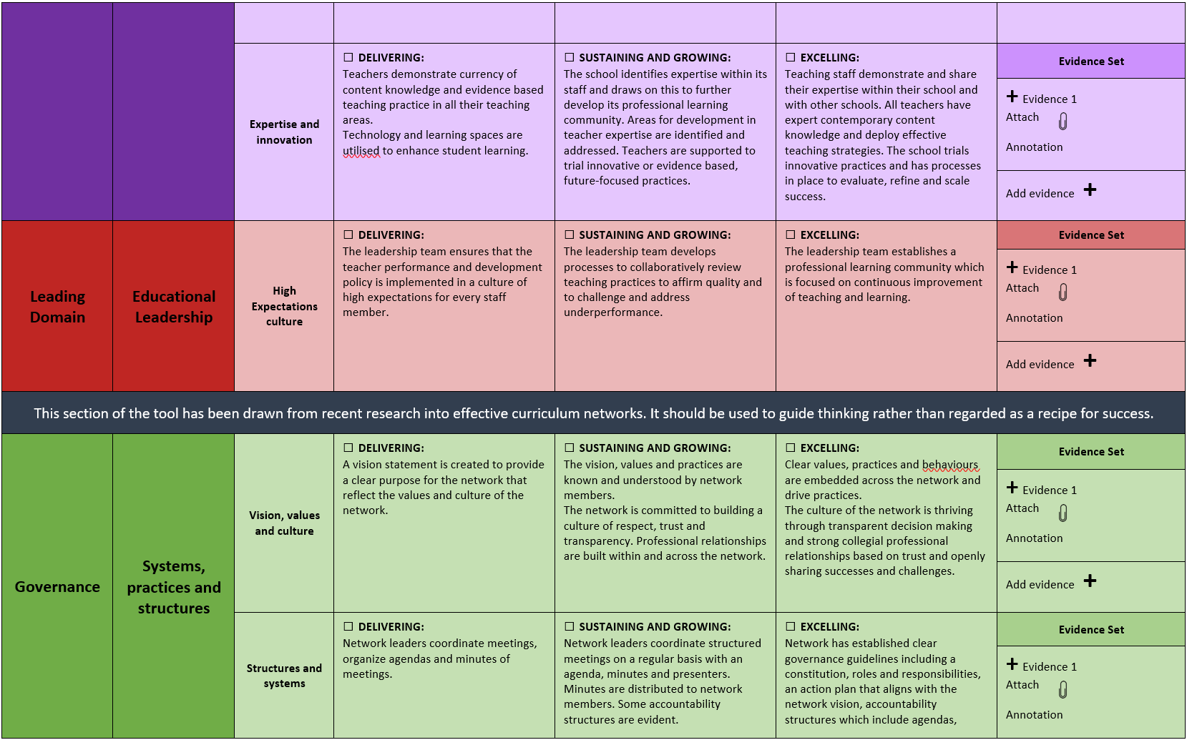
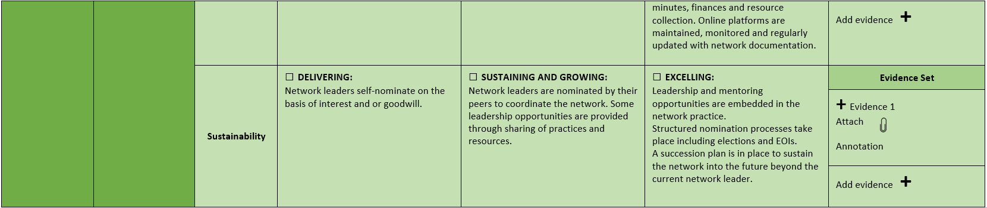

Appendix D.1: Evidence Set Template 1
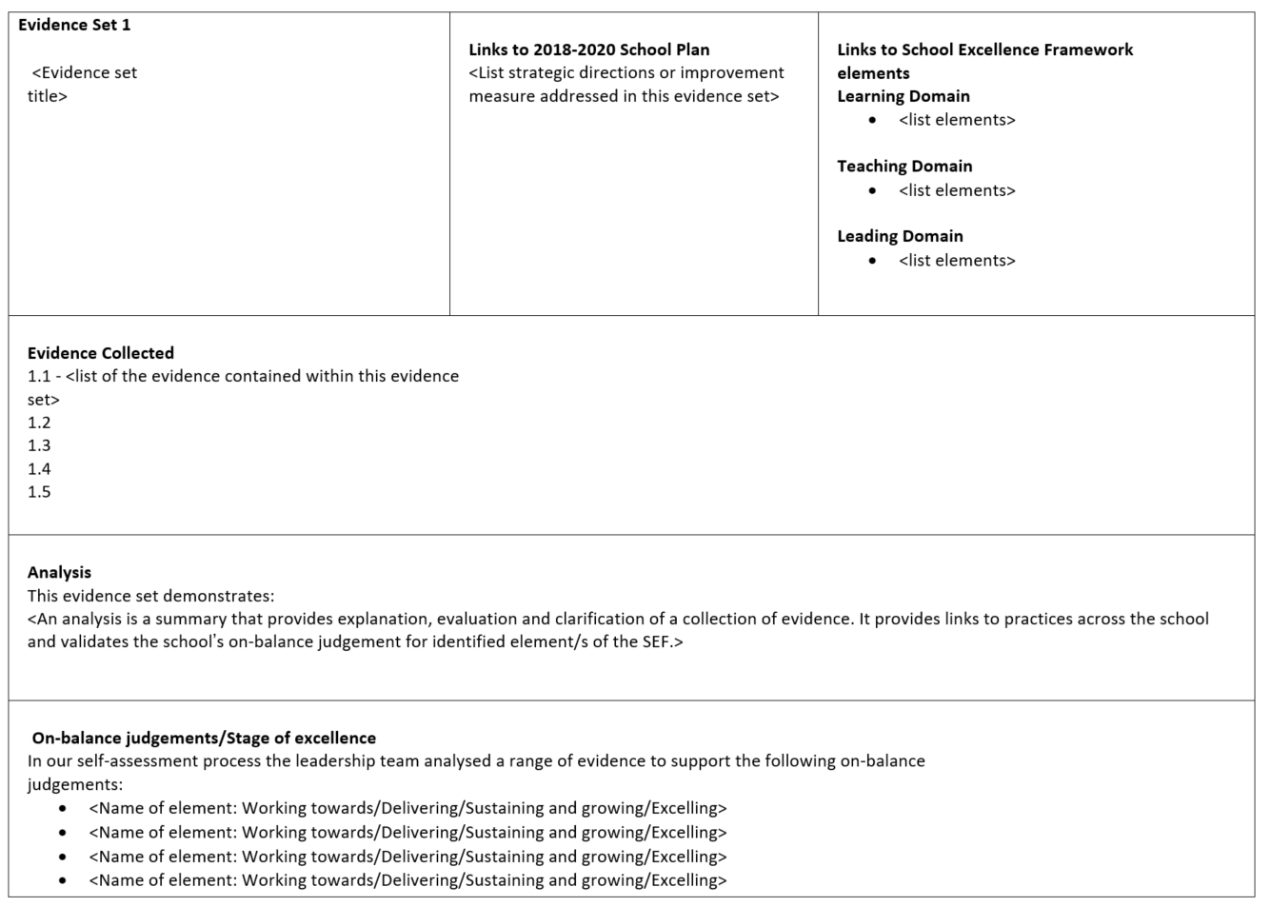
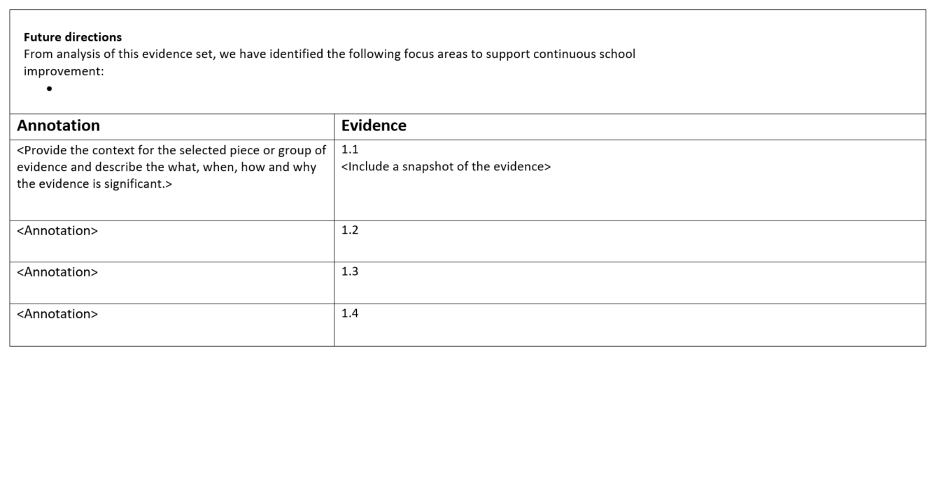

Appendix D.2: Evidence Set Template 2
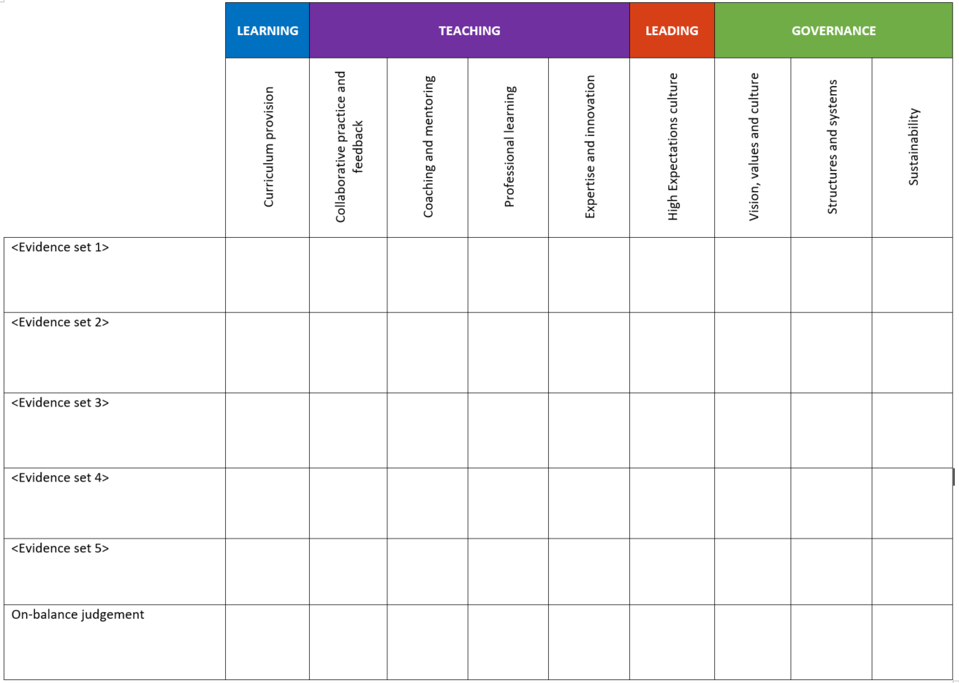
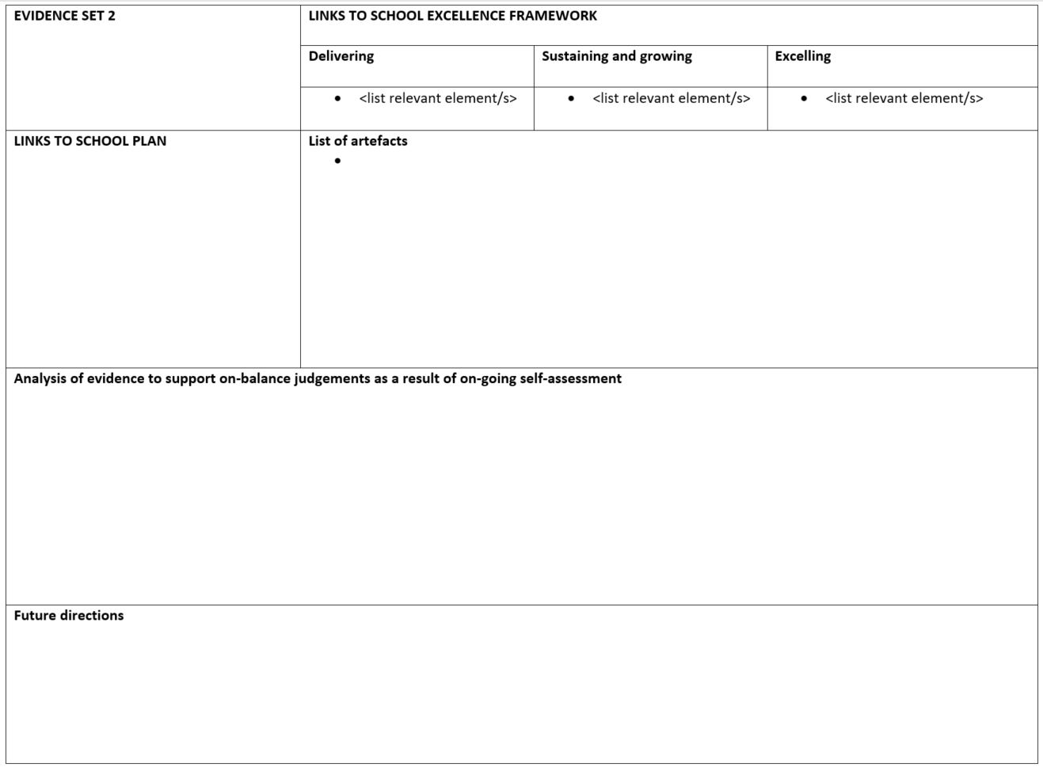

Appendix 4.3: Evidence Set Template 3
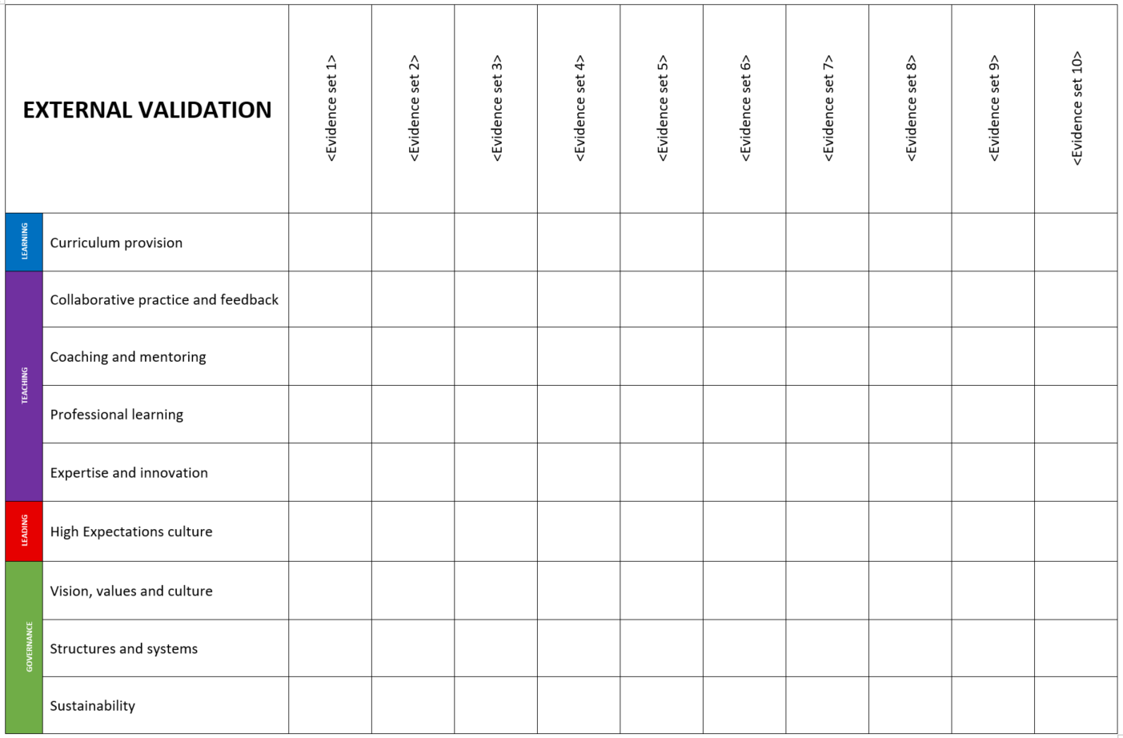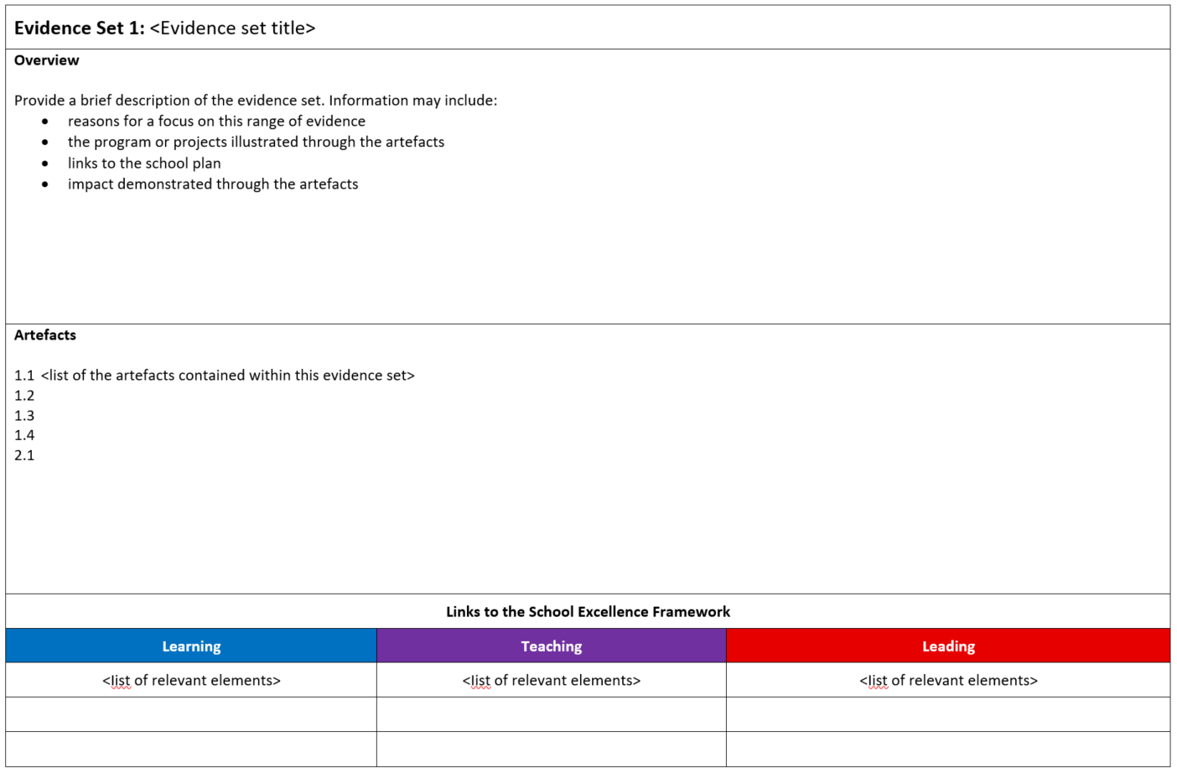

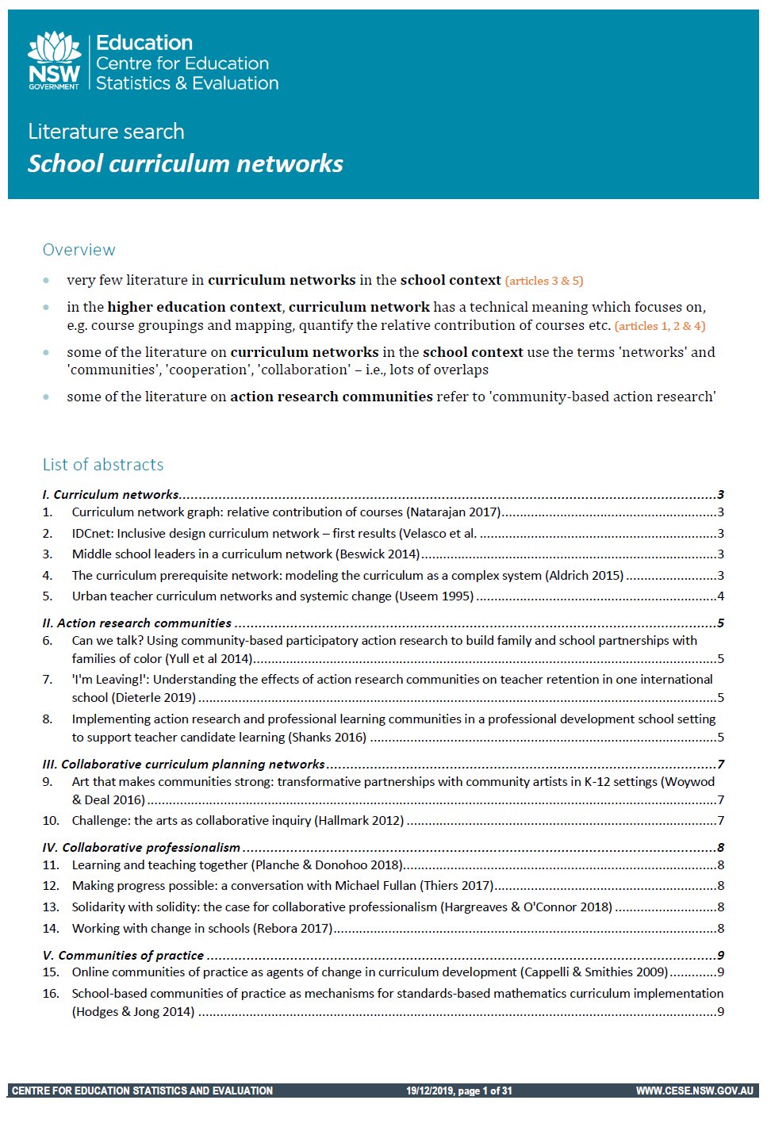
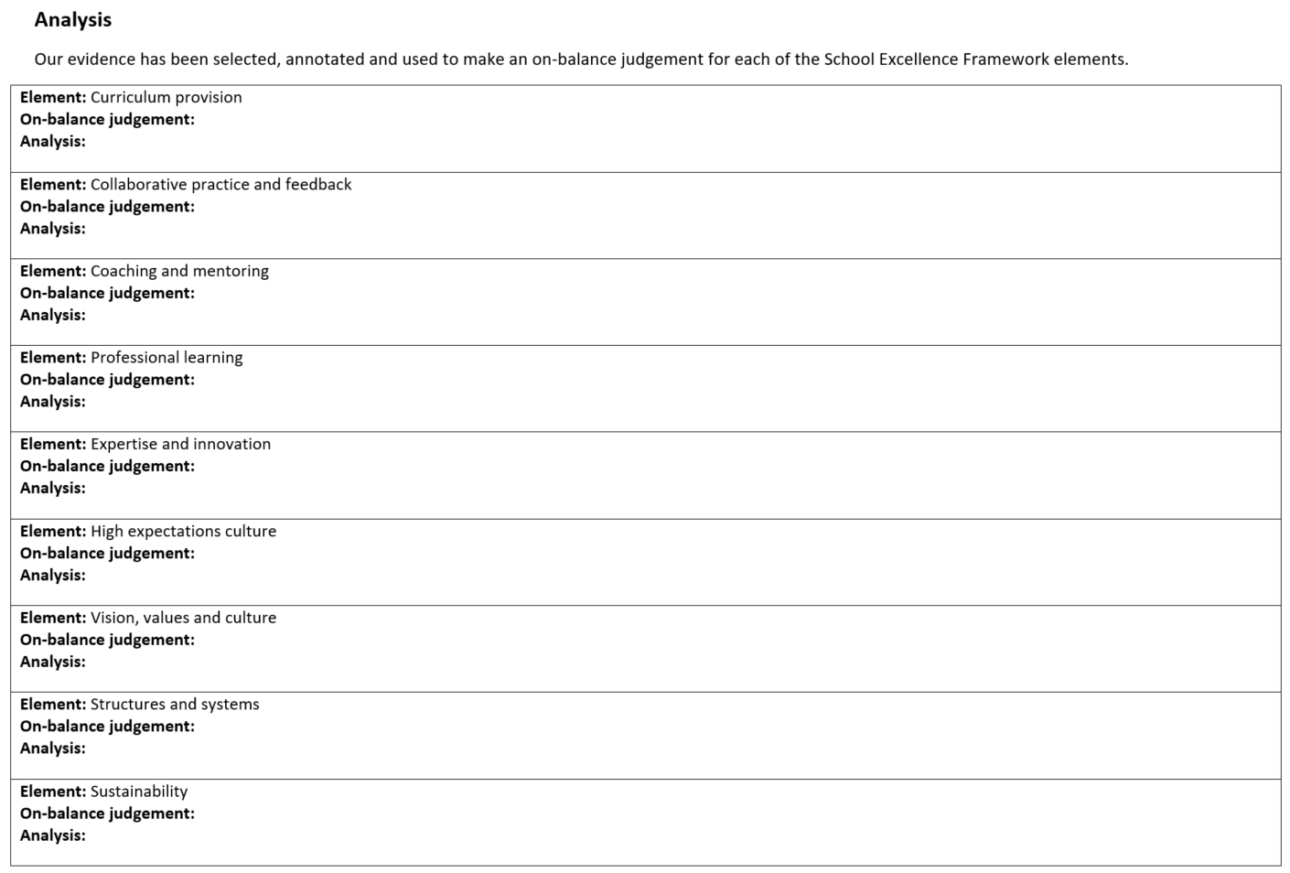
Appendix E: CESE Literature Search July 2

