Slopes as gradients
In this activity, students investigate the steepness of slopes around the school represented as a gradient and compare safe slopes with angle measurements.
This activity is designed as an introduction to gradients, for students to initially investigate the concept.

Visible learning

Learning intention
- To be able to calculate and represent a slope as a gradient.

Success criteria
- I can calculate the gradient of a surface.
- I can explain the meaning of a calculated gradient in terms of rise and run.

Syllabus outcomes
A student:
- develops understanding and fluency in mathematics through exploring and connecting mathematical concepts, choosing and applying mathematical techniques to solve problems, and communicating their thinking and reasoning coherently and clearly MAO-WM-01
- determines the midpoint, gradient and length of an interval and graphs linear relationships, with and without digital tools MA5-LIN-C-01
Mathematics K–10 Syllabus © NSW Education Standards Authority (NESA) for and on behalf of the Crown in right of the State of New South Wales, 2022.

Activity structure

Launch
This launch is also included in the activity How steep is too steep? as the 2 lessons are connected. The description of slope that we are going to focus on is the gradient, or the rise versus the run.
- Watch the video about the world's steepest street (0:45) (bit.ly/VideoSteepStreet).
- Ask students to take notes on the ways that the slope is described.
The video describes the slope in terms of the time taken to walk its 350 metres, its angle of inclination, and the rise and run of the slope.
- Have students construct a Notice and Wonder table (bit.ly/noticewonderstrategy) about the street in New Zealand, sharing with a peer before engaging in a class discussion.

Speed of slope (Optional)

Equipment
- Stopwatch
- Marbles, Jaffas or Maltesers (or anything else that is spherical)
- At least 2 reasonably sloped, hard surfaces

Method
- Watch the video about the Jaffa race (1:02) down the world's steepest street (bit.ly/VideoJaffaRace).
- Find at least 2 slopes in the school. Have students make an estimate as to which one is the steepest.
- Roll whatever spherical objects you have down each of the slopes, recording the time it takes to travel the same distance on each slope.
- Have students complete a Think-Pair-Share (bit.ly/thinkpairsharestrategy) based on the following reflection questions before discussing as a class.
- Which slope was steeper? How do you know?
- Do you think each of these slopes are safe for all purposes, such as walking, driving, bicycles and wheelchairs?
- How much faster was the steeper slope?
- How much steeper was the faster slope?

Explore
- Hand out Appendix A. Challenge students to answer the questions in pairs. Investigate student thinking using a strategy such as pause, pounce, bounce (bit.ly/pausepouncebouncestrategy).
For classes where devices with internet access are not available, the teacher can display this graph on their screen and lead a shorter discussion around the questions given.
- Display Figure 1. Explain that this represents Baldwin Street from our video. Every time we travel 2.86 metres horizontally, we go up one metre.
Figure 1 –a right-angled triangle representing Baldwin Street
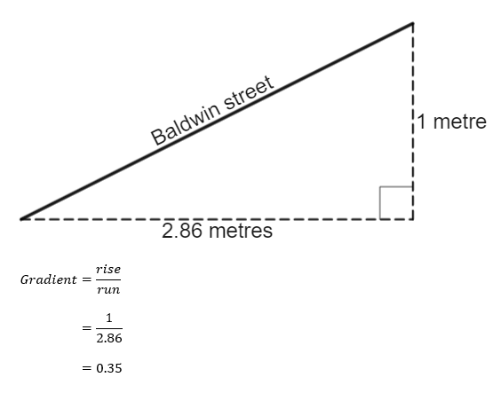
- Give students time to review. Students give a thumbs up to indicate to the teacher that they have finished their review.
- Have students complete a Think-Pair-Share (bit.ly/thinkpairsharestrategy) about the steps in this example, focusing on the terms of rise and run.
- Hand students Appendix B and have them complete the faded worked examples to find the gradient of lines.
- Have students complete a Notice and Wonder table (bit.ly/noticewonderstrategy) about the values they obtained for the gradient of slopes.

Summarise
- Acknowledge with students that finding the gradient of a slope is about finding the rise and the run.
- Hand students Appendix C and find the gradient using a grid.
- Display Figure 2. Explain that by placing a grid over a slope, we can count squares to find the rise and run, and hence find the gradient.
Figure 2 – hiker in the mountains
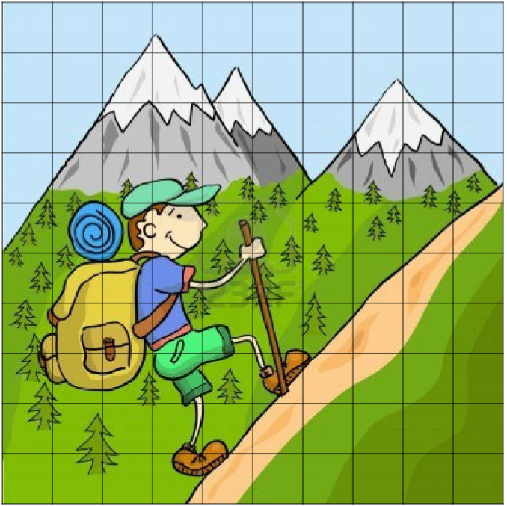
‘Mountains’ by Petra Matkovič is licensed under CC BY-NC-ND 3.0.
- Students complete Appendix C. If devices are available, students can engage with this task using the Desmos graph Gradients of real-world slopes (bit.ly/Desmosrealgradients).
- Have students work in groups to investigate how many different ways they can write the gradient of each slope in Appendix C.

Apply

Equipment
- Tape measure (one per group)

Method
- State that safety standards have determined that ramps suitable for people in a wheelchair require a maximum gradient of $\frac{1}{14}=0.071$ This can be confirmed by displaying the Design for Dignity website (bit.ly/Designfordignity), where the ratio of 1:14 is shown.
- Give each student a copy of Appendix D.
- Students follow the steps involved to measure the gradients of the different types of slopes around the school.
- Once completed, students should compare the slope with the wheelchair accessible standard of $0.071$ and the gradient of Baldwin Street in New Zealand, $0.35$.

Assessment and Differentiation

Suggested opportunities for differentiation
Explore
- Students are challenged to consider scenarios that would result in a specific gradient.
Summarise
- The Desmos graph removes the need to count squares and reduces the cognitive load on students, maintaining the focus on the concept.
- Challenge students to find a general expression for the gradient of the slopes in Appendix C.

Suggested opportunities for assessment
Explore
- The questions in step 6, challenge students to consider what is possible and how it can be achieved with gradients. Teachers can take the opportunity here for students to express their reasoning with regards to cause and effect.
Summarise
- Students can submit Appendix C as an exit slip, which can be used to assess their ability to calculate gradients.
Apply
- Students are demonstrating their ability to measure and calculate, in addition to their understanding of gradients when making choices about what to measure.

Appendix A

Investigating gradients
- Open the Desmos file 1 metre rise or run (bit.ly/Desmos1metreriserun). Drag the black point to change the run. Make the run 2.86 metres. This now represents the slope of Baldwin Street in New Zealand.
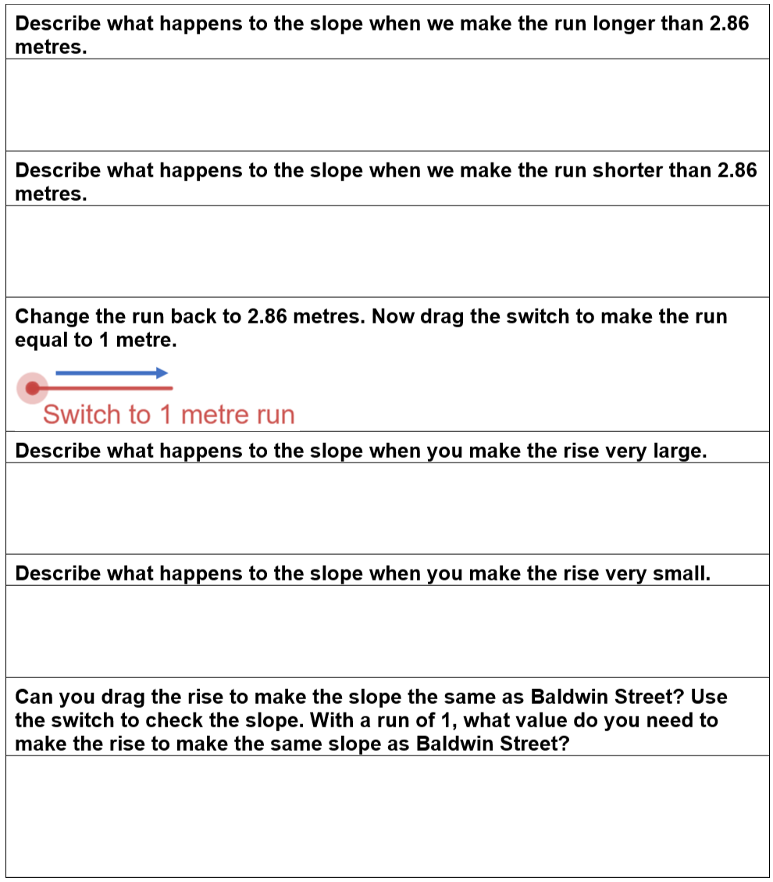

- Go to the Desmos graph Gradients (bit.ly/GradientInvestigation) and drag the points to answer the following question.
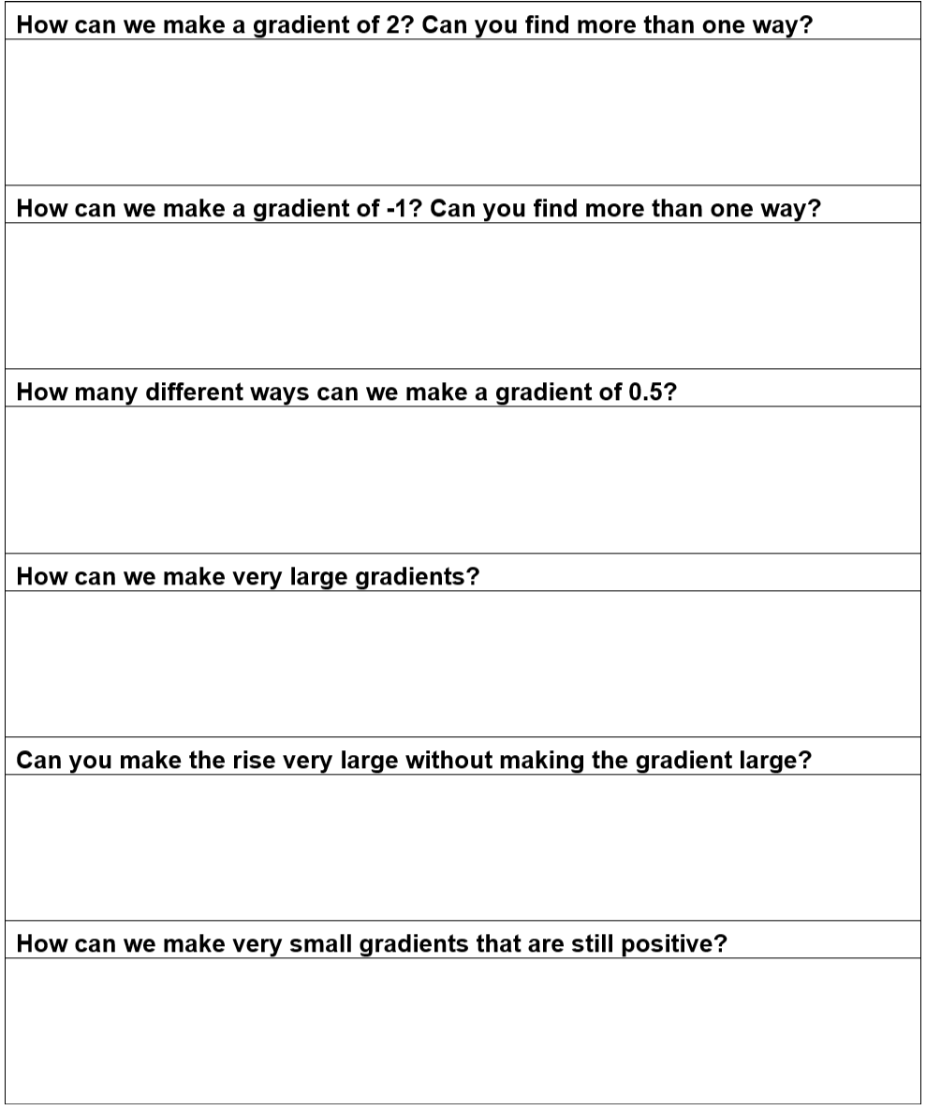

Appendix B – Faded worked examples
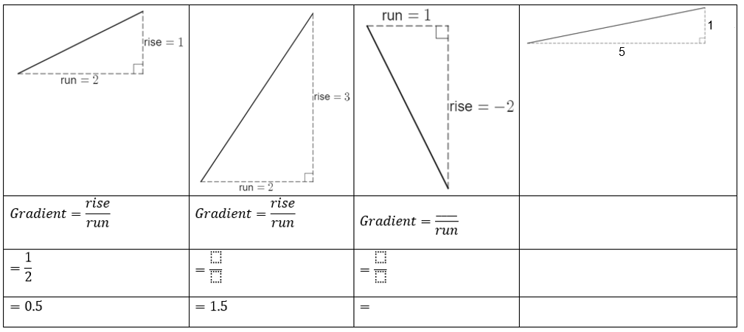

Appendix C

Finding gradients of real slopes
- Count squares to find an approximate rise and run of the slope displayed in each image.
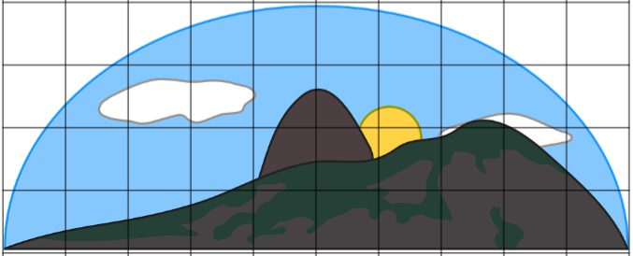

Appendix D

Evaluating slopes in your school

Ramps
- Find 3 ramps in your school that are visible from a side view.
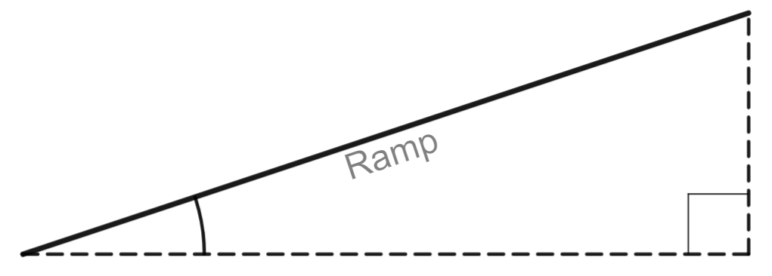
- Measure the rise and run with your tape measure.
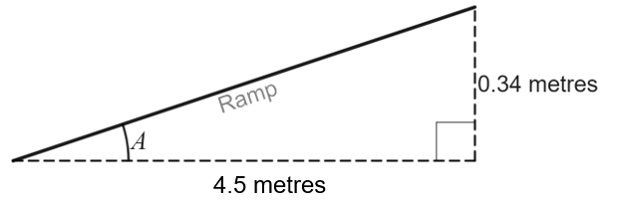
- Use $\frac{rise}{run}$ to find the gradient of the ramp.
Ramp number | Where is the ramp in your school? | Gradient
1
2
3
Do all the ramps in your school meet the standard of a maximum 0.071 gradient (ratio of 1:14)?

Sample solutions

Appendix A – investigating gradients
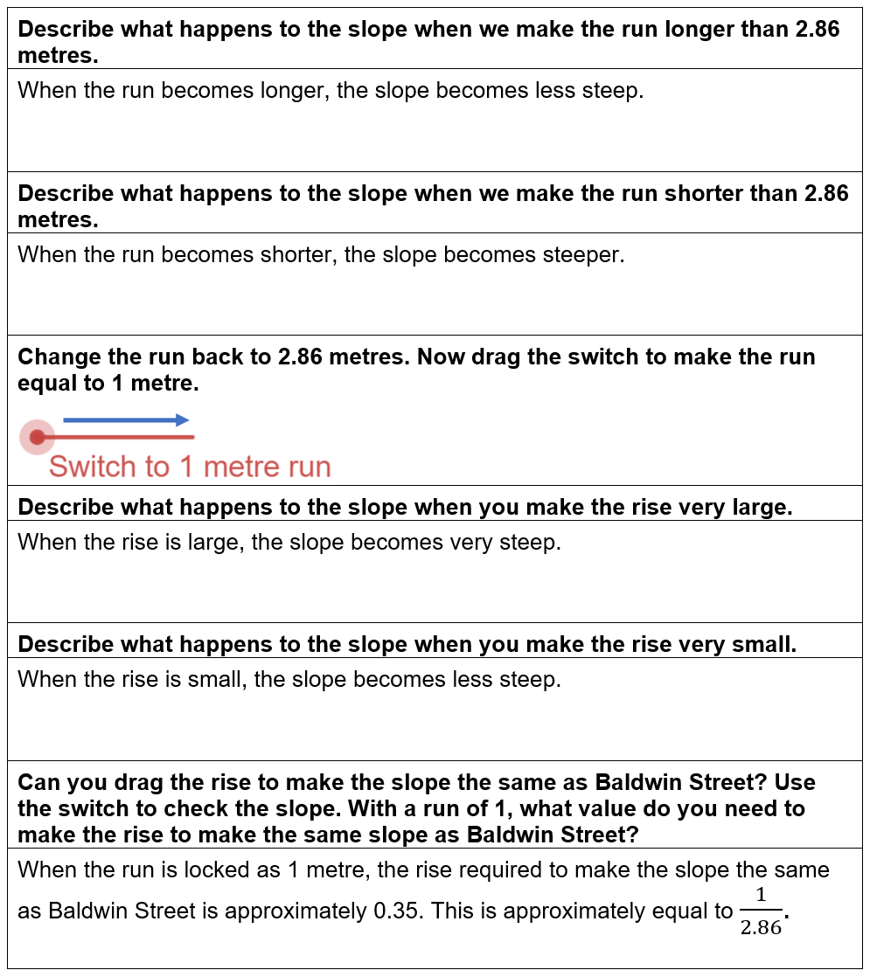
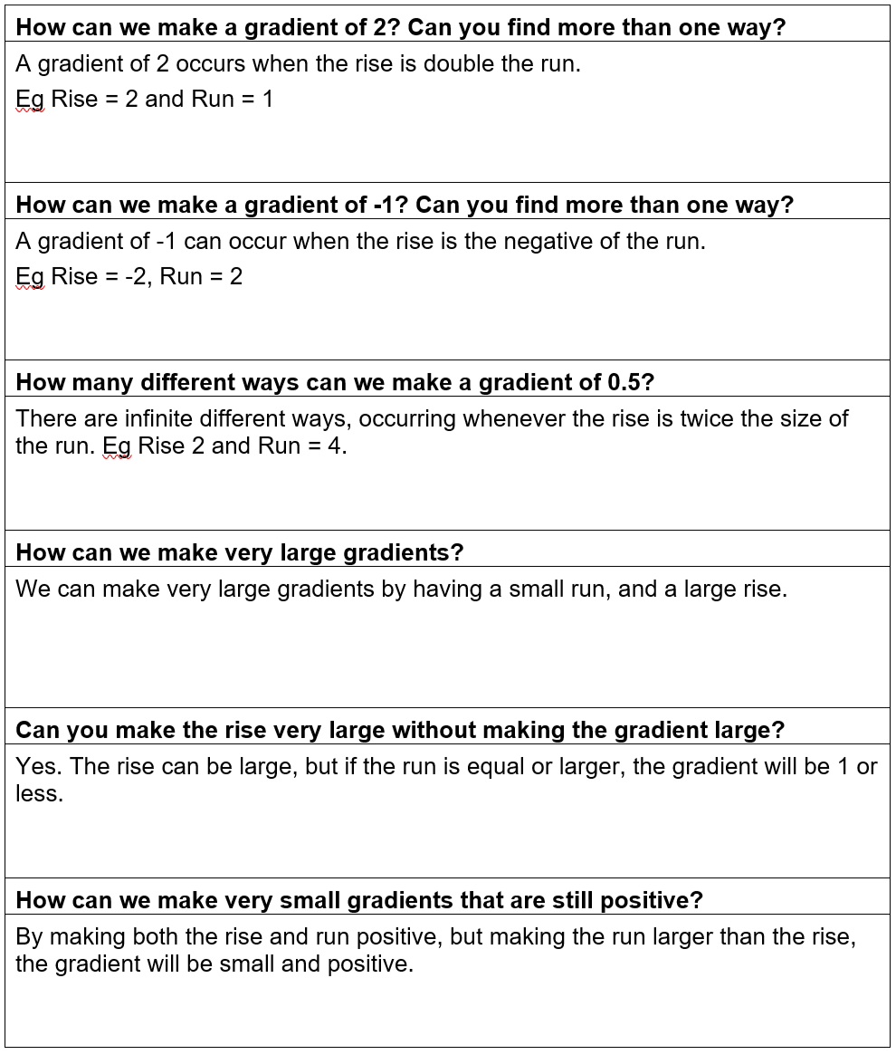

Appendix B
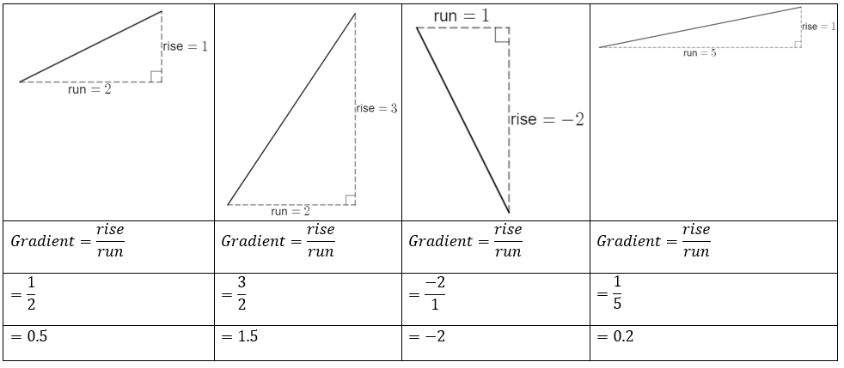

Appendix C
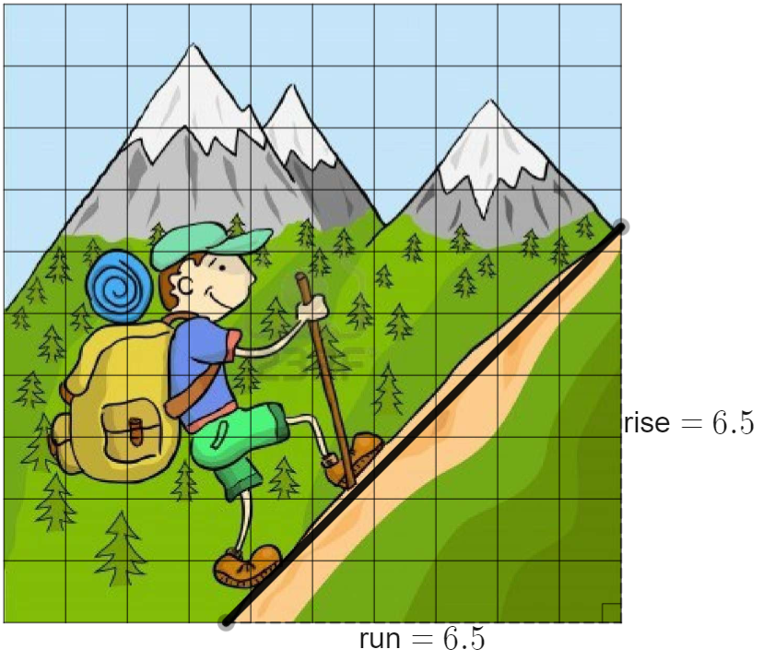
$$Gradient=\frac{rise}{run} \\ =\frac{6.5}{6.5} \\ =1$$

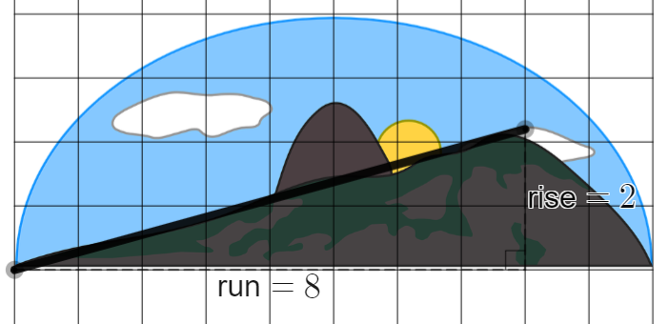
$$Gradient=\frac{rise}{run} \\ =\frac{2}{8} \\ =0.25$$
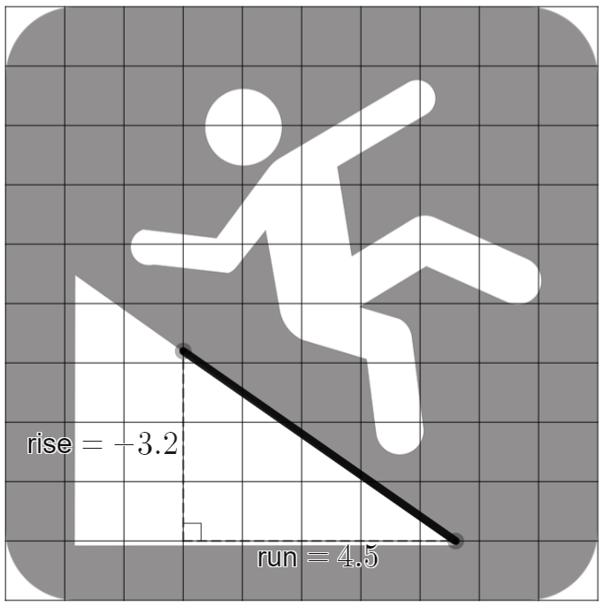
$$Gradient=\frac{rise}{run} \\ =\frac{-3.2}{4.5} \\ =-0.71$$

© State of New South Wales (Department of Education), 2023
The copyright material published in this resource is subject to the Copyright Act 1968 (Cth) and is owned by the NSW Department of Education or, where indicated, by a party other than the NSW Department of Education (third-party material).
Copyright material available in this resource and owned by the NSW Department of Education is licensed under a Creative Commons Attribution 4.0 International (CC BY 4.0) licence.
This licence allows you to share and adapt the material for any purpose, even commercially.
Attribution should be given to © State of New South Wales (Department of Education), 2023.
Material in this resource not available under a Creative Commons licence:
- the NSW Department of Education logo, other logos and trademark-protected material
- material owned by a third party that has been reproduced with permission. You will need to obtain permission from the third party to reuse its material.
Links to third-party material and websites
Please note that the provided (reading/viewing material/list/links/texts) are a suggestion only and implies no endorsement, by the New South Wales Department of Education, of any author, publisher, or book title. School principals and teachers are best placed to assess the suitability of resources that would complement the curriculum and reflect the needs and interests of their students.
If you use the links provided in this document to access a third-party's website, you acknowledge that the terms of use, including licence terms set out on the third-party's website apply to the use which may be made of the materials on that third-party website or where permitted by the Copyright Act 1968 (Cth). The department accepts no responsibility for content on third-party websites.

