How steep is too steep?
In this activity, students investigate the steepness of slopes around the school using a variety of methods, calculating angles using trigonometry and determining what angles describe safe slopes.
This activity has been designed to support students who have experience working with trigonometric ratios but have yet to be introduced to finding missing angles in right-angled triangles.

Visible learning

Learning intentions
- To understand how angles can be used to describe slopes.
- To be able to calculate the angle inside a right-angled triangle given 2 sides.

Success criteria
- I can recognise and describe slopes physically and using angles.
- I can use trigonometry to find a missing angle inside a right-angled triangle.

Syllabus outcomes
- develops understanding and fluency in mathematics through exploring and connecting mathematical concepts, choosing and applying mathematical techniques to solve problems, and communicating their thinking and reasoning coherently and clearly MAO-WM-01
- applies trigonometric ratios to solve right-angled triangle problems MA5-TRG-C-01
Mathematics K–10 Syllabus © NSW Education Standards Authority (NESA) for and on behalf of the Crown in right of the State of New South Wales, 2022.
Please use the associated PowerPoint How steep is too steep? to display images in this lesson.

Activity structure

Launch
This launch is also included in the activity Slopes as gradients as the 2 lessons are connected. The description of slope that we are going to focus on in this lesson is the angle.
- Watch the video about the world's steepest street (0:45) (bit.ly/VideoSteepStreet).
- Ask students to take notes of the ways that the slope is described.
The video describes the slope in terms of the time taken to walk its 350 metres, its angle of inclination and the rise and run of the slope.
- Have students construct a Notice and Wonder table (bit.ly/noticewonderstrategy) about the street in New Zealand, sharing with a peer before engaging in a class discussion.

Speed of slope (Optional)

Equipment
- Stopwatch
- Marbles, Jaffas or Maltesers (or anything else that is spherical)
- At least 2 reasonably sloped, hard surfaces

Method
- Watch the video about the Jaffa race (1:02) down the world's steepest street (bit.ly/VideoJaffaRace).
- Find at least 2 slopes in the school. Have students make an estimate as to which one is the steepest.
- Roll whatever spherical objects you have down each of the slopes, recording the time it takes to travel the same distance on each slope.
- Have students complete a Think-Pair-Share (bit.ly/thinkpairsharestrategy) based on the following reflection questions before discussing as a class:
- Which slope was steeper? How do you know?
- Do you think each of these slopes are safe for all purposes, such as walking, driving, bicycles and wheelchairs?
- How much faster was the steeper slope?
- How much steeper was the faster slope?

Explore

Solving trigonometric equations
- Display Figure 1.
Figure 1 – three trigonometric equations
- Inform students that $A, B$ and $C$ are positive whole numbers.
- Students are to use guess and check methods to find the values of $A, B$ and $C$.
- Use the How steep is too steep? PowerPoint for explicit teaching of the skills required for solving trigonometric equations involving one step, as shown in Figure 1. This includes using the inverse trigonometric function on a scientific calculator.
The explicit teaching technique used in the PowerPoint is Your turn. The first slide is a worked example which should be displayed for the students and then use the following steps:
- Reveal the question to students and its solution.
- Students read in silence.
- Students individually think and explain to themselves what is happening in each step.
- Students hold a thumbs up to the teacher when they have finished reading and have some sort of understanding.
- Think-Pair-Share. Students explain the solution to their partner.
- In pairs, students then answer the self-explanation questions.
- Finally, randomly select students to share their answers with the whole class.

Finding missing angles
- State that safety standards have determined that ramps suitable for people in a wheelchair require a maximum angle of $4^{o}$. This can be confirmed by displaying the Design for Dignity website (bit.ly/Designfordignity), where the ratio of 1:14 is shown.
- Display worked example 1 below. Give students time to review, placing a thumbs up in front of them to indicate to the teacher that they have reviewed.
Figure 2 – right-angled triangle
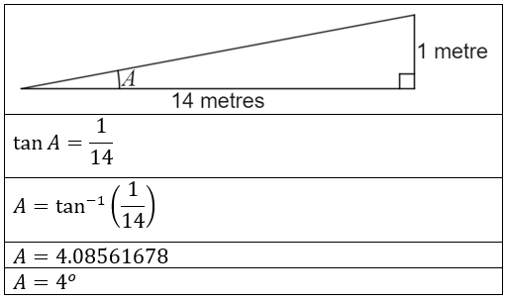
- Students are to engage in a Think-Pair-Share (bit.ly/thinkpairsharestrategy) to discuss what is happening at each step.
- Hand out Appendix A for each student to complete.

Evaluating slopes in your school

Equipment
- Tape measure (one per group)
- Trundle wheel (one per group)
- Device with Google maps
- Appendix D contains instructions on how to use Google Maps (if required)

Method
- Give each student a copy of Appendix B.
- Students follow the steps involved to measure the angles of the different types of slopes around the school.
- Once completed, students should compare the slope with the wheelchair accessible standard of $4^{o}$ and the angle in the video of Baldwin Street in New Zealand, ${19}^{o}$.

Summarise
- Open the boat dock interactive from Dan Meyer's website (bit.ly/BoatDockInteractive).
- If devices are available, have students open the interactive themselves. Encourage students to input values and complete a Notice and Wonder table about what is going on.
Students can investigate how many significant figures are relevant, for instance, if you modify the first decimal place, does the interactive show any noticeable difference?
- Have students find the length of the shortest ramp that never has an angle greater than $4^{o}$ for wheelchair access.
- If students have difficulty interpreting this problem and require support, teachers can show Figure 3 and engage in a Think-Pair-Share (bit.ly/thinkpairsharestrategy) to discuss how this diagram relates to the ramp situation.
Figure 3 – ramp with a 4-degree angle
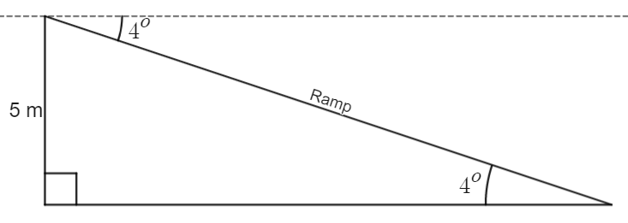

Apply

Connection with water
- Show at least the first 45 seconds of the video from the BBC, Aboriginal connection with water (1:18) (bit.ly/AboriginalWaterVideo).
- Hand out Appendix C and select a student to read out Statement 1. Alternatively, have students read in silence and Think-Pair-Share (bit.ly/thinkpairsharestrategy) before discussing the implications as a class.
- Ask students what they would consider important if they were finding a new home near a body of water.
Look for answers such as safety, shelter, food availability, amount of water and quality.
- Read Statement 2 as a class. This statement summarises some of the characteristics of desert waterholes that make them suitable to sustain life and would therefore be a good place for a mob to settle for a period of time.
- Read Statement 3 as a class. Aboriginal peoples used mathematics to determine how suitable bodies of water would be to settle next to and for how long. Explain that we will be examining one aspect of the safety of a site.
- Display Figure 4. Explain to students that this diagram represents a body of water sitting between a straight cliff and inclined land. Challenge students to calculate the angle of the slope, A.
Figure 4 – body of water that is a triangular prism
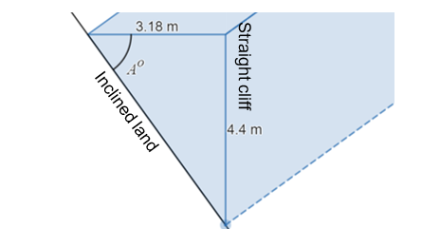
- Use the Desmos graph Water body (bit.ly/Waterbody) to display a waterbody. You can turn off the folder ‘Landform’ to examine just the water. Drag the point to make multiple problems for students to solve.
- Ask students to consider whether any of the landforms examined meet the demands of ramps we place on ourselves today (maximum slope of 4°).

Assessment and Differentiation

Suggested opportunities for differentiation
Explore
- Teachers can simplify the initial guess and check question by giving various clues, such as telling students that $A, B$ and $C$ are angles inside right-angled triangles, and therefore must be less than 90°.
- The faded worked examples follow thin slicing techniques, where questions increase in difficulty in only one component in each step. This allows students to observe things that stay the same and things that change, and what has caused these things to happen.
- Challenge students to convert the ratio of 1:14 into an angle to the nearest minute. Does this change how any of your ramps compare later in the lesson?
Summarise
- Teachers can choose to increase the information given to students by sharing Figure 3 and discussing it with students. It is then vital to give opportunities like those listed in step 4, empowering students to see the connection between the situation and Figure 3 as a representation.
- Challenge students by reducing the information and relying on the learning from the ‘Explore’ section. Reduce the question to simply ‘How long should the ramp be to ensure it is wheelchair accessible?’
Apply
- Teachers can choose to use the information at the University of Melbourne’s Indigenous Knowledge Institute to review Indigenous culture and its relevance to geometry.

Suggested opportunities for assessment
Explore
- Examine the angles students are choosing in the initial guess and check exploration to assess their general instincts.
Summarise
- Students can submit their solutions to the boat dock interactive as an exit slip to verify their ability to solve trigonometric problems.

Appendix A

Finding missing angles – faded worked examples
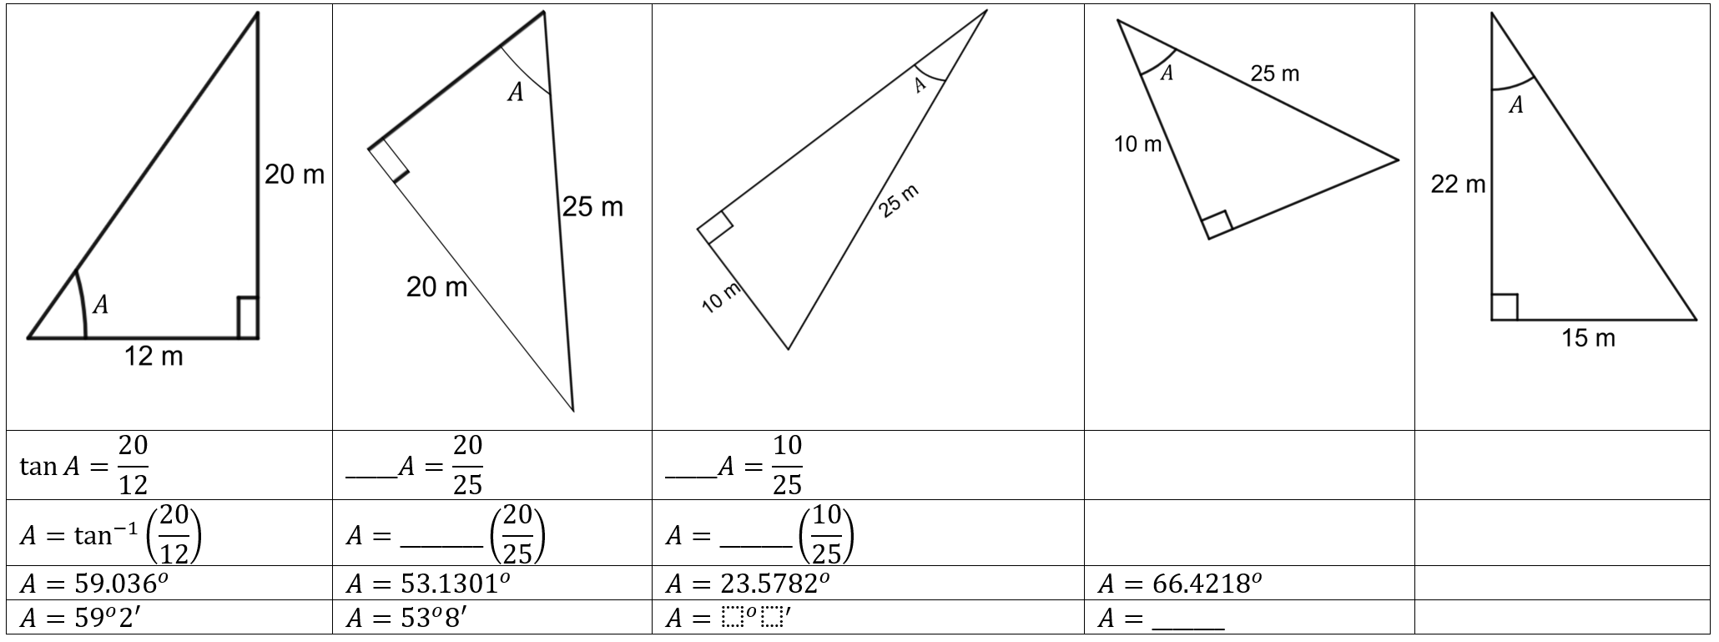

Appendix B

Evaluating slopes in your school

Ramps
- Find 3 ramps in your school that are visible from a side view.
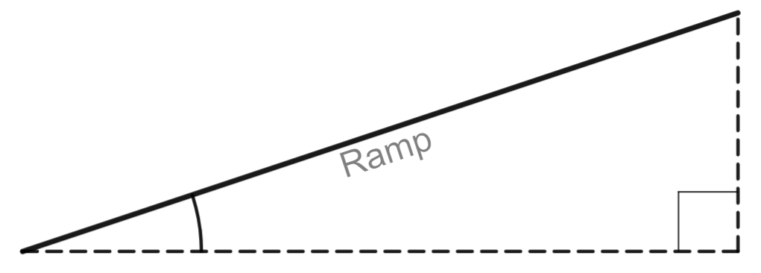
- Measure any 2 dimensions with your tape measure.
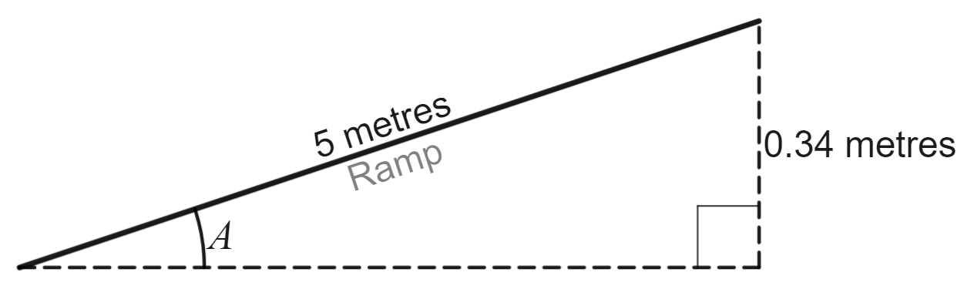
- Use trigonometry to find the angle of inclination of the ramp.
Ramp number | Where is the ramp in your school? | Angle of inclination
1
2
3
Do all the ramps in your school meet the standard of a maximum $4^{o}$ angle of inclination?

Slope of the land
- Find a stretch of land in your school that is sloped. Find this stretch of land on Google Maps and use the Measure distance option.
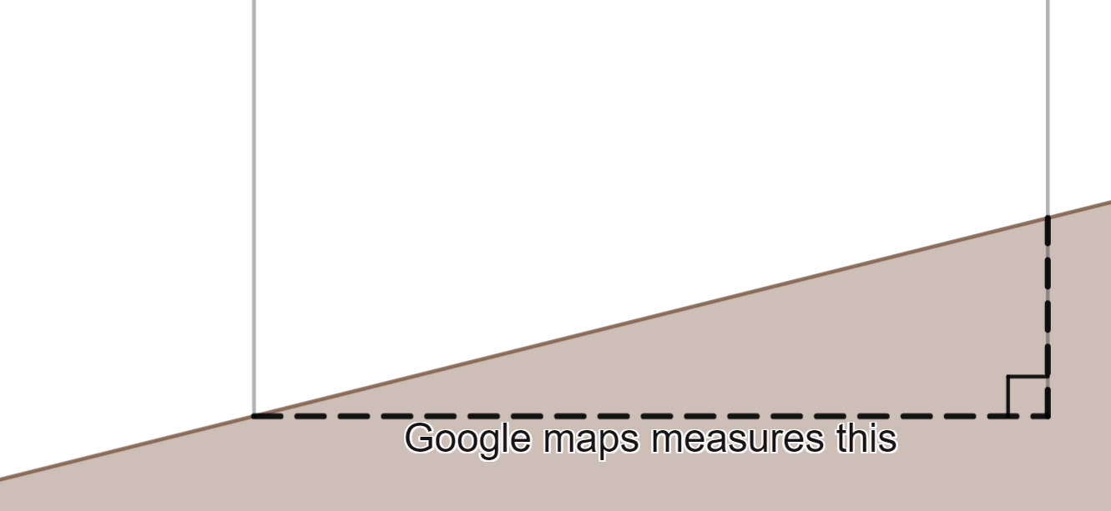
- Now measure this distance in real life with a trundle wheel.
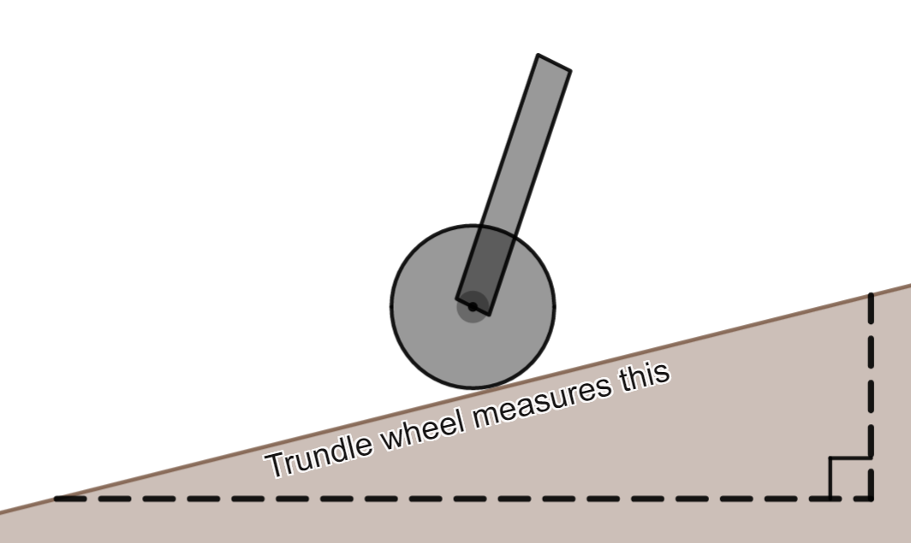
- Use trigonometry to find the angle of inclination, shown as A in the diagram below.
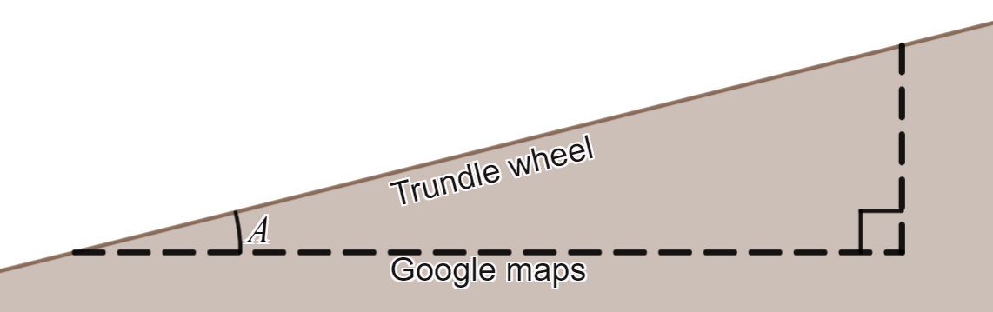
- Locate multiple slopes and complete the table below.
Ramp number | Where is the ramp in your school? | Angle of inclination
1
2
3
Do all the slopes in your school meet the standard of a maximum 4° angle of inclination?

Appendix C

Connection with water
The quotes below are from the University of Melbourne's Indigenous Knowledge Institute website (bit.ly/GeometryWaterSources).

Statement 1
There is a wide range of waterbody types across Australia and these can vary greatly in size, quality and permanence depending on local environmental conditions. Aboriginal and Torres Strait Islander people developed expertise in finding, maintaining and managing these resources for survival.

Statement 2
Desert waterholes – these features are often found within hill ranges in the arid interior of the country. They remain long after creek and river flows have subsided following flood events, and can be permanent to semi-permanent depending on climatic conditions. Because of their size they are able to sustain large populations of people for long periods of time, attract a range of fauna food sources as well as sustaining a variety of flora. These environments are therefore able to provide shelter and water, and support species used for food, medicine, tools and clothing.

Statement 3
Aboriginal and Torres Strait Islander people applied several mathematical concepts, including geometry, time dependant variations and spatial location. The application of these concepts included understanding the capacity (volumes), water quality and seasonal variations in the levels of waterholes and springs. Many reliable water sources were spatially mapped using songlines to ensure the water source locations were remembered and this knowledge able to then be passed on to others.
(Copyright © The University of Melbourne 1994–2017)

Appendix D

Measuring distances in Google Maps
The instructions below outline how to obtain measurements using Google Maps.
- Go to Google Maps (google.com/maps).
- Use the search function to find a location of interest, such as a street or suburb.
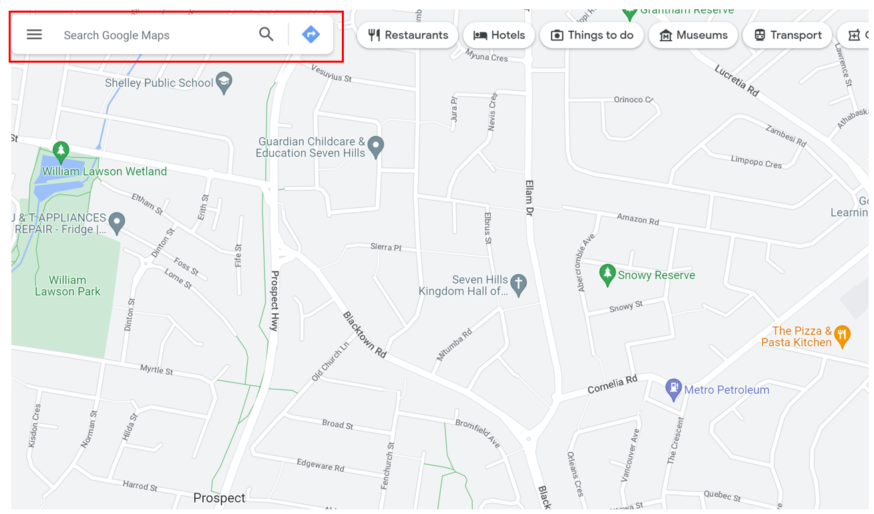
Map data © 2023 Google
- Right select where you would like to measure from on the map and select Measure distance.
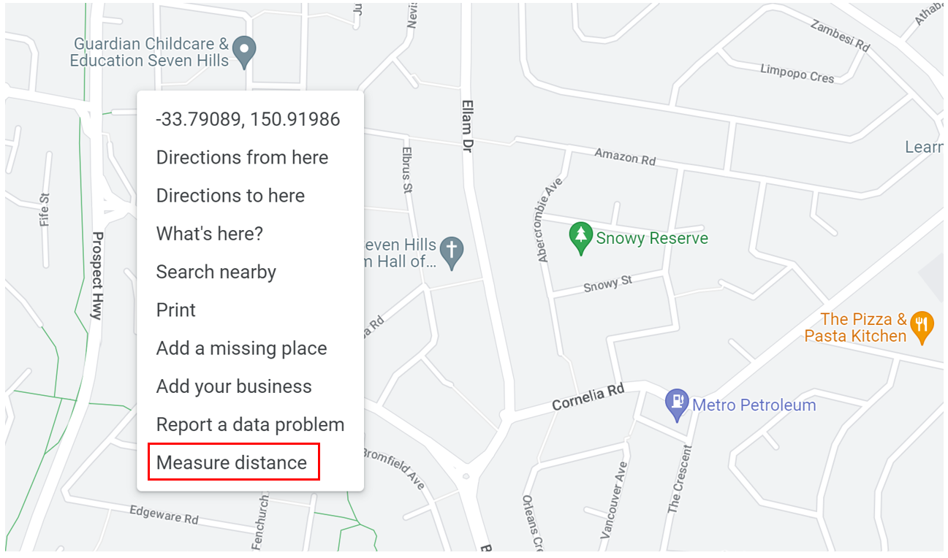
Map data © 2023 Google
- Select the endpoint of your destination and a measurement will appear.
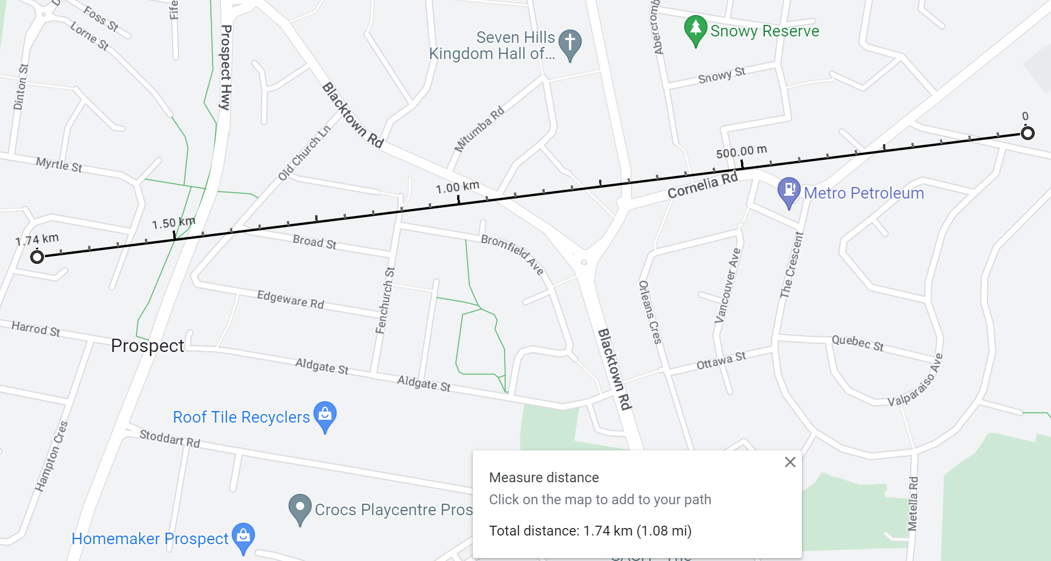
Map data © 2023 Google

Sample solutions

Explore
Solving trigonometric equations
$$A={30}^{o}$$
$$B={45}^{o}$$
$$C={60}^{o}$$

Summarise
Let the length of the ramp be equal to $R$.
$$\sin{4^{o}}=\frac{5}{R}$$
$$R×\sin{4^{o}}=5$$
$$R=\frac{5}{\sin{4^{o}}}$$
$R=71.68$ (correct to 2 significant figures)

Apply
$$\tan{A}=\frac{4.4}{3.18}$$
$$A=\tan^{-1}\left(\frac{4.4}{3.18}\right)$$
$$A={54}^{o}9'$$

Appendix A
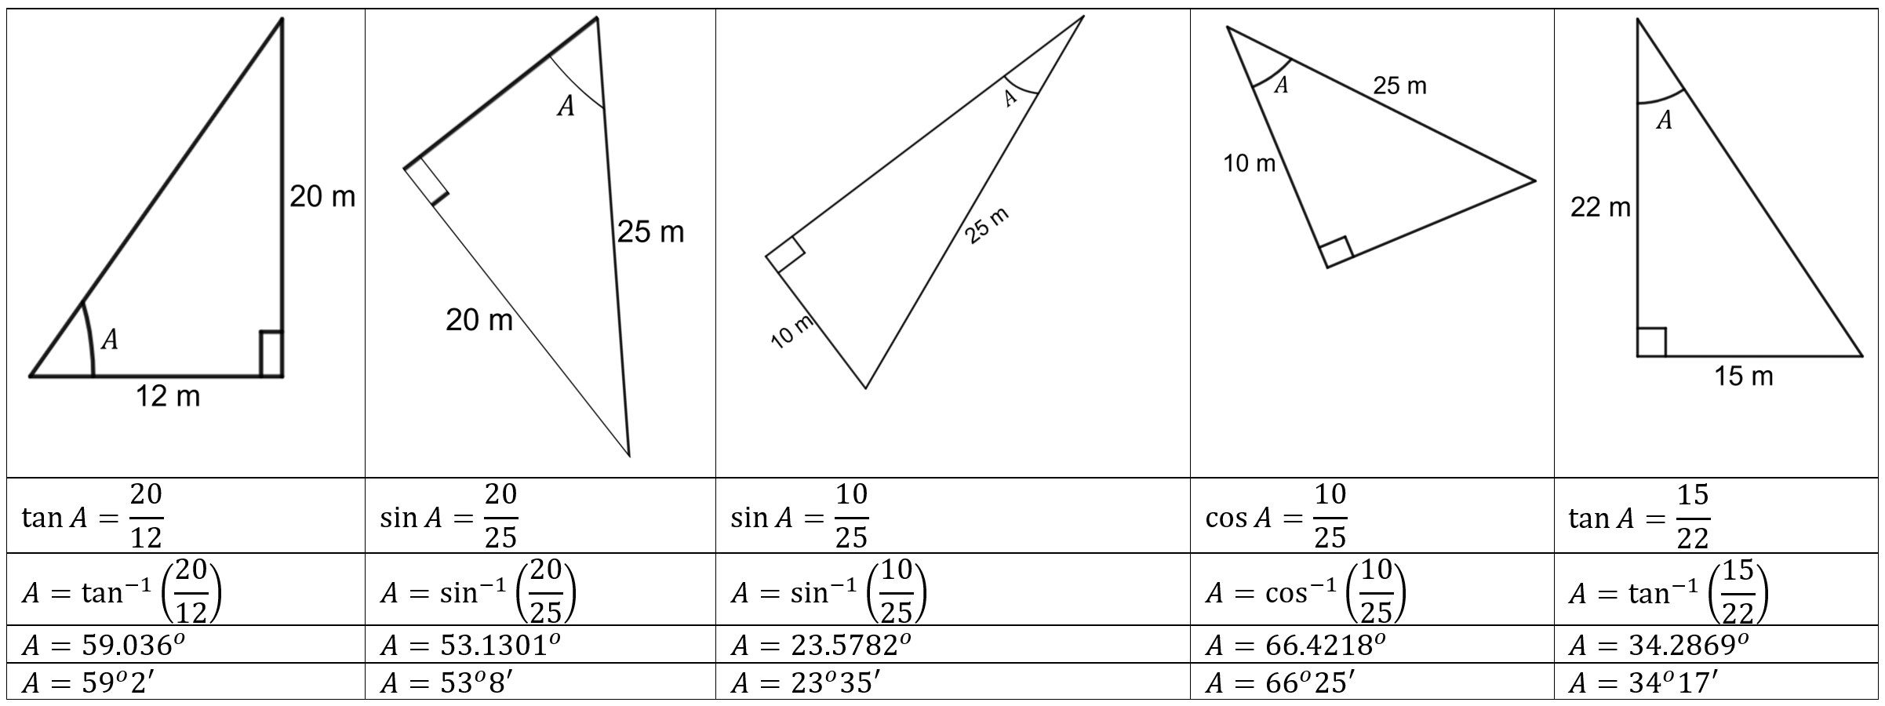

Appendix B
$$\sin{A}=\frac{0.34}{5}$$
$$A=\sin^{-1}\left(\frac{0.34}{5}\right)$$
$${A=3}^{o}54'$$
Ramp number | Where is the ramp in your school? | Angle of inclination
1 | Leading up to room D1 | $$3^{o}54'$$
This ramp is under $4^{o}$ and meets the safety standard.

© State of New South Wales (Department of Education), 2023
The copyright material published in this resource is subject to the Copyright Act 1968 (Cth) and is owned by the NSW Department of Education or, where indicated, by a party other than the NSW Department of Education (third-party material).
Copyright material available in this resource and owned by the NSW Department of Education is licensed under a Creative Commons Attribution 4.0 International (CC BY 4.0) licence.
This licence allows you to share and adapt the material for any purpose, even commercially.
Attribution should be given to © State of New South Wales (Department of Education), 2023.
Material in this resource not available under a Creative Commons licence:
- the NSW Department of Education logo, other logos and trademark-protected material
- material owned by a third party that has been reproduced with permission. You will need to obtain permission from the third party to reuse its material.
Links to third-party material and websites
Please note that the provided (reading/viewing material/list/links/texts) are a suggestion only and implies no endorsement, by the New South Wales Department of Education, of any author, publisher, or book title. School principals and teachers are best placed to assess the suitability of resources that would complement the curriculum and reflect the needs and interests of their students.
If you use the links provided in this document to access a third-party's website, you acknowledge that the terms of use, including licence terms set out on the third-party's website apply to the use which may be made of the materials on that third-party website or where permitted by the Copyright Act 1968 (Cth). The department accepts no responsibility for content on third-party websites.

