How far around is one degree?
Students explore the size of a single degree and learn about how technology can allow us to measure angles and direction with greater precision, introducing degrees and minutes.

Visible learning

Learning intentions
- To understand the concept of an angle as a measure of turning.
- To be able to use angles measured in degrees and minutes when solving problems.

Success criteria
- I can describe what a particular angle looks like as a measure of turning.
- I can convert an angle represented as a decimal into degrees and minutes.
- I can solve problems involving finding missing sides in right-angled triangles, with angles represented in degrees and minutes.

Syllabus outcomes
A student:
- develops understanding and fluency in mathematics through exploring and connecting mathematical concepts, choosing and applying mathematical techniques to solve problems, and communicating their thinking and reasoning coherently and clearly MAO-WM-01
- applies trigonometric ratios to solve right-angled triangle problems MA5-TRG-C-01
Mathematics K–10 Syllabus © NSW Education Standards Authority (NESA) for and on behalf of the Crown in right of the State of New South Wales, 2022.
Please use the associated PowerPoint How far around is one degree? to display images in this lesson.

Activity structure

Launch
- Display Figure 1. Discuss the meaning of the ${45}^{o}$ angle parking sign with students. This image is in the associated PowerPoint file.
Figure 1 – 45° angle parking sign
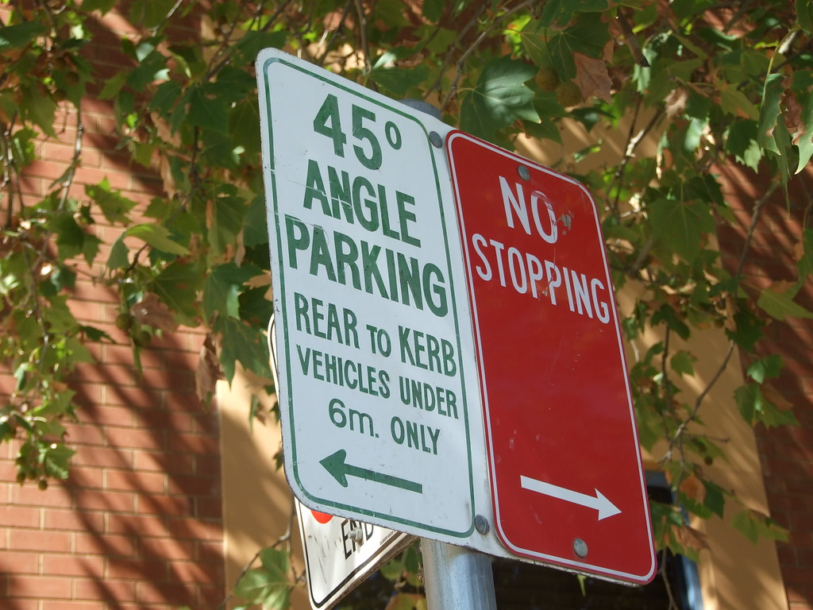
‘Parking with a protractor’ by Tamsin Slater is licensed under CC BY-SA 2.0.
- Open the Desmos graph 45 Degree parking (bit.ly/Desmos45degreepark). Ask students to guess which car they think is parked correctly at a ${45}^{o}$ angle (only one car is).
- Flick the switch on the screen to reveal the lines and discuss how we can be sure which car is the one accurately parked.
- Open the Desmos graph Angle guess (bit.ly/Desmosangleguess).
- Hand out mini whiteboards for students to guess the size of the angle (bit.ly/miniwhiteboards).
- The teacher should drag the point of the angle to a new position and have all students estimate the size of the angle.
- Students hold up their mini whiteboards with their estimate, then the teacher should reveal the size of the angle by flicking the switch on the screen.
It could benefit students for the teacher to also make an estimate, on occasion, after students have made and shown their estimates. This can demonstrate that the difference of a few degrees is very difficult to observe.
- Take a record of the range of answers given, considerately leaving out any significant outliers.
- Use the switch to hide the angle measurement and change the angle size to repeat the experiment.
- Acknowledge that it is difficult to observe the size of angles without measuring tools.

Explore

Drawing angles

Equipment
- Rulers (one per student)
- Protractors (one per student)
- Mini whiteboard or an A4 sheet of paper (per student)
- Appendix A (cut up into individual cards)

Method
- Give each student their equipment, including one card from Appendix A. Instruct students not to let their peers see their angle card.
- Have students use the ruler and protractor to construct the angle from their card onto either A4 paper or a mini whiteboard. Appendix B has a worked example that can be provided to students if they require support with constructing an angle.
- Have neighbours check measurements (each student’s neighbour will be the only one who knows what angle they intended to draw). If it is significantly incorrect, have them make a second attempt with support.
- Students then place an A4 piece of paper on their desk and hide the card (so no one can tell what angle they intended to draw).
- Students then rotate, attending the angle of their peers, using their protractor to measure, and on the A4 sheet of paper, write down what they believe the angle was meant to be.
- Once finished, students return to their A4 piece of paper. Instruct students to cross out any measurements that are more than 10 degrees away from their intended angle.
- Students then calculate the range of the remaining measurements of their peers.
- Show the reflection questions below and have students engage in a Think-Pair-Share (bit.ly/thinkpairsharestrategy) before engaging in a class discussion.
Reflection questions for discussion:
- What difficulties did you find when drawing an angle to the nearest degree?
- What do you think is an acceptable range when people measure your angle?

10 degrees

Equipment
- 1 large protractor
- 1 metre ruler
- Chalk

Method
- Take students out to a concrete area of the school. Have volunteer students mark out a chalk line using a one metre ruler, pointing toward a wide-open space (for example, a basketball court).
- Use the protractor to measure 10-degree angles and mark lines as shown in Figure 2 below.
Figure 2 – 10 lines spread out in 10-degree angles
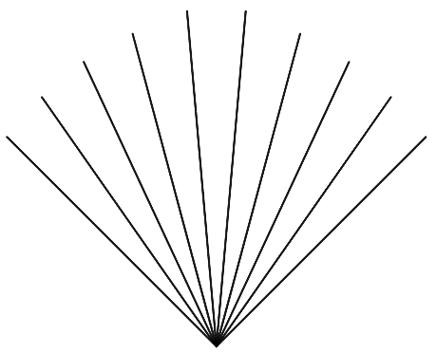
- Acknowledge with students that these are not very far apart, even though each line is 10 degrees apart.
- Have one student per line stand in the direction of each line, just far enough away to have their own space to stand.
- Ask each student to take 10 steps away in the direction of their line. Have the class observe the gaps between students.
This activity can also be completed using either compasses or the compass application on most mobile phones. Students can be given a starting point and asked to walk across a large open space, such as a sporting field, in a specific direction. Students can each be given directions that differ by one degree or a small number of degrees.
- Return to the classroom and display the angle from the Desmos graph (bit.ly/Desmos1degreeangle), informing students that this angle is one degree.
- Select the Play button to watch what happens when we travel large distances.
Summarise with students that even a small angle can be significant at great distances.

Degrees and minutes
- Display Figure 3. Have students engage in a Think-Pair-Share (bit.ly/thinkpairsharestrategy) about what this image means.
Figure 3 – map of NSW
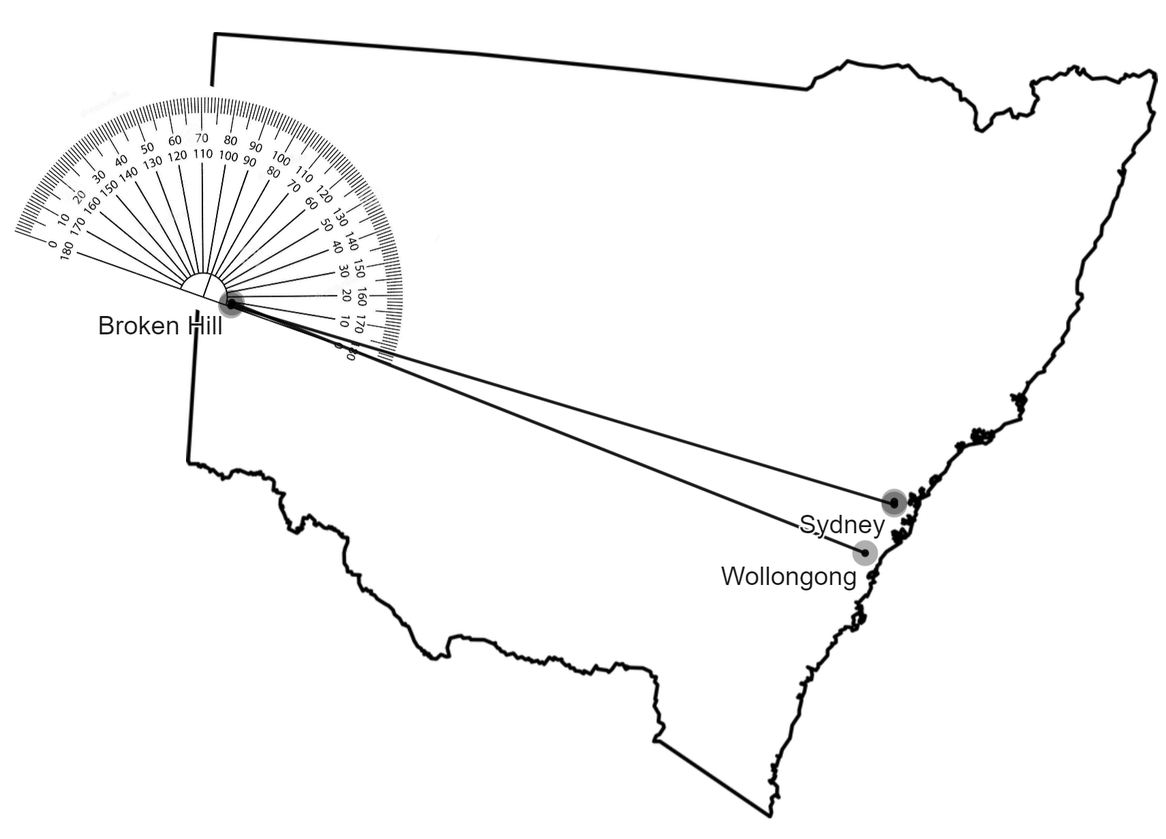
- Explain to students that when navigating, precision is important. This image shows that when travelling across NSW, a difference of just $3^{o}$ can be the difference between ending up in Sydney or Wollongong, which are over an hour drive apart. Travelling across the world or over the ocean, any error would be significant.
- Display Google Maps, from Sydney to Wollongong (bit.ly/GooglemapsWollSyd), identifying the many locations between these 2 places. Discuss how each of these places would need to be a different angle from Broken Hill, meaning we need parts of whole angles.
- Display the Desmos graph Degrees and minutes (bit.ly/Desmos-degrees-minutes) and explain that parts of degrees are called minutes, and there are 60 minutes in one degree.
- Hand out Appendix C. Give students access to the Desmos graph Degrees and minutes (bit.ly/Desmos-degrees-minutes) and have them complete the second column of the table, changing the angle from one form to the other.
- Students answer the questions at the bottom of Appendix C and then complete a Notice and Wonder table (bit.ly/noticewonderstrategy).

Summarise
- Use the How far around is one degree? PowerPoint for explicit teaching of the skills required for using angles in degrees and minutes. This includes:
- Converting between decimal form of angles and degrees and minutes.
- Inputting angles measured in degrees and minutes into a calculator.
- The explicit teaching technique used in the PowerPoint is ‘Your turn’. The first slide is a worked example which should be displayed for the students and then use the following steps:
- Reveal the question to students and its solution.
- Students read in silence.
- Students individually think and explain to themselves what is happening in each step.
- Students hold a thumbs up to the teacher when they have finished reading.
- Think-Pair-Share. Students explain the solution to their partner.
- In pairs students then answer the self-explanation questions.
- Finally, randomly select students to share their answers with the whole class.
- Students are then to complete the final column of Appendix C using the methods shown in the PowerPoint to convert exactly between forms of angles.

Apply
- Teacher to again refer to Figure 2, explaining that angles represent direction and in navigation, these angles must be precise.
This component links directly with the lesson Trigonometry for navigation.
- Students to complete problems in Appendix D, solving problems in trigonometry where angles are presented in degrees and minutes.

Assessment and Differentiation

Suggested opportunities for differentiation
Launch
- The angle in the Desmos graph will go anywhere in the 360° rotation. Make decisions about what students in your class are ready for, and show angles based on what they are ready for.
- Turn on the Modification switch to show the key angles to support students with ballpark figures.
Explore
- Give angle cards to students strategically based on your knowledge of their understanding of angles, potentially determined from the launch activity.
- Appendix B gives students who have had difficulty with constructing angles support in working with a protractor.
Explore, summarise and apply
- The angles for students to convert in Appendix C follow a method called thin slicing, where only a small component of the question has changed from one to the next. This allows students to observe what has changed and what stays the same between questions. For example, if only the minutes change in the question, only the decimal part of the conversion will change n the answer. This method has been applied to Appendix D also.

Suggested opportunities for assessment
Launch
- When students are holding up mini whiteboards or cards with their estimates of angles, review to identify any students whose estimates are significantly different, for example, estimating acute angles when the display is clearly obtuse.
Explore
- Observe neighbours assisting their peers with angle construction to determine if students are comfortable constructing angles with a protractor.
- When students measure one another's angles, there is an opportunity to monitor if any students are having regular difficulty measuring, or if any student's angle is causing confusion, and possibly misdrawn.
Summarise and apply
- Appendix C and Appendix D can be collected as an exit ticket that can be used to assess students’ skills with converting angles and using degrees and minutes to find missing sides in triangles.

Appendix A

Angle cards
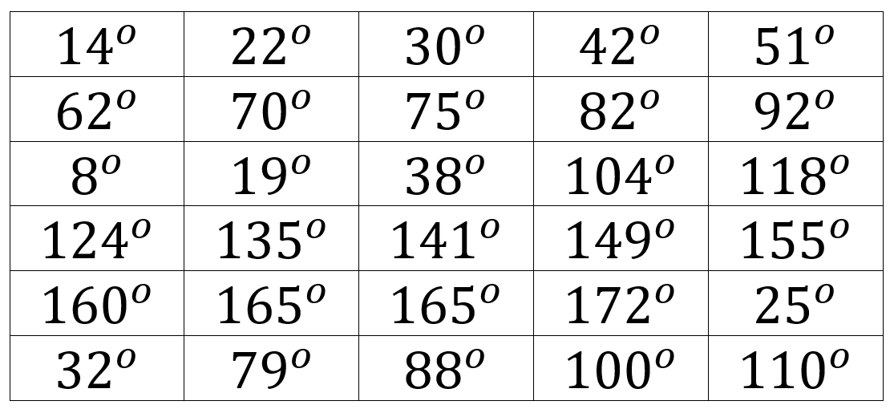

Appendix B

Constructing an angle of 42 degrees
- Use a ruler to make a horizontal line, of any length.
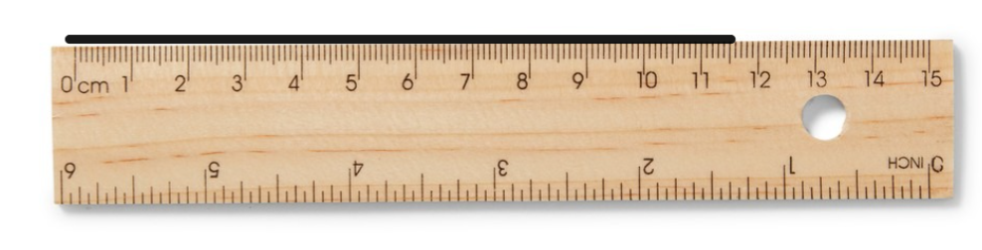
- Place a protractor over your line, so that one endpoint is at the centre of the protractor, and the line continues towards the '0'.
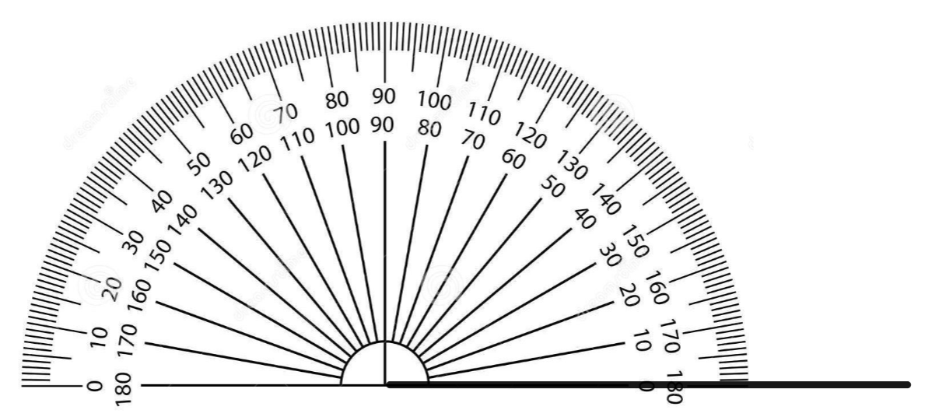
- Place a dot at ${42}^{o}$. (Place this dot at the point of the angle you are trying to draw. Be sure to use the scale that starts at 0).
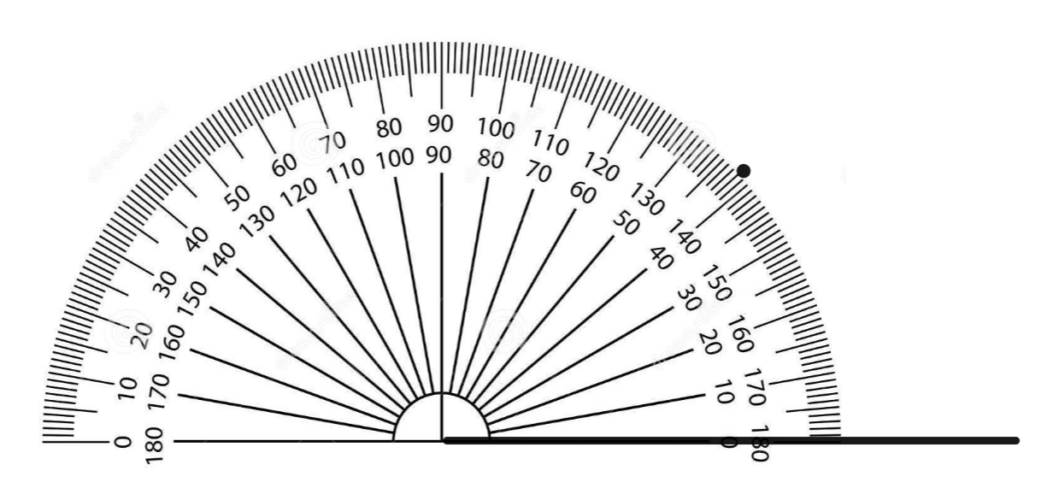
- Line your ruler between the endpoint of the first line, and the dot you placed.
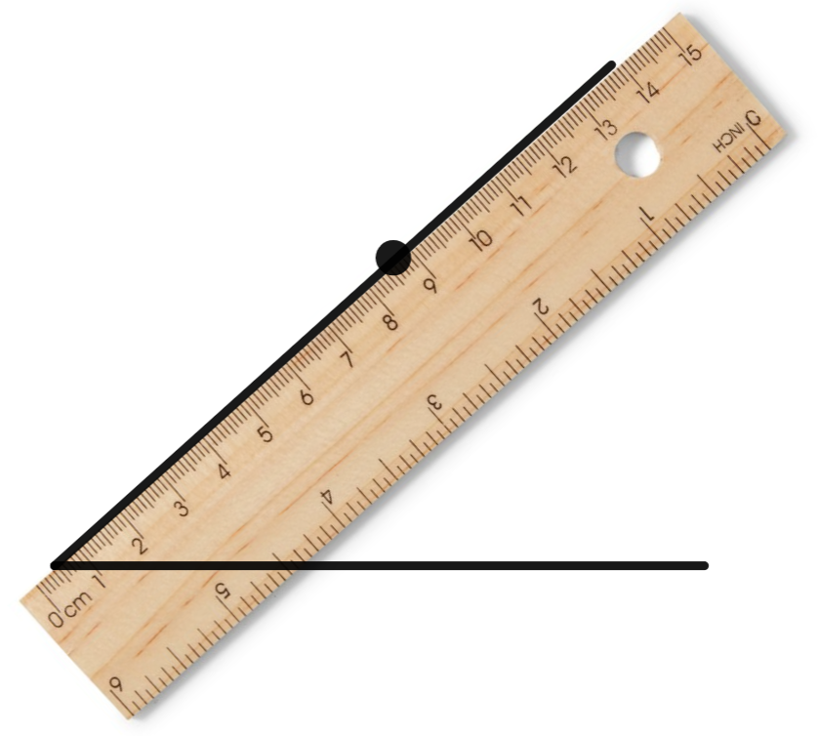

Appendix C

Converting angles to degrees and minutes
Use the Desmos graph (bit.ly/Desmos-degrees-minutes) to complete the table below.
Angles in the graph are difficult to make precise. If you cannot get the exact angle described in the table, make it as close as you can.
Angle | Convert to the other form | Exact conversion
$${21.5}^{o}$$
$$32.5°$$
$${114.5}^{o}$$
$${114.9}^{o}$$
$$180.9°$$
$${76.9}^{o}$$
$${76.99}^{o}$$
$$76.25°$$
$${10.25}^{o}$$
$${50.25}^{o}$$
$${50}^{o}15'$$
$${50}^{o}45'$$
$${120}^{o}45'$$
$${120}^{o}59'$$
$${30}^{o}59'$$
$${30}^{o}1'$$
$${29}^{o}59'$$
$${75}^{o}59'$$
$${75}^{o}60'$$
What is the largest number of minutes that appears in the table?
The last angle is not able to be displayed on the graph. What do you think the decimal representation of the angle would be?

Appendix D

Solving problems with degrees and minutes
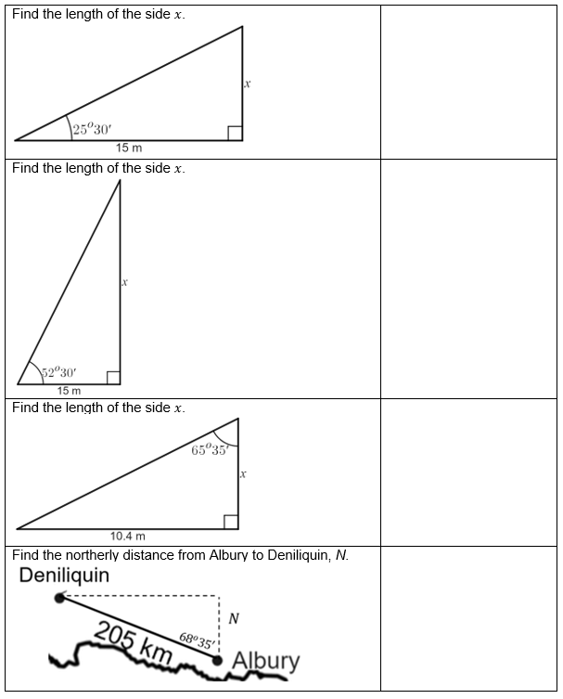

Sample solutions

Appendix C
Angle | Exact conversion
$${21.5}^{o}$$ | $${21}^{o}30'$$
$$32.5°$$ | $${32}^{o}30'$$
$${114.5}^{o}$$ | $$114°30'$$
$${114.9}^{o}$$ | $${144}^{o}54'$$
$$180.9°$$ | $$180°54'$$
$${76.9}^{o}$$ | $$76°54'$$
$${76.99}^{o}$$ | $${76}^{o}59'$$
$$76.25°$$ | $${76}^{o}15'$$
$${10.25}^{o}$$ | $${10}^{o}15'$$
$${50.25}^{o}$$ | $$50°15'$$
$${50}^{o}15'$$ | $${50.25}^{o}$$
$${50}^{o}45'$$ | $${50.75}^{o}$$
$${120}^{o}45'$$ | $${120.75}^{o}$$
$${120}^{o}59'$$ | $${120.98}^{o}$$
$${30}^{o}59'$$ | $${30.98}^{o}$$
$${30}^{o}1'$$ | $${30.02}^{o}$$
$${29}^{o}59'$$ | $${29.98}^{o}$$
$${75}^{o}59'$$ | $${75.98}^{o}$$
$${75}^{o}60'$$ | $${76}^{o}$$

Appendix D

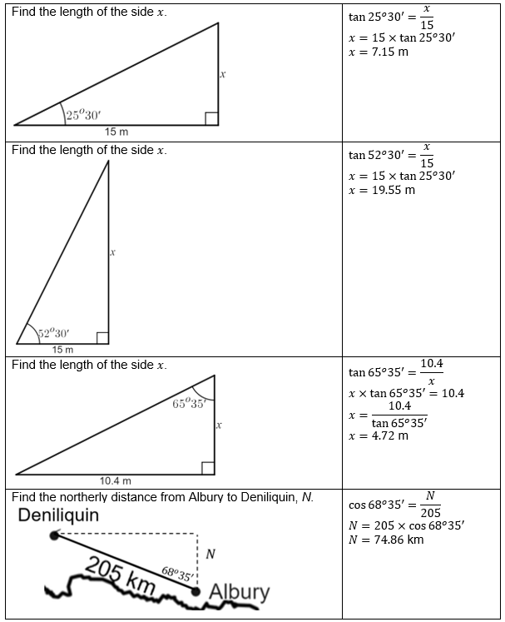

© State of New South Wales (Department of Education), 2023
The copyright material published in this resource is subject to the Copyright Act 1968 (Cth) and is owned by the NSW Department of Education or, where indicated, by a party other than the NSW Department of Education (third-party material).
Copyright material available in this resource and owned by the NSW Department of Education is licensed under a Creative Commons Attribution 4.0 International (CC BY 4.0) licence.
This licence allows you to share and adapt the material for any purpose, even commercially.
Attribution should be given to © State of New South Wales (Department of Education), 2023.
Material in this resource not available under a Creative Commons licence:
- the NSW Department of Education logo, other logos and trademark-protected material
- material owned by a third party that has been reproduced with permission. You will need to obtain permission from the third party to reuse its material.
Links to third-party material and websites
Please note that the provided (reading/viewing material/list/links/texts) are a suggestion only and implies no endorsement, by the New South Wales Department of Education, of any author, publisher, or book title. School principals and teachers are best placed to assess the suitability of resources that would complement the curriculum and reflect the needs and interests of their students.
If you use the links provided in this document to access a third-party's website, you acknowledge that the terms of use, including licence terms set out on the third-party's website apply to the use which may be made of the materials on that third-party website or where permitted by the Copyright Act 1968 (Cth). The department accepts no responsibility for content on third-party websites.

