Trigonometry for navigation
In this activity, students form right-angled triangles on maps based on given angles for directions and distances travelled, to determine how far we have travelled in the 4 cardinal directions.
This activity is designed to support students who have experience applying the trigonometric ratios to find missing sides in right-angled triangles.

Visible learning

Learning intention
- To be able to apply trigonometry to solve practical problems involving distance.

Success criteria
- I can construct a right-angled triangle around a diagonal distance on a map.
- I can locate positions on a map in the direction of north, east, south and west.
- I can explain how an angle communicates direction from a given location.
- I can interpret information from a problem to construct a right-angled triangle.

Syllabus outcomes
A student:
- develops understanding and fluency in mathematics through exploring and connecting mathematical concepts, choosing and applying mathematical techniques to solve problems, and communicating their thinking and reasoning coherently and clearly MAO-WM-01
- applies trigonometric ratios to solve right-angled triangle problems MA5-TRG-C-01
Mathematics K–10 Syllabus © NSW Education Standards Authority (NESA) for and on behalf of the Crown in right of the State of New South Wales, 2022.

Activity structure

Launch
- Display Figure 1.
Figure 1 – map 1 of Australia with the distance from Melbourne to Brisbane marked
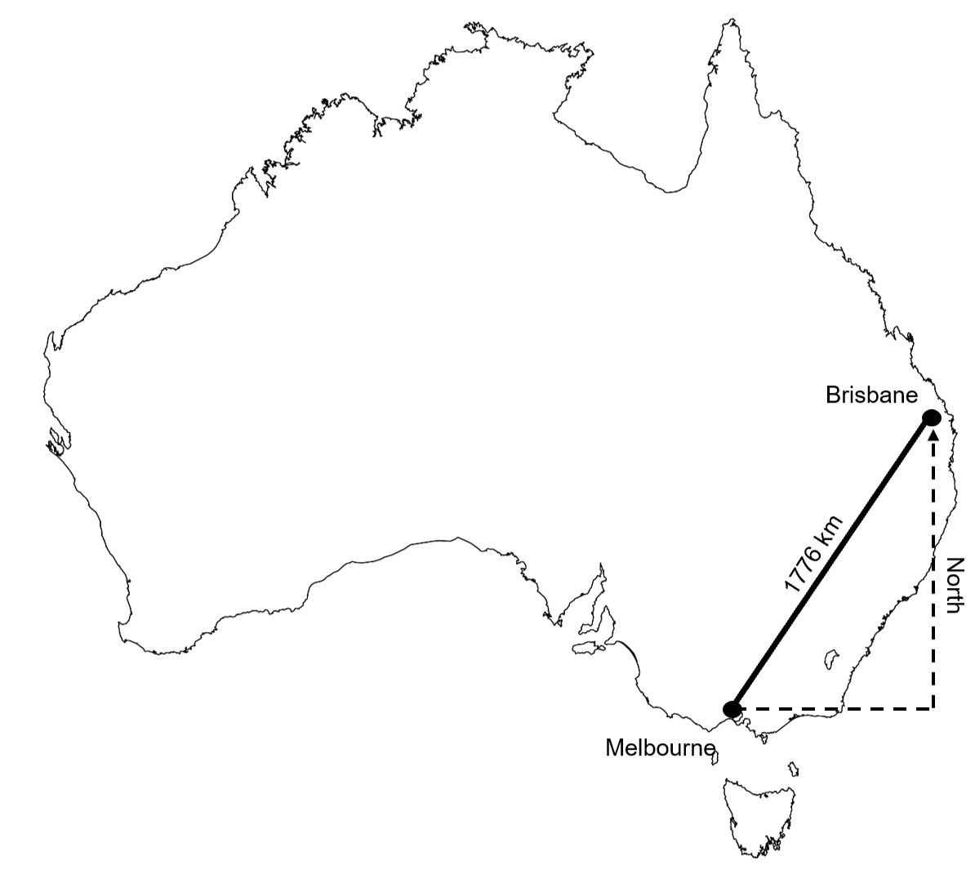
- Explain to students that we often want to know how far north, south, east or west one location is from another. Location affects things such as temperature, sea breezes and rainfall.
- In this image, we can see the distance between Melbourne and Brisbane.
- Have students engage in a Think-Pair-Share (bit.ly/thinkpairsharestrategy) to discuss what further information we need to be able to find the northerly distance displayed on the diagram.
Possible answers could include measuring the easterly direction and using Pythagoras' theorem or simply measuring the distance on Google Maps, both of which require us to locate a point that forms a right-angled triangle.
- Teachers use the Desmos graph Brisbane-Melbourne (bit.ly/DesmosBrisMelb) to demonstrate that breaking diagonal distances down into their N-S and E-W components to form a right-angled triangle is impractical and difficult, so finding either of the dotted lines is unlikely via measurement.
- Display Figure 2.
Figure 2 – compass
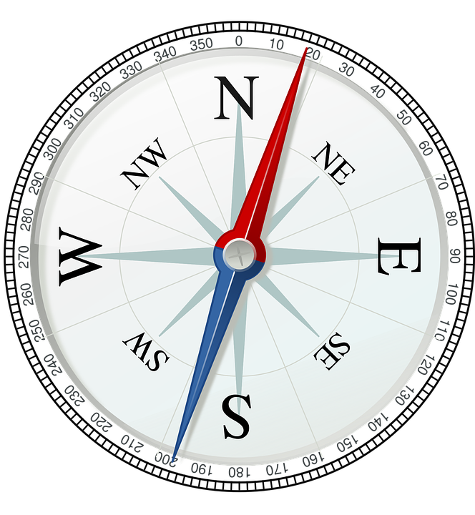
- Explain that a compass allows us to find angles that describe the direction from one position to another. The main points of north, south, east and west are called the cardinal directions or cardinal points.
Teachers could spend time showing students how to use a compass on their phone. They could find the direction or angle to familiar landmarks around the school or town.
- Display Figure 3, asking students to conduct a Think-Pair-Share (bit.ly/thinkpairsharestrategy) to answer the following questions:
- Where do the right angles in this situation come from?
- How can we use the information in the image to find the northerly distance?
Figure 3 – map 2 of Australia with the distance from Melbourne to Brisbane marked
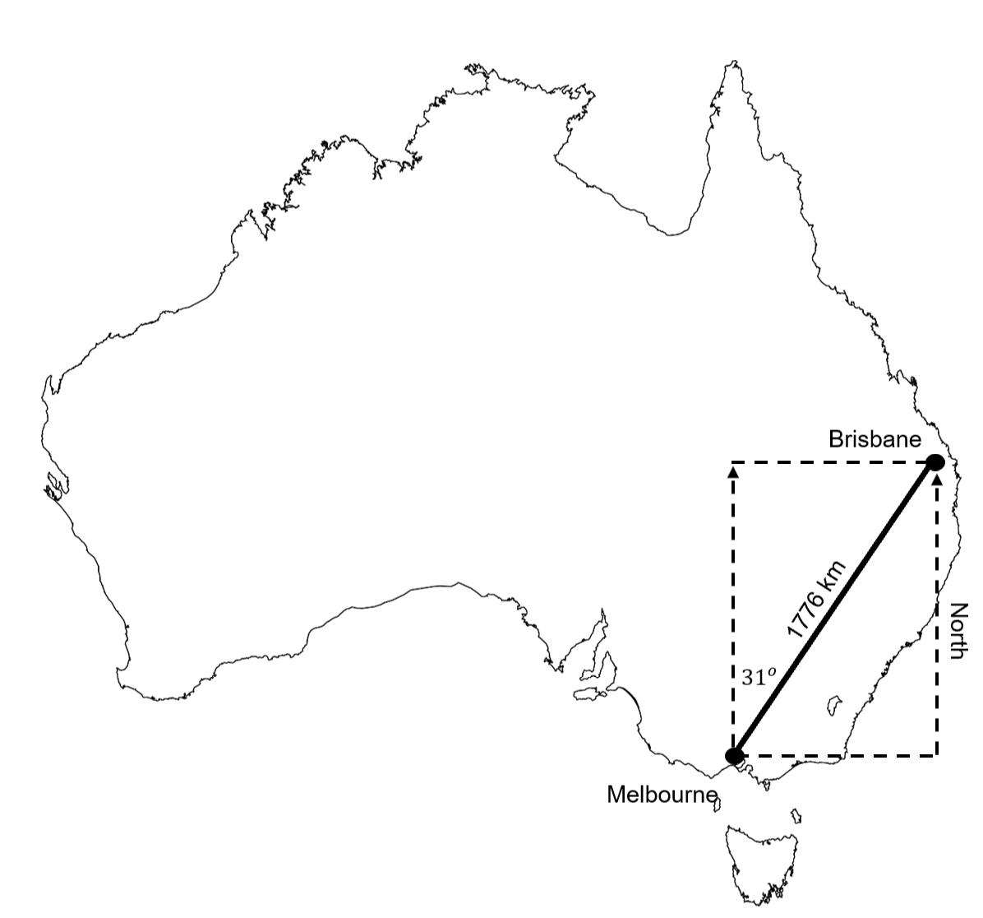
- Take suggested answers from students. Share any answers with an interesting or correct approach. Refer to Figure 2 when discussing the right angles in this situation.
The initial bearing needed to travel from Melbourne directly to Brisbane is approximately 31º. Students do not need any knowledge of bearings to be able to complete this task.

Explore
- Display Figure 4.
Figure 4 – map of NSW
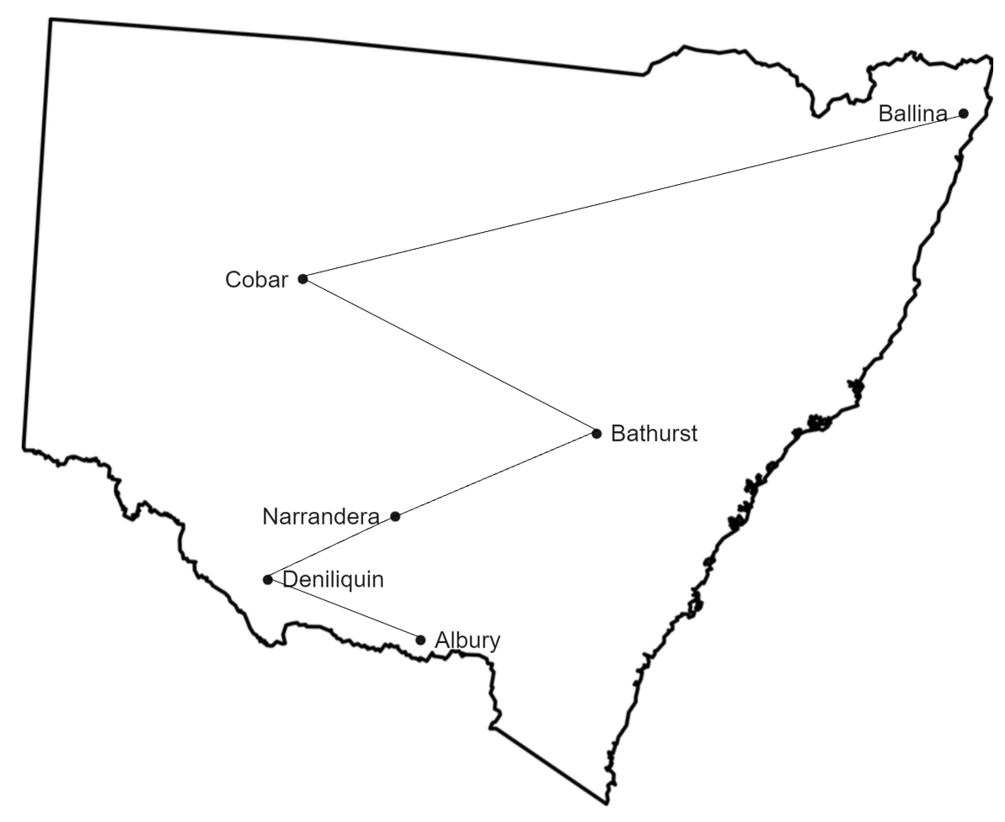
- Instruct students that they have been tasked with mapping NSW and need to make sure that everything is recorded to scale. It won't be enough to know how far apart 2 places are. We will need to find how far north each of the towns and cities of Albury, Deniliquin, Narrandera, Bathurst, Cobar and Ballina are from one another.
- Display Figure 5.
- Inform students that we have found the approximate distance between each location by travelling as close as possible in a straight line from one town to the next.
Figure 5 – map of NSW with distances between towns and cities marked
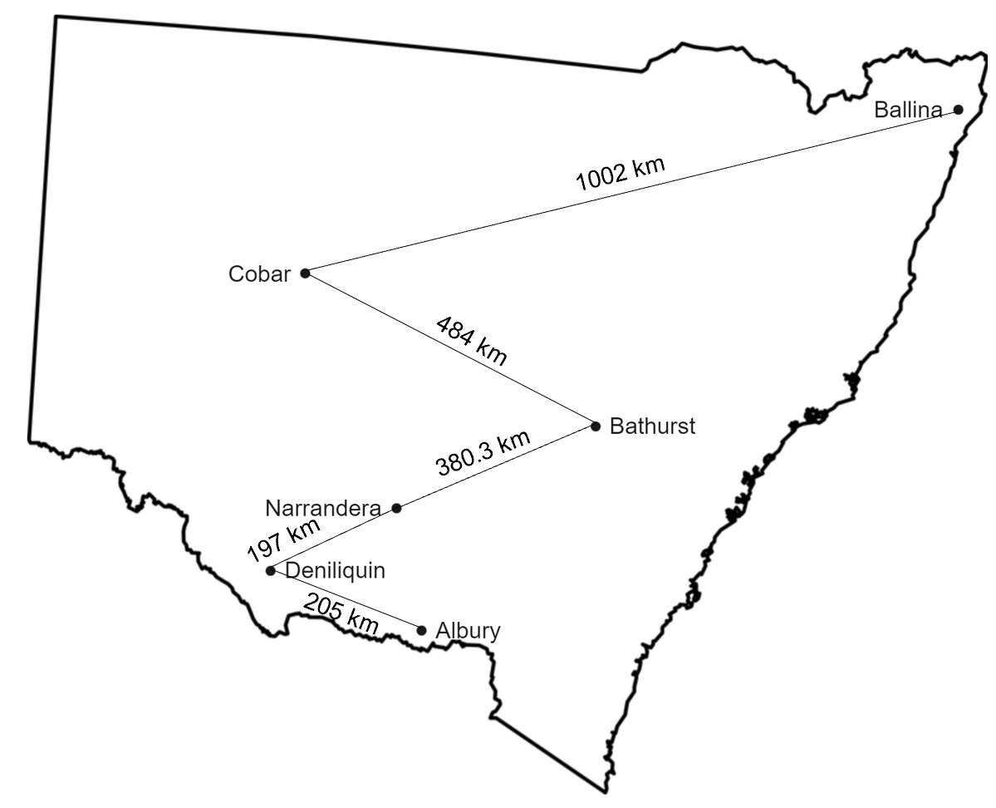
- Hand students a copy of Appendix A and ask them to read the examples individually.
- Students can place their hand on the desk as a thumbs up when they have finished reading.
- Students are then to engage in a pair-share, discussing what is going on in each step of the worked solution.
- Students should attempt to answer the self-explanation questions.

Summarise
- Give all students a copy of Appendix B.
- Have students complete this task, finding the distance north-south and east-west of the 2 locations in each example to one decimal place.

Apply

Equipment
- Protractors (at least one per group of students)
- Trundle wheel or tape measure (one per group of students)
- A copy of a map of the school (one per group students)

Method
- Inform students that angles are maintained in scale maps.
- Have students mark a distance on the map that can be measured with a trundle wheel, that is, not going through any buildings, and endpoints that can be located.
- Students are to go to these locations and use a trundle wheel or tape measure to measure these distances, marking them on the map.
- Students should then construct a right-angled triangle around their distance, using north, south, east and westerly lines.
- Have students measure an angle inside their right-angled triangle and use trigonometry to find how far north-south and how far east-west the 2 locations are from one another.

Assessment and Differentiation

Suggested opportunities for differentiation
Explore
- By obtaining a map of the local area, teachers can construct a more relevant map. Distances can be found using Google and angles are preserved in a map, so directions can be found by using a protractor.
- Bearings are acknowledged as being possible to set the scene for students, but these measurements are given to students in all examples to reduce the cognitive load.
Apply
- Challenge students to develop their own navigation on a blank map of the school or a known location, showing all north-south and east-west distances.

Suggested opportunities for assessment
- Students engaging in the launch of this lesson should have a background in trigonometry. Review participation and strategies in the final steps of the launch to assess students’ ability with using trigonometry to find a missing side.
- Appendix B could act as an exit ticket to assess students' ability not only to apply trigonometry to find missing sides in right-angled triangles, but to assess their ability to solve practical problems with this skill. Put specific focus on the final question and whether students can interpret east and west results as being opposite directions that need to be subtracted.

Appendix A

Finding distances – worked example
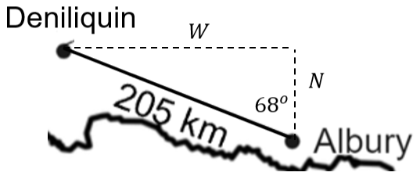

North-south distance
$$\cos{{68}^{o}}=\frac{N}{205}$$
$$N=205×\cos{{68}^{o}}$$
$$N=76.8 km$$

East-west distance
$$\sin{{68}^{o}}=\frac{W}{205}$$
$$W=205×\sin{{68}^{o}}$$
$$W=190.1 km$$

Self-explanation prompts
- What are the opposite and adjacent sides in this triangle?
- What is the hypotenuse?
- What is meant by east-west distance?
- How would these 2 answers change if we found out that the angle measurement was incorrect and it was actually ${65}^{o}$?

Appendix B

Finding distances
Find both the north-south distance (N) and the east-west distance (W) between the 2 locations in each example, correct to one decimal place.
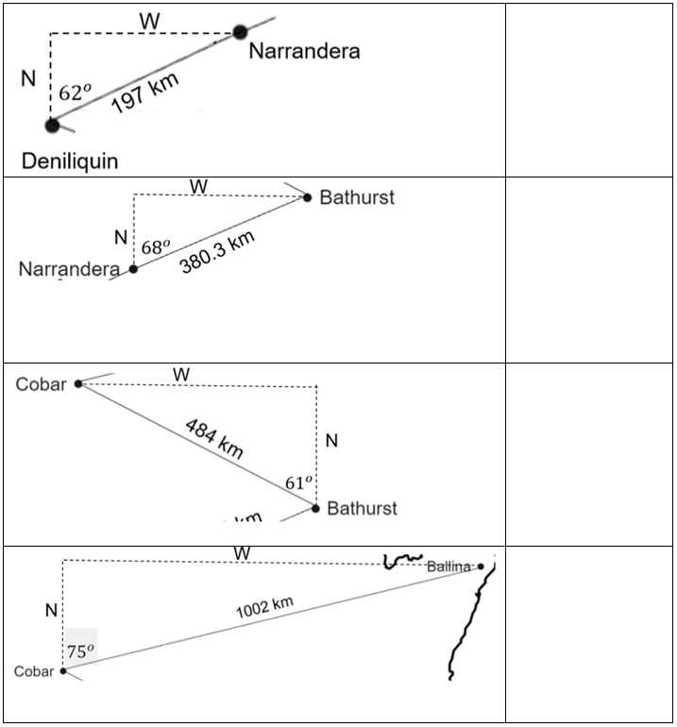
- Remembering that the first northerly distance from Albury to Deniliquin was 76.8 km, how far north have we travelled in total from Albury to Ballina?
- The distance from Albury to Deniliquin was 190.1 km west. How far east or west have we travelled in total from Albury to Ballina?

Sample solutions

Launch
$$\cos{{31}^{o}}=\frac{N}{1776}$$
$$N=1776×\cos{{31}^{o}}$$
$$N=1522.33 km$$

Appendix B
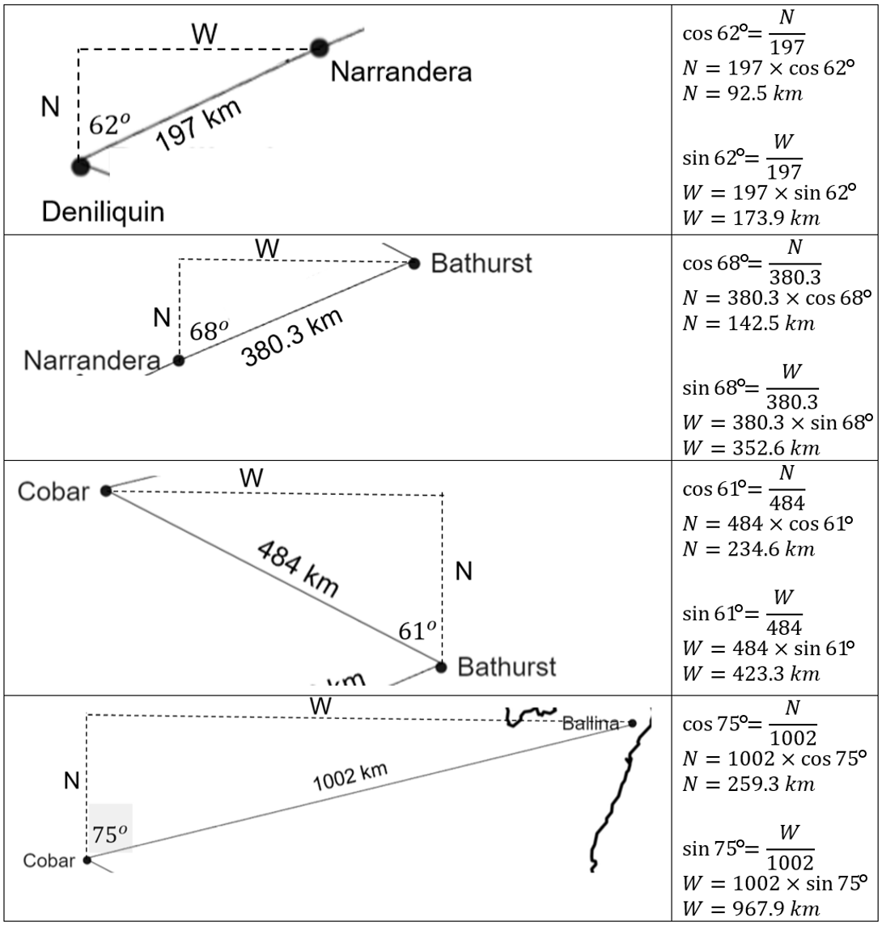

© State of New South Wales (Department of Education), 2023
The copyright material published in this resource is subject to the Copyright Act 1968 (Cth) and is owned by the NSW Department of Education or, where indicated, by a party other than the NSW Department of Education (third-party material).
Copyright material available in this resource and owned by the NSW Department of Education is licensed under a Creative Commons Attribution 4.0 International (CC BY 4.0) licence.
This licence allows you to share and adapt the material for any purpose, even commercially.
Attribution should be given to © State of New South Wales (Department of Education), 2023.
Material in this resource not available under a Creative Commons licence:
- the NSW Department of Education logo, other logos and trademark-protected material
- material owned by a third party that has been reproduced with permission. You will need to obtain permission from the third party to reuse its material.
Links to third-party material and websites
Please note that the provided (reading/viewing material/list/links/texts) are a suggestion only and implies no endorsement, by the New South Wales Department of Education, of any author, publisher, or book title. School principals and teachers are best placed to assess the suitability of resources that would complement the curriculum and reflect the needs and interests of their students.
If you use the links provided in this document to access a third-party's website, you acknowledge that the terms of use, including licence terms set out on the third-party's website apply to the use which may be made of the materials on that third-party website or where permitted by the Copyright Act 1968 (Cth). The department accepts no responsibility for content on third-party websites.

