Midpoints
In this activity, students engage with Desmos graphs to develop definitions for the midpoint between 2 points on the Cartesian plane, applying practical methods and generalising to develop a formula.
This activity is designed to support students who have some experience working with coordinates on the Cartesian plane and averages.
This lesson incorporates Path content.

Visible learning

Learning intention
- To be able to find the midpoint between 2 points on the Cartesian plane.

Success criteria
- I can apply averages to find the midpoint between 2 points on the Cartesian plane.
- I can apply a formula to find the midpoint between 2 points on the Cartesian plane.

Syllabus outcomes
A student:
- develops understanding and fluency in mathematics through exploring and connecting mathematical concepts, choosing and applying mathematical techniques to solve problems, and communicating their thinking and reasoning coherently and clearly MAO-WM-01
- determines the midpoint, gradient and length of an interval and graphs linear relationships, with and without digital tools MA5-LIN-C-01
- describes and applies transformations, the midpoint, gradient/slope and distance formulas and equations of lines to solve problems MA5-LIN-P-01
Mathematics K–10 Syllabus © NSW Education Standards Authority (NESA) for and on behalf of the Crown in right of the State of New South Wales, 2022.

Activity structure

Launch
- Display Figure 1.
Figure 1 – an interval drawn on a Cartesian plane
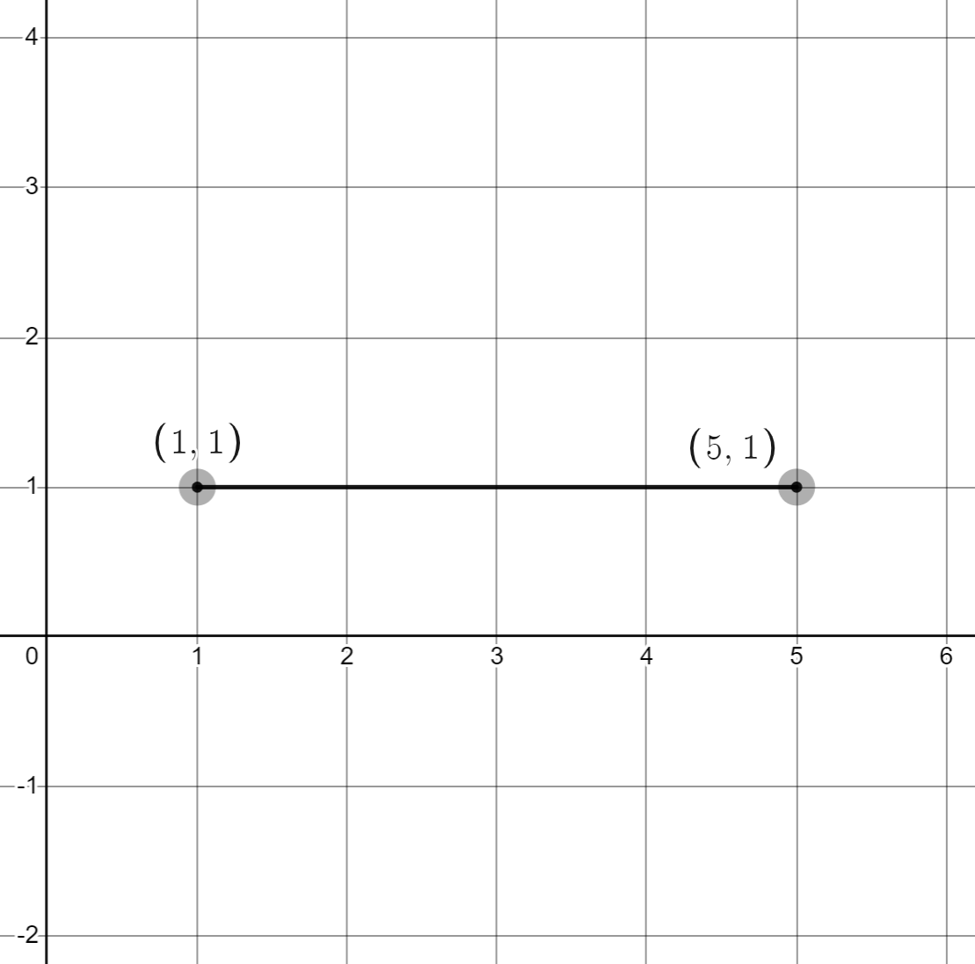
Image created using Desmos and is licensed under the Desmos Terms of Service.
- Ask students to individually write down where they believe is the midpoint of the interval.
- Have students engage in a Think-Pair-Share (bit.ly/thinkpairsharestrategy) focused on this question, emphasising the need to communicate reasons for their answer when sharing.
- Monitor student responses to determine if the concept requires review.
- Display Figure 2.
Figure 2 – a diagonal interval drawn on a Cartesian plane
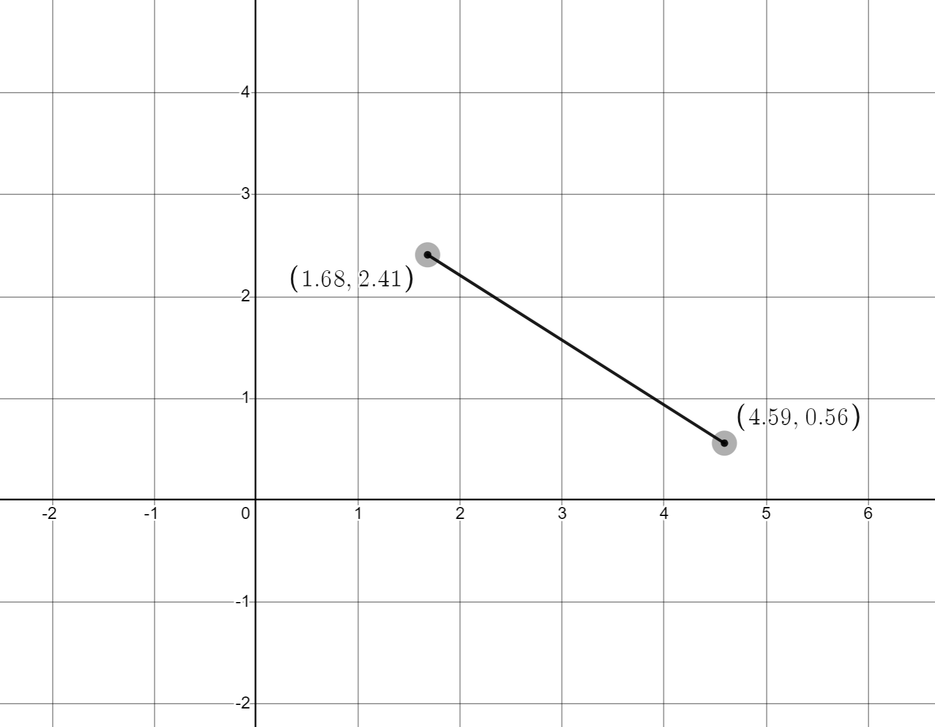
Image created using Desmos and is licensed under the Desmos Terms of Service.
- Ask students to individually consider the midpoint between the 2 points. Have students engage in a Think-Pair-Share (bit.ly/thinkpairsharestrategy) about this problem, encouraging them to focus on their reasons for their estimates.
- Select non-volunteers using the pause, pounce, bounce strategy, (bit.ly/pausepouncebounce) for students to share their estimates and reasoning.
- The teacher can display Desmos graph. Launch (bit.ly/desmoslaunchinterval) which contains this interval. Turning on the ‘Midpoint’ folder in Desmos, by selecting the dot next to midpoint on the far left, will reveal the approximate solutions.
Figure 3 – ‘Midpoint’ folder from Desmos
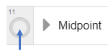
This Desmos graph and the following Desmos graphs have already been seen in the previous activity on Distances.
- Conclude that to accurately find midpoints for any situation, we need to establish a clear approach that can be used in any situation.

Explore
The instructions below describe technology used on the teacher's screen. Appendix A has been provided if there is no access to technology. If a device with internet access is available per student or between pairs, consider providing students access to each of the graphs to aid their investigation. The advantage here would be to allow them to adjust and investigate what is going on in each case.

Midpoints of vertical and horizontal intervals
- Use the Desmos graph Horizontal midpoints (bit.ly/Desmoshorizontalmid) to display any interval you choose by adjusting and moving the 2 end points of the interval. Consider your students when choosing an interval, for instance, it may be best to use positive whole numbers.
- Ask students to individually write down the midpoint.
- Students are to complete a Think-Pair-Share (bit.ly/thinkpairsharestrategy), focused on the approach they took to find their values.
Repeat the process in step 1 as many times as you wish by adjusting the interval in the graph. You can click and drag either of the endpoints and the interval will remain horizontal.
- Adjust the situation one step at a time via the changes listed below and ask students to consider if their method still works:
- Remove the grid in the settings in the top right corner of your Desmos graph. Alternatively, open this new graph with the grid removed (bit.ly/Desmoshorizontalmidnogrid).
- Drag one point such that the points are the same (on top of one another).
- Drag one point such that its x value is negative.
- Drag both points such that their x values are negative.
- Turn on the ‘Midpoint’ folder to reveal the averages method.
- Have students review the method individually and raise a thumbs up when they have finished reviewing and are ready to discuss.
- Students engage in a discussion with a peer about what is going on in the calculations on the screen.
- Ask a non-volunteer to explain the calculation.
- Turn off the ‘Midpoint’ folder and adjust the graph, giving students multiple opportunities to use the averages method to verify it will always work.
- Open the Desmos graph (bit.ly/DesmosHorizontalmidgen) with variables a, b and c in place of the numbers of the coordinates. Introduce the idea that ‘here, we have a graph where the coordinates are unknowns and are represented by pronumerals’.
- Students are to engage in a Think-Pair-Share (bit.ly/thinkpairsharestrategy), attempting to represent the midpoint between the 2 points using just the variables.
- Turn on the ‘Midpoint formula’ folder to reveal the solution.
- Repeat steps 1 to 6 with vertical intervals:
- vertical interval (bit.ly/DesmosVerticalMid)
- grid turned off (bit.ly/Verticalmidnogrid)
- unknowns Desmos graph (bit.ly/Desmosverticalmidgen).

Midpoints of diagonal intervals
- Display the Desmos graph (bit.ly/Desmosmidpoint) and move the endpoints to an appropriate interval for your students, for instance, positive integer values in the coordinates.
- Turn on the ‘Midpoint’ folder on the left of the screen, and have students engage in a Think-Pair-Share (bit.ly/thinkpairsharestrategy) about the calculations and midpoints on the screen. Ask:
- What are the calculations on the screen doing?
- Where do the numbers in the calculations come from? Ask each pair of students to write down up to 2 parts of the working that they would like to clarify.
- Review the solution with students, asking volunteers and non-volunteers to explain what they know and what they'd like to ask about the solution.
- Leave the worked solution on the board.
- Give students the link to the Desmos graph and have them adjust the endpoints to create different intervals.
- Students are to record the endpoints and calculate the midpoint, showing all working. Instruct students that they can turn on the ‘Midpoint’ folder to check their solutions. Advise the students that when changing the 2 endpoints, they should only change one element at a time, for instance, changing one $x$ value or one $y$ value only. Students could also consider:
- What happens if the $x$ value of one point is doubled?
- What happens if the $y$ value of one point is doubled?
- What happens if both the $x$ and $y$ values of one point are doubled?

Summarise

Generalising
- Open the Desmos graph (bit.ly/Desmosmidpointgen) and raise with students that we want to develop rules to follow to find the midpoint between any 2 points.
- Challenge students to find an expression for the midpoint between the 2 general points.
- Review the solution with students, asking volunteers and non-volunteers to explain what they know and what they'd like to ask about the solution.

Developing a formula
This part of the lesson is based around content from a Path focus area. It is unnecessary for students to complete both the ‘Generalising’ and the ‘Developing a formula’ sections.
- Open the Desmos graph Developing (bit.ly/Desmosmidpointformula) and raise with students that we want to develop rules to follow to find the midpoint between any 2 points.
- Challenge students to find an expression for the midpoint between the 2 general points.
- Review the solution with students, asking volunteers and non-volunteers to explain what they know and what they'd like to ask about the solution.

Apply
- Give students access to the Desmos graph Faded examples (bit.ly/Desmosmidpointfaded) which consists of faded worked examples (bit.ly/fadedexamplesstrategy).
- Have students move the endpoints to create a new problem for finding the midpoint between 2 points. Students should copy and complete a problem on Level 1.
- Students then move the endpoints by moving the switch at the top of the screen to Level 2, and copy and complete. Advise students that when changing the 2 endpoints, they should only change one element at a time, for instance, change one $x$ value or one $y$ value only. Students could also consider:
- What happens if the $x$ value of one point is doubled?
- What happens if the $y$ value of one point is doubled?
- What happens if both the $x$ and $y$ values of one point are doubled?
- Continue this process until you have completed a problem on every level, including Level 5 where the working is empty.

Assessment and Differentiation

Suggested opportunities for differentiation
- The Desmos graphs throughout the activity allow an exploration for students that does not depend on their skills plotting points.
- Consideration should be taken when choosing intervals for your students, for instance, weaker students may require positive whole numbers only and to challenge students you may consider using decimals.
Launch
- Students may need revising of Pythagoras’ theorem.
- Students may benefit from writing their strategy down on Vertical Non-Permanent Surfaces (VNPS) (bit.ly/VNPSstrategy) and conducting a gallery walk (bit.ly/DLSgallerywalk) with the class before selecting students to share their answers.
Explore
- Prior to turning on the ‘Midpoint’ folder, challenge students to share their own calculations with the class.
Summarise
- Both generalising how to find the midpoint between 2 points and developing the formula for the midpoint have been included in this activity, depending on your students select one and/or the other.

Suggested opportunities for assessment
- Monitor students’ responses after Think-Pair-Share activities to check for understanding.
Apply
- Review the answers found by students in the faded worked examples to assess their skills and understanding of finding the midpoint.

Appendix A

Midpoints

Midpoints of horizonal intervals
- Looking at the below interval, what is the midpoint? What strategy did you use to find the midpoint?
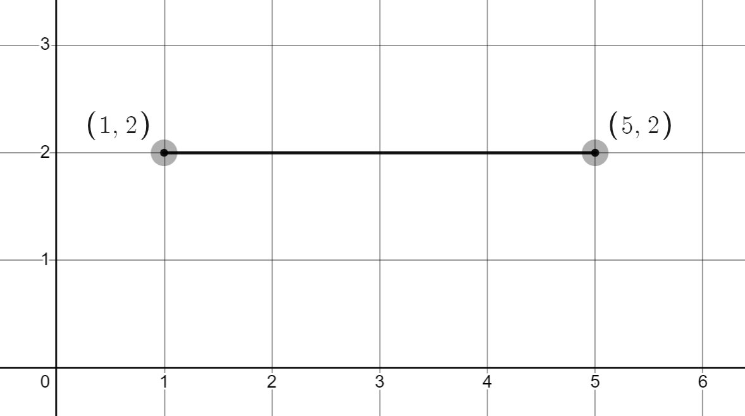
- Looking at the new interval below, what is the midpoint? Could you use the same strategy you used above? If no, what was your new strategy?
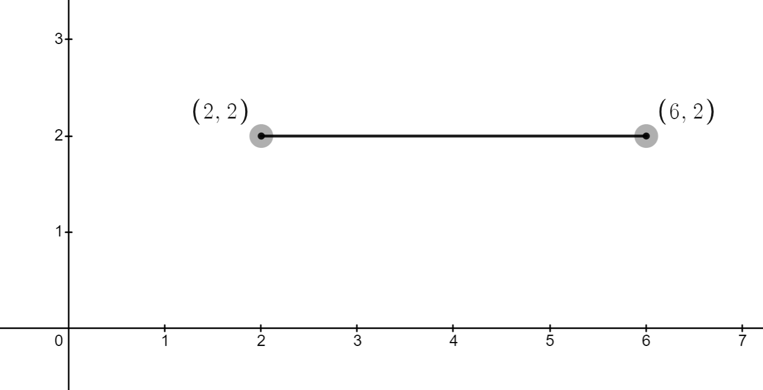
- The interval has now been changed so that one $x$ value is negative. Can you find the midpoint of this new interval? What strategy did you use? Is this the same strategy used previously?
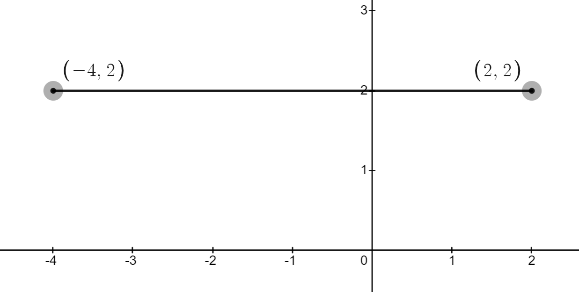
- The interval has been adjusted so that both $x$ values are negative. Can you find the midpoint? Explain your strategy.
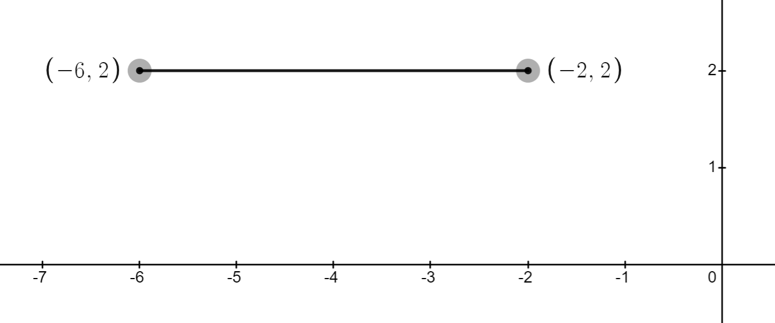
- What if each point had no numerical value provided and was represented as $(a, b)$ and $(c, d)$? How might your strategy work for these points? Or, if needed, what might be a new strategy?

Midpoints of vertical intervals
- Looking at the below interval, what is the midpoint? What strategy did you use to find the midpoint?
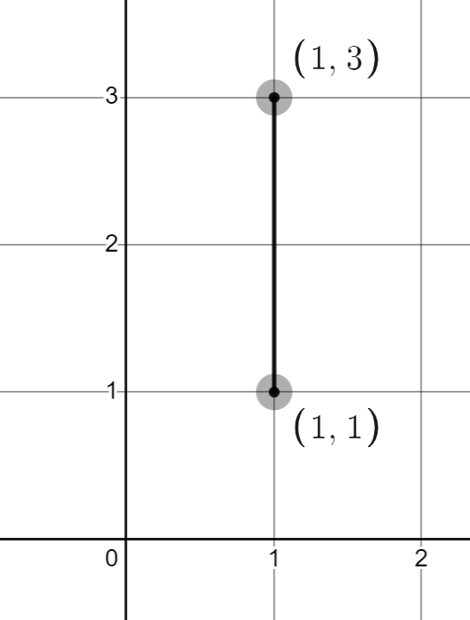
- Looking at the new interval below, what is the midpoint? Could you use the same strategy you used above? If no, what was your new strategy?
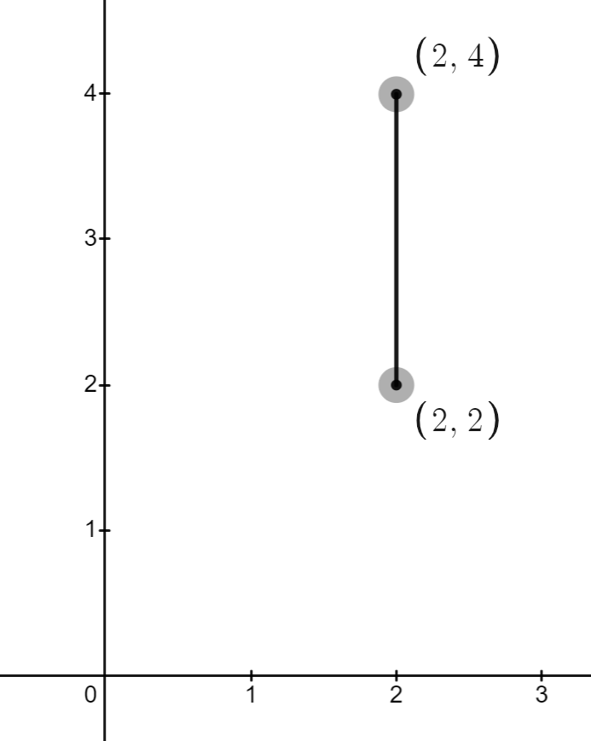
- The interval has now been changed so that one $y$ value is negative. Can you find the midpoint of this new interval? What strategy did you use? Is this the same strategy used previously?
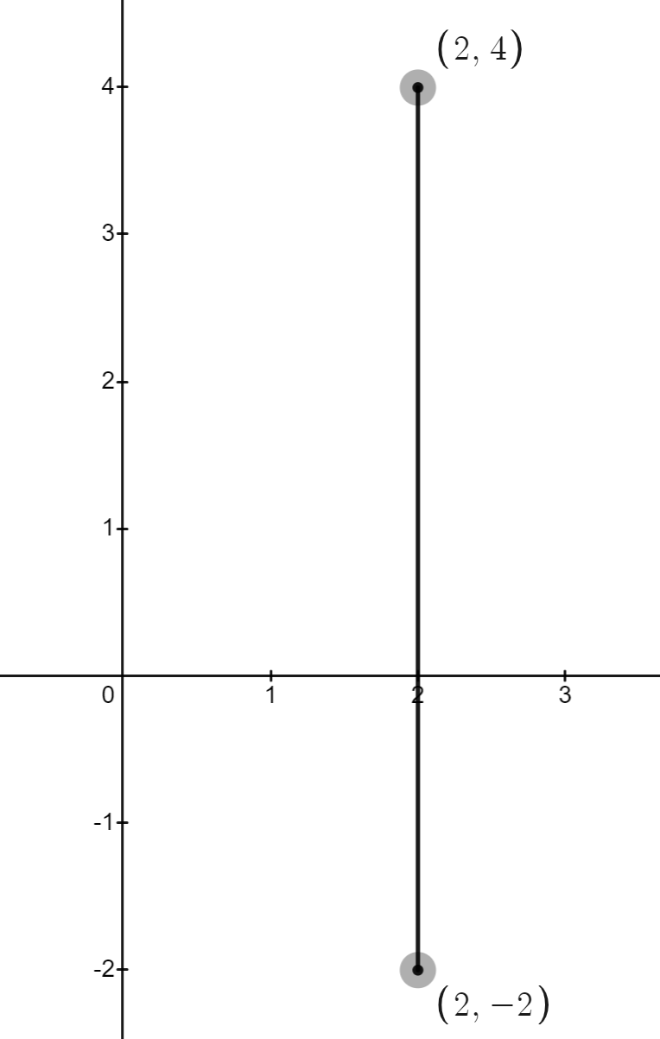
- The interval has been adjusted so that both $y$ values are negative. Can you find the distance? Explain your strategy.
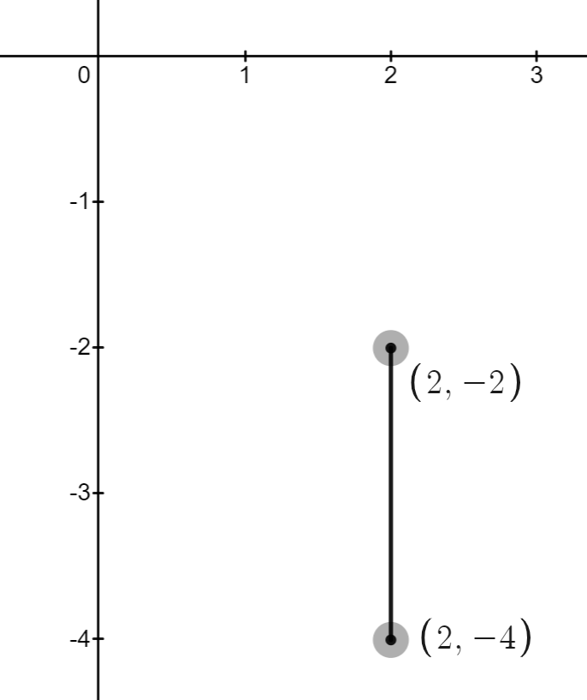
- What if each point had no numerical value given and was represented as $(a, b)$ and $(c, d)$. How might your strategy work for these points?

Diagonal distances
- Consider the diagonal interval shown below.
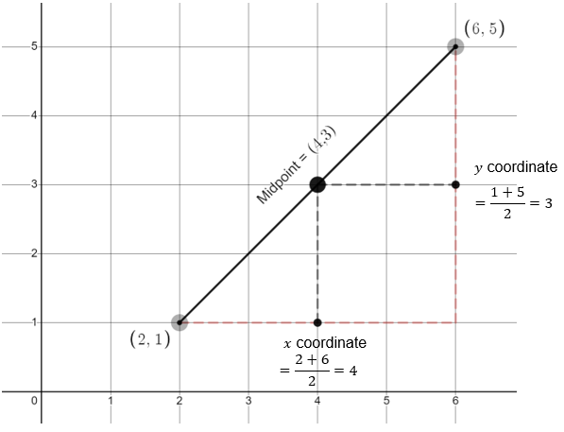
- What are the calculations doing?
- Where do the numbers in the calculations come from?
- How might you use the calculations to find the distance, $d$?
- Using this method, find the midpoint of the interval below.
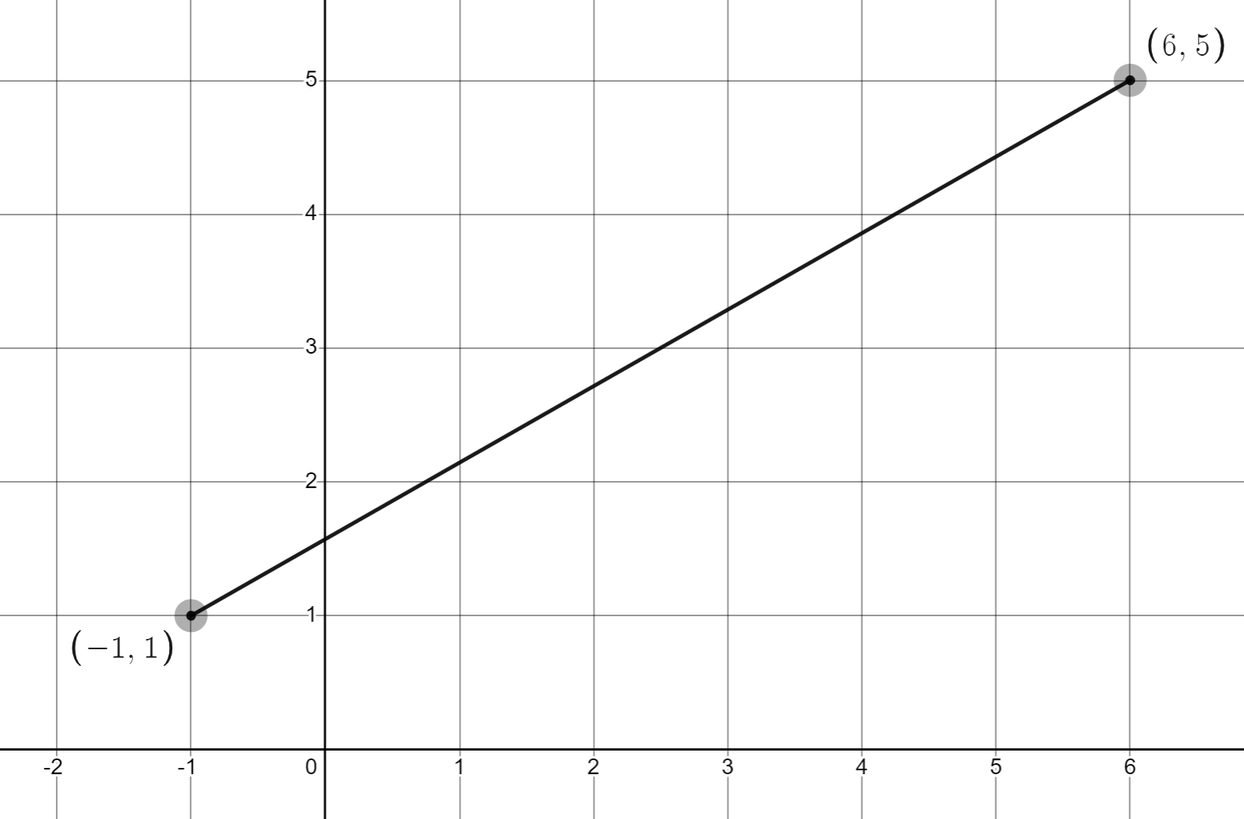
Images created using Desmos and are licensed under the Desmos Terms of Service.

© State of New South Wales (Department of Education), 2023
The copyright material published in this resource is subject to the Copyright Act 1968 (Cth) and is owned by the NSW Department of Education or, where indicated, by a party other than the NSW Department of Education (third-party material).
Copyright material available in this resource and owned by the NSW Department of Education is licensed under a Creative Commons Attribution 4.0 International (CC BY 4.0) licence.
This licence allows you to share and adapt the material for any purpose, even commercially.
Attribution should be given to © State of New South Wales (Department of Education), 2023.
Material in this resource not available under a Creative Commons licence:
- the NSW Department of Education logo, other logos and trademark-protected material
- material owned by a third party that has been reproduced with permission. You will need to obtain permission from the third party to reuse its material.
Links to third-party material and websites
Please note that the provided (reading/viewing material/list/links/texts) are a suggestion only and implies no endorsement, by the New South Wales Department of Education, of any author, publisher, or book title. School principals and teachers are best placed to assess the suitability of resources that would complement the curriculum and reflect the needs and interests of their students.
If you use the links provided in this document to access a third-party's website, you acknowledge that the terms of use, including licence terms set out on the third-party's website apply to the use which may be made of the materials on that third-party website or where permitted by the Copyright Act 1968 (Cth). The department accepts no responsibility for content on third-party websites.

