Distances
In this activity, students engage with Desmos graphs to develop definitions for the distance between 2 points on the Cartesian plane, applying practical methods and generalising to develop a formula.
This activity is designed to support students who have some experience working with coordinates in the Cartesian plane and Pythagoras' theorem.
This lesson incorporates Path content.

Visible learning

Learning intention
- To be able to find the distance between two points on the Cartesian plane.

Success criteria
- I can apply Pythagoras' theorem to find the distance between 2 points on the Cartesian plane.
- I can apply formulas to find the distance between 2 points on the Cartesian plane.

Syllabus outcomes
A student:
- develops understanding and fluency in mathematics through exploring and connecting mathematical concepts, choosing and applying mathematical techniques to solve problems, and communicating their thinking and reasoning coherently and clearly MAO-WM-01
- determines the midpoint, gradient and length of an interval and graphs linear relationships, with and without digital tools MA5-LIN-C-01
- describes and applies transformations, the midpoint, gradient/slope and distance formulas and equations of lines to solve problems MA5-LIN-P-01
Mathematics K–10 Syllabus © NSW Education Standards Authority (NESA) for and on behalf of the Crown in right of the State of New South Wales, 2022.

Activity structure

Launch
- Display Figure 1.
Figure 1 – a horizontal interval drawn on a Cartesian plane
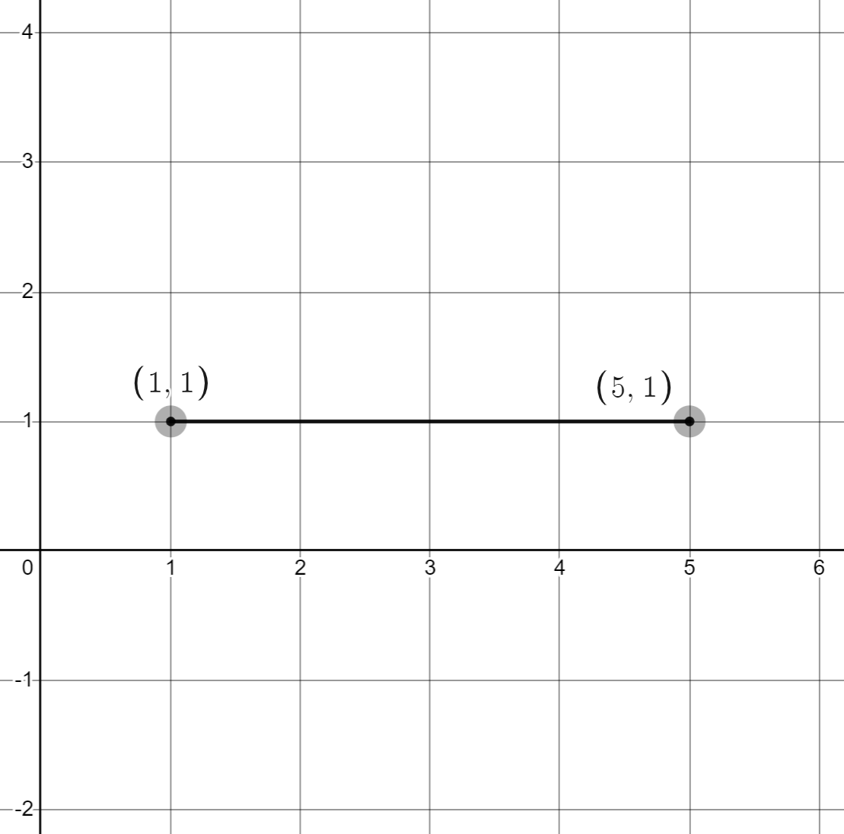
- Ask students to individually write down what they believe to be the distance of the interval.
- Have students engage in a Think-Pair-Share (bit.ly/thinkpairsharestrategy) focused on this question, emphasising the need to communicate reasons for their answer when sharing and the process they took to find their answer.
- Monitor student responses to determine if the concept requires review.
- Display Figure 2.
Figure 2 – a diagonal interval drawn on a Cartesian plane
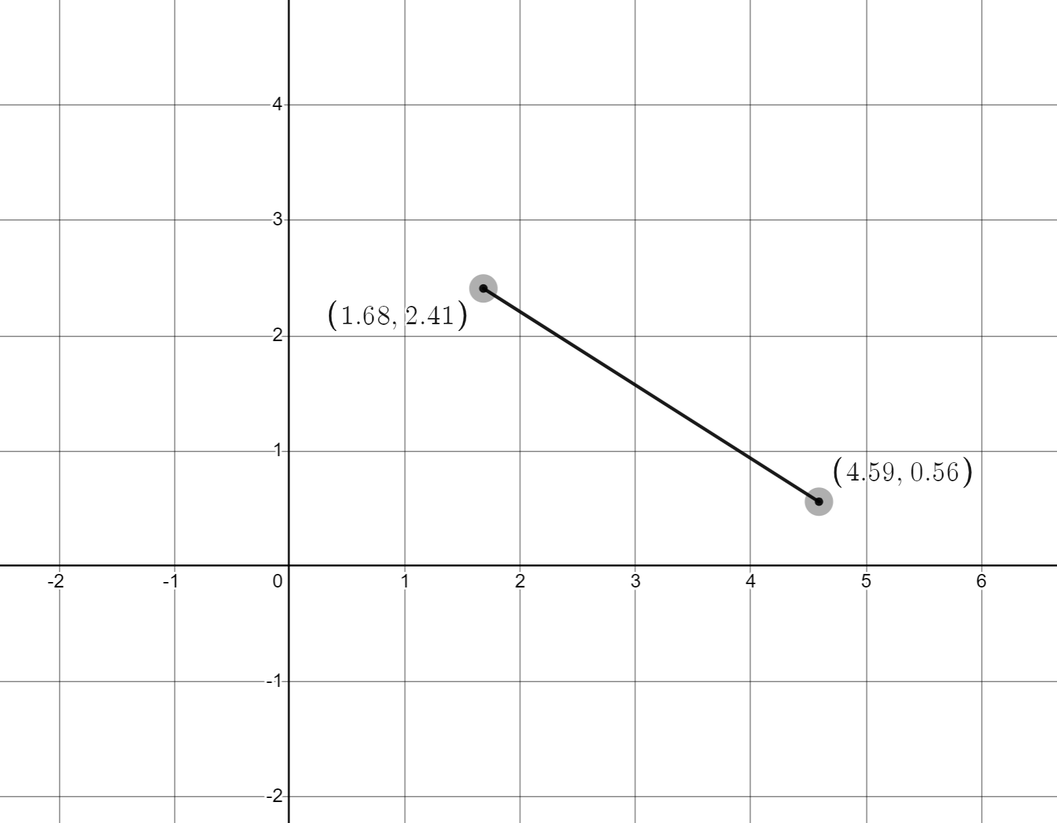
- Ask students to individually consider the distance between the two points. Have students engage in a Think-Pair-Share (bit.ly/thinkpairsharestrategy) about this problem, encouraging them to focus on their reasons for their estimates.
- Select non-volunteers using the pause, pounce, bounce strategy, (bit.ly/pausepouncebounce) for students to share their estimates and reasoning.
- The teacher can display this Desmos graph, Launch (bit.ly/desmoslaunchinterval), which contains this interval. Turning on the ‘Distance’ folder in Desmos, by clicking the dot next to distance on the far left will reveal the approximate solutions.
Figure 3 – Distance selection tool from Desmos
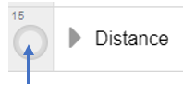
- Conclude that to accurately find distances for any situation, we need to establish a clear approach that can be used in any situation.

Explore
The instructions below describe technology used on the teacher's screen. Appendix A has been provided if there is no access to technology. If a device with internet access is available per student or between pairs, consider providing students access to each of the graphs to aid their investigation. The advantage here would be allowing them to adjust and investigate what is going on in each case.

Horizontal and vertical distances
- Use the Desmos graph Horizontal distances (bit.ly/desmosaninterval) to display any interval you choose by adjusting and moving the 2 end points of the interval. Ask students to individually write down the distance. Students are to complete a Think-Pair-Share (bit.ly/thinkpairsharestrategy), focused on the approach they took to find their values.
Repeat the process in step 1 as many times as you wish by adjusting the interval in the graph. You can click and drag either of the endpoints and the interval will remain horizontal.
- Adjust the situation one step at a time via the changes listed below and ask students to consider if their method still works.
- Remove the grid in the settings in the top right corner of your Desmos graph. Alternatively, open this new graph with the grid removed (bit.ly/desmosintervalnogrid).
- Drag one point such that the points are the same (on top of one another).
- Drag one point such that its x – value is negative.
- Drag both points such that their x – values are negative.
- Ask students to share their strategies, before turning on the ‘Distance’ folder in Desmos to reveal the subtraction method and re-explore the above changes.
- Open the Desmos graph, Horizontal distances with variables (bit.ly/desmosintervalvariables) with variables a, b and c in place of the numbers of the coordinates. Introduce the idea that here we have a graph where the coordinates are unknowns and are represented by pronumerals. Students are to engage in a Think-Pair-Share (bit.ly/thinkpairsharestrategy), attempting to represent the distance between the 2 points using just the variables.
- Turn on the ‘Distance formula’ folder to reveal the solution.
- Repeat steps 1 to 6 with vertical distances using the given Desmos graphs.
- Vertical interval (bit.ly/desmosverticalinterval).
- Grid turned off (/bit.ly/desmosgridoff).
- Unknowns Desmos graph (bit.ly/desmosunknowns).

Diagonal distances
- Display the Desmos graph Distances (bit.ly/Desmos-distances) and move the endpoints to an appropriate interval for your students, for example, positive integer values in the coordinates.
- Turn on the ‘Distance triangle’ folder on the left of screen, and have students engage in a Think-Pair-Share (bit.ly/thinkpairsharestrategy) about the calculations and distances on the screen. Ask:
- What are the calculations on the screen doing?
- Where do the numbers in the calculations come from?
- How might you use these calculations to find the distance, d?
- Turn on the ‘Distance calculations’ folder and give students time to read individually. Instruct students to give a thumbs up when they are ready to have a discussion with a peer.
- Have students engage in a Think-Pair-Share (bit.ly/thinkpairsharestrategy) to discuss what is happening at each step. Ask each pair of students to write down any parts of the working that they would like to clarify.
- Review the solution with students, asking volunteers and non-volunteers to explain what they know and what they'd like to ask about the solution.
- Leave the worked solution on the board.
- Give students the link to the Desmos graph and have them adjust the endpoints to create different intervals.
- Students are to record the endpoints and calculate the distance, showing all working. Instruct students that they can turn on the ‘Distance triangle’ folder if required and turn on the ‘Distance calculations’ folder to check their solutions.

Summarise

Generalising
- Open the Desmos graph Generalising (bit.ly/desmosintervalgeneralising) and raise with students that we want to develop rules to follow to find the distance between any 2 points.
- Challenge students to find an expression for the distance between 2 general points.
- Review the solution with students, asking volunteers and non-volunteers to explain what they know and what they'd like to ask about the solution.

Developing a formula
This part of the lesson is based around content from a Path focus area. It is unnecessary for students to complete both the ‘Generalising’ and the ‘Developing a formula’ sections.
- Open the Desmos graph Developing (bit.ly/desmosintervaldeveloping) and raise with students that we want to develop rules to follow to find the distance between any 2 points.
- Challenge students to find an expression for the distance between the 2 general points.
- Review the solution with students, asking volunteers and non-volunteers to explain what they know and what they'd like to ask about the solution.

Apply
- Give students access to the Desmos graph Faded examples (bit.ly/DesmosDistancefaded) which consists of faded worked examples (bit.ly/fadedexamplesstrategy).
- Have students move the endpoints to create a new problem finding the distance between 2 points. Students should copy and complete a problem on level 1. Advise the students that when changing the 2 endpoints they should only change one element at a time, in other words change one $x$ value or one $y$ value only. Students could also consider:
- What happens if the $x$ value of one point is doubled?
- What happens if the $y$ value of one point is doubled?
- What happens if both the $x$ and $y$ values of one point are doubled?
- Students then move the endpoints, move the switch at the top of the screen to level 2, and copy and complete.
- Students continue this process until they have completed a problem on every level, including level 5 where the working is empty.

Assessment and Differentiation

Suggested opportunities for differentiation
- The Desmos graphs throughout the activity allow an exploration for students that does not depend on their skills plotting points.
- When exploring the intervals, consider keeping the values smaller and positive whole numbers for weaker students.
- To challenge students, consider using decimal values for the coordinates.
Launch
- Students may need to revise Pythagoras’ theorem.
- Students may benefit from writing their strategy down on a VNPS (bit.ly/VNPSstrategy) and conducting a gallery walk (bit.ly/DLSgallerywalk) with the class before selecting students to share their answers.
Explore
- Prior to turning on the ‘Distance calculations’ folder, challenge students to share their own calculations with the class.
- When reviewing the distance calculations, have students take note of the number of decimal places and significant figures that the final result has been rounded to. Challenge students to drag the points to different distances to determine if the rounding is set to a specific number of decimal places or significant figures.
Summarise
- Both generalising how to find the distance between 2 points and developing the formula for the distance have been included in this activity, depending on your students select one and/or the other.

Suggested opportunities for assessment
- Monitor students’ responses after Think-Pair-Share activities to check for understanding.
Apply
- Review the answers found by students in the faded worked examples to assess their skills and understanding of finding the distance.

Appendix A

Distances

Horizontal distances
- Looking at the below interval, what is the distance? What strategy did you use to find the distance?
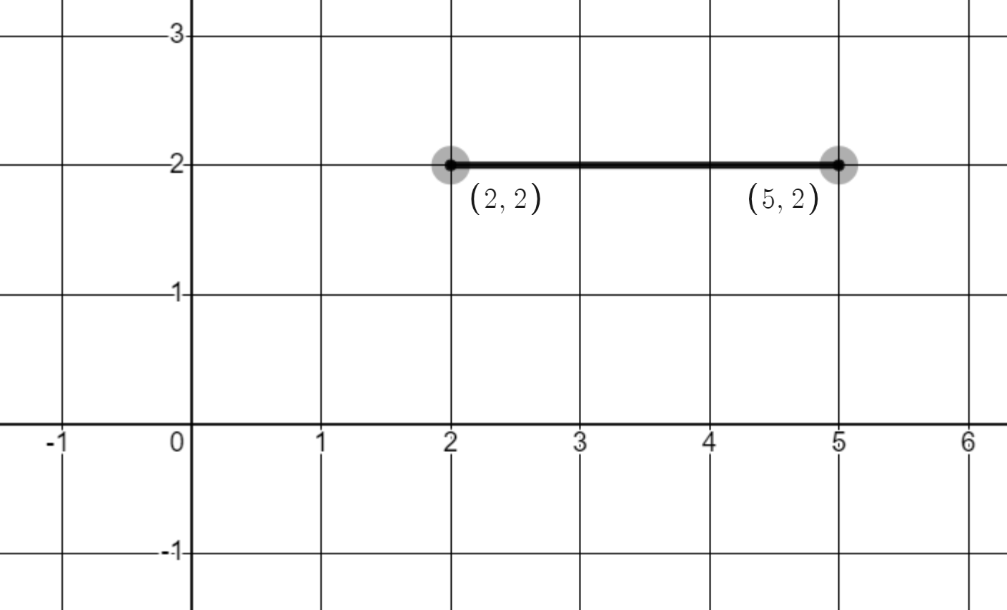
- Looking at the new interval below, what is the distance? Could you use the same strategy you used above? If no, what was your new strategy?
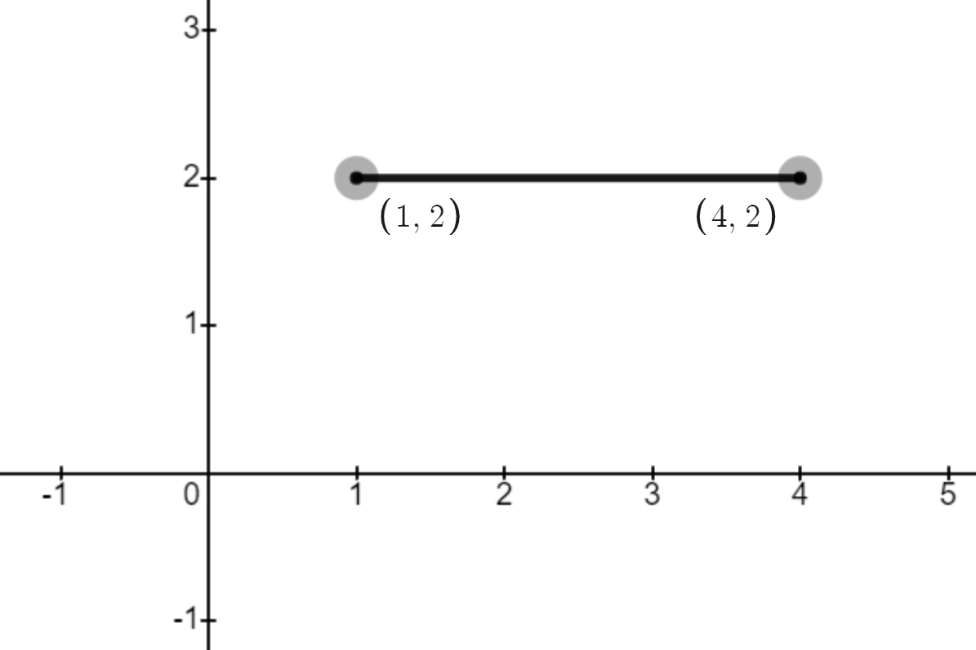
- The interval has now been changed so that one $x$ value is negative. Can you find the distance of the new interval below? What strategy did you use? Is this the same strategy used previously?
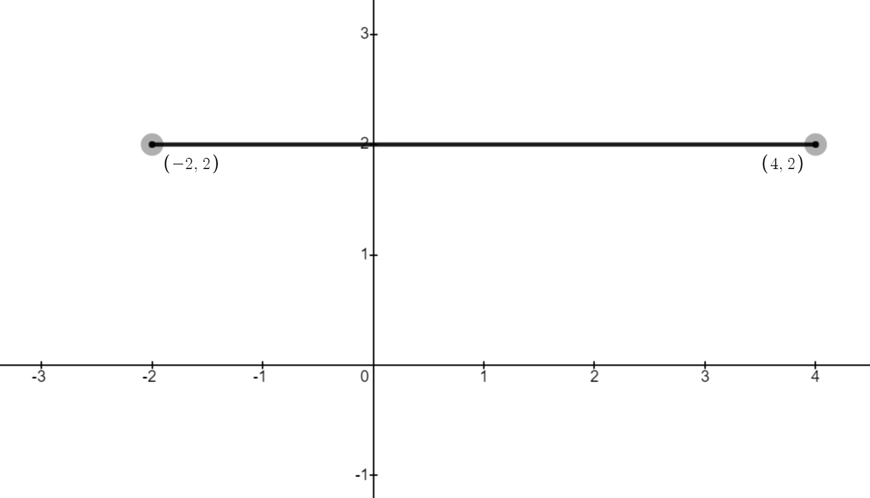
The interval has been adjusted so that both $x$ values are negative. Can you find the distance? Explain your strategy. 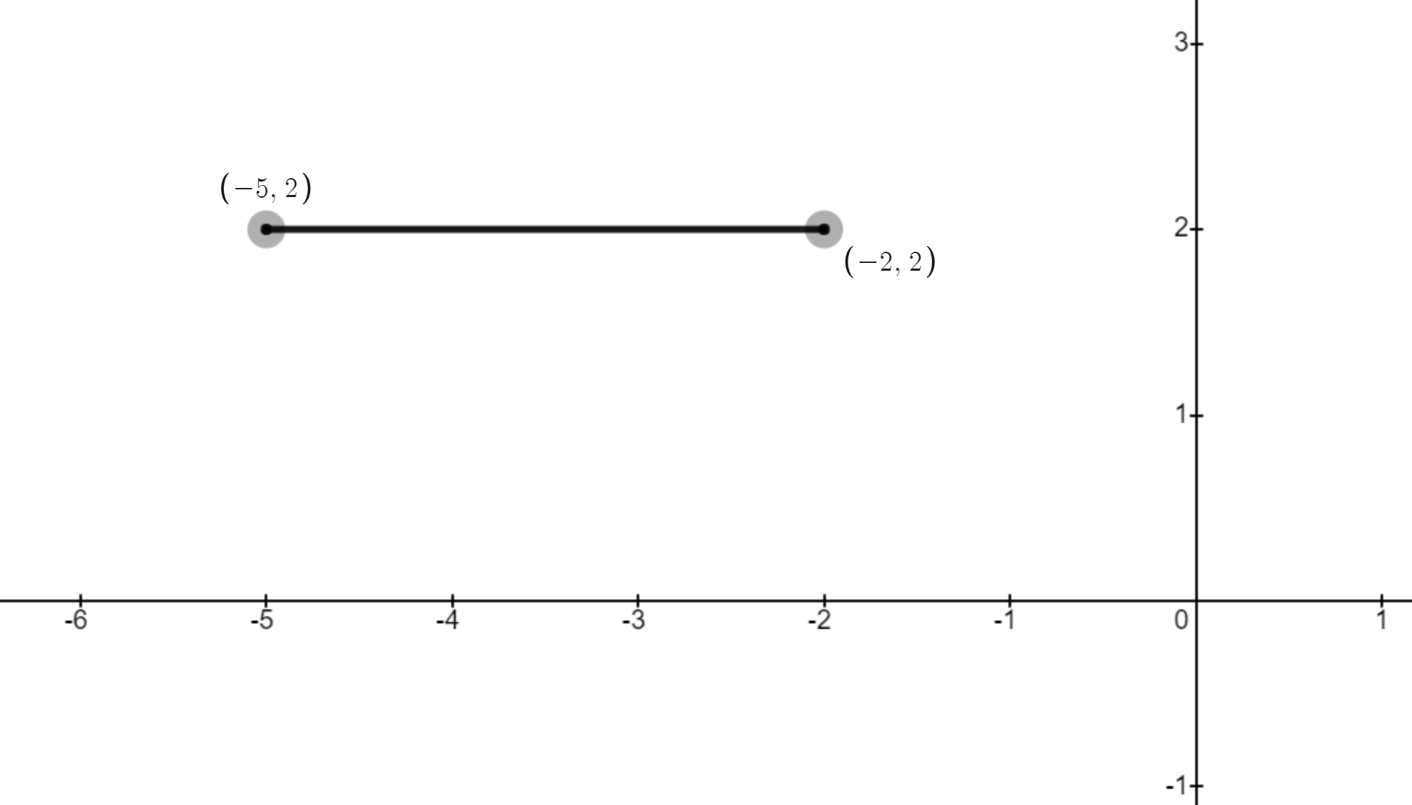

- What if each point had no numerical value given and was represented as $(a, b)$ and $(c, d)$. How might your strategy work for these points?

Vertical distances
- Looking at the below interval, what is the distance? What strategy did you use to find the distance?
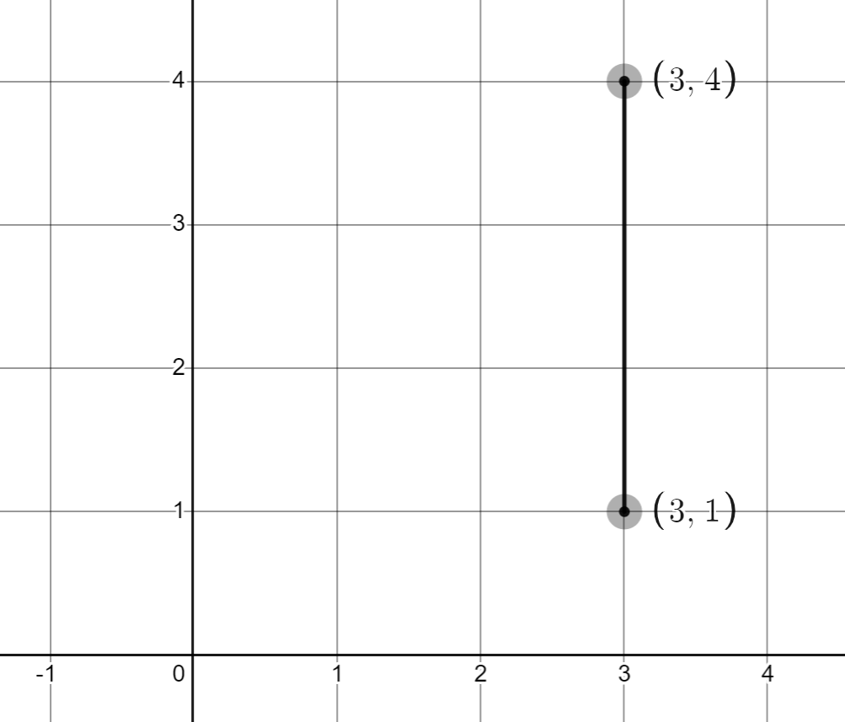

- Looking at the new interval below, what is the distance? Could you use the same strategy you used above? If no, what was your new strategy?
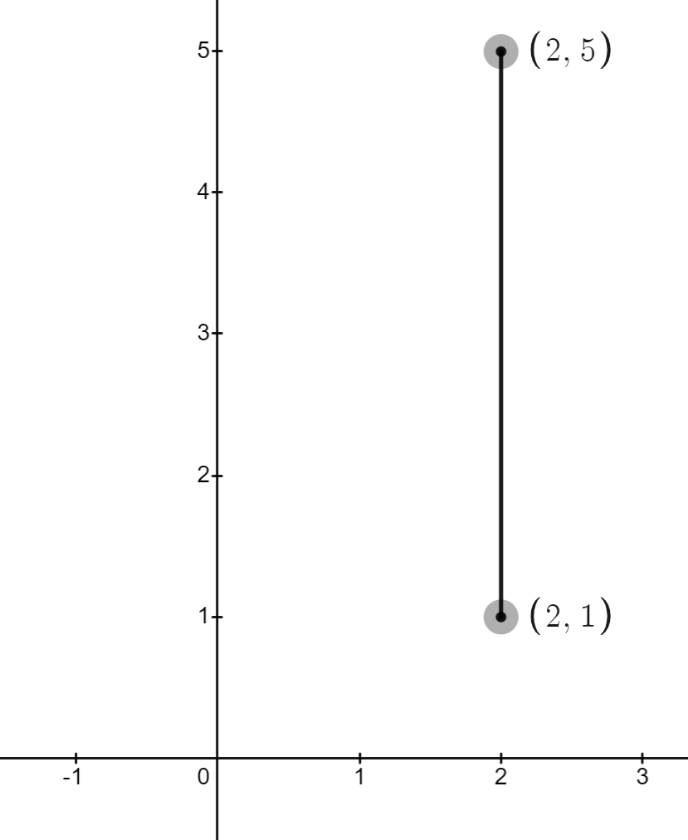
- The interval has now been changed so that one $y$ value is negative. Can you find the distance of the new interval below? What strategy did you use? Is this the same strategy used previously?
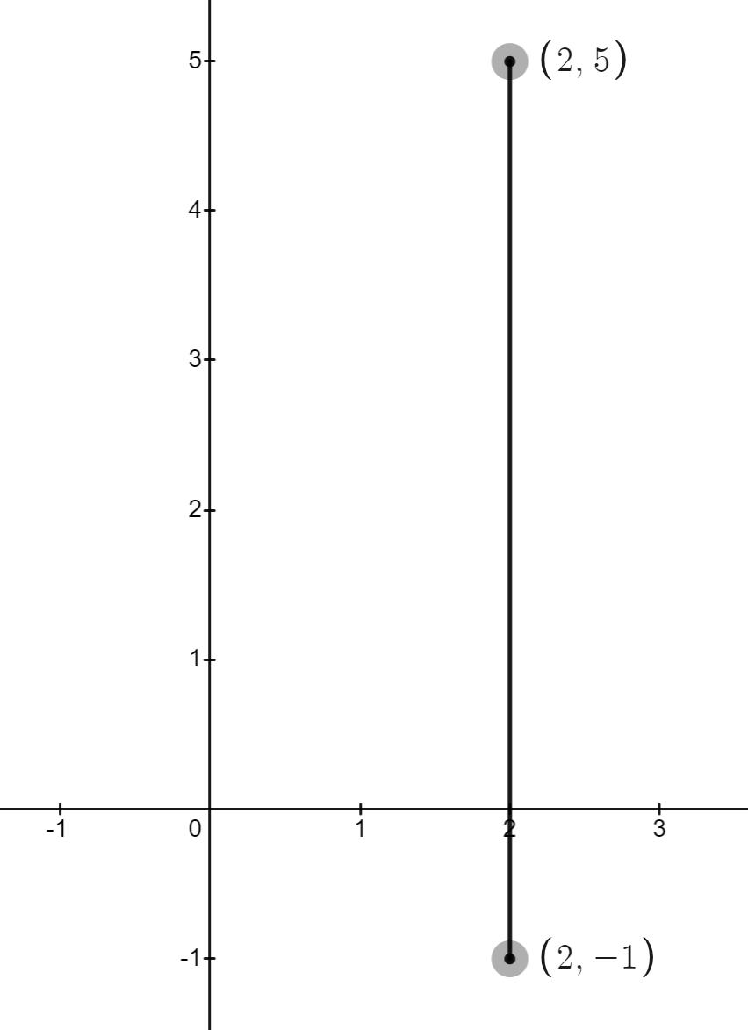
- The interval has been adjusted so that both $x$ values are negative. Can you find the distance? Explain your strategy.
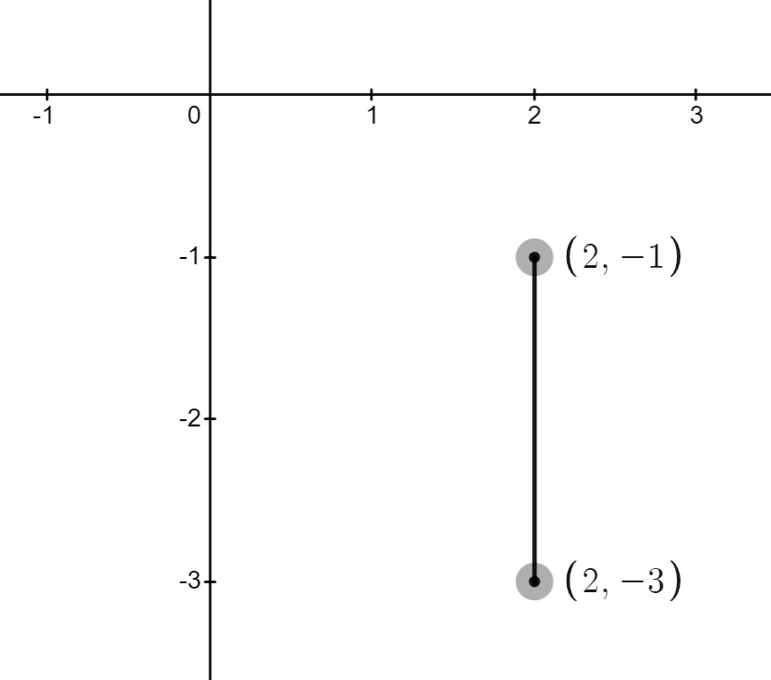
- What if each point had no numerical value given and was represented as $(a, b)$ and $(c, d)$. How might your strategy work for these points?

Diagonal distances
- Consider the diagonal distance shown below.
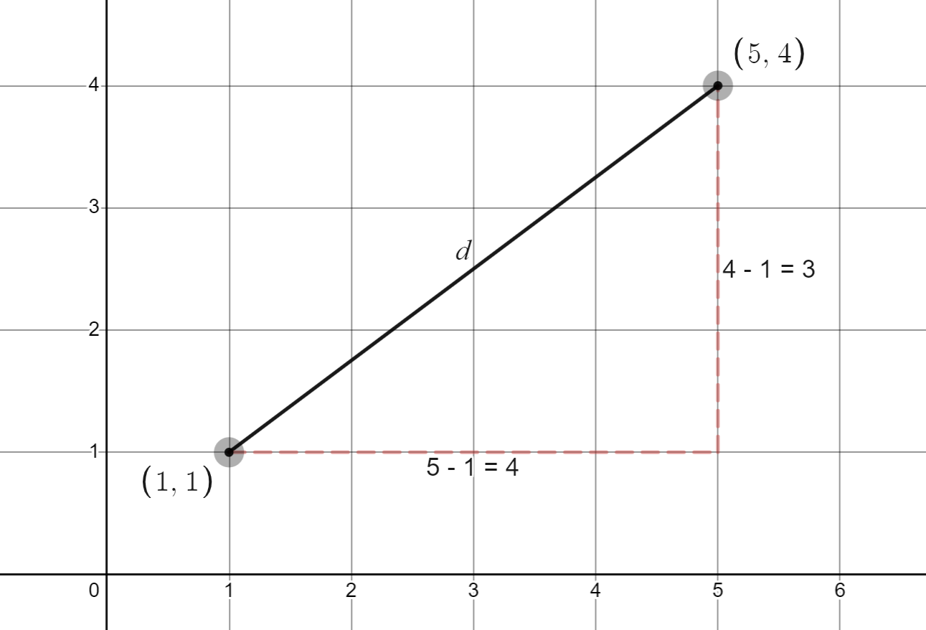
- Using the displayed calculations and distances, answer the questions:
- What are the calculations doing?
- Where do the numbers in the calculations come from?
- How might you use these calculations to find the distance, $d$?
- Your teacher will demonstrate how to find the distance, $d$. Once you have reviewed this and understand the solution try to find the distance of the interval below using the same method.
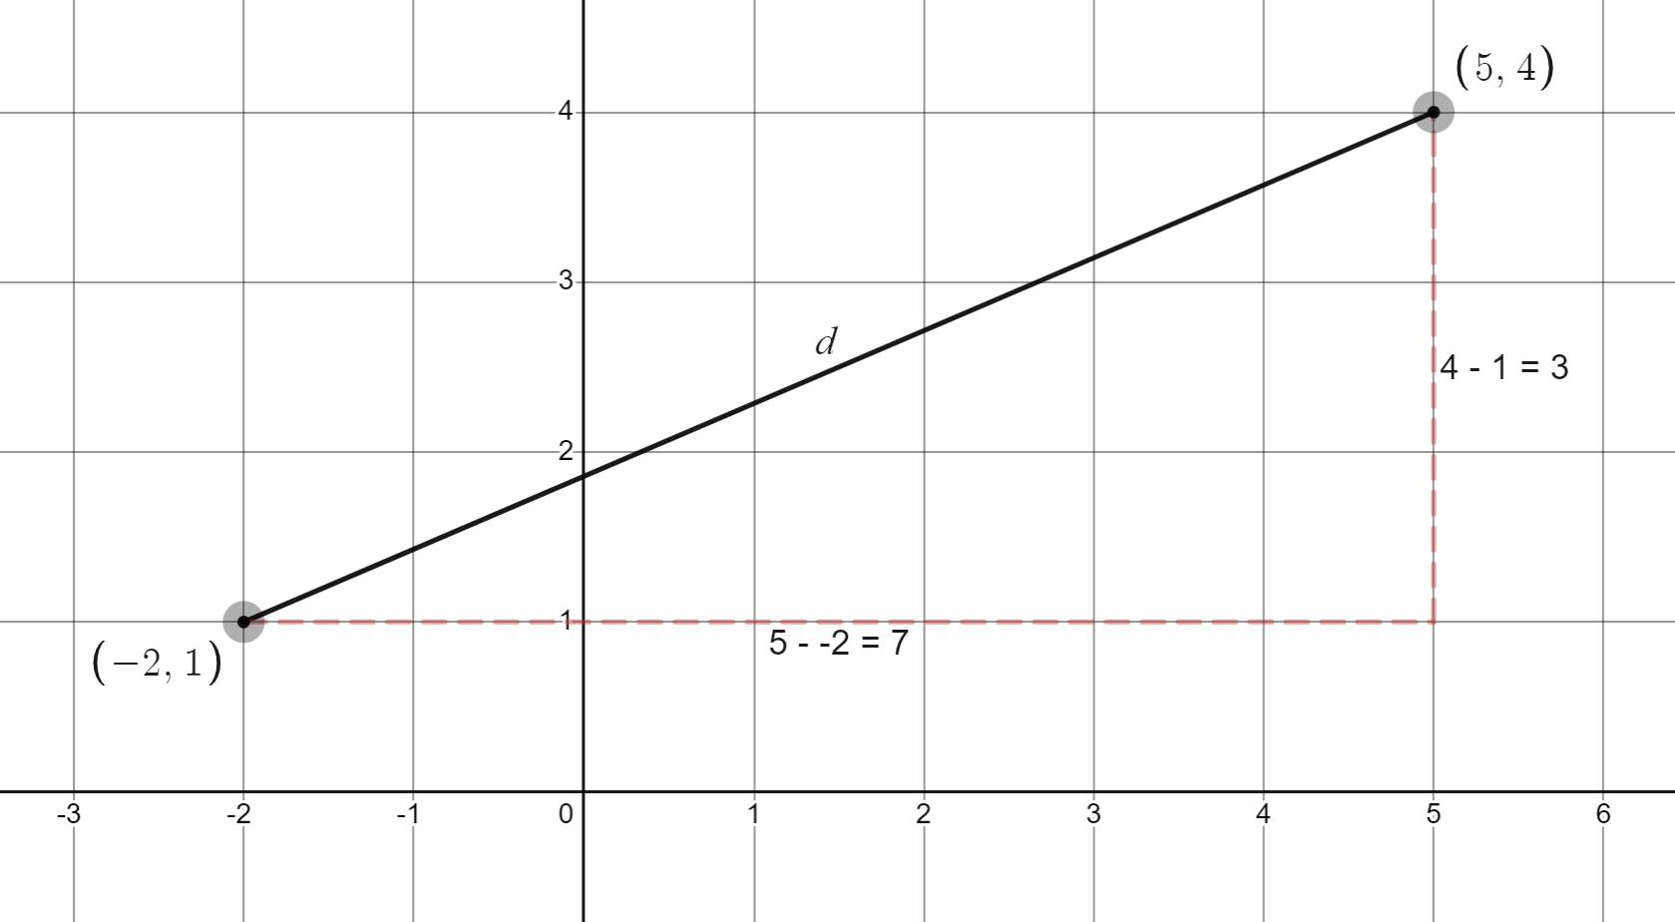
Images created using Desmos and are licensed under the Desmos Terms of Service.

© State of New South Wales (Department of Education), 2023
The copyright material published in this resource is subject to the Copyright Act 1968 (Cth) and is owned by the NSW Department of Education or, where indicated, by a party other than the NSW Department of Education (third-party material).
Copyright material available in this resource and owned by the NSW Department of Education is licensed under a Creative Commons Attribution 4.0 International (CC BY 4.0) licence.
This licence allows you to share and adapt the material for any purpose, even commercially.
Attribution should be given to © State of New South Wales (Department of Education), 2023.
Material in this resource not available under a Creative Commons licence:
- the NSW Department of Education logo, other logos and trademark-protected material
- material owned by a third party that has been reproduced with permission. You will need to obtain permission from the third party to reuse its material.
Links to third-party material and websites
Please note that the provided (reading/viewing material/list/links/texts) are a suggestion only and implies no endorsement, by the New South Wales Department of Education, of any author, publisher, or book title. School principals and teachers are best placed to assess the suitability of resources that would complement the curriculum and reflect the needs and interests of their students.
If you use the links provided in this document to access a third-party's website, you acknowledge that the terms of use, including licence terms set out on the third-party's website apply to the use which may be made of the materials on that third-party website or where permitted by the Copyright Act 1968 (Cth). The department accepts no responsibility for content on third-party websites.

