Surd is the word
In this activity, students apply Pythagoras’ theorem to measurement problems, investigating the effect of recording their solution as a surd, or rounded to a number of decimal places, as larger measurements are considered.
This lesson incorporates Path content.

Visible learning

Learning intentions
- To recognise that a surd is an exact value that can be approximated by a rounded decimal.
- To understand the need for maintaining accuracy.

Success criteria
- I can determine when a square root results in a surd.
- I can convert a surd into a decimal estimate.
- I know when to use surds and when it is appropriate to convert these to decimal estimates.

Syllabus outcomes
A student:
- develops understanding and fluency in mathematics through exploring and connecting mathematical concepts, choosing and applying mathematical techniques to solve problems, and communicating their thinking and reasoning coherently and clearly MAO-WM-01
- describes and performs operations with surds and fractional indices MA5-IND-P-02
Mathematics K–10 Syllabus © NSW Education Standards Authority (NESA) for and on behalf of the Crown in right of the State of New South Wales, 2022.

Activity structure

Launch
- Have students use a KWL/KWLH strategy (bit.ly/KWLH_strategy) to brainstorm what they know and can recall about Pythagoras’ theorem.
- Show students at least the first 45 seconds of the video How many ways are there to prove the Pythagorean theorem? (5:17) (bit.ly/howtoprovepythagorasyoutube). As they watch, ask them to add to or update their KWL/KWLH charts.
- Using a Think-Pair-Share (bit.ly/thinkpairsharestrategy) ask students to compare their list and knowledge with a partner to create an even more detailed list, then randomly select partners to share their responses with the class.
Before moving forward, ensure that students have collectively shared that Pythagoras’ theorem applies to right-angled triangles, that its formula is $a^{2}+b^{2}=c^{2}$, and that c represents the hypotenuse, whilst a and b represent the remaining, shorter sides.
- Refresh students’ memories on the concept of Pythagorean triads (3 integer values that can be substituted for a, b and c in Pythagoras’ theorem) and show them the video 3-4-5 Method (3:20) (bit.ly/345methodyoutube) on the practical use of the Pythagorean triad.
- Use the following example, or one involving an alternative Pythagorean triad, to showcase how the triad substitutes into the formula derived from Pythagoras’ theorem:
Do the side lengths displayed on the following triangle represent a Pythagorean triad?
Figure 1 – triangle
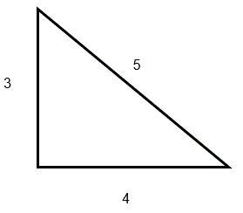
Pythagorean theorem states that $a^{2}+b^{2}=c^{2}$
Let $a=3, b=4$and $c=5$
$$∴LHS=3^{2}+4^{2} \\ =9+16 \\ =25 \\ =5^{2} \\ =RHS$$
$∴\left(3, 4, 5\right)$ for a Pythagorean triad.
- Setting a 5-minute timer, have students work in pairs to list and verify (using Pythagoras’ theorem) as many Pythagorean triads as they can with a hypotenuse less than 100 – refer to Appendix A to see a list of all triads that meet these requirements.
- Ask pairs to share their answers with the whole class – students are to update their KWL/KWLH notes with information about Pythagorean triads and should list a few examples.

Explore

Activity 1 – Finding the missing value
- Organise students into random groups of 3. Provide each group with a copy of Using Pythagoras’ theorem to find a shorter side (bit.ly/Mathslinksfadedshortside) and a copy of Using Pythagoras’ theorem to find the Hypotenuse (bit.ly/Mathslinksfadedhypotenuse).
- Have groups use vertical, non-permanent surfaces, or equivalent, where possible (bit.ly/VNPSstrategy) to complete the faded worked examples.
This is to enhance opportunities for thinking, but also aimed at enabling a gallery walk of student work. Students should not put their names on their work. Mini-whiteboards (bit.ly/miniwhiteboards) are an acceptable substitution or you can make your own with laminated, blank A4 or A3 paper if whiteboards are unavailable, or slip sheets of paper into clear, plastic sleeves.
- Do not specify the level of accuracy required, even when asked by students. Students making their own decisions about rounding is important to this activity.
- Once completed, display the worked solutions from student groups around the room (hung on walls or left clearly on desks) for all students to perform a gallery walk (bit.ly/DLSgallerywalk). Students should not modify any of the work around the room.
- The teacher should look for correct solutions around the room that have been rounded to differing levels of accuracy.
- Using a strategy such as pause, pounce, bounce (bit.ly/pausepouncebouncestrategy), pose questions such as the following:
- How is it that, for certain problems, we have arrived at different final answers?
- Are any of these solutions more correct than any of the others? Why or why not?
- Ask students to see if they can spot the point where everyone still had the same solution/answer.
- Draw everyone back to discuss that the consistency of the accuracy disappears once the square root of the non-square number is attempted to be calculated and written as a decimal estimate.
- Identify the concept that the square root of a non-square number is known as a surd, and that this is always more accurate than attempting to round the value, particularly when not given a requirement or practical need to do so.

Activity 2 – Where does this apply?
- Have students derive solutions for the following including as a surd, estimated to one decimal place and estimated to 2 decimal places.
Figure 2 – right-angled triangle
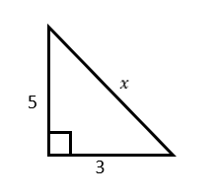
- Students are to be taken to a lined and marked field or court of a rectangular shape (hockey field, netball court or soccer oval are examples that would be suitable).
- Have students work in groups and spread out as evenly as possible to each of the corners.
- Students will be following the process that was outlined in the 3-4-5 Method (3:20) video from the Launch of this lesson sequence (youtube.com/embed/7mzvEgDLPn4).
- Using a tape measure, trundle wheel or similar, have students in their respective groups mark off the short edge lengths in metres, using the corner of the field as the point of intersection.
Figure 3 – image 1 of sporting field
- Where possible use something similar to tent pegs or distance markers for athletics events to mark the end points along the edge of the field, or chalk to mark the points on the side of hard surface courts made of bitumen or concrete (students can stand in place where this is not possible).
- Using a length of twine, join these 2 end points to form the hypotenuse for the triangle.
Figure 4 – image 2 of sporting field
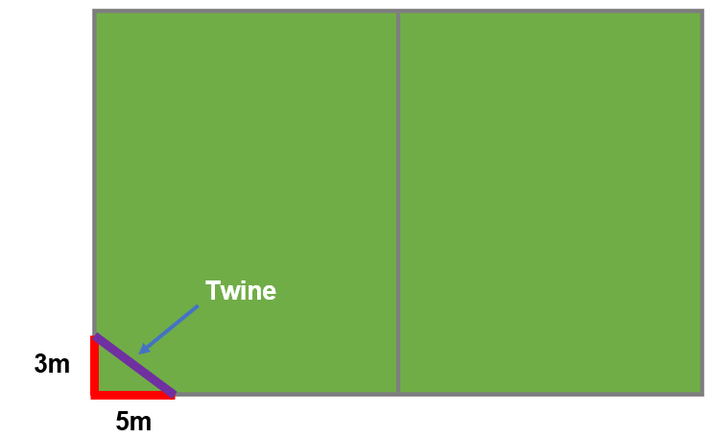
- Students are to measure the length of twine and compare this to their rounded estimates from their previous work.
As students are making this comparison, they need to communicate their thinking and reasoning about their findings and look at how the length of string compares to their decimal estimates.
- Students then repeat this exercise marking the side lengths along the field edge and marking out the hypotenuse with twine, increasing their initial side length values by multiplying by 2, 5 and 10.
It is important that students should not recalculate the hypotenuse each time using Pythagoras’ theorem or their surd value, but rather multiply their initial decimal estimates by 2, 5 and 10 respectively.
- For each increase in magnitude, students are to measure the length of twine and compare this to their respectively adjusted rounded estimates, communicating their thinking and reasoning.
As the side lengths are increased and the length of twine is measured and compared to their decimal estimates, students should begin to see that the twine length becomes increasingly different in length to the decimal estimates that have been multiplied each time.
- Finally, have students use their original surd value for the hypotenuse and multiply this by 2, 5 and 10 before finding each respective decimal estimate.
- Students will see that, maintaining the exact value of the surd is far more accurate than using a decimal estimate, particularly as further calculations are required to be performed.
The idea being that the larger the scale, the more important the level of accuracy becomes. By maintaining length as a surd until the time it is required to be applied practically, this ensures that the need is met accordingly for the intended purposes.

Summarise
- Students are to make notes to their future selves (bit.ly/notesstrategy) summarising what they have learnt from the previous activities. They need to be sure to include the definitions of surd, Pythagoras’ theorem, Pythagorean triad, rational and irrational numbers.
- Students should complete an Exit ticket (bit.ly/exitticketstrategy) to provide feedback on their level of understanding in relation to the learning intentions and success criteria for this lesson.

Apply

Task 1 – Pythagorean Shell
- Print or display the Pythagorean Shell problem at openmiddle.com/pythagorean-shell/.
- Students use Pythagoras’ theorem to find the length of all sides, expressed as surds.

Task 2 – Open Middle problem
- Print or display the Open Middle problem at openmiddle.com/pythagorean-theorem/.
- Students use the digits 0 to 9, at most one time each, to fill in the boxes to find 2 pairs of possible lengths for the missing sides.

Assessment and Differentiation

Suggested opportunities for differentiation
Explore (Activity 1)
- To support student understanding of the estimated, decimal value of surds, the use of a strategy such as Clothesline Maths (bit.ly/clothesline_math) could be employed. This would be well suited to supplement the work on finding unknown side/hypotenuse lengths particularly after the gallery walk.
- To encourage deeper thinking, students could explore how many decimal places are reasonably needed to ensure accuracy for the intended purpose. Allocating a small amount of time to researching which organisations utilise decimals in their work and to what significance do they round their values (For example, NASA only uses 15 digits of Pi for interplanetary navigation calculations – www.jpl.nasa.gov/edu/news/2016/3/16/how-many-decimals-of-pi-do-we-really-need).
Explore (Activity 2)
- If students require additional support, they could instead use known Pythagorean triads to test if the marked corners are, indeed, right-angles using the method outlined in the video from the Launch (supplementing metres for feet). They could then reason if the angle is larger/smaller depending on whether the hypotenuse is larger/smaller than the expected value given by the Pythagorean triad.
- Similar to activity 1, for students who can be encouraged to explore this concept in greater detail, they should round their answers to increasingly larger places. This can then be used to establish, for each multiple applied as outlined in this activity, how accurate their calculations need to be for each step to ensure that these are acceptably close to the actual distance of the measurable hypotenuse.
- Challenge students to record the level of accuracy that they have calculated their solutions to during step 6, both as a number of decimal places and a number of significant figures.

Suggested opportunities for assessment
- Monitor student KWL/KWLH notes to inform understanding as the lesson progresses and support determinations for when and how to progress.
- Collect responses from exit ticket to utilise as a form of formative assessment to check for students’ understanding.
- Utilise a strategy such as a whole-class feedback table (https://mrthorntonteach.com/2016/04/08/marking-crib-sheet/) to take quick notes throughout the lesson.

Appendix A

Pythagorean Triads
The following comprises all of the triplets that form Pythagorean triads with hypotenuse less than 100.
(3, 4, 5) | (20, 48, 52)
(6, 8,10) | (28, 45, 53)
(5, 12, 13) | (40, 42, 58)
(9, 12, 15) | (36, 48, 60)
(8, 15, 17) | (11, 60, 61)
(12, 16, 20) | (33, 56, 65)
(15, 20, 25) | (16, 63, 65)
(7, 24, 25) | (32, 60, 68)
(10, 24, 26) | (42, 56, 70)
(20, 21, 29) | (48, 55, 73)
(18, 24, 30) | (24, 70, 74)
(16, 30, 34) | (48, 64, 80)
(21, 28, 35) | (18, 80, 82)
(12, 35, 37) | (36, 77, 85)
(24, 32, 40) | (13, 84, 85)
(9, 40, 41) | (39, 80, 89)
(30, 40, 50) | (65, 72, 97)
(14, 48, 50)

© State of New South Wales (Department of Education), 2023
The copyright material published in this resource is subject to the Copyright Act 1968 (Cth) and is owned by the NSW Department of Education or, where indicated, by a party other than the NSW Department of Education (third-party material).
Copyright material available in this resource and owned by the NSW Department of Education is licensed under a Creative Commons Attribution 4.0 International (CC BY 4.0) licence.
This licence allows you to share and adapt the material for any purpose, even commercially.
Attribution should be given to © State of New South Wales (Department of Education), 2023.
Material in this resource not available under a Creative Commons licence:
- the NSW Department of Education logo, other logos and trademark-protected material
- material owned by a third party that has been reproduced with permission. You will need to obtain permission from the third party to reuse its material.
Links to third-party material and websites
Please note that the provided (reading/viewing material/list/links/texts) are a suggestion only and implies no endorsement, by the New South Wales Department of Education, of any author, publisher, or book title. School principals and teachers are best placed to assess the suitability of resources that would complement the curriculum and reflect the needs and interests of their students.
If you use the links provided in this document to access a third-party's website, you acknowledge that the terms of use, including licence terms set out on the third-party's website apply to the use which may be made of the materials on that third-party website or where permitted by the Copyright Act 1968 (Cth). The department accepts no responsibility for content on third-party websites.

