Significant distances
In this activity, students learn about significant figures by calculating distances between the Earth and the stars using trigonometry, developing the need for a simpler way of expressing large distances.
This activity is designed to support students who have experience using trigonometry to find missing sides in right-angled triangles.
This lesson can be simulated via the Desmos activity Significant distances (bit.ly/Desmos-significant-distances).

Visible learning

Learning intentions
- To appreciate the usefulness of significant figures in expressing very large measurements.
- To be able to round very large numbers to a specified number of significant figures for comparison.

Success criteria
- I can compare two very large numbers expressed to two significant figures.
- I can round a very large number to any number of significant figures.

Syllabus outcomes
A student:
- develops understanding and fluency in mathematics through exploring and connecting mathematical concepts, choosing and applying mathematical techniques to solve problems, and communicating their thinking and reasoning coherently and clearly MAO-WM-01
- applies trigonometric ratios to solve right-angled triangle problems MA5-TRG-C-01
- solves measurement problems by using scientific notation to represent numbers and rounding to give a number of significant figures MA5-MAG-C-01
Mathematics K–10 Syllabus © NSW Education Standards Authority (NESA) for and on behalf of the Crown in right of the State of New South Wales, 2022.
Please use the associated PowerPoint Significant distances to display images in this lesson.

Activity structure

Launch
- Display Figure 1.
Figure 1 – stars in night sky
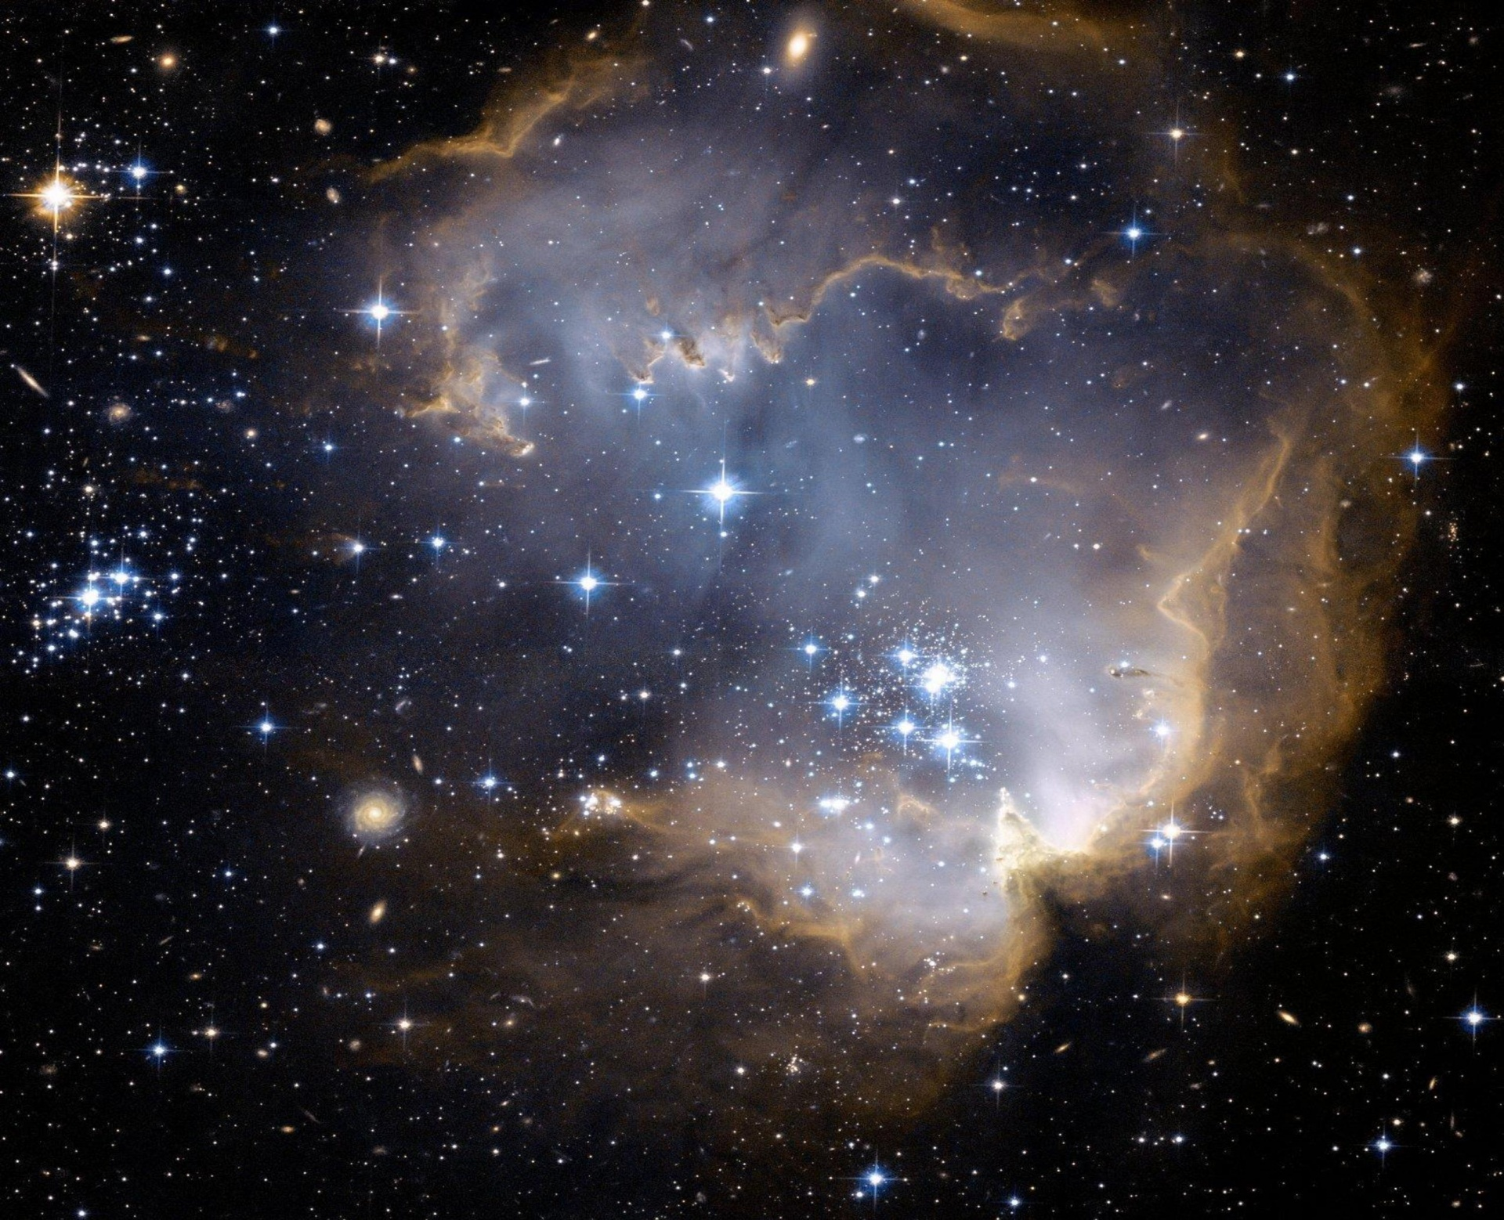
- Explain to students that this is an image of the sky taken from Earth. Have students think about the following 2 questions individually.
- Which star do you think is the closest to Earth?
- How do you know?
- Ask students to engage in a Think-Pair-Share (bit.ly/thinkpairsharestrategy) discussing their answers to the questions.

Explore
If students have a device with access to the internet, send them to this Desmos graph (bit.ly/DesmosDistancetoastar) and have them follow along with the steps below.
If devices are unavailable, follow these steps to demonstrate the process and follow the steps in the ‘Paper-based activity’ section below.
- Display the Desmos graph (bit.ly/DesmosDistancetoastar) on the screen.
- Turn on folders A and B to display the solar system.
- Turn on folder C to display some stars, each of which is numbered for reference.
Figure 2 – Solar system
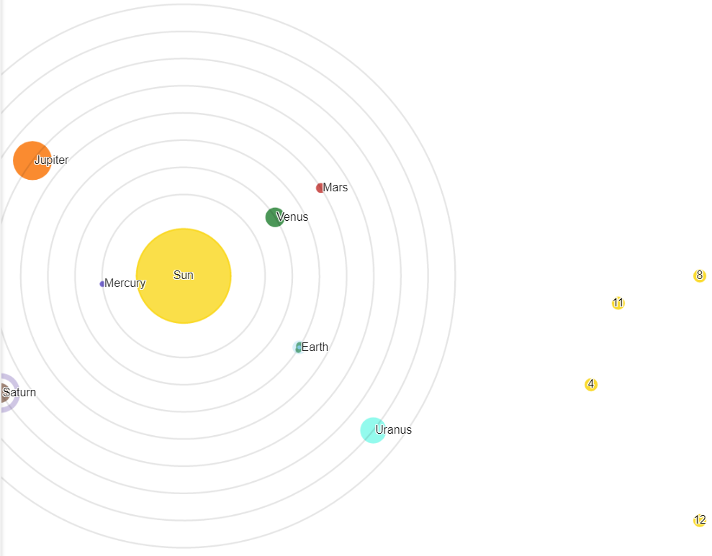
Image created using Desmos and is licensed under the Desmos Terms of Service.

- Have students complete a Notice and Wonder table (bit.ly/noticewonderstrategy) and discuss some shared wonderings.
Teachers may wish to acknowledge that this diagram is not to scale, and that the closest star to Earth and our solar system is over 50,000 times further away than these stars. Additionally, the orbit of the planets around the Sun is not circular.
- Turn off folder A and B to avoid the distraction of the other planets. Leave on folder C only.
- Inform students that we know the approximate distance from the Earth to the Sun, being 149,600 000 km. Turn on folder D to display this.
- Press the pause button next to A (line 75), to stop the Earth from spinning.
- Display Figure 3, where the Earth is directly in between the Sun and the star with number 1. This figure is in the associated PowerPoint file.
Figure 3 – image 1 of Sun, Earth and star
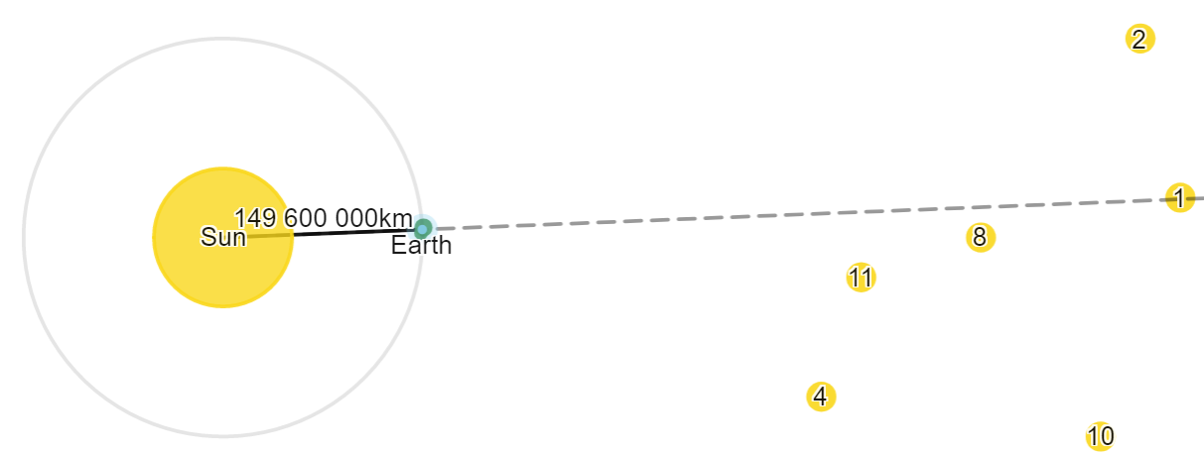
Image created using Desmos and is licensed under the Desmos Terms of Service.
- Challenge students to consider how we can know when the Earth, Sun and star form a right angle if we know the Earth is directly between the Sun and star right now.
If we know the Earth is directly between the Sun and a star right now, in 3 months, exactly a quarter of a year, the Earth, Sun and star will form a right angle.
- Demonstrate to students how we can form a right-angled triangle with the Earth, the Sun and a star as the 3 vertices, by taking the following steps.
- Turn on folder E to see measurements.
- Select the Earth and drag it around its orbit until the dotted line goes through a star, as shown in Figure 4 below. This is equivalent to us waiting until the right time of year, when the Earth, Sun and star form a right angle.
Figure 4 – image 2 of Sun, Earth and star
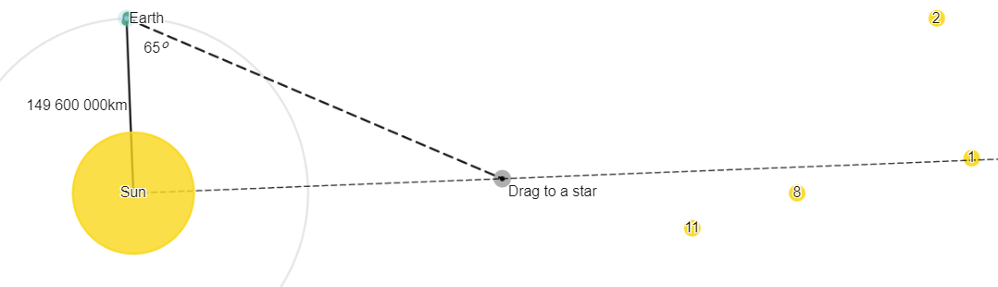
Image created using Desmos and is licensed under the Desmos Terms of Service.
- Drag the black point until it is on top of the star, to measure the angle to the star, as shown in Figure 5 below.
Figure 5 – image 3 of Sun, Earth and star
Image created using Desmos and is licensed under the Desmos Terms of Service.
- We now have a right-angled triangle, with one angle and a side length known. We can use this to find the distance from the Earth to the star, and the Distance from the Sun to the star, using trigonometry.
- Display Appendix B for students and have them review the worked example individually.
- Students indicate to the teacher when they have read the example by using a thumbs up.
- Students discuss the worked example with a peer, explaining what is happening at each step.
- Pairs should then adjust the triangle in Desmos to aim at Star 2 and complete the calculations for themselves.
- Alternatively, students could be handed Appendix A to measure the distance of the stars from the Earth and Sun using a protractor, ruler and pencil.
- Hand students a copy of Appendix C and have them record the distances of all 14 stars both from the Earth, and from the Sun, and answer the question about which star they believe is the furthest from us. They will leave the third and fifth columns empty for the moment.
It is likely that Appendix A will become difficult to work with after finding a few stars. Students could rub out existing working, be given multiple copies of the map, or work with peers. Appendix A could also be laminated and used with a whiteboard marker.

Significant figures
- Express to students that comparing the measurements found and recorded in Appendix C is challenging.
- Use the Significant distances PowerPoint for explicit teaching of the skills required for interpreting and rounding to significant figures. This includes:
- Identifying the number of significant figures of a measurement.
- Rounding a measurement to a specified number of significant figures.
The explicit teaching technique used in the PowerPoint is Your turn. The first slide is a worked example which should be displayed for the students and then use the following steps.
- Reveal the question to students and its solution.
- Students read in silence.
- Students individually think and explain to themselves what is happening in each step.
- Students give a thumbs up to the teacher when they have finished reading.
- Think, pair, share. Students explain the solution to their partner.
- In pairs, students then answer the self-explanation questions.
- Finally, randomly select students to share their answers with the whole class.

Summarise
- Students are to complete column 3 and 5 of Appendix C, rounding all of their measurements to 3 significant figures.
- Teacher to lead a discussion around significant conclusions from this investigation:
- Rounding to a number of significant figures, where we simplify measurements to show their most significant digits, improves the ease of understanding and comparison.

Apply
Students are to attempt the Goal free problem in Appendix D. Students are to round each measurement to 2 significant figures as they calculate.

Assessment and Differentiation

Suggested opportunities for differentiation
Explore
- Challenge students to consider the closest and furthest distances that the Earth will be from a star. Can this be calculated from what we know?
- Challenge students to consider how we might know when the Earth, the Sun, and a star form a right angle.
- Challenge students to investigate the scenario ‘What if all 0's could not be significant figures?’
Apply
- A goal free problem allows students to find what they are capable of. For students who find incorrect measurements via trigonometry, they will not be restricted from applying their learnt skills with rounding to a number of significant figures.
- Challenge students to investigate the differences in the final measurements if you did not round to 2 significant figures after each calculation.

Suggested opportunities for assessment
Explore
- The Desmos activity allows the teacher to record, review, and give feedback on student responses. There are multiple opportunities for students to express their thinking.
Summarise and Apply
- Collect Appendix C and/or Appendix D to act as an exit ticket, both to assess student's continuing development of trigonometry skills, as well as their newly developed concept of significant figures.

Appendix A

Map of the Earth, Sun and stars
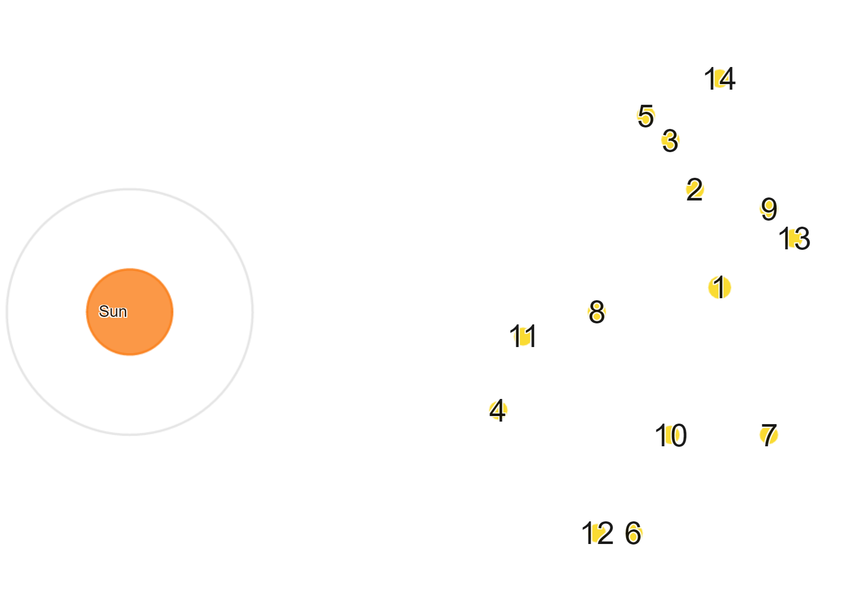

How to use this map
- Draw a line from the centre of the Sun to any star.
- Use your protractor to draw another line from the Sun to the Earth's orbit, making a right angle as shown below. Mark this new side with the distance between the Earth and the Sun, 149,600,000 km. 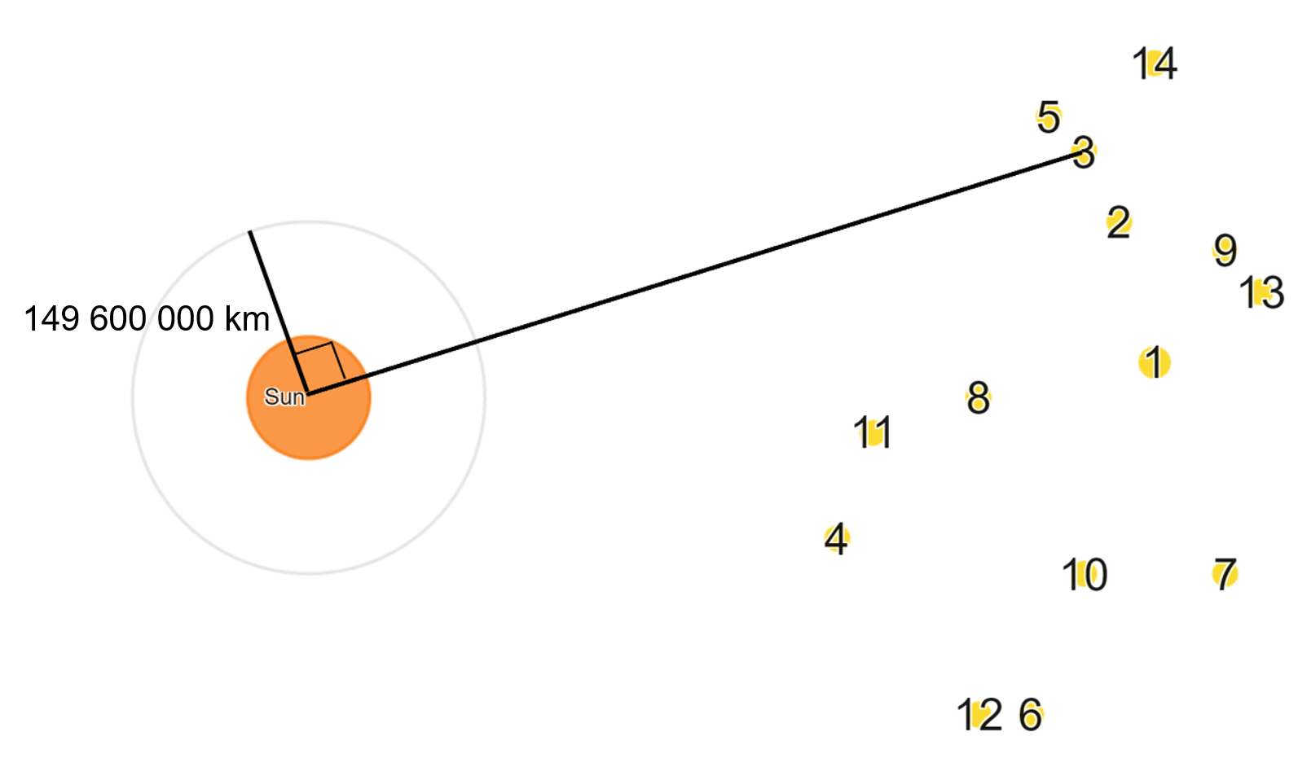
- Connect the final side and use a protractor to measure the angle on the Earth's orbit (we can only measure the angle from Earth).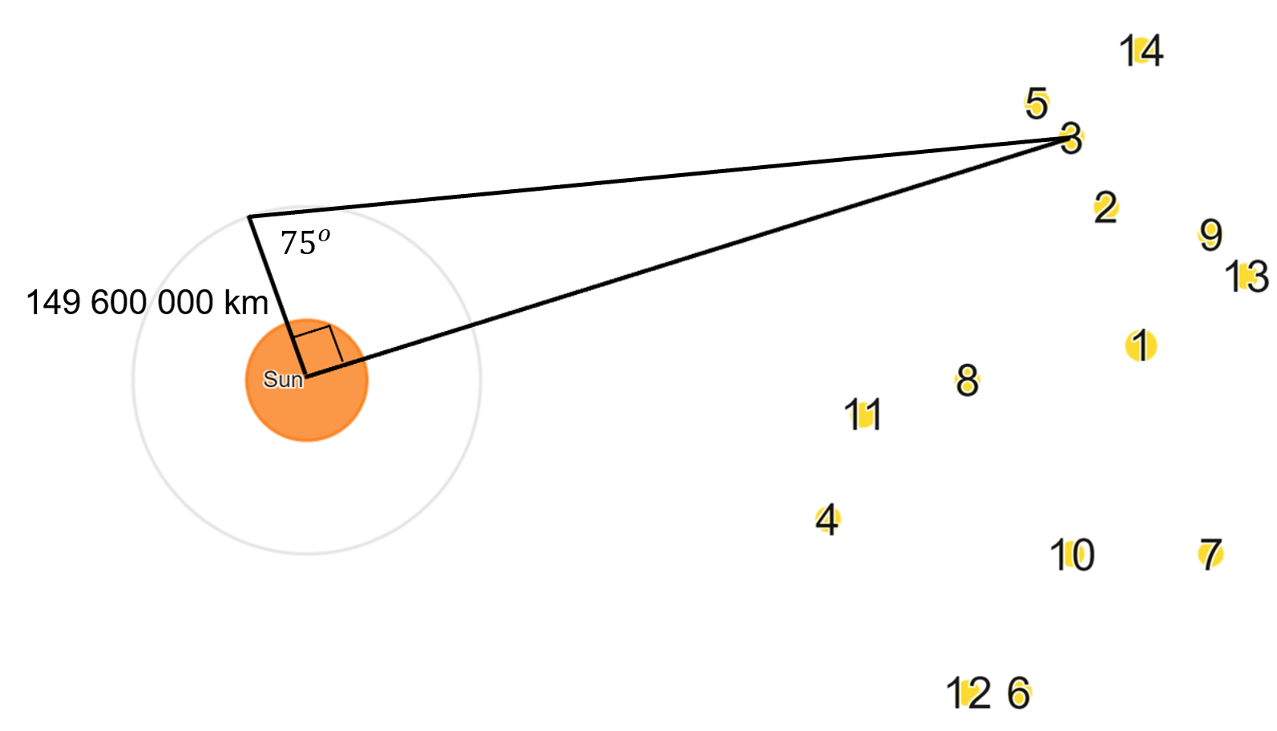
- Use trigonometry to find the length of the 2 remaining sides of the right-angled triangle.

Appendix B

Worked examples
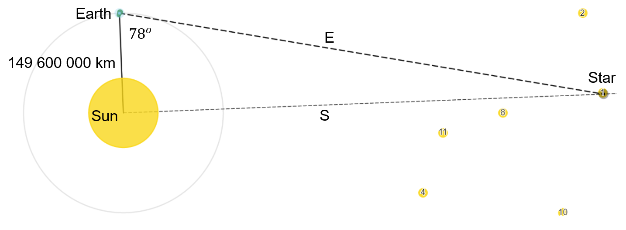

Distance from the Sun to the star
$$\tan{{78}^{o}}=\frac{S}{149 600 000}$$
$$S=149 600 000×\tan{{78}^{o}}$$
$$S=703 812 664.3779768$$
$$S=703 812 664 km$$

Distance from Earth to the star
$$\cos{{78}^{o}}=\frac{149 600 000}{E}$$
$$E×\cos{{78}^{o}}=149 600 000$$
$$E=\frac{149 600 000}{\cos{{78}^{o}}}$$
$$E=719 536 257.973722$$
$E=719 536 257 km$

Appendix C

The distance of 14 stars
Star | Distance from the Sun | 3 significant figures | Distance from the Earth | 3 significant figures
1 | 703,812,664 km | 704,000,000 km | 719,536,257 km | 720,000,000 km
2
3
4
5
6
7
8
9
10
11
12
13
14
Which star do you think is the closest to the Sun?
Which star do you think is the closest to the Earth?

Appendix D

Goal free problem
Find all the information you can in this diagram. Round each measurement to 2 significant figures.
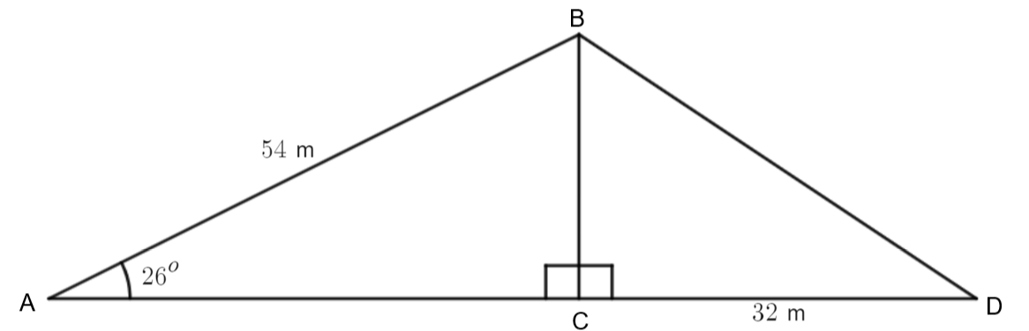

Sample solutions

Appendix D
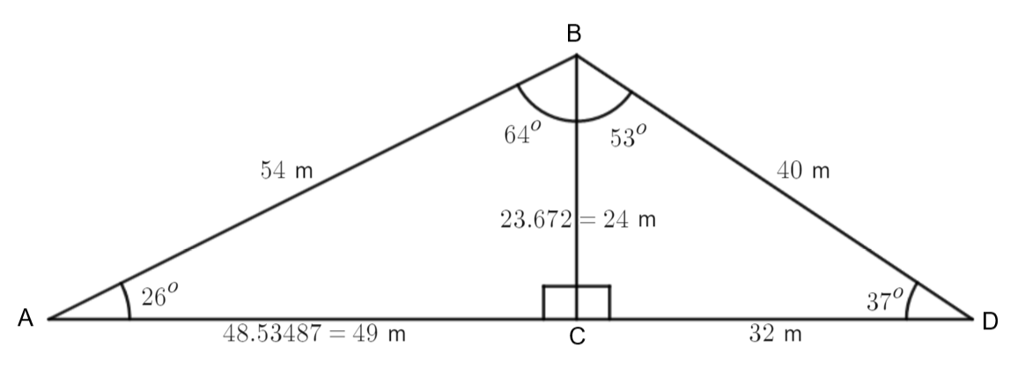
© State of New South Wales (Department of Education), 2023
The copyright material published in this resource is subject to the Copyright Act 1968 (Cth) and is owned by the NSW Department of Education or, where indicated, by a party other than the NSW Department of Education (third-party material).
Copyright material available in this resource and owned by the NSW Department of Education is licensed under a Creative Commons Attribution 4.0 International (CC BY 4.0) licence.
This licence allows you to share and adapt the material for any purpose, even commercially.
Attribution should be given to © State of New South Wales (Department of Education), 2023.
Material in this resource not available under a Creative Commons licence:
- the NSW Department of Education logo, other logos and trademark-protected material
- material owned by a third party that has been reproduced with permission. You will need to obtain permission from the third party to reuse its material.
Links to third-party material and websites
Please note that the provided (reading/viewing material/list/links/texts) are a suggestion only and implies no endorsement, by the New South Wales Department of Education, of any author, publisher, or book title. School principals and teachers are best placed to assess the suitability of resources that would complement the curriculum and reflect the needs and interests of their students.
If you use the links provided in this document to access a third-party's website, you acknowledge that the terms of use, including licence terms set out on the third-party's website apply to the use which may be made of the materials on that third-party website or where permitted by the Copyright Act 1968 (Cth). The department accepts no responsibility for content on third-party websites.

