Finding missing sides
In this activity, students explore the types of problems that trigonometry can help us solve, and the existing skills that support us to apply trigonometry to right-angled triangles. Students are explicitly taught how to use trigonometry to find a missing side of a right-angled triangle.
This activity is designed on the premise that students are already familiar with solving equations that involve one step, labelling sides of right-angled triangles and writing trigonometric ratios.

Visible learning

Learning intention
- To be able to find a missing side in a right-angled triangle, given an angle and a side.

Success criteria
- I can label the sides of a right-angled triangle as opposite, adjacent and hypotenuse.
- I can select an appropriate trigonometric ratio based on given information in a right-angled triangle.
- I can write an equation based on a trigonometric ratio.
- I can solve an equation to find a missing side in a right-angled triangle.

Syllabus outcomes
A student:
- develops understanding and fluency in mathematics through exploring and connecting mathematical concepts, choosing and applying mathematical techniques to solve problems, and communicating their thinking and reasoning coherently and clearly MAO-WM-01
- applies trigonometric ratios to solve right-angled triangle problems MA5-TRG-C-01
Mathematics K–10 Syllabus © NSW Education Standards Authority (NESA) for and on behalf of the Crown in right of the State of New South Wales, 2022.
Please use the associated PowerPoint Finding missing sides to display images in this lesson.

Activity structure

Warm up
The purpose of this warmup is to activate prior knowledge, and to consider the versatility of what we already know how to do.
Students solve a range of one-step equations, resembling those needed to solve right-angled triangle problems using trigonometry.
- Give each student a copy of Appendix A or use the associated PowerPoint and ask them to read the examples individually. Students can place their hand on the desk as a thumbs up when they have finished reading.
- Students are then to engage in a Think-Pair-Share (bit.ly/thinkpairsharestrategy), discussing what is going on in each step of the worked solution. Students should attempt to answer the self-explanation questions.
- Students should complete the ‘Your turn’ section in pairs.
- Repeat steps 1–3 for the second page in Appendix A, focusing on equations that contain a trigonometric ratio.

Launch
- Display Figure 1 or use the associated PowerPoint.
Figure 1 – ladder against a wall
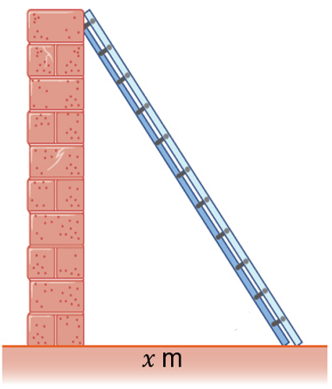
- Explain to students the following situation: we have a 6 metre ladder and have been advised that it is safest if the angle from the ground is 60°. We want to know how far out from the wall the ladder should be to achieve this.
- Using mini whiteboards (bit.ly/miniwhiteboards), have students roughly sketch the triangle shown, and mark the information from the problem in the relevant places.
- Use a strategy such as pause, pounce, bounce (bit.ly/pausepouncebouncestrategy) to investigate student solutions.
It is likely that some students will overlook the fact that the wall and floor form a right angle. Teachers may choose to wait until after step 7 and pose the question ‘Will these trigonometric ratios still apply without the right angle?’ and emphasise the importance of this part of the triangle.
- Display Figure 2 or use the associated PowerPoint.
Figure 2 – 6 m ladder against wall
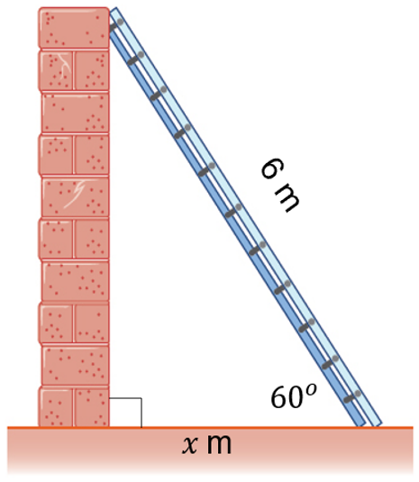
- Students engage in a Think-Pair-Share (bit.ly/thinkpairsharestrategy) about how they might find the required distance from the wall, $x$.
- Display the worked solution of this situation below. Students are to repeat the Think-Pair-Share process discussing the self-explanation prompts at each step.
Step | Worked example | Self-explanation prompts
1 | 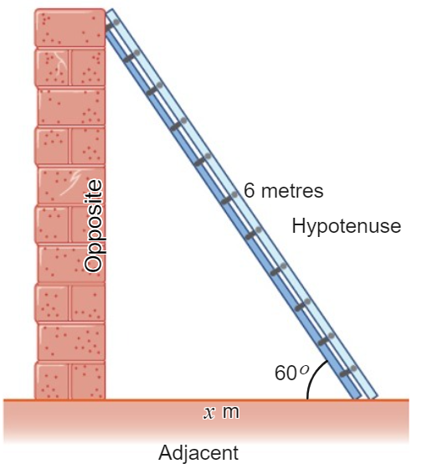 | - Which strategies might have been used to label the sides as hypotenuse, opposite and adjacent?
2 | 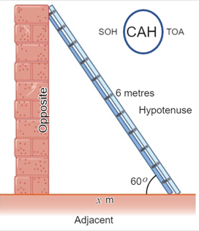 | - Why was CAH circled in SOH CAH TOA?
3 | $$\cos{θ}=\frac{\text{adjacent}}{\text{hypotenuse}}$$  $$\cos{60°}=\frac{x}{6}$$  $$\frac{1}{2}=\frac{x}{6}$$  $$∴x=3$$ | - Why was cosine used?  - Why was $θ$ replaced with $60°$?  - Why was adjacent replaced with $x$?  - Why was hypotenuse replaced with 6?  - How might this equation have been solved differently?

Explore
- Distribute copies of Appendix B to all students and instruct that they are to use the method shown previously to find the missing distance in each of the 3 examples.
- Have students work in groups to solve each problem.
In Building Thinking Classrooms in Mathematics, Peter Liljedahl outlines how groups who regularly experience working on vertical, non-permanent surfaces (bit.ly/VNPSstrategy) display greater productivity and likelihood of deep mathematical thinking.
- Reflection questions for discussion as a class:
- How did you know which trigonometric ratio to choose?
- How did you know which trigonometric ratio was definitely not helpful?
- How do you know your solution is correct?
Take this opportunity to allow individuals to share what they noticed, for example, when the hypotenuse is not involved, we always choose tan.

Summarise
- Print and distribute Appendix C to students.
- Display Example 1, shown on the next page.
- Have students construct a notice and wonder list (bit.ly/noticewonderstrategy) for Example 1.
- Students should be challenged to articulate how in the example a trigonometric ratio has been chosen.
- Model Example 1 for students, explaining the faded example structure (bit.ly/fadedexamplesstrategy).
- Students should now attempt examples 2 through to 5.

Example 1
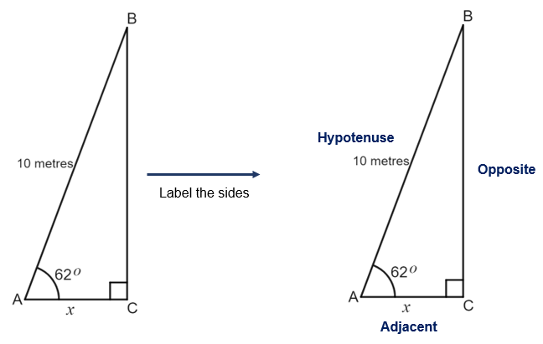Choose a trigonometric ratio
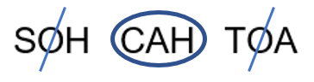

Write the ratio
$$\cos{θ}=\frac{adjacent}{hypotenuse}$$
$$\cos{62°}=\frac{x}{}$$

Solve the resulting equation
$0.469=\frac{x}{10}$ because $(\cos{62°}=0.469)$
$x=0.469×$…
$x=4.69$metres
I know this measurement is correct because the adjacent side AC should be less than the hypotenuse AB.

Apply
- Students complete the goal free problems in Appendix D. Students should be encouraged to find as much information as possible in each situation.
- Reflection questions to discuss:
- Did any students identify a mistake and correct it?
- Did any students confirm their result by comparing to other values they had found, for example, knowing the hypotenuse should be the longest side?

Assessment and Differentiation

Suggested opportunities for differentiation
Warm up
- Algebraic tiles have been used in the worked examples in Appendix A to aid students in solving one step equations.
- Students may need some assistance when $x$ is in the denominator in Appendix A.
Launch/Explore
- Images have been provided in the worked example to provide support for students.
Summarise
- Students may need some assistance in example 4 when $x$ appears in the denominator.

Suggested opportunities for assessment
- Collect all handouts completed from students to review their understanding of how to find a missing side.
- Monitor student responses in the class discussions to check for understanding.
- Appendix D could be used as an exit ticket (bit.ly/exitticketstrategy).

Appendix A

Solving equations involving one step

Worked example 1
Question | Method 1 | Method 2
Solve $4x=12$ | 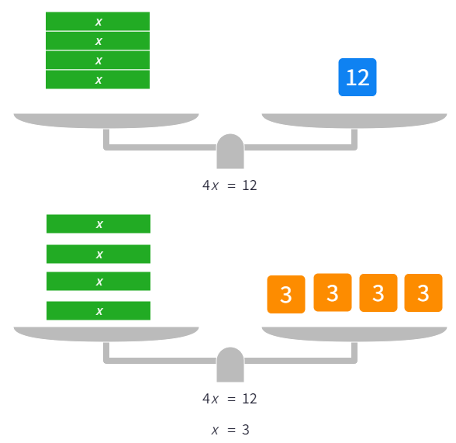 | $$4x=12 \\ \frac{4x}{4}=\frac{12}{4}$$  $$12÷4=3$$$∴x=3$, because  $$4×3=12$$
Solve  $$\frac{x}{2}=4$$ | 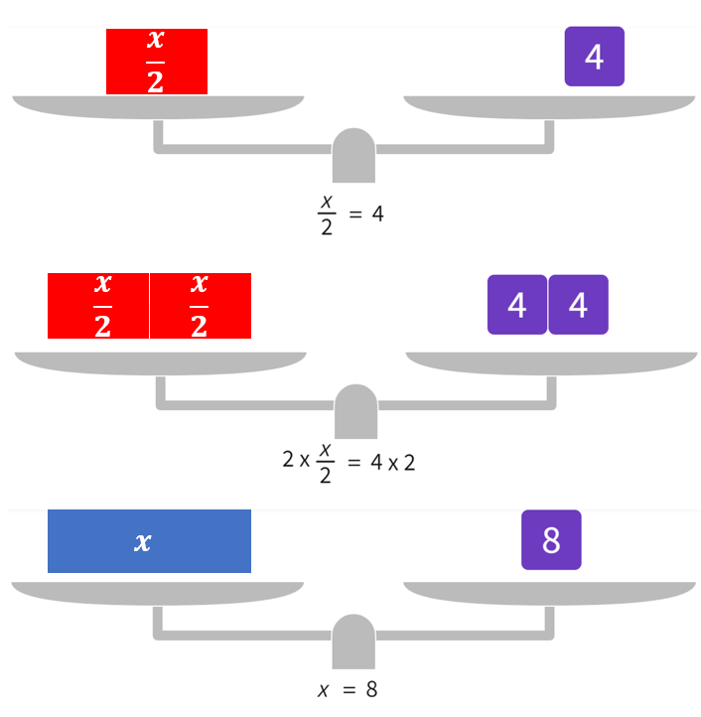 | $$\frac{x}{2}=4$$  $$\frac{x}{2}×2=4×2 \\ 4×2=8$$$∴x=8$, because $\frac{8}{2}=4$

Self-explanation prompts
- Which word could be used to replace the 'equals' (=) symbol?
- How might $4x=12$ be said in words?
- How might $\frac{x}{4}$ be written differently using a $÷$ symbol?
- Why do we divide when the original equation contains multiplication?
- Why do we multiply when the original equation contains division?
- Why is the final sentence important?

Your turn
Find the value of $x$ in each of the equations below.
- $2x=12$
- $\frac{x}{2}=12$
- $2x=1$
- $\frac{x}{3}=6$
- $\frac{x}{4}=7$

Worked example 2
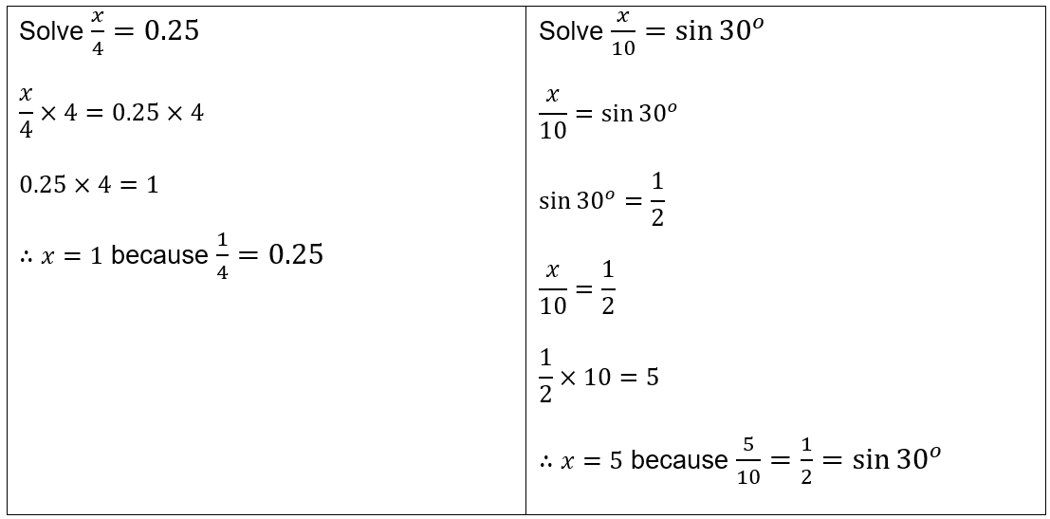

Self-explanation prompts
- Why do we multiply when the original equation contains division?
- Why does the example change the equation from $\frac{x}{10}=\sin{30}$ into $\frac{x}{10}=\frac{1}{2}$ ?
- How might $\frac{x}{4}$ be written differently using a $÷$ symbol?

Your turn
Find the value of $x$ in each of the trigonometric equations below.
- $\cos{{60}^{o}}=\frac{x}{8}$
- $\tan{{45}^{o}}=\frac{x}{10}$

Appendix B

Finding side lengths using trigonometry
Right-angled triangle scenario 1
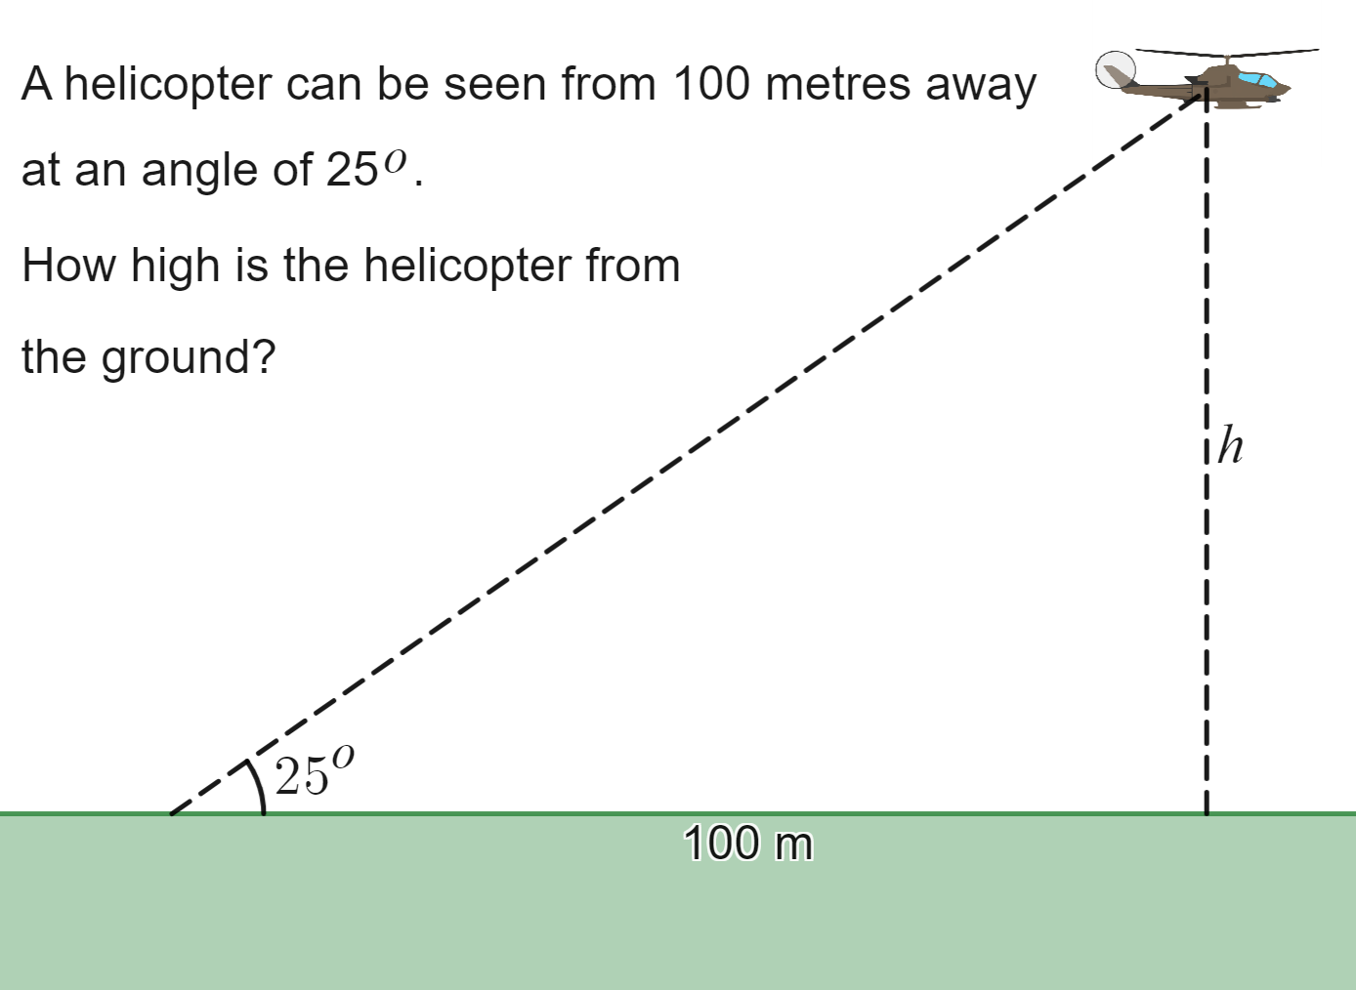
Right-angled triangle scenario 2
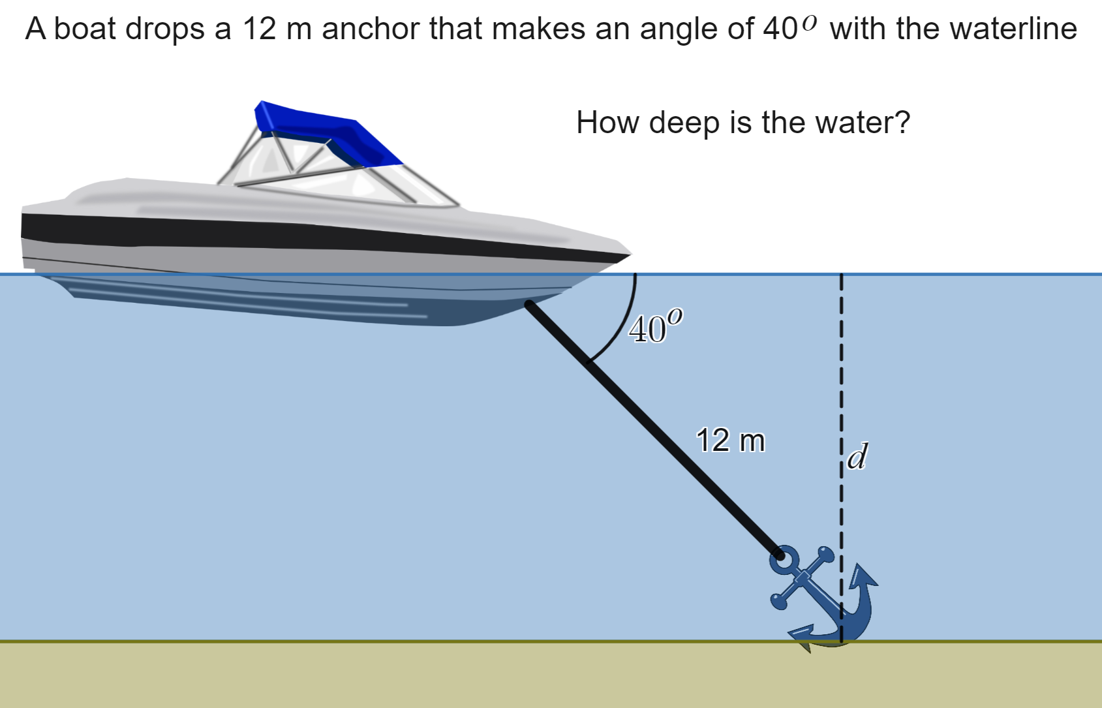
Right-angled triangle scenario 3
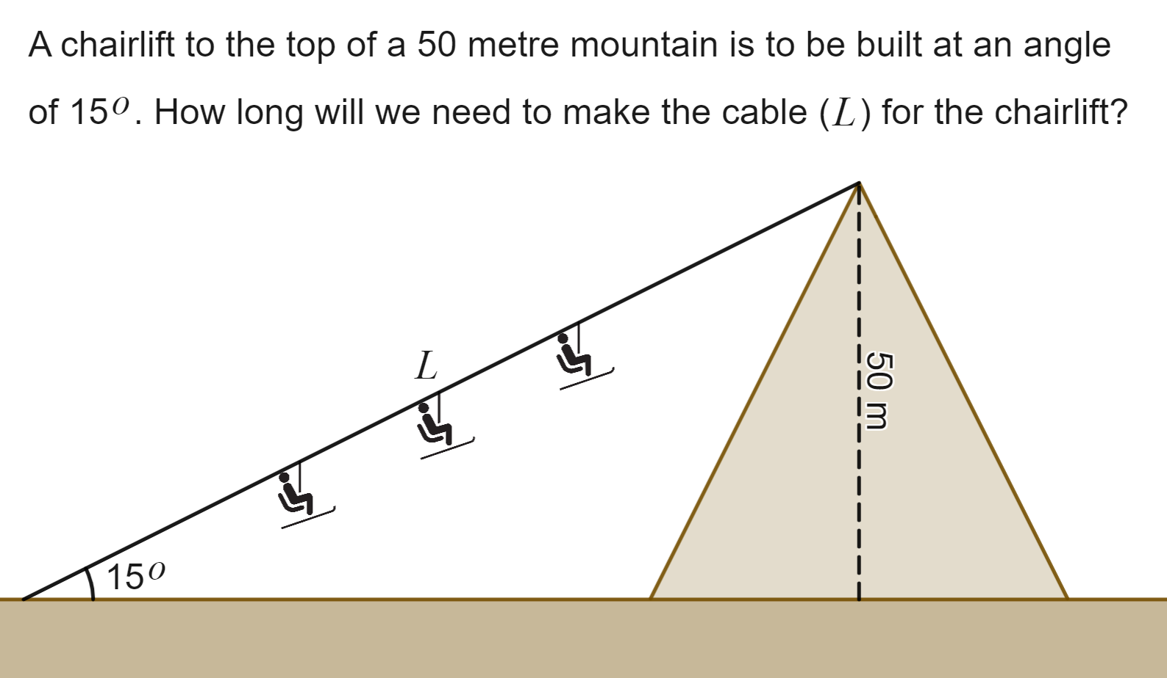
Images created using Desmos and are licensed under the Desmos Terms of Service.

Appendix C

Faded examples – Finding missing sides

Example 1

Choose a trigonometric ratio

Write the ratio
$$\cos{θ}=\frac{adjacent}{hypotenuse}$$
$$\cos{{62}^{o}}=\frac{x}{}$$

Solve the resulting equation
$0.469=\frac{x}{10}$ because $(\cos{{42}^{o}}=0.469)$
$x=0.469×$…
$x=4.69$metres
I know this measurement is correct because the adjacent side AC should be less than the hypotenuse AB.

Example 2 | Example 3 | Example 4 | Example 5
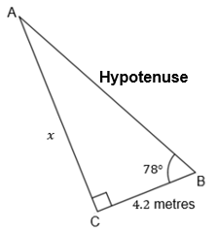 | 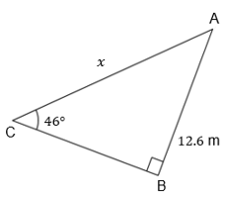 | 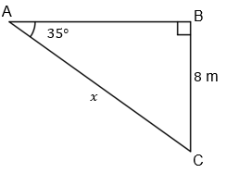 | 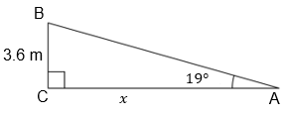
Label the sides | Label the sides | Label the sides
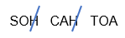
$$\tan{θ}=$$
$$\tan{78^{o}}=$$
$4.705=\frac{x}{4.2}$ because
$$x=$$
$x=19.76$metres |  | $x=13.95$metres
I know this measurement is correct because the opposite side AC (19.76 metres) is opposite a much larger angle than the adjacent side BC | I know this measurement is correct because…

Appendix D

Goal free problems
Find any information you can in the scenarios below. How do you know when you are finished?

Scenario 1
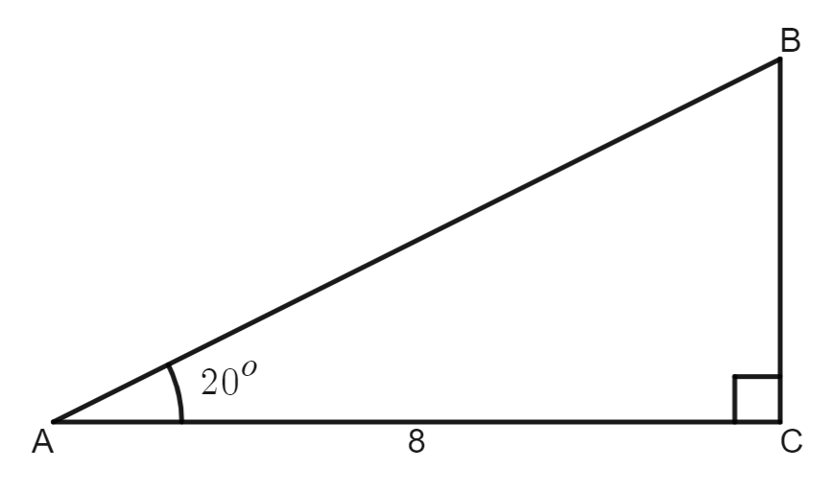

Scenario 2
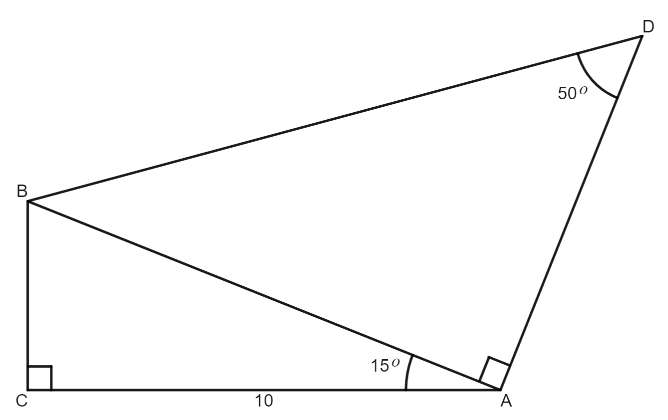

Sample solutions

Appendix A

Worked example 1 – Your turn
- $x=6$
- $x=24$
- $x=\frac{1}{2}$
- $x=18$
- $x=28$

Worked example 2 – Your turn
- $\cos{{60}^{o}}=\frac{x}{8}$
$$\frac{1}{2}=\frac{x}{8} \\ x=4$$
- $\tan{{45}^{o}}=\frac{x}{10}$$$1=\frac{x}{10}$$$x=10$

Appendix B
Solution for right-angled triangle scenario 1
$$\tan{{25}^{o}}=\frac{h}{100}$$
$$0.466=\frac{h}{100}$$
$h=46.6$ m
Solution for right-angled triangle scenario 2
$$\sin{{40}^{o}}=\frac{d}{12}$$
$$0.643=\frac{d}{12}$$
$$d=7.71$$
Solution for right-angled triangle scenario 3
$$\sin{{15}^{o}}=\frac{50}{L}$$
$$0.259=\frac{50}{L}$$
$$0.259L=50$$
$$L=\frac{50}{0.259}$$
$$L=193.19$$

Appendix C

Example 1

Choose a trigonometric ratio

Write the ratio
$$\cos{θ}=\frac{adjacent}{hypotenuse}$$
$$\cos{{62}^{o}}=\frac{x}{10}$$

Solve the resulting equation
$0.469=\frac{x}{10}$ because $(\cos{{42}^{o}}=0.469)$
$$x=0.469×10$$
$x=4.69$metres
I know this measurement is correct because the adjacent side AC should be less than the hypotenuse AB.

Example 2 | Example 3 | Example 4 | Example 5
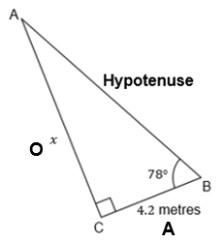 | 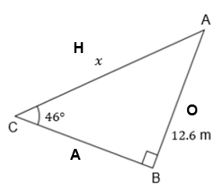 | 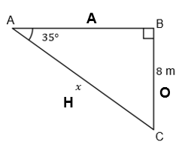 | 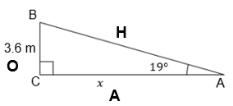
Label the sides | Label the sides | Label the sides | Label the sides
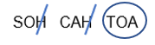 | 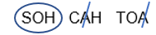
$$\tan{θ}=\frac{\text{opposite}}{\text{adjacent}}$$ | $$\sin{θ}=\frac{\text{opposite}}{\text{hypotenuse}}$$ | $$\sin{θ}=\frac{\text{opposite}}{\text{hypotenuse}}$$ | $$\tan{θ}=\frac{\text{opposite}}{\text{adjacent}}$$
$$\tan{78^{o}}=\frac{x}{4.2}$$ | $$\sin{{46}^{o}}=\frac{x}{12.6}$$ | $$\sin{{35}^{o}}=\frac{8}{x}$$ | $$\tan{{19}^{o}}=\frac{3.6}{x}$$
$4.705=\frac{x}{4.2}$ because  $$\tan{78^{o}=4.705}$$ | $0.719=\frac{x}{12.6}$ because  $$\sin{{46}^{o}=0.719}$$ | $0.574=\frac{8}{x}$ because  $$\sin{{35}^{o}}=0.574$$ | $0.344=\frac{3.6}{x}$ because $\tan{{19}^{o}}=0.344$
$$x=4.705×4.2$$ | $$x=0.719×12.6$$ | $$0.574×x=8$$  $$x=8÷0.574$$ | $$0.344×x=3.6$$  $$x=3.6÷0.344$$
$x=19.76$metres | $x=9.06$ metres | $x=13.95$metres | $x=10.46$metres
I know this measurement is correct because the opposite side AC (19.76 metres) is opposite a much larger angle than the adjacent side BC | I know this measurement is correct because the opposite side should always be less than the hypotenuse. | I know this measurement is correct because the hypotenuse should be longer than the opposite side. | I know this measurement is correct because the opposite side is opposite a much smaller angle than the adjacent side BC.

Appendix D

Scenario 1
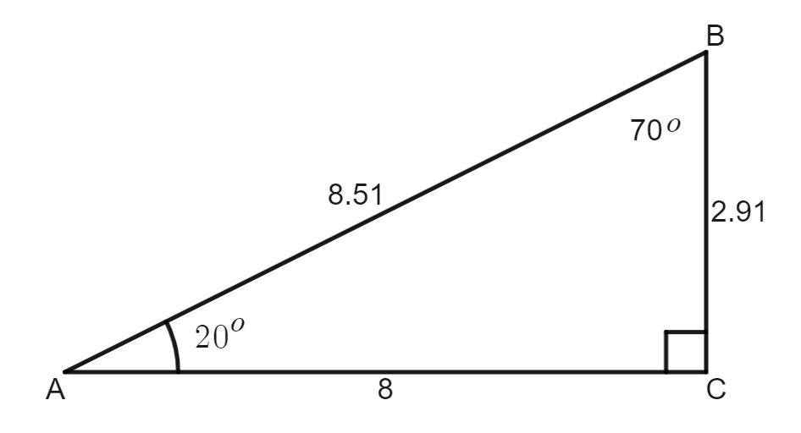

Scenario 2
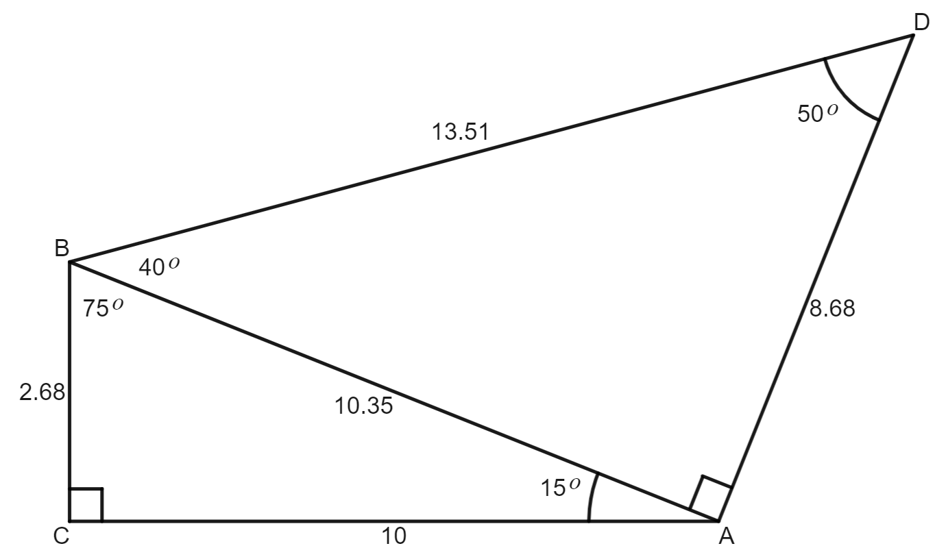

© State of New South Wales (Department of Education), 2023
The copyright material published in this resource is subject to the Copyright Act 1968 (Cth) and is owned by the NSW Department of Education or, where indicated, by a party other than the NSW Department of Education (third-party material).
Copyright material available in this resource and owned by the NSW Department of Education is licensed under a Creative Commons Attribution 4.0 International (CC BY 4.0) licence.
This licence allows you to share and adapt the material for any purpose, even commercially.
Attribution should be given to © State of New South Wales (Department of Education), 2023.
Material in this resource not available under a Creative Commons licence:
- the NSW Department of Education logo, other logos and trademark-protected material
- material owned by a third party that has been reproduced with permission. You will need to obtain permission from the third party to reuse its material.
Links to third-party material and websites
Please note that the provided (reading/viewing material/list/links/texts) are a suggestion only and implies no endorsement, by the New South Wales Department of Education, of any author, publisher, or book title. School principals and teachers are best placed to assess the suitability of resources that would complement the curriculum and reflect the needs and interests of their students.
If you use the links provided in this document to access a third-party's website, you acknowledge that the terms of use, including licence terms set out on the third-party's website apply to the use which may be made of the materials on that third-party website or where permitted by the Copyright Act 1968 (Cth). The department accepts no responsibility for content on third-party websites.

