The sine and cosine ratios
In this activity, students investigate the sine and cosine functions on their calculator and compare them with right-angled triangles they construct by hand or using digital tools, to establish the sine and cosine ratios.
This activity is designed to be the first introduction to the sine and cosine ratios for students. The design of the activity presumes students are familiar with labelling the sides of a right-angled triangle and the tangent ratio.

Visible learning

Learning intentions
- To be able to use language associated with trigonometry to describe right-angled triangles.
- To know and be able to define the trigonometric ratios of sine, cosine and tangent.

Success criteria
- I can identify the hypotenuse, opposite and adjacent sides with respect to an angle in a right-angled triangle.
- I can explain the relationship between the value of $\sin{{30}^{o}}$ found in my calculator and a right-angled triangle with a ${30}^{o}$ angle.
- I can write three trigonometric ratios for a given angle in a right-angled triangle.

Syllabus outcomes
A student:
- develops understanding and fluency in mathematics through exploring and connecting mathematical concepts, choosing and applying mathematical techniques to solve problems, and communicating their thinking and reasoning coherently and clearly MAO-WM-01
- applies trigonometric ratios to solve right-angled triangle problems MA5-TRG-C-01
Mathematics K–10 Syllabus © NSW Education Standards Authority (NESA) for and on behalf of the Crown in right of the State of New South Wales, 2022.
Please use the associated PowerPoint The sine and cosine ratios to display images in this lesson.

Activity structure

Launch
Determine if students would benefit from reviewing labelling the sides of triangles, and use either the associated PowerPoint file, or the Desmos activity, Sides of triangles (bit.ly/desmossidesoftriangles).
- Hand out Appendix A. Give students access to the Desmos graph, The ratios of sides (bit.ly/Desmos-ratiosofsides).
- Instruct students to turn on the opposite and adjacent sides using the switches in the graph.
Figure 1 – Desmos graph switches
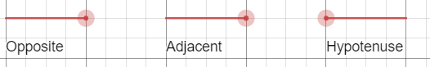
Image created using Desmos and is licensed under the Desmos Terms of Service.
- Students are to drag the point to construct a new triangle. An example is available in the image below.
Figure 2 – right-angled triangle
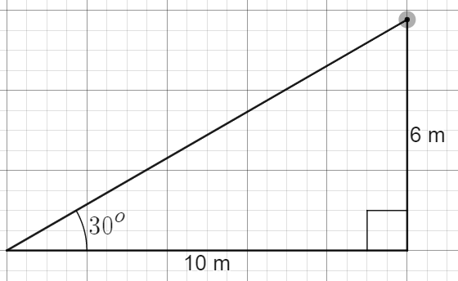
Image created using Desmos and is licensed under the Desmos Terms of Service.

- Students record the ratio of the 2 sides in their table in Appendix A.
Figure 3 – sample answer recorded in the Appendix A table
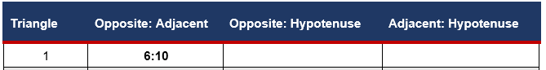

- Instruct students to turn on the hypotenuse.
Figure 4 – hypotenuse button on Desmos, and sample right-angled triangle
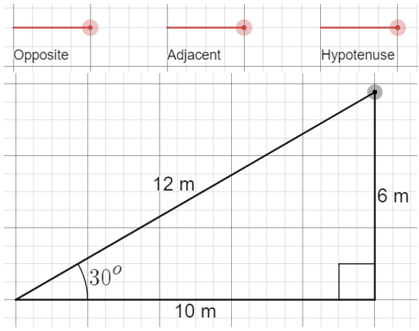
Image created using Desmos and is licensed under the Desmos Terms of Service.
- Students complete the rest of this row of the table.
Figure 5 –first row from Appendix A filled in with answers
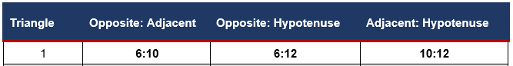
- Students drag the point to make a new triangle and fill in the next row of the table. If it helps students to engage, they can turn off the side they aren’t using at any time.
- Students then use the slider on the screen to change angle to ${45}^{o}$ to complete the second table, and ${60}^{o}$ to complete the third table.
- Students are to engage in a Think-Pair-Share (bit.ly/thinkpairsharestrategy) to examine their table and answer the questions in Appendix A.
The graph also contains a slider for the number of decimal places to be displayed. The slider defaults to 0 decimal places.

Explore
This exploration challenges students to interrogate relationships between measurements in right-angled triangles to establish the trigonometric ratios.
The remainder of this task can alternatively be completed online using the Desmos activity, Trigonometric ratios (bit.ly/desmostrigonometricratios).

Understanding the sine and cosine ratios

Equipment
- Appendix B, 1 per student
- Ruler, 1 per student
- Protractor, 1 per student

Method
- Hand out Appendix B, a ruler and protractor to all students.
- As a class, show in a calculator that $\sin{{30}^{o}}=\frac{1}{2}$. Discuss that the 30 with sin means a right-angled triangle that also has a ${30}^{o}$ angle.
- All students should write the value for $\sin{{30}^{o}}$ on their version of Appendix B.
- Randomly sort students into groups of 3, using a deck of cards or dice.
In Building Thinking Classrooms in Mathematics, Peter Liljedahl outlines how visibly random groups of 3 seem to be the most conducive to mathematical thinking.
- Have students work together to perform the investigation.
In Building Thinking Classrooms in Mathematics, Peter Liljedahl outlines how groups who regularly experience working on vertical, non-permanent surfaces (bit.ly/VNPSstrategy) display greater productivity and likelihood of deep mathematical thinking.
- Students are to search for an answer to the question ‘What does $\sin{{30}^{o}}$ mean?’ by following the steps in Appendix B.
- Repeat this process to investigate the question ‘What does $\cos{{60}^{o}}$mean?’, also using Appendix B.

Summarise
- Demonstrate to students how to write 6 ratios for a given triangle by constructing a right-angled triangle, measuring all angles and sides and recording them. This is in the associated PowerPoint.
For example:
Figure 6 – a right-angled triangle with acute angles
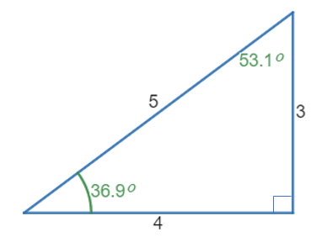
- Write the 6 trigonometric ratios we can see in this triangle:
For example:
$$\sin{{36.9}^{o}}=\frac{3}{5} \\ \cos{{36.9}^{o}}=\frac{4}{5} \\ \tan{{36.9}^{o}}=\frac{3}{4} \\ \sin{{53.1}^{o}}=\frac{4}{5} \\ \cos{{53.1}^{o}}=\frac{3}{5} \\ \tan{{53.1}^{o}}=\frac{4}{3}$$
- Ask students what they notice and what they wonder (bit.ly/noticewonderstrategy) about the ratios they have found.
- Have students construct one final right-angled triangle, measuring side lengths and angles, and write all 6 ratios. Are the things they noticed in your example true of every triangle?

Apply
Students explore methods of remembering the trigonometric ratios.
- Go to Crystal clear mathematics site, How to remember SOHCAHTOA (bit.ly/howtoremembersohcahtoa) and watch the videos at the bottom of the page.
- Students read the phrases used in point 3 to make SOHCAHTOA an acronym and select their favourite 3.
- Students develop their own phrase to remember SOHCAHTOA.

Assessment and Differentiation

Suggested opportunities for differentiation
Launch
- The Desmos graph can make the measurements more or less accurate, depending on the needs of students, by dragging the slider on the screen. The graph also allows students to turn off irrelevant sides to reduce cognitive load.
- When students are engaging in a Think-Pair-Share to answer the questions in Appendix A, the teacher has the option of directing student attention to the ratios that have the most obvious relationships, being sin30, cos60 and tan45.
Explore
- The Desmos activity allows an exploration for students that does not depend on their skills with measuring tools.
- Appendix B provides a scaffold for students to develop a hypothesis and interrogate. Challenge students to complete this starting with cos60, without the second page of the Appendix as a scaffold.

Suggested opportunities for assessment
Explore
- The Desmos activity allows the teacher to record, review, and give feedback on student responses. There are multiple opportunities for students to express their thinking.
- The investigation provides opportunities for students to explain their thinking and use evidence to support an argument. Review student responses to determine if they understand and appreciate a second example (step g in Appendix B) as evidence to support their argument.
Summarise
- The construction of a final right-angled triangle with 6 trigonometric ratios calculated and expressed can act as an exit ticket to be collected and reviewed.
Apply
- Have students share and submit their phrases to make SOHCAHTOA an acronym and review for accuracy.

Appendix A

Ratios of sides
Use the Desmos graph The ratios of sides (bit.ly/Desmosratioofsides) to create different triangles with the same angle. View pairs of sides and determine a ratio between them.
Table 1 – 30° angle
Triangle | Opposite: Adjacent | Opposite: Hypotenuse | Adjacent: Hypotenuse
1 | 6:10
2
3
Table 2 – 45° angle
Triangle | Opposite: Adjacent | Opposite: Hypotenuse | Adjacent: Hypotenuse
1
2
3
Table 3 – 60° angle
Triangle | Opposite: Adjacent | Opposite: Hypotenuse | Adjacent: Hypotenuse
1
2
3
- If you make a different triangle with the same angle, for example, 30°, how do the ratios change?
- Do your calculator values for $\tan{{30}^{o}}$, $\tan{{45}^{o}}$ and $\tan{{60}^{o}}$ match with the ratios for Opposite: Adjacent?

Appendix B

The sine ratio
- Find the value of $\sin{{30}^{o}}$ by typing this into your calculator: $\sin{{30}^{o}}=$
- Draw a 30° angle.
- Use this angle to form a right-angled triangle.
- Measure and mark all sides and angles. It should look something like the triangle below, with different numbers.
For example:
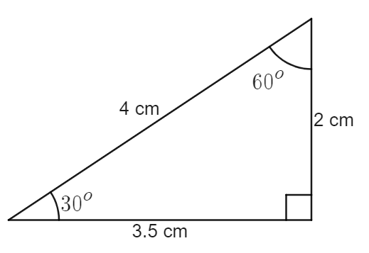
- Can you find any relationship equal to $\frac{1}{2}$ (because $\sin{{30}^{o}}=\frac{1}{2}$)
- Write down your hypothesis:
$\sin{{30}^{o}}$ is equal to …
- Draw a second right-angled triangle with a different angle instead of 30°.
- Measure and mark all the sides and angles, and use a calculator to find sin of your new angle.
For example:
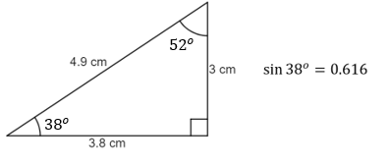
- Does your new sin value work the same in this triangle?
- Describe what $\sin{θ}$ is with relation to a right-angled triangle.
$$\sin{θ}=$$

The cosine ratio
- Find the value of $\cos{{60}^{o}}$ by typing this into your calculator.
$$\cos{{60}^{o}}=$$
- Draw a ${60}^{o}$ angle.
- Use this angle to form a right-angled triangle.
- Measure and mark all sides and angles. It should look something like the triangle below, with different numbers.
For example:
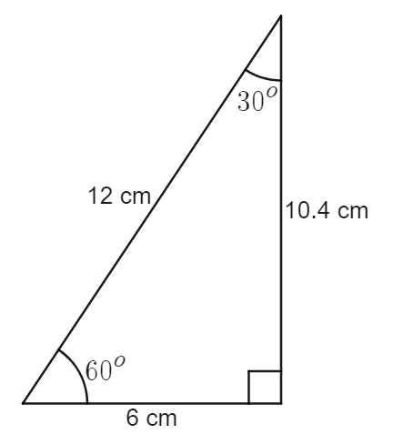
- Can you find any relationship equal to $\frac{1}{2}$ (because $\cos{{60}^{o}}=\frac{1}{2}$)?
- Write down your hypothesis.

- Draw a second right-angled triangle with a different angle instead of ${60}^{o}$.
Measure and mark all the sides and angles and use a calculator to find cos of your new angle.
For example:
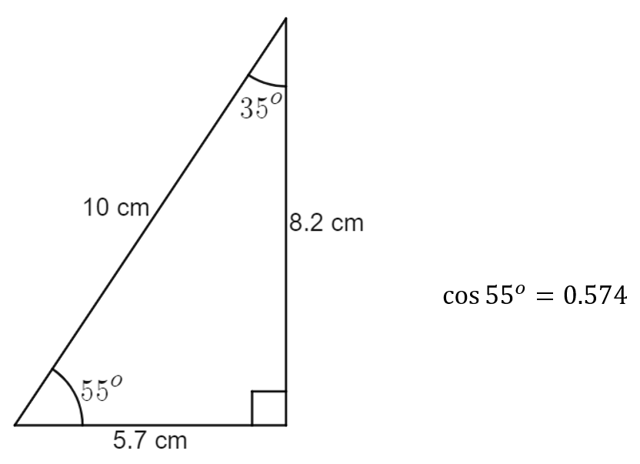
- Does your new cos value work the same in this triangle?
- Describe what $\cos{θ}$ is with relation to a right-angled triangle.
$$\cos{θ}=$$

© State of New South Wales (Department of Education), 2023
The copyright material published in this resource is subject to the Copyright Act 1968 (Cth) and is owned by the NSW Department of Education or, where indicated, by a party other than the NSW Department of Education (third-party material).
Copyright material available in this resource and owned by the NSW Department of Education is licensed under a Creative Commons Attribution 4.0 International (CC BY 4.0) licence.
This licence allows you to share and adapt the material for any purpose, even commercially.
Attribution should be given to © State of New South Wales (Department of Education), 2023.
Material in this resource not available under a Creative Commons licence:
- the NSW Department of Education logo, other logos and trademark-protected material
- material owned by a third party that has been reproduced with permission. You will need to obtain permission from the third party to reuse its material.
Links to third-party material and websites
Please note that the provided (reading/viewing material/list/links/texts) are a suggestion only and implies no endorsement, by the New South Wales Department of Education, of any author, publisher, or book title. School principals and teachers are best placed to assess the suitability of resources that would complement the curriculum and reflect the needs and interests of their students.
If you use the links provided in this document to access a third-party's website, you acknowledge that the terms of use, including licence terms set out on the third-party's website apply to the use which may be made of the materials on that third-party website or where permitted by the Copyright Act 1968 (Cth). The department accepts no responsibility for content on third-party websites.

