The tangent ratio
Students investigate the tangent function on their calculator and compare it with right-angled triangles they construct by hand or using digital tools, to establish the tangent ratio. Students learn to name sides of triangles and recall the trigonometric ratios.
This activity is designed to be the first introduction to the trigonometric ratios for students.

Visible learning

Learning intentions
- To be able to use language associated with trigonometry to describe right-angled triangles.
- To know and be able to define the tangent ratio.

Success criteria
- I can identify the hypotenuse, opposite and adjacent sides with respect to an angle in a right-angled triangle.
- I can explain the relationship between the value of $\tan{{30}^{o}}$ found in my calculator and a right-angled triangle with a 30° angle.
- I can write the tangent ratio for a given angle in a right-angled triangle.

Syllabus outcomes
A student:
- develops understanding and fluency in mathematics through exploring and connecting mathematical concepts, choosing and applying mathematical techniques to solve problems, and communicating their thinking and reasoning coherently and clearly MAO-WM-01
- applies trigonometric ratios to solve right-angled triangle problems MA5-TRG-C-01
Mathematics K–10 Syllabus © NSW Education Standards Authority (NESA) for and on behalf of the Crown in right of the State of New South Wales, 2022.
Please use the associated PowerPoint The tangent ratio to display images in this lesson.

Activity structure

Launch
- Initiate a discussion using strategies such as Think-Pair-Share (bit.ly/thinkpairsharestrategy). Ask students to:
- Look at your calculator with a partner. Write down any of the buttons that you aren't sure what they do.
Figure 1 – two different calculators
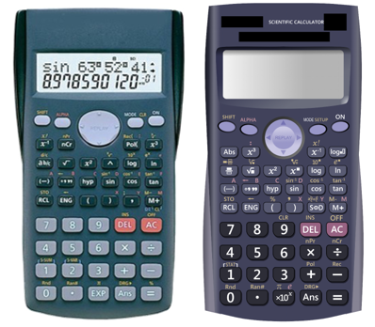
This image is in the associated PowerPoint.
This is a good opportunity to clarify the meaning of some buttons that students would've ideally mastered in stage 4 or earlier, such as $x^{2}$, $x^{n}$ or $^$.
- Reveal that the buttons on their calculator sin, cos and tan relate to right-angled triangles and we are going to investigate what they mean.

Explore
This exploration challenges students to interrogate relationships between measurements in right-angled triangles to establish the trigonometric ratios.

Labelling sides of triangles
To enable the discussion, students will need to have familiarity with the different sides of right-angled triangles.
- Demonstrate the need for side labels by showing scenarios where we don't always just have an angle, a horizontal base and a vertical height.
- The tree in this Desmos graph, Tree height (bit.ly/desmostreeheight) is an example where we have a base and an angle and want to know the height.
- However, the boat in the Desmos graph, Boat (bit.ly/desmosboat) is an example where we have an angle at the top, have the height and are looking for the length of the base of the triangle.
- The ramp in the Desmos graph, House ramp (bit.ly/desmoshouseramp) leads up to a house, where we know the angle we desire for the ramp not to be too steep, and the 1 metre height we want to get to the top of, and we are trying to find the length of the ramp, which is actually the hypotenuse of the triangle.
Students can engage with the Desmos activity, Sides of triangles (bit.ly/desmossidesoftriangles) which demonstrates approaches to labelling sides of triangles, and asks students to label diagrams online.
- Give students strategies to label the 3 sides of right-angled triangles, using the images and the Desmos animations below or use the images in the associated PowerPoint.
- Desmos Hypotenuse (bit.ly/desmoshypotenuse)
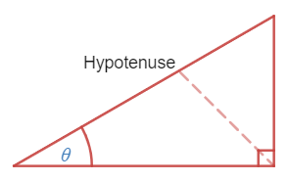
Image created using Desmos and is licensed under the Desmos Terms of Service
- Desmos Opposite side (bit.ly/desmosoppositeside)
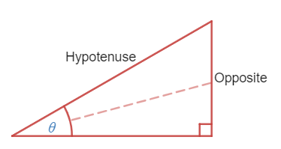
Image created using Desmos and is licensed under the Desmos Terms of Service
- Desmos Adjacent side (bit.ly/desmosadjacentside)
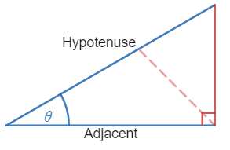
Image created using Desmos and is licensed under the Desmos Terms of Service
This is an opportunity to discuss the common use of Greek letters, such as $θ$, to represent an unknown angle.
- Students to practice labelling the sides of triangles in the activity at Transum website, Which side? (bit.ly/transumwhichside)

Understanding the tangent ratio
The remainder of this task can alternatively be completed online using the Desmos activity, Trigonometric ratios (bit.ly/desmostrigonometricratios).

Equipment
- Class set of protractors.
- Class set of rulers.
- Grid paper.
- Scientific calculators.

Method
- Explain to students that as a class we will explore the tangent ratio, and the tan button on their calculator.
- Ask students to use their protractors and rulers to each draw ${45}^{o}$ angles on grid paper, and then use a right angle to close the triangle. Measure and label the sides.
Figure 2 – a right-angled triangle and an acute angle
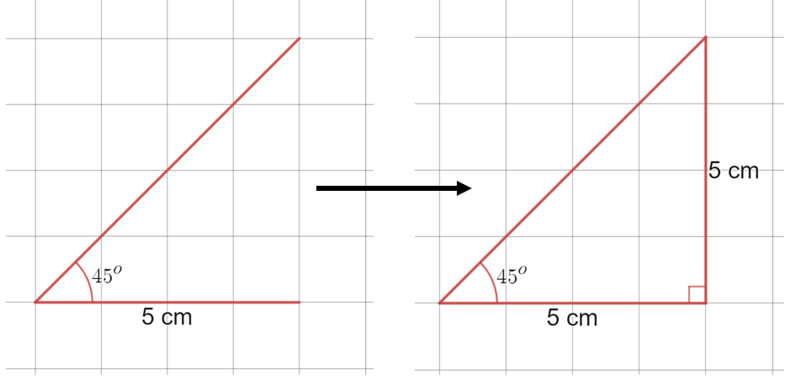
Image created using Desmos and is licensed under the Desmos Terms of Service.
- Instruct students to type $\tan{{45}^{o}}$ into their calculator and discuss the result. Explain that the 45 in this expression refers to a ${45}^{o}$ angle in a right-angled triangle, as we have all drawn.
- Lead students to search for anything in their triangle that could be represented by the number 1. If students have difficulty finding this, encourage them to discuss with their neighbour to find anything that is common to both of their triangles.
- Reveal that the relationship is that the opposite and adjacent sides are the same and have a ratio of 1:1.
- Write down the hypothesis that tan of any angle gives a number that describes the ratio between the opposite and adjacent sides.
- Have all students repeat this process with a ${63}^{o}$ angle instead of ${45}^{o}$. Make a right-angled triangle with a ${63}^{o}$ angle and measure and mark all sides. Encourage students to make the adjacent side a whole number measurement.
- Ask all students to type $\tan{{63}^{o}}$ into their calculators, and round the answer to the nearest whole number (it should be 2).
- Have students engage in a Think-Pair-Share (bit.ly/thinkpairsharestrategy) to consider the question ‘How does $\tan{{63}^{o}}$ relate to the triangle you have drawn?’
- The conclusion should be that the opposite side divided by the adjacent side gives an approximate value of 2, for instance, $\frac{opposite}{adjacent}≈2$, $opposite=2×adjacent$ and that the ratio of opposite to adjacent sides is 2:1. Students should be encouraged to verify that this is always the case by reviewing one another's different sized ${63}^{o}$ angle triangles.

Summarise
- Draw the conclusion that $\tan{θ}=\frac{opposite}{adjacent}$.
- Students test the conclusion by:
- drawing 3 random right-angled triangles on grid paper.
- measuring all sides and angles of all 3 triangles.
- finding ratios of opposite and adjacent sides and comparing with tan values of the relevant angle.
Students who believe their ratio of sides, and their tan values are not matching up, are likely to either have difficulty rounding, or are incorrectly labelling the opposite and adjacent sides in triangles they have constructed themselves.
- Challenge students to use their triangles from step 2 to consider the following questions.
- What happens to the ratio of the opposite and adjacent sides as the angle becomes very large?
- What happen to the ratio of the opposite and adjacent sides as the angle becomes very small?
- For what angles A is $\tan{A}>0$?

Apply
- Give each student a copy of Appendix A.
- Students are to write the tangent ratio for each scenario and engage in a Think-Pair-Share (bit.ly/thinkpairsharestrategy) to answer the following questions.
- Which of the side lengths in the questions would be difficult to measure in real life?
- Which of the side lengths are important measurements?
- Do each of the three scenarios contain a right angle in the real world?
Sightlines, heights of tall objects such as a tree or cliff, and distances along water would be difficult to measure using practical tools. Sightlines such as those found in the first 2 scenarios in Appendix A would often not be relevant measurements.

Assessment and Differentiation

Suggested opportunities for differentiation
Explore
- The Desmos activity allows an exploration for students that does not depend on their skills with measuring tools.
- The use of grid paper improves the likelihood that students will successfully construct the required angles and have a purposeful discussion based on accurate measurements.
Summarise
- The questions in step 3 challenge students to generalise trends that they notice.
Apply
- Challenge students to justify which measurements are difficult to measure and which are actually relevant.

Suggested opportunities for assessment
Explore
- The Desmos activity allows the teacher to record, review, and give feedback on student responses. There are multiple opportunities for students to express their thinking.
Summarise
- Monitor students’ success with having triangles that match the tan values from their calculator, to assess their ability to use measuring tools, as well as labelling sides of triangles.
Apply
- Appendix A can be used as an exit ticket to assess students’ ability to label sides and use these to write tangent ratios.
- Monitor and record student responses to prompting questions in the Think-Pair-Share activity. This is an opportunity to assess whether students can interpret right-angled triangles found in the real world.

Appendix A

The tangent ratio
Write the tangent ratio for the labelled angle in each of the diagrams below.
Diagram | Tangent ratio
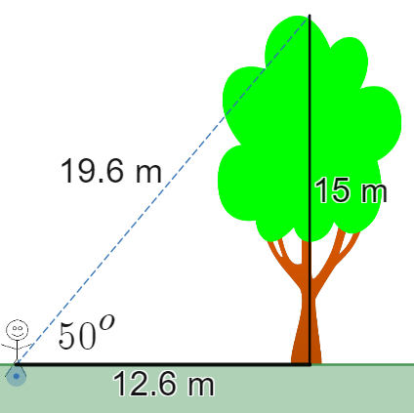
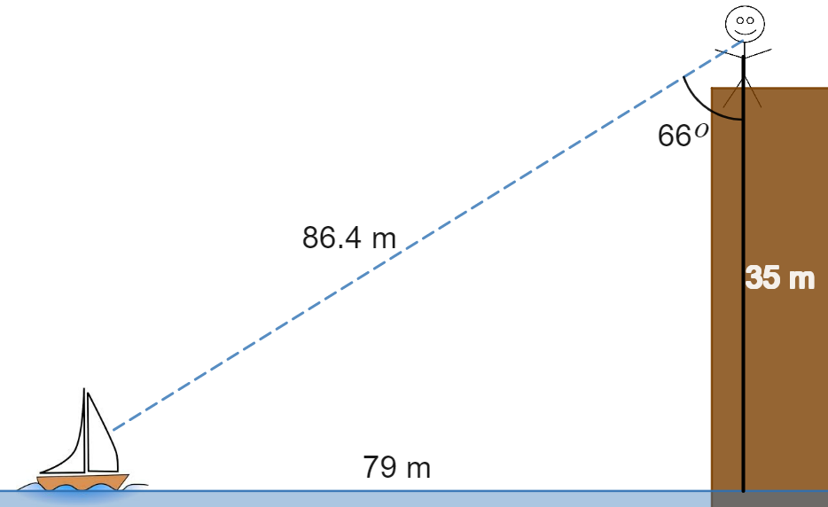
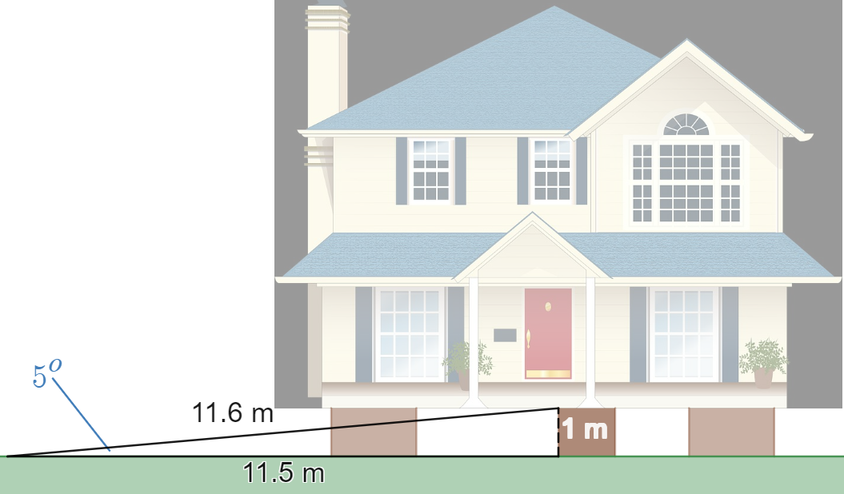
Images created using Desmos and licensed under the Desmos Terms of Service.

Sample solutions

Appendix A
Diagram | Tangent ratio
 | $$\tan{{50}^{o}}=\frac{15}{12.6}$$
 | $$\tan{{66}^{o}}=\frac{79}{35}$$
 | $$\tan{5^{o}}=\frac{1}{11.5}$$

© State of New South Wales (Department of Education), 2023
The copyright material published in this resource is subject to the Copyright Act 1968 (Cth) and is owned by the NSW Department of Education or, where indicated, by a party other than the NSW Department of Education (third-party material).
Copyright material available in this resource and owned by the NSW Department of Education is licensed under a Creative Commons Attribution 4.0 International (CC BY 4.0) licence.
This licence allows you to share and adapt the material for any purpose, even commercially.
Attribution should be given to © State of New South Wales (Department of Education), 2023.
Material in this resource not available under a Creative Commons licence:
- the NSW Department of Education logo, other logos and trademark-protected material
- material owned by a third party that has been reproduced with permission. You will need to obtain permission from the third party to reuse its material.
Links to third-party material and websites
Please note that the provided (reading/viewing material/list/links/texts) are a suggestion only and implies no endorsement, by the New South Wales Department of Education, of any author, publisher, or book title. School principals and teachers are best placed to assess the suitability of resources that would complement the curriculum and reflect the needs and interests of their students.
If you use the links provided in this document to access a third-party's website, you acknowledge that the terms of use, including licence terms set out on the third-party's website apply to the use which may be made of the materials on that third-party website or where permitted by the Copyright Act 1968 (Cth). The department accepts no responsibility for content on third-party websites.

