Larger and smaller angles
In this activity, students construct right-angled triangles with double, triple and other simple ratios between 2 sides, to find angles greater than and smaller than 45° to use for measuring heights of tall objects.
This activity follows directly from the previous lesson 45-degree angles, where students used the 1:1 ratio of 2 sides of isosceles right-angled triangles to measure heights of tall objects. The lesson is based on students having not yet been introduced to trigonometric ratios.

Visible learning

Learning intentions
- To be able to explain that the ratio between sides of a right-angled triangle remains the same if the angle is the same, regardless of size.
- To be able to use ratios to find the heights of objects.

Success criteria
- I can use a clinometer to find positions that give desired angles towards tall objects.
- I can use ratios in right-angled triangles to predict the heights of objects.

Syllabus outcomes
A student:
- develops understanding and fluency in mathematics through exploring and connecting mathematical concepts, choosing and applying mathematical techniques to solve problems, and communicating their thinking and reasoning coherently and clearly MAO-WM-01
- applies trigonometric ratios to solve right-angled triangle problems MA5-TRG-C-01
Mathematics K–10 Syllabus © NSW Education Standards Authority (NESA) for and on behalf of the Crown in right of the State of New South Wales, 2022.
Please use the associated PowerPoint Larger and smaller angles to display images in this lesson.

Activity structure

Launch
- Review the previous lesson outcome: we discovered that if we find a position where the angle to the top of a tree is 45°, then the height of the tree is equal to the distance to the tree (which we can easily measure).
Figure 1 – person and tree, showing angle
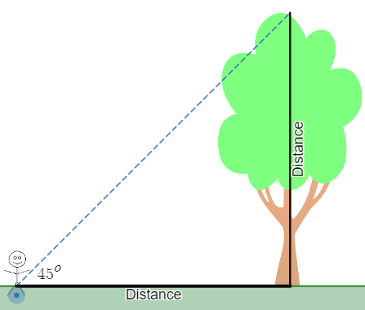
Image created using Desmos and is licensed under the Desmos Terms of Service.
- Give students access to the Desmos graph Larger angles scenario (bit.ly/Desmoslargeranglesintroduction) or show the associated PowerPoint. Use strategies such as Think-Pair-Share (bit.ly/thinkpairsharestrategy) to discuss the following questions.
- If we can't get back far enough to form a 45° angle, how could you measure the height of the tree?
- What happens to the angle if we move closer to the tree?
- What happens to the ratio of the 2 sides of the triangle?
Consider finding such a tree or building, where a fence or other object prevents you from standing far enough back to obtain a 45-degree angle to aid this discussion.
- Give students access to the Desmos graph Smaller angles scenario (bit.ly/desmossmalleranglesscenario) or show the associated PowerPoint. Use strategies such as Think-Pair-Share (bit.ly/thinkpairsharestrategy) to discuss the following questions.
- If we can't get close enough to form a 45° angle, how could you measure the height of the tree?
- What happens to the angle if we move further from the tree?
- What happens to the ratio of the 2 sides of the triangle?
Consider finding such a tree or building in the distance, where the building is close and tall enough to be seen, but far enough offsite to not get close to it without leaving school grounds.

Explore
Students draw right-angled triangles with heights that are double the distance from the object, triple the distance, and so on. They find angles that create these ratios and use these triangles to find heights of objects.
The exploration below can be conducted via Desmos in the activities, Larger angles (bit.ly/desmoslargerangles) and Smaller angles (bit.ly/desmossmallerangles).

Equipment
- Class set of protractors
- Class set of rulers
- Grid paper (ideally 1 cm grid)
- Discuss with students that while we cannot easily find the height of these very tall objects using our 45° angles as we did last lesson, we can find other relationships for larger angles that can be almost as simple.
Given a ruler, protractor and grid paper, all students draw a right-angle and measure and mark the base length. Students can choose any length. The example below shows 3 centimetres.
Figure 2 – pair of perpendicular lines
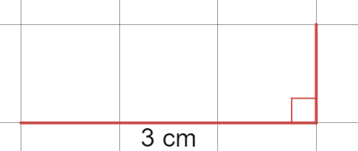

- Extend the height of the triangle so that it is double the length of the base.
Figure 3 –pair of perpendicular lines with base line of 3 cm and vertical line of 6cm
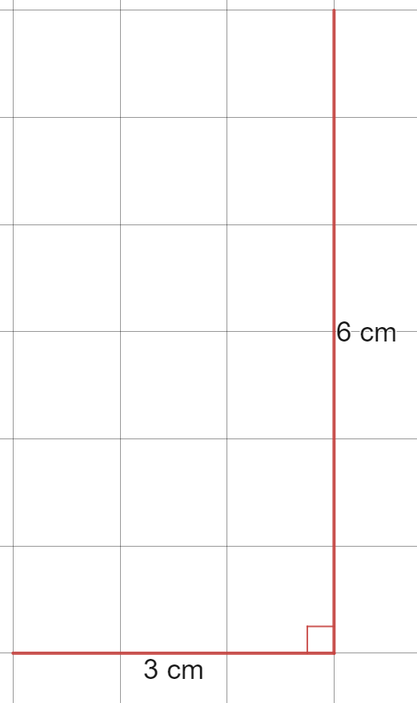
It is important to highlight the language of the ratio that the height length to the base length is 2:1.
- Students join the sides to form a right-angled triangle and measure the base angle.
Figure 4 – right-angled triangle, 3 cm × 6 cm
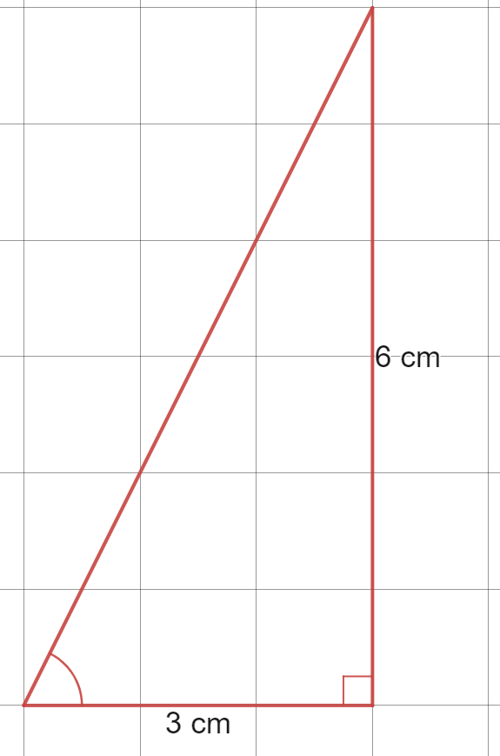
All students should have different triangles and should be challenged to discuss and share what they find the same. (All triangles should have approximately 63° angles at the base).
- Pose the question, will a 63° angle always make the ratio of height to base, 2:1? Challenge students to approximately draw a 63° angle with their protractor on grid paper, as shown below.
Figure 5 – an acute angle
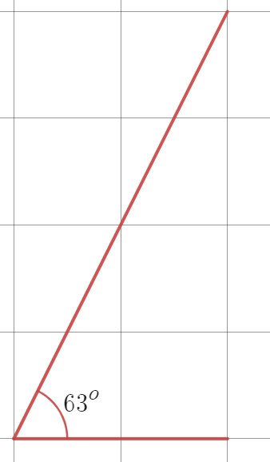
- Close the triangle at any size by forming a right angle and measure the 2 sides with a ruler or by counting the grid squares as shown in an example below.
Figure 6 – a right angled triangle, 2 × 4 cm
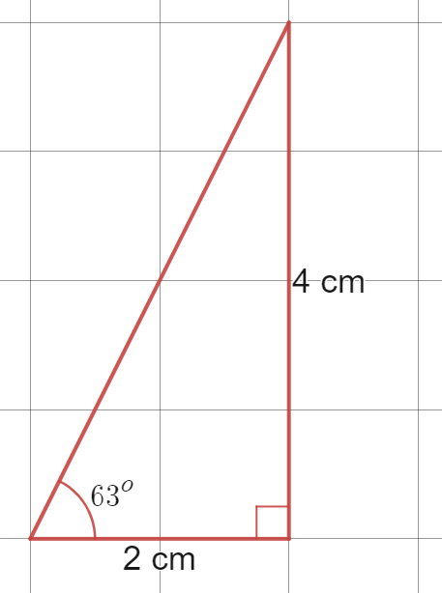
Again, students should discuss what they find in common.
- Ask students to predict the height of a tree in the scenario below (this image is in the associated PowerPoint), where we know that we can see the height of the tree at a 63° angle, and we have measured the distance to the foot of the tree to be 8 m.
Figure 7 – image shows angle of 63° and distance of 8 m
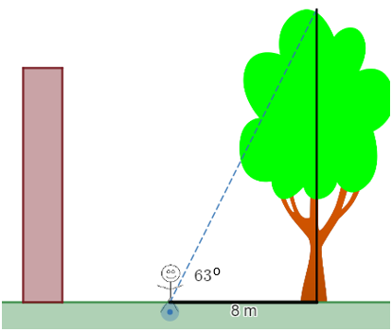
Image created using Desmos and is licensed under the Desmos Terms of Service.
- Students repeat this process of drawing right angles measured to a specific ratio, and record the measured angle in Appendix B. Have students complete the 2 problems at the bottom of Appendix B, using their table.

Summarise

Draw conclusions
- Students to engage in a Think-Pair-Share (bit.ly/thinkpairsharestrategy) to consider what they have just found in the table from Appendix B.
Take this opportunity to question students on whether the ratios will be the same without the right angle.
- Teacher to lead a discussion around significant conclusions from this investigation:
- in every right-angled triangle with a given angle, the 2 sides that form the right angle will have a constant ratio.
- we can use these ratios to find the heights of objects where we know the angle.
- Have students write notes to their future self (bit.ly/notesstrategy) about these conclusions.
- Students complete exit ticket (bit.ly/exitticketstrategy) from Appendix A. This exit ticket is also in the associated PowerPoint.

Consider why this occurs
- Students to engage in a Think-Pair-Share (bit.ly/thinkpairsharestrategy), considering the question ‘how can you tell that these triangles are similar?’ These triangles are in the associated PowerPoint.
Figure 8 – two right-angled triangles
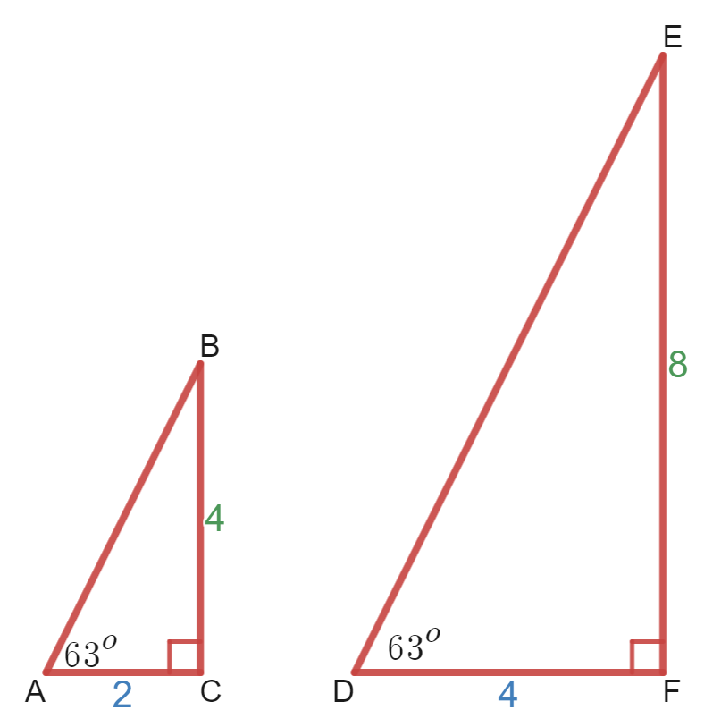
Alternatively, students could consider this same question, by looking at the triangles that they themselves have constructed during the ‘Explore’ section of this activity.
- Lead a discussion connecting this conclusion of similarity to the previous topic regarding similar figures, and the minimum requirements for 2 triangles to be similar.
- Evidence can include:
- the common ratio $AC:BC=DF:EF=1:2$
- the common pairs of angles, ${∠BAC=∠EDF=63}^{o}$ and $∠ACB=∠DFE={90}^{o}$.

Apply
Students use the angles found in the table in the ‘Explore’ section to find the heights of tall trees and buildings around the school, where a ${45}^{o}$ angle is unattainable, as described in the ‘Launch’ section above.
Equipment: Clinometer, trundle wheel or tape measure
- Students stand back from a tall tree, looking at the top through a clinometer, until the angle becomes any of the angles found in the table in the ‘Explore’ section.
- A partner measures the distance from this point to the foot of the tree.
In the scenario where students are measuring the height of a tall tree or building in the distance, they can use Google Maps (google.com/maps/) to find the distance. To find approximate distances, locate your starting position and the position of the object, right click and select Measure distance.
Figure 9 – image shows angle and distance between person and tree
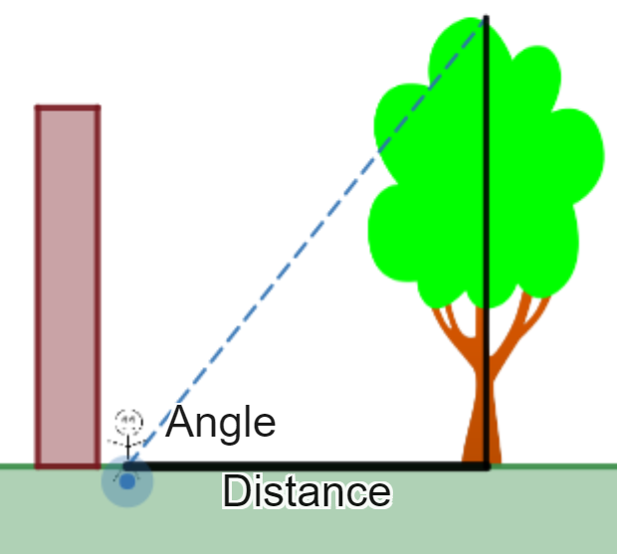
Image created using Desmos and is licensed under the Desmos Terms of Service.
- Use the ratios in the table and the distance measured to find the height of the tree, as in the example below.
Figure 10 – image shows angle of 76° and distance of 7 metres
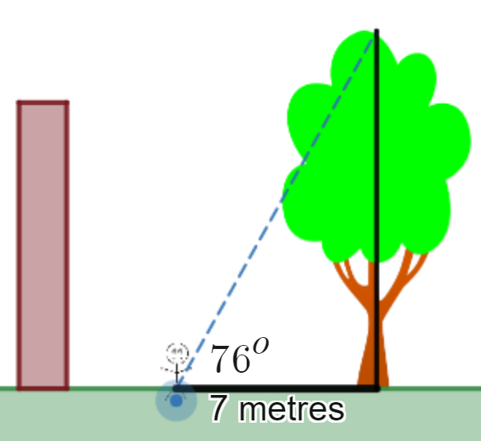
Image created using Desmos and is licensed under the Desmos Terms of Service.
As 76° gives a height to base ratio of 4:1, the height of the tree will be 4 × 7 = 28 metres.

Assessment and Differentiation

Suggested opportunities for differentiation
Explore
- The Desmos activity allows an exploration for students that does not depend on their skills with measuring tools.
- Giving students the required angles printed and requiring them to simply use the triangles and a ruler to construct and measure a right-angled triangle increases the likelihood of successful measurements, which would in turn improve the opportunity for students to investigate patterns and results. Using grid paper also improves these opportunities.
- The table in Appendix B currently contains suggested ratios that can be investigated. It is not necessary for students to investigate all the included ratios. The table should be modified to suit the ability and needs of students.
- Acknowledge that many of the angles found in the table in Appendix B are close together and difficult to accurately measure, such as 76° and 79°. Challenge students to find angles that are spread further apart by investigating ratios that do not contain a unitary part, such as 2:3.
Summarise
- Challenge students to write a complete explanation as to how they know the 2 triangles are similar. This could be extended to challenge the thinking of 2 pairs of equal sides being enough on their own.
Apply
- Challenge students to compare multiple measurements for the height of a particular object, obtained using different angles from their table.

Suggested opportunities for assessment
Explore
- Monitor the measurements found by students to assess their skills with using protractors and rulers.
- The Desmos activity allows the teacher to record, review, and give feedback on student responses. There are multiple opportunities for students to express their thinking.
Summarise
- Collect student exit tickets to assess their learning of the overall concept, that right-angled triangles with 45° angles have equal sides that can be used to solve problems.
Apply
- Monitor the measurements found by students to assess their skills with using larger practical measuring tools, clinometers, trundle wheels and tape measures.

Appendix A

Exit ticket
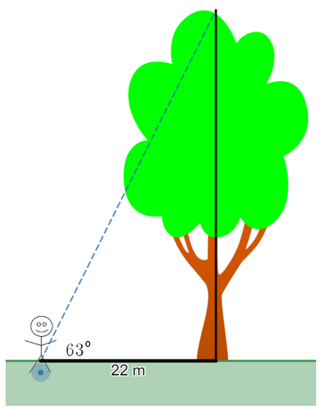
Image created using Desmos and is licensed under the Desmos Terms of Service.
- How tall is the tree?
- How do you know?

Appendix B
Height to base ratio | Height | Base | Approximate angle | Test: Does the angle always cause this ratio?
1:1 | eg 4 cm | eg 4 cm | 45° | Yes
2:1 | eg 6 cm | eg 3 cm | 63° | Yes
3:1
4:1
5:1
10:1
1:2
1:3
1:4
1:5
1:10
Predict the heights of the 2 trees shown below. These are both in the associated PowerPoint.
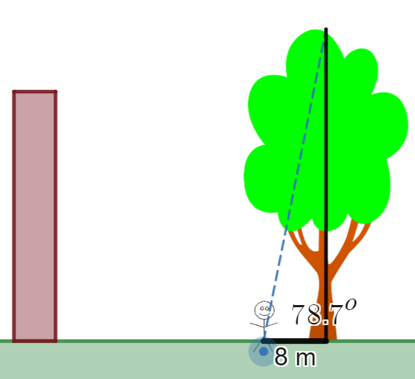
Image created using Desmos and is licensed under the Desmos Terms of Service.
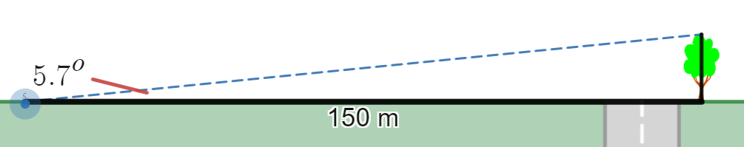
Image created using Desmos and is licensed under the Desmos Terms of Service.

Sample solutions

Appendix B
Height to base ratio | Height | Base | Approximate angle | Test: Does the angle always cause this ratio?
1:1 | 4 cm | 4 cm | 45° | Yes
2:1 | 6 cm | 3 cm | 63° | Yes
3:1 | 9 cm | 3 cm | 72° | Yes
4:1 | 16 cm | 4 cm | 76° | Yes
5:1 | 25 cm | 5 cm | 79° | Yes
10:1 | 60 cm | 6 cm | 84° | Yes
1:2 | 4 cm | 8 cm | 27° | Yes
1:3 | 3 cm | 9 cm | 18 | Yes
1:4 | 3 cm | 12 cm | 14° | Yes
1:5 | 2 cm | 10 cm | 11° | Yes
1:10 | 2 cm | 20 cm | 6° | Yes
The base and height measurements in the table above are examples, as all students will draw their own, various sized triangles.
Image created using Desmos and is licensed under the Desmos Terms of Service.
Using the table, a 79° angle creates a ratio of approximately 5:1 between the tree height and the ground distance. The tree should be approximately $8×5=40 m$ tall.
Image created using Desmos and is licensed under the Desmos Terms of Service.
Using the table, a 6° angle creates a ratio of approximately 1:10 between the tree height and the ground distance. The tree should be approximately $150÷10=15 m$ tall.
© State of New South Wales (Department of Education), 2023
The copyright material published in this resource is subject to the Copyright Act 1968 (Cth) and is owned by the NSW Department of Education or, where indicated, by a party other than the NSW Department of Education (third-party material).
Copyright material available in this resource and owned by the NSW Department of Education is licensed under a Creative Commons Attribution 4.0 International (CC BY 4.0) licence.
This licence allows you to share and adapt the material for any purpose, even commercially.
Attribution should be given to © State of New South Wales (Department of Education), 2023.
Material in this resource not available under a Creative Commons licence:
- the NSW Department of Education logo, other logos and trademark-protected material
- material owned by a third party that has been reproduced with permission. You will need to obtain permission from the third party to reuse its material.
Links to third-party material and websites
Please note that the provided (reading/viewing material/list/links/texts) are a suggestion only and implies no endorsement, by the New South Wales Department of Education, of any author, publisher, or book title. School principals and teachers are best placed to assess the suitability of resources that would complement the curriculum and reflect the needs and interests of their students.
If you use the links provided in this document to access a third-party's website, you acknowledge that the terms of use, including licence terms set out on the third-party's website apply to the use which may be made of the materials on that third-party website or where permitted by the Copyright Act 1968 (Cth). The department accepts no responsibility for content on third-party websites.

