45-degree angles
In this activity, students establish the constancy of the ratio between 2 sides of isosceles right-angled triangles and use this 1:1 ratio to measure heights of tall objects.
This activity is designed for students who have no experience with trigonometric ratios and aims to begin the process of introducing these concepts. Students will benefit from some knowledge of similar triangles.

Visible learning

Learning intentions
- To understand the constant properties of all right-angled isosceles triangles.

Success criteria
- I can use a clinometer to measure angles to tall objects.
- I can use 45°, right-angled, isosceles triangles to measure the heights of tall objects.
- I can explain why the distance to a tree is the same as the height of a tree when the angle is 45°.

Syllabus outcomes
A student:
- develops understanding and fluency in mathematics through exploring and connecting mathematical concepts, choosing and applying mathematical techniques to solve problems, and communicating their thinking and reasoning coherently and clearly MAO-WM-01
- applies trigonometric ratios to solve right-angled triangle problems MA5-TRG-C-01
Mathematics K–10 Syllabus © NSW Education Standards Authority (NESA) for and on behalf of the Crown in right of the State of New South Wales, 2022.
Please use the associated PowerPoint 45-degree angles to display images in this lesson.

Activity structure

Launch
Teacher to initiate a discussion on the following questions, using strategies such as Think-Pair-Share (bit.ly/thinkpairsharestrategy):
- How tall is the tallest tree (or building) in our school?
- How do you know which is the tallest?
- How would you measure the tree?
Figure 1 – a tall tree
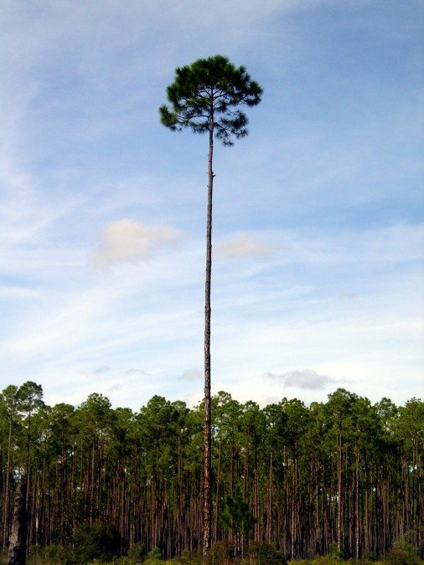

Explore
Students investigate right-angled triangles with 45-degree angles to determine that 2 side lengths will always be equal, and how we can use this to find heights of objects.
This activity has been written with the intention of introducing the language of the sides of triangles in a future lesson. Teachers can choose to introduce this language now if they prefer.
The exploration below can be conducted online via Desmos in the activity 45 degree angles (bit.ly/Desmos45degreeangle).

Equipment
- Class set of rulers
- Class set of protractors
- Grid paper (ideally 1 cm grid)

Method
- Display the Desmos graph The height of a tree (bit.ly/Desmos-treeheight). Drag the character to show changes in the triangle but do not press the switch.
- Have students engage in a Think-Pair-Share (bit.ly/thinkpairsharestrategy) and discuss what we know and what we can measure with conventional tools.
- Flick the switch in the Desmos graph to conclude that we can measure the distance to the tree from anywhere we stand with a trundle wheel, and the angle to the top of the tree with a clinometer.
- It is vital to also draw attention to the assumed approximate right angle between the ground and the tree. Have students consider if this is always true.

This is a possible opportunity to acknowledge with students that to form an accurate triangle, we need to adjust for the height of our eyes above ground level.
Students can be shown how to make a clinometer, and what a clinometer is using the following videos:
- YouTube: Clinometer (How to make and use) (2:10) (bit.ly/Clinometerinstructions).
- Eddie Woo: How to use a Clinometer (5:15) (bit.ly/wootubeclinometer).
- Appendix A: How to build and use a clinometer.
- Given a ruler, protractor and grid paper, all students draw a right angle and measure to make the 2 sides the same (they can choose any length and count squares on the grid for lengths).
Figure 2 – 90-degree angle
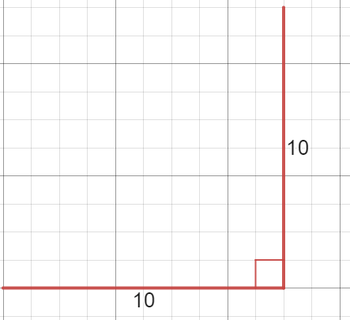
- Join the sides to form a right-angled isosceles triangle and measure the base angle.
Figure 3 – right-angled triangle
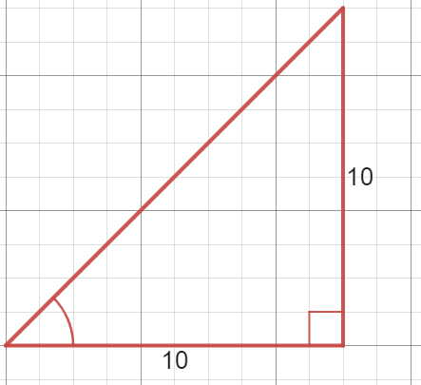
- All students should have different triangles and should be challenged to discuss and share what they find the same. (All triangles should have approximately 45-degree angles at the base).
- Will 45-degree angles always make the sides equal in length? Challenge students to draw a 45-degree angle with their protractor on grid paper.
Figure 4 – 45-degree angle
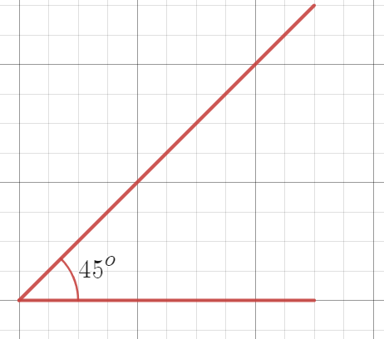
- Close the triangle at any size such that a right angle is formed and measure the 2 sides with a ruler or counting the square in the grid.
- Again, students should discuss what they find in common.
- Ask students to predict the height of a tree in the scenario below (this image is in the associated PowerPoint), where we know that we can see the height of the tree at a 45-degree angle, and we have measured the distance to the foot of the tree to be 15 m.
Figure 5 – person standing 15 m from a tree
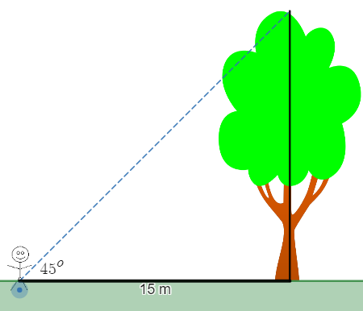
Image created using Desmos and is licensed under the Desmos Terms of Service.

Summarise

Draw conclusions
- Teacher to lead a discussion around significant conclusions from this investigation:
- in every isosceles right-angled triangle, the base to height ratio is 1:1, meaning the 2 sides that form the right angle will be equal.
- if we stand back from a tree until our clinometer reads 45°, the height of the tree will be the same as the distance along the ground to the tree, which we can easily measure with a tape measure or trundle wheel.
- Have students write notes to their future self about these conclusions (bit.ly/notesstrategy).
- Students complete exit ticket from Appendix B. This exit ticket is in the associated PowerPoint.

Consider why this always occurs
- Students to engage in a Think-Pair-Share (bit.ly/thinkpairsharestrategy), considering the question ‘how can you tell that these triangles are similar?’
Figure 6 – 2 right-angled triangles
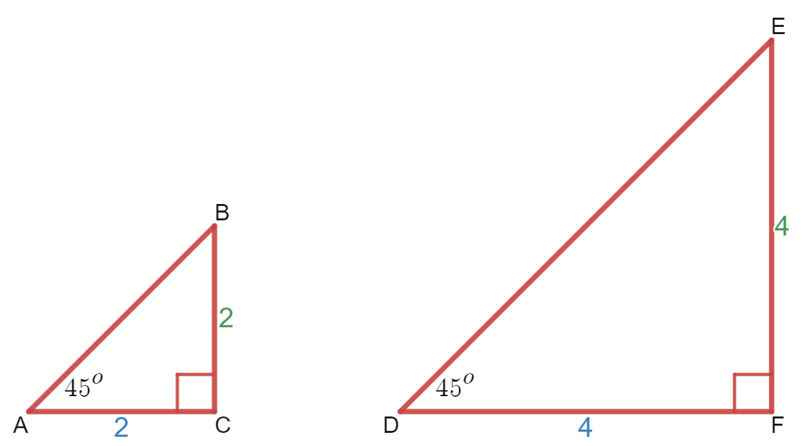
Alternatively, students could consider this same question, by looking at the triangles that they themselves have constructed during the ‘Explore’ section of this activity.
- Lead a discussion connecting this conclusion of similarity to the previous topic regarding similar figures, and the minimum requirements for 2 triangles to be similar.
- Evidence can include:
- the common ratio $AC:BC=DF:EF=1:1$.
- the common pairs of angles ${∠BAC=∠EDF=45}^{o}$ and $∠ACB=∠DFE={90}^{o}$.

Apply
Students use 45° in right-angled triangles to find the heights of tall trees and buildings around the school. The instructions for this are in the associated PowerPoint.
This process can be demonstrated to the class using the Desmos graphs, Heights of trees (bit.ly/Desmos-heightsoftrees). The instructions on the left of screen describe how to use the graph. Turn on folders by clicking on the circle beside the folder name.
Figure 7 – 'Angle' folder icon from Desmos
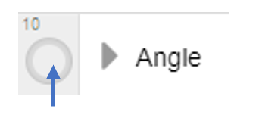
Additional examples include finding the heights of ceilings in classrooms and the school hall, or goalposts and basketball rings, which can then be checked against regulations.

Equipment
Clinometer, trundle wheel or tape measure

Method
- Students stand back from a tall tree, looking at the top through a clinometer, until the angle becomes 45°.
This is a second opportunity to acknowledge measuring the angle from the ground and considering what can be done to compensate for measuring while standing, for example, adding the height of your eyes above the ground to the calculated height of the tree.
- A partner measures the distance from this point to the foot of the tree.
Figure 8 – person standing distance from a tree
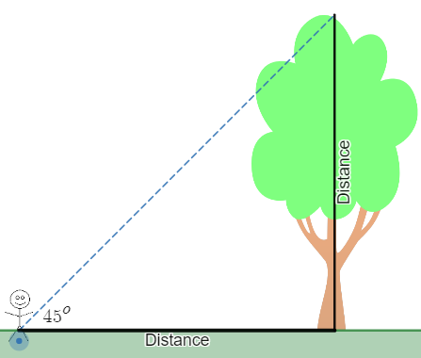
Image created using Desmos and is licensed under the Desmos Terms of Service.
- This distance will be the same as the height of the tree.

Reflection questions
- Why are the distances the same? Try measuring the top angle in the triangles you drew.
- What would happen if you couldn't walk back to be at a 45° angle? How would you find the height in this circumstance?

Assessment and Differentiation

Suggested opportunities for differentiation
Explore
- The Desmos activity allows an exploration for students that does not depend on their skills with measuring tools.
- Using grid paper supports students to construct more accurate right-angled triangles. Advise students when drawing horizontal and vertical lines to choose lengths that are whole numbers of squares in length.
Summarise
- Challenge students to write a complete explanation as to how they know the 2 triangles are similar.
Apply
- Have groups of students collaborate by standing at the base of a tree and all moving back until they are at a 45° angle of inclination. Students can then measure via the process and compare their results.

Suggested opportunities for assessment
Explore
- Monitor the measurements found by students to assess their skills with using protractors and rulers.
- The Desmos activity allows the teacher to record, review, and give feedback on student responses. There are multiple opportunities for students to express their thinking.

Summarise
- Collect student exit tickets to assess their learning of the overall concept, that right-angled triangles with 45° angles have equal sides that can be used to solve problems.
Apply
- Monitor the measurements found by students to assess their skills with using larger practical measuring tools, clinometers, trundle wheels and tape measures.

Appendix A

How to build a clinometer
Equipment: straws; string; adhesive putty; protractor, sticky tape
- Tie the string around the centre of the straw OR poke a hole in the straw and tie the string through the hole.
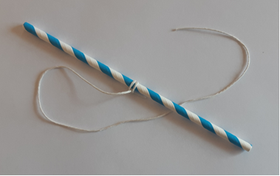
- Use the sticky tape to attach the straw to the straight edge of the protractor.
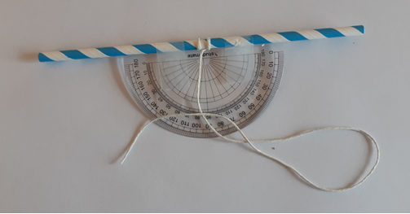
- Attach a ball of the adhesive putty to the other end of the string (or any other weight such as the nut shown below)
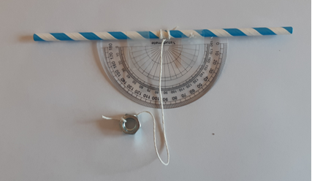
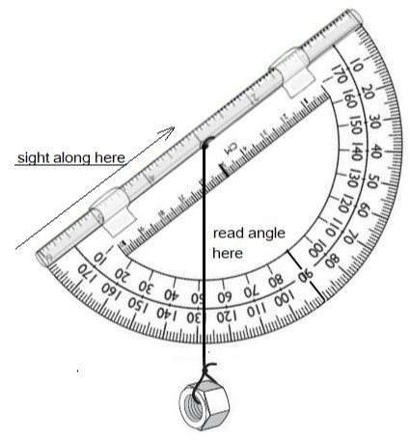

Appendix B

Exit ticket
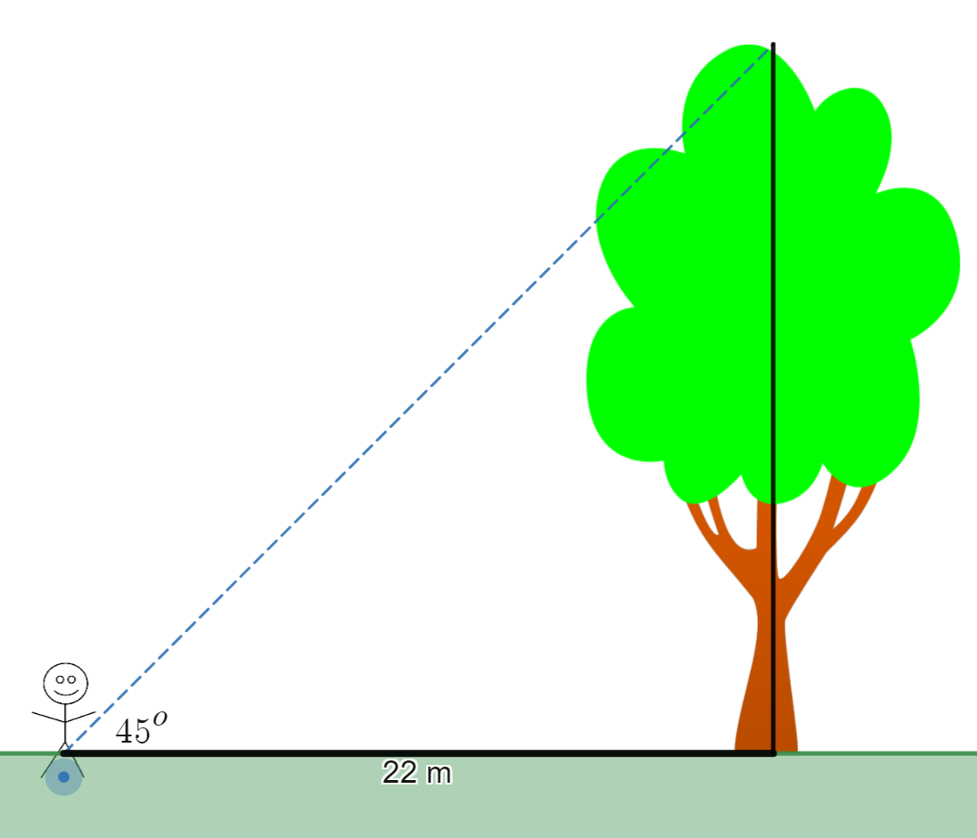
Image created using Desmos and is licensed under the Desmos Terms of Service.
- How tall is the tree?
- How do you know?
© State of New South Wales (Department of Education), 2023
The copyright material published in this resource is subject to the Copyright Act 1968 (Cth) and is owned by the NSW Department of Education or, where indicated, by a party other than the NSW Department of Education (third-party material).
Copyright material available in this resource and owned by the NSW Department of Education is licensed under a Creative Commons Attribution 4.0 International (CC BY 4.0) licence.
This licence allows you to share and adapt the material for any purpose, even commercially.
Attribution should be given to © State of New South Wales (Department of Education), 2023.
Material in this resource not available under a Creative Commons licence:
- the NSW Department of Education logo, other logos and trademark-protected material
- material owned by a third party that has been reproduced with permission. You will need to obtain permission from the third party to reuse its material.
Links to third-party material and websites
Please note that the provided (reading/viewing material/list/links/texts) are a suggestion only and implies no endorsement, by the New South Wales Department of Education, of any author, publisher, or book title. School principals and teachers are best placed to assess the suitability of resources that would complement the curriculum and reflect the needs and interests of their students.
If you use the links provided in this document to access a third-party's website, you acknowledge that the terms of use, including licence terms set out on the third-party's website apply to the use which may be made of the materials on that third-party website or where permitted by the Copyright Act 1968 (Cth). The department accepts no responsibility for content on third-party websites.

