Maps and scale
This lesson builds on students understanding of scale to explore and solve problems involving various graphical representations, including maps and floor plans.

Visible learning

Learning intentions
- To explore the similarities and differences of various graphical representations
- To apply scale in context

Success criteria
- I can read various graphical displays, including maps and floorplans
- I can solve problems involving a scale

Syllabus outcomes
A student:
- develops understanding and fluency in mathematics through exploring and connecting mathematical concepts, choosing and applying mathematical techniques to solve problems, and communicating their thinking and reasoning coherently and clearly MAO-WM-01
- identifies and applies the properties of similar figures and scale drawings to solve problems MA5-GEO-C-01
Mathematics K–10 Syllabus © NSW Education Standards Authority (NESA) for and on behalf of the Crown in right of the State of New South Wales, 2022.
Please use the associated PowerPoint Maps and scale to display images in this lesson.

Activity structure

Warm up
- Display Figure 1.
Figure 1 – Which one doesn't belong?
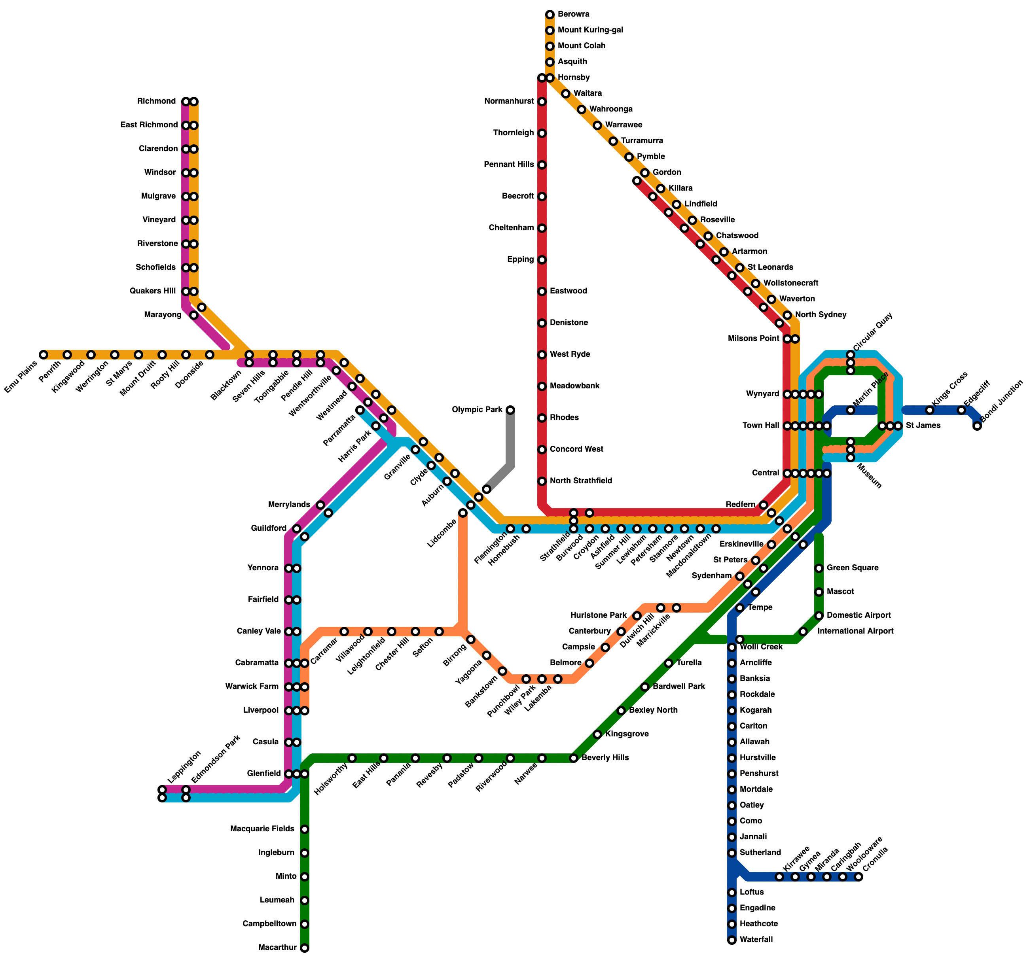  ‘Map of the Sydney Trains rail network’ by Krupadeluxe is licensed under CC BY-SA 4.0 | 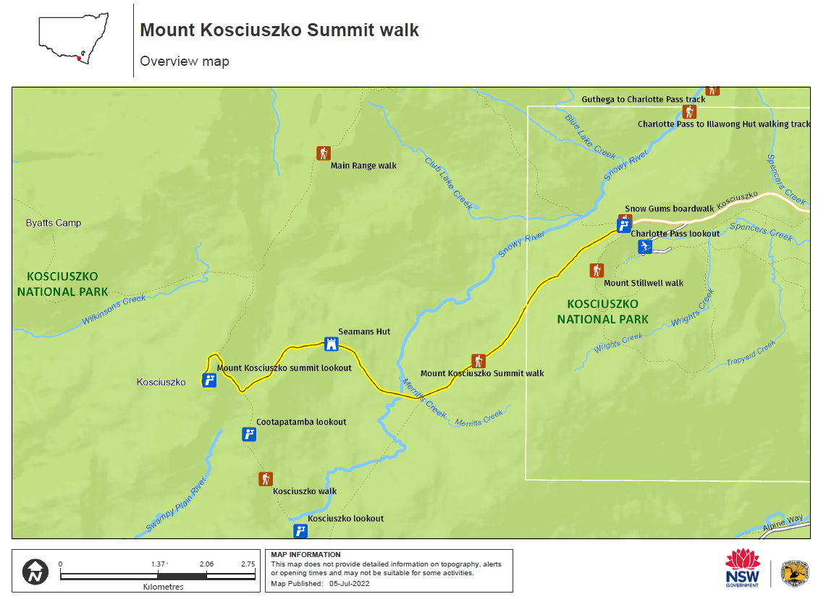  ‘Mount Kosciuszko Summit walk map’ by State of New South Wales and Department of Planning and Environment is licensed under CC BY 4.0
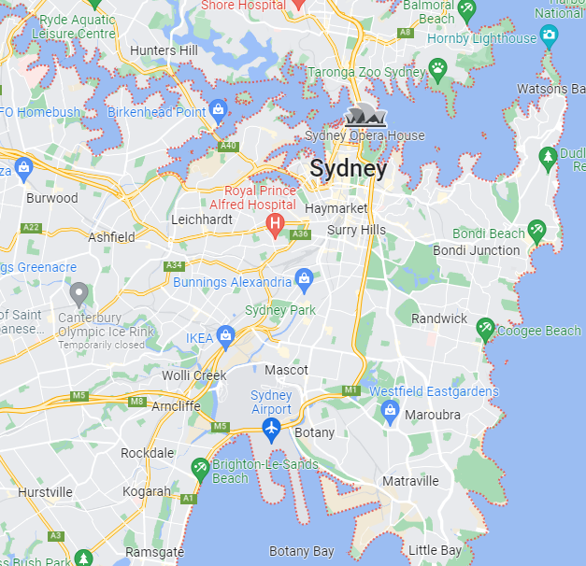  Map data © 2023 Google | 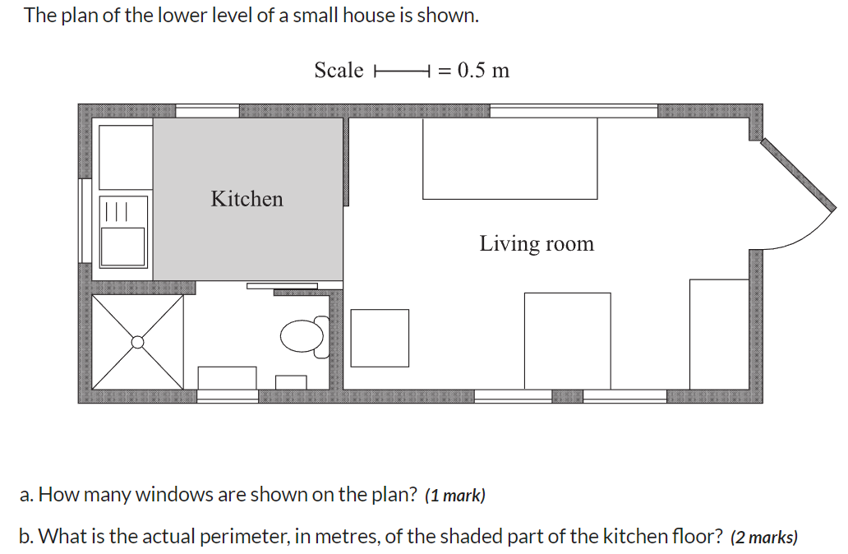  HSC 2019 Mathematics Standard 1 Q20 © NSW Education Standards Authority (NESA) for and on behalf of the Crown in right of the State of New South Wales, 2019.
- This is a which one doesn’t belong activity. Have students perform a Think-Pair-Share (bit.ly/thinkpairsharestrategy) to justify which image doesn’t belong.
- Encourage discussion of similarities and differences between graphical representations.

Launch
- Print and distribute the Mount Kosciuszko Summit walk overview map (Figure 2).
Figure 2 – Mount Kosciuszko walk overview map
‘Mount Kosciuszko Summit walk map’ by State of New South Wales and Department of Planning and Environment is licensed under CC BY 4.0.
- Have students create a notice/wonder list (bit.ly/noticewonderstrategy) about Figure 2.
- Important points for discussion:
- What does the bar in the bottom left corner mean?
- Where does the track start and finish?
- Could you figure out the distance from Seamans hut to Mount Kosciuszko summit lookout?
- Who would use this map and why?
- Why are some sections darker/lighter?
- Demonstrate how to use the scale bar to show the distance between two points on the map.
- Ask students to estimate, then calculate (approximately) the distance from:
- Snow Gums boardwalk to Seamans Hut.
- Seamans Hut to Mount Kosciuszko summit lookout.
Students will need to measure in segments which are as straight as possible.

Explore

Map scale online game
- Direct students to mrnussbaum.com/map-scale-online-game
- In this game students use the on-screen ruler to measure the distance between various cities, then use the map scale to convert it from cm to km.
- Model an example for students.
- As students are finishing their first attempt, ask reflection questions such as:
- What is the scale used?
- Could you write it as a ratio? (Note: This is an opportunity to teach students that units are not written in ratios, instead they will have to convert units).
- Would you use the same scale for a map of the school?
- Ask students for strategies they found effective. For example, how did they use the ruler?

Thin slicing
- Print and distribute Appendix A. Ideally students should complete these problems in random groups of 3 at a vertical non-permanent surface. Give students one problem at a time to work on, only giving them the next problem once they have achieved success with the previous problem. Visit the website (bit.ly/VNPSstrategy) to learn more about this strategy.
- Ensure students are checking their answers make sense given the context.

Non-routine problems
- Print and distribute Appendix B.
- Students could work on this task in their books or at a non-permanent vertical surface.
- Ensure students are checking their answers make sense given the context.

Summarise
- Print and distribute the floor plan (Figure 3).
- Students could work on this task in their books or at a vertical non-permanent surface.
Figure 3 – HSC 2019 Standard 1 Q20
HSC 2019 Mathematics Standard 1 Q20 © NSW Education Standards Authority (NESA) for and on behalf of the Crown in right of the State of New South Wales, 2019.
- Ask students to share similarities and differences between the maps observed this lesson and the floor plan presented in Figure 3.
- Summarise that scales are used in a variety of graphical representations, however the mathematics involved is often very similar.
If students have struggled to solve problems involving scale, you might like to explicitly model strategies with simple examples.

Apply
- Print off and distribute to students a map of your school’s local area. Ensure the scale bar is included in the printout as shown in the bottom right corner of the example below.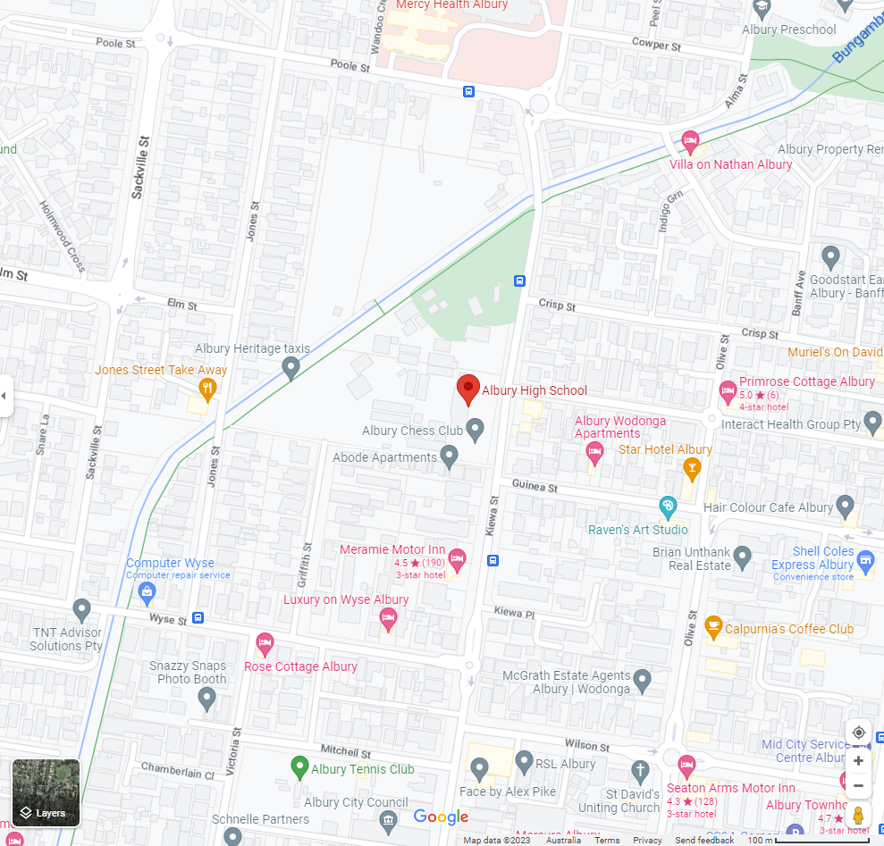
Map data © 2023 Google
- Challenge students to draw a walking trail on the map that meets the following conditions:
- Is between 2 and 4 kilometres.
- Starts at and returns to the school.
- Is possible to walk (doesn’t go through buildings).
- Students should use the scale bar shown to calculate the distance of their trail.
The task could be presented as organising a fun run or walking as a sports afternoon option.

Assessment and Differentiation

Suggested opportunities for differentiation
Launch
- You might like to use a simpler map, such as those from a typical textbook chapter on maps and scale, to reduce cognitive overload.
Explore
- Adjust Appendices A&B to have manageable solutions.
Apply
- This activity: Navigating our way through country, though pitched at Year 4 level, would be a more accessible application of scale in maps.
Further challenges
- Provide students an opportunity to create and/or modify a floor plan of the classroom.
- Extend students to calculate areas using a scale diagram.

Suggested opportunities for assessment
- Many of the activities could be collected as work samples or used as a test.

Appendix A

Thin slicing
- What is the distance between points A and B on the map below?
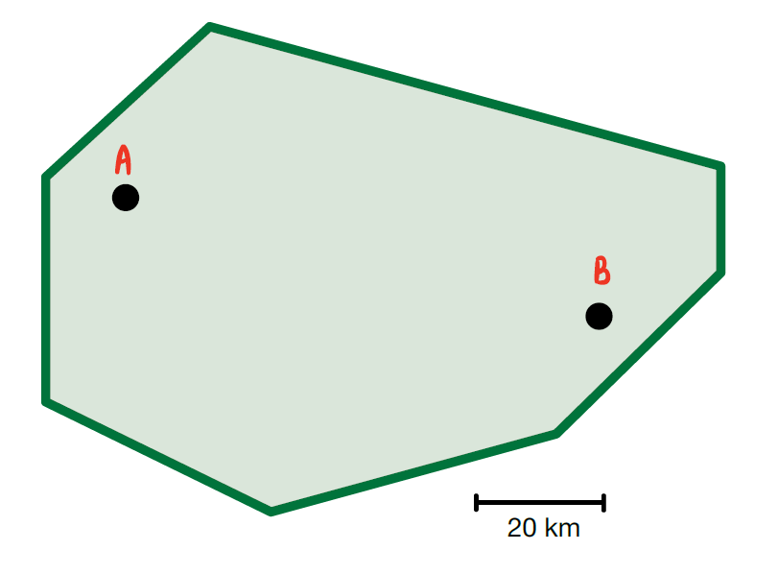
- The map below has a scale of 1:2000.
Find the actual distance (in centimetres) points A and B: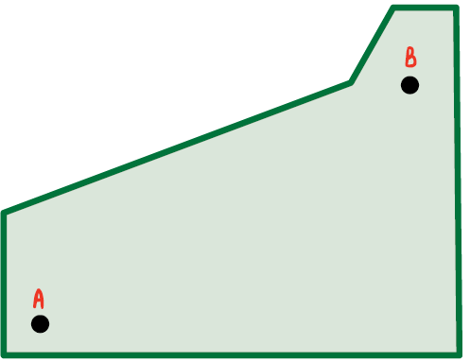
- Maria is reading a map with a scale of 1:100 in the map legend.
Find the actual distance (in centimetres) between 2 points that are 17 cm apart on the map.

- Consider a map with a scale of 1:20 000.
Find the actual distance (in metres) between 2 points that are 13 cm apart on the map.
- Consider a map with a scale of 1:25 000.
Find the actual distance (in kilometres) between 2 points that are 21 cm apart on the map.
- A draftsman is adjusting a house plan with a scale of 1:200.
- They need to extend a wall 1120 mm. How long will this extension be on the scale drawing?
- They are asked to extend the length of the shower by 15%. It was originally planned to be 1.5 meters long. How long will the new shower be on the drawing?
- They are asked to provide the area of the bathroom to the tiler. On the drawing the bathroom measures 17 mm x 26 mm. What is the actual area?
- Pippin checked his fitness watch to know that his average walking speed is 7 km/hr.
He is looking at a map of a mountain with a scale of 1:140 000. He measures the distance from his starting point to his destination as 26.2 cm.
If he leaves at 6am, is Pippin likely to make it back before sunset at 8pm?
Justify your answer with calculations.

Appendix B

Non-routine problems

Problem 1
You could either display this image or print student copies.
Sam was staying at a hotel on New Year’s Eve and noticed there was a 3 second delay between when they saw the fireworks burst and heard the burst.
Sam had heard that a 3 second delay in hearing would mean they were 1000 m away from where the fireworks were being launched.
On the map provided, the pentagon indicates where the fireworks were launched from and the other symbols represent hotels in the area.
Where might Sam have been staying?
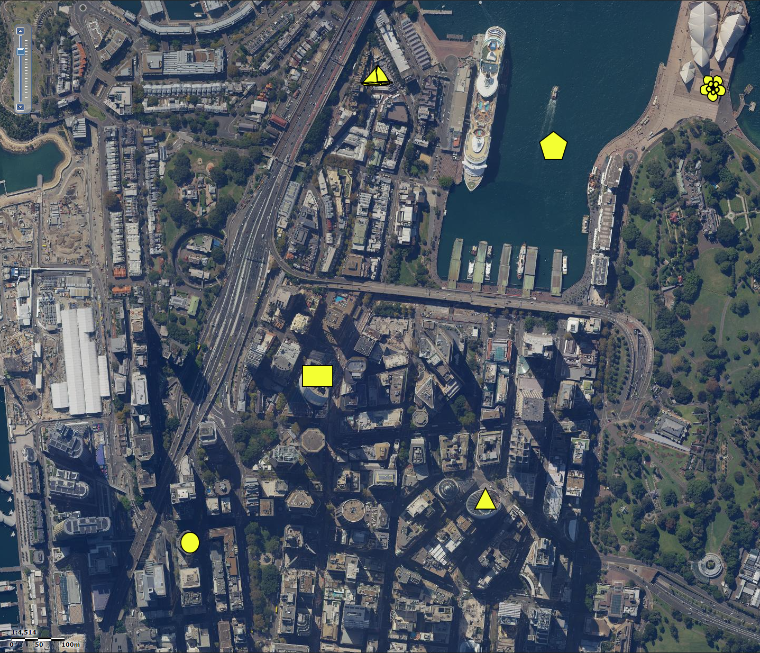
Map data ©2023 Google

Problem 2
Sydney and Albury are 555 km apart.
It takes a train 8 hours to travel from Sydney to Albury.
A car travels between the two cities at a constant speed of 110 km per hour.
How much slower is the train than the car?

Possible solutions

Appendix A – thin slicing
- Approximately 6 x 20 =120 km
- Approximately 8 x 2000= 16000 cm
- 1. 1:100
17 :1700 cm
Actual distance = 1700 cm
- 1:20000
13: 260000 cm
Actual distance = 2600 m
- 3. 1:25000
21: 525000 cm
Actual distance = 5.25 km

- 1:200
$$\frac{1}{200}:1$$
$$\frac{1120}{200}:1120mm$$
Scaled length = 5.6 mm
- 1.15 × 1500 = 1725
$$\frac{1}{200}:1$$
$$\frac{1725}{200}:1725mm$$
Scaled length of new shower = 8.625 mm
- 1:200
17:3400
Width of room is 3.4 m
1:200
26:5200
Width of room is 5.2 m
Area = 5.2 x 3.4
=17.68 m2
- 1:140 000
26.2:3668000 cm
Actual distance = 36.68 km
Time to travel = 36.68km / 7
= 5.24 hours

Appendix B – non-routine problems
Problem 1
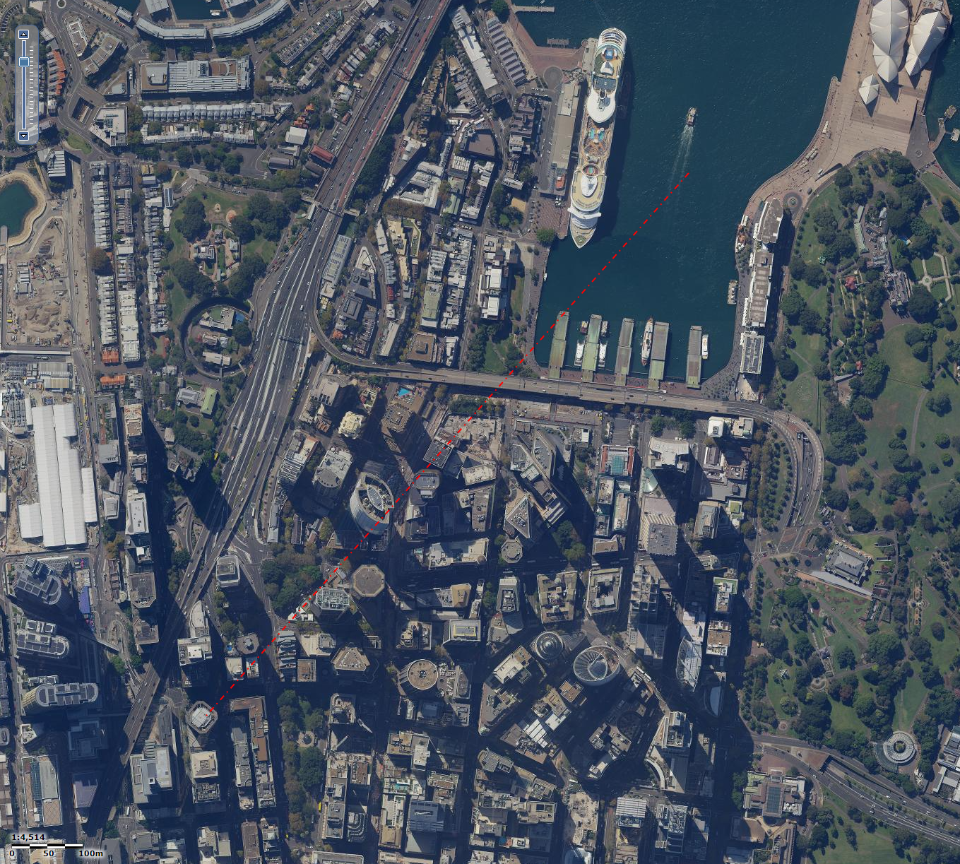
Circle is approx. 1000 m away
Problem 2
Time = $\frac{555}{110}$
= 5 hours and 2 minutes.
The train is 2 hours and 56 minutes slower than the car.
© State of New South Wales (Department of Education), 2023
The copyright material published in this resource is subject to the Copyright Act 1968 (Cth) and is owned by the NSW Department of Education or, where indicated, by a party other than the NSW Department of Education (third-party material).
Copyright material available in this resource and owned by the NSW Department of Education is licensed under a Creative Commons Attribution 4.0 International (CC BY 4.0) licence.
This licence allows you to share and adapt the material for any purpose, even commercially.
Attribution should be given to © State of New South Wales (Department of Education), 2023.
Material in this resource not available under a Creative Commons licence:
- the NSW Department of Education logo, other logos and trademark-protected material
- material owned by a third party that has been reproduced with permission. You will need to obtain permission from the third party to reuse its material.
Links to third-party material and websites
Please note that the provided (reading/viewing material/list/links/texts) are a suggestion only and implies no endorsement, by the New South Wales Department of Education, of any author, publisher, or book title. School principals and teachers are best placed to assess the suitability of resources that would complement the curriculum and reflect the needs and interests of their students.
If you use the links provided in this document to access a third-party's website, you acknowledge that the terms of use, including licence terms set out on the third-party's website apply to the use which may be made of the materials on that third-party website or where permitted by the Copyright Act 1968 (Cth). The department accepts no responsibility for content on third-party websites.

