Movie magic
In this lesson, students move from using scale factor between similar figures to using scale in non-routine ways. Students explore scale models used in The Lord of the Rings and Harry Potter movies and answer questions using a scale given as a ratio.

Visible learning

Learning intentions
- To develop students’ understanding of scale
- To solve problems involving ratios and scales

Success criteria
- I can describe how scale is used in real life situations
- I can solve scale problems using ratios

Syllabus outcomes
A student:
- develops understanding and fluency in mathematics through exploring and connecting mathematical concepts, choosing and applying mathematical techniques to solve problems, and communicating their thinking and reasoning coherently and clearly MAO-WM-01
- identifies and applies the properties of similar figures and scale drawings to solve problems MA5-GEO-C-01
Mathematics K–10 Syllabus © NSW Education Standards Authority (NESA) for and on behalf of the Crown in right of the State of New South Wales, 2022.

Please use the associated Movie magic PowerPoint to display images in this lesson.

Activity structure

Warm up
- Print and distribute Figure 1.
The size you print will affect the answer, so measure and come up with your own answer once you’ve printed.
Figure 1 – butterfly scale drawing
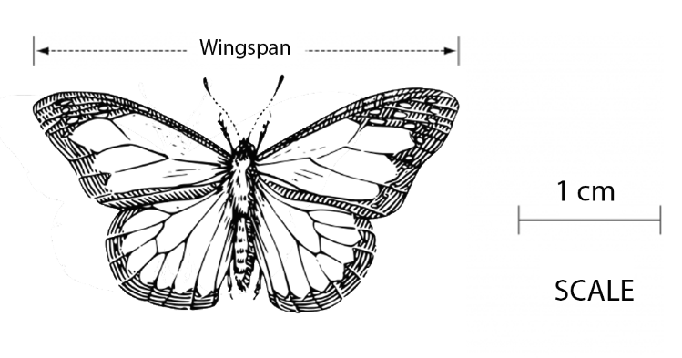
‘Butterfly Wings Insect’ by Clker-Free-Vector-Images is licensed under the Pixabay License.
- Ask students to:
- predict what questions might be asked about this image.
- pair up and answer their partner’s question.
- Ask students to share their questions with the class.
- Explain to students ‘What is the actual wingspan of the butterfly?’, presented similarly to Figure 1, was a HSC question (Std2 M7 2005). If students haven’t already suggested this as a possible question, answer it as a class.
- As a Think-Pair-Share (bit.ly/thinkpairsharestrategy), define ‘scale’.
- How many meanings does it have? (for example, scale mountain, scales on fish, enlarge or shrink, weighing device)
- Who would use scale? Why?
Scale has many origins. Its relationship to measurement came about in late 14th century, where the term ‘scala’ meaning ladder or flight of stairs was transformed to mean a series of marks laid down to determine distance along a line.

Launch
- Ask students if they have seen the Lord of the Rings or Hobbit movies. You might like to show a short video clip or look at some photos.
- What’s interesting about the Lord of the Rings sets, particularly the shire (where the movies often start) is that it was filmed in New Zealand. The set was destroyed after the original trilogy of movies, but with the more recent Hobbit trilogy, they built a permanent set that you can visit.
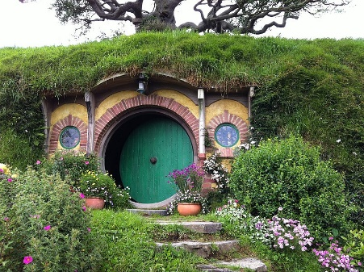  ‘Hobbit hole "Bag End" in Hobbiton’ by David Broad is licensed under CC-BY-3.0 | 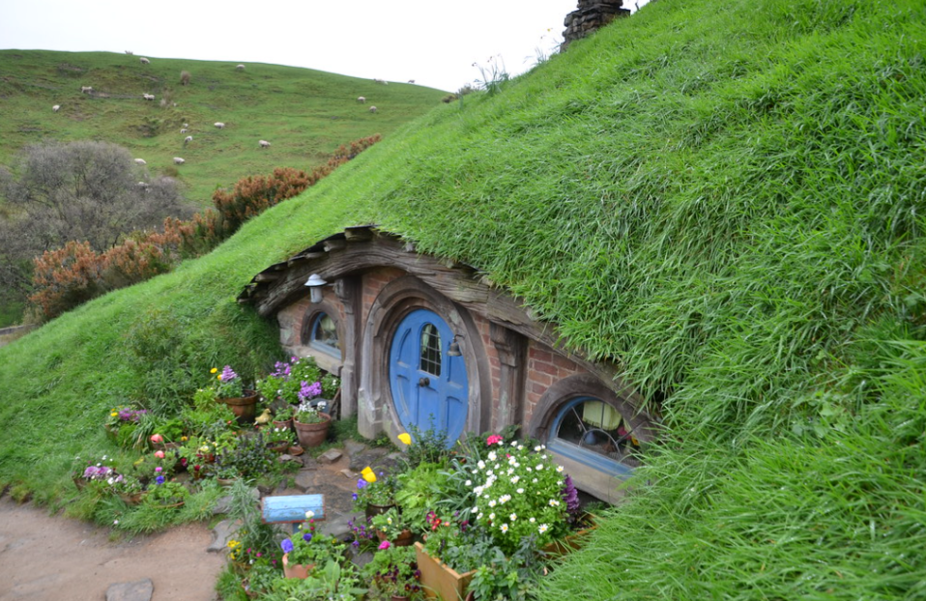  'Hobbit Hole -- Hobbiton Movie Set, Matamata, New Zealand 2016' by Joe Ross is licensed under CC BY-SA 2.0 | 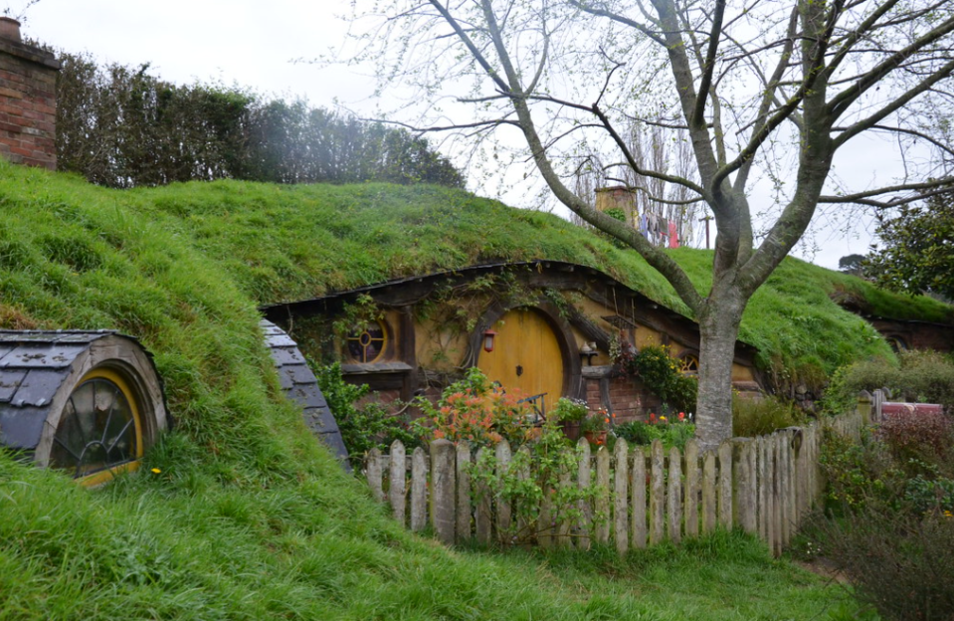  'Hobbit hole' by Joe Ross is licensed under CC BY-SA 2.0
- The hobbit holes are built in 3 different scales, 100% human scale, 90% human scale, and 60% human scale.
- Ask students why they would have built 3 different scale houses.
- The reason was to trick the viewer into thinking characters were larger or smaller than in real life. Hobbits, small characters, were filmed in front of the 100% human scale houses, whilst Gandalf, a very tall wizard, was filmed in front of the 60% human scale houses to give the impression that he was much taller.
- Film makers use scale to trick the viewer all the time.

- Ask students if they have seen the Harry Potter movies. You might like to show a short video or look at some photos.
- When students saw exterior shots of Hogwarts, the school in the Harry Potter movies, they were seeing a small-scale model of the building. The model was built for the first movie, ‘Harry Potter and the Philosophers Stone’ and has been used in every one of the Harry Potter movies since.
- Ask students why the film makers would create a model rather than building or using an existing castle. What are the benefits of using a scale model when filming?
You could display the Hogwarts scale model (Figure 5), or you could show Superb Model Hogwarts Castle Filming Miniature in the Snow (0:15): (https://bit.ly/Hogwarts_scale_model) which shows people surrounding the model which will help students understand the scale
Figure 2 – Hogwarts scale model
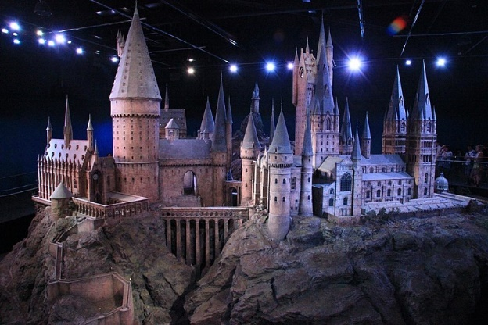
’The Making of Harry Potter 29-05-2012’ by Karen Roe is licensed by CC BY 2.0

Explore
- Present the following statement to students: ‘The Hogwarts Castle model was built to a 1:24 scale.’
- This means if a length is 5 cm wide, in the movies it would appear 24 times larger: 120 cm or 1.2 m.
- Print and distribute Appendix A. Students need to know the scale used was 1:24.
- Model calculating the ‘real’ size of a brick length as an example.
- In order to calculate ‘window height’ students will have to apply the inverse operation. Encourage students to solve this problem on their own or with a partner and reflect as a class on strategies used.

Summarise
- Have students write notes to their future selves (bit.ly/notesstrategy) for applying scale when written as a ratio.
Example responses
The tree from the Hogwarts model was 14 cm tall.
The ratio used was 1:24 which means its ‘real’ size would be 24 times longer.
14x24=336 cm
So the tree is 336 cm in real life.
The window height in real life was 5 m tall.
The ratio used was 1:24 which means it’s scale model would be $\frac{1}{24}$^{th} of its length.
5 x $\frac{1}{24}$=0.21 m
It’s important that students understand that units stay the same, they could convert units before or after scaling.

Apply
- Print and distribute Appendix B.
- Students should complete the task individually.

Assessment and Differentiation

Suggested opportunities for differentiation
Explore
- If working from the provided activities is not accessible for your students, have them use the same 1:24 scale to find how small, real things in the classroom or around the school, would be.
- Teachers could also choose to simplify the scale to 1:20 or even 1:10 to assist students in their calculations.
- Challenge students to generalise a rule for the result when multiplying by a scale factor greater than 1 and less than 1.
Extension
- Print or display Appendix C – extension component, for the Hagrid’s shack task.

Suggested opportunities for assessment
- Students could complete Appendix C as an exit ticket.
- Review students’ notes to future self and ensure they have correct procedures for both enlargement and reduction.

Appendix A

Hogwarts scale model
Each of the measurements below was taken from the scale model.
Convert each length into its ‘real’ size. (Round answers to 2 decimal places if required.)
Object | Scale model | ‘Real’ size
Brick length | 1 cm
Chimney height | 64 cm
Window height |  | 5 m
Bridge length |  | 18 m
Tree height | 14 cm
Dome roof diameter |  | 7.5 m

Appendix B

Hagrid’s shack

Task
Hagrid’s shack is a well-known location on Hogwarts grounds. Next to his shack is plot of land where Hagrid grows crops.
The set designers had to build a farm that was based on the scale model already built.
Given the scale drawing below calculate the total area to be filled with soil.
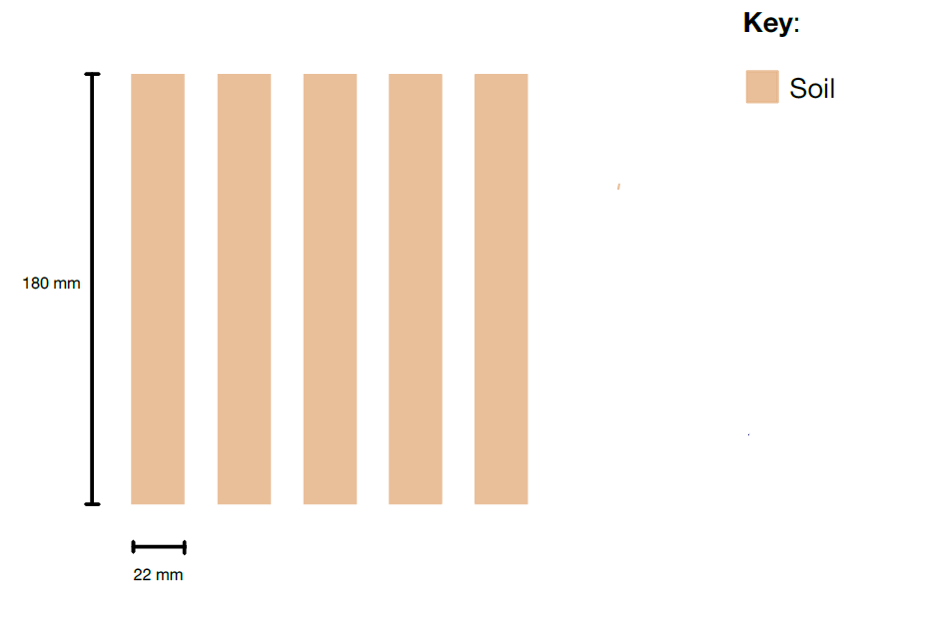

Appendix C

Extension component
The set designers want to plant the maximum number of pumpkins in the soil. Each pumpkin will grow to have a diameter of 50 cm.
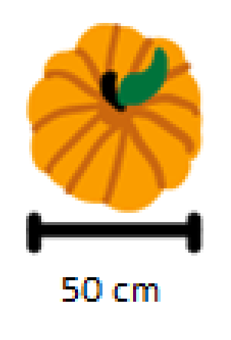
What is the maximum number of pumpkins that can be planted?

Suggested solutions

Appendix A – Hogwarts scale model
Object | Scale model | ‘Real’ size
Brick length | 1 cm | 24 cm
Chimney height | 64 cm | 1536 cm = 15.63 m
Window height | 20.83 cm | 5 m
Bridge length | 75 cm | 18 m
Tree height | 14 cm | 336 m = 3.36 m
Dome roof diameter | 31.25 cm | 7.5 m

Appendix B – Hagrid’s shack
Length = 180 x 24 = 4320 mm = 4.32 m
Width = 22 x 24 = 528 mm = 0.528 m
Area = 4.32 x 0.528 x 5 = 11.4 m²

Appendix C – Extension component
With the width being 50 cm, only 1 pumpkin will fit width ways.
432/50=8.64
So 8 pumpkins will fit in each row therefore, 40 pumpkins altogether.
© State of New South Wales (Department of Education), 2023
The copyright material published in this resource is subject to the Copyright Act 1968 (Cth) and is owned by the NSW Department of Education or, where indicated, by a party other than the NSW Department of Education (third-party material).
Copyright material available in this resource and owned by the NSW Department of Education is licensed under a Creative Commons Attribution 4.0 International (CC BY 4.0) licence.
This licence allows you to share and adapt the material for any purpose, even commercially.
Attribution should be given to © State of New South Wales (Department of Education), 2023.
Material in this resource not available under a Creative Commons licence:
- the NSW Department of Education logo, other logos and trademark-protected material
- material owned by a third party that has been reproduced with permission. You will need to obtain permission from the third party to reuse its material.
Links to third-party material and websites
Please note that the provided (reading/viewing material/list/links/texts) are a suggestion only and implies no endorsement, by the New South Wales Department of Education, of any author, publisher, or book title. School principals and teachers are best placed to assess the suitability of resources that would complement the curriculum and reflect the needs and interests of their students.
If you use the links provided in this document to access a third-party's website, you acknowledge that the terms of use, including licence terms set out on the third-party's website apply to the use which may be made of the materials on that third-party website or where permitted by the Copyright Act 1968 (Cth). The department accepts no responsibility for content on third-party websites.

