Scale factor in similar triangles
Students explore similar triangles in routine and non-routine problems, with a focus on exploring shadows.
There are lots of options and potential activities in this lesson. You could make choices and deliver this as one lesson, or you could utilise every activity and spread it out over multiple lessons.

Visible learning

Learning intention
- To solve routine and non-routine problems involving similar triangles.

Success criteria
- I can solve routine problems using similar triangles.
- I can recognise problems I can solve using similar triangles.

Syllabus outcomes
A student:
- develops understanding and fluency in mathematics through exploring and connecting mathematical concepts, choosing and applying mathematical techniques to solve problems, and communicating their thinking and reasoning coherently and clearly MAO-WM-01
- identifies and applies the properties of similar figures and scale drawings to solve problems MA5-GEO-C-01
Mathematics K–10 Syllabus © NSW Education Standards Authority (NESA) for and on behalf of the Crown in right of the State of New South Wales, 2022.
Please use the associated PowerPoint Scale factor in similar triangles to display images in this lesson.

Activity structure

Warm up
- Display Figure 1 as students enter the room.
- Have students draw the 4 triangles and find as many missing values as possible.
- The 4 triangles shown in Figure 1 are similar. Find as many missing values as you can.
Figure 1 – four triangles
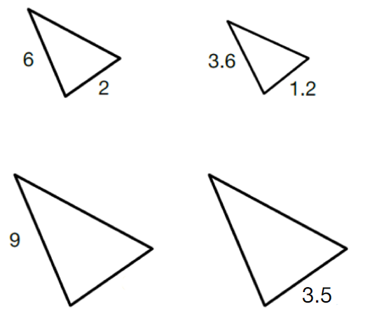

Launch
- Display Figure 2.
Figure 2 – three highlighters in different positions
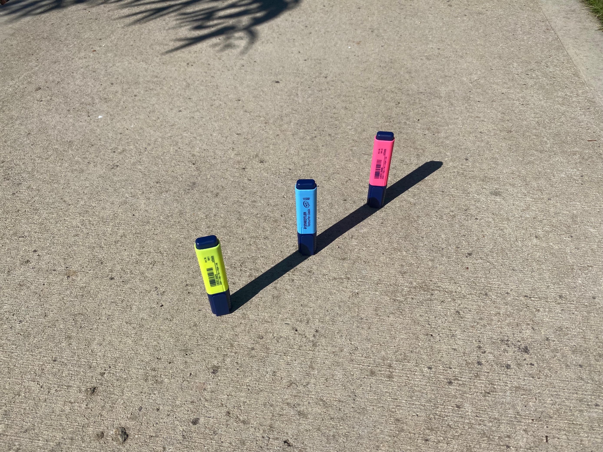
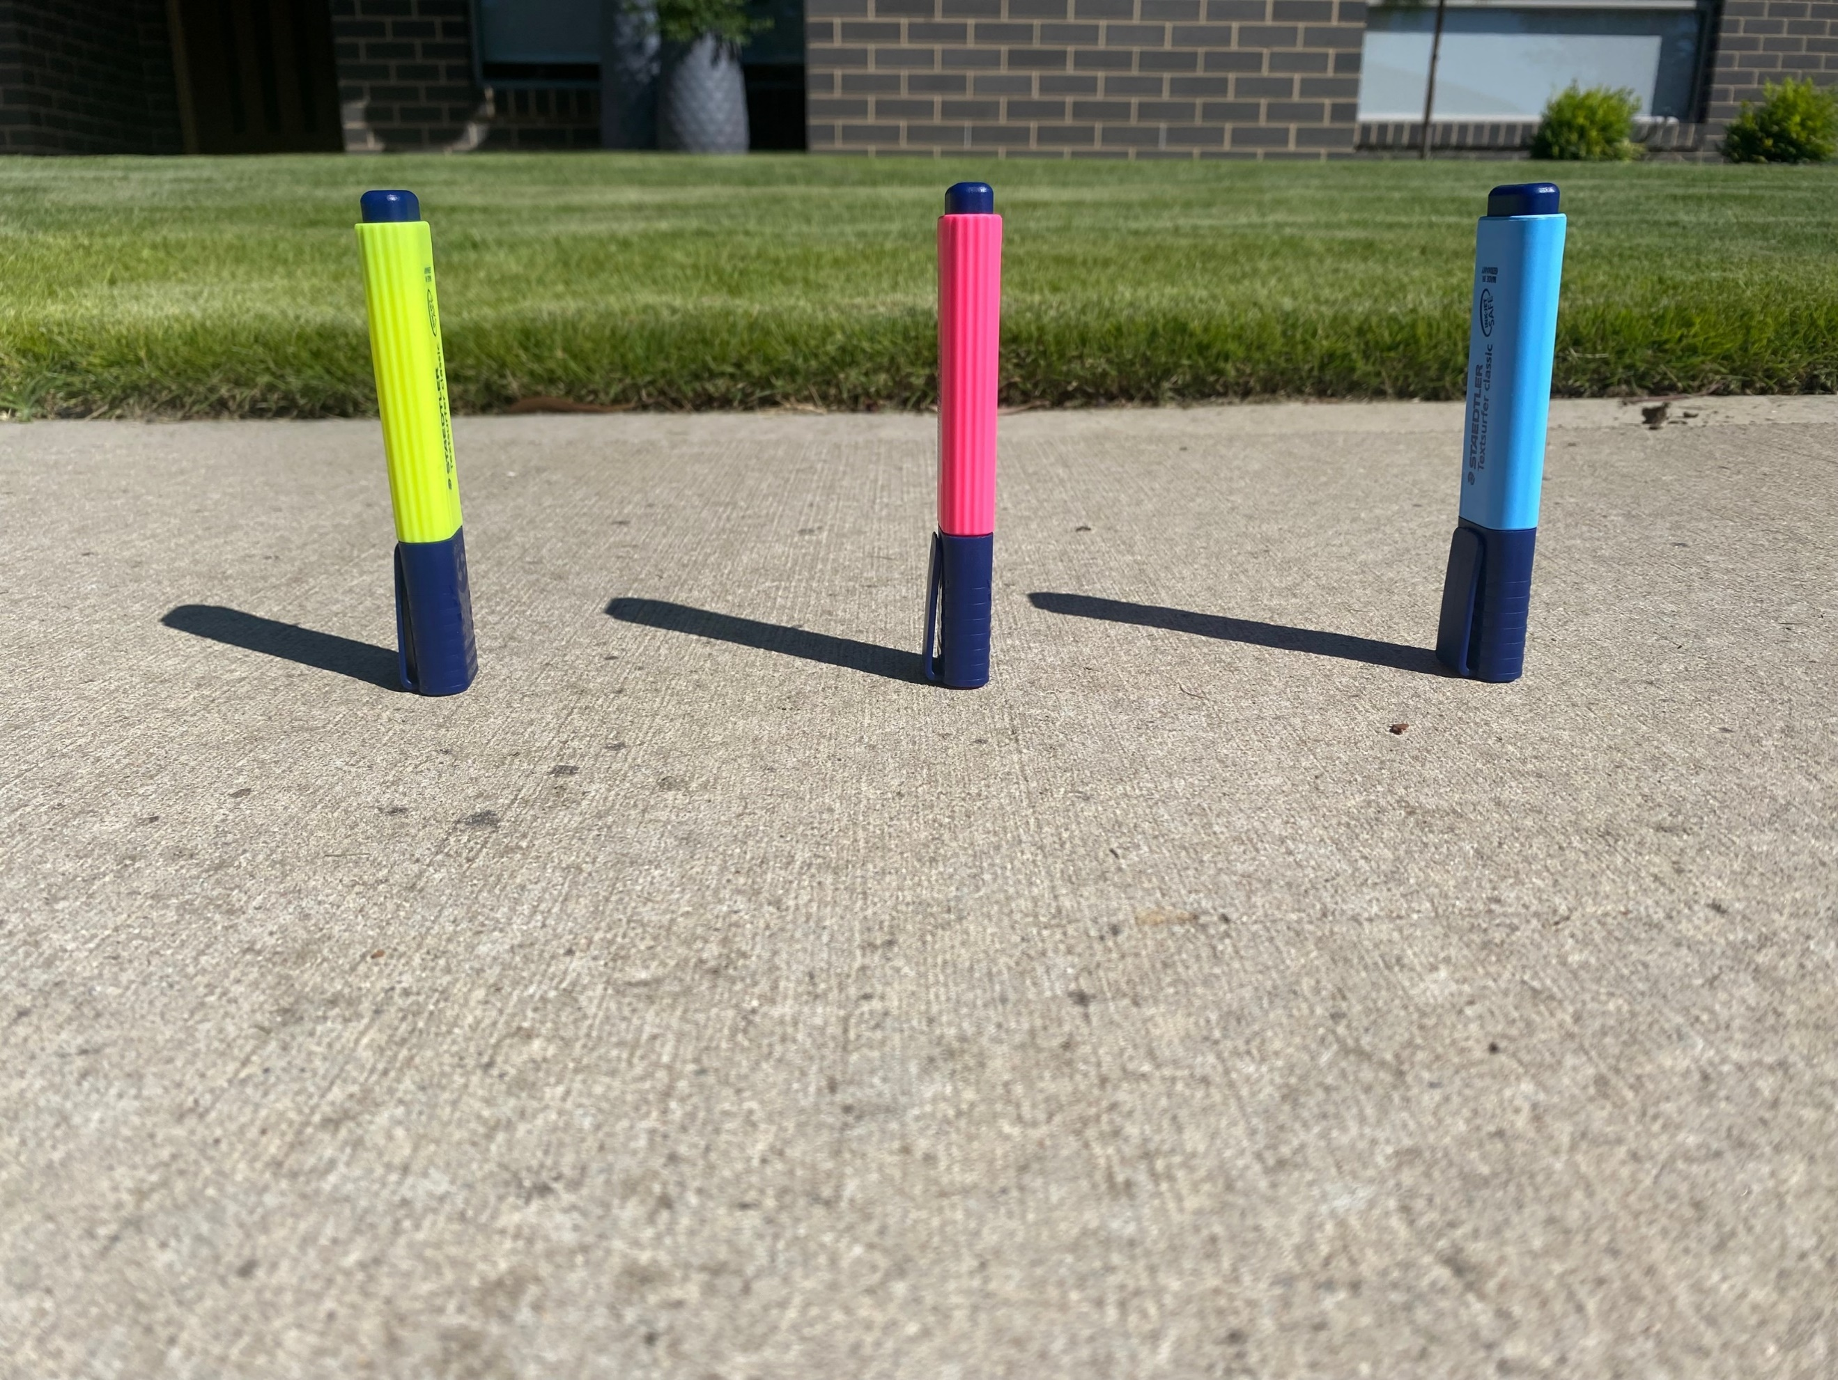
- Have students create a notice/wonder list (bit.ly/noticewonderstrategy) based on Figure 2.
- In discussing students’ notice/wonder lists, emphasise similar triangles. You could even draw a triangle over each highlighter and its shadow.
Ensure students understand that for this lesson, we will assume shadows cast form similar triangles.

Explore

Shadows
- Display Figure 3.
Figure 3 – bottle and highlighter with shadows
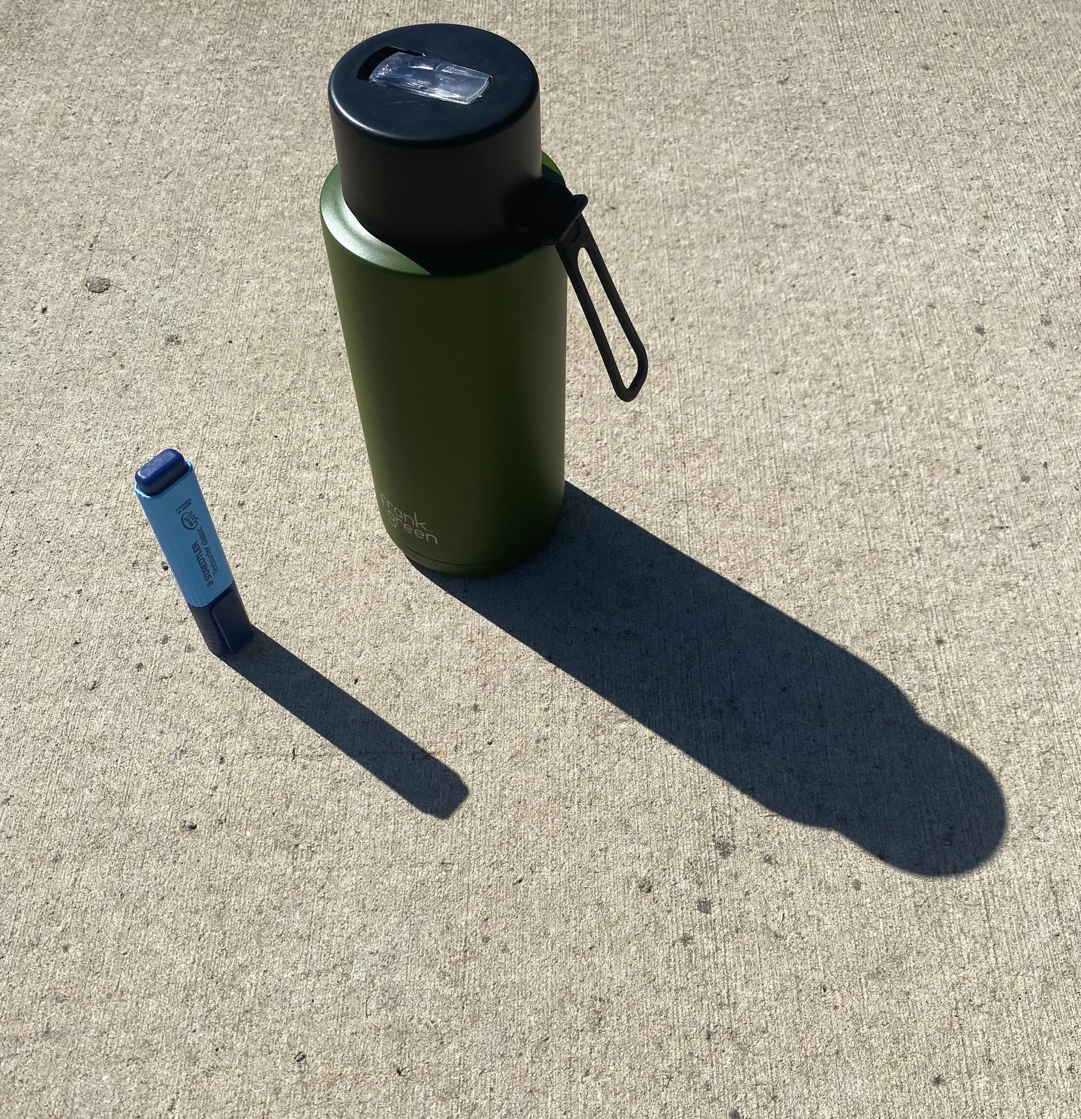
- Give students thinking time.
- Ask students what maths we could do with the image provided. Prompt students to think of larger scale contexts where this would be useful.

- Display Figure 4.
Figure 4 – person and tree with shadows
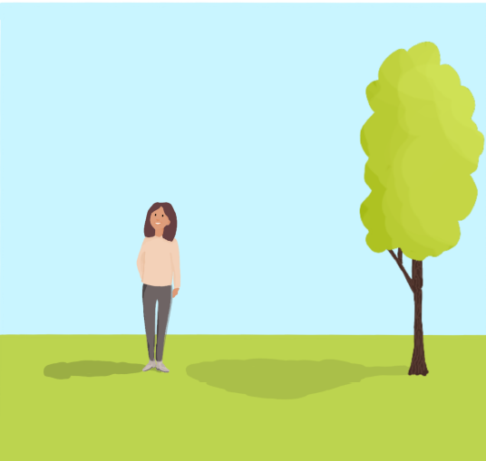
- Have students suggest what we could find out about the image presented.
- Ensure students are all aware of the similar triangles present.
- Lead students to finding the height of the tree.
- Ask students what information they would need to find the height of the tree (assuming we can’t measure the tree ourselves).

- To provide this information you could do any of the following:
- display Figure 5
- add the measurements on yourself
- print and have students draw the measurements on.
Figure 5 – person and tree with shadows with measurements
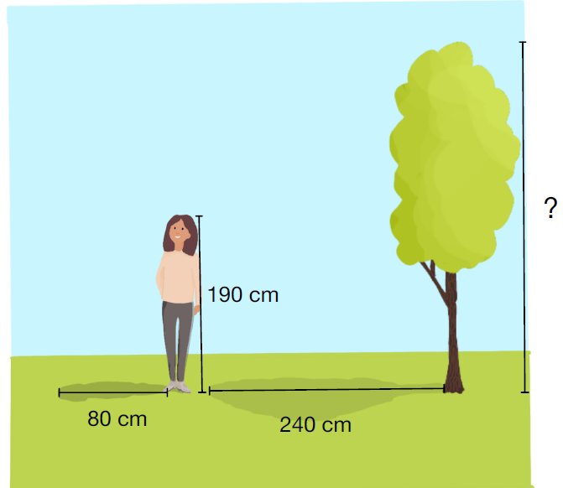
- Ask students to find the height of the tree.
- Gather student responses and emphasise the multiple possible approaches.
- Model a correct response.

Similar triangles
- Display Figure 6.
Figure 6 – two triangles
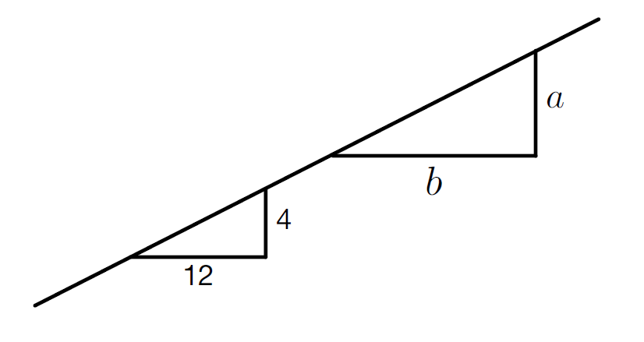
- Ask students to answer these questions using the pounce/bounce (https://www.youtube.com/watch?v=808ogFj3sD4) technique to have other students extend responses:
- Are these triangles similar (How do you know? Discuss slope)?
- Determine the value of $\frac{a}{b}$ (Why do we care about $\frac{a}{b}$? What does $\frac{a}{b}$ mean?)?
- Model for students how to use the ratio method to find missing lengths in similar triangles.
- Emphasise that this method is only applicable if 2 figures are known to be similar, which is why it was important that we recognised these to be similar triangles.

Thin slicing activity
- Print and distribute Appendix A.
- Students should draw the questions and solutions, making notes to their future selves on any strategies or important points to remember.

Summarise
- Have students create a problem that can be solved using similar triangles.
- Have students write notes to their future selves (bit.ly/notesstrategy) explaining how to solve the problem.
In addition, you could ask students to identify where they might go wrong with solving this style of question in the future. How could their notes help to prevent that?

Apply

GeoGebra summary
- Have students access: geogebra.org/m/pQMyRNE5
- Have students engage in a Think-Pair-Share with the applet.
- Prompting questions might include:
- Why are the sides written as a fraction?
- Why are the fractions always the same?
- What does the angle affect?
- Is there an angle that causes the shadows to be equal?
- Ensure students understand that the 2 bottom fractions are important when working with similar triangles.
- Explain that a ratio of 2 corresponding sides will always be equal between 2 similar triangles.

Chalk and shadows summary

Equipment
- Tape measures
- Chalk

Method
- Take students outside in groups.
- Students use chalk to mark out the length of 2 group members’ shadows.
- Students then measure the 2 group members and their shadows.
- Verify that the sun creates similar triangles.
If students’ results do not produce similar triangles, encourage discussion of possible reasons why this would occur.
- Conclude this activity by recognising similar triangles are an important and naturally occurring concept. If we know the measurements of a smaller triangle, we can use the idea of scale factor to find the measurements of a larger similar triangle.

Assessment and Differentiation

Suggested opportunities for differentiation
Warm up
- If students need extending, have them create a set of 4 triangles, with only 3 being similar. Swap with a partner and prove which one doesn’t belong.
Launch
- If students aren’t quite ready to access the questions in this activity, you could have students experiment with shadows and lengths outside and create a set of questions based on their experiments.
Summarise
- Thin slicing activity: If students are struggling, draw a similar problem with different numbers and model a correct solution, and complete the activity as a faded example exercise. Students could also complete these activities in random groups of 3 at a vertical non-permanent surface.
Apply
Activities to take the concepts within this lesson further:
- Shadow bars
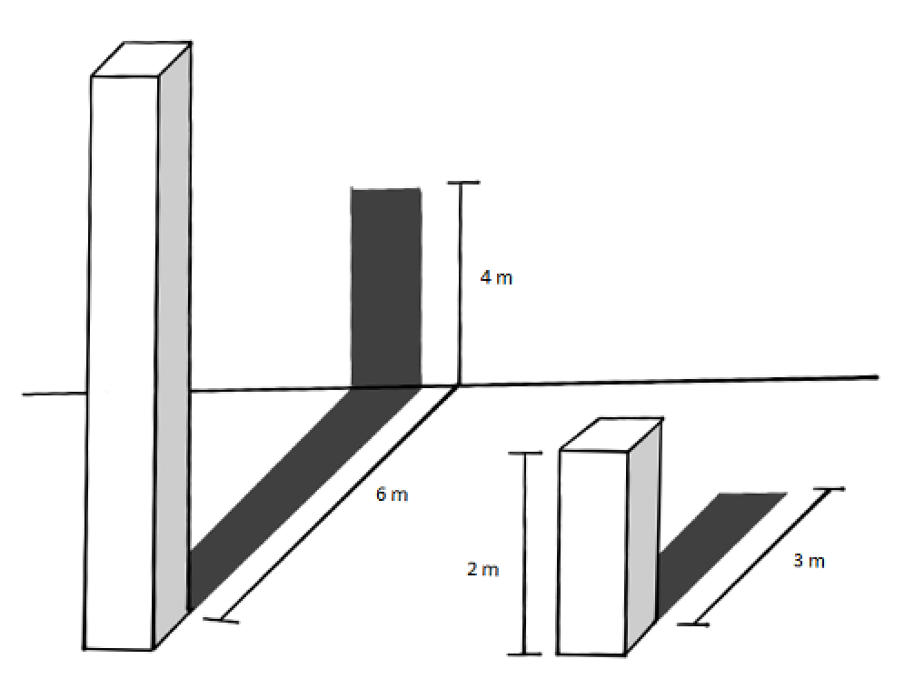
- This is a well-known maths problem that has a deeper solution than first meets the eye. It’s a great opportunity to address students’ misconceptions about geometry.
- If you have a class who are enthusiastic about finding the solution, there are answers explained below. The total height of the left bar is 8 metres.
- Matter of scale
- This activity is from NRICH and can be accessed at (nrich.maths.org/811/index).

Suggested opportunities for assessment
- Warm up activity acts as a hinge point question. If students are unsure of how to find missing sides, this might be a point for revision before continuing with this lesson.
- Review students’ notes to future selves.
- Students could choose an activity from the Summarise section to produce a piece of work for assessment.

Appendix A
- Find the missing side length $x$
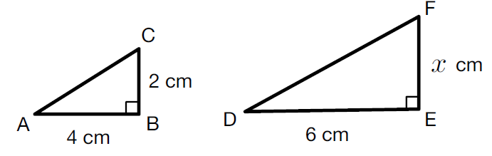
- Find the missing side length $x$
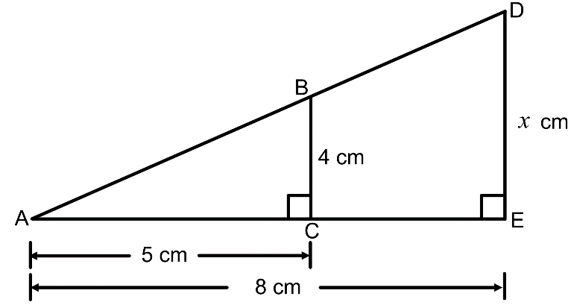

- Find the length of $AE$ in the triangle $ACE$
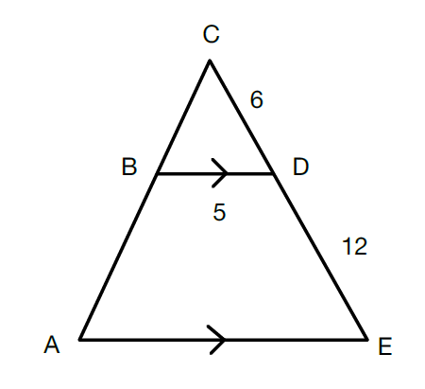
- Find the value of $x$and hence find the scale factor used to reduce triangle $ABC$ to triangle $DEF$
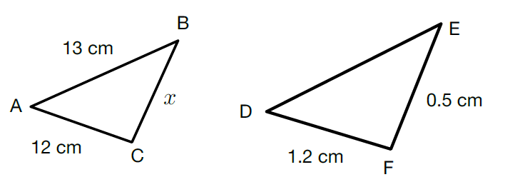

- Find the missing side length $x$
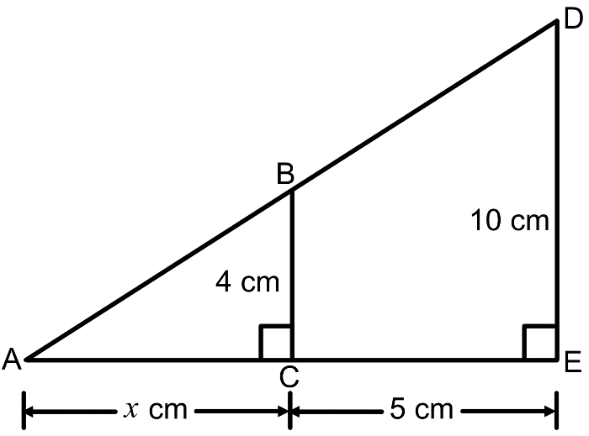

- Line 𝐴𝐵 passes through points 𝐴 (11,12) and 𝐵 (14,18). Find the coordinates of the point 𝑃 that lies on the 𝑥-axis.
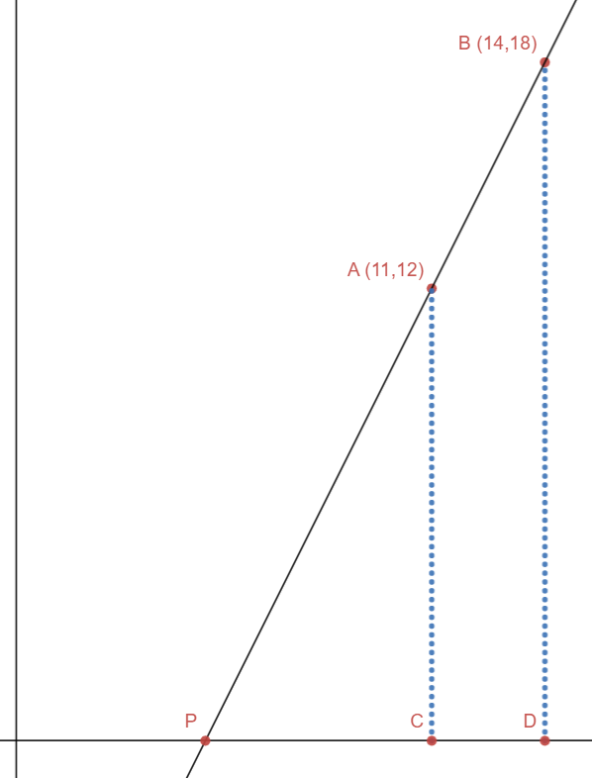

Sample solutions

Appendix A
1.  $$\frac{AB}{DE}=\frac{BC}{EF}$$  $$\frac{4}{6}=\frac{2}{x}$$  $$4x=24$$  $$x=6$$ | 2.  $$\frac{AC}{AE}=\frac{BC}{DE}$$  $$\frac{5}{8}=\frac{4}{x}$$  $$5x=32$$  $$x=6.4$$
3.  $$\frac{CD}{CE}=\frac{BD}{AE}$$  $$\frac{6}{18}=\frac{5}{AE}$$  $$6AE=90$$  $$AE=15$$ | 4.  $$\frac{AC}{DF}=\frac{BC}{EF}$$  $$\frac{12}{1.2}=\frac{x}{0.5}$$  $$12×0.5=1.2x$$  $$x=5$$  Scale factor = = $\frac{1}{10}$
5.  $$\frac{AC}{AE}=\frac{BC}{DE}$$  $$\frac{4}{10}=\frac{x}{x+5}$$  $$10x=4(x+5)$$  $$6x=20$$  $$x=\frac{10}{3}$$ | 6.  Let$y = PC$  $$\frac{AC}{BD}=\frac{PC}{PD}$$  $$\frac{12}{18}=\frac{y}{y+3}$$  $18y=12(y+3)$  $$6y=36$$  $$y=6$$  $$∴x=5$$  If you would like to display this question using Desmos: https://www.desmos.com/calculator/wasivplrg9

Explore
Shadows activity – height of tree
Method 1  $$\frac{240}{80}=3$$  So scale factor $=3$  So tree is $3×190=570 cm$ | Method 2  $$\frac{190}{80}=2.375$$  So tree is $240×2.375=570 cm$
Thin slicing activity

$$\frac{AE}{CE}=\frac{BD}{CD}$$
$$\frac{AE}{18}=\frac{5}{6}$$
$$AE=\frac{5}{6}×18$$
$$AE=15$$

Students could write the fractions as $\frac{CE}{AE}$ which would require solving an equation where the pronumeral is on the denominator. If this is the case, have students consider why this happened and if they could develop a strategy to avoid this in future questions.
- This question requires students to think about which sides are important and their role in the process.
Students could solve this problem by finding the scale factor, recognising this is a right triangle, or using the ratio method.
Suggested opportunities for differentiation –shadow bars
This website contains an explanation to the shadow bars problem:
https://math.stackexchange.com/questions/2471016/find-the-height-of-a-bar-given-the-lengths-of-shadows-cast-by-it-and-another-bar

© State of New South Wales (Department of Education), 2023
The copyright material published in this resource is subject to the Copyright Act 1968 (Cth) and is owned by the NSW Department of Education or, where indicated, by a party other than the NSW Department of Education (third-party material).
Copyright material available in this resource and owned by the NSW Department of Education is licensed under a Creative Commons Attribution 4.0 International (CC BY 4.0) licence.
This licence allows you to share and adapt the material for any purpose, even commercially.
Attribution should be given to © State of New South Wales (Department of Education), 2023.
Material in this resource not available under a Creative Commons licence:
- the NSW Department of Education logo, other logos and trademark-protected material
- material owned by a third party that has been reproduced with permission. You will need to obtain permission from the third party to reuse its material.
Links to third-party material and websites
Please note that the provided (reading/viewing material/list/links/texts) are a suggestion only and implies no endorsement, by the New South Wales Department of Education, of any author, publisher, or book title. School principals and teachers are best placed to assess the suitability of resources that would complement the curriculum and reflect the needs and interests of their students.
If you use the links provided in this document to access a third-party's website, you acknowledge that the terms of use, including licence terms set out on the third-party's website apply to the use which may be made of the materials on that third-party website or where permitted by the Copyright Act 1968 (Cth). The department accepts no responsibility for content on third-party websites.

