# Corresponding sides and angles

This lesson introduces students to formal similarity statements for corresponding sides and angles through explicit teaching with faded examples.

## Visible learning

In this lesson, the learning intentions and success criteria are introduced within the launch rather than at the beginning of the lesson.

### Learning intentions

* To match corresponding sides and angles of similar figures.
* To write similarity statements using appropriate notation.

### Success criteria

* I can locate sides and angles using labelled vertices.
* I can identify corresponding sides and angles within similar figures.
* I can explain the meaning of symbols used in similarity statements.
* I can write similarity statements.

### Syllabus outcomes

A student:

* develops understanding and fluency in mathematics through exploring and connecting mathematical concepts, choosing and applying mathematical techniques to solve problems, and communicating their thinking and reasoning coherently and clearly **MAO-WM-01**
* identifies and applies the properties of similar figures and scale drawings to solve problems **MA5-GEO-C-01**

[Mathematics K–10 Syllabus](https://curriculum.nsw.edu.au/learning-areas/mathematics/mathematics-k-10-2022) © NSW Education Standards Authority (NESA) for and on behalf of the Crown in right of the State of New South Wales, 2022.

Please use the associated PowerPoint Corresponding sides and angles to display images in this lesson.

## Activity structure

### Warm up

1. Print and cut out each card from Appendix A (enough for one per student).
2. As students enter the room, hand them a random card for which they are to find all missing angle measures without the use of a protractor.
3. Encourage collaboration as students sitting next to each other will hopefully have different cards. Cards could be placed on student desks to ensure this.
4. Once the activity is completed, have students reflect on which angles they were confident finding, which angles they needed help to find and what mathematics they have to remember to find their missing angles?

### Launch

1. Display Figure 1.

Figure 1 – 4 triangles

Triangles:
ABC is equilateral.
DEF has 130 and 30 degree angles.
GHI is isosceles with a 55 degree angle between one of the equal sides and the other side.
JKL is a right-angled triangle.

1. Have students justify [which one doesn’t belong](http://www.meaningfulmathmoments.com/which-one-doesnt-belong-wodb.html) ([bit.ly/wodbstrategy](https://bit.ly/wodbstrategy)) in a [Think-Pair-Share](https://app.education.nsw.gov.au/digital-learning-selector/LearningActivity/Card/645) ([bit.ly/thinkpairsharestrategy](https://bit.ly/thinkpairsharestrategy)).

Students will likely struggle to explain their thinking. This is an opportunity to emphasise the need for naming conventions. Model correct naming conventions to assist students sharing with the class, then encourage students to share their suggestions using correct terminology.

1. Explain to students why we need terminology and conventions when discussing similar figures.
2. Introduce the learning intentions and success criteria at this point.

#### Word web

As polygon may be a new word for students, it’s important they understand its meaning.

1. Write the suffix gon on the board and have students perform a Think-Pair-Share to create a list of words that end with gon.
2. Use students’ words and the etymology of gon (Greek origin, meaning -angled) to establish the definition of polygon.

This is also a good opportunity to discuss the similarities and differences between the terms polygons and figures.

**Polygon** is a plane figure with at least 3 straight sides and angles

Etymology: (Greek) polugōnos ‘many-angled’

**Figure** has many definitions but in this context means a diagram or shape

Etymology: (Latin) figura ‘shape, figure, form’

### Explore

1. Display Figure 2.

Figure 2 – 2 rectangles with similarity statement

Small rectangle ABCD
Larger similar rectangle EFGH

1. Students create a [Notice and Wonder](https://www.nctm.org/noticeandwonder/) list ([bit.ly/noticewonderstrategy](https://bit.ly/noticewonderstrategy)) for Figure 2 with a partner.
2. Highlight the similarity statement at the top and ask students to suggest what the ~ (tilda) symbol might mean.

Draw attention to the order of the vertices in the similarity statement (ABCD ~ EFGH). Students need to understand that A, B are matching with vertices E,F, and therefore AB is corresponding to EF.

1. Explain to students that corresponding sides are written as fractions to communicate that corresponding sides in similar figures are in proportion (equal).
2. If students struggle to match corresponding sides in similar figures, they might benefit from being explicitly taught how to identify corresponding sides.

#### Faded examples

1. Print and distribute Appendix B to students.
2. Display Example 1.
3. Have students construct a [Notice and Wonder](https://www.nctm.org/noticeandwonder/) list ([bit.ly/noticewonderstrategy](https://bit.ly/noticewonderstrategy)) for Example 1.
4. Students should identify ($∼$) to mean similar. Ask students to explain why sides are written as fractions and angles have the equal sign ($=$).
5. Model Example 1 for students, explaining the [faded example structure](https://iopscience.iop.org/article/10.1088/1742-6596/1097/1/012114#:~:text=Faded-examples%20consist%20of%20completion,fading%20and%20backward%20fading%20types.) ([bit.ly/fadedexamplesstrategy](https://bit.ly/fadedexamplesstrategy)). In Example 1, the only missing information is side HE and $∠$ EHG.

#### Example 1

Figure 3 – example 1 from Appendix B

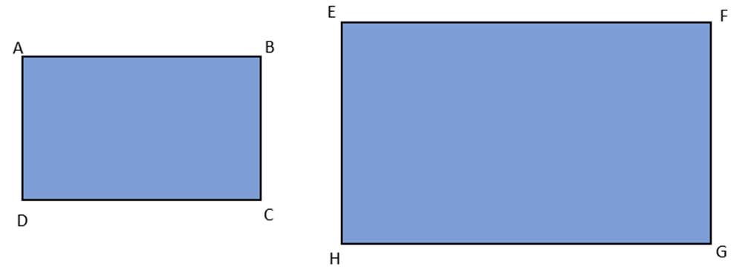

|  |  |
| --- | --- |
| **Sides** | **Angles** |
| $$\frac{AB}{EF}=\frac{BC}{FG}=\frac{CD}{GH}=\frac{DA}{\left[ \right]}$$ | $$∠BAD=∠FEH$$ $$∠ABC=∠EFG$$ $$∠BCD=∠FGH$$ $$∠ADC=$$ |

$$∴ABCD\sim EFGH$$

1. Students should now attempt Examples 2 through to 4 from Appendix B.

### Summarise

1. Display Figure 4.

Figure 4 – exit ticket

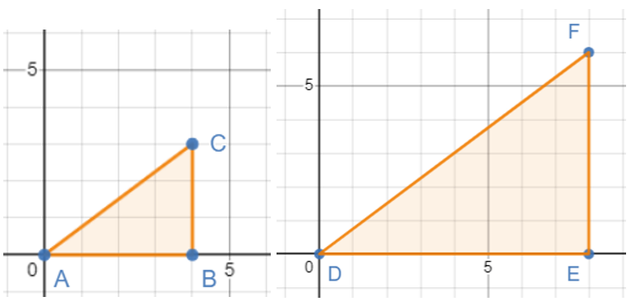

1. Print and distribute Appendix C to students.
2. Define show with students. Ultimately, they are replicating the process completed in the faded examples.

### Apply

In this lesson, students have revised angle properties, naming conventions and similarity. Students know that finding 2 congruent angle pairs is sufficient to show similarity. Students can recognise 2 figures are similar if one is an enlargement of another.

1. Print Appendix D so that each student has 4 copies of Image A to draw on, colour in and cut.
2. Encourage students to work collaboratively to find every triangle similar to $∆DJI.$

## Assessment and Differentiation

### Suggested opportunities for differentiation

**Explore**

* If needed, assist students by modelling steps of faded examples until they are able to work independently.

**Summarise**

* Rather than asking students to show, you could direct students to this link: <https://teacher.desmos.com/activitybuilder/custom/63e2ea7a6ab51e3b9c63dac1>

And have them justify why each scaled copy is a similar triangle.

### Suggested opportunities for assessment

* Review students’ faded examples activity.
* Exit ticket – see Appendix C.

## Appendix A

### Finding angles activity

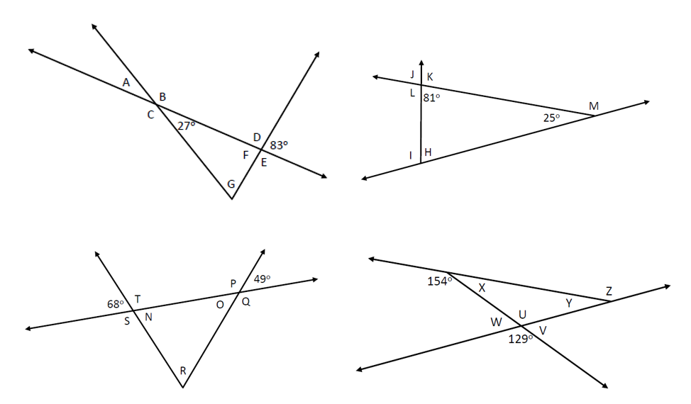

## Appendix B

### Corresponding sides and angles

#### Example 1

Two similar rectangles
ABCD and EFGH

|  |  |
| --- | --- |
| **Sides** | **Angles** |
|  |  |

#### Example 2

Two similar shapes
ABCDE and LMNOPQ

|  |  |
| --- | --- |
| **Sides** | **Angles** |
|  |  |

#### Example 3

Two similar right-angled triangles
ABC and PRQ

|  |  |
| --- | --- |
| **Sides** | **Angles** |
|  |  |

#### Example 4

**Hint:** You may like to draw these 2 triangles separately before you try to match up the sides and angles.

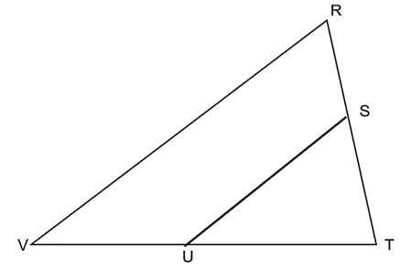

|  |  |
| --- | --- |
| Sides | Angles |

## Appendix C

### Exit ticket

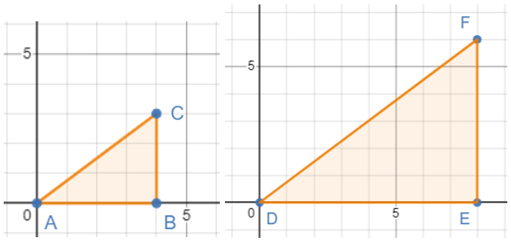

1. Show that $∆ABC$ and ∆ $DEF$ are similar.
2. What is the scale factor from $∆ABC$ to ∆ $DEF$?

## Appendix D

### Pentagon and on and on …

Three different scale factors were used to make triangles similar to $∆AIJ$.

In the diagram, find at least one triangle of each size that is similar to .

Pentagon ABCDE with lines joining to the opposite vertex.
FGHIJ points mark the intersection of the lines joining the vertices.

## Sample solutions

### Appendix A

1.

A=27° B=153° C=153° D=97°

E=97° F=83° G=70°

2.

H=74° I=106° J=81° K=99°

L=99° M=155°

3.

N=68° O=49° P =131° Q=131°

R=63° S=117° T=117°

4.

U=129° V=51° W=51°

X=26° Y=25° Z=155°

### Appendix B

#### Example 1

Two similar rectangles
ABCD and EFGH

|  |  |
| --- | --- |
| **Sides** | **Angles** |
|  |  |

#### Example 2

Two similar shapes
ABCDE and LMNOPQ

|  |  |
| --- | --- |
| **Sides** | **Angles** |
|  |  |

#### Example 3

Two similar right-angled triangles
ABC and PRQ

|  |  |
| --- | --- |
| **Sides** | **Angles** |
|  |  |

#### Example 4

**Hint:** You may like to draw these 2 triangles separately before you try to match up the sides and angles.

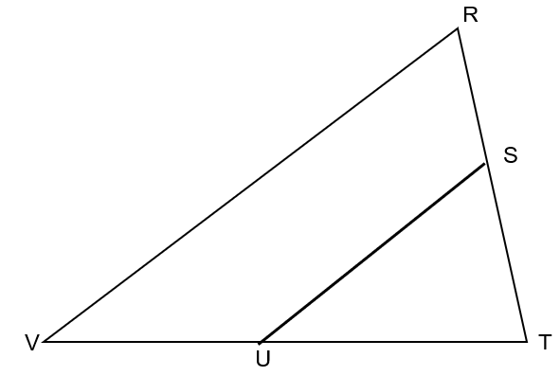

|  |  |
| --- | --- |
| **Sides** | **Angles** |
| $$\frac{TU}{TV}=\frac{TS}{TR}=\frac{SU}{RV}$$ | $$∠TUS=∠TVR$$ $$∠TSU=∠TRV$$ $$∠STU=∠RTV$$ |

$$∴△TUS\sim △TVR$$

### Appendix C

$$AB:DE=4:8$$

$$BC:EF=3:6$$

$AC:DF=5:10$ (Pythagoras Theorem)

All corresponding sides are in the same ratio therefore are similar triangles.

The scale factor is 2.

### Appendix D

Congruent to AIJ: EJF, DFG, CGH and so on.

Larger scaled copy of AIJ: BAJ, EIA, DJE, and so on.

Largest scaled copy of AIJ: ACD, DBE, and so on.

Important to address: BAE is not similar to AIJ.

Pentagon ABCDE with lines joining to the opposite vertex
FGHIJ points mark the intersection of the lines joining the vertices

**© State of New South Wales (Department of Education), 2023**

The copyright material published in this resource is subject to the *Copyright Act 1968* (Cth) and is owned by the NSW Department of Education or, where indicated, by a party other than the NSW Department of Education (third-party material).

Copyright material available in this resource and owned by the NSW Department of Education is licensed under a [Creative Commons Attribution 4.0 International (CC BY 4.0) licence](https://creativecommons.org/licenses/by/4.0/).

[](https://creativecommons.org/licenses/by/4.0/)

This licence allows you to share and adapt the material for any purpose, even commercially.

Attribution should be given to © State of New South Wales (Department of Education), 2023.

Material in this resource not available under a Creative Commons licence:

* the NSW Department of Education logo, other logos and trademark-protected material
* material owned by a third party that has been reproduced with permission. You will need to obtain permission from the third party to reuse its material.

**Links to third-party material and websites**

Please note that the provided (reading/viewing material/list/links/texts) are a suggestion only and implies no endorsement, by the New South Wales Department of Education, of any author, publisher, or book title. School principals and teachers are best placed to assess the suitability of resources that would complement the curriculum and reflect the needs and interests of their students.

If you use the links provided in this document to access a third-party's website, you acknowledge that the terms of use, including licence terms set out on the third-party's website apply to the use which may be made of the materials on that third-party website or where permitted by the *Copyright Act 1968* (Cth). The department accepts no responsibility for content on third-party websites.