How many angles?
In this lesson, students construct triangles and explore the minimum requirements to know 2 triangles are similar.

Visible learning
This lesson incorporates Path content.

Learning intention
- To be able to determine if 2 triangles are congruent, similar or neither based on the number of angles known.

Success criteria
- I can determine if 2 triangles are congruent, similar or neither.
- I can state whether 2 triangles will be similar based on the number and position of congruent angles.

Syllabus outcomes
A student:
- develops understanding and fluency in mathematics through exploring and connecting mathematical concepts, choosing and applying mathematical techniques to solve problems, and communicating their thinking and reasoning coherently and clearly MAO-WM-01
- identifies and applies the properties of similar figures and scale drawings to solve problems MA5-GEO-C-01
- establishes conditions for congruent triangles and similar triangles and solves problems relating to properties of similar figures and plane shapes MA5-GEO-P-01
Mathematics K–10 Syllabus © NSW Education Standards Authority (NESA) for and on behalf of the Crown in right of the State of New South Wales, 2022.
Please use the associated PowerPoint How many angles? to display images in this lesson.

Activity structure

Warm up
- Display Figure 1.
- Have students create a Notice and Wonder list (bit.ly/noticewonderstrategy) based on the 3 triangles.
- Ultimately have students determine if any of the triangles are similar.
This is a great opportunity to define congruent and similar with students.
Figure 1 – 3 triangles of different sizes and angles
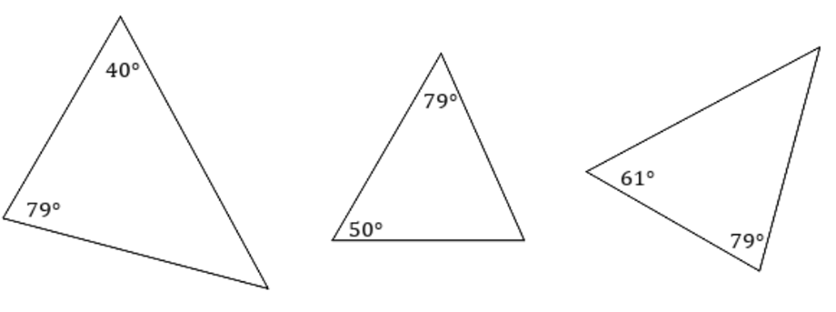

Launch
Instead of using physical manipulatives, students could complete the below activity using either:
Desmos geometry: https://www.desmos.com/geometry?lang=en
Mathigon’s Polypad: https://mathigon.org/polypad
- Display Figure 2.
Figure 2 – 4 triangles with different angles
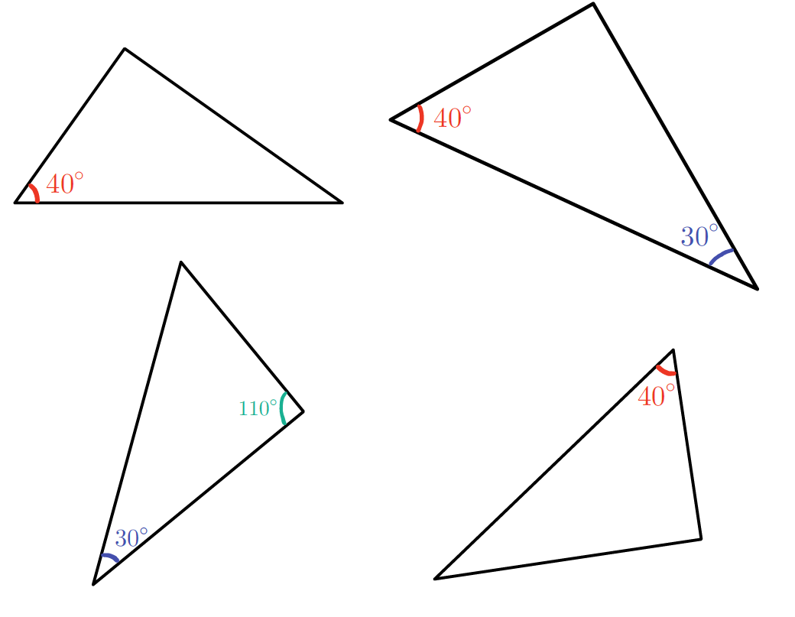
- Explain to students that the difference between the warm up and the launch is the number of angles, for example, the amount of information that we know.
- Ask students to determine if any of the triangles shown are similar.
- Question students in a Pause–Pose–Pounce–Bounce [PDF 201 KB] (bit.ly/pausepouncebounce) style to have them explain and elaborate on one another’s explanations.

Explore

Equipment
- Straight pasta (for example, spaghetti). Enough so each group has spares
- Printed angles cut out, one of each angle per group (Appendix A)
- Sticky tape
- Ruler
- Assign students in random groups of 3.
- Print and distribute Appendix A to each student and provide equipment.

One angle in common (most will have unique triangles)
- Students create a triangle using 3 pieces of pasta and angle 30°. Their triangle must include the given 30° angle, but otherwise students are free to make any triangle.
Figure 3 – triangle made from spaghetti with 30 degree angle
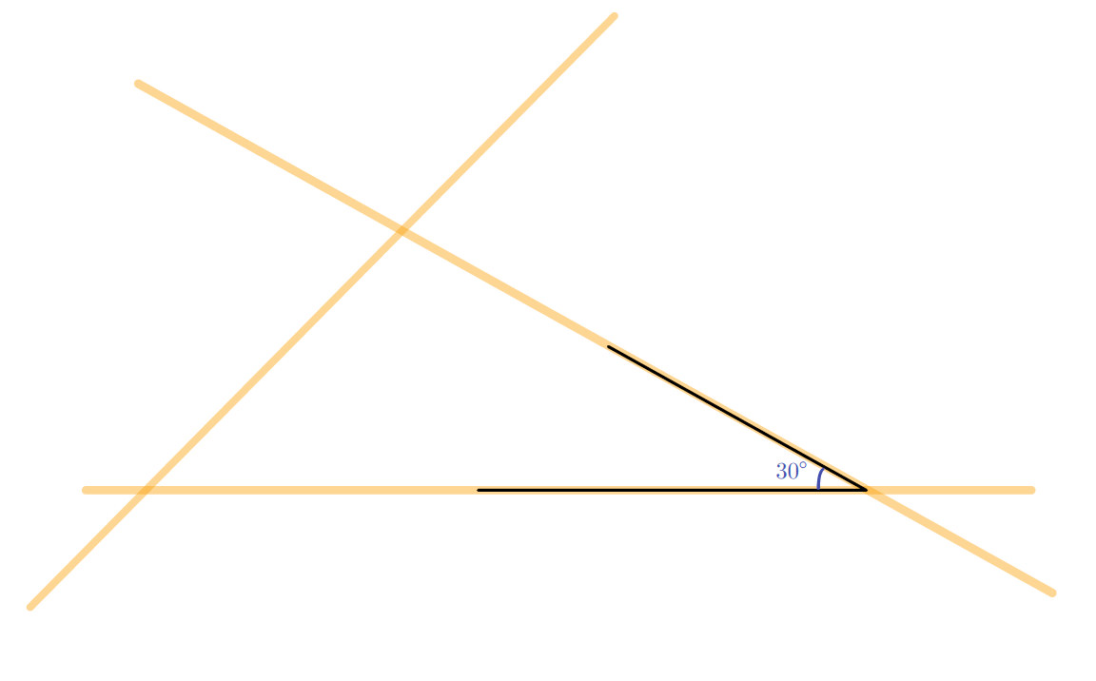
- Students tape their pasta triangle to a sheet of paper, so it won’t move (they will need the 30° angle again, so don’t tape this down).
- Students measure with a ruler and record the length on the paper next to each side.
Figure 4 – triangle made from spaghetti with 30 degree angle with lengths measured
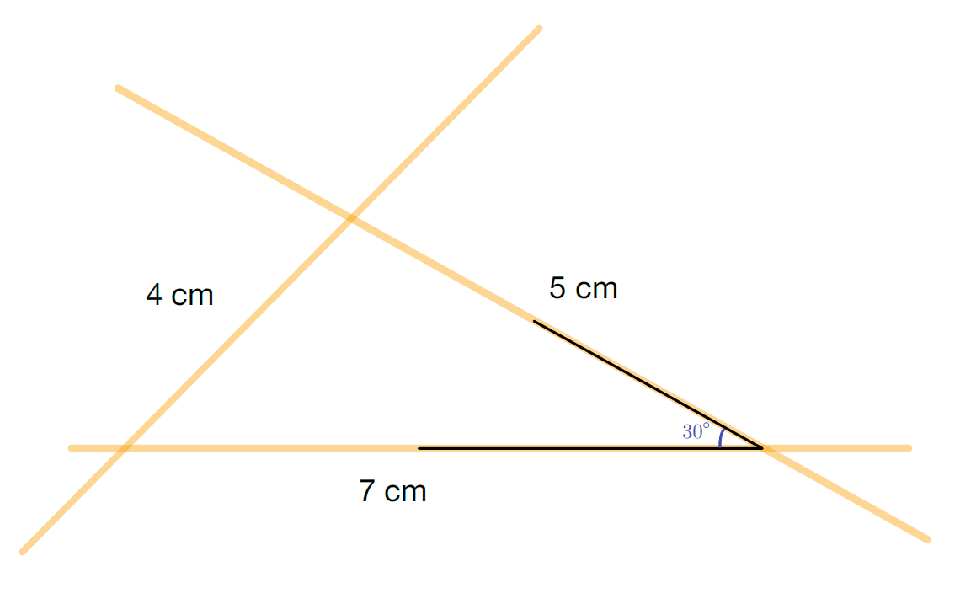
- Measure each angle (to the nearest 5 degrees) using a protractor and record the angle on the paper inside each vertex.
- Compare triangles with group members and answer each question:
- What is the same?
- What is different?
- Are any of your triangles congruent or similar?
- Ask groups to share how they knew.

One included angle in common (all should be similar or congruent)
- Students create an included angle using the 30° angle, and 2 adjacent pieces of pasta measured and broken to be the same length. In the diagram below, the sides have the same length of 6 cm.
Figure 5 – included angle using the 30° angle with 2 sides of 6 cm lengths
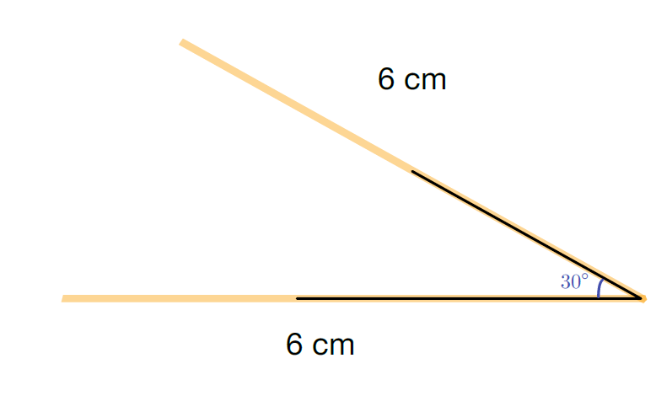
- Students place a third piece of pasta to connect the ends of each side to complete the triangle.
- Students tape their pasta triangle to a sheet of paper, so it won’t move.
- Students measure with a ruler and record the length on the paper next to each side.
- Measure each angle (to the nearest 5 degrees) using a protractor and record the angle on the paper inside each vertex.
- Compare triangles with group members and answer each question:
- What is the same?
- What is different?
- Are any of your triangles congruent or similar?
- Ask groups to share how they knew.
- What can we conclude about triangles with congruent angles included between sides that are in proportion? How are these triangles different to those created in the previous activity.

Two angles in common (all should be similar or congruent)
- Students create a triangle using 3 pieces of pasta and angles $45°$ and $60°$. Their triangle must include the 2 given angles, but otherwise students are free to make any triangle.
Figure 6 – triangle made from spaghetti with 45 and 60 degree angles
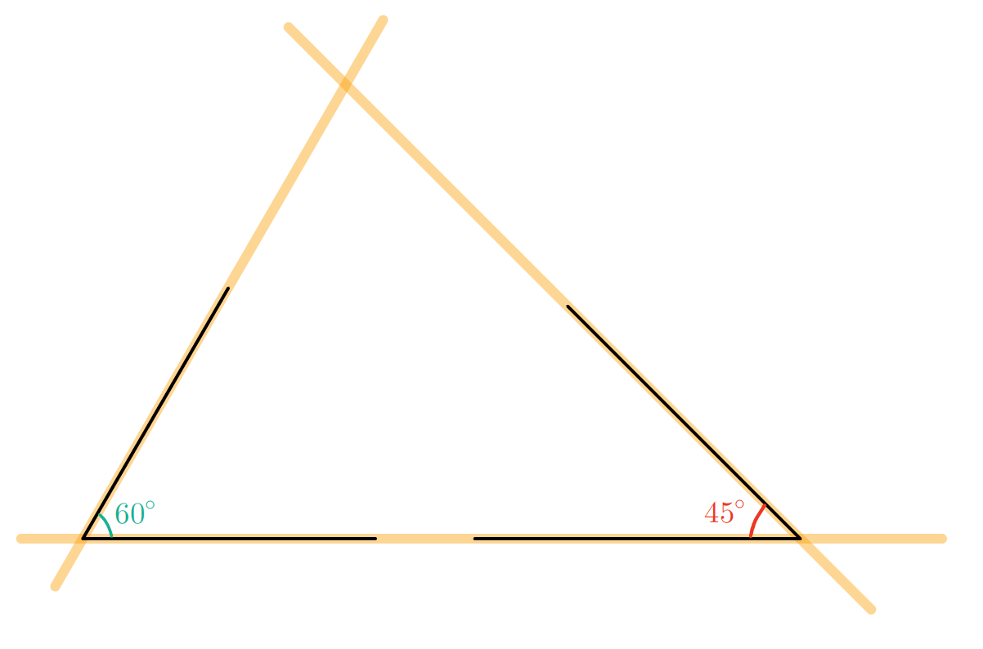
- Students tape their pasta triangle to a sheet of paper, so it won’t move.
- Students measure with a ruler and record the length on the paper next to each side.
- Measure each angle (to the nearest 5 degrees) using a protractor and record the angle on the paper inside each vertex.
- Compare triangles with group members, and answer each question:
- What is the same?
- What is different?
- Are any of your triangles congruent or similar?
- Ask groups to share how they knew.
- What can we conclude about triangles with 2 congruent angles?

Summarise
- Revisit the figure below.
Figure 7 – 4 triangles with different angles
- Remind students that at the start of the lesson, they were asked to determine which triangles were similar.
Hopefully students can now see that for some triangles there is enough information to state that they are similar (however they could also be congruent), and for some triangles we don’t have enough information.
- Have students write a heading in their notes: ‘How many angles to be similar’.
- Have them write notes to their future selves, for each given number of congruent angles within 2 triangles, with an example for each. For example:
- 1 angle: only sufficient when it is an included angle between corresponding sides.
- 2 angles: will always be a similar or congruent triangle.
- 3 angles: will always be a similar of congruent triangle.
Students could explore Path content to do a lesson on similarity tests, alternatively, students should have an understanding that an included angle between corresponding sides or 2 congruent angles are sufficient proof that 2 triangles are similar or congruent.

Assessment and differentiation

Suggested opportunities for differentiation
Explore
- If students are quick to discern the rules, have them draw a series of polygons with an increasing number of sides. For each, determine the minimum number of angles required to know every angle in the polygon.
- When students realise that it is always one less than the total number of angles, here are some potential options to extend:
- Do you always have to have n-1 angles (where n is the total number of angles) to know every angle? Encourage students to explore special cases such as isosceles and equilateral triangles, special quadrilaterals
- Ask students to add the interior angles and generalise a rule for the interior angles of polygons.

Suggested opportunities for assessment
- Listen for students’ justification and content knowledge in their explanations.
- You could provide an exit ticket, such as:
- Give students a slip with 2 triangles. Ask them if there is sufficient information to determine if the triangles are similar, congruent or neither.
- Give students a non-example where 2 triangles are given and an incorrect statement is made. Have students identify the incorrect aspects of the statement given.
- Students’ notes to their future selves could be collected for review as formative assessment.

Appendix A

Angles for printing
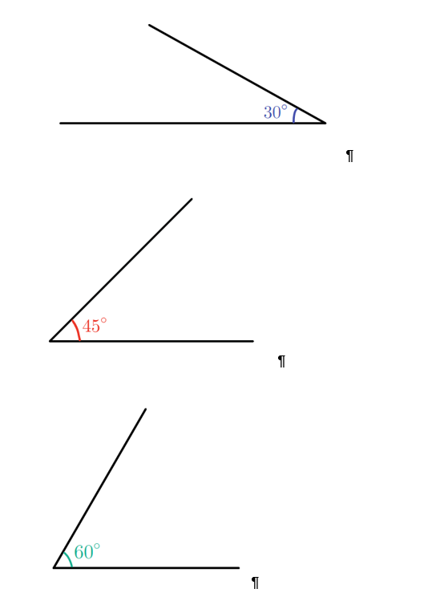

© State of New South Wales (Department of Education), 2023
The copyright material published in this resource is subject to the Copyright Act 1968 (Cth) and is owned by the NSW Department of Education or, where indicated, by a party other than the NSW Department of Education (third-party material).
Copyright material available in this resource and owned by the NSW Department of Education is licensed under a Creative Commons Attribution 4.0 International (CC BY 4.0) licence.
This licence allows you to share and adapt the material for any purpose, even commercially.
Attribution should be given to © State of New South Wales (Department of Education), 2023.
Material in this resource not available under a Creative Commons licence:
- the NSW Department of Education logo, other logos and trademark-protected material
- material owned by a third party that has been reproduced with permission. You will need to obtain permission from the third party to reuse its material.
Links to third-party material and websites
Please note that the provided (reading/viewing material/list/links/texts) are a suggestion only and implies no endorsement, by the New South Wales Department of Education, of any author, publisher, or book title. School principals and teachers are best placed to assess the suitability of resources that would complement the curriculum and reflect the needs and interests of their students.
If you use the links provided in this document to access a third-party's website, you acknowledge that the terms of use, including licence terms set out on the third-party's website apply to the use which may be made of the materials on that third-party website or where permitted by the Copyright Act 1968 (Cth). The department accepts no responsibility for content on third-party websites.

