Scaled copies or fakes?
In this lesson students define similarity by exploring the concept of scaled versus distorted copies.

Visible learning

Learning intention
- To be able to describe characteristics of similar figures.

Success criteria
- I can identify similar figures.
- I can explain why figures are similar or not similar.

Syllabus outcomes
A student:
- develops understanding and fluency in mathematics through exploring and connecting mathematical concepts, choosing and applying mathematical techniques to solve problems, and communicating their thinking and reasoning coherently and clearly MAO-WM-01
- identifies and applies the properties of similar figures and scale drawings to solve problems MA5-GEO-C-01
Mathematics K–10 Syllabus © NSW Education Standards Authority (NESA) for and on behalf of the Crown in right of the State of New South Wales, 2022.
Please use the associated PowerPoint Scaled copies or fakes to display images in this lesson.

Activity structure

Launch
- Display Figure 1.
Figure 1 – odd one out
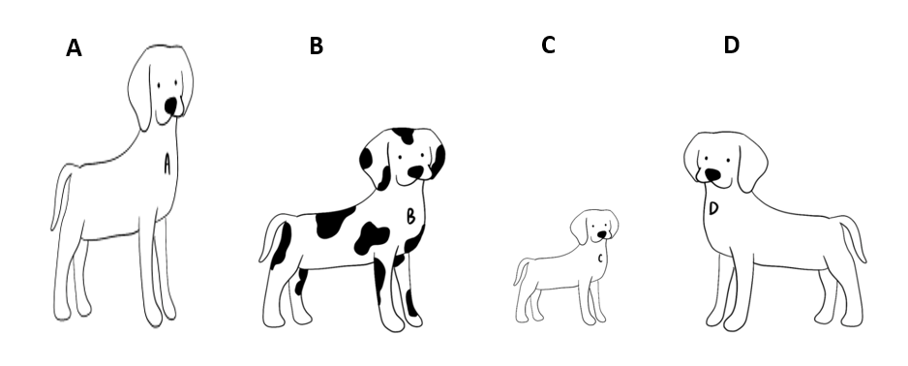
- Students are to choose the dog they think is the odd one out using the Which One Doesn’t Belong strategy (bit.ly/wodbstrategy).
There is no wrong answer. The aim of the activity is for students to be introduced to the idea that A does not belong because of distortion.

Explore

Portrait activity
The aim of this activity is to get students to start recognising that scaled copies are different to a change in proportion.
- Here is a portrait of a person.
- Consider each version of the portrait below and answer each of the following questions:
- How is each portrait the same as or different to the original?
- Some of the portraits are similar to the original, which portraits do you think are similar?
Figure 2 – 5 portraits
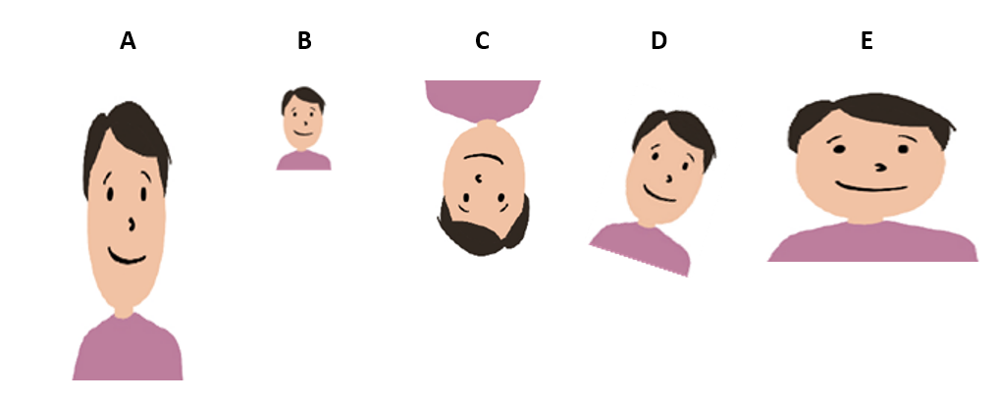

Find the fakes activity (Appendices A and B)
- Print and distribute Appendix A.
- Have students write their similarity definitions in their own notebooks.
In these activities students will define similarity based on shapes presented. Their initial definitions will likely house misconceptions.
- Print and distribute Appendix B.
- Have students refer to their definitions from Appendix A, to make initial predictions for which trapeziums are similar.
- Challenge and address students’ misconceptions about similarity.

Summarise
- Assign the following activity to your class from teacher.desmos.com:
- Desmos Scaling Machines.
- Teachers who have not used Desmos classroom activities before can seek help from the website bit.ly/desmosclassroomstrategy.
- Important points of discussion throughout the activity:
- How do we know if two shapes are similar?
- Are scaled copies always larger?
The aim of this activity is to use student responses to develop a class definition of similarity in mathematics.
Informally, similarity can be defined as figures that remain the same shape but change size (scale).
Students could also be introduced to congruence at this point (Path content) as a special case of similarity, where the scale is 1.

Apply
In this activity students will take a closer look at circles and squares and justify why they are similar. Give students the fact that all circles are similar to all other circles and all squares are similar to all other squares. Get students to answer the following questions:
- Can you explain why this is the case?
- Can you explain why this is not true for all rectangles?
- Can you think of any other shapes or objects where this is true?
Students should determine that all circles and squares are similar.

Assessment and Differentiation

Suggested opportunities for differentiation
Explore
- Have students build similar shapes using pattern tiles to verify shapes are similar.
- If students have difficulties drawing scaled copies, have them use elastic bands on a geoboard.
- Provide students with sets of similar, congruent, and different triangles for them to sort and justify groupings.
- Provide students with a blank grid and have them create a ‘find the fakes’ activity with their own shapes. This would allow for a higher ceiling if students chose more complex polygons.
Apply
- Students use Microsoft Word to create similar squares and circles using the corner drag while holding shift and distorted copies by corner dragging without shift.
- Students use Polypad draggable shapes to explore which shapes remain similar (https://mathigon.org/polypad#polygons).
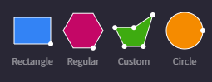
Image created using the free virtual manipulatives at Polypad.org

Suggested opportunities for assessment
- If you setup a Desmos teacher account you can view student progress in the activity, in real time. You might like to pause on a screen to have students elaborate or justify their statements.
- Students will demonstrate their working mathematically skills in discussions and justifications.

Appendix A

Defining similarity
- Each of these 5 rectangles are similar. Use the figures below to develop a definition for similar with a partner and collect mathematical evidence from the examples to support your thinking.
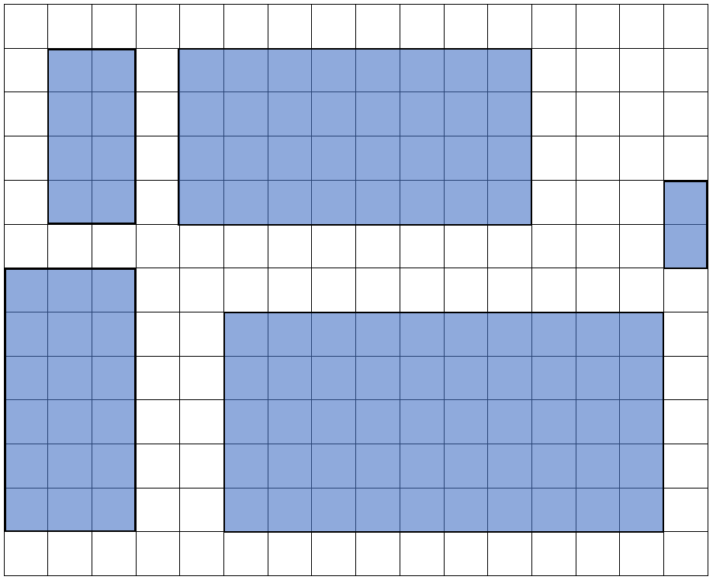
- Each of these 4 triangles are similar. Write your own definition of similar (to help you remember and understand).
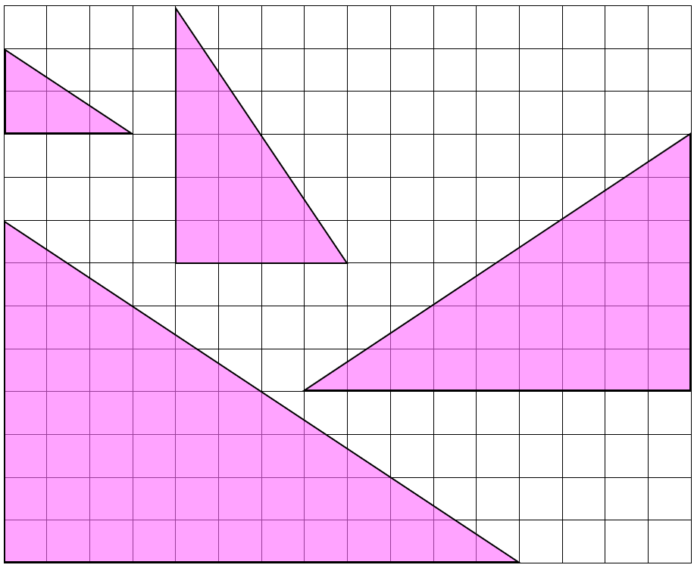

Appendix B

Find the Fakes!
Some of these shapes are similar to the original trapezium.
Identify the non-similar trapeziums (i.e. the fakes) and support your answers with mathematical calculations or reasoning.
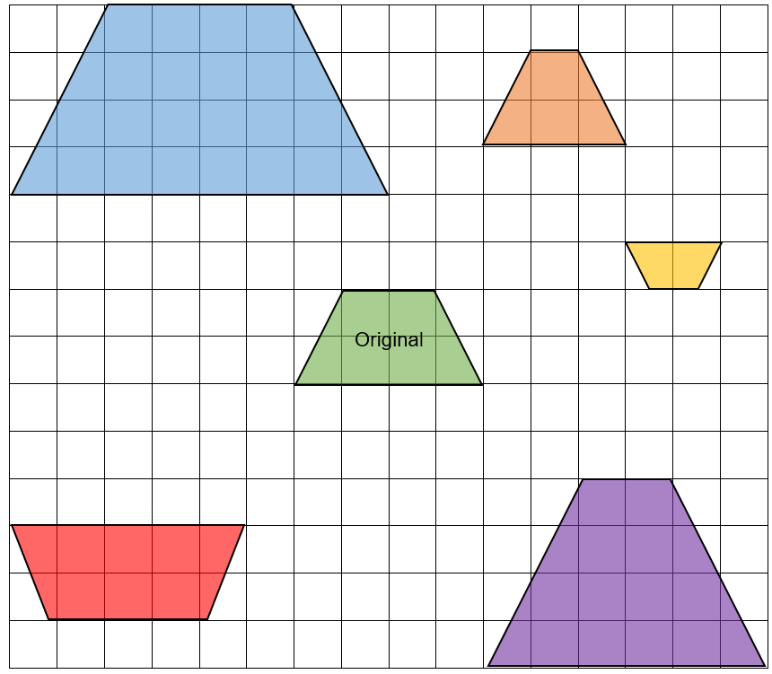

Create your own ‘find the fakes’ activity
Create some shapes that are similar to the original triangle and some that are not. Try to be tricky in your creations.
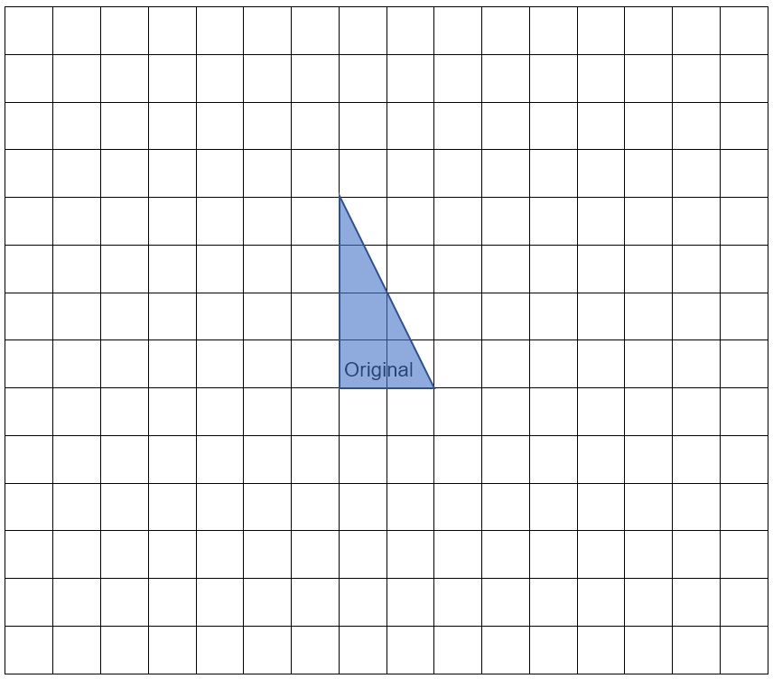
Share your sheet with a partner and have them find the fakes. Don’t forget to support your answer with mathematics.

Sample solutions

Portrait activity
A is stretched vertically, B is in proportion but smaller, C is in proportion but rotated, D is in proportion but rotated, E is stretched horizontally.

Find the Fakes activity
The blue is double the green.
The yellow is half the green.
The orange, red and purple are distorted.

© State of New South Wales (Department of Education), 2023
The copyright material published in this resource is subject to the Copyright Act 1968 (Cth) and is owned by the NSW Department of Education or, where indicated, by a party other than the NSW Department of Education (third-party material).
Copyright material available in this resource and owned by the NSW Department of Education is licensed under a Creative Commons Attribution 4.0 International (CC BY 4.0) licence.
This licence allows you to share and adapt the material for any purpose, even commercially.
Attribution should be given to © State of New South Wales (Department of Education), 2023.
Material in this resource not available under a Creative Commons licence:
- the NSW Department of Education logo, other logos and trademark-protected material
- material owned by a third party that has been reproduced with permission. You will need to obtain permission from the third party to reuse its material.
Links to third-party material and websites
Please note that the provided (reading/viewing material/list/links/texts) are a suggestion only and implies no endorsement, by the New South Wales Department of Education, of any author, publisher, or book title. School principals and teachers are best placed to assess the suitability of resources that would complement the curriculum and reflect the needs and interests of their students.
If you use the links provided in this document to access a third-party's website, you acknowledge that the terms of use, including licence terms set out on the third-party's website apply to the use which may be made of the materials on that third-party website or where permitted by the Copyright Act 1968 (Cth). The department accepts no responsibility for content on third-party websites.

