Scale factor and area
This lesson provides students with opportunities to explore the relationship between scale factor and area. Students can take this further with an investigation into the relationship between scale factor and surface area and volume.
This lesson includes Path content.

Visible learning

Learning intention
- To solve problems involving similar figures and area.

Success criteria
- I can solve problems involving similar figures and area.
- I can use scale factor to calculate the areas of similar figures.

Syllabus outcomes
A student:
- develops understanding and fluency in mathematics through exploring and connecting mathematical concepts, choosing and applying mathematical techniques to solve problems, and communicating their thinking and reasoning coherently and clearly MAO-WM-01
- identifies and applies the properties of similar figures and scale drawings to solve problems MA5-GEO-C-01
- establishes conditions for congruent triangles and similar triangles and solves problems relating to properties of similar figures and plane shapes MA5-GEO-P-01
Mathematics K–10 Syllabus © NSW Education Standards Authority (NESA) for and on behalf of the Crown in right of the State of New South Wales, 2022.

Activity structure

Launch
- Display the Which one doesn’t belong activity retrieved from wodb.ca/images/shape19.jpg. For more information about this strategy, refer to bit.ly/wodbstrategy.
- Have students justify which one doesn’t belong in a Think-Pair-Share (bit.ly/thinkpairsharestrategy).
- Lead students to discuss similar figures and scale factor. You could ask how many times bigger is the red or brown square than the white square.

Explore

Pattern blocks
If you don’t have pattern blocks you can use Polypad as an online alternative: mathigon.org/polypad – polygons
- Display Appendix A and model making a square with scale factor 2. Each side will be 2 squares which creates a square with area 4.
Figure 1 – Square with scale factor 2
Image created using the free virtual manipulatives at Polypad.org
- Students use pattern tiles to build each shape with the given scale factor (side length) and record the tiles used.
Opportunities for extension: Have students create a rule that could be used to relate scale factor and area of similar figures.

Summarise
- Display the GeoGebra applet (www.geogebra.org/m/A8wW79ud).
- Ask students if they noticed any patterns between the scale factor and blocks used in the previous activity.
- Lead students to develop the concept: The ratio of areas between 2 similar figures is equal to the square of the scale factor.
- Demonstrate this on the GeoGebra applet by dragging the slider to increase the side lengths in rectangle Y.

Apply
Print and distribute Appendix B.
Appendix B provides students with an opportunity to apply their learning in a routine context. If you would like your students to compare this with non-routine problems, there is an investigation below.

Investigation
This investigation, Appendix C, explores scale factor in 3D objects and the ratios of their sides, areas, and volumes. This task also draws upon content about volume and surface area.

Assessment and Differentiation

Suggested opportunities and differentiation
Explore
- Students could spend the entire lesson exploring the relationship between side lengths, scale factor and area if that is the level they are working at. Provide manipulatives and more general prompts such as what happens to the area of a square if you keep doubling the side lengths?
Investigation
- As an extension the students could find their own products. As an assistance for students who are struggling, they could be given a product where the scale factor is a nice 2 or 3 like modelled above.

Suggested opportunities for assessment
- Students could complete the investigation as an assessment task.
- Through their engagement with a new type of problem, students will likely present misconceptions about core skills in the topic.

Appendix A

Pattern blocks
Use pattern blocks to fill in the table below.
Scale factor | Square | Triangle | Rhombus
Scale factor | Square tiles | Triangle tiles | Rhombus tiles
1 | 1 | 1 | 1
2 | 4
3
4
10
$$\frac{1}{2}$$

Appendix B

Thin slicing questions
For each question the original is on the left
Question 1
- Find the scale factor
- Find the area of each square
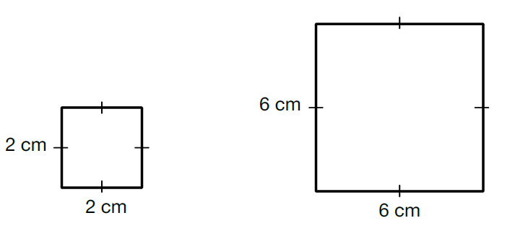
Question 2
- Find the scale factor
- Find the side length of each square
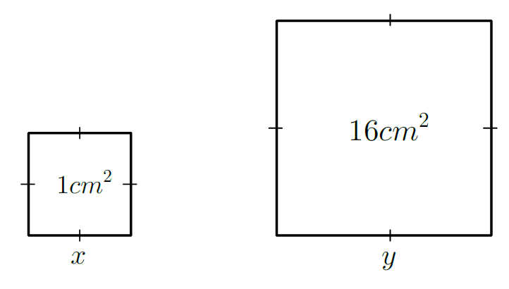
Question 3
Find as much information as you can for each set of rectangles below.
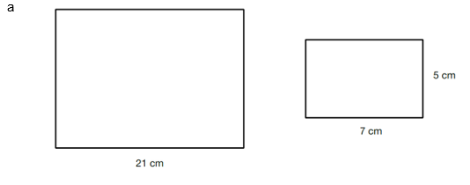
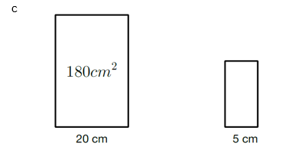
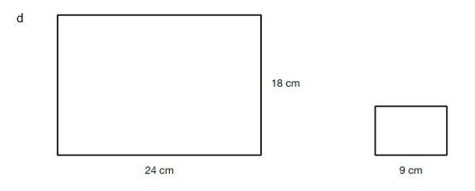
Question 4
The corresponding sides of 2 similar triangles are 7 cm and 21 $cm$. Find the area of the larger triangle, given the area of the smaller triangle is 14 $cm^{2}$.
Question 5
The diameter of a circle is doubled. What happens to its area?

Appendix C

Similar solids – what are similar solids?
Two three-dimensional (3D) objects are similar if you can multiply each of the side lengths in the smaller shape, by the same number (called the ‘scale factor’) to get the side lengths of the larger object.
For each of the following real-life objects:
- find out if they are similar solids, and if they are, find the scale factor
- if they aren’t similar, adjust the measurements of the larger shape to make them similar
- find the surface area and volume of each
- find out what the scale factor is for both the surface area and volume.

Your investigation

Task 1 – Gathering data
Vegemite
- 150 g: 4.5 cm radius and 7.5 cm tall
- 400 g: 7 cm radius and 9.5 cm tall
SPC Fruit Salad
- 410 g: 7.5 cm radius and 11 cm tall
- 825 g: 10 cm radius and 12 cm tall
Baked Beans
- 130 g: 5.3 cm radius and 6.8 cm tall
- 420 g: 7.5 cm radius and 11 cm tall

Flour
- 1 kg: 9.5 cm wide, 7 cm deep, 17 cm high
- 2 kg: 12 cm wide, 9.5 cm deep, 22 cm high
Cornflakes
- 460 g: 24 cm wide, 6.7 cm deep, 32 cm high
- 775 g: 25 cm wide, 9.5 cm deep, 35.8 cm high
Toblerone
- 50 g: 2.8 cm wide, 2.5 cm high, 16.5 cm long
- 100 g: 3.5 cm wide, 3 cm high, 21 cm long
- 200 g: 4.5 cm wide, 4 cm high, 27.5 cm long
Duo Laundry Detergent
- 500 g: 6 cm deep, 13 cm wide, 11.5 cm high
- 1.5 kg: 7.8 cm deep, 15 cm wide, 20 cm high

Task 2 – analysing data
What is the connection between the scale factor for side lengths and the scale factor for surface area and volume?

Sample solutions

Pattern blocks
Scale factor | Square | Triangle | Rhombus
Scale factor | Square tiles | Triangle tiles | Rhombus tiles
1 | 1 | 1 | 1
2 | 4 | 4 | 4
3 | 9 | 9 | 9
4 | 16 | 16 | 16
10 | 100 | 100 | 100

Thin slicing questions
Question 1
- Scale factor = 3
- Area 1 = 4 Area 2 = 36
Question 2
- Scale factor = 4
- $x=1$ $y=4$

Question 3
a. | Scale factor = 1/3 | Area 1 = 215 | Area 2 = 35
b. | Scale factor = 1/2 | Side length 2 = 2.5 | Side length 1 = 5 | Area 1 = 60
c. | Scale factor =1/4 | Side length 1 = 9 | Side length 2 = 2.25 | Area 2 = 11.25
d. | Scale factor = 8/3 | Area 1 = 432 | Side length 2 = 6.75 | Area 2 = 60.75
Question 4
Scale factor = 3
Area scale factor = $3^{2}$ =9
14 × 9 = 126
Larger triangle has an area of $126 cm^{2}$
Question 5
The new area becomes 4 times larger.

© State of New South Wales (Department of Education), 2023
The copyright material published in this resource is subject to the Copyright Act 1968 (Cth) and is owned by the NSW Department of Education or, where indicated, by a party other than the NSW Department of Education (third-party material).
Copyright material available in this resource and owned by the NSW Department of Education is licensed under a Creative Commons Attribution 4.0 International (CC BY 4.0) licence.
This licence allows you to share and adapt the material for any purpose, even commercially.
Attribution should be given to © State of New South Wales (Department of Education), 2023.
Material in this resource not available under a Creative Commons licence:
- the NSW Department of Education logo, other logos and trademark-protected material
- material owned by a third party that has been reproduced with permission. You will need to obtain permission from the third party to reuse its material.
Links to third-party material and websites
Please note that the provided (reading/viewing material/list/links/texts) are a suggestion only and implies no endorsement, by the New South Wales Department of Education, of any author, publisher, or book title. School principals and teachers are best placed to assess the suitability of resources that would complement the curriculum and reflect the needs and interests of their students.
If you use the links provided in this document to access a third-party's website, you acknowledge that the terms of use, including licence terms set out on the third-party's website apply to the use which may be made of the materials on that third-party website or where permitted by the Copyright Act 1968 (Cth). The department accepts no responsibility for content on third-party websites.

