Comparing representations
In this lesson, students explore the similarities and differences between maps and network diagrams.
This lesson incorporates Path content.

Visible learning

Learning intention
- To recognise the similarities and differences between networks and maps.

Success criteria
- I can explain the similarities and differences between networks and maps.
- I can use network diagrams to solve problems.

Syllabus outcomes
A student:
- develops understanding and fluency in mathematics through exploring and connecting mathematical concepts, choosing and applying mathematical techniques to solve problems, and communicating their thinking and reasoning coherently and clearly MAO-WM-01
- identifies and applies the properties of similar figures and scale drawings to solve problems MA5-GEO-C-01
- solves problems involving the characteristics of graphs/networks, planar graphs and Eulerian trails and circuits MA5-NET-P-01
Mathematics K–10 Syllabus © NSW Education Standards Authority (NESA) for and on behalf of the Crown in right of the State of New South Wales, 2022.
Please use the associated PowerPoint Comparing representations to display images in this lesson.

Activity structure

Launch

Sprouts
Players take turns in joining dots (vertices) according to simple rules, until one player cannot make a move.

Setup:
- For this game, students will play in pairs.
- They will need whiteboards and markers or paper and pens.
- You can display Figure 1 to show an example game.

How to play:
- Start by drawing 2 vertices (dots) on a piece of paper.
- Players then take turns to make a move, by drawing an edge (line) that connects 2 vertices, and then adding a new vertex (dot) on their edge.
- When making a move, players must adhere to the following rules:
- Your edge cannot cross another edge or pass through a vertex.
- Your edge can start at a vertex and return to the same vertex.
- A vertex can have at most 3 edges emerging from it. If an edge loops back to the same vertex, this counts as 2 edges.
- The game is over when there are no moves a player can make.
- The winner is the last player to successfully add an edge.
Figure 1 – example game of sprouts
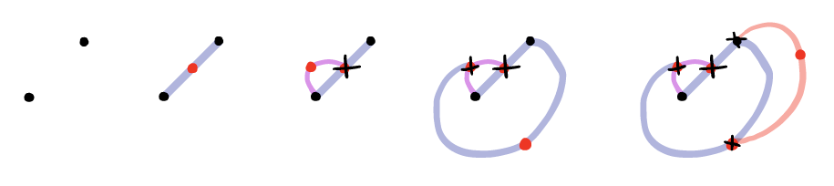
- Students should play 1 to 2 games without interruption.
- Once students are confident with the game, have them start with additional dots each round (For example, start with 3 dots instead of 2). The same rules apply for a 3, 4, or 5 dot game as before.
- As you move around the room, model correct terminology – using vertices and edges, as you challenge students to express strategies they’ve discovered.
- To conclude the activity, display Figure 2.
Figure 2 – two example games of sprouts
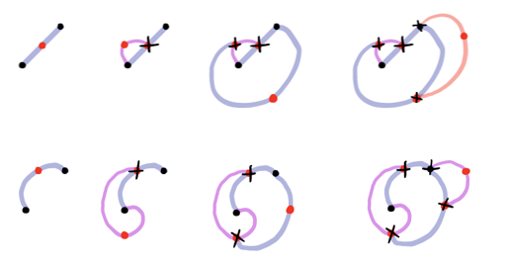
- Ask students to look for similarities and differences between the 2 games. Students should discover that the games are identical.
- Explain that students have created a network diagram.
- Highlight that network diagrams are about connections, where the lengths of the edges are unimportant.

Explore
- Display The Bridges of Konigsberg problem by NRICH (https://nrich.maths.org/2327?part=index)
- Ask students to brainstorm a list of questions that could be asked about the image.
- After sharing student questions, ask what is more important in the image – length or connections?
- Display or print the student facing questions.

Student facing questions
- Can you find a route around Konigsberg which crosses each bridge exactly once?
- Can you remove a bridge and find a walk that crosses each remaining bridge exactly once?
- Can you add a bridge and find a walk that crosses all the bridges exactly once?
Students should construct a network diagram to solve this problem. Explicitly model how to construct a network diagram, ensuring the use of correct terminology. Encourage discussions around what features will be the vertices, where will they go, and so on.

Summarise
- Print and distribute Appendix A.
- Guide students through each question as a class.
- Have students work in pairs to create a T-chart (bit.ly/tchartstrategy) with the headings maps and networks.
- Students identify key points of difference between maps and network diagrams.
- Students should refer to the networks they have drawn in the sprouts game and Konigsberg bridges problem. What are the similarities and differences between their networks?
It might be useful to print or display a variety of maps and network diagrams. Such as a map of Sydney versus Sydney train network, house plan versus electrical plan, and so on.

Connect networks to Aboriginal artwork
- Display artworks from Aboriginal Art Symbols (artark.com.au/pages/aboriginal-art-symbols) and remind students of their investigation into the meaning of symbols in traditional Aboriginal artwork (Lesson 3 – Similar figures in art). For example, concentric circles often show meeting places.
- Ask students to consider what they’ve learned today to decide if the artwork shown in Figure 3 (below) is more like a map or a network.

Apply
This task is based on NESA’s sample task for Mathematics Standard 1, retrieved from: educationstandards.nsw.edu.au/wps/portal/nesa/resource-finder/sample-work/mathematics/mathematics-standard-1-stage-6-2017-sample-work-year-12-networks-working-on-job-sites
- Display Figure 3 and print and distribute Appendix A.
Figure 3 – networks: working on job sites – map for task
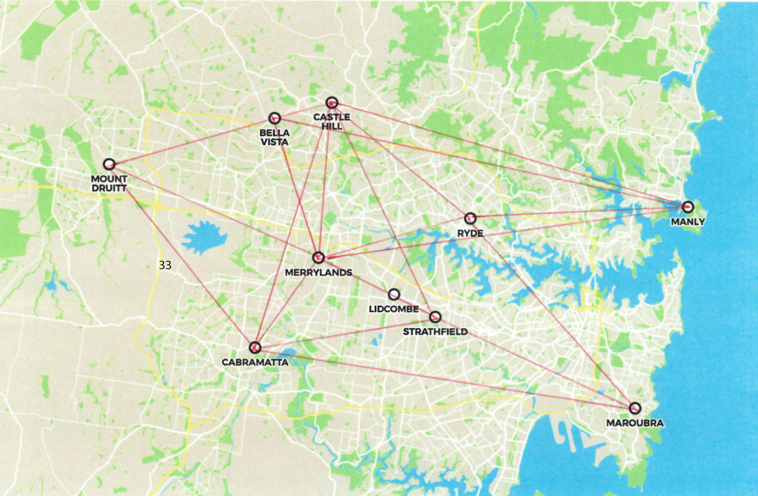
© NSW Education Standards Authority (NESA) for and on behalf of the Crown in right of the State of New South Wales, 2017.
- Upon completing the student facing task, have students add up their total travel times and compare with a partner.
- List all total times on the board and have the students with the fastest times share their first several moves.
- Encourage students to look for similarities in the fastest strategies.
- Ask students to consider if they could have used distances instead of time for this activity? Use this question to conclude that maps and networks serve unique purposes.

Assessment and Differentiation

Suggested opportunities for differentiation
Launch & Explore
- Support students by allowing them to physically trace or construct the networks.
- Challenge students to use correct terminology: Edge, vertex, vertices. Students could be extended by introducing additional terminology such as degree or path.
Apply
- Extend students by providing the full investigation task from NESA.

Suggested opportunities for assessment
- The investigation task could be assigned as an assessment task.
- Create an exit ticket requiring students to label graphics as scale diagrams or networks.
- Monitor student discussions whilst they work for correct use of new terminology of vertices, edges, walk.

Appendix A

Networks task

Student facing task
Use the map of Sydney suburbs provided to answer the questions below. There are 8 points marked on the map next to the name of a suburb. These points indicate the job sites you are to work at throughout the day.
- Terminology – state the number of:
Vertices ____
Edges ____
- Use an online map application to determine the estimated travel time between each suburb and record this on the map of Sydney suburbs. The time taken to travel from Mount Druitt to Cabramatta is provided as an example.
- Starting from Merrylands, use a highlighter to indicate on the map below, the path you would take to visit each suburb in the shortest time possible.
© NSW Education Standards Authority (NESA) for and on behalf of the Crown in right of the State of New South Wales, 2017.

© State of New South Wales (Department of Education), 2023
The copyright material published in this resource is subject to the Copyright Act 1968 (Cth) and is owned by the NSW Department of Education or, where indicated, by a party other than the NSW Department of Education (third-party material).
Copyright material available in this resource and owned by the NSW Department of Education is licensed under a Creative Commons Attribution 4.0 International (CC BY 4.0) licence.
This licence allows you to share and adapt the material for any purpose, even commercially.
Attribution should be given to © State of New South Wales (Department of Education), 2023.
Material in this resource not available under a Creative Commons licence:
- the NSW Department of Education logo, other logos and trademark-protected material
- material owned by a third party that has been reproduced with permission. You will need to obtain permission from the third party to reuse its material.
Links to third-party material and websites
Please note that the provided (reading/viewing material/list/links/texts) are a suggestion only and implies no endorsement, by the New South Wales Department of Education, of any author, publisher, or book title. School principals and teachers are best placed to assess the suitability of resources that would complement the curriculum and reflect the needs and interests of their students.
If you use the links provided in this document to access a third-party's website, you acknowledge that the terms of use, including licence terms set out on the third-party's website apply to the use which may be made of the materials on that third-party website or where permitted by the Copyright Act 1968 (Cth). The department accepts no responsibility for content on third-party websites.

