Mathematics Stage 5 (Year 9) – assessment task notification
Contents
How accessible is your school? 2
Task description 2
Part 1 – reviewing ramps 3
Part 2 – movement throughout the school 5
Submission details 10
Part 1 – designing a ramp 10
Part 2 – movement throughout the school 10
Marking guidelines 12
Teacher notes 17
Additional resources to be provided to students 17
Suggested opportunities for differentiation 18
Sample solutions 19
References 36

How accessible is your school?
Type of task: Investigation
Outcomes being assessed:
- develops understanding and fluency in mathematics through exploring and connecting mathematical concepts, choosing, and applying mathematical techniques to solve problems, and communicating their thinking and reasoning coherently and clearly MAO-WM-01
- identifies and applies the properties of similar figures and scale drawings to solve problems MA5-GEO-C-01
- solves problems involving the characteristics of graphs/networks, planar graphs and Eulerian trails and circuits MA5-NET-P-01
Mathematics K–10 Syllabus © NSW Education Standards Authority (NESA) for and on behalf of the Crown in right of the State of New South Wales, 2022.

Task description
Your school is about to welcome a new student who uses a wheelchair to assist with their mobility. Your principal has approached the SRC to seek their assistance with determining what modifications will need to be made to ensure accessibility for all.
You will investigate the necessary accessibility requirements and the existing pathways around your school to make recommendations about how we might improve accessibility.

Part 1 – reviewing ramps
Ramps are required for accessibility where steps or kerbs exist. Ramps are measured using the ratio of the perpendicular height to the horizontal distance. For example, the ramp below would have a ratio of 1:10.
Figure 1 – example ramp
Different ratios are required depending on where the ramp is placed. This information can be seen in the table below.
Table 1 – Australian Standards for ramps, landings, and walkways
Ramp type | Ratio (maximum steepness)
Kerb ramp | 1:8
Step ramp (for 1 step) | 1:10
Stair ramp (flight of stairs) | 1:14
(Design For Dignity n.d.) bit.ly/designfordignity

A. Find 2 ramps in your school or local area
Look for 2 ramps that appear to have similar slopes.
- Take a photo of each of the ramps selected.
- Measure the height and the horizontal length of each chosen ramp.

B. Create a scale drawing of each ramp
- Each scale drawing of the ramps should be clear and include:
- all relevant measurements
- the determined scale
- mathematical calculations to support the determined scale
- a statement explaining why you have chosen the scale you have for your diagram.

C. Compare the ramps
Consider the scale drawings created in Part 1B to answer each question below. Explain your answers using mathematical arguments and reasoning.
- Does each ramp satisfy the Australian Standards?
- Are your chosen ramps mathematically similar?

Part 2 – movement throughout the school
Can a person with accessibility needs access every area of the school?
The SRC are collecting ‘A day in the life of a student’ information to determine how accessible the route is that each student must take to get to their classes.
Your teacher will give you a map of your school to assist with this part of the investigation.

A. Map out a day of your timetable
- Select one day from your school timetable.
- Using the map provided by your teacher, draw the path you take from when you enter the school in the morning to when you leave. An example is provided in Figure 2.
- If you take the same path twice, for example from Sport/Court to Block C then from Block C back to Sport/Court, do not draw that path again.

Example: Map out a day of your timetable
Figure 2 – stars represent buildings/areas visited in the timetable below
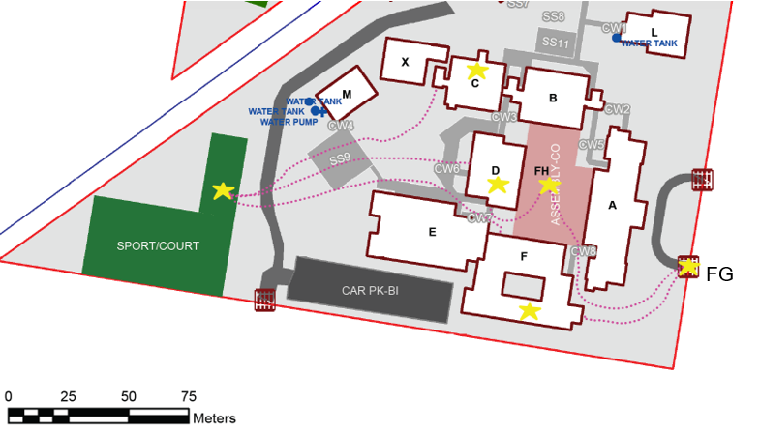
Table 2 – school timetable for a single day
Period | Building/Area
Enter school | Front gate (FG)
Before school | FH
Period 1 | D block
1st Recess | SPORT/COURT (SC)
Period 2 | C block
Lunch | SPORT/COURT (SC)
Period 3 | F block
2nd Recess | SPORT/COURT (SC)
Period 4 | F block
After school | Front gate (FG)

B. Convert to a network diagram
- Construct a network diagram that shows the different buildings each of your lessons are in, as well as any major areas (such as the quad or oval) that you pass through on your way to each lesson.
- Each building or major area is a vertex.
- Each edge represents the path that you take to get between each building or major area.
The diagrams below show the network diagram being constructed for the example timetable in Table 2.
Figure 3 – network diagram from ‘Enter school’ to ‘1st Recess’ in the timetable in Table 2
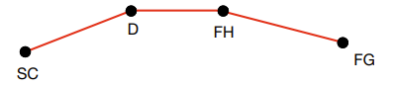
Figure 4 – completed network diagram for the timetable in Table 2
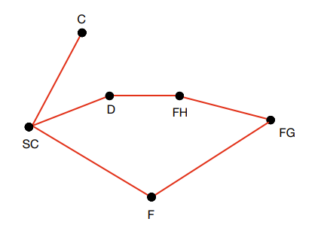

C. Redraw your network diagram, considering accessibility requirements
- When redrawing your network diagram each edge must now represent an accessible path. If no accessible path exists the edge will need to be removed.
- Important points to consider:
- If an edge is removed, can an alternate route be created, for example, through another building?
- Are there any locations that aren’t accessible?
- If no elevators currently exist, would adding these make the school more accessible?
In the example below, the student would need to use the one elevator to transition between every class and break. The only edge that is accessible without requiring the use of the elevator is from FG to FH.
Figure 5 – adjusted network diagram for the timetable in Table 2
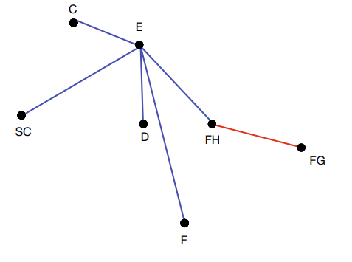

D. Network reflections
- Comment on any differences between the network diagrams. Are there any paths between locations that require you to pass through significantly more locations than for a person who uses a wheelchair?
- How do the network diagrams that were created in Parts 2B and 2C impact your view of the school’s accessibility?
- What are the benefits and limitations of the network diagrams created in Parts 2B and 2C?

E. Choose 2 locations where a ramp could improve accessibility within the school
- When selecting your 2 locations you may consider finding stairs, a single step, or a kerb.
- Take a photo of each of the locations selected.
- Measure the height of each chosen location where a ramp is to be added.

F. Construct a scale drawing of your proposed new ramps
- Use Table 1 to determine the minimum horizontal distance each ramp will cover, showing all working to support your final answer.
- Draw a scale diagram showing the location of each proposed new ramp, overlaid on top of a map of the school. Each scale drawing of the ramps should be clear and include:
- all relevant measurements
- mathematical calculations using the given scale.

G. Determine if both ramps should be built in the proposed locations
- Considering the required size of the ramps and the locations in which they are to be built, would it be feasible to build a ramp in these locations? If not, can you recommend another solution?
- Explain your answer using mathematical arguments and reasoning.

Submission details
Student should submit the following, supported by calculations, reasoning, and justifications.

Part 1 – designing a ramp
- Find 2 ramps in your school or local area
☐ 2 photos of ramps within your school or local area.
☐ Height and horizontal length of each chosen ramp.
- Create a scale drawing of each ramp
☐ 2 scale drawings.
☐ All mathematical calculations used.
- Compare the ramps
☐ Answers to each question.

Part 2 – movement throughout the school
- Map out a day of your timetable
☐ Map with path drawn to represent the buildings and areas you visit in one chosen day of your school timetable.
- Convert to a network diagram
☐ Network diagram representing the path shown in Part 2A.
- Redraw your network diagram, considering accessibility requirements
☐ Network diagram representing the path a student in a wheelchair would take to visit the same locations as in Part 2B.
- Network reflections
☐ Answers to each question.
- Choose 2 locations in your school where a ramp could improve accessibility within the school
☐ 2 photos of areas within the school where a ramp could be added.
☐ Heights of each chosen location where a ramp is to be added.
- Construct a scale drawing of your proposed new ramps
☐ Calculations and conclusion of minimum horizontal distance of each ramp.
☐ 2 scale drawings of the ramps, located on a map of the school.
☐ All mathematical calculations used.
- Determine if both ramps should be built in the proposed locations
☐ Justification for each ramp to be built or not.

Marking guidelines
The assessment marking guidelines in Table 3 are organised into the skills students have had the opportunity to demonstrate within the outcomes being assessed, MAO-WM-01, MA5-GEO-C-01 and MA5-NET-P-01. Teachers are encouraged to review student work with these skills in mind before using Table 3 to make a determination of the level to which the skill has been demonstrated.
During this task, there are multiple opportunities for students to demonstrate competence in the required skills. The assessment marking guidelines describe the occasions where these opportunities arise and what student performance may look like at different levels.
Table 3 – assessment marking guidelines
Criteria | Working towards developing | Developing | Developed | Well developed | Highly developed
Parts 1 and 2 – finding and using scales and ratios | - Presents drawings of 2 existing ramps with an attempt to reference scale with errors.  - Informally marks the sizes and locations of the proposed ramps on a map of the school, drawing the ramps by eye with no reference to the given scale.  - Communicates information about a proposed ramp in the school. | - Presents scale drawings of 2 existing ramps with some accuracy but no supporting calculations.  - Attempts to interpret the given scale, with errors, to mark the location of proposed ramps on a map of the school.  - Communicates measurements for a proposed ramp in the school with some reference to the Australian Standards. | - Presents accurate scale drawings of 2 existing ramps with adequate supporting calculations.  - Uses the appropriate scale from the Australian standards to correctly calculate the desired horizontal length for a proposed ramp.  - Interprets and correctly uses the given scale to present inaccurate drawings showing the proposed location of 2 new ramps on a map of the school. | - Presents accurate scale drawings of 2 existing ramps using a logical scale factor and provides thorough supporting calculations.  - Interprets and correctly uses the given scale to present accurate drawings showing the proposed location of 2 new ramps on a map of the school. | n/a
Part 2 – drawing and using network diagrams | - Represents their movements during a school day on a map of the school.  - Refers to the map when discussing pathways in the school. | - Attempts to convert their movements during a school day into a network diagram.  - Uses limited language associated with networks to identify at least one potential accessibility issue in the school. | - Presents a map of the school with their day marked and presents a correct matching network diagram.  - Uses language associated with networks to review the accessibility of the school. | - Uses language associated with networks to review the accessibility of the school and discuss the strengths and weaknesses of network diagrams. | n/a
Part 2 – making recommendations | - Attempts to use results to inform decisions about adding ramps in the school. | - Uses limited mathematical language to show the results they have found.  - Uses informal mathematical reasoning to support decisions about adding ramps in the school. | - Uses mathematical language to discuss the process undertaken to find the lengths of proposed ramps.  - Makes decisions about whether to recommend construction of ramps based on sound reasoning. | - Uses appropriate mathematical language to effectively explain the process undertaken to find the lengths of proposed ramps.  - Uses calculations and diagrams to support their reasoning as to whether it is feasible for the ramps to be built in their proposed locations. | - Uses precise mathematical language consistently and effectively to explain the process undertaken to find the lengths of proposed ramps.  - Selects and uses calculations and diagrams to construct mathematical arguments to justify choice made to recommend constructing a ramp, lift, or other alternative.

Teacher notes
The examples in this package are provided so that schools and teachers may choose relevant information and adjust for their contexts and their school-based practices. Relevant information should be transferred into the school’s assessment task template.
- Sample solutions are provided for the teacher.
- By providing students with a digital copy of this document they can check off boxes, type into the template and include photos.

Additional resources to be provided to students
A scale map of the school is to be provided to students for Part 2, which can be obtained using the Staff portal, essentials app – AMS on the Web.
- Type and select your school.
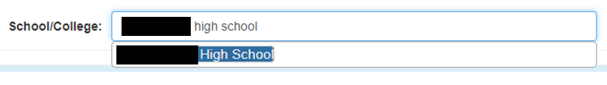
- Once your school information comes up, select ‘PDF Sites and Building Plans’ at the top of the page.
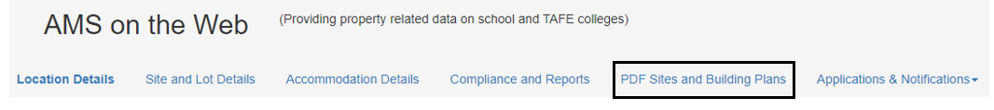
- Click on the link Site & Building Plans File, which will take you to a PDF file where the first page is a scale map of your school.

Suggested opportunities for differentiation
Part 1
- Some students may find working in millimetres and conversions difficult. A review of these concepts may be required.
- Provide a grid for scale drawing.
- Some students may struggle with the different types of scale they are using, for example, at times they are finding the ratio of the perpendicular height to the horizontal distance and then finding the ratio of corresponding sides.
Part 2
- Networks is in the path content of the syllabus, so this section may need to be modified if students are unfamiliar with terms such as networks, vertices, and edges. Students could skip Parts 2B, 2C and 2D and use their map from Part 2A to identify potential locations where ramps might be required to continue with Part 2E.
- To enrich considerations by students around comparisons between networks, teachers may choose to modify the task so that students include all accessible routes in their entire school, or a section of their school, rather than just those covered in a day of their timetable.

Sample solutions
The solutions below represent a sample of what a student may produce. They are developed to improve clarity for teachers using the task and are not designed to be used as an exemplar for student review.

Part 1 – designing a ramp

A. Find 2 ramps in your school or local area
Ramp 1
Figure 6 – ramp 1 that is running alongside a single storey building
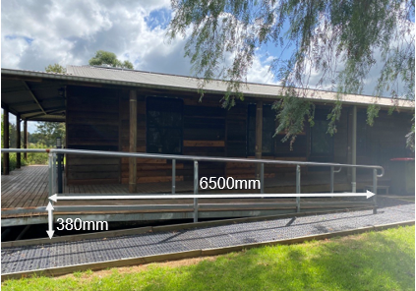
- Height: 380 mm
- Horizontal length: 6500 mm

Ramp 2
Figure 7 – ramp 2, a single step with a small ramp
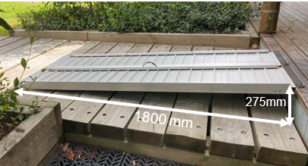
- Height: 275 mm
- Length: 1800 mm

B. Create a scale drawing of each ramp
Ramp 1
- Let 1 cm in the diagram represent 38 cm in real life, therefore the scale is $1:38$.
- Perpendicular height of the scale diagram $= 1 \text{cm}$,
since 1 cm represents$38 \text{cm} = 380 \text{mm}$.
- Horizontal distance of scale diagram:
- $6500 \text{mm}=650 \text{cm}$
- $650 \text{cm}÷38=17.1 \text{cm} \text{(rounded correct to 1 decimal place)}$
- Scale drawing of ramp 1
Figure 8 – scale drawing of ramp 1
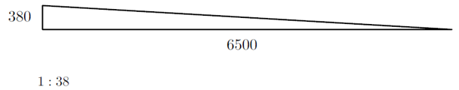
Ramp 2
- Let 1 cm in the diagram represent 27.5 cm in real life, therefore the scale is $1:27.5$.
- Perpendicular height of the scale diagram $=1 \text{cm}$,
since 1 cm represents $27.5 \text{cm}=275 \text{mm}$.
- Horizontal distance of scale diagram:
- $1800 \text{mm}=180 \text{cm}$
- $180 \text{cm}÷27.5=6.5 \text{cm (rounded correct to 1 decimal place)}$
- Scale drawing of ramp 2
Figure 9 – scale drawing of ramp 2
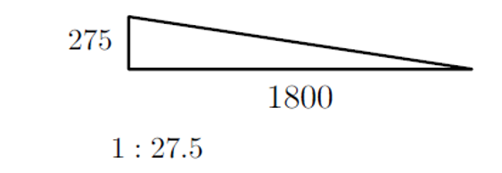

C. Compare the ramps
Does Ramp 1 satisfy the Australian Standards?
- This is a stair ramp so needs to be at a minimum ratio of 1:14
- Ratio of perpendicular height to horizontal distance
- $= 380:6500$
- $=1:\frac{6500}{380}$
- $=1:17$
- The ratio $1:17$ is bigger than 1:14, which means that it is less steep than a standard stair ramp, as can be seen in the scale diagram below.
Figure 10 – scale diagrams representing Ramp 1 and a standard stair ramp
Therefore, this ramp meets the Australian standards for a stair ramp.
Does Ramp 2 satisfy the Australian Standards?
- This is a step ramp so needs to be at a minimum ratio of 1:10
- Ratio of perpendicular height to horizontal distance
- $= 275 :1800$
- $=1:\frac{1800}{275}$
- $=1: 6.54$
- This ratio $1:6.54$ is smaller than 1:10, which means that this ramp is steeper than a standard step ramp, as can be seen in the scale diagrams below.
Figure 11 – scale diagrams representing Ramp 2 and a standard step ramp
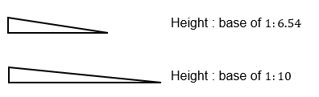
Therefore, this ramp does not meet Australian standards for a stair ramp.
Are the ramps mathematically similarity?
Figure 12 – a scale drawing of both ramps
For similar triangles, corresponding sides must be in the same ratio.
- Ratio of heights
$$\text{Ramp 1:Ramp }\text{2}$$
$$380:275$$
$$76: 55$$
- Ratio of perpendicular lengths
$$\text{Ramp 1:Ramp }\text{2}$$
$$6500:1800$$
$$65: 18$$
- The 2 ramps are not similar, as the ratio of heights to the base are not the same.

Part 2

A. Map out a day of your timetable
One day from the school timetable
Table 4 – a sample day from a student’s timetable
Period | Subject | Building/Major area
Enter school |  | Main gate
Before school |  | Assembly
1 | Maths | D Block
2 | PE | L Block then Sport/Oval 2
Recess |  | Sport/Oval 1
3 | History | B Block
4 | English | A Block
Lunch |  | Sport/Oval 1
5 | Food Technology | F Block
Leaving school |  | Main gate

Path taken on a school map
Figure 13 – routes taken to move between buildings from before school until leaving school
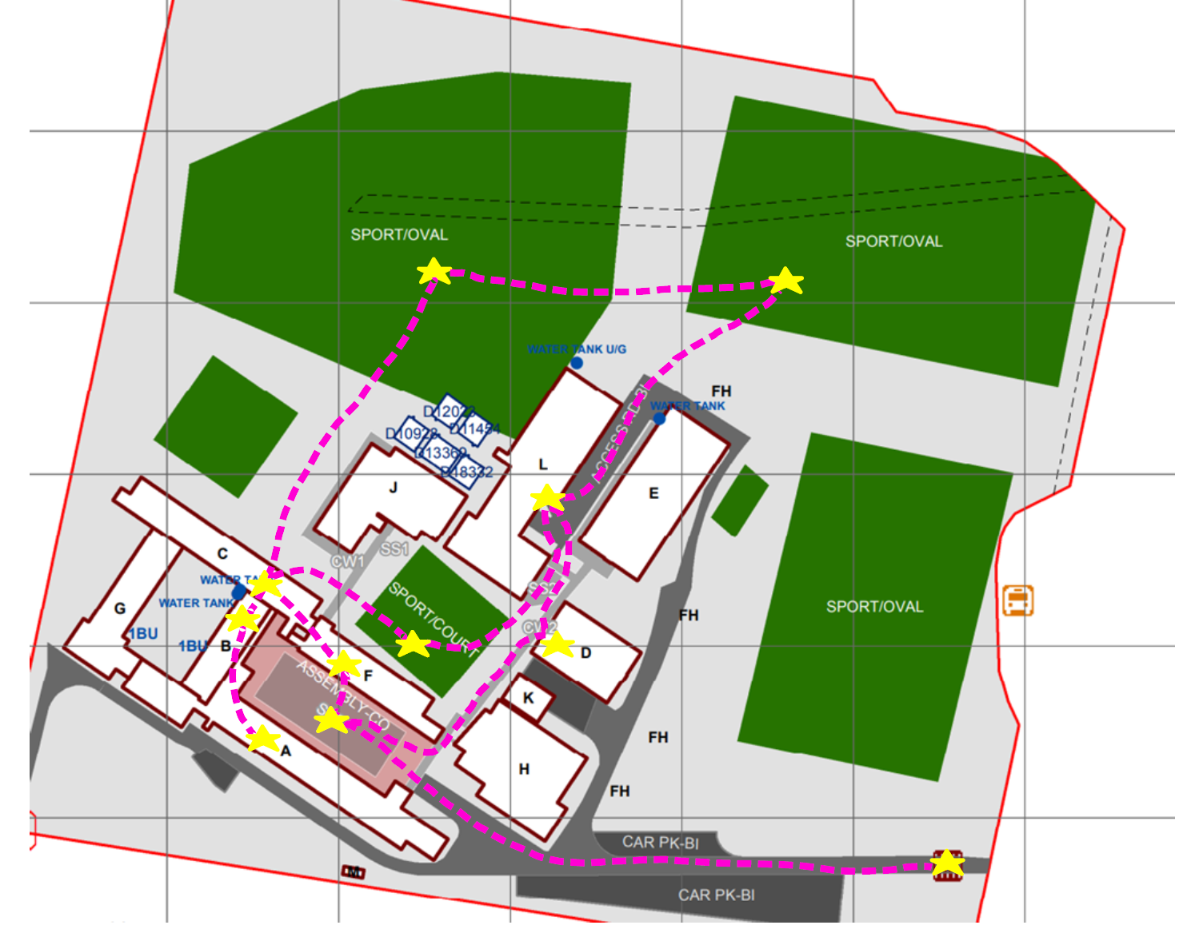

B. Convert to a network diagram
Figure 14 – network diagram, created using GeoGebra, geogebra.org/calculator
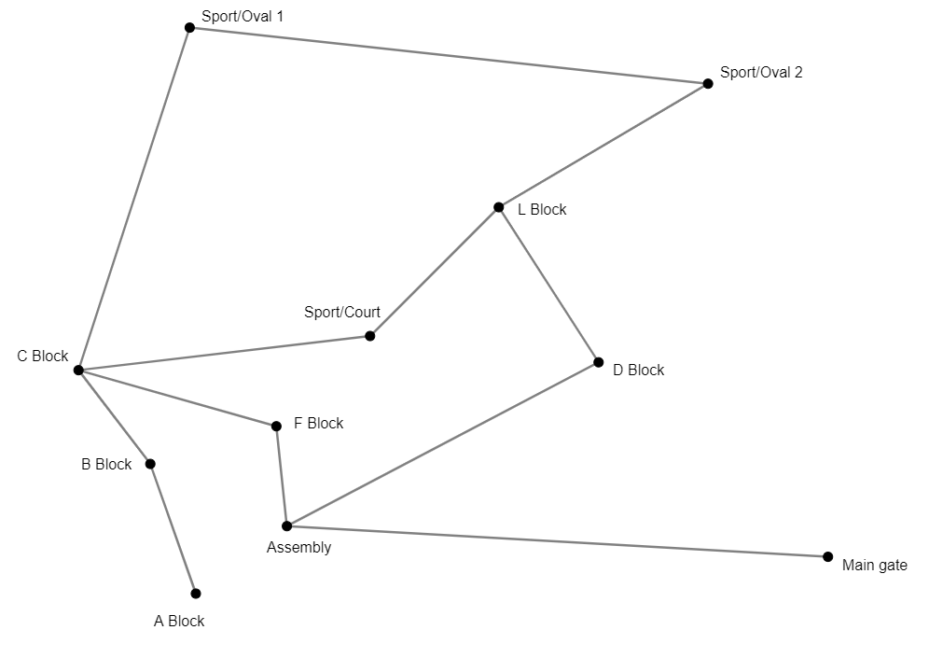

C. Redraw your network diagram, considering accessibility requirements
Figure 15 – network diagram considering accessibility requirements, created using GeoGebra, geogebra.org/calculator
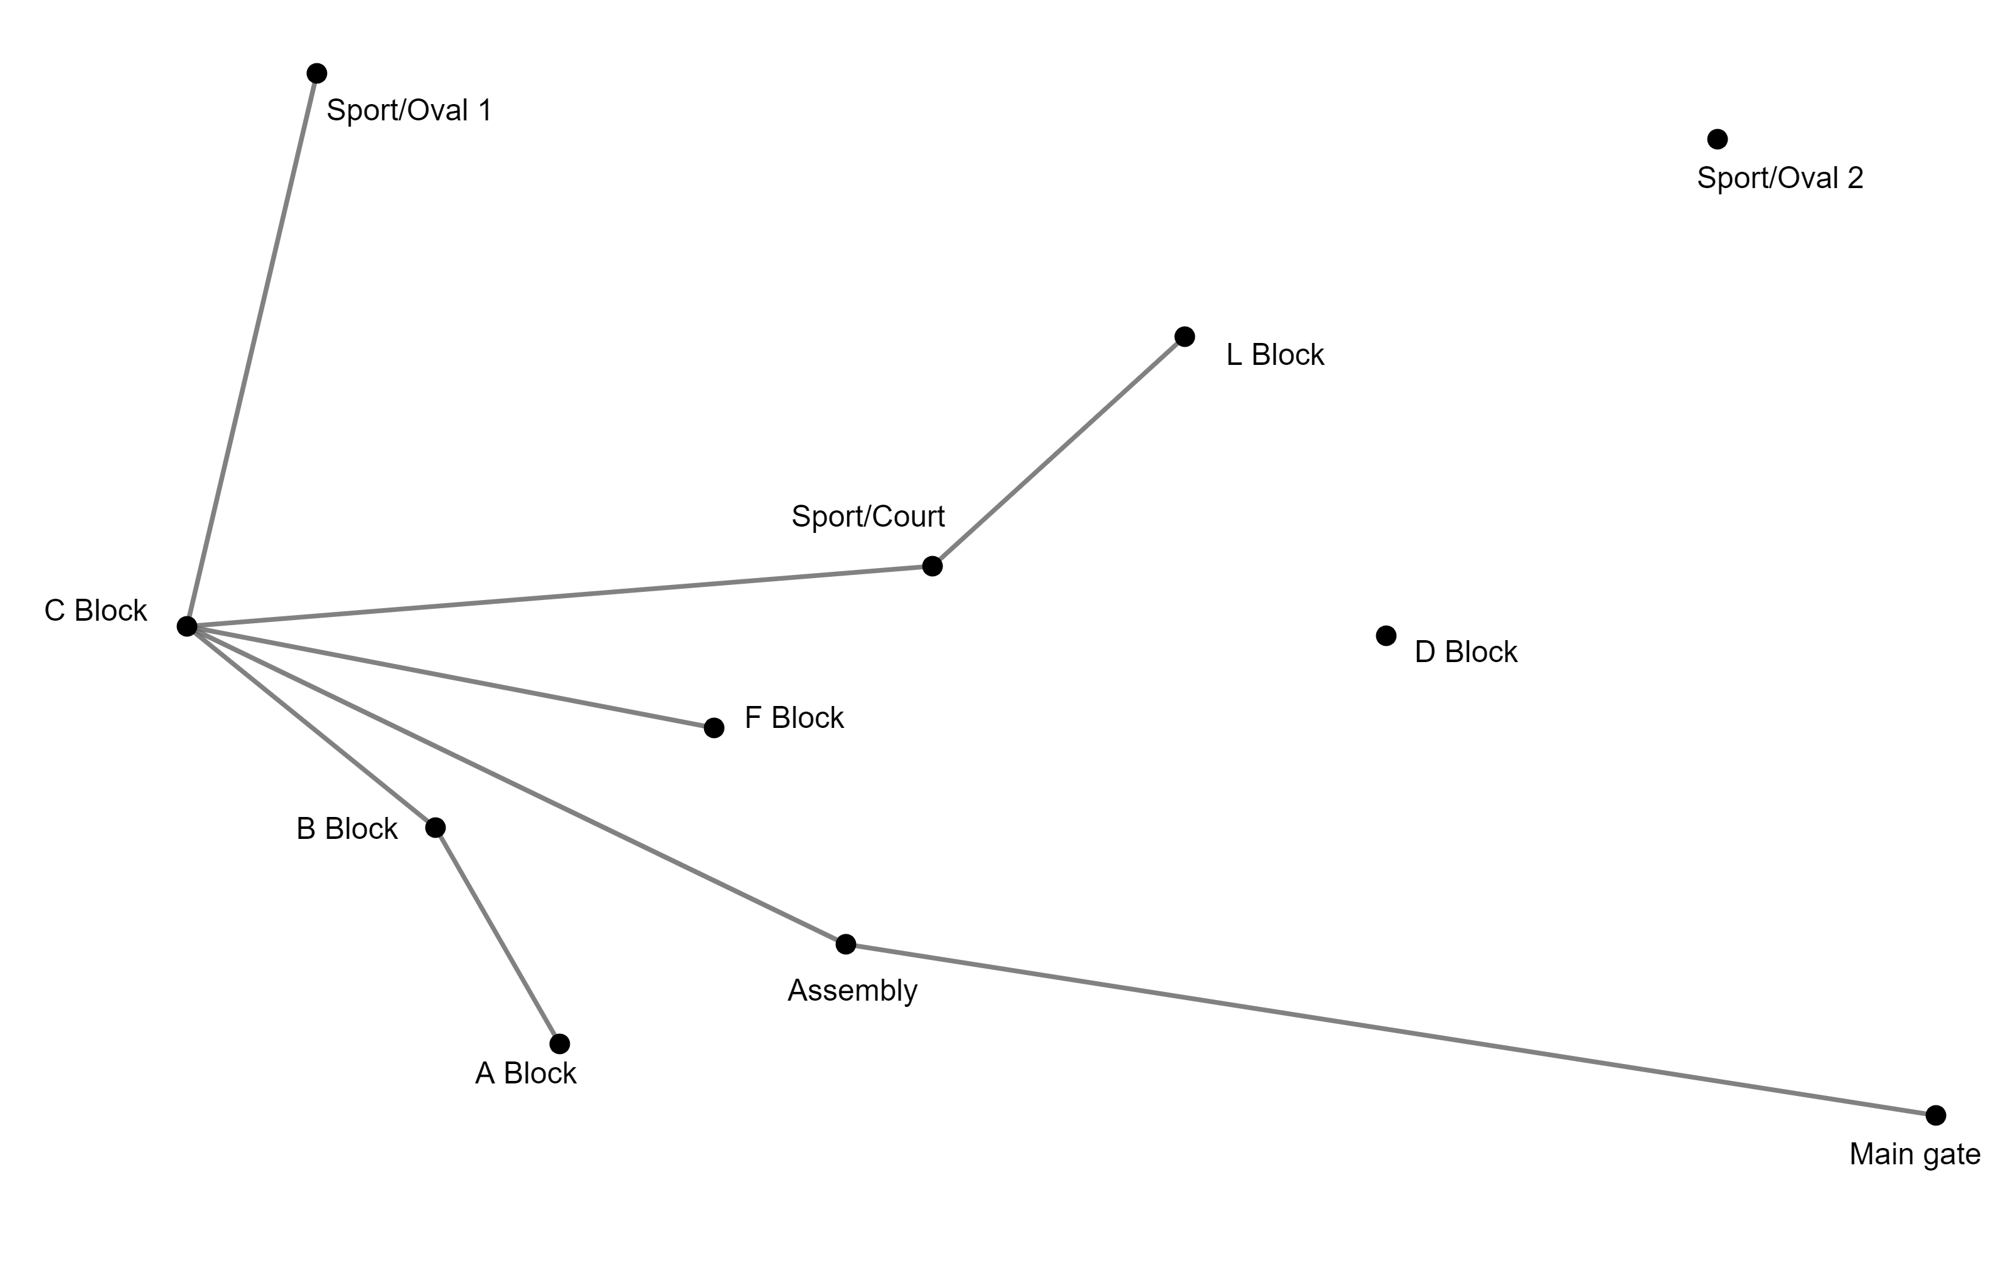

D. Network reflections
Comment on any differences between the network diagrams. Are there any paths between locations that are significantly longer for a person who uses a wheelchair?
There are 2 isolated locations that are disconnected from the network, meaning that a person who uses a wheelchair will not be able to access D Block or Sport/Oval 2 via any path. When travelling from L Block back to the assembly area, I can go straight through D block, which is only 2 edges in my network diagram. A person who uses a wheelchair would need to travel 3 edges, going from L Block back to the Sport/Court area, through C Block and then arriving at the assembly area.
Similarly, where I can travel a path from Sport/Oval 1, to Sport/Oval 2, to L Block (2 edges), a person who uses a wheelchair would need to go from Sport/Oval 1, to C Block, to Sport/Court, to L Block (3 edges).
How do the network diagrams that were created in Parts 2B and 2C impact your view of the school’s accessibility?
There are places in the school that a person who uses a wheelchair cannot access which is unfair. D Block has mostly technology classrooms but they can only be accessed via stairs.
A person who uses a wheelchair also needs to frequently take paths from one place to another that involve going through an extra location, which is also unfair.
It is good, however, that a person who uses a wheelchair has access to almost all of the school, and never has to go around the whole school just to get between 2 places.
What are the benefits and limitations of the network diagram created in Part 2C in supporting your suggested alteration?
The main benefit of constructing a network diagram is to be able to easily see the accessible paths around the school as well as the buildings that are inaccessible. Despite the network diagram being able to show the paths between blocks and major areas it unfortunately does not show the distances. I know that travelling from Sport/Oval 1 to L Block by walking past Sport/Oval 2 is much quicker than going through C Block and the Sport/Court, but in the network diagram it is 2 edges in one path and 3 edges in the other. The network diagram also does not show any reasoning why something might not be accessible. For example, many of the blocks are 2 storeys and this is not shown anywhere on the diagram.

E. Choose 2 locations in your school where ramps could be added
Location 1 – access to L Block
Figure 16 – location 1, a set of stairs to L Block
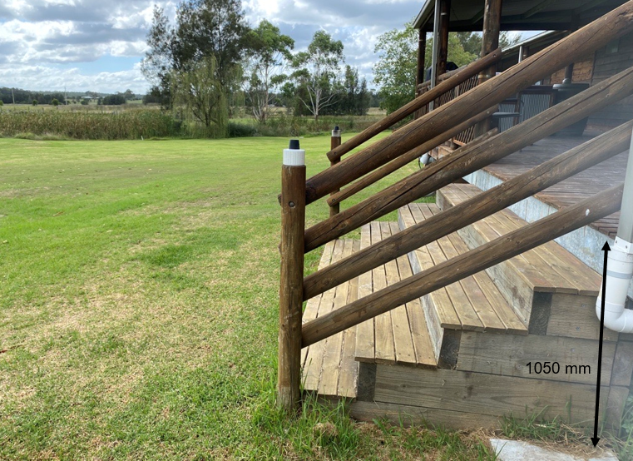
- Height = 1050 mm
- The ramp required at location 1 is a stair ramp.

Location 2 – access to D Block
Figure 17 – location 2, a set of stairs to D Block
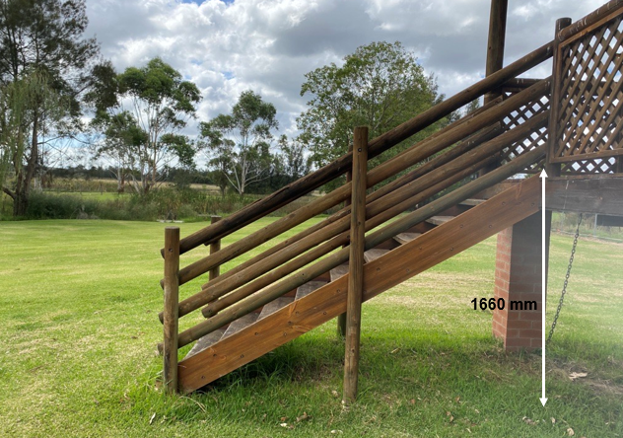
- Height = 1660 mm
- The ramp required at location 2 is a stair ramp.

F. Construct a scale drawing of your proposed new ramps
Figure 18 – scale diagram of map of the school showing the size and location of the proposed new ramps
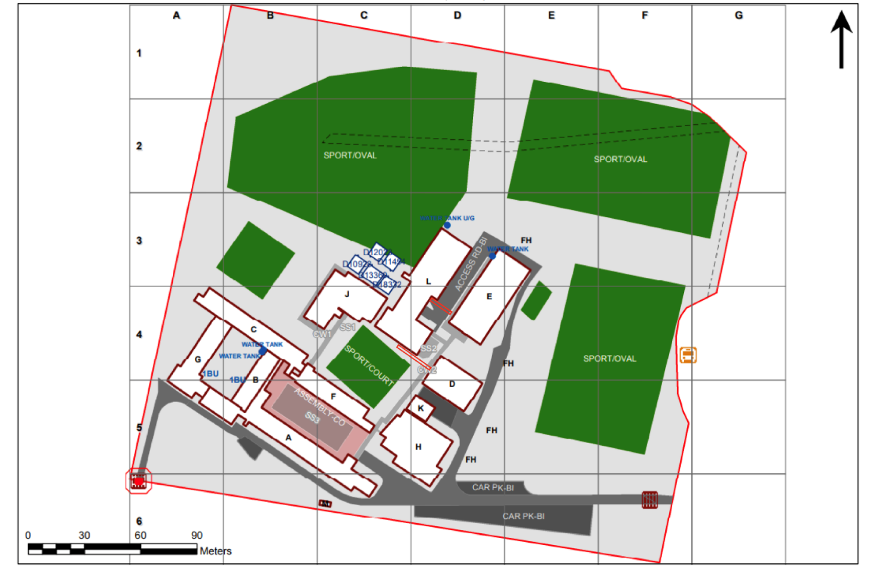
Ramp 1 (L block):
Horizontal distance = 14700 mm
Map scale is 1:1590
Horizontal distance on map will be:
14700 x $\frac{1}{1590}$ = 9.245…
9.2 mm rounded to 2 significant figures
Ramp 2 (D block):
Horizontal distance = 23240 mm
Map scale is 1:1590

Horizontal distance on map will be:
23240 x $\frac{1}{1590}$ = 14.616…
14.6 mm rounded to 3 significant figures
The minimum width of a ramp in Australia is 1000 mm (Accessed 2021). https://accessed.com.au/news/australian-standards-wheelchair-access-tips-and-advice
Map scale is 1:1590
Ramp width on map will be:
1000 x $\frac{1}{1590}$ = 0.629…
0.6 mm rounded to 1 significant figure

G. Determine if both ramps should be built in the proposed locations
Location 1 – access to L Block
$$14700 \text{mm}=1470 \text{cm}=14.7 \text{m}$$
This ramp will need to come out 14.7m from the side of the building. This is quite a long ramp to go straight over the existing stairs; however a ramp could instead be built alongside the building in one section.
Figure 19 – new ramp for Location 1 – access to L Block
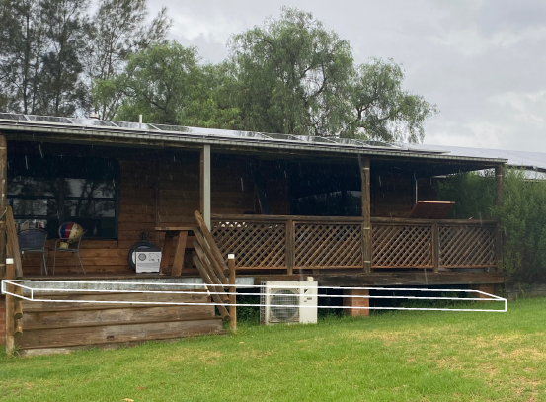
Building the ramp perpendicular to the building would mean that the ramp would extend nearly into E Block and would block off the pathway between L Block and E Block. This would be inconvenient for students and could be considered a tripping hazard.
Location 2 – access to D Block
$$23240 \text{mm}=2324 \text{cm}=23.4 \text{m}$$
This ramp will need to come out 23.24 m from the side of the building. This is a very long ramp to go over the existing stairs; however a two-part ramp could be made instead to go alongside the building.
Figure 20 – new ramp for Location 2 – access to D Block
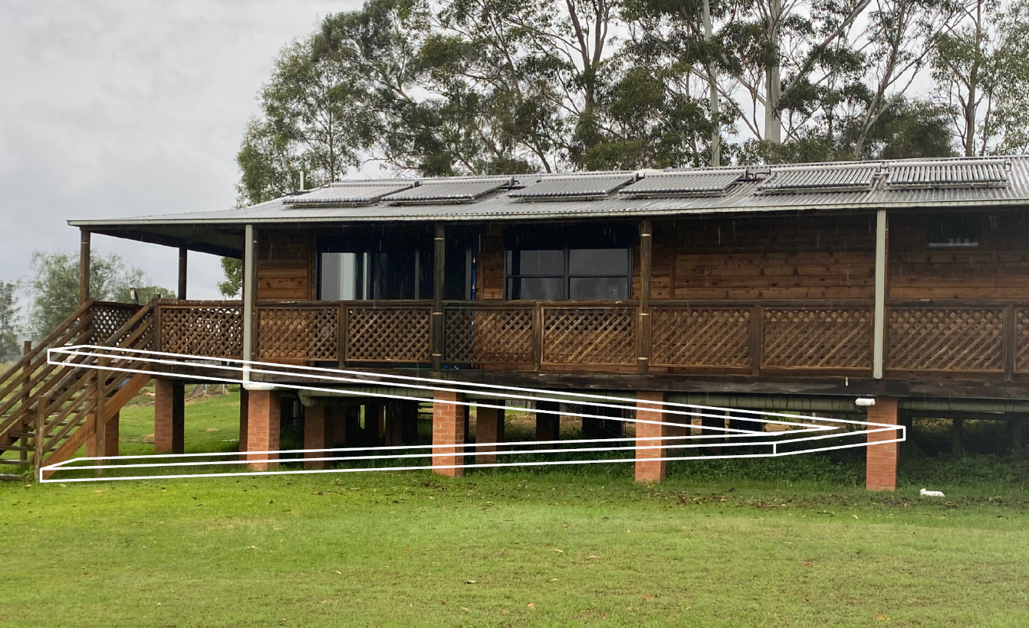
Again, building this ramp perpendicular to the building would block off the pathway to L Block.
Figure 21 – scale diagram of the school showing the size and location of the proposed ramps if they run parallel to the buildings
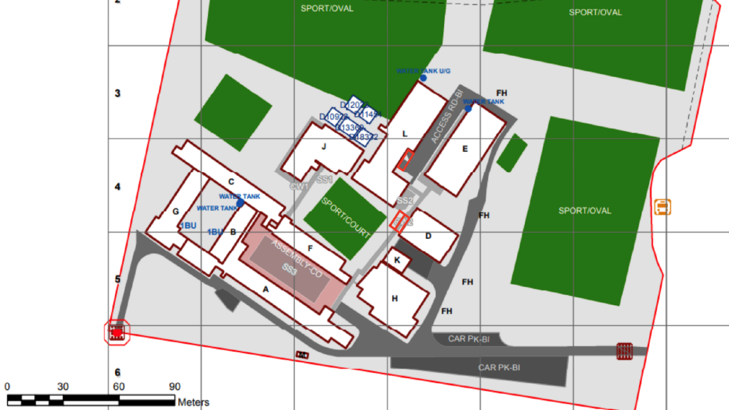

References
Mathematics K–10 Syllabus © NSW Education Standards Authority (NESA) for and on behalf of the Crown in right of the State of New South Wales, 2022.
Accessed (2021) Australian Standards wheelchair access: tips and advice, Accessed website, accessed 3 April 2023.
Design for Dignity (n.d.) ‘Guidance on premises: Ramps, landings and walkways’, Retail Guidelines, Design for Dignity website, accessed 3 April 2023.

© State of New South Wales (Department of Education), 2023
The copyright material published in this resource is subject to the Copyright Act 1968 (Cth) and is owned by the NSW Department of Education or, where indicated, by a party other than the NSW Department of Education (third-party material).
Copyright material available in this resource and owned by the NSW Department of Education is licensed under a Creative Commons Attribution 4.0 International (CC BY 4.0) licence.
This licence allows you to share and adapt the material for any purpose, even commercially.
Attribution should be given to © State of New South Wales (Department of Education), 2023.
Material in this resource not available under a Creative Commons licence:
- the NSW Department of Education logo, other logos and trademark-protected material
- material owned by a third party that has been reproduced with permission. You will need to obtain permission from the third party to reuse its material.
Links to third-party material and websites
Please note that the provided (reading/viewing material/list/links/texts) are a suggestion only and implies no endorsement, by the New South Wales Department of Education, of any author, publisher, or book title. School principals and teachers are best placed to assess the suitability of resources that would complement the curriculum and reflect the needs and interests of their students.
If you use the links provided in this document to access a third-party's website, you acknowledge that the terms of use, including licence terms set out on the third-party's website apply to the use which may be made of the materials on that third-party website or where permitted by the Copyright Act 1968 (Cth). The department accepts no responsibility for content on third-party websites.

