How heavy is too heavy?
Students collect data to compare the weight of their bags with the recommended weight for their age group. They then write a letter to the principal or P&C to convince them of the need for lockers, using statistics and graphs from their analysis.

Visible learning

Learning intentions
- To be able to select an appropriate graphical representation to display data.
- To be able to calculate measures of centre using a spreadsheet.

Success criteria
- I can select an appropriate graph type to represent continuous, numerical data.
- I can use formulas in Excel to calculate mean, median, maximum, minimum and range.
- I can use statistics and graphs to justify a decision an argument.

Syllabus outcomes
A student:
- develops understanding and fluency in mathematics through exploring and connecting mathematical concepts, choosing, and applying mathematical techniques to solve problems, and communicating their thinking and reasoning coherently and clearly MAO-WM-01
- classifies and displays data using a variety of graphical representations
MA4-DAT-C-01
- analyses simple datasets using measures of centre, range, and shape of the data MA4-DAT-C-02
Mathematics K–10 Syllabus © NSW Education Standards Authority (NESA) for and on behalf of the Crown in right of the State of New South Wales, 2022.

Activity structure
Students will be exploring how to misuse statistics and graphs by petitioning the principal and/or school P&C. Half of the class will argue that lockers need to be purchased, in which to store their belongings, so they don’t have to carry heavy bags around all day. The other half will argue that lockers are not needed, and student bags are not heavy enough to cause concern. (Higher achieving students may find it more of a challenge to argue against using lockers). Both groups of students will calculate statistics and create graphs to include in their letter.

Launch
- Show students the picture below and ask them whether they think the bags in the picture are too heavy for the students carrying them?
- What about their own bags? Are they too heavy for them to carry at their age? Ask them to explain their reasoning, for example, back pain.
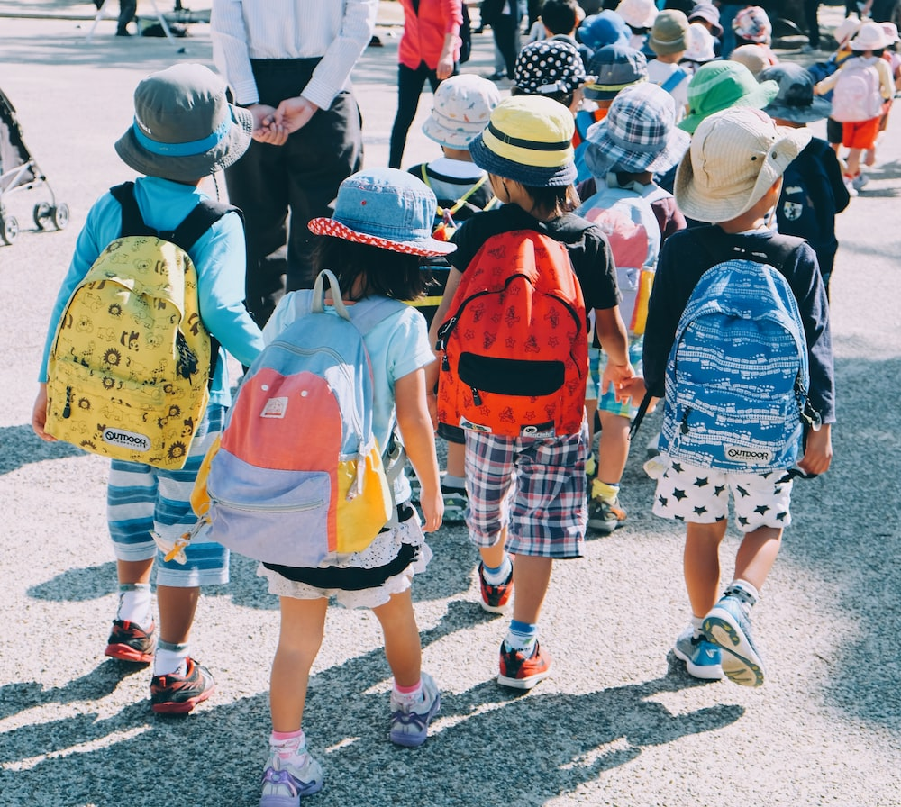
- Tell students that guidelines state that a student’s bag should be no more than
10–15% of their body weight (simplyhealth.com.au/heavy-heavy-childs-backpack/).
- Ask them to predict how heavy their bag is and whether it is heavier than it should be.

Explore
- Students will weigh their bag on its own, if possible, otherwise they will weigh themselves on their own and then weigh themselves wearing their bag and subtract to find the weight of their bag.
This could be done as a homework exercise if necessary, so students do not have to weigh themselves in front of others.
Teachers could introduce rounding skills by asking students to use their knowledge of ordering decimals to consider which whole number their bag weight is nearest to.
- Discuss with students what type of data we are collecting, for example, Numerical – Continuous.
- Students will enter the weight of their bag into column B of the shared spreadsheet How heavy is too heavy? (they will fill in the other sections later). See notes in Appendix A for information on how to manage the use of a spreadsheet in class.
- Show students how to use formulas in a spreadsheet to calculate the average, median, mode, minimum, maximum and range for their bag weights. They will enter these formulas into the shaded boxes in column G. Links to a YouTube tutorial are included next to each relevant cell.
- Students should also use the sort feature to arrange the bag weights into ascending order (make sure they select the bag weights in column B only, before using the sort command). What do students notice about the placement of the median and mean? Are they near the middle of the data?
- Using the spreadsheet, students are to draw suitable graphs of their ag weights (column B) to represent their data and to include in a later report. Appendix A contains information on how to draw graphs in Excel.

Summarise
The range of weights for a 13-year-old boy is 33 kg to 70 kg
The range of weights for a 13-year-old girl is 33.5 kg to 73.4 kg
(qldpaedendocrinology.com.au/growth-disorders-brisbane)
- Share the weight ranges above with students.
- Ask students to calculate, using a calculator, what the range of weights for a recommended bag should be. For example, using the lightest weight for a student (33 kg) to determine the lightest bag weight and using the heaviest weight for a student (73.4 kg) to determine the heaviest bag weight.
- Discuss with students what bag weight you will use for future calculations and enter this into cell D4 of the spreadsheet. Allow students to justify their choices and come to a group consensus. You may choose to use the lightest bag weight as a worst-case scenario, or you may choose to use a measure of centre such as mean or median.
- Students should then compare the bag weights in the spreadsheet with this value by creating a subtraction formula in column C, for example, =B7-D4.
- Discuss with students how many of their bags are above and below the recommended weight range.
- Discuss with students how the mean and median of their bag weights compare to the recommended weight range.
- Discuss with students what statistic they would use to argue that lockers are necessary. Which statistic would they use if they were representing the negative case?
- Discuss with students how they could manipulate their graphs to assist with arguing each side of the debate.

Apply
Students are to write a persuasive letter to the principal or P&C arguing the case for lockers, or that lockers are not necessary. They should quote relevant statistics and include and refer to graphical representations in their letters. Students may need to manipulate the scales on their graphs to help support their case.
See Appendix B for a persuasive letter template to assist students.

Assessment and Differentiation

Suggested opportunities for differentiation
Explore and Summarise
- Teachers could introduce rounding skills by asking students to use their knowledge of ordering decimals to consider which whole number their bag weight is closest to. Teachers can choose whether to allow students to work with whole numbers, or decimal values.
- Spreadsheets are used to perform most calculations, so that students can focus on interpreting the result of these calculations, rather than the procedures themselves.
- Students could use their understanding of 10% (benchmark percentage from Stage 3) to calculate 5% and use them both to calculate 15%, without the use of a calculator.
Apply
- A scaffold has been provided to assist students to write their persuasive letter.
- Students may find it easier to argue the positive case – that students need lockers because their bags are too heavy – as most students’ bags will be heavier than the recommended weight and the statistics will naturally support this argument.
- Challenge students to argue the negative case by manipulating the statistics and graphs to support this argument.

Suggested opportunities for assessment
- Student’s letter to the principal could be used as a summative assessment for this unit of learning.
- Monitor student responses during discussion to assess their understanding of mean, median, mode and range.
- Create an exit ticket asking students to write Excel formulas to calculate the minimum, maximum, mean, median and mode of some data (or calculate the same using a calculator).

Appendix A

Using the spreadsheet
Ideally, students will need shared access to the spreadsheet to be able to add their own data. They should then download their own copy of the spreadsheet and save in their personal drive, before they calculate the mean, median, minimum, maximum and range. This can be achieved by using a normal File-Save As command.

Sharing spreadsheet files with your class

Whole class activities
Cloud storage is most suitable when you want your whole class to be entering and viewing data in the one spreadsheet file.

Cloud storage – Google Drive
Visit t4l.schools.nsw.gov.au/resources/professional-learning-resources/google-resources/google-drive.html to watch a short video explaining how to share Google Drive files with others (0:57).

Cloud storage – One Drive
Visit t4l.schools.nsw.gov.au/resources/professional-learning-resources/microsoft-resources/microsoft-onedrive.html to watch a short video explaining how to share One Drive files with others (1:11).

Individual student activities
Assignments in either Google Classroom or Microsoft Teams are useful when you want students to work on their own individual spreadsheet file.

Assignments in Microsoft Teams
Visit t4l.schools.nsw.gov.au/resources/professional-learning-resources/microsoft-resources/microsoft-teams/using-assignments-in-teams.html to learn how to create and manage assignments in Microsoft Teams.

Assignments in Google Classroom
Visit t4l.schools.nsw.gov.au/resources/professional-learning-resources/google-resources/google-classroom0/using-assignments-in-google-classroom.html to learn how to create and manage assignments in Google Classrooms

Other alternatives
Files may also be shared with students via email attachments or your school’s learning management system, for example, Canvas, Moodle.
Information on how to use Microsoft Outlook can be found at https://t4l.schools.nsw.gov.au/resources/professional-learning-resources/microsoft-resources/outlook--staff-email-.html.

Formulas
A useful video which explains how to write formulas in Excel can be found at youtube.com/watch?v=Jl0Qk63z2ZY (12:28).
Links to the appropriate places in this video have been included in the spreadsheet next to the necessary cell.
The formulas necessary for the spreadsheet are:
Mean: =average(B7:B37)
Median: =median(B7:B37)
Minimum: =min(B7:B37)
Maximum: =max(B7:B37)
Range: = F11-F9 (minimum – maximum cells)

Graphs
A useful video which explains how to create basic graphs can be found at youtube.com/watch?v=ZM-9xj4DW88 (2:52). There are many others available on the internet.

Appendix B

Persuasive letter template
{Your name}
{Street address}
{Town, postcode}
{Today’s date}
{Name of principal}
{School street address}
{School town and postcode}
Dear {Name of Principal}
My name is… {Introduction – your name and year level}
I believe that…. {State your stance on lockers. Are they needed or not?}
There are many reasons to support my argument, and these include….
{Briefly state each of your 3 reasons. You do not need any proof just yet.}
The first reason is….
{State your strongest argument and include a statistic or graph to prove your point}
In addition to this….
{State your next strongest argument and include a statistic or graph to prove your point.}
Furthermore, another reason is…
{State your last argument and include a statistic or graph to prove your point}
Finally, in conclusion….
{Restate your point of view on whether lockers are needed or not and your arguments.}
Thank you for taking the time to read my letter and listen to my point of view.
Yours faithfully,
{your signature}
{your name}

© State of New South Wales (Department of Education), 2023
The copyright material published in this resource is subject to the Copyright Act 1968 (Cth) and is owned by the NSW Department of Education or, where indicated, by a party other than the NSW Department of Education (third-party material).
Copyright material available in this resource and owned by the NSW Department of Education is licensed under a Creative Commons Attribution 4.0 International (CC BY 4.0) licence.
This licence allows you to share and adapt the material for any purpose, even commercially.
Attribution should be given to © State of New South Wales (Department of Education), 2023.
Material in this resource not available under a Creative Commons licence:
- the NSW Department of Education logo, other logos and trademark-protected material
- material owned by a third party that has been reproduced with permission. You will need to obtain permission from the third party to reuse its material.
Links to third-party material and websites
Please note that the provided (reading/viewing material/list/links/texts) are a suggestion only and implies no endorsement, by the New South Wales Department of Education, of any author, publisher, or book title. School principals and teachers are best placed to assess the suitability of resources that would complement the curriculum and reflect the needs and interests of their students.
If you use the links provided in this document to access a third-party's website, you acknowledge that the terms of use, including licence terms set out on the third-party's website apply to the use which may be made of the materials on that third-party website or where permitted by the Copyright Act 1968 (Cth). The department accepts no responsibility for content on third-party websites.

