Going to the movies
Students collect data and create graphs to compare Marvel movies with the Harry Potter series to determine which is more popular. Through this context they will learn about frequency histograms and polygons and when they should be used over a column graph or line graph.

Visible learning

Learning intentions
- To be able to graph column and line graphs, and frequency histograms and polygons.
- To understand the relationship between data type and graph selection.

Success criteria
- I can graph column and line graphs.
- I can graph frequency histograms and polygons.
- I can determine which graph to draw based on data type.

Syllabus outcomes
A student:
- develops understanding and fluency in mathematics through exploring and connecting mathematical concepts, choosing, and applying mathematical techniques to solve problems, and communicating their thinking and reasoning coherently and clearly MAO-WM-01
- classifies and displays data using a variety of graphical representations
MA4-DAT-C-01
Mathematics K–10 Syllabus © NSW Education Standards Authority (NESA) for and on behalf of the Crown in right of the State of New South Wales, 2022.

Activity structure
All graphs in this lesson could be drawn by hand but it is a good opportunity to introduce to students to how to use spreadsheet software such as Microsoft Excel or Google Sheets to draw the graphs for them.
The benefit of using a spreadsheet to draw a graph, is that if the data that the graph is based on changes, the graph will automatically update.

Launch
- To launch the activity, ask students what Marvel movies they have seen. This could be done through a simple hands up or a Mentimeter poll (www.mentimeter.com).
- Which one was their favourite?
- What would they score the movie out of 10?
- What would they score Marvel movies overall out of 10?
- Do they know how many Marvel movies have been released since 2011? (34)
- Ask students what Harry Potter movies they have seen. Repeat questions from above.
- Ask students whether they think the Harry Potter movies have been more or less successful than the Marvel movies?
- Discuss how we could find out.

Explore
Students will begin by analysing data for the Marvel movies.
- Give each student an individual data set card (Appendix A) for a different Marvel movie made between 2011 and 2021. The source of this data is at IMDB (imdb.com).
The data that is contained on the cards includes the title, genre(s), release date, average audience rating (on a scale of 1 to 10) and the run time.
- Discuss with the class what they notice and wonder about what is on their card. Can they tell from their card, how popular the Marvel movies are overall?
- Discuss how we can determine how successful the Marvel movies are overall.
- How can we compare each person’s data?
- How can we display the data?
- What sort of things will we be looking for in the displays to tell us how successful the movies are?

Activity 1: Analysing release year
- Collate release date data as a class, into a frequency table similar to the one below.
- Ask students to classify the data and suggest the best graph to display the data.
Release year | Frequency
2011 | 4
2012 | 2
2013 | 3
2014 | 4
2015 | 3
2016 | 3
2017 | 3
2018 | 3
2019 | 4
2020 | 1
2021 | 4
- Ask students to draw a column graph and a line graph to represent the data.
- Ask students to compare their line graph with their column graph.
- What do they notice and wonder?
- Are their advantages in displaying the data in one form over the other?
- Which year/s produced the most movies? Discuss that this is called the mode(s).
- What is the range of data?
- Discuss with the class whether this data tells them anything useful about how popular the movies are. (Given that they are still being produced after 10 years this may be an indication, as would multiple movies being produced in the one year, or the range – how long the movies have been produced for.)

Activity 2: Analysing genre categories
- Brainstorm: What various categories of movies are there?
- Discuss that many movies often fall into multiple categories. Direct them to look at the category on their card and collate these into a frequency table on the board.
Genres (raw data) | Frequency
Act | Adv | Sci-Fi | 18
Act | Adv | Fant | 4
Act | Sci-Fi | 1
Act | Adv | Sci-Fi | Com | 4
Act | Adv | Sci-Fi | Thrill | 1
Act | Adv | Sci-Fi | Fant | 4
Act | Horr | Sci-Fi | Mys | 1
Act | Fan | Thrill | 1
- Students will then create an appropriate graph for their data.
- What does this data tell us about how popular the movies are? (Students will make a decision about which data was the most useful in determining popularity in a later activity)

Activity 3: Analysing review ratings

Frequency tables using class intervals
- Ask students to categorise and collect data on Review Rating and to create a table similar to those they have used in the previous activities.
- After students have attempted to create their frequency tables, lead a discussion of why this is a difficult exercise.
- Use slides 2 and 3 of the Going to the movies PowerPoint to explicitly show students how to create class groups in their frequency tables. Notes are included on the PowerPoint slides to explain this process.
- On Slide 3, students will then create appropriate groups and create a frequency table for the Review Rating data.
Review Rating | Frequency
4–4.9 | 2
5–5.9 | 2
6–6.9 | 9
7–7.9 | 17
8–8.9 | 4
- Discuss with students whether this table is easier to analyse and interpret than their first attempt, not using class intervals.
Students should be able to identify that most ratings were between 7 and 8 and could even extend this to say that the majority of ratings were between 6 and 8. This was much harder to identify in their first attempt without class intervals.

Frequency histograms
- Using Slides 4 to 9 of the PowerPoint, explicitly show students what a histogram looks like and discuss the differences between a histogram and a column graph. There are notes on the PowerPoint slides to explain this process.
Explain to students that although a histogram is usually used for continuous data, it can be used for discrete data if there is a large amount of it.
The data that we graphed for the release years for the Marvel movies was numeric- discrete and we graphed it as a column graph because there was only a small amount of data.
If we had data for a one-hundred-year period, we would have reorganised the data into classes or bins (For example, 2000–2004, 2005–2009) and drawn a histogram.
- Students should then create a frequency histogram for the Review Rating data.

Frequency polygons
- Again, using PowerPoint slides 10 and 11, explicitly show students how to add a frequency polygon to their frequency histogram and discuss why this is useful. There are notes on the PowerPoint slides to explain this process.
- Students should then add a frequency polygon to their movie ratings histogram.
- Discuss with students what their frequency histogram and polygon tells them about the popularity of the movies. What is the modal class? What is the median? What is the mean rating? (Median and mean to be calculated using raw data only). Which statistic, mode, median or mean would be best to describe the overall ratings review? Why?

Activity 4: Analysing movie run-time
- Lead a class discussion: Which graph would be better for movie run-time; column or histogram? Why or why not?
- Ask students to group and collate data from the movie run time category and graph the histogram and polygon.
Data could be collated in groups of 5 or 10. Points for discussion:
- Why would you group in 10’s rather than 5’s?
- Why don’t we need the < sign in these class intervals?
- What do you do if you have nothing in a column?
- What information can I interpret from these graphs?
Movie Run Time | Frequency
90–99 | 4
100–109 | 1
110–119 | 6
120–129 | 5
130–139 | 11
140–149 | 6
150–159 | 0
160–169 | 0
170–179 | 0
180–189 | 1
- What do students notice and wonder about this data? What was the most popular movie length? What was the range of lengths? Does this data help us to determine the popularity of the movies?

Apply
- Discuss with students what data was the best to help determine how popular the movies were.
- Students are then to collect data on the Harry Potter movies and create appropriate frequency tables and graphs as they did for the Marvel data.
- Looking at the graphs of the Marvel movies side by side with the Harry Potter graphs, what do they notice and what do they wonder?
- Students should make a decision as to which movies are the most popular and to write a few sentences to justify their choice.

Assessment and Differentiation

Suggested opportunities for differentiation
- It is suggested that students use a spreadsheet program to draw their graphs throughout this lesson. This allows them to focus on an appropriate graph choice, and the inclusion of titles, labels and so on.
- Spreadsheet programs will also suggest a suitable graph type for selected data and the teacher may choose to allow students to use this feature.
Explore and Summarise
- Teachers could extend students by introducing the terms uniform, unimodal, bimodal, and multimodal to describe the type of mode.
- Teachers could challenge students to look at combinations of the data, that is, do the longest movies have the worst ratings? Does a particular genre have better ratings than another genre?
Apply
- Challenge students to consider if there is any other data that would have assisted them in making their decision. They could then collect this data and re-evaluate their decision, that is, box office earnings.

Suggested opportunities for assessment
- Teachers could collect student graphs for review to assess their understanding.
- Teachers could collect the student’s decision and justification paragraph to review to assess their understanding.
- Teachers could ask students to include their graphs, decision and justification in a formal report and thus turn this lesson into a formal summative assessment task.
- Monitor student responses during discussion to assess their ability to analyse and interpret data in graphical form.

Appendix A
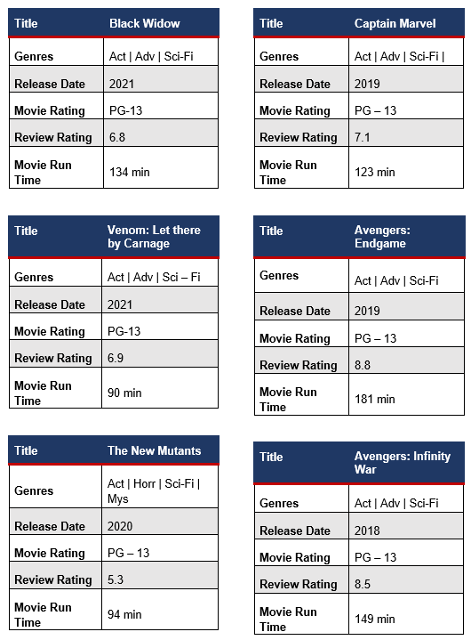

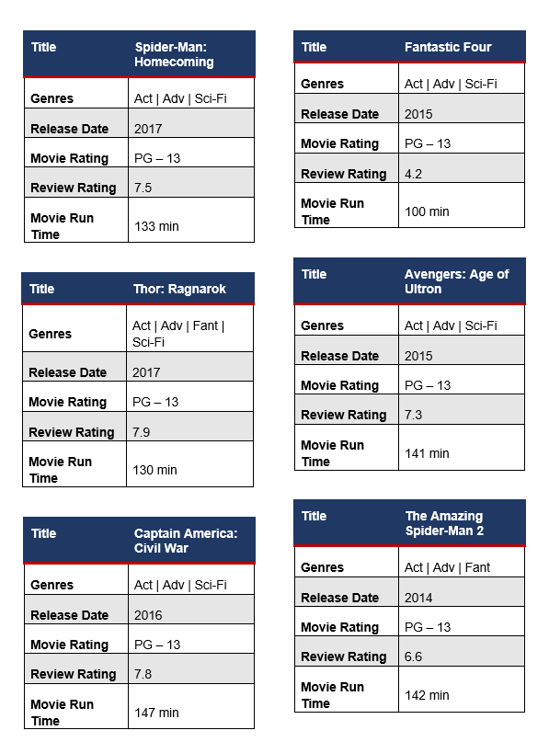
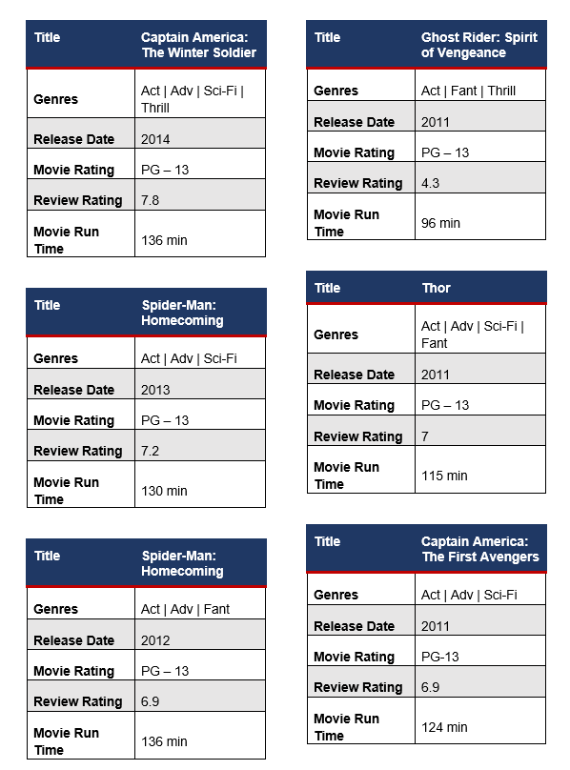
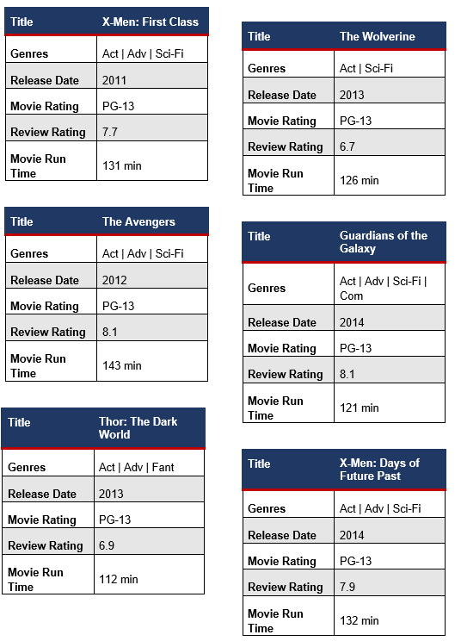
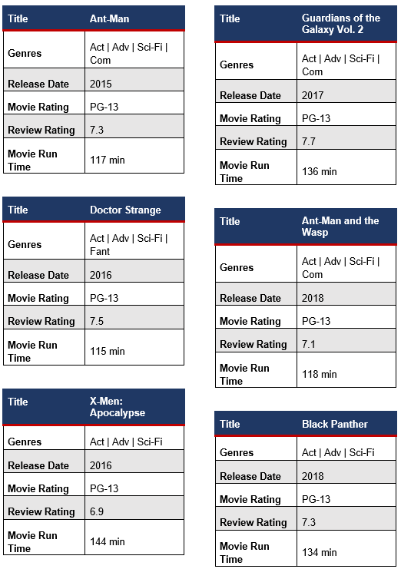
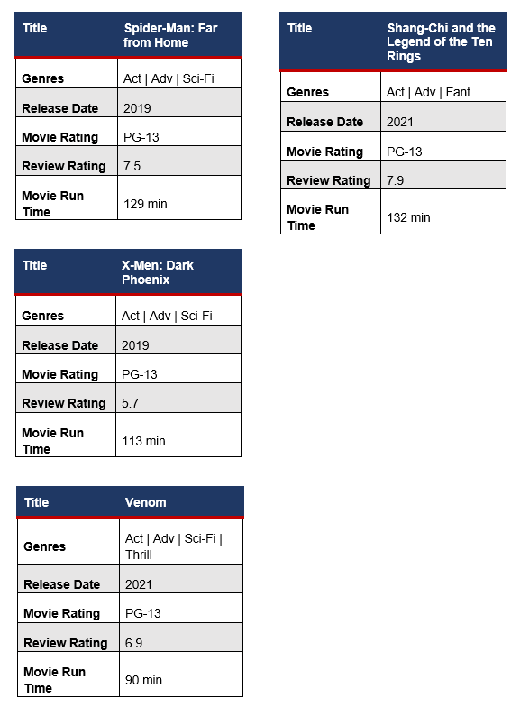

© State of New South Wales (Department of Education), 2023
The copyright material published in this resource is subject to the Copyright Act 1968 (Cth) and is owned by the NSW Department of Education or, where indicated, by a party other than the NSW Department of Education (third-party material).
Copyright material available in this resource and owned by the NSW Department of Education is licensed under a Creative Commons Attribution 4.0 International (CC BY 4.0) licence.
This licence allows you to share and adapt the material for any purpose, even commercially.
Attribution should be given to © State of New South Wales (Department of Education), 2023.
Material in this resource not available under a Creative Commons licence:
- the NSW Department of Education logo, other logos and trademark-protected material
- material owned by a third party that has been reproduced with permission. You will need to obtain permission from the third party to reuse its material.
Links to third-party material and websites
Please note that the provided (reading/viewing material/list/links/texts) are a suggestion only and implies no endorsement, by the New South Wales Department of Education, of any author, publisher, or book title. School principals and teachers are best placed to assess the suitability of resources that would complement the curriculum and reflect the needs and interests of their students.
If you use the links provided in this document to access a third-party's website, you acknowledge that the terms of use, including licence terms set out on the third-party's website apply to the use which may be made of the materials on that third-party website or where permitted by the Copyright Act 1968 (Cth). The department accepts no responsibility for content on third-party websites.

