Mythbusters
Students explore a variety of misleading graphs and identify features of graphs that are used to make them misleading.

Visible learning

Learning intentions
- To be able to recognise when data is misrepresented in graphs.

Success criteria
- I can identify features of graphs that are used to make them misleading.
- I can redraw graphs so that the data is not misrepresented.

Syllabus outcomes
A student:
- develops understanding and fluency in mathematics through exploring and connecting mathematical concepts, choosing, and applying mathematical techniques to solve problems, and communicating their thinking and reasoning coherently and clearly MAO-WM-01
- classifies and displays data using a variety of graphical representations
MA4-DAT-C-01
Mathematics K–10 Syllabus © NSW Education Standards Authority (NESA) for and on behalf of the Crown in right of the State of New South Wales, 2022.

Activity structure

Launch
- Display the graph below from the PowerPoint file Mythbusters.
Figure 1 – graph of the different heights and weights of Batmen
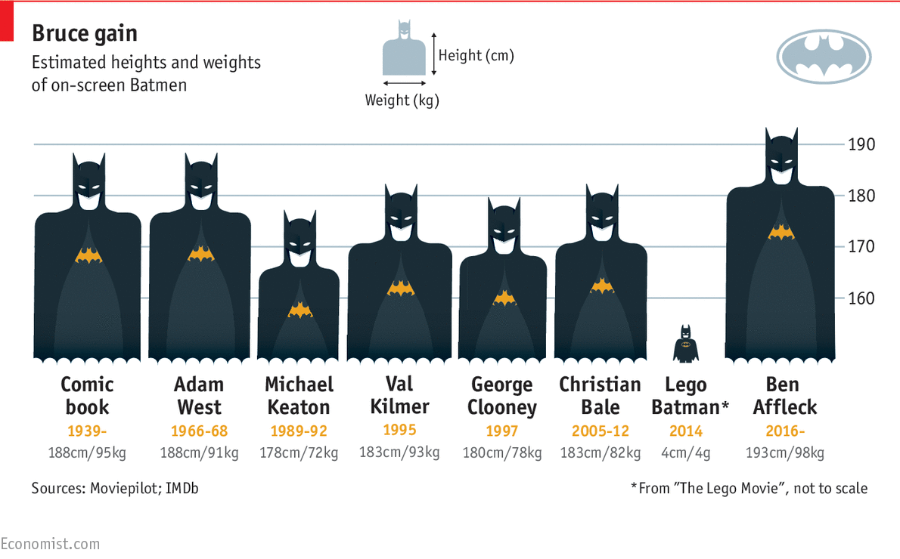
Image from ‘50 years of Batman on film: how has his physique changed?’ from The Economist.
- Ask students to discuss, in pairs, what story the graph is trying to tell.
- Ask pairs to share their ideas with the class.
The graph was designed to show that Ben Affleck, as the newest Batman at that time, was physically larger both in height and weight than previous actors who had played the role.
- Discuss with students whether the graph achieves this purpose and whether it is a true reflection of the difference in size between the actors.
- Ask students to compare this graph with the one below, and on slide 2 of the PowerPoint. What features have changed?
Figure 2 – graph with the heights of different Batmen
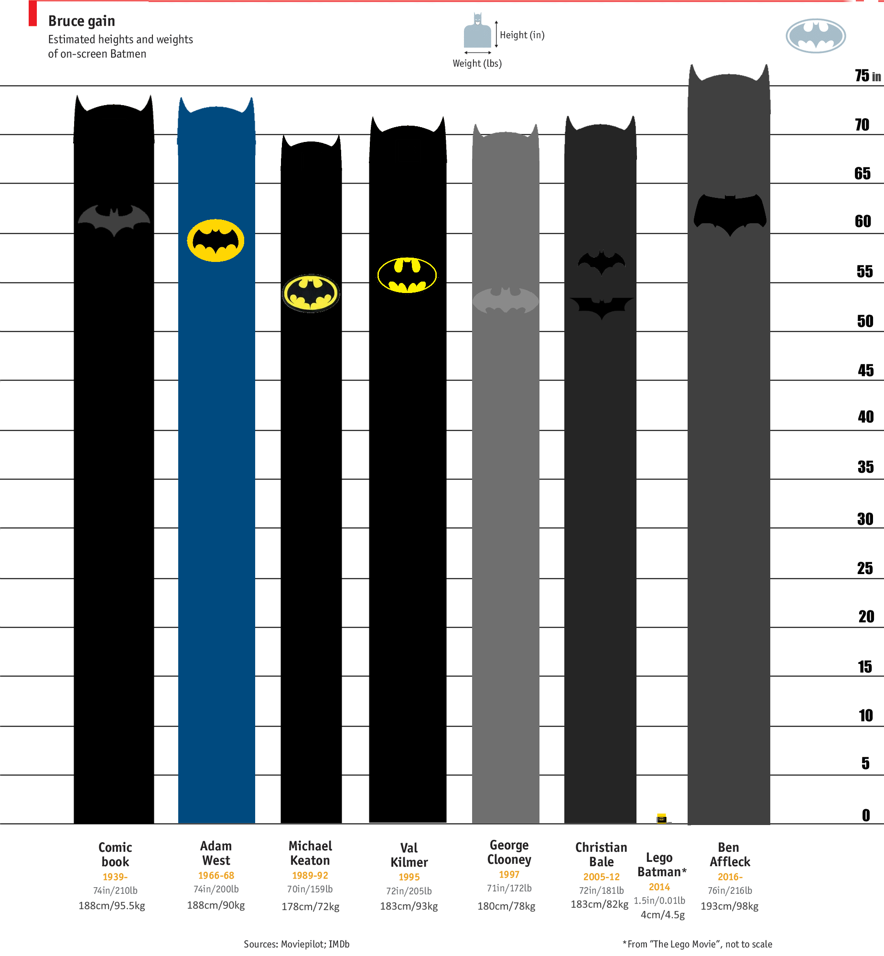
Image from ‘Estimated heights and weights of on-screen Batmen (fixed)’ by Mike Tava.
- Discuss with students whether this graph tells a different story to the original graph. Which one is more accurate?
- Discuss whether there is an alternative method of displaying the data that could be even better. Students may consider a column graph similar to the one below.
Figure 3 – graph with heights and weights of on-screen Batman
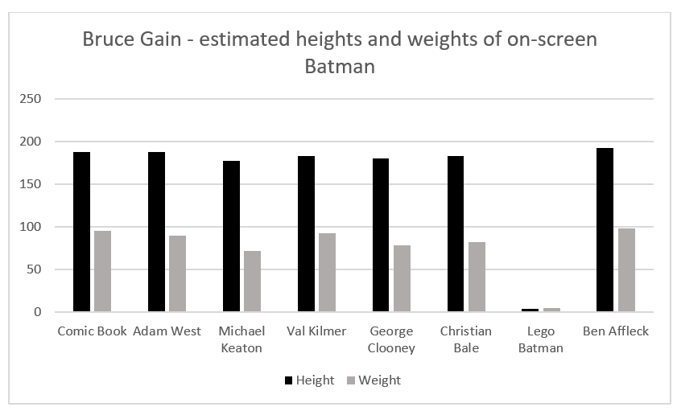

Explore
The media and businesses often manipulate graphs to support the story or message they are trying to tell.
COVID-19 may be a sensitive issue for some students. The graphs used in this section of the lesson could be replaced with other examples if this is a concern for your students.
During COVID many graphs were manipulated to change the perception of the truth.
- Appendix A has 3 COVID-19 graphs. Print these and place them around the room.
- Print enough copies of the three graphs, to have no more than 3 students at any graph at one time.
- Have students, in randomly chosen groups of 3, do a gallery walk and record what they notice and wonder. How does the graph help to tell the story in each instance?
- Bring students back to share things they notice and wonder about each graph. Discuss the story each graph is trying to tell and how the features of the graph support that story. Teachers can use the PowerPoint to display the graphs on a screen during these discussions.
- Place the graphs in Appendix B next to those from Appendix A. In the same groups, have students do a gallery walk recording what is similar in these graphs and what is different.
- Ask groups to share, with the whole class, things that they noticed were similar in the graphs and what features had been changed.
- As students share what features of the graphs have been manipulated, compose a list of questions on the board for students to refer to in the next activity.
This could include (but not restricted to):
- Do the visuals match the numeric?
- Are the increments used on each axis consistent?
- Is the scale too small or too big?
- Does the graph exaggerate the importance of something small?

Summarise
- Teachers are to find a variety of misleading graphs that would be of interest to their students. These could be printed, displayed using a projector or shared with students via a learning management system.
Misleading graphs can be found using the websites below.
- reddit.com/r/dataisugly/
- mathslinks.net/links/incorrect-graph-ethical-dilemmas-channel-7
- mathslinks.net/links/incorrect-graph-asthma-breakthrough
- mathslinks.net/links/fox-news-bar-chart-gets-it-wrong
- Using a Think-Pair-Share (bit.ly/thinkpairsharestrategy) students are to look at a variety of graphs and identify what makes the graph misleading. An example could be shortening the y-axis or changing the widths of columns.
- They should add to the list composed on the board if they find additional methods used to make graphs misleading.

Apply
Students should re-draw each of the graphs from the Summarise section, using technology. They should rectify any of the issues they identified to create a more accurate representation of the data.

Assessment and Differentiation

Suggested opportunities for differentiation
Launch and Explore
- A notice and wonder strategy is used here to include all students. This would be a good opportunity to call on students who do not normally volunteer answers, as this is a risk-free activity with no right or wrong answers.
Summarise and Apply
- This activity is accessible by all students as they can write about any observable information they interpret from the graph.
- The graphs found using the links vary in complexity.

Suggested opportunities for assessment
- Monitor student discussion and completion of the graph summary exercise to assess their understanding of the important features to look out for in order to determine if a graph is misleading. After the activity, this summary could be blown up into A3 size and displayed in the classroom.
- Student questions about new graphs or own misleading graph with reasoning could be collected.
- Create an exit ticket with a misleading graph and ask students to identify which features make it misleading and what would they do to the graph to make it a true representation of the data.

Appendix A

Tests per million inhabitants
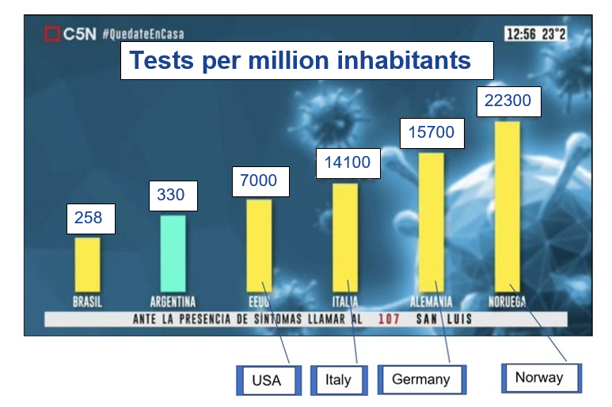
Image from C5N.

Russian TV used this graph to illustrate a flattening of the curve
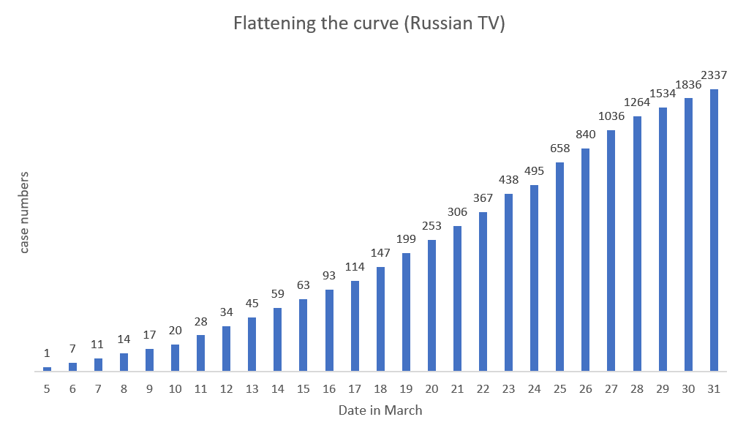
Image from ‘Stopping COVID-19 with Misleading Graphs’ by Nikita Kotsehub.

Cases in counties over the past 15 days
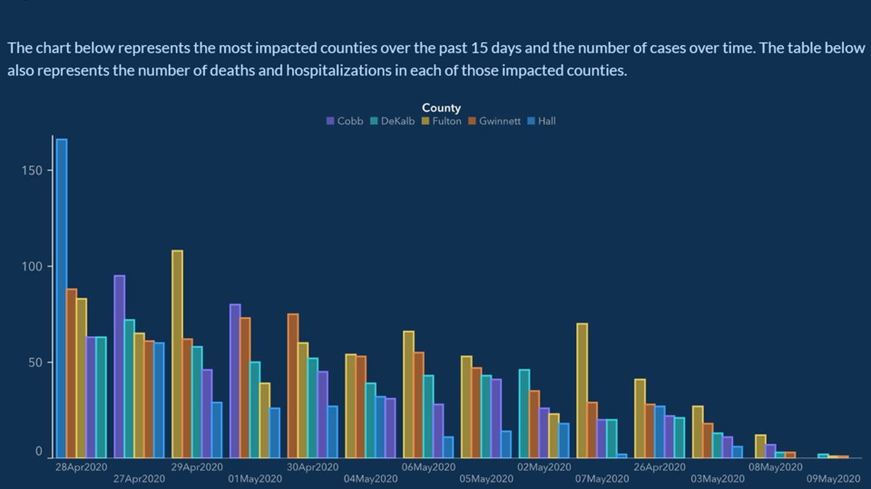
Image from ‘Week COVID-19 Data Reporting’ by Georgia Department of Public Health.

Appendix B
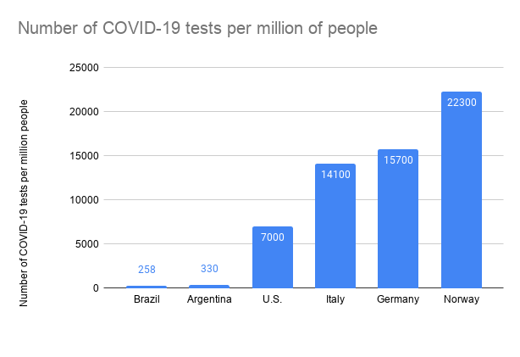
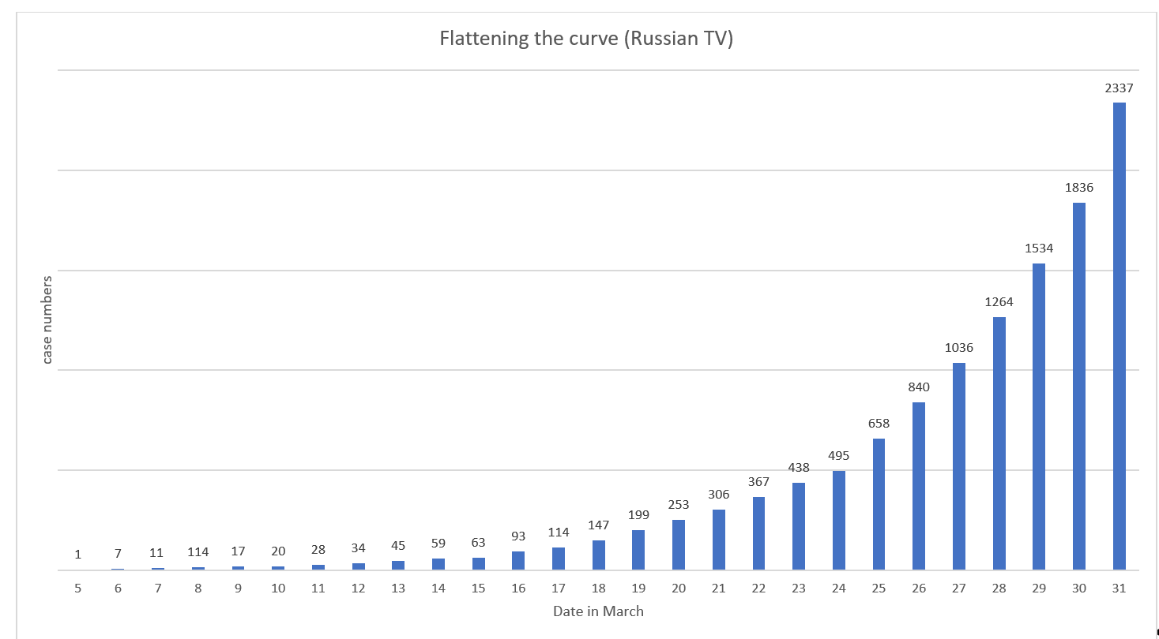
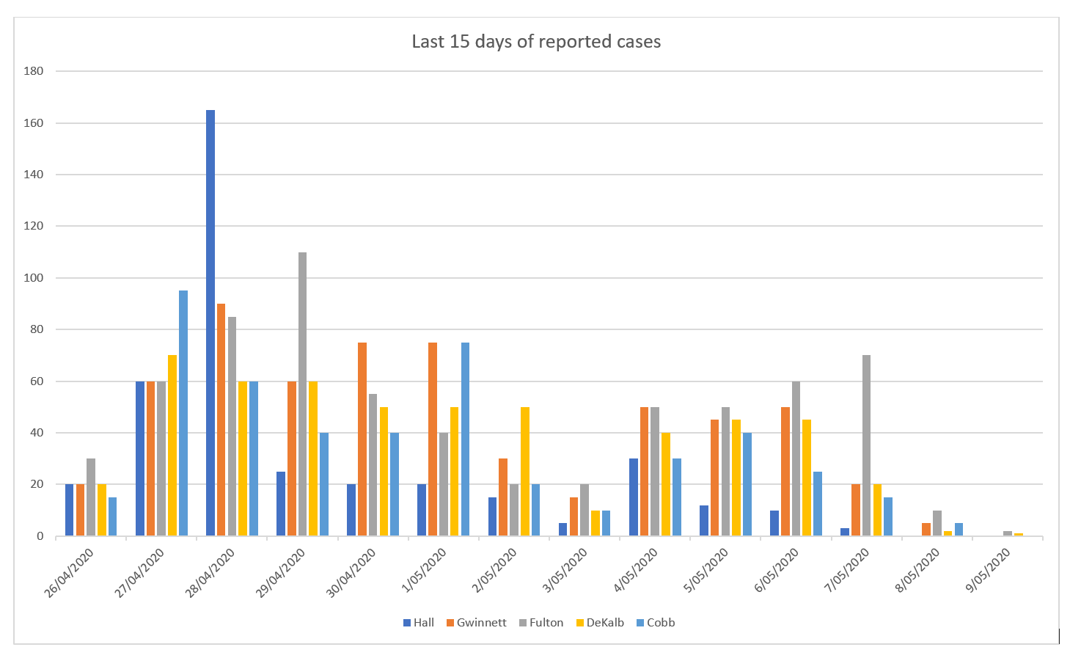
© State of New South Wales (Department of Education), 2023
The copyright material published in this resource is subject to the Copyright Act 1968 (Cth) and is owned by the NSW Department of Education or, where indicated, by a party other than the NSW Department of Education (third-party material).
Copyright material available in this resource and owned by the NSW Department of Education is licensed under a Creative Commons Attribution 4.0 International (CC BY 4.0) licence.
This licence allows you to share and adapt the material for any purpose, even commercially.
Attribution should be given to © State of New South Wales (Department of Education), 2023.
Material in this resource not available under a Creative Commons licence:
- the NSW Department of Education logo, other logos and trademark-protected material
- material owned by a third party that has been reproduced with permission. You will need to obtain permission from the third party to reuse its material.
Links to third-party material and websites
Please note that the provided (reading/viewing material/list/links/texts) are a suggestion only and implies no endorsement, by the New South Wales Department of Education, of any author, publisher, or book title. School principals and teachers are best placed to assess the suitability of resources that would complement the curriculum and reflect the needs and interests of their students.
If you use the links provided in this document to access a third-party's website, you acknowledge that the terms of use, including licence terms set out on the third-party's website apply to the use which may be made of the materials on that third-party website or where permitted by the Copyright Act 1968 (Cth). The department accepts no responsibility for content on third-party websites.

