Texting competition
Students collect and analyse data to determine who is the fastest texter in their class. They create graphical representations of the data in order to make accurate conclusions.
A typing website such as typing.com/student/tests could be used instead of texting on mobile phones.

Visible learning

Learning intentions
- To be able to identify and compare different graph types.
- To understand how to interpret data represented in graphical representations.

Success criteria
- I can create a stem-and-leaf plot from a set of data.
- I can create a dot plot from a set of data.
- I can create a divided bar graph from a set of data.
- I can interpret data represented in different types of graphs.

Syllabus outcomes
A student:
- develops understanding and fluency in mathematics through exploring and connecting mathematical concepts, choosing, and applying mathematical techniques to solve problems, and communicating their thinking and reasoning coherently and clearly MAO-WM-01
- classifies and displays data using a variety of graphical representations
MA4-DAT-C-01
Mathematics K–10 Syllabus © NSW Education Standards Authority (NESA) for and on behalf of the Crown in right of the State of New South Wales, 2022.

Activity structure

Launch
- Verbally state or display the question ‘How are athletes chosen to compete in the Olympics?’
- Students participate in a Think-Pair-Share (bit.ly/thinkpairsharestrategy) to discuss the question. Some prompts could include:
- Is it based on one competition?
- Do athletes need consistent results in multiple competitions?
- If using multiple competitions, is it their best result used? Their worst? Their average result?
- Conduct a class discussion where students can share some of their answers.
- Explain to the students that the school is going to run a texting competition where there are three different events:
- Sprint: short message
- Marathon: long message
- Hurdles: message with numbers, symbols, and an emoji.
- Explain to the class that only one student can participate from each class. Verbally state or display the following questions for students to Think-Pair-Share (bit.ly/thinkpairsharestrategy):
- Who should we choose to represent us?
- How do we know they are the best?
- How could we find out?
These questions should prompt students to think about the need for data to determine the best person to represent the class.

Explore

Equipment
- Mobile phones (or computer)
- Stopwatch (online stopwatch, physical stopwatch, or another mobile phone)
This activity could be adjusted to a typing competition if students do not have access to mobile phones. Students could use a typing test website (typing.com/student/tests ) and record their times. A 1-minute test could become the sprint, a 3-minute test could become the hurdles event and the 5-minute test could become the marathon.

Collecting data
- In groups of 3, using the Groups tab on the texting competition spreadsheet, or the table in Appendix B, students are to time and record how long in seconds it takes to type out the following messages. Students should round their answers to the sprint task to 1 decimal place. Figure 1 will need to be displayed for students.
Figure 1 – event texts
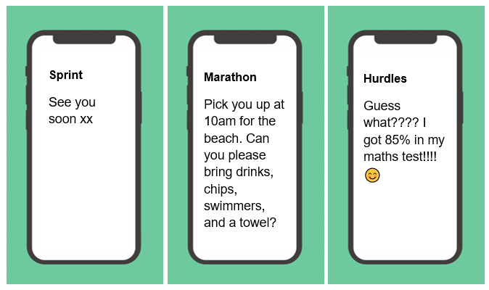
- The results for all students will need to be recorded and collected for the whole class. This can be done using the Class Data tab in the shared Texting competition spreadsheet, (see Appendix A for instructions on how to share a spreadsheet) or by students writing their times on the board.
- One student in the group can be texting, whilst a second times and the third records the result in the spreadsheet, or on the board. Students should then swap roles until all students have completed each role.

Analysing group data
- Each group of 3 will be selecting one player to represent their group in a class competition. To do this the students will need to construct and analyse the data using a divided bar graph.
Students will need to be explicitly shown how to do this either by using the spreadsheet or by working through how to construct the graph by hand.
Figure 2 – Texting Olympics times and challenges
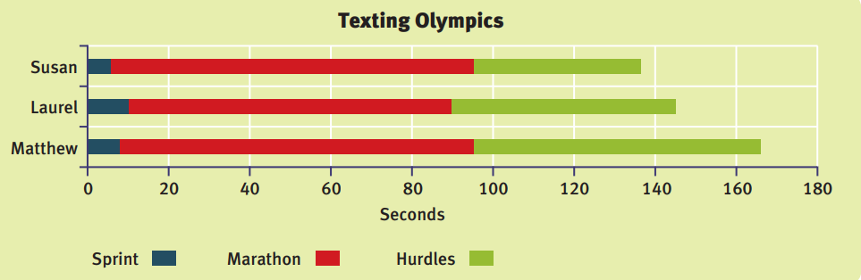
- Students are to save their own copy of the Texting competition spreadsheet.
- Students should highlight their data and create a stacked bar chart making sure to include relevant titles. (A template has been provided for students to manually draw this graph, in Appendix B)
- From the divided bar graph, students should discuss who they think should represent their group in the class competition and their reasons why.
- Each group should share their representative with the class, justifying how they came to their decision.

Analysing class data – hurdles
- Students are to construct a dot plot that represents the hurdles times for all students in the class. There is a number line on the worksheet in Appendix B for students to draw their dot plot.
- Students should compare this graph to the champions they chose from their groups. Does this graph support their group’s decision?
- Based on this graph students are to determine who they would send to represent the class in the school’s texting competition.
Some students may need to be explicitly shown how to do this, or to have the scale on their axis determined for them. This could be developed as a class instead of in groups.

Analysing class data – marathon and sprint
- Explicitly demonstrate how to construct a stem and leaf plot.
- Students will now use the whole class data set to construct stem and leaf plots for the Marathon and Sprint data, to help determine who should represent the class at the school texting competition.
For the sprint event, the stem will become the seconds and the leaf will be tenths, students may find this difficult, and this may need to be done as a class.
- Students interpret the stem and leaf plot to determine who will represent the class. Do their results support their previous conclusion?

Summarise
- Students are to reflect on each of their graphs to see how much information can be obtained. Statement starters could be given to the students to use, such as:
- Very few students…
- Almost half the students…
- No students…
- Most students…
- More students…
- Specifically for the dot plot, students could complete the following statement starters:
- The peak of the data is…
- The cluster of the data is…
- The data outlier is…
- Was there a clear winner/loser?
- Using the Think-Pair-Share strategy (bit.ly/thinkpairsharestrategy) students are to discuss:
- Which graph do you think is easier to understand and why?
- Which graph do you think gives the most information and why?
- What are the advantages and disadvantages of each graph?
- Students can then share these answers during a class discussion where the advantages and disadvantages for each group are determined, for instance, an advantage of the divided bar graph is that all the information is displayed on the one graph and a disadvantage of the divided bar graph might be that it is difficult to determine the accuracy of each result.
- Have students make notes to their future self (bit.ly/notesstrategy) outlining the key features of each graph and important points to remember when constructing the graphs.

Apply

Extending the analysis
- Explain to the students that a points system is a more accurate way of determining who could represent the class at the school texting competition. The student’s overall points are determined by:
- 5 points for the winner of each group
- 4 points for second place
- 3 points for third place
Within their groups, students are to determine each player’s points and discuss whether the leading point scorer is the same as their previous representative, or who should represent their group.
- Once students have analysed their own group’s overall points, add each student’s results to the Class data- points tab in the spreadsheet.
- Students can use the spreadsheet to calculate the total and mean scores for each student using formulas, for example, =SUM(C7:E7) and =AVERAGE(C7:E7)
- Students should draw graphs to assist in interpreting their data. They can use any of the graph types from this lesson or from previous lessons. They should be encouraged to justify the type of graph they choose.
- Have a class discussion using questions such as:
- Who has the highest overall points?
- Should the student with the highest points represent the class?
- What are the advantages and/or disadvantages of this method?

Optional activity
Students could create their own text message for the sprint, marathon and hurdles event and challenge other students to time themselves to compete for the fastest texter.
This data could be collected and displayed in a graph of their choosing. Students could then determine which graph will display their data most effectively.

Assessment and Differentiation

Suggested opportunities for differentiation
Launch and Explore
- As students are recording data to one decimal place, this is a good opportunity to revise and reinforce place value with decimals.
- Students may need to construct a dot plot as whole class, rather than individually.
- Students may need to construct the divided bar graph as a whole class, rather than individually.
- Students may need to construct stem and leaf plots as a whole class, rather than in small groups.
- Students could be given the framework or scales for each graph to assist them drawing the graphs.
- Discuss with students whether the time is the only factor that needs to be taken in to account when collecting this data, for instance, what about accuracy?
- Challenge students by asking them if additional time should be added for errors or do you make the contestant go back and fix their mistakes before stopping the timer.
Apply
- Data could be rounded the nearest whole number or to two decimal places.

Suggested opportunities for assessment
- Review students’ notes to future self to check for understanding.
- Circulate around the room and observe whether the graphical representations match the conclusions regarding who would be best to represent the group/class.
- Collect graphs and student reasoning.

Appendix A

Sharing spreadsheet files with your class

Whole class activities
Cloud storage is most suitable when you want your whole class to be entering and viewing data in the one spreadsheet file.

Cloud storage – Google Drive
Visit Google Drive (t4l.schools.nsw.gov.au/resources/professional-learning-resources/google-resources/google-drive.html) to watch a short video explaining how to share Google Drive files with others (0:57).

Cloud storage – One Drive
Visit Microsoft OneDrive (t4l.schools.nsw.gov.au/resources/professional-learning-resources/microsoft-resources/microsoft-onedrive.html) to watch a short video explaining how to share One Drive files with others (1:11).

Appendix B

Texting competition
Record the times for each member of your group for each of the events in the table below. Record your answers to 1 decimal place for the Sprint event.
Student | Sprint | Marathon | Hurdles

Divided bar graph – texting Olympics
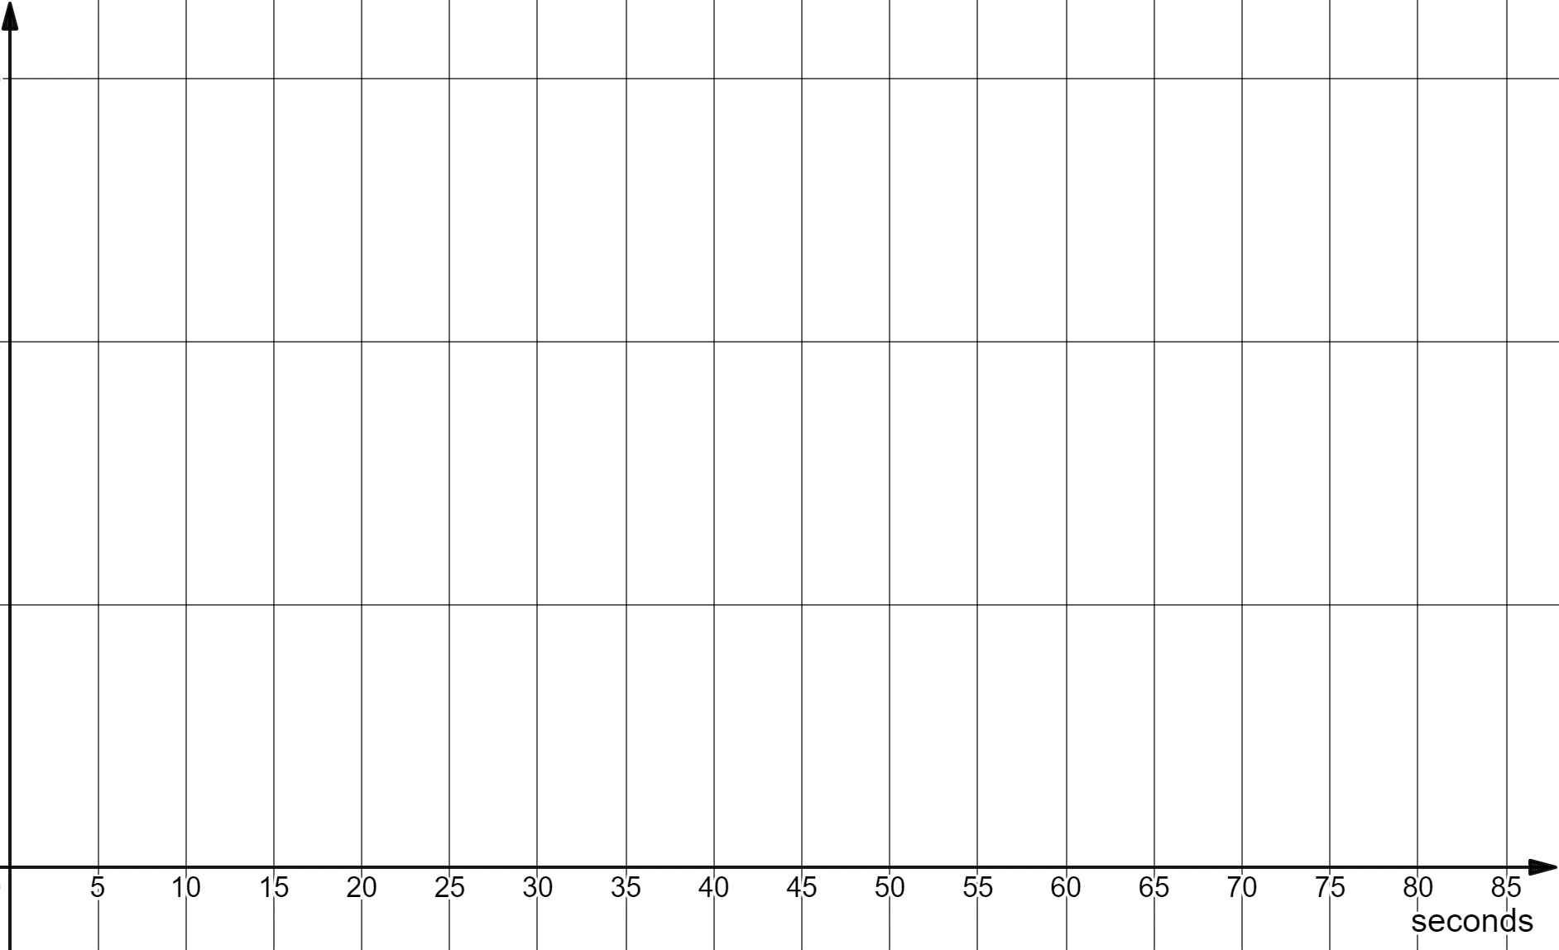
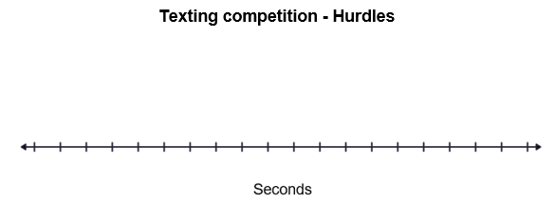

Appendix C
- A points system is a more accurate way of determining who is the best texter. To determine a student’s overall points, use:
- 5 points for the winner
- 4 points for second place
- 3 points for third place
For instance, if you are the fastest texter in your group for the sprint event, you get 5 points.
- Record each member of your group’s overall points.
Student | Sprint points | Marathon points | Hurdles points | Total points
- Is your group’s leading point scorer the same as the previous decision on who should represent your group?
© State of New South Wales (Department of Education), 2023
The copyright material published in this resource is subject to the Copyright Act 1968 (Cth) and is owned by the NSW Department of Education or, where indicated, by a party other than the NSW Department of Education (third-party material).
Copyright material available in this resource and owned by the NSW Department of Education is licensed under a Creative Commons Attribution 4.0 International (CC BY 4.0) licence.
This licence allows you to share and adapt the material for any purpose, even commercially.
Attribution should be given to © State of New South Wales (Department of Education), 2023.
Material in this resource not available under a Creative Commons licence:
- the NSW Department of Education logo, other logos and trademark-protected material
- material owned by a third party that has been reproduced with permission. You will need to obtain permission from the third party to reuse its material.
Links to third-party material and websites
Please note that the provided (reading/viewing material/list/links/texts) are a suggestion only and implies no endorsement, by the New South Wales Department of Education, of any author, publisher, or book title. School principals and teachers are best placed to assess the suitability of resources that would complement the curriculum and reflect the needs and interests of their students.
If you use the links provided in this document to access a third-party's website, you acknowledge that the terms of use, including licence terms set out on the third-party's website apply to the use which may be made of the materials on that third-party website or where permitted by the Copyright Act 1968 (Cth). The department accepts no responsibility for content on third-party websites.

