Slow reveal graphs
Students explore why graphical representations of data are easier to interpret than raw data and investigate the features of a graph that are necessary to tell the story of the data.
This lesson features data from the First Fleet which could be triggering for some students.

Visible learning

Learning intentions
- To learn the features of graphs that make them a useful visual representation of data.
- To interpret data from different types of graphs.

Success criteria
- I can explain what features are necessary on a graph to make it a useful visual representation of data.
- I can interpret data presented in graphical form.
- I can explain what type of graph is best suited for different types of data.

Syllabus outcomes
A student:
- develops understanding and fluency in mathematics through exploring and connecting mathematical concepts, choosing, and applying mathematical techniques to solve problems, and communicating their thinking and reasoning coherently and clearly MAO-WM-01
- classifies and displays data using a variety of graphical representations
MA4-DAT-C-01
Mathematics K–10 Syllabus © NSW Education Standards Authority (NESA) for and on behalf of the Crown in right of the State of New South Wales, 2022.

Activity structure

Launch
- Discuss with students the adage A picture is worth a thousand words. What do they think it means?
- Display the First Fleet spreadsheet and scroll through the data. What do students notice? What do they wonder?
This database contains a record of all the convicts that were transported to Australia from England as a punishment for their crimes.
The database lists the names, gender, age they were when they were transported, crime, sentence, boat they were transported on and so on, for each convict.
Students should be challenged to make connections with prior knowledge they have of the colonisation of Australia. Remembering that this is a contentious issue for Aboriginal Australians.
The focus should be on interpreting the data – the imbalance between males and females, the length of sentences and young age of some of the convicts.
- Scroll through the Gender column. Looking at the data ask students if they think there were more males or females that were transported.
- Click on the Males vs Females tab to reveal the graph. Discuss how much easier the graph is to interpret. Did they realise there were 3 times as many men as women, just by looking at the data?
- Repeat with Age of convicts, Ship, and Original Sentence.
- What do students now think about the phrase A picture is worth a thousand words?

Explore
Students will explore the features of different types of graphs using a slow-reveal process.
- Display and run the PowerPoint deck Slow reveal graphs in slide show mode.
- Select, using the mouse or keyboard to reveal each new feature of the graph.
- Notes are included on each slide of the deck with suggested questions to ask students after each feature of the graph is revealed.
Teachers should focus on:
- what type of data each graph is displaying
- what new information is shown at each step
- how it helps our understanding of the data.
Teachers can find out more about the process at Slow Reveal Graphs slowrevealgraphs.com/introduction/

Summarise
Ask students to create a table similar to the one in Appendix A (or print and distribute Appendix A), that lists the necessary features of each type of graph and the type of data it is most useful for.
This could be done individually and then conduct a pair/share to compare answers or students could complete this in pairs from the outset.

Apply

Data truths and lies
Using newspapers, magazines, or the internet, find at least 5 different graphs.
- For each graph, students should determine what type of data is being displayed and then write 3 facts. Two of these facts should be true and the third should be a lie. Students should try and make their lie as undetectable as possible.
- Students should swap their work with another student and have them try to determine the lie for each graph.

Assessment and Differentiation

Suggested opportunities for differentiation
Launch and Explore
- A notice and wonder strategy should be used here to include all students. This would be a good opportunity to call on students who don’t normally volunteer answers, as this is a risk-free activity with no right or wrong answers.
- Students should be challenged to make connections with prior knowledge they have of the colonisation of Australia. Remembering that this is a contentious issue for Aboriginal Australians. The focus should be on interpreting the data – the imbalance between males and females, the length of sentences and young age of some of the convicts.
Apply
- This activity is accessible by all students as they can write about any observable information they interpret from the graph.
- Students are challenged in this activity to make their lie as hard to detect as possible by writing about something that seems plausible but isn’t. Students should also be challenged to use new types of graphs that they haven’t studied in previous years. This could include infographics.

Suggested opportunities for assessment
- Monitor student discussion and completion of the graph summary exercise to assess their understanding of the important features of each graph type. After the activity, this summary could be blown up into A3 size and displayed in the classroom.
- Student questions and answers for the Data truths and lies activity could be collected to be used as formative assessment.
- Create an exit ticket with an incomplete graph and ask students to identify which features are missing.

Appendix A

Types of graphs
Type | Features | Best suited for…
Column graph
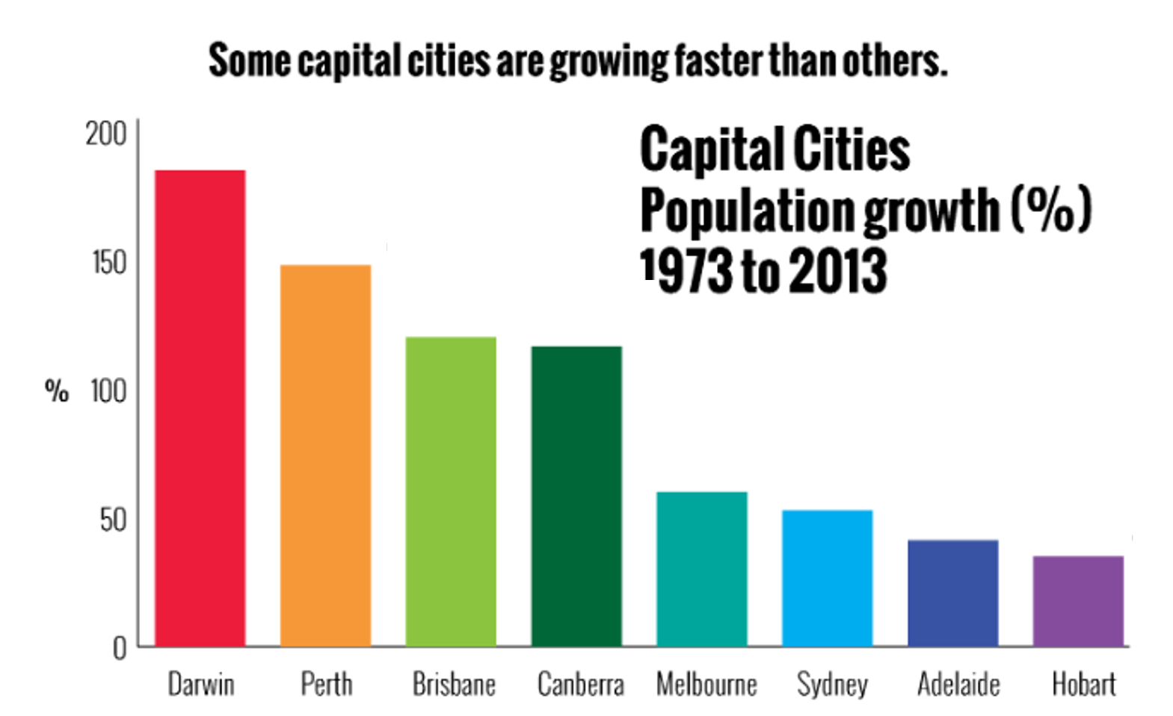
Pictograph
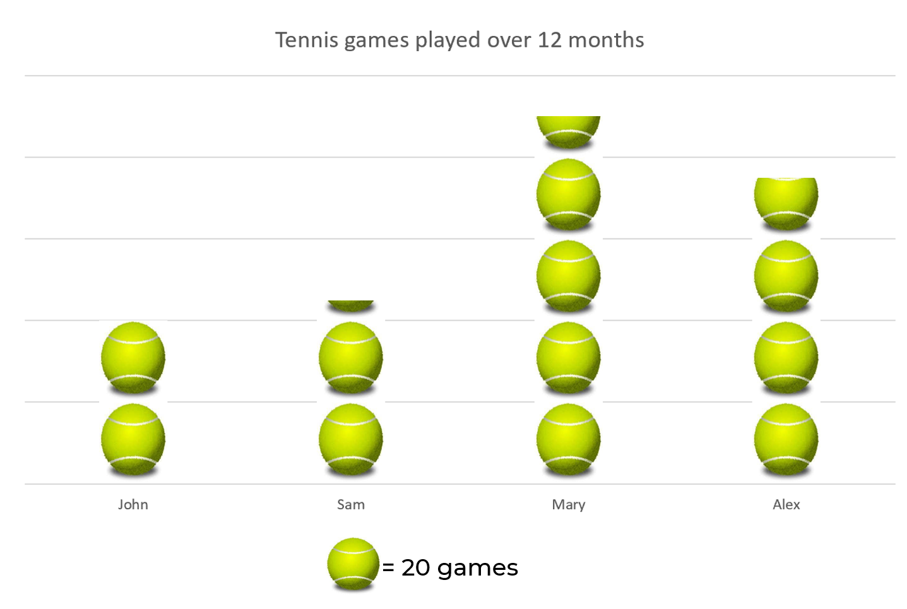
Dot Plot
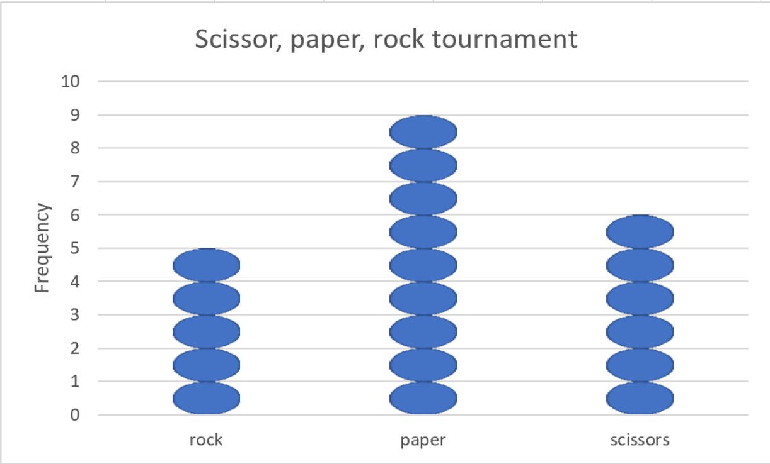
Divided Bar
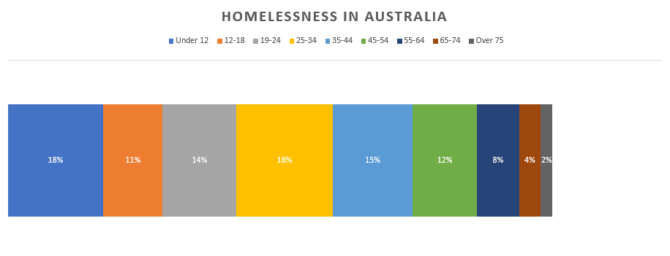
Sector graph
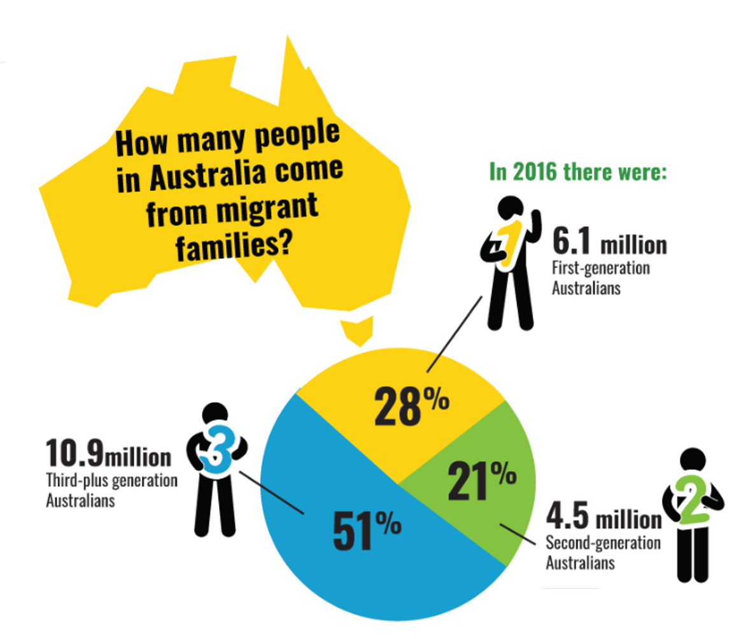
Line graph
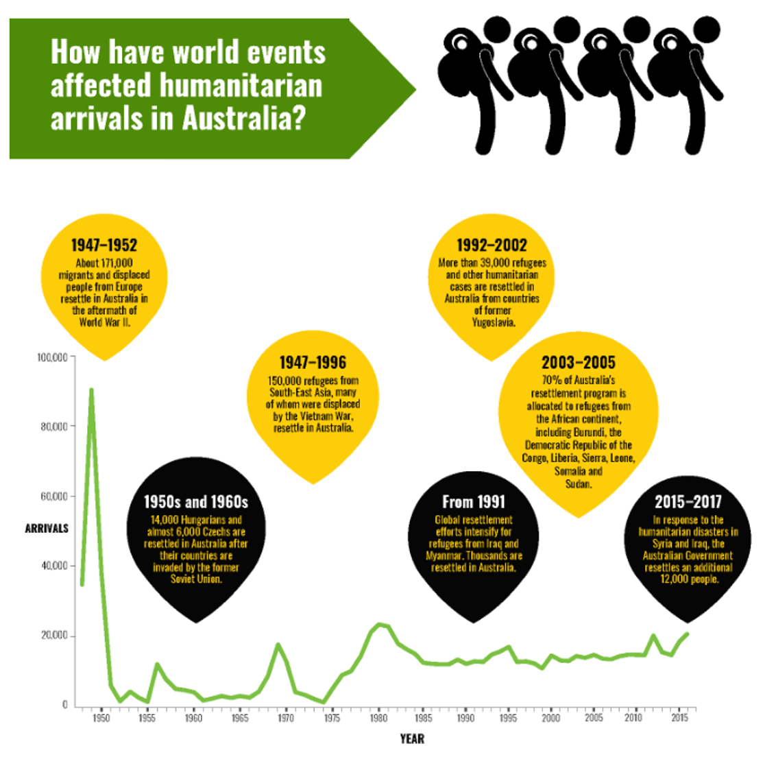
Stem and Leaf graph
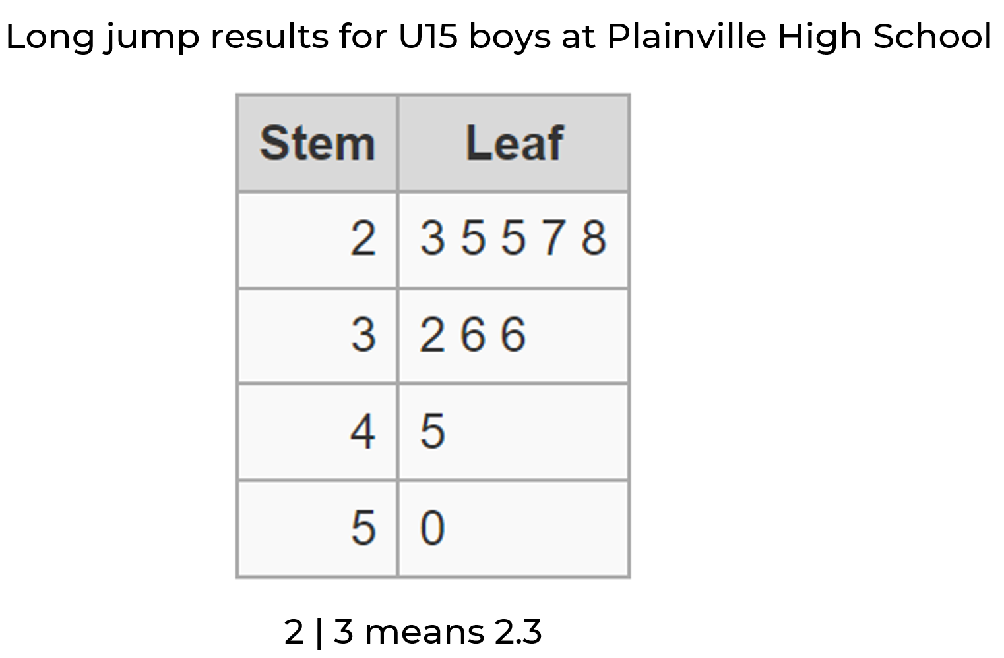

Solutions – types of graphs
Type | Features | Best suited for…
Column graph | - A column for each category  - Space between each column  - Each column is same width  - Categories along the horizontal axis  - Frequencies along the vertical axis- equal spacing  - Title of graph and labels on both axes | Categorical data  Numerical – discrete
Pictograph | - Key to show what symbol or picture means  - Each picture is identical in size and shape  - Title of graph and label on horizontal axis | Categorical data  Numerical – discrete
Dot Plot | - Categories along horizontal axis  - Frequency along vertical axis – equal spacing  - Each dot is the same size and shape  - The total number of dots in each column represents the frequency of the data value  - Title of graph, labels on both axes | Categorical data  Numerical – discrete
Divided Bar | - Whole bar represents the whole data set  - Each segment represents the proportional size of each category  - Similar to a sector graph  - Title of graph and labels for each segment (could be shown in a legend)  - Number or percentages showing the size of each segment | Categorical data  Numerical – discrete
Sector graph | - Circle represents the whole data set  - Each segment represents the proportional size of each category  - Similar to a divided bar graph  - Title of graph and labels for each segment (could be shown in a legend)  - Number or percentages showing the size of each segment | Categorical data  Numerical – discrete
Line graph | - Title of graph and labels on both axes  - Time is often displayed on horizontal axis – equal spacing  - Frequency is displayed on vertical axis – equal spacing  - Individual data points are joined by a line | Categorical – ordinal  Numerical – discrete
Stem and Leaf graph | - Data is displayed in two columns  - The left column displays the first digit of the number (thousands, hundreds, tens, or units)  - The right column shows the last digit/s as the leaf  - Title to explain the context of the information  - A legend is often included to explain how numbers are represented | Numerical – discrete

© State of New South Wales (Department of Education), 2023
The copyright material published in this resource is subject to the Copyright Act 1968 (Cth) and is owned by the NSW Department of Education or, where indicated, by a party other than the NSW Department of Education (third-party material).
Copyright material available in this resource and owned by the NSW Department of Education is licensed under a Creative Commons Attribution 4.0 International (CC BY 4.0) licence.
This licence allows you to share and adapt the material for any purpose, even commercially.
Attribution should be given to © State of New South Wales (Department of Education), 2023.
Material in this resource not available under a Creative Commons licence:
- the NSW Department of Education logo, other logos and trademark-protected material
- material owned by a third party that has been reproduced with permission. You will need to obtain permission from the third party to reuse its material.
Links to third-party material and websites
Please note that the provided (reading/viewing material/list/links/texts) are a suggestion only and implies no endorsement, by the New South Wales Department of Education, of any author, publisher, or book title. School principals and teachers are best placed to assess the suitability of resources that would complement the curriculum and reflect the needs and interests of their students.
If you use the links provided in this document to access a third-party's website, you acknowledge that the terms of use, including licence terms set out on the third-party's website apply to the use which may be made of the materials on that third-party website or where permitted by the Copyright Act 1968 (Cth). The department accepts no responsibility for content on third-party websites.

