What does Google know about me?
Students investigate the types of data that can be collected and categorise it using the labels categorical, numerical, continuous, discrete, nominal and ordinal.

Visible learning

Learning intentions
- To be able to identify and categorise data.

Success criteria
- I can describe different types of data.
- I can identify different types of data.
- I can identify techniques to analyse different types of data.

Syllabus outcomes
A student:
- develops understanding and fluency in mathematics through exploring and connecting mathematical concepts, choosing, and applying mathematical techniques to solve problems, and communicating their thinking and reasoning coherently and clearly MAO-WM-01
- classifies and displays data using a variety of graphical representations
MA4-DAT-C-01
Mathematics K–10 Syllabus © NSW Education Standards Authority (NESA) for and on behalf of the Crown in right of the State of New South Wales, 2022.

Activity structure

Launch
- Ask students to raise their hands if they use Google.
- Use a think, pair, share strategy to brainstorm what type of data they think Google knows about them.
- Show students the video ‘What Google knows about you (2:02)’ (bit.ly/Google_data). As they watch, ask them to write down the data that Google stores about them.
- Using the same pair as before, ask students to compare their list with the list from the video.
- Ask students to consider what Google uses this data for? Why would they be interested in how far you have travelled on any particular day?
- Ask pairs to share their answers with the whole class.

Explore

Activity 1 – categorising data
- Distribute a set of cards (Appendix A) to each pair.
- Ask students to sort the cards in any manner that makes sense to them.
- Combine with a nearby pair and discuss how and why they sorted their cards the way they did. As a group, decide which method is better.
- Combine with another group, to form a group of 8. Have each group of 4 share how they have sorted their cards and justify their method. Again, ask the group of 8 to come to a consensus as to which method is better.
- Have each group of 8 share with the whole class.
Students should realise that there are at least 2 different data types – categorical and numerical. They have studied these terms in Primary school. We now want to direct students’ attention to the fact that we can further classify the data within these 2 different types, for instance, nominal and ordinal, and discrete and continuous.
- If students haven’t already, focus their attention on the categorical pile and see if they can further sort the cards into categories.
- Introduce the terms ‘nominal’ and ‘ordinal’.
- Again, if students haven’t already, focus their attention on the numerical pile and see if they can further sort the cards into categories.
- Introduce the terms ‘discrete’ and ‘continuous’.

Activity 2 – analysing different types of data
- Distribute the worksheet from Appendix B.
- Working in pairs or random groups of 3, students are to use their knowledge of statistics to determine what knowledge Google could gain from the data, for example, ‘How much do I normally spend on lunch?’ ‘What is my favourite active wear brand?’

Summarise
- Ask students to share how they analysed each data set.
- Discuss as a class, how analysis of categorical data differs from that of numerical.
This is a good opportunity to discuss that numbers can be categorical data. Postcodes are a great example as the numbers have no meaning. It makes no sense to find the median or mean of postcodes. In the UK they use letters and numbers to represent postcode. Another example are dates. These can be sorted in order but again it makes no sense to calculate the mean.
- Students are to make notes to their forgetful selves (bit.ly/notesstrategy) summarising what they have learnt from the previous activities. They should make sure that they understand the definitions of nominal, ordinal, discrete and continuous and should include examples that seem counter intuitive, for instance, postcodes.

Apply
- Visit the website games.abc.net.au/education/statistics-game/index.htm#/ (or use data collected from newspaper and magazine articles and graphs)
- Find examples of nominal, ordinal, discrete and continuous data. Students should write a sentence to justify their choices.

Assessment and Differentiation

Suggested opportunities for differentiation
Launch and Explore
- During these discussions there are no right or wrong answers, so all students should be encouraged to share their ideas and explain their reasoning.
- Whilst working on Activity 2 from Appendix B, students should be challenged to consider whether the mean, median or mode would be more suitable for Google to use.
- Students should be encouraged to continue to use blocks or counters to assist them to find the median and mean, if required.
Apply
- Students could be challenged to find other types of data that look numerical but are actually treated as categorical. Examples would include postcodes or shoe sizes.

Suggested opportunities for assessment
- Teachers could create an exit ticket where students have to categorise the type of a data set.
- Monitor student discussions throughout the lesson to check for understanding.

Appendix A

What does Google know about me?
Arrange the cards into any order that makes sense to you. Be prepared to justify your choices.
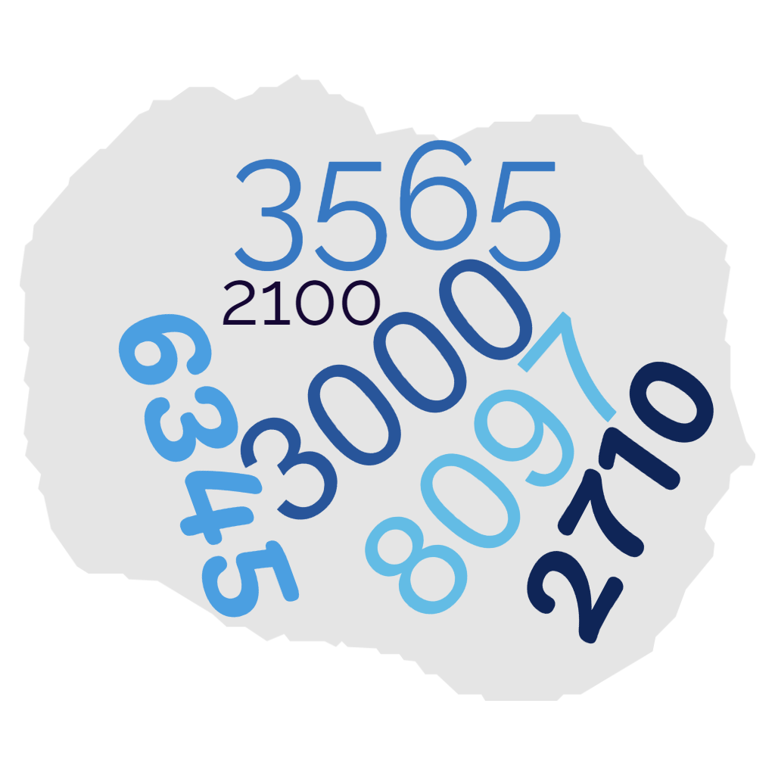 | 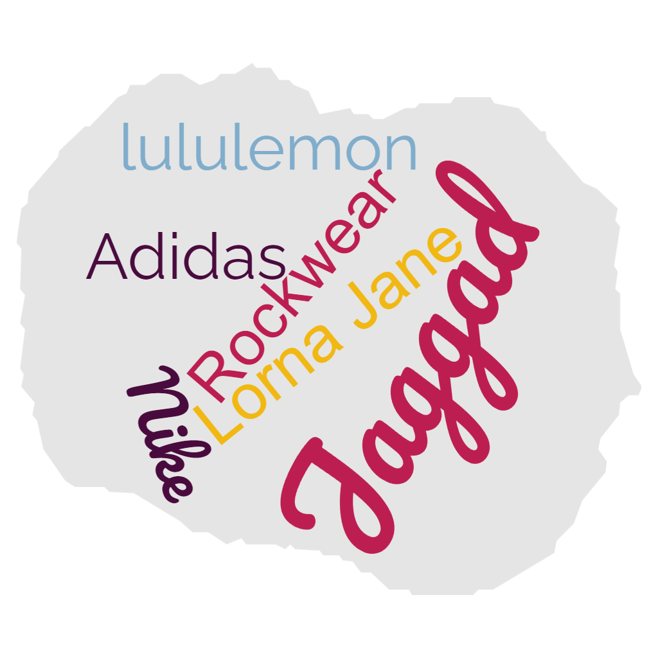 | 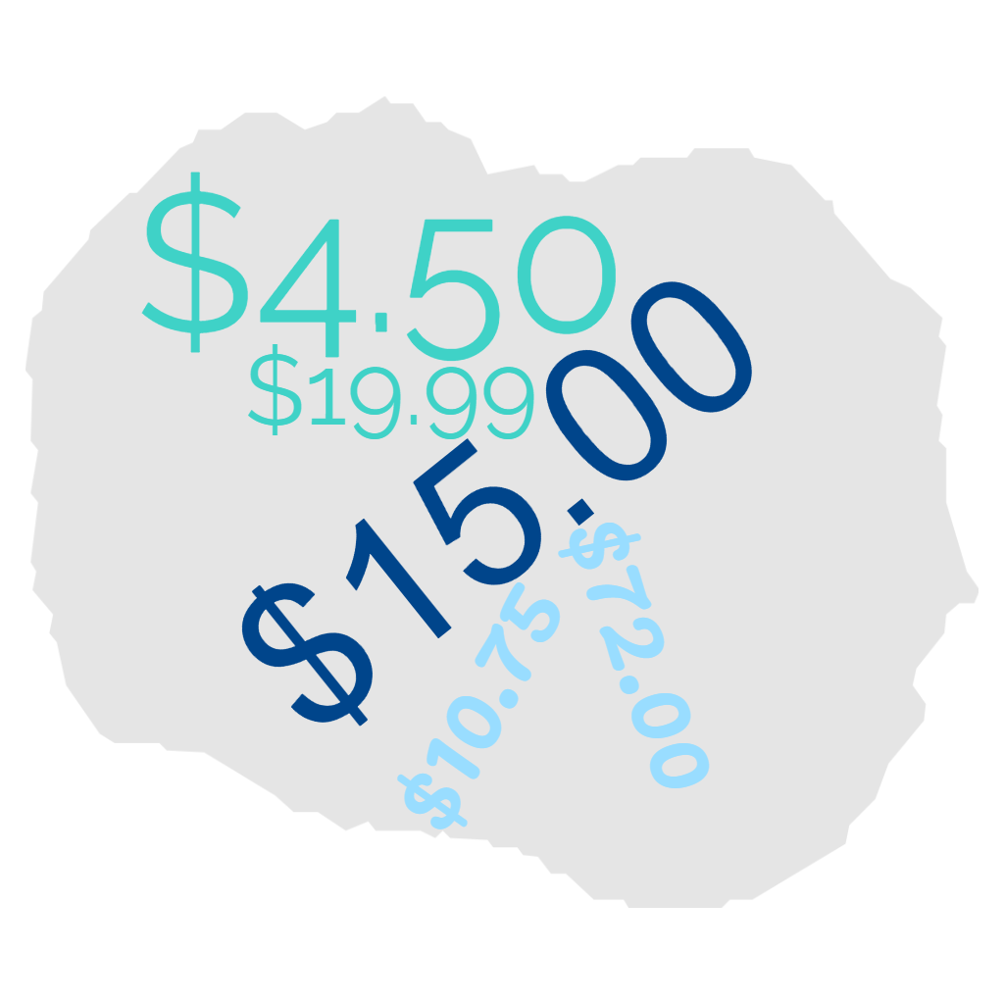
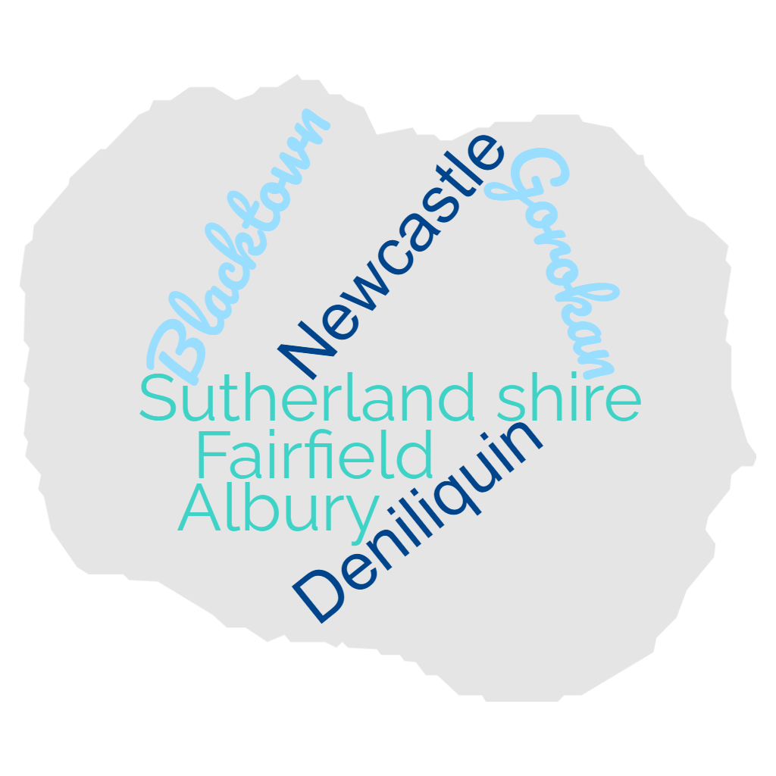 | 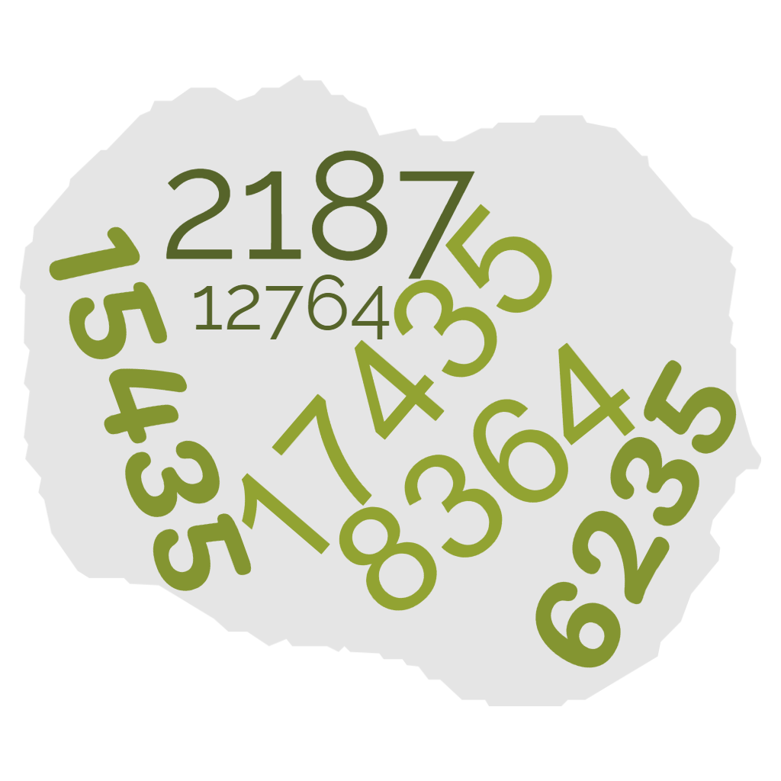 | 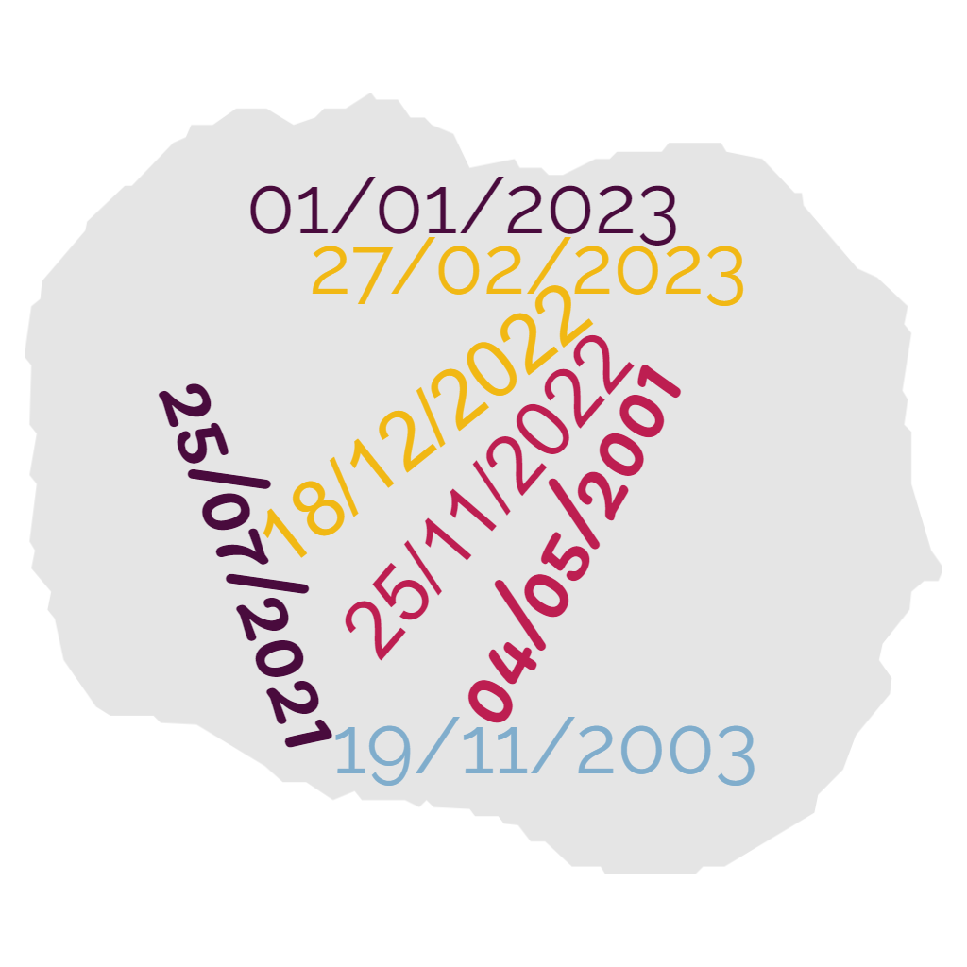
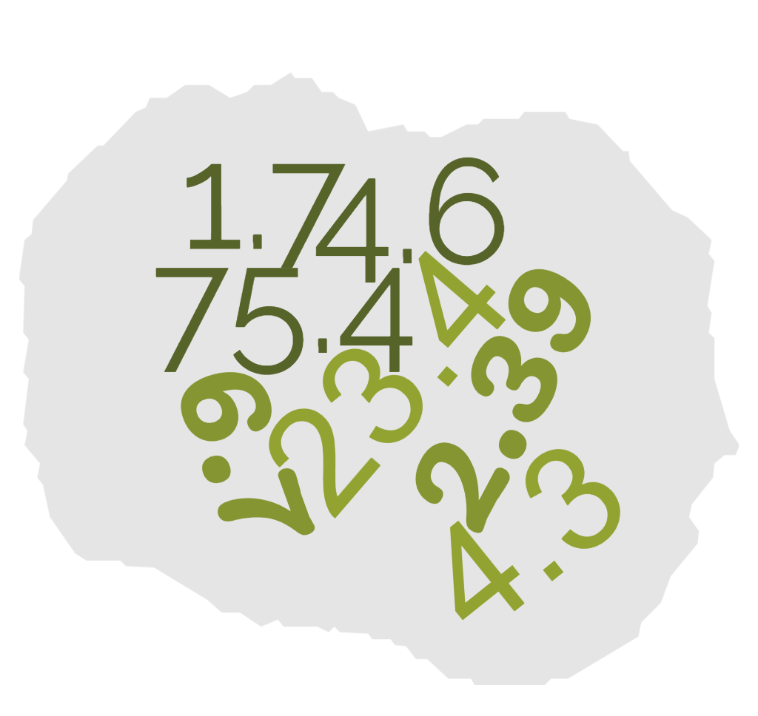 | 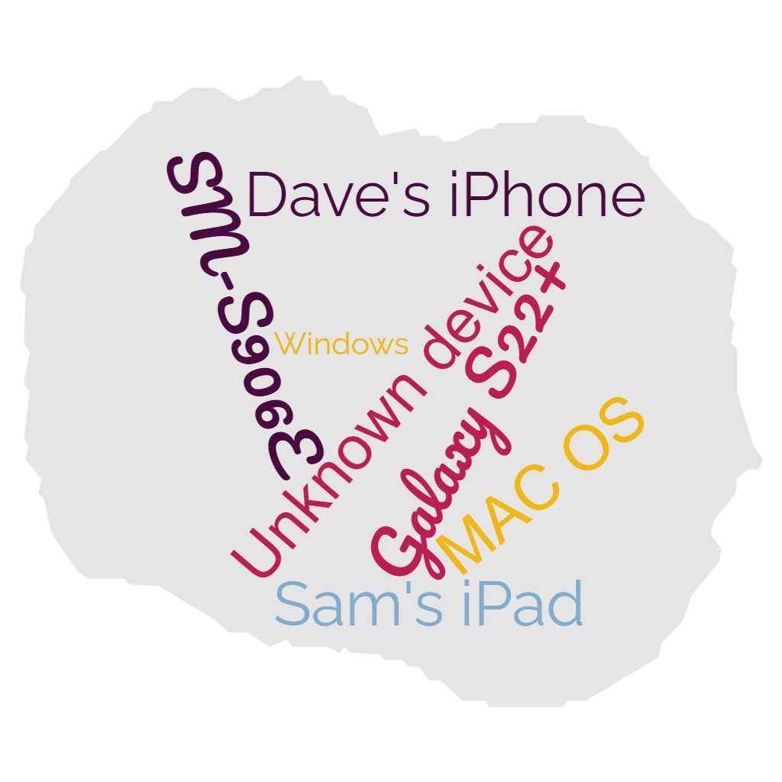

Appendix B

What can Google analyse about me?
For each activity, pretend you are Google and analyse the data to determine what you know about the person. What is ‘normal’ for them?

Activity 1 – favourite brand
This data shows the number of times I visited each website in a 30-day period.
- What is my favourite brand? How did you determine this?
- What could Google do with this data?
Brand | Number of times website has been visited
Jaggad | 15
Rockwear | 2
lululemon | 3
Lorna Jane | 34
Nike | 17
Adidas | 9

Activity 2 – places I’ve been
This data shows the number of times I have visited each postcode in a 30-day period.
- Where are the ‘normal’ places I hang out? How did you determine this?
- What could Google do with this data?
Postcode | Number of times visited
2177 | 30
2173 | 22
2200 | 3
2560 | 1
2145 | 4
2148 | 4

Activity 3 – number of steps
This data shows the number of steps I took, each day for a week.
- What is the ‘normal’ number of steps I take each day? How did you determine this?
- What could Google do with this data?
Sunday | Monday | Tuesday | Wednesday | Thursday | Friday | Saturday
15435 | 8364 | 6235 | 17435 | 2187 | 12764 | 5467

Activity 4 – lunch prices
This data shows how much I spend on lunch each day during the week.
- What is the ‘normal’ amount I spend on lunch? How did you determine this?
- What could Google do with this data?
Monday | Tuesday | Wednesday | Thursday | Friday
$4.50 | $19.00 | $15.00 | $10.75 | $72.00

Activity 5 – photo activity
This data shows how many photos I took on particular dates.
- What can you say about my photographic activity?
- What could Google do with this data?
Date | Number of photos
25/7/2022 | 11
01/01/2023 | 9
04/05/2022 | 1
26/01/2023 | 2
19/11/2022 | 3
25/12/2022 | 20

© State of New South Wales (Department of Education), 2023
The copyright material published in this resource is subject to the Copyright Act 1968 (Cth) and is owned by the NSW Department of Education or, where indicated, by a party other than the NSW Department of Education (third-party material).
Copyright material available in this resource and owned by the NSW Department of Education is licensed under a Creative Commons Attribution 4.0 International (CC BY 4.0) licence.
This licence allows you to share and adapt the material for any purpose, even commercially.
Attribution should be given to © State of New South Wales (Department of Education), 2023.
Material in this resource not available under a Creative Commons licence:
- the NSW Department of Education logo, other logos and trademark-protected material
- material owned by a third party that has been reproduced with permission. You will need to obtain permission from the third party to reuse its material.
Links to third-party material and websites
Please note that the provided (reading/viewing material/list/links/texts) are a suggestion only and implies no endorsement, by the New South Wales Department of Education, of any author, publisher, or book title. School principals and teachers are best placed to assess the suitability of resources that would complement the curriculum and reflect the needs and interests of their students.
If you use the links provided in this document to access a third-party's website, you acknowledge that the terms of use, including licence terms set out on the third-party's website apply to the use which may be made of the materials on that third-party website or where permitted by the Copyright Act 1968 (Cth). The department accepts no responsibility for content on third-party websites.

