What is normal?
Students are introduced to measures of centre by considering what is ‘normal.’ They utilise physical or online manipulatives to find the mode, median and mean of single datasets.

Visible learning

Learning intentions
- To explore measures of centre as a method of determining the average or typical value of a dataset

Success criteria
- I can calculate and describe the mode of a single dataset.
- I can calculate and describe the median of a single dataset.
- I can calculate and describe the mean of a single dataset.

Syllabus outcomes
A student:
- develops understanding and fluency in mathematics through exploring and connecting mathematical concepts, choosing, and applying mathematical techniques to solve problems, and communicating their thinking and reasoning coherently and clearly MAO-WM-01
- classifies and displays data using a variety of graphical representations
MA4-DAT-C-01
- analyses simple datasets using measures of Centre, range, and shape of the data MA4-DAT-C-02
Mathematics K–10 Syllabus © NSW Education Standards Authority (NESA) for and on behalf of the Crown in right of the State of New South Wales, 2022.

Activity structure

Launch
- Display the photo below for the class to view.
- Pose the question ‘Is this normal?’ Discuss with students:
- How many students in the class have a visible piercing?
- How many students have more than one visible piercing?
- Do students know of anyone who has a lot of piercings?
- How many piercings would they consider to be normal?
- How do they determine what is a normal number of piercings?
Figure 1 – extreme piercings and tattoos
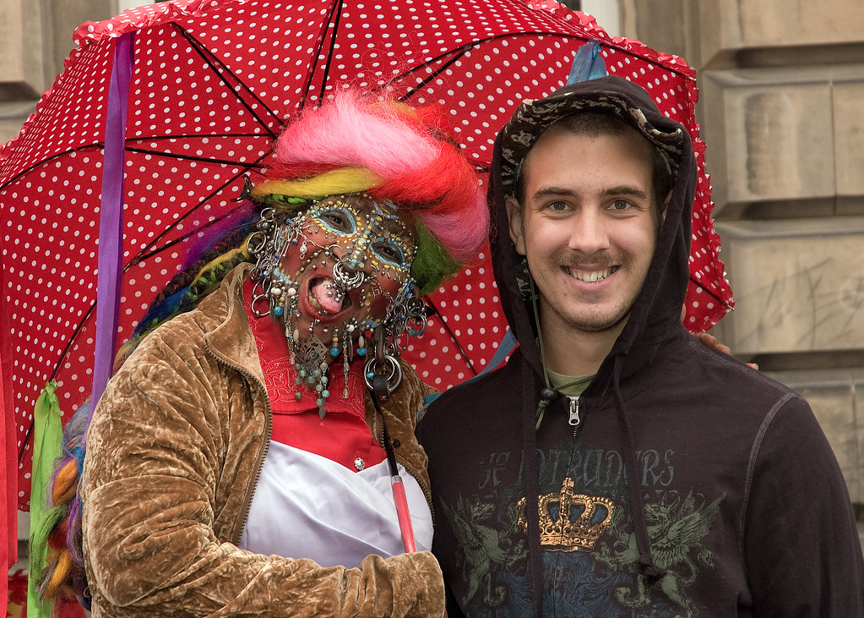
“Extreme Piercing and Tattoos” by Mr G’s Travels is licensed under CC BY-NC-SA 2.0.

Explore
- Select 7 students to come to the front of the room and grab a handful of counters or blocks.
- Ask students to count how many counters in their handful.
- Discuss with the whole class, who has the most, who has the least, and if anyone has the same number? What is the range of the counters?
- Discuss with the whole class how many counters they would consider to be a ‘normal’ handful. Ask students to explain how they came up with this number.
- Ask students to arrange themselves in order of their handful size, from smallest to largest.
- Discuss which student is in the middle and explain that their handful size is the median. How close was this number to their definition of ‘normal’? Did any students use this method to come up with their definition of ‘normal’?
- Ask students to now share out their counters equally amongst the 7 of them. Discuss the method they used to do this.
- How many does each student receive?
- How close is this number to their ‘normal’?
Most likely students will use a levelling up strategy to share their counters equally. This is where they will borrow blocks or counters from other students until all students possess the same amount.
- Explain that this number is called the mean.
- Revisit the definition of the mode and explain that these 3 terms and calculations are all used to determine the average or typical value of a dataset.
- Pick an even numbered group of students and repeat the process. Discuss how we calculate the median when we have an even number of items.

Summarise

Finding the mean
- Visit Mean of a Data Set (https://mathigon.org/task/mean-of-a-data-set) and assign students the activity Mean 1 in Polypad (there are instructions on the website which explain how to do this). An offline worksheet of this and the following activities can be found in Appendix A. Students will use counters or blocks to replicate the drawings.
- After students have completed the activity, summarise the strategies that they used, including those used in the handful activity. The Approach 1, 2 and 3 videos on the above website could be shown to students to demonstrate different strategies and to also demonstrate how to use the features of Polypad.
- Students are to then complete the activities Mean 2, 3, 4 and 5. Note that Mean 3 results in an answer of 7.5. Tiles cannot be split in half. Encourage students to find their own way of representing this on the canvas.
- Students to complete the Backward Means worksheet in Appendix B to practise their skills. Students should challenge themselves to predict what the answer will be in each case before they perform any calculations or draw any diagrams.
This is a fantastic opportunity to discuss how zero in a dataset affects the mean, as opposed to having one less number in the dataset.

Finding the median
- Revise how to find the median for both an odd and even number of data values.
- Students complete the Finding the median worksheet in Appendix C. After calculating the median for the first set of data, they will need to record how the data has changed in each subsequent data set. They should then predict how the median will change, based on their observations, before calculating the new median.

Apply
Students will now apply their skills by solving the less, same, more problem in Appendix D and the Venn diagram challenge in Appendix E.

Less, same, more
Students need to fill each cell by finding a dataset of 5 numbers that meet the criteria of the cell.
Students should start by finding the median and mean of the given dataset.
They will then find it easiest to fill the top left cell first, where they need to find a dataset with a smaller median and mean than the given dataset. Challenge higher achieving students to make the smallest number of changes possible, for instance, can they achieve this by only changing one number in the given dataset?

Venn diagram
Students need to find a dataset of 5 numbers that satisfy the criteria of each region.
Students will find it easiest to fill sections A, B and C where they only need to satisfy one condition. They can then move on to D, E and F before considering sections G and H.

Assessment and Differentiation

Suggested opportunities for differentiation
Launch
- There are no correct answers in the discussion around a ‘normal’ number of piercings. All students should be encouraged to share their thoughts and to justify their reasoning.
Summarise
- Encourage students to continue to use physical or online manipulatives, as necessary.
- Students may find it easier to find the median and mean of small data sets initially.
Apply
Less, same, more hints
- Students will find it easiest to fill the less, less, and more, more cells first.
- Lower achieving students may begin by randomly choosing 5 numbers, finding the mean and median and then selecting which cell they belong in.
- Higher achieving students should be encouraged to think more strategically by changing as few numbers as possible to achieve the goal of each cell. Can they change just one number each time?
- Students could also be challenged to see how many different datasets they can find for each region.
Venn diagram hints
- Students will find it easiest to fill sections A, B and C where they only need to satisfy one condition. They can then move on to D, E and F before considering sections G and H.
- Lower achieving students can be encouraged to make up a set of 5 numbers and calculate the mean, median, mode and range and then consider which section they belong in.
- Higher achieving students should be challenged to try and make as few changes to their data set as possible when completing sections.

Suggested opportunities for assessment
- Teachers should monitor student answers during class discussions to assess their understanding.
- Teachers could choose to ask students to complete an exit ticket where they find the mode, median and mean for a set of data – with the aid of manipulatives if necessary.
- Teachers could choose to collect the less, same, more or Venn diagram problems to check for understanding.

Appendix A

Mean of a data set
Use counters or blocks to replicate the diagram in each question and then rearrange your counters into equal stacks to find the mean.

Mean 1
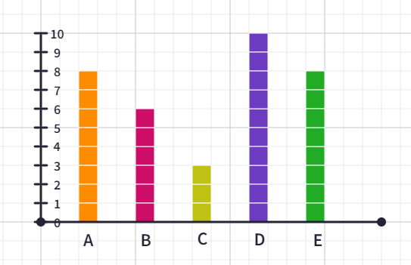
Explain the strategy you used to create your equal stacks.

Mean 2
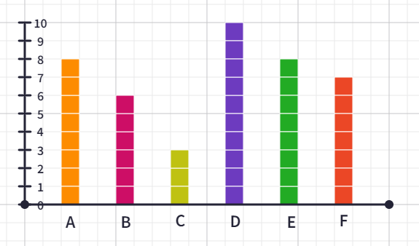
Did your strategy change now that there were 6 stacks?

Mean 3
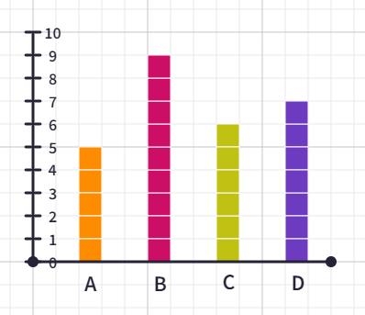
What was different about this question? How did your strategy have to change?

Mean 4
Roll a die to find the mean of 4 numbers.
Use counters to help as needed.
Explain how you found the mean.

Mean 5
Health professionals recommend adults get between 7–9 hours of sleep a night.
Mark has decided that he wants to average 8 hours sleep a night across the span of a week.
How many hours sleep will Mark need to get on Fri night to achieve his average?
- Sat – 6 hours
- Sun – 7 hours
- Mon – 10 hours
- Tues – 7 hours
- Wed – 8 hours
- Thurs – 9 hours
- Fri – ??

Appendix B

Backward means
- Find the mean of each set. Justify your answer in words, using a diagram or a calculation.
 |  |  |  |  | Answer and reason
4 | 4 | 4 | 4 | 4
8 | 8 | 8 | 8 | 8
8 | 8 | 8 | 8
8 | 8 | 8 | 8 | 0
8 | 7 | 8 | 7
12 | 12 | 12 | 8
1 | 2 | 3 | 4 | 5
1 | 2 | 3 | 4 | 50
2 | 4 | 6 | 8 | 10
3 | 6 | 9 | 12 | 15

- Find the missing number for the given mean. Use counters or a diagram as needed.
 |  |  |  |  | Mean
5 | 5 | 5 | _ |  | Mean = 5
5 | 5 | 5 | _ |  | Mean = 6
5 | 5 | 5 | _ |  | Mean = 7
5 | 5 | 5 | 5 | _ | Mean = 5
5 | 5 | 5 | 5 | _ | Mean = 6
5 | 5 | 5 | 5 | _ | Mean = 7
4 | 2 | 8 | _ |  | Mean = 4
4 | 2 | 8 | _ |  | Mean = 5
5 | 3 | 9 | _ |  | Mean = 5
10 | 6 | 18 | _ |  | Mean = 10
10 | 6 | 18 | _ |  | Mean = 20
10 | 6 | 18 | _ | 20 | Mean = 20
10 | 6 | 18 | _ | 0 | Mean = 20
Adapted from:
- https://variationtheory.com/2018/02/22/mean-from-a-list-of-data-missing-numbers/
- https://startingpointsmaths.com/2018/05/23/mean/
- https://startingpointsmaths.com/2018/05/23/backwards-mean/

Answers
Appendix B – question 1
 |  |  |  |  | Answer and reason
4 | 4 | 4 | 4 | 4 | Mean = 4  Everyone already has the same amount
8 | 8 | 8 | 8 | 8 | Mean = 8  Everyone has the same amount
8 | 8 | 8 | 8 |  | Mean = 8  Everyone has the same amount
8 | 8 | 8 | 8 | 0 | Mean = 6.4  There are 34 counters to be split amongst 5 people. Each person gets 5 each and the remaining 4 have to be split between the 5 people.
8 | 7 | 8 | 7 |  | Mean = 7.5  There are 30 counters to be split amongst 4 people. Each gets 7 and the remaining 2 counters have to be split into halves.
12 | 12 | 12 | 8 |  | Mean = 11  44 counters, split between 4 people
1 | 2 | 3 | 4 | 5 | Mean = 3  15 counters, split between 5 people
1 | 2 | 3 | 4 | 50 | Mean = 12  60 counters, split between 5 people
2 | 4 | 6 | 8 | 10 | Mean = 6  30 counters split between 5 people  These numbers are double those in a previous question, so the mean has been doubled.
3 | 6 | 9 | 12 | 15 | Mean = 15  45 counters split between 5 people  These numbers are triple those in a previous question, so the mean has been tripled.

Appendix B – question 2
 |  |  |  |  | Mean
5 | 5 | 5 | 5 |  | Mean = 5
5 | 5 | 5 | 9 |  | Mean = 6
5 | 5 | 5 | 13 |  | Mean = 7
5 | 5 | 5 | 5 | 5 | Mean = 5
5 | 5 | 5 | 5 | 10 | Mean = 6
5 | 5 | 5 | 5 | 15 | Mean = 7
4 | 2 | 8 | 2 |  | Mean = 4
4 | 2 | 8 | 6 |  | Mean = 5
5 | 3 | 9 | 3 |  | Mean = 5
10 | 6 | 18 | 6 |  | Mean = 10
10 | 6 | 18 | 46 |  | Mean = 20
10 | 6 | 18 | 46 | 20 | Mean = 20
10 | 6 | 18 | 66 | 0 | Mean = 20

Appendix C

Finding the median
Complete the table below by:
- noticing what is different between the new dataset and the previous one.
- predicting how you think the median will change from the previous median, and then, calculating the actual median.
Data | What’s changed from data set in previous row? | Predicted median | Actual median
10, 5, 3, 1, 1 | Nil
1, 1, 3, 5, 10
1, 3, 1, 10, 5
2, 2, 6, 10, 20
3, 3, 7, 11, 21
3, 3, 7, 11, 210
3, 4, 5, 6, 7
3, 4, 5, 6, 7, 8
2, 3, 4, 5, 6, 7, 8
1, 2, 3, 4, 5, 6, 7, 8
2, 4, 5, 6, 7, 8
2, 3, 4, 6, 7, 8
Adapted from https://variationtheory.com/2018/02/22/median-from-a-list-of-data/

Answers
Data | What’s changed from data set in previous row? | Predicted Median | Actual Median
10, 5, 3, 1, 1 | Nil |  | 3
1, 1, 3, 5, 10 | In reverse order |  | 3
1, 3, 1, 10, 5 | Same numbers but mixed up. Need to put in order before calculating median |  | 3
2, 2, 6, 10, 20 | Numbers have all been doubled |  | 6
3, 3, 7, 11, 21 | Numbers have all increased by one |  | 7
3, 3, 7, 11, 210 | Last number has been multiplied by 10 |  | 7
3, 4, 5, 6, 7 | New dataset. Each number is one higher than the number before |  | 5
3, 4, 5, 6, 7, 8 | New number has been added to the end |  | 5.5
2, 3, 4, 5, 6, 7, 8 | Additional number has been added to the start |  | 5
1, 2, 3, 4, 5, 6, 7, 8 | Additional number has been added to the start |  | 4.5
2, 4, 5, 6, 7, 8 | Two numbers removed from before the median |  | 5.5
2, 3, 4, 6, 7, 8 | 5 has been removed and 3 added. There is now a 2 number gap between the middle 2 numbers |  | 5

Appendix D

Mean vs median
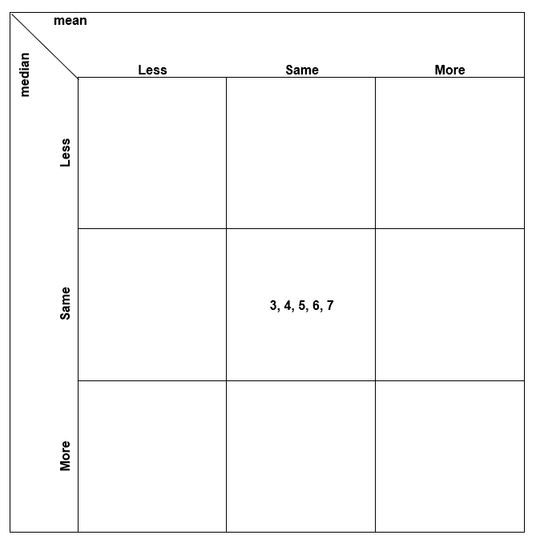
Adapted from More/Same/Less: Standard Deviation and Mean by Chris McGrane.

Example solution
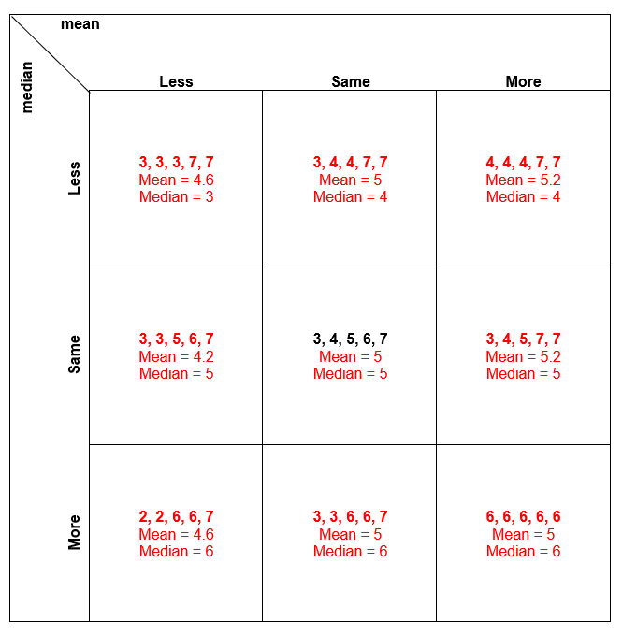

Appendix E

Mean, median, mode and range
Think of a list of 5 numbers that could belong in each region. If you think a region is impossible to fill, convince me why!
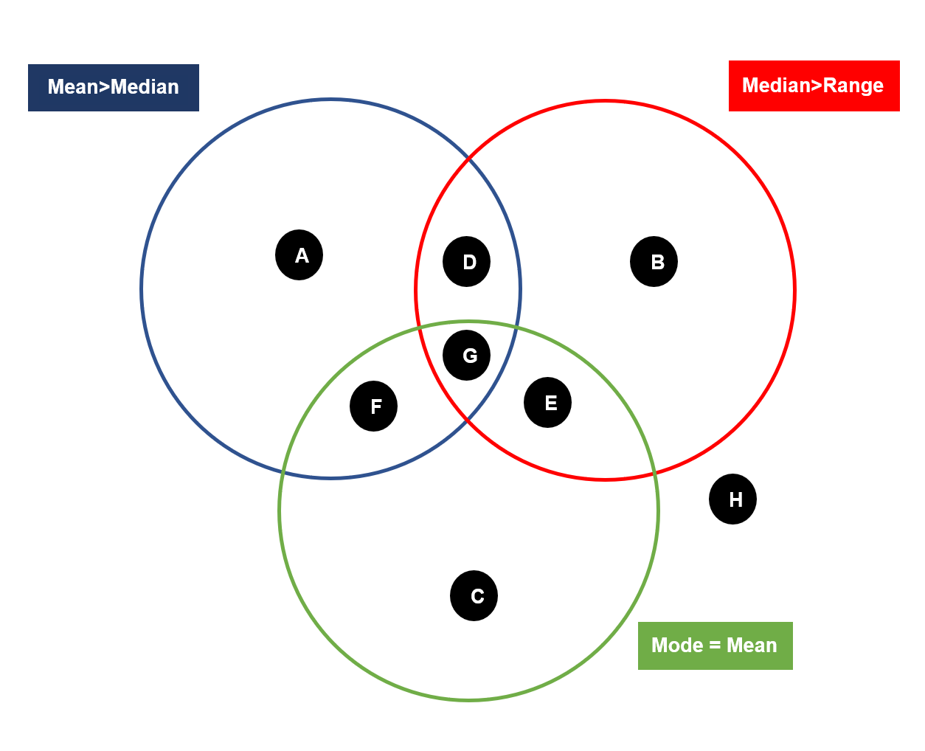
Adapted from Venn Diagram Rich Tasks by Erica Richards.
http://www.mrbartonmaths.com/teachers/rich-tasks/venn-diagrams.html

Example solution
A = 2, 2, 3, 6, 7 (median = 3, Mean = 4)
B = 2, 2, 3, 3, 3 (median = 3, range = 1)
C = 2, 2, 2, 2, 2 (mode = 2, mean = 2)
D = 4, 4, 5, 6, 7 (mean = 5.2, median = 5, range = 3)
E= 5, 7, 7, 7, 8 (mode = 7, median = 7, Range = 3)
F = no solution with 5 numbers. For mean to not equal median the mode must be in position 4 and 5 or 1 and 2. These will make the mean < mode and mean > mode, respectively.
G = no solution as there was no solution to F
H = 1, 5, 9, 12, 15 (mean = 8.4, median = 9, range = 14)
© State of New South Wales (Department of Education), 2023
The copyright material published in this resource is subject to the Copyright Act 1968 (Cth) and is owned by the NSW Department of Education or, where indicated, by a party other than the NSW Department of Education (third-party material).
Copyright material available in this resource and owned by the NSW Department of Education is licensed under a Creative Commons Attribution 4.0 International (CC BY 4.0) licence.
This licence allows you to share and adapt the material for any purpose, even commercially.
Attribution should be given to © State of New South Wales (Department of Education), 2023.
Material in this resource not available under a Creative Commons licence:
- the NSW Department of Education logo, other logos and trademark-protected material
- material owned by a third party that has been reproduced with permission. You will need to obtain permission from the third party to reuse its material.
Links to third-party material and websites
Please note that the provided (reading/viewing material/list/links/texts) are a suggestion only and implies no endorsement, by the New South Wales Department of Education, of any author, publisher, or book title. School principals and teachers are best placed to assess the suitability of resources that would complement the curriculum and reflect the needs and interests of their students.
If you use the links provided in this document to access a third-party's website, you acknowledge that the terms of use, including licence terms set out on the third-party's website apply to the use which may be made of the materials on that third-party website or where permitted by the Copyright Act 1968 (Cth). The department accepts no responsibility for content on third-party websites.

