Greedy pig
Students determine a strategy for playing the game Greedy pig by collecting and analysing data to determine the average number of throws before the poison number is rolled.

Visible learning

Learning intention
- To understand that collecting data can help us to predict events and make decisions when the theoretical probability cannot be calculated.

Success criteria
- I can organise data into a frequency table.
- I can make a prediction based on collected data.

Syllabus outcomes
A student:
- develops understanding and fluency in mathematics through exploring and connecting mathematical concepts, choosing, and applying mathematical techniques to solve problems, and communicating their thinking and reasoning coherently and clearly MAO-WM-01
- solves problems involving the probabilities of simple chance experiments
MA4-PRO-C-01
- classifies and displays data using a variety of graphical representations
MA4-DAT-C-01
- analyses simple datasets using measure of centre, range, and shape of the data MA4-DAT-C-02
Mathematics K–10 Syllabus © NSW Education Standards Authority (NESA) for and on behalf of the Crown in right of the State of New South Wales, 2022.

Activity structure

Launch
Students will play the game Greedy pig. The aim of the game is to get the highest possible score after 5 rounds. This video explains how to play Greedy Pig (5:37)
- Explain the rules of the game:
- Everybody starts each round by standing up.
- The teacher rolls a die and everyone records that number on their score sheet.
- After each roll of the die, students add the new number onto their previous total and record on their recording sheet (for example 3 + 2 + 6 + …) (Appendix A).
- They then decide whether to keep playing and possibly increase their score, or to sit down and bank their current total.
- If the number 2 is rolled (poison number), students still standing lose all the points in their bank and receive zero for the round. Students who have chosen to sit, retain the money in their bank.
- The first 2 rolls of the game are free and everyone collects points without going out, even if the poison number is rolled.
- Play the game at least 3 times to allow students to get a feel for what is a high score, how soon different students will sit down and to develop a strategy for the game.
- Discuss with students what strategy they have been using and ask them to justify their strategy.
- Discuss with students whether their strategy would need to change if they used a different poison number, for instance one.

Explore
- Discuss with students what the probability is of getting the poison number on the first throw (they should easily be able to answer $\frac{1}{6})$.
- Discuss with students what would be the probability of getting the poison number on the second, third, fourth throw, and so on. Students don’t have the knowledge to be able to answer this yet but should be able to express the probability using words, for instance, more likely, less likely, and so on.
- Discuss how many throws it would take before the probability became certain.
- Explain to students that they are going to collect some data to explore how long it takes for the poison number to be rolled.
- Give each student (or pair of students) a die and ask them to continue to roll the die until the poison number is rolled. They should record the number of rolls (including the poison number roll) it took them in their books. They will repeat this 10 times.
- Students should then open the Greedy pig spreadsheet. See Appendix C for tips on using spreadsheets with a class.
- Selecting the Greedy pig – recording sheet tab, they should enter the number of throws from their 10 experiments, anywhere in the blue coloured cells B5:G34.
- The teacher (displaying the spreadsheet on the board) can press F9 to update the Frequency table and produce the column graph.
Students have studied column graphs and mode in Stage 3 and revisit these concepts in the Making Decisions unit, but this is a good opportunity to revise their features.
- What do students notice and wonder? What was the most common length of time before the poison number was rolled? Remind students that this is called the mode.

Summarise
- Students pair/share with a partner to discuss how they will use this new information to change or confirm the strategy they were using when playing the game.
- Play the game again and allow students to use their new strategy. Discuss with students whether it made a difference to their final scores and whether they won or lost the game.

Apply
Have students apply their investigation skills by finding a winning strategy for the game Skunk. Skunk is similar to Greedy pig except that it is played with 2 dice.
- Play the game as a whole class first so that all students know the rules (if the poison number comes up on either or both dice, the total is zero and the round over).
- Students can then play the game individually using the website (transum.org/Maths/Game/Skunk/). This link allows students to play the game online and records the scores.
- Students can use the website to record how many turns before the poison number appears on either die. They can use the Skunk – recording sheet tab in the Greedy pig spreadsheet to record these values for the class and compare the results with the Greedy pig game.
- Discuss with the students:
- How does introducing a second die change the probabilities?
- If we use one as a poison number, what are the chances of getting a one now and reducing our score to zero?
- Is it easier to win a game of Greedy pig or Skunk?

Assessment and Differentiation

Suggested opportunities for differentiation
Noticing and wondering is used throughout the discussions in this lesson to allow all students to participate in a risk-free environment.
Launch
- If students find it difficult to add numbers mentally, they can be allowed to use a calculator or to use tally marks to help them find their score.
Explore
- Students could be challenged by investigating how long it would take to roll the poison number on an 8-sided or 12-sided dice.
Apply
- Students could be challenged to write down the sample space for rolling 2 dice and to circle all the combinations that contain the poison number. What is the probability of rolling a poison number with 2 dice as opposed to one? Is it lower or higher?

Suggested opportunities for assessment
- Teachers should monitor student responses during discussion to assess their understanding of probability, collecting data and column graphs.
- Teachers could ask students to explain and justify their strategy for playing the game, in writing, for review.

Appendix A

Greedy pig score sheet
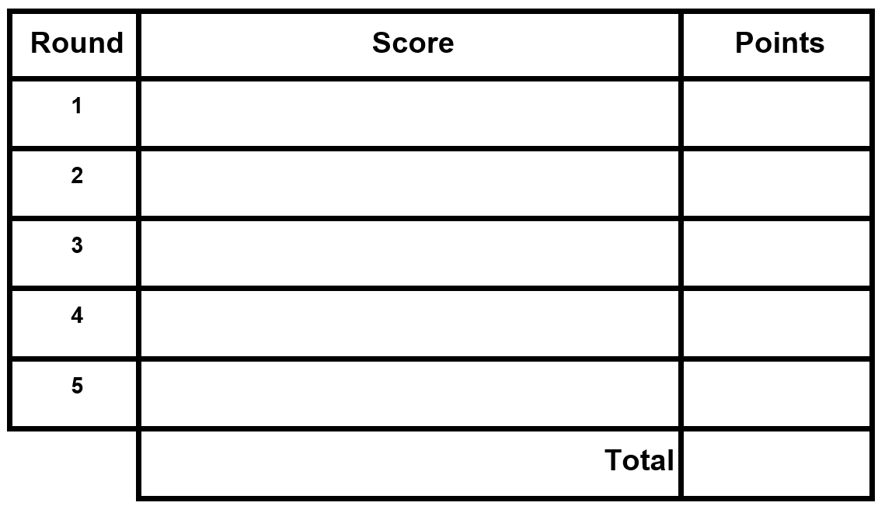
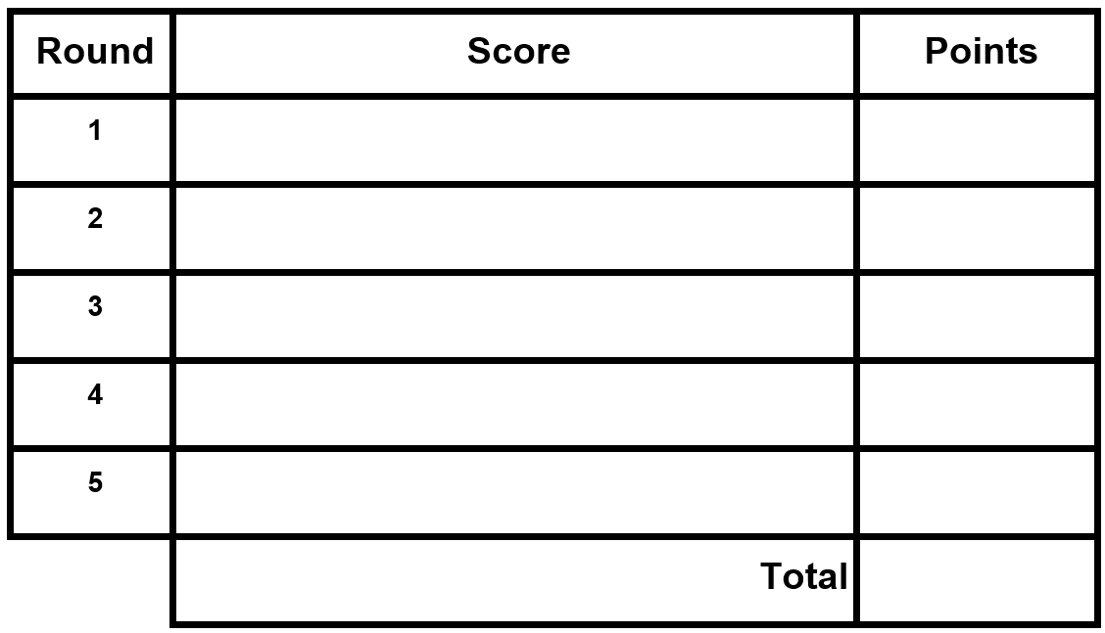

Appendix B

Skunk score sheet
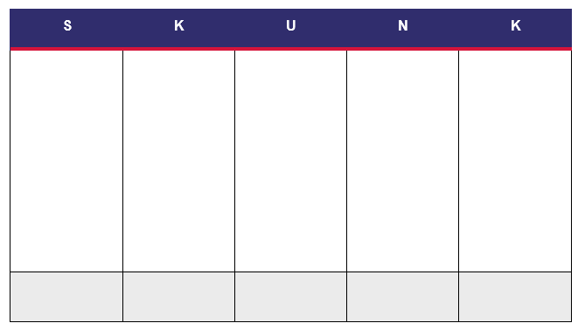

Appendix C

Using the spreadsheet
The spreadsheet is password protected. If the teacher wishes to make changes, they can unlock the spreadsheet using the password Greedy23.
Ideally, students will need shared access to the spreadsheet to be able to collate the results for the class. If this is not possible, the teacher can display a copy of the spreadsheet and students can come up and enter their results or read out their results for the teacher to enter.

Sharing spreadsheet files with your class

Whole class activities
Cloud storage is most suitable when you want your whole class to be entering and viewing data in the one spreadsheet file.

Cloud storage – Google Drive
Visit https://t4l.schools.nsw.gov.au/resources/professional-learning-resources/google-resources/google-drive.html to watch a short video explaining how to share Google Drive files with others (0:57).

Cloud storage – One Drive
Visit https://t4l.schools.nsw.gov.au/resources/professional-learning-resources/microsoft-resources/microsoft-onedrive.html to watch a short video explaining how to share One Drive files with others (1:11).

Individual student activities
Assignments in either Google Classroom or Microsoft Teams are useful when you want students to work on their own individual spreadsheet file.

Assignments in Microsoft Teams
Visit https://t4l.schools.nsw.gov.au/resources/professional-learning-resources/microsoft-resources/microsoft-teams/using-assignments-in-teams.html to learn how to create and manage assignments in Microsoft Teams.

Assignments in Google Classroom
Visit https://t4l.schools.nsw.gov.au/resources/professional-learning-resources/google-resources/google-classroom0/using-assignments-in-google-classroom.html to learn how to create and manage assignments in Google Classrooms.

Other alternatives
Files may also be shared with students via email attachments or your school’s learning management system, for instance, Canvas, Moodle.
Information on how to use Microsoft Outlook can be found at https://t4l.schools.nsw.gov.au/resources/professional-learning-resources/microsoft-resources/outlook--staff-email-.html.

© State of New South Wales (Department of Education), 2023
The copyright material published in this resource is subject to the Copyright Act 1968 (Cth) and is owned by the NSW Department of Education or, where indicated, by a party other than the NSW Department of Education (third-party material).
Copyright material available in this resource and owned by the NSW Department of Education is licensed under a Creative Commons Attribution 4.0 International (CC BY 4.0) licence.
This licence allows you to share and adapt the material for any purpose, even commercially.
Attribution should be given to © State of New South Wales (Department of Education), 2023.
Material in this resource not available under a Creative Commons licence:
- the NSW Department of Education logo, other logos and trademark-protected material
- material owned by a third party that has been reproduced with permission. You will need to obtain permission from the third party to reuse its material.
Links to third-party material and websites
Please note that the provided (reading/viewing material/list/links/texts) are a suggestion only and implies no endorsement, by the New South Wales Department of Education, of any author, publisher, or book title. School principals and teachers are best placed to assess the suitability of resources that would complement the curriculum and reflect the needs and interests of their students.
If you use the links provided in this document to access a third-party's website, you acknowledge that the terms of use, including licence terms set out on the third-party's website apply to the use which may be made of the materials on that third-party website or where permitted by the Copyright Act 1968 (Cth). The department accepts no responsibility for content on third-party websites.

