Alphabet soup (the sequel)
Students return to the game they played in the first lesson where they used alphabet tiles based on their own name to investigate if the probability can be calculated. They will ultimately use relative frequency in an attempt to describe their chances and compare with peers.

Visible learning

Learning intentions
- To understand that a calculation of relative frequency can describe the probability of future success.
- To know the limitations of relative frequencies, and the nature of their calculation

Success criteria
- I can explain why the probability of me winning this game cannot be easily calculated.
- I can use my results from the game to express the chances of me winning future games.
- I can predict who is likely win a game between two classmates, based on their past results.

Syllabus outcomes
A student:
- develops understanding and fluency in mathematics through exploring and connecting mathematical concepts, choosing and applying mathematical techniques to solve problems, and communicating their thinking and reasoning coherently and clearly MAO-WM-01
- represents and operates with fractions, decimals and percentages to solve problems MA4-FRC-C-01
- solves problems involving the probabilities of simple chance experiments
MA4-PRO-C-01
Mathematics K–10 Syllabus © NSW Education Standards Authority (NESA) for and on behalf of the Crown in right of the State of New South Wales, 2022.

Activity structure

Launch
- Remind students of the game from Lesson 1, Alphabet soup, with the instructions below.
- Using Appendix A, place all letters in a bag (each pair of students will need their own bag). Do not show the students what is in the bag.
- In pairs, students will randomly draw one letter at a time from their bag.
- If the letter drawn is in their name, they get the number of points that is on that letter tile. Each letter of your name can only be used once, so students are to cross successful letters off their name.
- The tile is replaced after each turn.
- Students are to keep score and complete 10 rounds of drawing letters from the bag, unless a player completes their name and then the game stops earlier.
- The winner is the player with the most points.
- Students to engage in a Think-Pair-Share activity to answer the following 2 questions:
- Can you write a fraction that might describe your probability of winning the game?
- Can you write a fraction that might describe your probability of winning a point?
- Ask students to share any fractions they have been able to form, and discuss what each of these fractions mean and how they determined them.
If students have significantly over or underestimated probabilities, consider having them face off in a challenge in front of the class. If you have a high probability and you face someone who has a low probability, surely you will win.

Explore
Students are to engage in an experiment to rank each person based on who has the greatest chance of winning the game. The way they will play the game is an activity called Speed Dating (bit.ly/strategyspeed)
- Sit half of the class in a circle facing inside the circle. Each of these students should have a bag with the alphabet tiles inside.
- Have the other half of the class each sit in front of a partner, as shown in the image below.
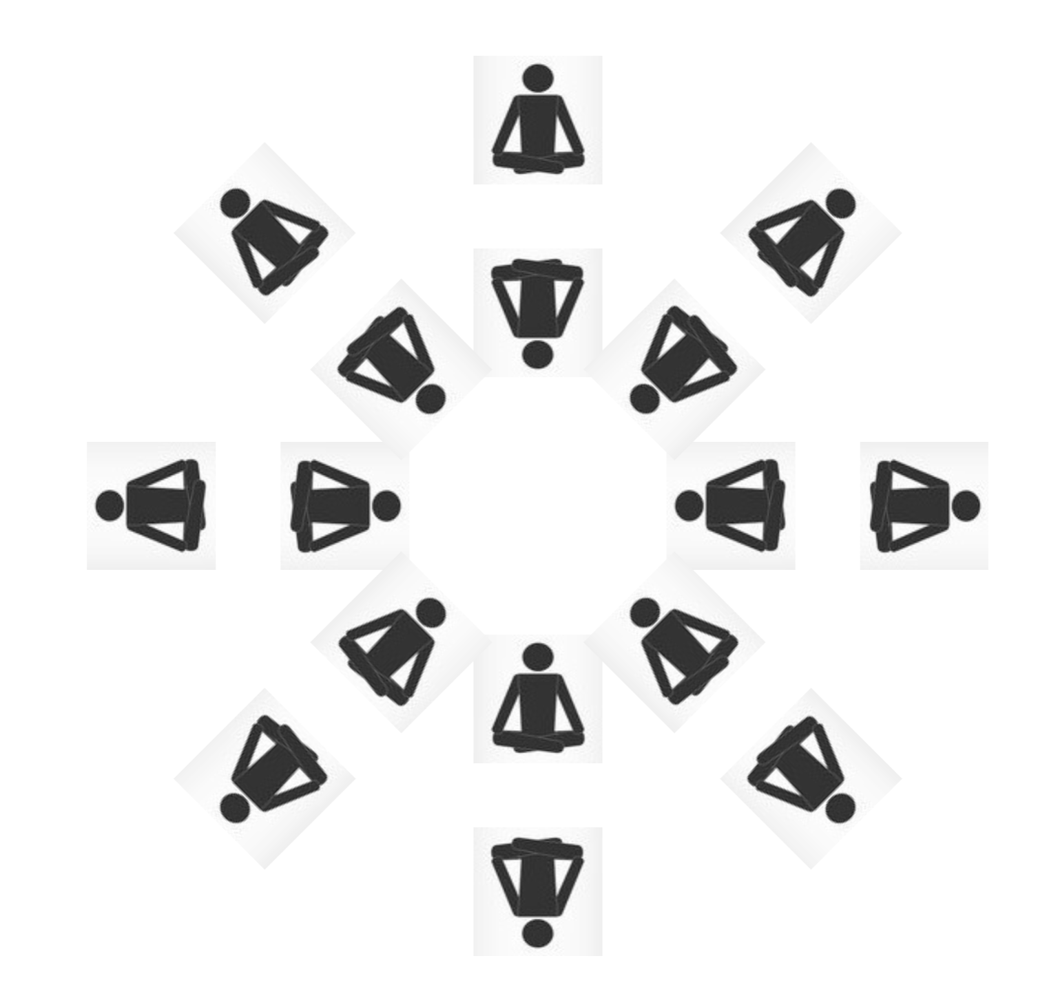
- Hand out Appendix B to each student, and have students complete 2 games against the opponent they are facing.
You could allow students to play as many games as they have time to play before they are asked to move. If different students play different numbers of games, it will make for a more challenging comparison during the Summarise section.
- Once all games have finished, have the students on the inside circle move one seat to the left, leaving the bag and alphabet tiles with the person in the outside circle.
- Repeat, playing the game twice against each opponent until everyone from the inside circle has played everyone from the outside circle.
Possible reflection question: You played half the class, twice. How many games should you have played?

Summarise
- All students should complete Appendix B, finding their relative frequency from the game.
- Explain that this relative frequency can represent what is called their observed probability, or the chances that they will win, based on what has happened in previous games.
- Have students order themselves from most likely to least likely.
- Ask students if they can identify anyone who is more likely than them, but who they were able to win against. Is there anyone lower than you who was able to win against you?
- Ask students to identify any trends. For example, did those who had the highest observed probability all have:
- longer names?
- shorter names?
- high scoring letters?
- more common letters?

Apply

Testing observed probability
- Pair students up with the person whose observed probability was closest to theirs. For example, first versus second, third versus fourth and so on.
- Have students play the game and identify if anyone who was ranked lower is able to win.

A significant upset
- Pair students up whose observed probability was significantly different. For example, first versus second last, and second versus last.
- Have the students play the game, to see if an upset is likely or close.

What does my observed probability mean
- Have students write a sentence about their observed probability as an individual. For example, ‘My observed probability of x/y means that if I play the game y times, I expect to win x times’.
To extend students, challenge students to consider what a statement like the one above would look like when interpreting their observed probability and an opponent's observed probability when evaluating multiple games between them and how many times they expect to win. For example, ’My observed probability is $\frac{17}{30}$ and my opponent's observed probability is $\frac{10}{30}$, so if we play 30 times, I would expect to win approximately 17 to 20 times, and my opponent would expect to win approximately 10 to 13 times’.

Assessment and Differentiation

Suggested opportunities for differentiation
Launch
- As this question is able to be explored, but not accurately answered, it is important students are encouraged to find any numbers they can to compare.
- Challenge students who are demonstrating a deep understanding of probability and fraction concepts to conclude on a single fraction, and write a short description of why they have chosen this fraction. While students could see this as impossible to determine, ask them to choose the fraction that they feel best represents the chance of them winning.
Explore
- Ensure that the game has been played the same number of times by all students to enforce easier calculations and comparisons. However, if students are demonstrating good skills with comparing fractions, allow them to simply complete as many games as possible against an opponent before moving them on, giving varied denominators and a need to compare.
Summarise and apply
- When facing off in games, it is important that students are identified as being more or less likely so all students are aware of what is expected in the game.
- Students are asked to express what their probabilities mean in words dependent on their level.

Suggested opportunities for assessment
Launch
- Monitor student responses and language used when considering the possible numerical representations of probability of their chances of winning.
Explore, summarise and apply
- Monitor and record student input when selecting the order of their class. This is an opportunity to verify each student's skills in comparing fractions.
- Make an exit ticket out of the final task in apply, writing a sentence about the meaning of their observed probabilities.

Appendix A

Alphabet tiles
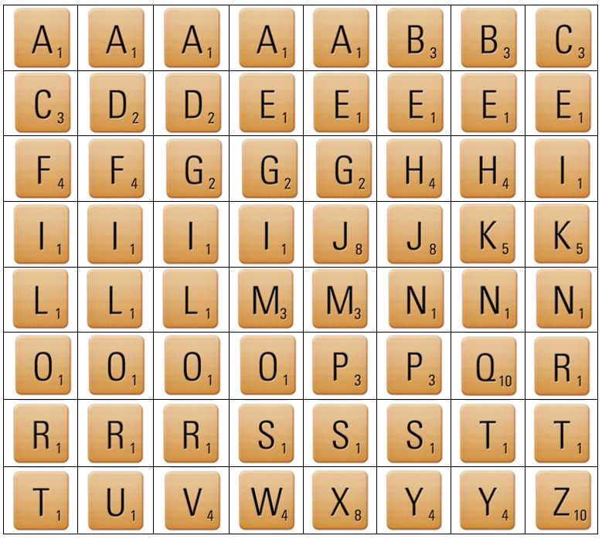

Appendix B

Relative frequency
Complete the table below as you play each opponent.
For example, if you win your first game your table should look like this:
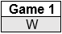
If you lose your 11th, 12th and 13th games, but then win your 14th game, your table should look like this:
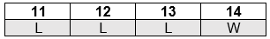
Note that you may not play all 30 games, depending how many students are in your class.
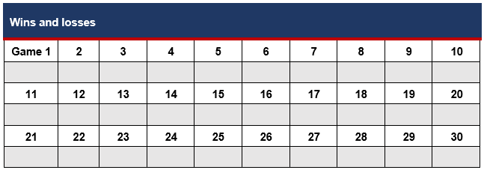
At the end of all games, answer the following questions.
- How many games did you win?
- How many games did you play?

Your relative frequency can be written as a fraction, using the numbers above.
Relative frequency = $\frac{Wins}{Games played}$
- Write down your relative frequency
My relative frequency =

© State of New South Wales (Department of Education), 2023
The copyright material published in this resource is subject to the Copyright Act 1968 (Cth) and is owned by the NSW Department of Education or, where indicated, by a party other than the NSW Department of Education (third-party material).
Copyright material available in this resource and owned by the NSW Department of Education is licensed under a Creative Commons Attribution 4.0 International (CC BY 4.0) licence.
This licence allows you to share and adapt the material for any purpose, even commercially.
Attribution should be given to © State of New South Wales (Department of Education), 2023.
Material in this resource not available under a Creative Commons licence:
- the NSW Department of Education logo, other logos and trademark-protected material
- material owned by a third party that has been reproduced with permission. You will need to obtain permission from the third party to reuse its material.
Links to third-party material and websites
Please note that the provided (reading/viewing material/list/links/texts) are a suggestion only and implies no endorsement, by the New South Wales Department of Education, of any author, publisher, or book title. School principals and teachers are best placed to assess the suitability of resources that would complement the curriculum and reflect the needs and interests of their students.
If you use the links provided in this document to access a third-party's website, you acknowledge that the terms of use, including licence terms set out on the third-party's website apply to the use which may be made of the materials on that third-party website or where permitted by the Copyright Act 1968 (Cth). The department accepts no responsibility for content on third-party websites.

