Predicting evens
Students explore the relationship between theoretical probability and the relative frequency of rolling a die and predicting how many even numbers should occur.

Visible learning

Learning intention
- To understand the relationship between theoretical probability and the observed probability of events.

Success criteria
- I can make predictions for events.
- I can justify my predictions using my theoretical probability knowledge.
- I can compare theoretical probability with observed probability.
- I can explain how the number of trials in an experiment is likely to change the relationship between theoretical probability and observed probability.

Syllabus outcomes
A student:
- develops understanding and fluency in mathematics through exploring and connecting mathematical concepts, choosing and applying mathematical techniques to solve problems, and communicating their thinking and reasoning coherently and clearly MAO-WM-01
- solves problems involving the probabilities of simple chance experiments
MA4-PRO-C-01
Mathematics K–10 Syllabus © NSW Education Standards Authority (NESA) for and on behalf of the Crown in right of the State of New South Wales, 2022.

Activity structure

Launch
- Students are to play the Odds and Evens game in pairs.
- You can download the rules and a digital version of the game here https://bit.ly/3Xwtas3.
- Select the blue USE TEMPLATE button in the top right corner of the screen, to save a copy to your google account.
- You can then share this with your students via google classroom or a link in an email or other learning management system.
- If you prefer a printable version of the game board, print off Appendix A.
This game has been created so that students can get a feel for the probability of rolling odd and even numbers on a dice.
- After students have played the game a few times, ask the following questions:
- Does it matter that the odd player starts the game?
- Who wins the most games?
- Did odd numbers or even numbers come up more often?
- Do you think that the odd player going first makes the game fairer as the even player can roll the largest number on the die?

Explore
The spreadsheet used in this section expresses probability as a decimal. You will need to ensure that as a minimum, students understand that 0.5 = ½. This would be a good opportunity to visit some simple decimal place value.
Students are now going to explore the link between theoretical probability and the observed probability of events by conducting experiments of rolling even numbers on a die.
- Provide pairs of students with a copy of the spreadsheet Predicting evens and Appendix C handout. See notes in Appendix B for information on how to manage the use of a spreadsheet in class.
- Students will move through the different Acts in the handout which correspond to different worksheet (tabs) in the spreadsheet and increase the number of trials as they go, so they can observe the difference between what happens short term and long term.
Throughout this task, teachers should discuss comparing the theoretical probability of an event with the relative frequency, how often the event occurs compared with the number of trials.
Teachers will also define the observed probability as equal to the relative frequency and considered as a measure of the probability of the event occurring in the future.

Summarise
Conduct a whole class discussion.
Compare your responses to questions 2, 3 and 4 with Act 1, 2 and 3.
- What do you notice?
- What do you wonder?
- What conclusions can be drawn?
These questions come from Act 4 question 6 of the handout from Appendix C that students used in the last activity.
This discussion should lead to a clear understanding that the more experimental trials we undertake, the closer we get to the theoretical probability of the event.

Apply
- Students apply their knowledge from the dice simulations to make predictions about a bag of 1,000 marbles, using Act 5 in the spreadsheet and Appendix D handout.
- Students will simulate randomly drawing a marble out of a bag that contains 1,000 marbles that are either red, blue, green or yellow.
- They will gradually simulate drawing 10, 50, and 100 marbles and make predictions of how many of each colour they think are in the bag using their understanding of probability to make a prediction.
- When you are satisfied with a student attempt, show them how to unhide the answer, The reveal by right clicking on any of the tabs down the bottom, selecting unhide and selecting ok. Students then compare this to their predictions.

Assessment and Differentiation

Suggested opportunities for differentiation
- The activity in the apply section may need to be completed as a whole class.

Suggested opportunities for assessment
- Listen for students using correct vocabulary and reasoning in their discussions.
- Collecting student responses for Appendix D handout should give an idea of a student’s understanding of repeated trials and how it links to theoretical probability.

Appendix A

Odds and evens board game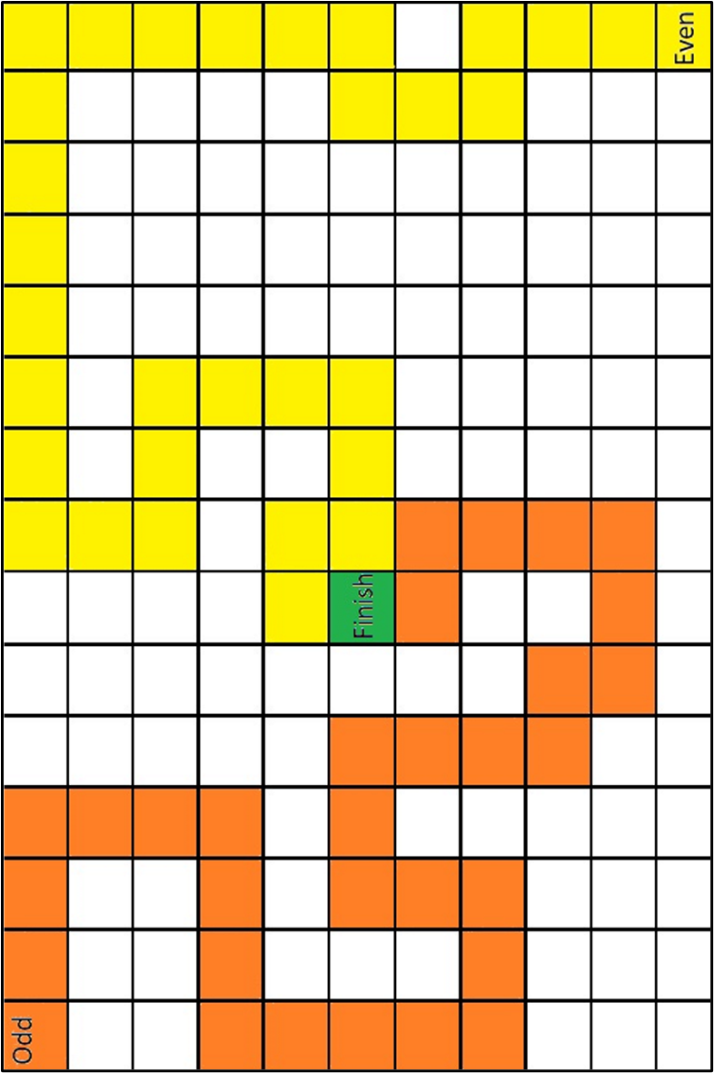
The game has been adapted from a version created by kidscrayonsandcoffee.wixsite.com/blog.

Appendix B

Using the spreadsheet file
This file needs the desktop version of Microsoft Excel.
The file has been password protected. If teachers wish to make changes, they can unlock the spreadsheet using the password ‘predicting23’.

Sharing spreadsheet files with your class

Whole class activities
Cloud storage is most suitable when you want your whole class to be entering and viewing data in the one spreadsheet file.

Cloud storage – Google Drive
Visit t4l.schools.nsw.gov.au/resources/professional-learning-resources/google-resources/google-drive.html to watch a short video explaining how to share Google Drive files with others (0:57).

Cloud storage – One Drive
Visit t4l.schools.nsw.gov.au/resources/professional-learning-resources/microsoft-resources/microsoft-onedrive.html to watch a short video explaining how to share One Drive files with others (1:11).

Individual student activities
Assignments in either Google Classroom or Microsoft Teams are useful when you want students to work on their own individual spreadsheet file.

Assignments in Microsoft Teams
Visit t4l.schools.nsw.gov.au/resources/professional-learning-resources/microsoft-resources/microsoft-teams/using-assignments-in-teams.html to learn how to create and manage assignments in Microsoft Teams.

Assignments in Google Classroom
Visit t4l.schools.nsw.gov.au/resources/professional-learning-resources/google-resources/google-classroom0/using-assignments-in-google-classroom.html to learn how to create and manage assignments in Google Classrooms.

Other alternatives
Files may also be shared with students via email attachments or your school’s learning management system, for example, Canvas, Moodle.
Information on how to use Microsoft Outlook can be found at t4l.schools.nsw.gov.au/resources/professional-learning-resources/microsoft-resources/outlook--staff-email-.html

Appendix C

Making a prediction

Act 1: make a prediction on 10 rolls
You are going to simulate rolling a die 10 times and examine the likelihood of obtaining an even number. Before rolling the die calculate the theoretical probability of rolling an even number (column 2) and how many even numbers you expect to be rolled (column 3) in the table below.
Outcome | Theoretical probability | Expected frequency | Number of evens rolled | Observed probability
Even
- On worksheet 1 Act 1 of the spreadsheet, in cell B9 type =randbetween(1,6). This will randomly generate an integer between 1 and 6 inclusive and simulate the result of rolling a die once. Fill this down to simulate 10 rolls. Hint: Select cell B9 and then double left click the bottom right corner.
- Look at your results and the graph displayed in the worksheet. The graph displays the proportion of throws that are even after 1, 2, 3…10 throws, ie the observed probability of an even.
- What do you notice? What do you wonder?
- Calculate the difference between the observed and theoretical probability.
- Compare your calculation to other classmates.
- Were your results consistent?
- Was there any variation?
- Why is this the case?

Act 2: make a prediction on 100 rolls
You are going to simulate rolling a die 100 times and examine the likelihood of obtaining an even number. Before rolling the dice calculate the theoretical probability of rolling an even number and how many even numbers you expect to be rolled in the table below.
Outcome | Theoretical probability | Expected frequency | Number of evens rolled | Observed probability
Even
- Select the Act 2 worksheet at the bottom of the spreadsheet.
- Use the randbetween function to simulate 100 throws.
- Look at your results and the graph displayed in the worksheet. The graph displays the proportion of rolls that are even after 1, 2, 3…100 throws. For example, the observed probability of an even.
- What do you notice? What do you wonder?
- Calculate the difference between the observed and theoretical probability.
- Compare your calculation to other classmates.
- Were your results consistent?
- Was there any variation?
- Why is this the case?
- Compare your responses to questions 2 and 3 with Act 1.
- What do you notice?
- What do you wonder?

Act 3: make a prediction on 1,000 rolls
You are going to simulate rolling a die 1,000 times and examine the likelihood of obtaining an even number. Before rolling the dice calculate the theoretical probability of rolling an even number (column 2) and how many even numbers you expect to be rolled (column 3) in the table below.
Outcome | Theoretical probability | Expected frequency | Number of evens rolled | Observed probability
Even
- Select the Act 3 worksheet at the bottom on the spreadsheet.
- Use the randbetween function to simulate 1,000 rolls.
- Look at your results and the graph displayed in the worksheet. What do you notice? What do you wonder?
- Calculate the difference between the experimental and theoretical probability.
- Compare your calculation to other classmates.
- Were your results consistent?
- Was there any variation?
- Why is this the case?
- Compare your responses to questions 2, 3 and 4 with Act 1 and 2.
- What do you notice? What do you wonder?

Act 4: make a prediction on 10,000 rolls
You are going to simulate rolling a die 10,000 times and examine the likelihood of obtaining an even number. Before rolling the dice calculate the theoretical probability of rolling an even number (column 2) and how many even numbers you expect to be rolled (column 3) in the table below.
Outcome | Theoretical probability | Expected frequency | Number of evens rolled | Observed probability
Even
- Select the Act 4 worksheet at the bottom of your spreadsheet.
- Use the randbetween function to simulate 10,000 throws.
- Look at your results and the graph displayed in the worksheet. What do you notice? What do you wonder?
- Calculate the difference between the observed and theoretical probability.
- Compare your calculation to other classmates.
- Were your results consistent?
- Was there any variation?
- Compare your responses to questions 2, 3 and 4 with Act 1, 2 and 3.
- What do you notice?
- What do you wonder?
- What conclusions can be drawn?
- Describe the relationship between the observed and theoretical probability of an event as the number of trials increases.

Appendix D

Predictions with unknown data sets
- You are going to simulate randomly drawing a marble out of a bag that contains 1,000 marbles that are either red, blue, green or yellow.
- Between each draw, the marble is replaced and the marbles shaken.
- You will not know how many of each colour there are, but you will use an understanding of probability to make predictions.
- In cell B5, type =randbetween(1,1000). This will randomly draw a marble out of the bag and its colour will be stated in C5.

10 trials
Copy or re-type this formula to simulate drawing 10 marbles and complete the table below.
Colour | Frequency | Relative Frequency | Predicted number of the colour in the bag of 1,000
Red
Blue
Green
Yellow

50 trials
Simulate drawing 50 marbles and complete the table below.
Colour | Frequency | Relative Frequency | Predicted number of the colour in the bag of 1,000
Red
Blue
Green
Yellow

100 trials
Simulate drawing 100 marbles and complete the table below.
Colour | Frequency | Relative Frequency | Predicted number of the colour in the bag of 1,000
Red
Blue
Green
Yellow
Discussion questions to consider:
- Which table of predictions should you rely upon? Why?
- Ask your teacher how to reveal the answer of how many marbles were actually in the bag. Compare the actual number of each coloured marbles with your predictions.
- Explain how you could increase the accuracy of your prediction.
© State of New South Wales (Department of Education), 2023
The copyright material published in this resource is subject to the Copyright Act 1968 (Cth) and is owned by the NSW Department of Education or, where indicated, by a party other than the NSW Department of Education (third-party material).
Copyright material available in this resource and owned by the NSW Department of Education is licensed under a Creative Commons Attribution 4.0 International (CC BY 4.0) licence.
This licence allows you to share and adapt the material for any purpose, even commercially.
Attribution should be given to © State of New South Wales (Department of Education), 2023.
Material in this resource not available under a Creative Commons licence:
- the NSW Department of Education logo, other logos and trademark-protected material
- material owned by a third party that has been reproduced with permission. You will need to obtain permission from the third party to reuse its material.
Links to third-party material and websites
Please note that the provided (reading/viewing material/list/links/texts) are a suggestion only and implies no endorsement, by the New South Wales Department of Education, of any author, publisher, or book title. School principals and teachers are best placed to assess the suitability of resources that would complement the curriculum and reflect the needs and interests of their students.
If you use the links provided in this document to access a third-party's website, you acknowledge that the terms of use, including licence terms set out on the third-party's website apply to the use which may be made of the materials on that third-party website or where permitted by the Copyright Act 1968 (Cth). The department accepts no responsibility for content on third-party websites.

