What’s the chance?
Students explore the difference between theoretical and observed probability using a chore spinner and conduct simulations of their own.

Visible learning

Learning intentions
- To be able to compare the outcome of different events.
- To understand the difference between theoretical and observed probability.

Success criteria
- I can evaluate the probability of an event occurring from a range of different spinners.
- I can compare theoretical and observed probability.
- I can conduct repeated trials of a simulation.

Syllabus outcomes
- develops understanding and fluency in mathematics through exploring and connecting mathematical concepts, choosing and applying mathematical techniques to solve problems, and communicating their thinking and reasoning coherently and clearly MAO-WM-01
- represents and operates with fractions, decimals and percentages to solve problems
MA4-FRC-C-01
- solves problems involving the probabilities of simple chance experiments
MA4-PRO-C-01
Mathematics K–10 Syllabus © NSW Education Standards Authority (NESA) for and on behalf of the Crown in right of the State of New South Wales, 2022.

Activity structure

Launch
- As a class, watch the video from The Office – Chore Wheel! (https://bit.ly/thechorewheel).
- Pause the video at the time marker 0:32, and give students time for a Think-Pair-Share. Discussion questions for the students could include:
- What do you notice?
- If you spin the middle wheel of people’s names, would they all get a different chore to do?
- Do you think it’s fair?
- Pause the video at the time marker 1:01. The middle wheel of names has now been removed from the chore wheel and each person must spin to see where the needle will stop. Discussion questions for the students could include:
- Is this wheel better?
- Justify why/why not?

Explore
In the video, the staff did not think Pam’s chore wheel was any fun, so Pam came up with a different design that included prizes and penalties.
Figure 1 – Screen shot from The Office – Chore Wheel video
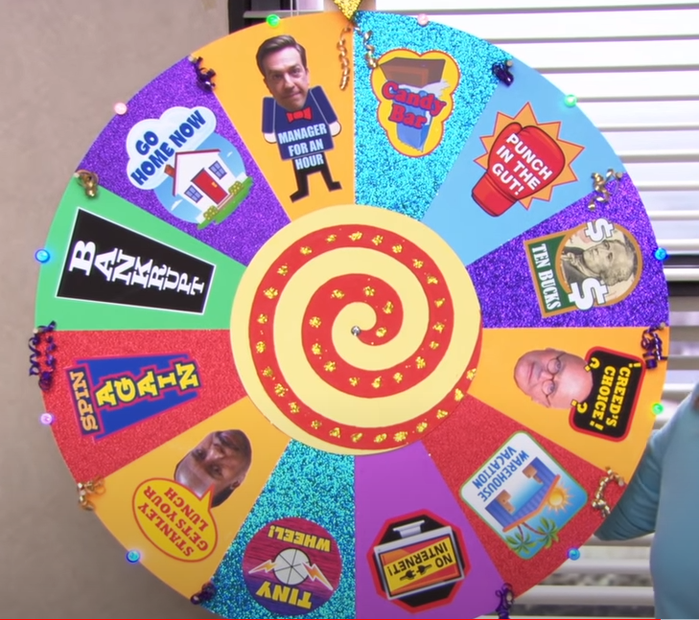
- Have a class discussion using prompting questions similar to:
- Do students think they would have more, less, or an even chance of getting a prize compared to a penalty?
- Is each prize and penalty equally likely to occur?
- What is the probability of getting a prize?
- Ask students to explain their thinking around prize vs penalty.
- Students can now create this chore wheel and conduct an experiment to see if their answers to the class discussion questions are correct. Use Appendix A handout for students to record their results.
- Students can go to National Council of Teachers of Mathematics’ (NCTM) adjustable spinner (nctm.org/adjustablespinner/) to create the chore wheel by changing the number of each sector and colour coding it to match the chore wheel.
- Students make a prediction as to what they think the table might look like after the 10 spins.
- Students then enter 10 spins. Ask students to look at the 10 spin simulation count column in the table, and prompt them with the following questions:
- Were there an even number of prizes and penalties spun?
- How close were these results to your initial prediction?
- Students gradually increase the number of spins they make until they get up to 1,000 spins.
- After students have explored individually, they Think-Pair-Share with the following prompting questions:
- What do you notice about the percentages in the observed (experimental) % and the theoretical % columns on the NCTM adjustable spinner site?
- What would happen if you rearranged your spinner so that all the prizes were together, and all the penalties were together? Maybe try adjusting your spinner and conduct some experiments.
- When the prizes and penalties are together, what effect does this have on their chances? ie does it make them more likely to occur?
- What if the chore wheel changed to include another prize. What effect would this have on the chances of a prize?
- What if the chore wheel changed to include another penalty. What effect would this have on the chances of a penalty?
- If you had the choice, what would you choose to add, one more prize or one more penalty?

Summarise
Once students have finished their Think-Pair-Share, coordinate a class discussion on the above questions, conduct an agree or disagree activity as a class to consolidate their understanding. Students can provide their answers using a Mentimeter poll (mentimeter.com/) and volunteer their ‘I agree because…’ or ‘I disagree because…’.
Alternatively, use each side of the room as the agree and disagree sides. Students then have a discussion with someone on the same side of the room as them to explore their reasoning. The teacher then calls out a few students to explain their reasoning to the class.
Use prompts similar to the ones below:
- A spinner with 50 red and 50 green equal parts is the same as a spinner with 2 red and 2 green equal parts.
- I just rolled a 6 on a regular six-sided dice, so I should get a different number the next time I roll it.
- Theoretical probability and observed probability are the same thing.

Apply
- Using the same NCTM adjustable spinner site from earlier, students are to design 3 different chore wheels for each of the following criteria:
- More prizes than chores.
- No chores equally likely.
- Two chores with one being twice as likely as the other.
- After creating each of the chore wheels, students need to run an experiment to verify that the chore wheel is correct and that the observed and theoretical probability percentages in the table match the descriptions.
- Students can be challenged by asking if it is possible to create multiple different chore wheels for each probability scenario.

Assessment and Differentiation

Suggested opportunities for differentiation
Launch
- Students may need some prompting to remind them of what equally likely means.
Explore
- Students can create spinners to test their answers to the discussion questions if they are unsure.
Apply
- Students can use a trial-and-error approach to create their wheels.
- Students can be challenged to create a variety of wheels that match the given criteria, rather than just one.

Suggested opportunities for assessment
- Monitor responses in class discussions to check student understanding.
- The Mentimeter poll at the conclusion of the lesson should provide formative assessment on students overall understanding.
- Students can submit their wheels and test the results from the Apply section for review.

Appendix A

Spinner simulations
- Create your spinner with 12 equal parts using NCTM adjustable spinner (nctm.org/adjustablespinner/) and record the colour of each section in the table.
- Make a prediction as to what they think the table might look like after 10 spins and record this in column 3 in the table below.
- Simulate 10 spins of the spinner and record results in column 3 below. Consider:
- Was there an even number of prizes and penalties spun?
- How close were these results to your initial prediction?
- Gradually increase the number of spins simulated until you get up to 1,000 spins. Record your final results in the last column of the table.
Spin | Colour assigned on your spinner | Prediction with 10 spins | 10 spin simulation count | 1,000 spin simulation count
Candy Bar
Punch in the gut
Ten bucks
Creed’s choice
Warehouse vacation
No internet
Tiny wheel
Stanley gets your lunch
Spin again
Bankrupt
Go home now
Manager for an hour

© State of New South Wales (Department of Education), 2023
The copyright material published in this resource is subject to the Copyright Act 1968 (Cth) and is owned by the NSW Department of Education or, where indicated, by a party other than the NSW Department of Education (third-party material).
Copyright material available in this resource and owned by the NSW Department of Education is licensed under a Creative Commons Attribution 4.0 International (CC BY 4.0) licence.
This licence allows you to share and adapt the material for any purpose, even commercially.
Attribution should be given to © State of New South Wales (Department of Education), 2023.
Material in this resource not available under a Creative Commons licence:
- the NSW Department of Education logo, other logos and trademark-protected material
- material owned by a third party that has been reproduced with permission. You will need to obtain permission from the third party to reuse its material.
Links to third-party material and websites
Please note that the provided (reading/viewing material/list/links/texts) are a suggestion only and implies no endorsement, by the New South Wales Department of Education, of any author, publisher, or book title. School principals and teachers are best placed to assess the suitability of resources that would complement the curriculum and reflect the needs and interests of their students.
If you use the links provided in this document to access a third-party's website, you acknowledge that the terms of use, including licence terms set out on the third-party's website apply to the use which may be made of the materials on that third-party website or where permitted by the Copyright Act 1968 (Cth). The department accepts no responsibility for content on third-party websites.

