Myths and misconceptions
Students analyse 2 theories of how many heads and tails will appear on 20 coin tosses by physically conducting the experiment and then simulating this experiment multiple times.

Visible learning

Learning intentions
- To be able to make a prediction based on theoretical probability.
- To be able to justify a prediction based on the relative frequency of an experiment.

Success criteria
- I can make a prediction of the outcome of an event.
- I can create simulations of tossing a coin.
- I can make a prediction based on the relative frequency of an experiment.

Syllabus outcomes
A student:
- develops understanding and fluency in mathematics through exploring and connecting mathematical concepts, choosing and applying mathematical techniques to solve problems, and communicating their thinking and reasoning coherently and clearly MAO-WM-01
- solves problems involving the probabilities of simple chance experiments MA4-PRO-C-01
Mathematics K–10 Syllabus © NSW Education Standards Authority (NESA) for and on behalf of the Crown in right of the State of New South Wales, 2022.

Activity structure

Launch
- Pose the following 2 questions to the students one by one. Collect their thoughts either through a class discussion or a Mentimeter poll (mentimeter.com), followed by a class discussion.
- If I toss a coin 20 times, what would you expect me to get?
- If the first 4 tosses have been heads (4 heads and no tails so far), what do you expect from the next 16 tosses?
- Students should be asked to justify why they have made their predictions.

Explore
- Using a spreadsheet, students will be analysing 2 different views from 2 different people.
- Theory A: I still expect 10 heads and 10 tails, and since I’ve already got 4 heads, I now expect 10 tails and 6 heads from the remaining 16 tosses. So, in the next few tosses, I expect more tails than heads.
- Theory B: There are 16 tosses to go. For these 16 tosses, I expect 8 heads and 8 tails. This means I now expect 12 heads and 8 tails from my original 20 throws.
- Prior to starting the spreadsheet analysis, conduct an online poll as to which theory the students agree with.
- Conduct a class discussion to allow students to justify their choice.
- Students will investigate the theories in pairs. Each pair will need:
- a coin
- Appendix B handout
- to be assigned a number 1–15 which correlates to a tab in the spreadsheet
- access to the spreadsheet, Myths and misconceptions – whole class. Refer to Appendix A for instructions on how to issue this to all students.
- By following the steps on the handout, students firstly discuss Theory A and Theory B, then test the theories by manually flipping a coin and then explore simulations using the spreadsheet.
- By using the spreadsheet, students will simulate tossing a coin 16 times, with it known that 4 heads have already been tossed. Students repeat the experiment 5 times in their pairs and then compare the whole class’s results, reflecting on their initial prediction.
Explicitly mention that this is repeated trials of a simulation.

Summarise
Display the class data tab for all students to view and conduct a class discussion. Prompting questions may include:
- Did your pair’s results support Theory A or Theory B?
- Do the whole class results support Theory A or Theory B?
- How would the results change if the experiment was repeated 1000 times?
- Can you explain why people have a misconception about the results of tossing a coin?
- After the class’s analysis, which theory do you think is correct? (This can be conducted using a Mentimeter poll (mentimeter.com).
- Justify why the theory that you have chosen is the correct one.
Explicitly use the term relative frequency when discussing the results of the simulations.

Apply
In pairs, students are to discuss the following question:
If you were playing a game where you had to guess whether you were going to flip a head or a tail on each flip, what would your strategy be?
Students could then share their strategies with the class, or by rotating one partner to another pair, using something similar to the speed dating strategy (https://bit.ly/strategyspeed).

Assessment and Differentiation

Suggested opportunities for differentiation
Launch
- As this activity has no correct answer and is subject to opinion, all students should be able to attempt some prediction.
Explore
- Depending on the class, this may be done as a class activity and not in pairs.
Summarise
- Students may need a visual representation of what results could look like if a coin was tossed 1000 times.

Suggested opportunities for assessment
- The Mentimeter polls used throughout the lesson should be used as formative assessment to check for understanding of theoretical probability and how it can be used to make predictions.
- Teachers create an exit ticket asking students to justify how many heads and tails they would expect if tossing a coin 30 times and the first 4 throws were heads.

Appendix A

Using the spreadsheet file
This spreadsheet needs the desktop version of Microsoft Excel.
The spreadsheet has been password protected. If teachers wish to make changes, they can unlock the spreadsheet using the password ‘myths23’.

Sharing spreadsheet files with your class

Whole class activities
Cloud storage is most suitable when you want your whole class to be entering and viewing data in the one spreadsheet file.

Cloud storage – Google Drive
Visit t4l.schools.nsw.gov.au/resources/professional-learning-resources/google-resources/google-drive.html to watch a short video explaining how to share Google Drive files with others (0:57).

Cloud storage – One Drive
Visit t4l.schools.nsw.gov.au/resources/professional-learning-resources/microsoft-resources/microsoft-onedrive.html to watch a short video explaining how to share One Drive files with others (1:11).

Individual student activities
Assignments in either Google Classroom or Microsoft Teams are useful when you want students to work on their own individual spreadsheet file.

Assignments in Microsoft Teams
Visit t4l.schools.nsw.gov.au/resources/professional-learning-resources/microsoft-resources/microsoft-teams/using-assignments-in-teams.html to learn how to create and manage assignments in Microsoft Teams.

Assignments in Google Classroom
Visit t4l.schools.nsw.gov.au/resources/professional-learning-resources/google-resources/google-classroom0/using-assignments-in-google-classroom.html to learn how to create and manage assignments in Google Classrooms.

Other alternatives
Files may also be shared with students via email attachments or your school’s learning management system, for example, Canvas, Moodle.
Information on how to use Microsoft Outlook can be found at t4l.schools.nsw.gov.au/resources/professional-learning-resources/microsoft-resources/outlook--staff-email-.html.

Appendix B

Myths and misconceptions
Discuss in your pair which theory you agree with and justify your reasons why.
- Theory A: I still expect 10 heads and 10 tails, and since I’ve already got 4 heads, I now expect 10 tails and 6 heads from the remaining 16 tosses. So, in the next few tosses I expect more tails than heads.
- Theory B: There are 16 tosses to go. For these 16 tosses, I expect 8 heads and 8 tails. This means I now expect 12 heads and 8 tails from my original 20 throws.

Experiment
Flip a coin until you get 4 heads in a row. Continue to flip the coin another 16 times, recording what you get on each flip.
- How many heads and tails did you get altogether?
- Has your initial prediction been proven true?
- Do your results agree with Theory A or Theory B?

Gathering evidence
- Using the spreadsheet provided, Myths and Misconceptions – whole class, go to the Investigation tab number that was assigned by your teacher.
- Continue to select the Refresh button until you have 4 heads in the red section.
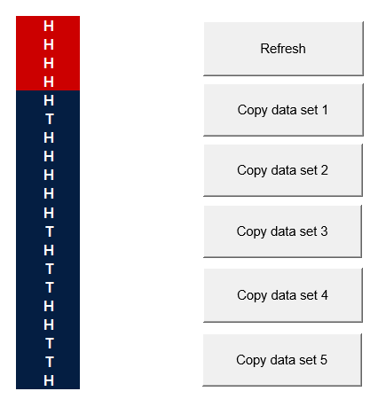
- Copy these results into the table by using the appropriate Copy data set button.
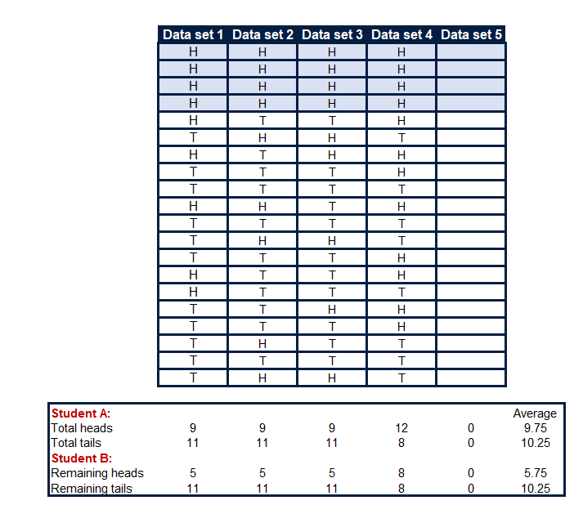
- Repeat the experiment 5 times.

Analysing the results
- Which student’s theory do your results support, Theory A or Theory B?
- Go to the Class data tab to view the results from the other students in your class.
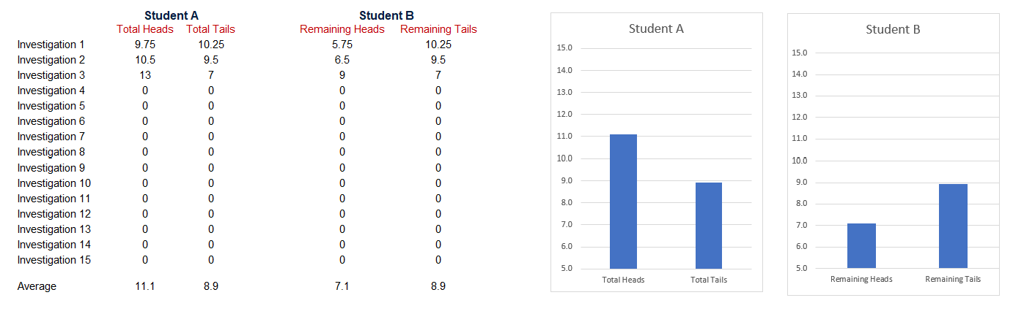
- Which student’s theory do the class results support?
- If we repeated the experiment 1000 times, which theory would you support?
- What if we tossed the coin 30 times and the first 4 throws were heads? How many heads would you expect to get in the remaining throws?
© State of New South Wales (Department of Education), 2023
The copyright material published in this resource is subject to the Copyright Act 1968 (Cth) and is owned by the NSW Department of Education or, where indicated, by a party other than the NSW Department of Education (third-party material).
Copyright material available in this resource and owned by the NSW Department of Education is licensed under a Creative Commons Attribution 4.0 International (CC BY 4.0) licence.
This licence allows you to share and adapt the material for any purpose, even commercially.
Attribution should be given to © State of New South Wales (Department of Education), 2023.
Material in this resource not available under a Creative Commons licence:
- the NSW Department of Education logo, other logos and trademark-protected material
- material owned by a third party that has been reproduced with permission. You will need to obtain permission from the third party to reuse its material.
Links to third-party material and websites
Please note that the provided (reading/viewing material/list/links/texts) are a suggestion only and implies no endorsement, by the New South Wales Department of Education, of any author, publisher, or book title. School principals and teachers are best placed to assess the suitability of resources that would complement the curriculum and reflect the needs and interests of their students.
If you use the links provided in this document to access a third-party's website, you acknowledge that the terms of use, including licence terms set out on the third-party's website apply to the use which may be made of the materials on that third-party website or where permitted by the Copyright Act 1968 (Cth). The department accepts no responsibility for content on third-party websites.

