Rock paper scissors
This activity is adapted from Probability: Rock Paper Scissors by reSolve: Mathematics by Inquiry (bit.ly/resolverockpaperscissors). Students explore the game of rock, paper, scissors and analyse if the outcomes are equally likely, the potential for bias and whether adding in 2 elements changes the chances of winning.

Visible learning

Learning intentions
- To understand the concept of randomness.
- To understand what makes events equally likely.

Success criteria
- I can determine if a game has equally likely outcomes.
- I can determine if a game is fair and unbiased.
- I can evaluate and compare the probability of winning games.

Syllabus outcomes
A student:
- develops understanding and fluency in mathematics through exploring and connecting mathematical concepts, choosing and applying mathematical techniques to solve problems, and communicating their thinking and reasoning coherently and clearly MAO-WM-01
- solves problems involving the probabilities of simple chance experiments MA4-PRO-C-01
Mathematics K–10 Syllabus © NSW Education Standards Authority (NESA) for and on behalf of the Crown in right of the State of New South Wales, 2022.

Activity structure

Launch

Round 1
- In pairs, students play 10 games of rock, paper, scissors (RPS), recording their results using Appendix A. Students may need a demonstration of how to play the game.
- At the conclusion of the activity, student reflection questions could include:
- Is RPS a fair game?
- Could you predict what your opponent was going to select?
- What was your strategy?
- Is there one option that wins more than the others?

Round 2
- Show Player 1 only, a clip that outlines a theory on how to win at Rock Paper Scissors (3:08) (bit.ly/abchowtowin). Students then play another 10 games of RPS, recording their results to test out the theory.
- At the conclusion of this round, student reflection questions could include:
- Did Player 1 win more times this round?
- Did each game have an equally likely outcome of a draw, Player 1 winning or Player 2 winning?
The purpose of this activity is for students to realise that each outcome is not equally likely as all players bring their own personal biases to the game. When they choose scissors, paper or rock, they are not doing so completely randomly, but are taking into consideration what has been chosen before and what they think the other player will choose.

Explore
- Students discuss how to make the game fair by removing personal bias and making each outcome equally likely.
- Students replay 10 games of RPS and record their results, using either:
- Option 1: Two dice, dice 1 representing Player 1 and dice 2 representing Player 2.
Table 1 – rock, paper, scissors and dice outcomes
Outcome on dice | RPS outcome
1 or 2 | Rock
3 or 4 | Paper
5 or 6 | Scissors
- Option 2: online simulator for RPS (bit.ly/rockpaperscissorssimulator).
- Students explore the chances of winning now that the outcomes are equally likely. The first part of the Rock paper scissors PowerPoint can be used for this. Students can use the results from their experiments to calculate the relative frequency or they can list the sample space by considering the different combinations of moves and calculate the theoretical probability.
The PowerPoint contains extension material on using tree diagrams and tables to list the sample space. This is not part of the Stage 4 course, but teachers may choose to show students for extension purposes.
- The class watches the Big Bang Theory’s explanation of rock, paper, scissors, lizard, Spock (1:26) (RPSLS) (bit.ly/bigbangRPSLS).
- Students play 10 rounds of RPSLS using their hands, recording their results using Appendix B:
- Did they have a strategy?
- Was it easier to win playing RPSLS than it was playing RPS?
- Are the outcomes equally likely?
- Students are to now design a way of playing RPSLS where the outcomes would be equally likely with no strategy involved. They may like to use a dice to allocate numbers for each of the outcomes or an online random number generator (bit.ly/Googlenumbergenerator).
- Following this, students explore the chances of winning RPSLS. Students should use the results of their experiment to determine the relative frequency or list the sample space by considering the different combinations of moves and determine the theoretical probability.
Teachers could choose to extend students by using the table in Appendix C and the second part of the Rock paper scissors PowerPoint which demonstrates how to list the sample space using a table.

Summarise
Reflection questions to be considered by students:
- Did each game (RPS and RPSLS) have an equal chance of winning?
- Which game would give you the greater odds of winning?
- Why was the game fair when you played using dice as opposed to playing with your hands?

Apply
- To revisit fractions on a number line, students are to draw a 15 cm number line and plot the chances of winning for each of the outcomes for each game. They will need to have the chance of winning each game listed as fraction.
- Students should then be challenged to come up with a new game where the chances of winning are increased. Students can extend on the rock, paper, scissors game or create their own using dice (any number of sides), coins and/or spinners.
- Discussion questions could include:
- If the chances of winning are increased, does the probability of winning get closer or further away from one?
- What changes can you see in the numerator and/or denominator if the chances of winning are increased?

Assessment and Differentiation

Suggested opportunities for differentiation
Visual representations of each of the probabilities may be used to support students.
Launch
- Students may need a few demonstrations of how to play rock, paper, scissors.
Explore
- Students could be extended by showing them how to use tables and tree diagrams to help them list the sample space.
Apply
- Students should play their games with the class and check that their predictions are correct.

Suggested opportunities for assessment
- Monitor responses in class discussions to check student understanding of what makes a game fair.

Appendix A

Rock, paper, scissors
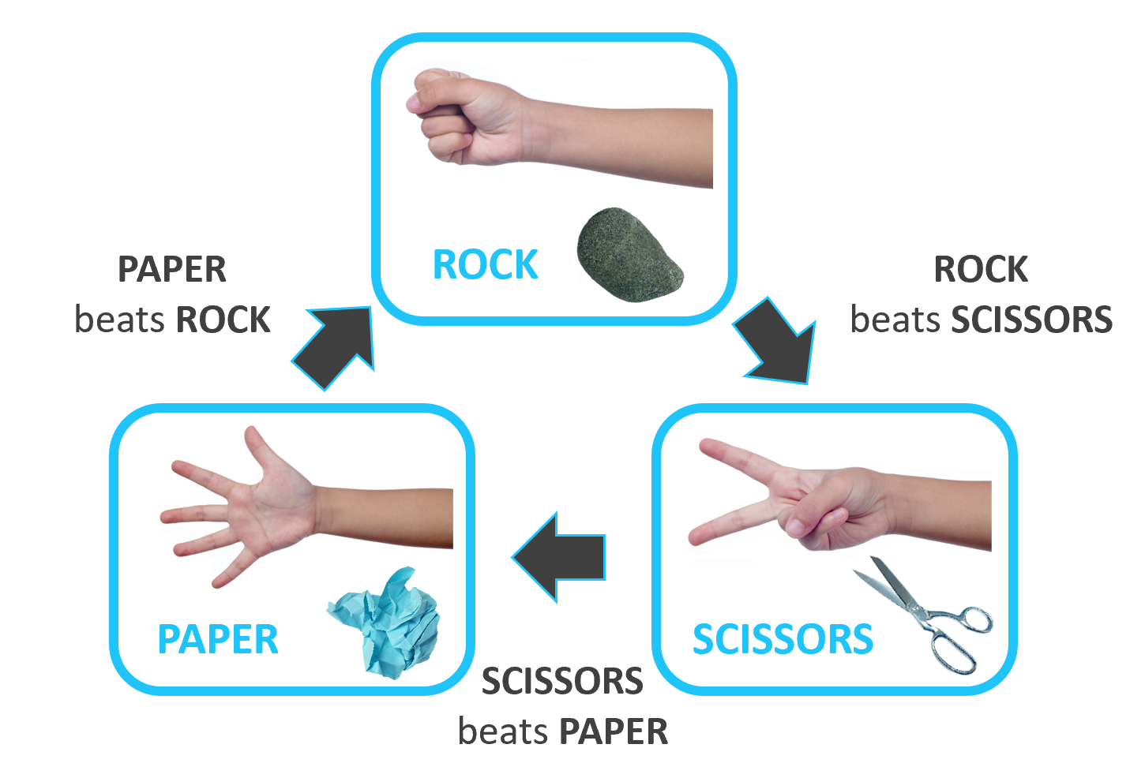
'Rock Paper Scissors' by reSolve is licensed under CC BY-NC-SA 4.0.

Score sheet
Player 1 | Player 2 | Result
R P S | R P S | P1 P2 Draw
R P S | R P S | P1 P2 Draw
R P S | R P S | P1 P2 Draw
R P S | R P S | P1 P2 Draw
R P S | R P S | P1 P2 Draw
R P S | R P S | P1 P2 Draw
R P S | R P S | P1 P2 Draw
R P S | R P S | P1 P2 Draw
R P S | R P S | P1 P2 Draw
R P S | R P S | P1 P2 Draw

Appendix B

Rock, paper, scissors, lizard, Spock
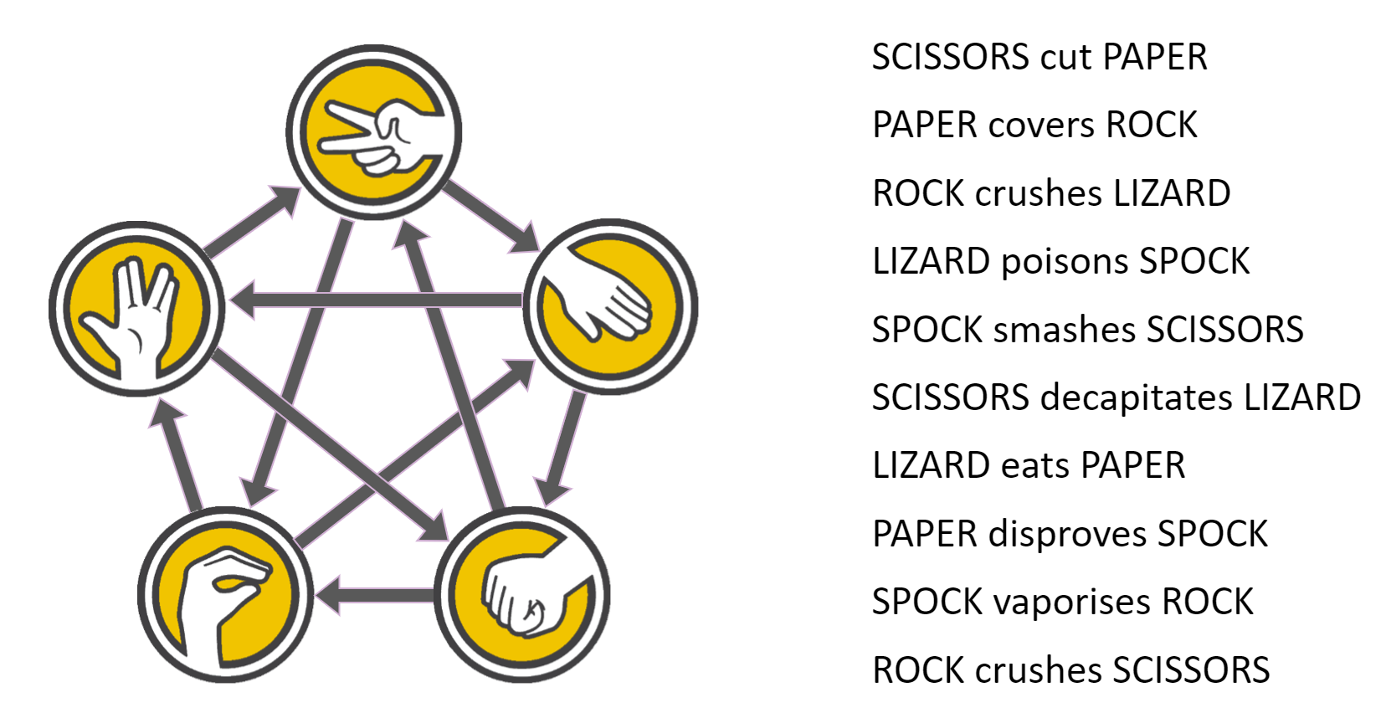
‘Rock, paper, scissors, lizard, Spock’ by reSolve is licensed under CC BY-NC-SA 4.0.

Score sheet
Player 1 | Player 2 | Result
R P Sc L Sp | R P Sc L Sp | P1 P2 Draw
R P Sc L Sp | R P Sc L Sp | P1 P2 Draw
R P Sc L Sp | R P Sc L Sp | P1 P2 Draw
R P Sc L Sp | R P Sc L Sp | P1 P2 Draw
R P Sc L Sp | R P Sc L Sp | P1 P2 Draw
R P Sc L Sp | R P Sc L Sp | P1 P2 Draw
R P Sc L Sp | R P Sc L Sp | P1 P2 Draw
R P Sc L Sp | R P Sc L Sp | P1 P2 Draw
R P Sc L Sp | R P Sc L Sp | P1 P2 Draw
R P Sc L Sp | R P Sc L Sp | P1 P2 Draw

Appendix C

Exploring RPSLS probability
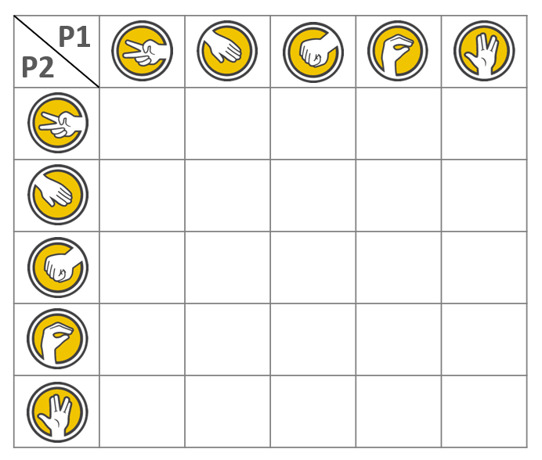
‘Rock, paper, scissors, lizard, Spock’ by reSolve is licensed under CC BY-NC-SA 4.0.

© State of New South Wales (Department of Education), 2023
The copyright material published in this resource is subject to the Copyright Act 1968 (Cth) and is owned by the NSW Department of Education or, where indicated, by a party other than the NSW Department of Education (third-party material).
Copyright material available in this resource and owned by the NSW Department of Education is licensed under a Creative Commons Attribution 4.0 International (CC BY 4.0) licence.
This licence allows you to share and adapt the material for any purpose, even commercially.
Attribution should be given to © State of New South Wales (Department of Education), 2023.
Material in this resource not available under a Creative Commons licence:
- the NSW Department of Education logo, other logos and trademark-protected material
- material owned by a third party that has been reproduced with permission. You will need to obtain permission from the third party to reuse its material.
Links to third-party material and websites
Please note that the provided (reading/viewing material/list/links/texts) are a suggestion only and implies no endorsement, by the New South Wales Department of Education, of any author, publisher, or book title. School principals and teachers are best placed to assess the suitability of resources that would complement the curriculum and reflect the needs and interests of their students.
If you use the links provided in this document to access a third-party's website, you acknowledge that the terms of use, including licence terms set out on the third-party's website apply to the use which may be made of the materials on that third-party website or where permitted by the Copyright Act 1968 (Cth). The department accepts no responsibility for content on third-party websites.

