Same, same, but different
Students explore equivalent fractions by designing their own spinners and marble bags that have the same probability as a given event.

Visible learning
Learning intentions should be displayed after the launch.

Learning intentions
- To be able to recognise equivalent fractions.
- To understand how to generate equivalent fractions.

Success criteria
- I can identify equivalent fractions.
- I can compare equivalent fractions.
- I can create equivalent fractions.

Syllabus outcomes
A student:
- develops understanding and fluency in mathematics through exploring and connecting mathematical concepts, choosing and applying mathematical techniques to solve problems, and communicating their thinking and reasoning coherently and clearly MAO-WM-01
- represents and operates with fractions, decimals and percentages to solve problems MA4-FRC-C-01
- solves problems involving the probabilities of simple chance experiments MA4-PRO-C-01
Mathematics K–10 Syllabus © NSW Education Standards Authority (NESA) for and on behalf of the Crown in right of the State of New South Wales, 2022.

Activity structure

Launch
- Display the following for all students and ask them to Think-Pair-Share which one doesn’t belong.
Figure 1 – Which one doesn’t belong?
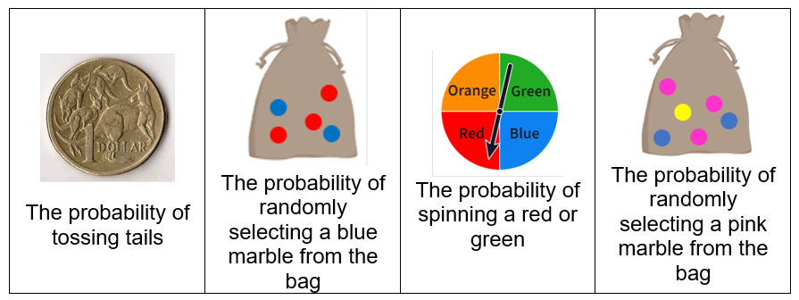
- After Think-Pair-Share, poll the students using a Mentimeter poll (mentimeter.com) or a similar poll as to which one doesn’t belong.
- Students could then share their reasoning behind their choices with the class.
This is an activity for students to explore events where some of the probabilities are equivalent fractions.

Explore
- In pairs or small groups, students complete Activity 1 of Appendix A. Students are to create visual representations of each event by firstly writing the probability of the events. An example has been provided.
Students could create the diagrams digitally using Polypad fraction bars. (mathigon.org/polypad). Polypad has a tutorial on how to use the fraction tools, (mathigon.org/task/tutorial-fractions).
- Students then use these visuals to generate more equivalent fractions by splitting their representations into a given number of parts or combining parts.
- Prompting questions may include:
- How many parts do I need in my visual representation?
- Where is this number represented in the probability of the event, for example, numerator or denominator?
- How many parts do I need to shade?
- Where is this number represented in the probability of the event?
Students develop equivalent fractions and explore the relationship between the numerator and the denominator for each new fraction they create.
- Following this they will complete Activity 2 from Appendix A where they will create spinners and marble bags that give the same probability as the event in the first column.
Students may find it useful to use the Desmos activity Fraction comparison (bit.ly/Fraction_Comparison) to assist them to find equivalent fractions.
- To conclude, conduct a class discussion:
- Recall creating the marble bags and the spinners. What strategy did you use to create these?
- Compare the spinners and marble bags to your visual representations and new fractions you have created. What do you notice? What do you wonder?

Summarise
Using the Same, same, but different PowerPoint, explicitly define and explore equivalent fractions, for example, what they are, how to generate them and where do we see equivalent fractions in probability?
The explicit teaching technique used in the PowerPoint is Your turn. The first slide shows a number of representations of one-half, which should be displayed for the students and then use the following steps for the subsequent slides.
- Reveal the question to students and its solution.
- Students read in silence.
- Students individually think and explain to themselves what is happening in each step.
- Students give up a thumbs up to the teacher when they have finished reading and have some sort of understanding.
- Think-Pair-Share. Students explain the solution to their partner.
- In pairs, students then answer the self-explanation questions.
- Finally, randomly select students to share their answers with the whole class.
Students can do further exploring of their own using fraction kits, Polypad fraction manipulatives (mathigon.org/polypad) and/or fraction walls.

Apply
This activity is based on a resource from Top Drawer Teachers (bit.ly/Colourinfractionsgames).
Figure 2 – completed Colour in Fractions game
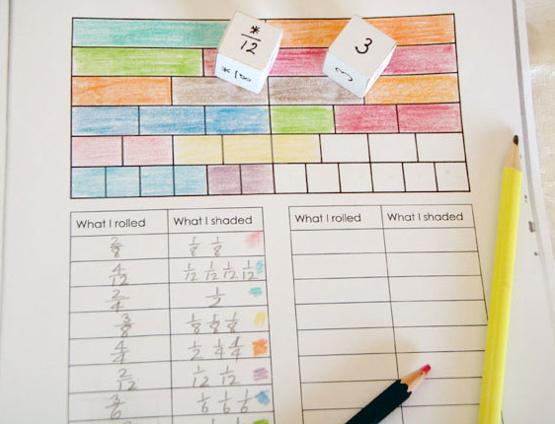
‘Gameboard for the Colour in Fractions game’ has been adapted from Top Drawer Teachers and is licensed under the Top Drawer Teacher’s copyright.
Students will play the game Fraction Bingo in pairs.

Equipment
- Appendix B, physical fraction kit or digitally using the Fraction wall (visnos.com/demos/fraction-wall)
- Two custom made dice or an online custom dice simulator like the app RollMyDice (wychway.studio/roll-my-dice/):
- numerator dice is labelled 1, 2, 2, 3, 3, 4
- denominator dice is labelled $\frac{*}{2}, \frac{*}{3}, \frac{*}{4}, \frac{*}{6}, \frac{*}{8}, \frac{*}{12}$

Game
- Each horizontal strip on the fraction wall gameboard is one-whole.
- Students roll both dice to create a fraction – one dice generates a numerator and the other, a denominator.
- Students colour in sections of the wall that correspond to the fraction that they rolled with the dice. For example, if they throw 2 and $\frac{*}{4}$, then they can colour in $\frac{2}{4}$ of one line, or $\frac{4}{8}$ of one line, or $\frac{1}{4}$ of one line and $\frac{2}{8}$, or any other combination that is equivalent to $\frac{2}{4}$.
- Players take turns with the first player to colour in their whole wall being declared the winner.
- If a player is unable to use their turn, they can pass.

Conclusion
Discuss with students: If you were to play again tomorrow, what would you do differently?
This game can be modified to suit the needs of your students, for example, the game board could just consist of halves, quarters and eighths or include fifths, twelfths, and so on for more of a challenge.

Assessment and Differentiation

Suggested opportunities for differentiation
Encourage the use of visual representations throughout the lesson to support students.
Explore
- Encourage students to do a gallery walk (bit.ly/DLSgallerywalk) halfway through the activity.
Summarise
- Students are encouraged to create as many equivalent fractions from the starting model of $\frac{1}{2}$ as they can. This open-ended question is designed to challenge students about whether or not there is a finite number of answers.
Apply
- Modify the board game to suit the needs of your students, for example, just halves, quarters and eighths or include fifths, twelfths, and so on, for more of a challenge.

Suggested opportunities for assessment
- Use the mentimeter poll at the beginning of the lesson as formative assessment on students’ prior knowledge of equivalent fractions to guide the support required for students in this lesson.
- Monitor students’ answers during class discussion and Think-Pair-Share activities to assess their understanding of the concepts.
- Collect Appendix B to use as summative assessment throughout the unit.
- Create an exit ticket asking students to create visual representations that demonstrate that 2 given fractions are equivalent.

Appendix A

Visual representations – activity 1

Example – tossing a coin
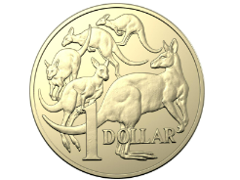
Probability of tossing a tail on a coin = $\frac{1}{2}$
Instruction | Visual representation 1 | Visual representation 2 | Fraction
Row 1: Represent the probability of tossing a tail | 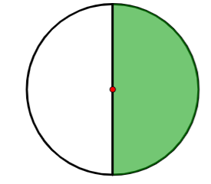 |  | $$\frac{1}{2}$$
Row 2: Split each part of the diagrams in row 1 into 3 equal parts | 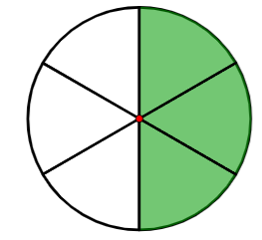 |  | $$\frac{3}{6}$$
Row 3: Create another representation for the diagrams in row 1 by either splitting or combining parts | 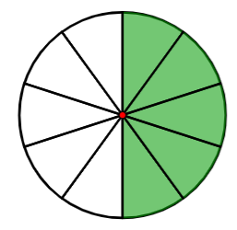 | 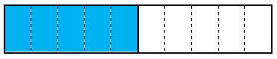 | $$\frac{5}{10}$$
- What do you notice about each visual representation?
- What do you notice about the relationship between the numerator and the denominator in each of the fractions?
- Can you list any more fractions that represent the same probability as tossing a tail on a coin and draw their visual representation?

Sock selection
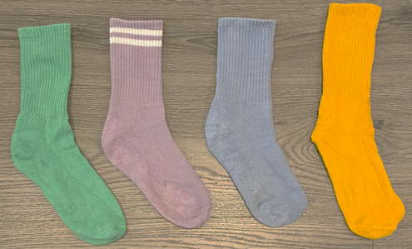
Probability of selecting the sock with stripes = __.
Instruction | Visual representation 1 | Visual representation 2 | Fraction
Row 1: Represent the probability of selecting the sock with stripes | 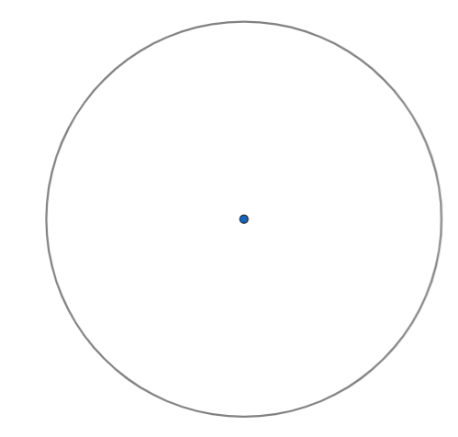
Row 2: Split each part of the diagrams in row 1, into 3 equal parts
Row 3: Create another representation for the diagrams in row 1 by either splitting or combining parts
- What do you notice about each visual representation?
- What do you notice about the relationship between the numerator and the denominator in each of the fractions?
- Can you list any more fractions that represent the same probability as selecting the sock with stripes?

Rolling a regular die
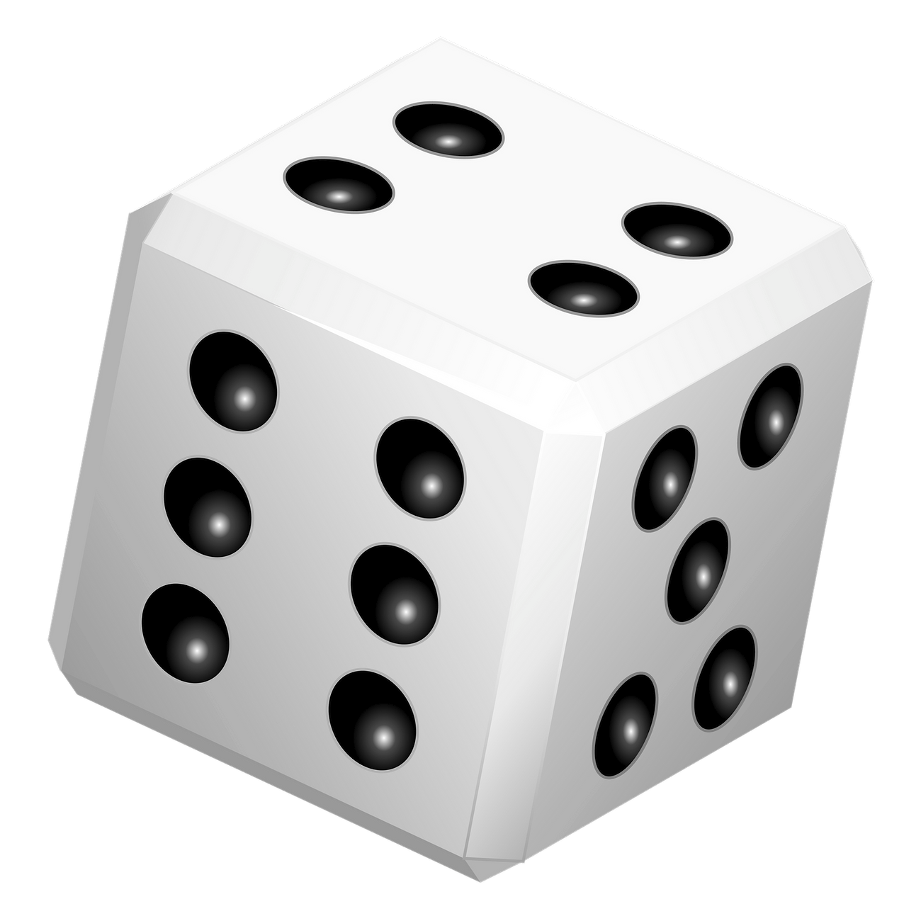
‘Dice png sticker, transparent background’ is licensed under CC0 1.0.
Probability of rolling a 3 on a regular die = __.
Instruction | Visual representation 1 | Visual representation 2 | Fraction
Row 1: Represent the probability of rolling a 3 on a regular die
Row 2: Combine each set of 2 parts of the diagrams in row 1
Row 3: Create another representation for the diagrams in row 1 by either splitting or combining parts
- What do you notice about each visual representation?
- What do you notice about the relationship between the numerator and the denominator in each of the fractions?
- Can you list any more fractions that represent the same probability as rolling a multiple of 3?

Team captain
‘Friendship garland clipart, colorful illustration’ is licensed under CC0 1.0.
Probability of being randomly selected team captain in a team of 5 players = __.
Instruction | Visual representation 1 | Visual representation 2 | Fraction
Row 1: Represent the probability of being randomly selected team captain in a team of 5 players
Row 2: Split each part of the diagrams in row 1 into 2 equal parts
Row 3: Create another representation for the diagrams in row 1 by either splitting or combining parts
- What do you notice about each visual representation?
- What do you notice about the relationship between the numerator and the denominator in each of the fractions?
- Can you list any more fractions that represent the same probability as randomly selecting a captain from a team of 5 players?

Same, same, but different – activity 2
Design different spinners and marble bags to represent the same probability as the event.
Event | Spinner | Marble bag
Tossing a tail on a coin | 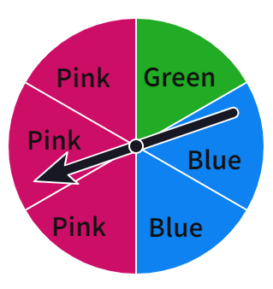  Spinning pink | 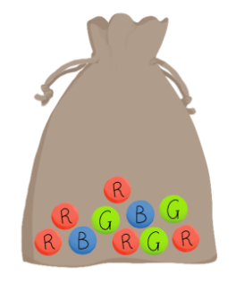  Selecting a red marble
Randomly selecting the sock with 2 stripes  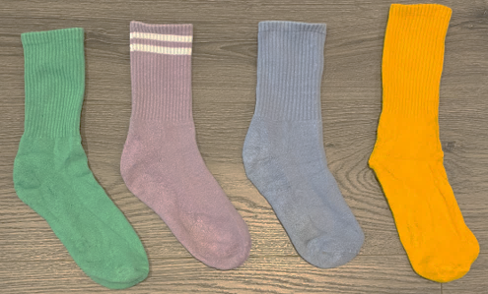 |  | 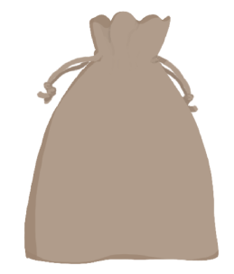
Rolling a multiple of 3 on a regular dice
Randomly selected as team captain in a team of 5 players

Appendix B

Fraction bingo
What I rolled | What I shaded
‘Gameboard for the Colour in Fractions game’ has been adapted from Top Drawer Teachers and is licensed under the Top Drawer Teacher’s Copyright.

© State of New South Wales (Department of Education), 2023
The copyright material published in this resource is subject to the Copyright Act 1968 (Cth) and is owned by the NSW Department of Education or, where indicated, by a party other than the NSW Department of Education (third-party material).
Copyright material available in this resource and owned by the NSW Department of Education is licensed under a Creative Commons Attribution 4.0 International (CC BY 4.0) licence.
This licence allows you to share and adapt the material for any purpose, even commercially.
Attribution should be given to © State of New South Wales (Department of Education), 2023.
Material in this resource not available under a Creative Commons licence:
- the NSW Department of Education logo, other logos and trademark-protected material
- material owned by a third party that has been reproduced with permission. You will need to obtain permission from the third party to reuse its material.
Links to third-party material and websites
Please note that the provided (reading/viewing material/list/links/texts) are a suggestion only and implies no endorsement, by the New South Wales Department of Education, of any author, publisher, or book title. School principals and teachers are best placed to assess the suitability of resources that would complement the curriculum and reflect the needs and interests of their students.
If you use the links provided in this document to access a third-party's website, you acknowledge that the terms of use, including licence terms set out on the third-party's website apply to the use which may be made of the materials on that third-party website or where permitted by the Copyright Act 1968 (Cth). The department accepts no responsibility for content on third-party websites.

