Sense of order
Students explore different events with a range of probabilities and attempt to order these accurately on a number line.

Visible learning

Learning intentions
- To be able to use visual representations to compare the size of different probabilities.
- To be able to plot fractions with different denominators on a number line.

Success criteria
- I can interpret visual representations of fractions to compare sizes.
- I can determine which fraction is larger or smaller.
- I can order fractions with different denominators on a number line.
- I can use fractions to describe probabilities to compare likelihood of events.

Syllabus outcomes
A student:
- develops understanding and fluency in mathematics through exploring and connecting mathematical concepts, choosing and applying mathematical techniques to solve problems, and communicating their thinking and reasoning coherently and clearly MAO-WM-01
- represents and operates with fractions, decimals and percentages to solve problems MA4-FRC-C-01
- solves problems involving the probabilities of simple chance experiments
MA4-PRO-C-01
Mathematics K–10 Syllabus © NSW Education Standards Authority (NESA) for and on behalf of the Crown in right of the State of New South Wales, 2022.

Activity structure

Launch
- Using one set of Appendix A, assign each card to a student. You may like to enlarge the appendix so that the cards can be seen by all students in the room.
- Ask students with cards to silently position themselves in a row in ascending order.
- Once the students have stopped moving about, blue tac the cards to the board in this order.
- Tell students that we will come back to their order later to see how accurate they were.
This is a silent task, but it should spark some thoughts on:
- how far apart from each other the students should be
- the need to compare by finding the probabilities and making sense of ordering these fractions accurately.

Explore
- In pairs or small groups, students are to be issued with handout from Appendix B and a link to the Desmos activity – Fraction comparison (bit.ly/desmosfractioncomparison).
- Firstly, they write the probabilities for each event in the last column on the handout.
- They then attempt to accurately place the probabilities on a number line, using the Desmos activity if needed. The Desmos activity allows students to compare the size of 2 fractions using visual representations.

Summarise
- Ask the students if they think the initial ordering was correct, why or why not?
- As a class allow students to share the strategies they used to plot the probabilities.
- Slowly reveal the answers, showing where each probability should have been plotted. Ask the students what feature could be added to the number line to plot the probabilities more accurately.
Polypad fraction bars (mathigon.org/polypad) can also be used to assist with this process.
For example, start with just plotting $\frac{1}{2}$ on the number line. Which events can be accurately plotted now?
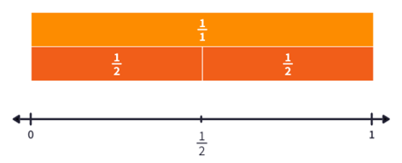
What if we halved each section to make quarters? What events can be accurately plotted now?
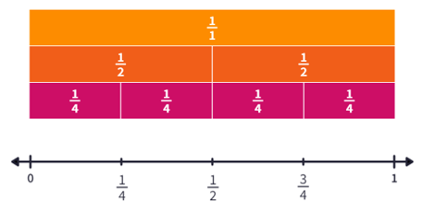
Continue this by plotting thirds, fifths and sixths until all events can be shown. It may help students to see $\frac{3}{6}$ plotted with $\frac{1}{2}$ to see if they can plot $\frac{1}{6},\frac{2}{6}$ from this.
Images from Polypad by Mathigon in accordance with the Mathigon Licence.

Apply

Would you rather…?
- Either verbally call out each scenario and have students select which one by picking a side of the room or display each in a mentimeter poll (mentimeter.com/) for the whole class.
- After collecting results on what students would rather ask one student to display both options on a number line to confirm their selection.
- Win $100 if you flip heads on a coin or win $100 if you roll a 3 on a 6-sided dice?
- Win if you draw any card of hearts from a regular deck of cards or win if you roll a multiple of 3 on a 6-sided dice?
- Win the game if you roll an even number with a 6-sided dice or win the game if you roll an even number with an 8-sided dice?

Assessment and differentiation

Suggested opportunities for differentiation
Launch
- You may like to allocate specific cards to particular students, knowing your students and how they learn, for example, students with a solid understanding of fractions and probability could be assigned the 8-sided dice card rather than 0 or 1.
Explore and Summarise
- Visual representations are used to assist students with their understanding when comparing the size of fractions with different denominators
- For some students, restrict the plotting of fractions on the number line to just $\frac{1}{4},\frac{1}{2}$ and $\frac{3}{4}$.
- Add in more cards for students that need a challenge, such as events where the probability is $\frac{1}{12}$, etc.

Suggested opportunities for assessment
- Monitor student responses during discussion to assess their understanding of likelihood of events.
- Collect Appendix B to check for student understanding of the probability terms and to use as summative assessment.
- The mentimeter poll at the conclusion of the lesson is a form of formative assessment to check students’ understanding.

Appendix A

Probability cards
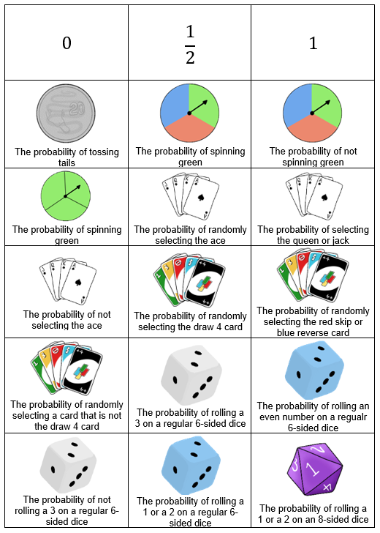

Appendix B

Sense of size
Complete the table by writing the probability of each event in the final column.
Card | Diagram | Description | Probability
A | 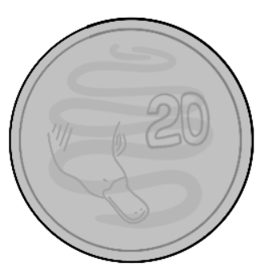 | The probability of tossing tails
B |  | The probability of spinning green
C |  | The probability of not spinning green
D | 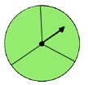 | The probability of spinning green
E | 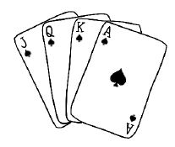 | The probability of randomly selecting the ace
F | 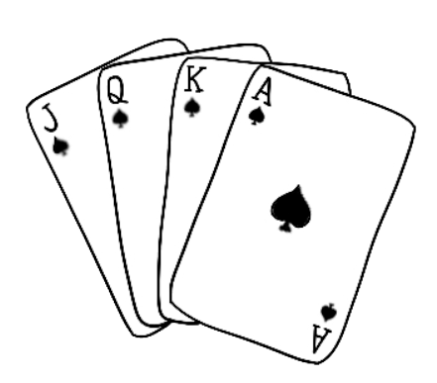 | The probability of selecting the queen or jack
G |  | The probability of not selecting the ace
H | 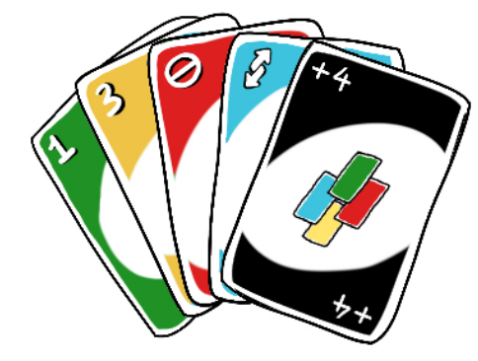 | The probability of randomly selecting the draw 4 card
I |  | The probability of randomly selecting the red skip or blue reverse card
J |  | The probability of randomly selecting a card that is not the draw 4 card
K | 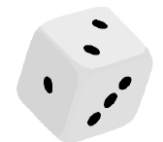 | The probability of rolling a 3 on a regular 6-sided dice
L |  | The probability of rolling an even number on a regular 6-sided dice
M |  | The probability of not rolling a 3 on a regular 6-sided dice
N |  | The probability of rolling a 1 or a 2 on a regular 6-sided dice
O | 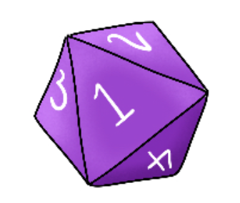 | The probability of rolling a 1 or a 2 on an 8-sided dice

Plotting on a number line
Use the letter associated with each card and plot each of the above events as accurately as possible on the number line below.
Use the Desmos graph – Fraction comparison (https://bit.ly/fractioncomparison), for assistance.

Sample answers
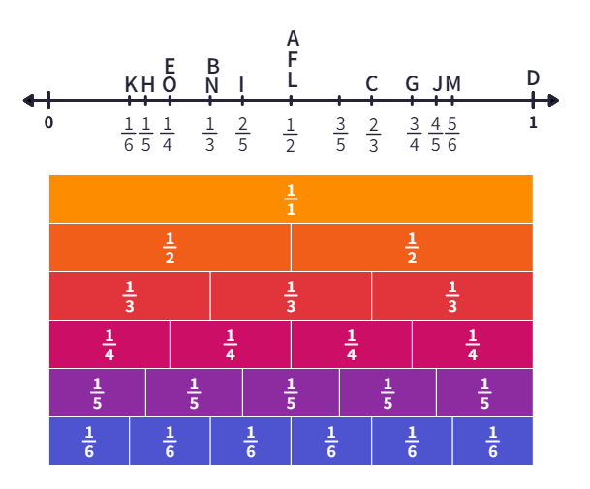
Image from Polypad by Mathigon is used in accordance with the Mathigon Licence.

© State of New South Wales (Department of Education), 2023
The copyright material published in this resource is subject to the Copyright Act 1968 (Cth) and is owned by the NSW Department of Education or, where indicated, by a party other than the NSW Department of Education (third-party material).
Copyright material available in this resource and owned by the NSW Department of Education is licensed under a Creative Commons Attribution 4.0 International (CC BY 4.0) licence.
This licence allows you to share and adapt the material for any purpose, even commercially.
Attribution should be given to © State of New South Wales (Department of Education), 2023.
Material in this resource not available under a Creative Commons licence:
- the NSW Department of Education logo, other logos and trademark-protected material
- material owned by a third party that has been reproduced with permission. You will need to obtain permission from the third party to reuse its material.
Links to third-party material and websites
Please note that the provided (reading/viewing material/list/links/texts) are a suggestion only and implies no endorsement, by the New South Wales Department of Education, of any author, publisher, or book title. School principals and teachers are best placed to assess the suitability of resources that would complement the curriculum and reflect the needs and interests of their students.
If you use the links provided in this document to access a third-party's website, you acknowledge that the terms of use, including licence terms set out on the third-party's website apply to the use which may be made of the materials on that third-party website or where permitted by the Copyright Act 1968 (Cth). The department accepts no responsibility for content on third-party websites.

