Would you rather …?
Students explore chance and likelihood by deciding between a range of everyday scenarios that represent their chances of winning a prize. Students then relate probability terms to these scenarios and consider their definitions and limitations.

Visible learning

Learning intention
- To be able to describe and compare probabilities using words or phrases.

Success criteria
- I can explain the likelihood of an event using the terms of probability.
- I can rank the probability terms to describe the chance of everyday events.
- I can compare different terms of probability.

Syllabus outcomes
A student:
- develops understanding and fluency in mathematics through exploring and connecting mathematical concepts, choosing and applying mathematical techniques to solve problems, and communicating their thinking and reasoning coherently and clearly MAO-WM-01
- solves problems involving the probabilities of simple chance experiments
MA4-PRO-C-01
Mathematics K–10 Syllabus © NSW Education Standards Authority (NESA) for and on behalf of the Crown in right of the State of New South Wales, 2022.

Activity structure

Warm up
Students play a game of Would you rather, where they are given scenarios and need to decide which they would prefer.
- Have all students stand in the centre of the room.
- Show 2 Would you rather…? scenarios on the screen or read them out. Students choosing the first option move to the left of the room, and students choosing the second move to the right.
- Ask a few students to justify why they have chosen a particular answer.
There are no incorrect answers. This activity is aimed at priming the students to justify why they have particular preferences and make choices.
- A short list of possible would you rather scenarios are listed below.
Would you rather:
- Be able to fly, or be able to turn invisible?
- Be able to speak every language, or be able to play every instrument?
- Eat a raw potato, or eat a whole lemon?
- Be 2 years old again, or be 20 years old?
- Live without music, or live without movies?
- Go on a rollercoaster or a waterslide?
- Be a bird or be a horse?
Many lists of context-specific Would you rather questions are available via a quick online search. Check all questions before using to ensure they are appropriate for students.
Consider the Would You Rather Math website (www.wouldyourathermath.com/) for maths-specific would you rather questions.

Launch
Students consider a range of events and determine which one they want to bet their chances on.

Equipment
- Appendix A cut into a deck of cards x 1 per student
- Appendix B cut into a deck of cards x 1 per student

Win $1 million
- Give each student a copy of Appendix A and tell them they have a chance to win $1 million today. Students are allowed to pick one event from the list in Appendix A. If this event occurs, you win $1 million.
- Ask each student to submit a poll response. Teachers can use software to collect the information as a poll or take the information verbally as a vote. Mentimeter (www.mentimeter.com) is an excellent online option.
- Ask students to justify their choice, selecting students who have chosen a range of different events to rest their hopes on.

Multiple ways to win
- Now there are 12 prizes: $1,000,000, $10,000, $1,000, $100, $50, $20, $15, $10, $5, $1, 50 cents, and $-$$100 (you lose $100).
- Students need to choose which event to put against which prize. If that event happens, you win that prize. Hand students Appendix B and have them sort the prize amounts into order from largest to smallest.
- Have students sort the events from Appendix A to align each event to a prize from Appendix B.
The terms chance and likelihood should be explicitly used in this activity.
- Lead a discussion with students about why they made the choices they made. Ask students to justify why they put something very low or very high.
Consider looking for non-volunteers, there are no wrong answers to this task.
- Be clear that what they have done is ordered events from most likely to least likely.

Explore
Students are to categorise chance events using common probability terms.

Equipment
- Appendix A cut into a deck of cards x 1 per student (students already have this from the previous activity)
- Appendix C cut into a deck of cards x 1 per student
- Clothesline and pegs (optional)
- Adhesive putty (optional)
- Sticky tape (optional)

Method
- Hand students a set of cards from Appendix C and ask them to individually decide on the order of these terms from least likely to most likely (left to right).
- Conduct a Think-Pair-Share (bit.ly/DLSthinkpairshare) where they discuss with a partner after completion.
- Confirm the correct order using the relevant cards from Appendix D on the board, a class clothesline or wall, shown below. (You will use the remaining cards from Appendix D shortly) 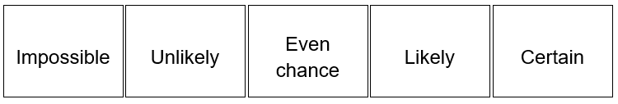
- Share the definitions of these terms:
- Impossible: won't happen, no chance of happening.
- Unlikely: probably won't happen. Greater chance of not happening.
- Even chance: equal chance of happening or not happening.
- Likely: probably will happen. Greater chance of happening.
- Certain: will happen, no chance of not happening.
- Ask students to categorise each of the events from Appendix A into the 5 groups, impossible, unlikely, even chance, likely and certain. Students should justify why they have made these choices with reference to the definitions. For example: 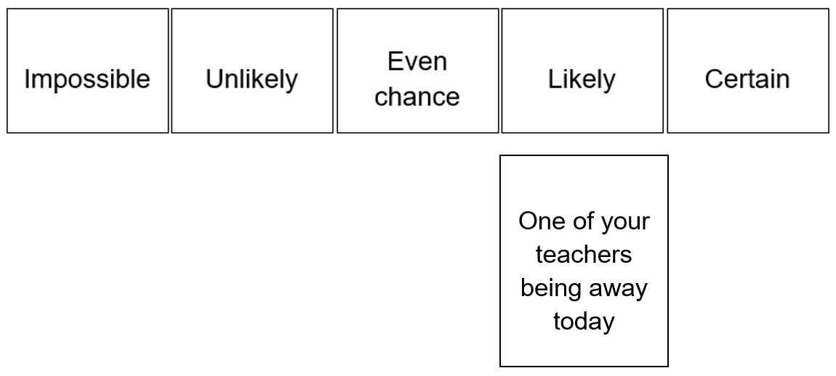
- Discussion questions to consider:
- Are the events you placed in the even chance group all equally likely?
All events placed in the even chance group should be equally likely, so if anyone claims they have one more likely than another in this group, use this as a discussion point. This is true for certain and impossible also.
- Are the events you placed in the likely group all equally likely?
All events placed in the likely group do not have to be equally likely, so look for students who claim they have one more likely than another in this group and use this as a discussion point. This is true for unlikely also.
- Place the remaining cards from Appendix D on the board, wall or clothesline, with assistance from the class to determine positioning. Students should be challenged to justify why each card should go in a specific place.
- Do these words give you a greater ability to organise your events? Allow students to Think-Pair-Share while they redistribute their cards if necessary.

Summarise
To consolidate their understanding, students can play Vile Vendor (bit.ly/vile-vendor) to practise using the probability terms.

Apply
- Students identify 3 events from their daily lives to fit into each of the main 5 categories: impossible, unlikely, even chance, likely, certain (Appendix C).
- Students reflect upon and write about a situation where their opinion on an event has recently changed, eg ‘What is something that you previously thought was impossible that you now can see is just unlikely?’

Assessment and Differentiation

Suggested opportunities for differentiation
Explore
- Students may benefit from first ranking integers from smallest to highest as a class to check students numerical understanding.
- As this activity has no incorrect answers and is subject to opinion, all students should be able to attempt ranking based on their own experiences.
- Challenge students to explain the difference between terms such as likely and unlikely, when compared to terms that mean a very specific chance, such as impossible, even chance and certain.
Apply
- All students should be able to choose events and probability words that describe them. When discussing with students, teachers can encourage their students to think about their decisions with the question ‘do you think this will happen?’.

Suggested opportunities for assessment
Explore
- Review whether students are able to adjust their categorisation of events so that they can confidently say that all events listed as even chance have the same likelihood.
- Create an exit ticket where students need to choose 2 events from Appendix A and write in words why they described it using a particular probability term from Appendix B.

Appendix A

Ordering events
Scoring 8 goals in soccer at lunch | Seeing someone famous today
One of your teachers being away today | Getting home before 3:30pm this afternoon
Hearing your favourite song somewhere today | Getting more than 1000 likes on a post today
Learning something new today | Getting rained on today
Winning 3 straight games of scissors, paper, rock | Randomly selecting a person, and them being left-handed
The moon falling and landing out the front of the school | Your family having something completely new for dinner tonight

Appendix B

Many ways to win
$1,000,000 | $10,000
$1,000 | $100
$50 | $20
$15 | $10
$5 | $1
50 cents | $-$$100 (You lose $100)

Appendix C

The language of probability (individual)
impossible | likely
certain | unlikely
even chance

Appendix D

The language of probability (whole class)
impossible | likely
certain | unlikely
even chance | very likely
very unlikely | almost certain
almost impossible

© State of New South Wales (Department of Education), 2023
The copyright material published in this resource is subject to the Copyright Act 1968 (Cth) and is owned by the NSW Department of Education or, where indicated, by a party other than the NSW Department of Education (third-party material).
Copyright material available in this resource and owned by the NSW Department of Education is licensed under a Creative Commons Attribution 4.0 International (CC BY 4.0) licence.
This licence allows you to share and adapt the material for any purpose, even commercially.
Attribution should be given to © State of New South Wales (Department of Education), 2023.
Material in this resource not available under a Creative Commons licence:
- the NSW Department of Education logo, other logos and trademark-protected material
- material owned by a third party that has been reproduced with permission. You will need to obtain permission from the third party to reuse its material.
Links to third-party material and websites
Please note that the provided (reading/viewing material/list/links/texts) are a suggestion only and implies no endorsement, by the New South Wales Department of Education, of any author, publisher, or book title. School principals and teachers are best placed to assess the suitability of resources that would complement the curriculum and reflect the needs and interests of their students.
If you use the links provided in this document to access a third-party's website, you acknowledge that the terms of use, including licence terms set out on the third-party's website apply to the use which may be made of the materials on that third-party website or where permitted by the Copyright Act 1968 (Cth). The department accepts no responsibility for content on third-party websites.

