Alphabet soup
Students play a game using alphabet tiles based on their own name to observe that the chance of winning can be different for each player and can be compared.

Visible learning

Learning intention
- To understand that in a game, the chances of winning can be different and comparable.

Success criteria
- I can determine my own maximum score.
- I can make decisions to increase my chance of winning.
- I can justify my comparisons of who has the greater chance of winning a game.

Syllabus outcomes
A student:
- develops understanding and fluency in mathematics through exploring and connecting mathematical concepts, choosing and applying mathematical techniques to solve problems, and communicating their thinking and reasoning coherently and clearly MAO-WM-01
- solves problems involving the probabilities of simple chance experiments
MA4-PRO-C-01
Mathematics K–10 Syllabus © NSW Education Standards Authority (NESA) for and on behalf of the Crown in right of the State of New South Wales, 2022.

Activity structure

Launch
- Using Appendix A, or your own alphabet tiles, place all letters in a bag. Each pair of students will need their own bag. Do not show the students what is in the bag.
- In pairs, students will randomly draw one letter at a time from a bag.
- If the letter drawn is in their name, they get the number of points that is on that letter tile.
- Each letter of their name can only be used once, so students are to cross successful letters off their name.
- The tile is replaced after each turn.
- Students are to keep score and complete 10 rounds of drawing letters from the bag, unless a player completes their name and then the game stops earlier.
- The winner is the player with the most points.
- Discuss the following reflection questions with students at the conclusion of the 10 rounds:
- What did you notice about each letter tile?
- Was this a fair game? Why or why not?
- Would the player who completes their name first always win the game?
- Would it have been a fairer game if we replaced the letters each time?
- Is it possible for everyone to win? Is there an equal chance that everyone could win?
- Reveal the learning intention for the lesson.

Explore

Maximum score
- Students empty the letter tiles from the bag and calculate the maximum score they could have reached if they had drawn all of the letters for their name. For example, Samantha could achieve a maximum score of 13.
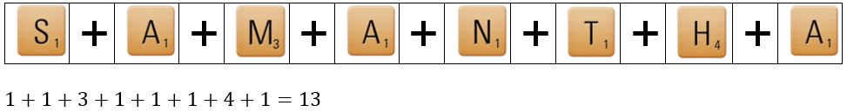
- Reflection questions to discuss with students:
- Which student in the class could have achieved the most points?
- For which student in the class is it easiest to obtain all letters from their name? Why?

Make your own bag
- Each pair from the previous activity now becomes a team.
- Each pair is to create their own bag with 20 tiles of their choice, using their current letter tiles. Students should consider:
- What letters will give them the best chance of getting points?
- What letters might you exclude and why?
- Is there a strategy that can be used when creating this bag?
- Each pair plays 10 rounds against another pair using their own bag. They then play a second game using the other team’s bag. Students are to record their results.
- Reflection questions to discuss with the class:
- Did your team win when playing with your own bag?
- Did the other team win when playing with their bag?
- Is there a different strategy you would take when creating your bag if you played another game?

Summarise
- Using game scenarios similar to the ones below, discuss with the class who they think would win and why. Students will need to view, either on the board or as a handout, Appendix B to help make their choices.
Students could show their results by standing on different sides of the room, or using an online poll such as a mentimeter (http://mentimeter.com/).

Game scenario 1
- Player 1: Jaxon
- Player 2: Ali

Game scenario 2
- Player 1: Giovanni
- Player 2: Savannah

Game scenario 3
- Player 1: Yukio
- Player 2: Florence

Game scenario 4
- Player 1: Ezra
- Player 2: Felix
- Player 3: Zoey

Each game scenario should be strategically selected, and thought should be put into each name’s maximum points (for example, if they could select all letters of their name what is the maximum amount of points they would get), the length of each name (for example, how many letters are in the name), as well as the frequency of each letter in the bag.
Some scenarios that could be considered include:
- Compare 2 names with completely different maximum points.
- Compare 2 names with similar maximum points and similar lengths.
- Compare 2 names with similar maximum points and different lengths.
- Compare 3 names to extend the students reasoning and justification.
- Conclude as a class that we would love to be able to know for certain who is most likely to win.

Apply
- Display all students’ first names and the letter points table from Appendix B for the class.
- Students are to decide which class member they would want on their team to maximise their chances of winning and justify why they have made this decision.
- Once students have had individual thinking time to select a team member, use a mentimeter word cloud (mentimeter.com/) or similar, for students to submit their answer.
- Reflection questions to discuss as a class:
- Did students select a team member with the shortest or longest name? Which is best?
- Did students select a team member based on the letters within a student’s name? Justify why.
- Can the students use numerical values when justifying their selection?

Assessment and Differentiation

Suggested opportunities for differentiation
Launch
- Students may need a demonstration of how to play the game before playing in their pairs.
Explore and Summarise
- The task allows for simple choices, such as students maximising the letters from their name and then randomly selecting the remaining letter. It also gives opportunity for students to challenge themselves to make decisions about common letters in people's first names and use this to justify decisions about what to exclude from their bag.
- To challenge students, ask them to justify and list all the factors that will determine whether a student will win or lose, for example, letters in their name, maximum points for their name, letter with the greatest points in their name, and so on.

Suggested opportunities for assessment
- Monitor student responses during discussion to assess their understanding of likelihood of events.
- Students will be constantly justifying their decisions, and their justifications can correctly draw upon at least 4 factors: the length of their name, their maximum score, the frequency of individual letters from their name and the scores of individual letters from their name. When giving justifications, it is important to monitor whether students are using, one, some or all of these factors, and whether they are relating the factors to one another, eg ‘my name Aziz has a maximum score of 22, but there is only one z tile, and this is where 20 of my points come from’.
- Create an exit ticket where students compare 2 names and the chances of each name winning the game.

Appendix A

Alphabet tiles
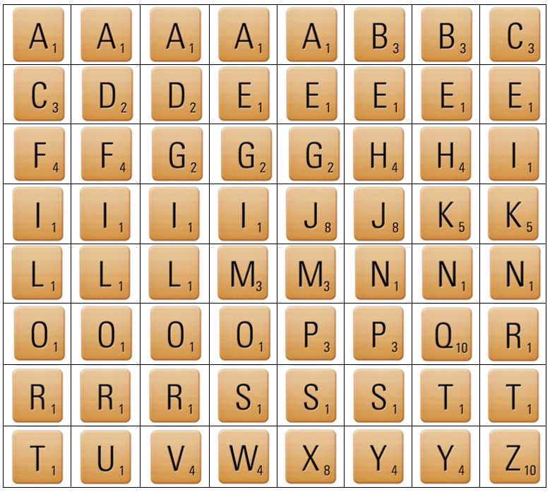

Appendix B

Scenarios
Who do you expect would win each game, and why?

Game scenario 1
- Player 1: Jaxon
- Player 2: Ali

Game scenario 2
- Player 1: Giovanni
- Player 2: Savannah

Game scenario 3
- Player 1: Yukio
- Player 2: Florence

Game scenario 4
- Player 1: Ezra
- Player 2: Felix
- Player 3: Zoey

Letter point values
Points | Letters
1 | A, E, I, O, U, L, N, S, T, R
2 | D, G
3 | B, C, M, P
4 | F, H, V, W, Y
5 | K
8 | J, X
10 | Q, Z

Frequency | Letters
1 | Q, U, V, W, X, Z
2 | B, C, D, F, H, J, K, M, P, Y
3 | G, L, N, S, T
4 | O, R
5 | A, E, I

© State of New South Wales (Department of Education), 2023
The copyright material published in this resource is subject to the Copyright Act 1968 (Cth) and is owned by the NSW Department of Education or, where indicated, by a party other than the NSW Department of Education (third-party material).
Copyright material available in this resource and owned by the NSW Department of Education is licensed under a Creative Commons Attribution 4.0 International (CC BY 4.0) licence.
This licence allows you to share and adapt the material for any purpose, even commercially.
Attribution should be given to © State of New South Wales (Department of Education), 2023.
Material in this resource not available under a Creative Commons licence:
- the NSW Department of Education logo, other logos and trademark-protected material
- material owned by a third party that has been reproduced with permission. You will need to obtain permission from the third party to reuse its material.
Links to third-party material and websites
Please note that the provided (reading/viewing material/list/links/texts) are a suggestion only and implies no endorsement, by the New South Wales Department of Education, of any author, publisher, or book title. School principals and teachers are best placed to assess the suitability of resources that would complement the curriculum and reflect the needs and interests of their students.
If you use the links provided in this document to access a third-party's website, you acknowledge that the terms of use, including licence terms set out on the third-party's website apply to the use which may be made of the materials on that third-party website or where permitted by the Copyright Act 1968 (Cth). The department accepts no responsibility for content on third-party websites.

