Mathematics Stage 4 (Year 7) –assessment task notification
Contents
Game on 2
Task description 2
What is probability? 3
Part 1 – what are the chances? 3
Part 2 – the problem of points 7
Part 3 – conclusions 8
Submission details 9
Part 1 – what are the chances? 9
Part 2 – the problem of points 9
Part 3 – conclusions 9
Marking guidelines 10
Student support material 17
Part 1 – tabulating data 17
Part 2 – determining winners 18
Teacher notes 19
Differentiation 20
Sample solutions 22
Part 3 – conclusions 29

Game on
Type of task: Investigation task
Outcomes being assessed:
- develops understanding and fluency in mathematics through exploring and connecting mathematical concepts, choosing, and applying mathematical techniques to solve problems, and communicating their thinking and reasoning coherently and clearly MAO-WM-01
- solves problems involving the probabilities of simple chance experiments MA4-PRO-C-01

Task description
Students will explore how probability influences games to really consider the question:
Can knowing how the game works, ruin all the fun?

What is probability?
Figure 1
‘Coin toss’ by ICMA Photos is licensed under CC BY-SA 2.0
Probability theory is mostly attributed to 2 very famous mathematicians, Pierre de Fermat and Blaise Pascal. They wrote letters back-and-forth to one another, discussing what is now known as the problem of points.

Part 1 – what are the chances?
Figure 2
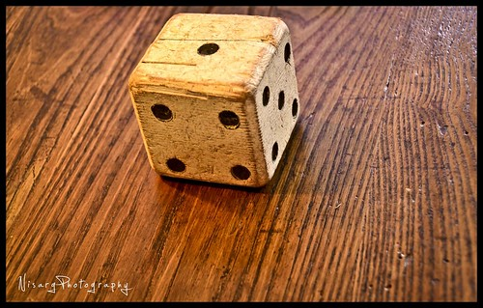
‘Let’s roll the dice...’ by Nisarg Lakhmani is licensed under CC BY-NC 2.0
Board games and video games utilise probability to create a random element to the actions we take and decisions we make. This ensures that we don’t have absolute control over the outcomes but must adapt to the results we receive.
This uncertainty is what helps to make games, particularly board, video, and card games, popular to play time and again.

The scenario
- Many games use the results of rolling (or simulating rolling) a standard, fair, six-sided dice.
- Such a dice has a sample space of {1, 2, 3, 4, 5, 6}.
- Each outcome has an equally likely chance of $\frac{1}{6}$.
- These games most often require you to move a piece several spaces equal to the dice result and perform the action on the space on which it lands.
- As a player you have little to no control over the game and rely entirely on random chance to determine if you succeed or fail.

The problem
When changes are made to the sample space and likelihood of results, should this improve how engaging and re-playable a game becomes?

Required student responses – process
Conduct an experiment involving multiple trials, to determine a relative frequency for all the results you receive from rolling and adding together the value of 2, standard, fair, six-sided dice.
- Type, ‘Roll 2 six-sided dice’ into a Google search. This will give you an app with 2 dice that adds the total together for you. Press the Roll button to roll the dice.
Figure 3 – example of results from Google's dice rolling simulation tool
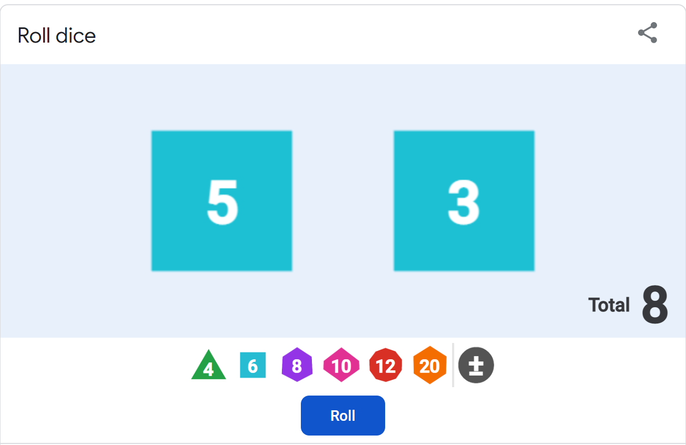
- Otherwise, you can use 2, physical, six-sided dice that you may have available at home or school.
As an alternative, you could replace one or both dice with dice that do not have 6 sides – there are dice that range from 4 sides up to 20 sides and beyond.
The Google dice-roller can represent these dice for you.
- Record your results in a table like Table 2 – recording the results of rolling 2 dice and adding the numbers.
- You will need to roll the dice multiple times to gather enough data to see what is happening.
- Write down the sample space from your results. What were all the different totals that you rolled?
- Calculate relative frequencies, as fractions, for each of the totals in your sample space.
- Identify which total occurred the most and which occurred the least. Can you explain why this is the case?

Required student responses – questions
- Create a simple game where players must roll 2 dice and add the numbers together. Your game should not be fair. It should give one player more chance of winning than the other.
- Clearly explain the rules of your game.
- Use your knowledge of probability to explain each player’s chances of winning. How does your game favour one player over the other?
- Test your game by playing it several times. Do the results of your test agree with what you thought would happen?

Part 2 – the problem of points

The scenario
- There are 2 players, Abe and Bea, playing a fair game split into rounds.
- The game consists of flipping a fair coin, with Abe winning on heads and Bea winning on tails.
- Abe and Bea have both contributed an equal amount to a winner-takes-all prize.
- The one who wins a total of 10 rounds will win the overall game and receive the entire prize.
- The game is stopped unexpectedly.
- Abe has won 7 rounds and Bea has won 8 rounds.

The problem
No one made it to 10 rounds so there is no winner according to the rules, and now Abe and Bea can’t agree on what should happen with the prize.

Required student responses
Using your understanding of probability, you need to answer the following:
- It is possible that the next 4 rounds play out as follows:
Heads, Heads, Tails, Heads (HHTH).
In this outcome, Abe wins 3 more times and finishes with 10 points and wins the game. Bea wins one more time and finishes with 9 points.
- How many other, different outcomes are possible? Create a list of all the possible ways these rounds could play out using Table 3 – possible combinations for remaining 4 rounds (including the example provided).
- To determine a winner, the maximum number of rounds that could possibly be played is 4. Explain why this is the case.
- Using your list of possible results from question 1, determine what fraction of the prize to give to each person, justifying your response.
- What if Abe and Bea had played one extra round before the game was stopped – would this change your answer to the previous question? Justify your response.
- Consider if Abe had won 9 rounds and Bea had won zero when the game was interrupted. Would it be a fair and reasonable outcome for Abe to receive the entire prize-pool? Explain your answer using mathematical arguments and reasoning.

Part 3 – conclusions
After studying different games and their outcomes, how might knowing the relative frequencies (chances of winning) impact your decisions during the game or your motivation to play the game? Justify your response.

Submission details
Students should submit the following:

Part 1 – what are the chances?
☐ Table showing result of experiment
☐ Sample space for your experiment
☐ Relative frequencies from your experiment
☐ Explanation of most and least frequent results
☐ Set of rules for new game
☐ Results of test for new game
☐ Explanation of how knowing relative frequencies impacts your decisions

Part 2 – the problem of points
☐ Answers to questions 1 to 5

Part 3 – conclusions
☐ Detailed explanation of answer to question

Marking guidelines
The assessment marking guidelines in Table 1 are organised into the skills students have the opportunity to demonstrate within the outcomes being assessed, MAO-WM-01 and MA4-PRO-C-01. Teachers are encouraged to review student work with these skills in mind before using Table 1 to make a determination on the level to which the skill has been demonstrated.
Table 1 – assessment marking guidelines
Criteria | Working towards developing | Developing | Developed | Well developed | Highly developed
Part 1 – conducting an experiment | - Student completes a small number of trials and attempts to record the results. | - Student completes a small number of trials and accurately records the results.  - Student lists some elements of the sample space.  - Student records a tally or total for each element in their sample space. | - Student conducts a suitable number of trials to determine a mostly accurate sample space.  - Student calculates the relative frequency for all values listed in their sample space.  - Student attempts to explain why some totals occur more or less frequently than others. | - Student lists a sample space that includes all possible outcomes either as a result of comprehensive trials, or through the development of a mathematical model.  - Student uses appropriate mathematical language to provide some correct reasons why a particular total may occur more or less often than others. | - Student uses precise mathematical language and calculations to demonstrate extensive understanding of probability concepts, and to explain why a particular total occurs the most or the least.
Part 1 – creating a game | - Student creates a game involving 2 dice and uses limited mathematical language to explain the rules of the game. No consideration is given to whether or not the game is fair.  - Student tests the game and keeps a simple record of who wins. | - Student creates a game involving 2 dice and uses probability words to explain how they have made the game unfair.  - Student conducts a limited test of the game and attempts to use the results to support their explanation of the chances of winning for each player. | - Student creates a game involving 2 dice and uses the results from their experiment to determine rules for the game, such that the game is unfair.  - Student uses some mathematical language to explain the chances of each player winning the game.  - Student conducts a suitable test of their game and accurately records and compares the results with their predicted outcome. | - Student creates a game that incorporates the relative frequencies to clearly favour one player over another.  - Student uses appropriate mathematical language and calculations to explain the chances of each player winning the game.  - Student performs an adequate test of the game and compares the chances of winning with their predicted outcome. | - Student creates a complex game that incorporates the relative frequencies to clearly favour one player over another.  - Student uses precise mathematical language and calculations to explain the chances of each player winning the game.  - Student performs a comprehensive test of the game and compares the relative frequencies from their test with those obtained from the chance experiment.
Part 2 – determining points | - Student uses the letters H and T to successfully list at least one outcome for the remaining for rounds. | - Student attempts to explain, using limited mathematical language, why there are a maximum 4 remaining rounds.  - Student accurately describes some additional outcomes to the example given. | - Student provides adequate reasoning, using some mathematical language, to support the conclusion of a maximum of 4 remaining rounds.  - Student compiles a sufficiently complete list of outcomes. | - Student constructs a concise argument, using precise mathematical language, to support the conclusion of a maximum of 4 remaining rounds.  - Student compiles a complete and organised list of the possible outcomes for the remaining rounds.
Part 2 – determining prizes | - Student provides statements using limited mathematical language stating how to divide the prize. Arguments are made with no mathematical basis and no correct reasoning nor justification is present. | - Student selects a partially correct mathematical strategy to divide the prize in at least one of the given scenarios.  - Student provides statements using limited mathematical language to describe the choices made. Some correct reasoning is present, and arguments are made with some mathematical basis. | - Student selects an appropriate strategy in most scenarios, to divide the prize.  - Student provides statements with adequate mathematical basis. A systematic approach to reasoning is used, incorporating appropriate mathematical language. | - Student selects an appropriate strategy in all scenarios, to divide the prize.  - Student constructs arguments that support the decision of how to divide the prize, referring to factors from the scenarios and using appropriate terminology. | - Student applies an efficient strategy to provide an appropriate solution to each of the problems posed.  - Student constructs detailed arguments using evidence to justify and support decisions made.
Part 3 –drawing conclusions | - Student provides isolated statements, using very limited mathematical language, about strategies for play or conclusions regarding motivation.  - Lines of reasoning are difficult to follow. | - Student provides statements, using limited mathematical language, about choices they would make, strategies used and conclusions regarding motivation.  - Statements have some mathematical basis and lines of reasoning are clear though not always logical or complete. | - Student uses mathematical language to communicate reasoning and explain choices made, strategies for play and conclusions regarding motivation.  - Statements reference relative frequencies as evidence and lines of reasoning are clear and somewhat logical or complete. | - Student uses appropriate mathematical language to effectively communicate reasoning, explain choices made, strategies for play and conclusions regarding motivation.  - Statements effectively reference relative frequencies, and the lines of reasoning are logical and complete. | - Student clearly explains using precise mathematical language consistently and effectively to communicate reasoning, explain solutions and justify their results.  - Student uses mathematical arguments to generalise at which point they would choose not to play the game.  - The lines of reasoning are concise, logical, and complete.

Student support material

Part 1 – tabulating data
Table 2 – recording the results of rolling 2 dice and adding the numbers
Total of 2 dice | Frequency (use tally marks) | Total (as a number) | Relative frequency

Part 2 – determining winners
Table 3 – possible combinations for remaining 4 rounds
Round 16 | Round 17 | Round 18 | Round 19 | Winner
H | H | T | H | Abe

Teacher notes
The examples in this package are provided so that schools and teachers may choose relevant information and adjust for their contexts and their school-based practices. Relevant information should be transferred into the school’s assessment task template.
- Sample solutions are provided for the teacher.
- By providing students with a copy of this document, they can check off boxes and type into the tables.

Differentiation
Some students may benefit from chunking the task and handing out one section or question at a time.
Table 4 – differentiation opportunities
Part | Suggested opportunities for differentiation
1 | - Students could be challenged to explore the sample space for rolling non-standard dice, such as those with more sides.  - Encourage students to use Table 2 –recording the results of rolling 2 dice and adding the numbers to support them with organising their data. They should add new totals to a new row in their table as they occur. Students could reorganise the table into numerical order later if they wished.  - Use extending prompts to encourage students to conduct more trials of their experiment. Questions such as ‘What do you think would happen if you rolled the dice another 10 times? What about another 50 times?’ Do not tell students how many trials to conduct, this is assessing their knowledge of the concept that the more trials we conduct, the closer we get to the theoretical probability. There is no need in this task for students to calculate the theoretical probability of rolling 2 dice.  - If students are considering the dice combinations that give them particular totals, you may like to extend students by asking them to consider if rolling a one on the first die and a 5 on the second die is the same as rolling a 5 on the first die and a one on the second die?  - Students can express their creativity when creating their own game. This is a chance for them to demonstrate what they know about probability. Challenge high achieving students to create more complex games.  - If students have only tested their game once, challenge them to consider what would happen if they played the game again, or another 10 times?
2 | - Encourage students to finish playing Abe and Bea’s game to observe what could happen. By finishing the game several times, this will help them to record some of the possibilities.  - Students may also benefit from ‘acting out’ the scenarios in the other questions, to help them determine and explain what might happen.
3 | - Prompt students to consider if they knew the chances of winning, would they still play the game they created?  - Ask students if they know what the chances are of winning lotto? (Very small) Ask them to consider why so many people continue to play?  - Ask students to consider how low the chances of winning would have to be for them to not want to play?

Sample solutions
These solutions are not intended as marking guidelines, and do not necessarily show correct answers. They are designed to provide an example of a typical response from a student working at a Year 7 level.

Part 1 – what are the chances?
Table 5 – sample student responses to questions 1–3, 5
Total of 2 dice | Frequency (use tally marks) | Total (as a number) | Relative frequency
2 |  | 7 | $$\frac{7}{100}$$
3 |  | 8 | $$\frac{8}{100}$$
4 |  | 14 | $$\frac{14}{100}$$
5 |  | 5 | $$\frac{15}{100}$$
6 |  | 17 | $$\frac{17}{100}$$
7 |  | 13 | $$\frac{13}{100}$$
8 |  | 10 | $$\frac{10}{100}$$
9 |  | 15 | $$\frac{15}{100}$$
10 |  | 6 | $$\frac{6}{100}$$
11 |  | 3 | $$\frac{3}{100}$$
12 |  | 2 | $$\frac{2}{100}$$
Question 4
Sample space = {2, 3, 4, 5, 6, 7, 8, 9, 10, 11, 12}
Question 6
The total of 6 occurred the most and 12 appeared the least. One didn’t appear at all. It is impossible to get a total of one with 2 dice.
To get a total of 6 there are 5 possible combinations you can roll:
1, 5
5,1
2, 4
4, 2
3, 3
To get a total of 12 there is only one possible combination you can roll:
6, 6
7 should have occurred the most because there are 6 possible combinations you can roll:
1, 6
6, 1
2, 5
5, 2
3, 4
4, 3
Question 7
Both players take turns to roll 2 dice and add the numbers together.
Player 1 scores a point if the total is a 1–6. This occurs a total of $\frac{51}{100}$ times.
Player 2 scores a point if the total is 7–12. This occurs a total of $\frac{49}{100}$ times.
The first player to win 10 points, wins the game.
This gives the appearance of being a fair game because both players have the same number of totals that they can win on (even though rolling a total of one is impossible) but the chances of Player 1 winning are only very slightly more than Player 2.
Table 6 – test of my game
Round | Total rolled | Player A points | Player B points
1 | 5 | 1 | 0
2 | 8 | 1 | 1
3 | 8 | 1 | 2
4 | 6 | 2 | 2
5 | 10 | 2 | 3
6 | 4 | 3 | 3
7 | 7 | 3 | 4
8 | 3 | 4 | 4
9 | 4 | 5 | 4
10 | 7 | 5 | 5
11 | 9 | 5 | 6
12 | 12 | 5 | 7
13 | 8 | 5 | 8
14 | 4 | 6 | 8
15 | 8 | 6 | 9
16 | 5 | 7 | 9
17 | 10 | 7 | 10
Unlike what I expected, Player B won this game. I need to test this a few more times to see what will happen with more trials.

Part 2 – the problem of points
Question 1
Abe needs to win 3 more times or Bea needs to win 2 more times. The game will stop as soon as one of these occurs.
Table 7 – sample results for Table 3
Round 16 | Round 17 | Round 18 | Round 19 | Winner
H | H | T | H | Abe
H | H | H | H | Abe
H | H | H | T | Abe
H | H | T | T | Bea
H | T | H | H | Abe
H | T | H | T | Bea
H | T | T | H | Bea
H | T | T | T | Bea
T | H | H | H | Abe
T | H | H | T | Bea
T | H | T | H | Bea
T | H | T | T | Bea
T | T | H | H | Bea
T | T | H | T | Bea
T | T | T | H | Bea
T | T | T | T | Bea
In the combinations above, the highlighted rounds would not need to be played, as either Abe or Bea has already won.
Students may record the different possible combinations of Heads and Tails for 4 rounds by considering when the game stops. They may then attempt to calculate Abe and Bea’s chances of winning without realising that these outcomes are not equally likely. Students should be given some credit for attempting to justify their reasoning by using mathematics.
HHTH, HHTT, HHH, HTHH, HTHT, HTT, TT, THHH, THHT, THT
Question 2
The current scores are Abe (Heads) on 7 points, and Bea (Tails) on 8 points. Bea can win one more round without ending the game, taking her to 9 points. Abe can win 2 more rounds without ending the game, taking him also to 9 points. This could be 3 more rounds without anyone winning the game. Any further round will either be won by Abe or Bea, taking that player to 10 points, and ending the game.
Question 3
Abe should receive $\frac{5}{16}$ of the prize. Five of the possible 16 outcomes (HHHH, HHTH, HHHT, HTHH, THHH) result in Abe winning.
Bea should then receive $\frac{11}{16}$ of the prize. Eleven of the possible 16 outcomes (HHTT, HTHT, HTTH, HTTT, THHT, THTH, THTT, TTHH, TTHT, TTTH, TTTT) result in Bea winning.
Question 4
If Abe and Bea had played one extra round before they had to stop, and Abe won, the score would now be 8–8. The maximum remaining rounds to play would then be 3, if Bea and Abe each win one more round to make the score 9–9, and then one final round is played, the winner of this round would win the game.
Table 8 – sample results
Round 1 | Round 2 | Round 3 | Winner
H | H | H | Abe
H | H | T | Abe
H | T | H | Abe
T | H | H | Abe
T | T | T | Bea
T | H | T | Bea
T | T | H | Bea
H | T | T | Bea
The outcomes from this point would be HHH, HHT, HTH, THH, TTT, THT, TTH, HTT. In reality the highlighted round would not need to be played, as someone has already won. The first 4 of these outcomes see Abe win, and the second 4 see Bea win, so their likelihood of winning from a point of 8–8 is equal, and the prize should be split equally, $\frac{1}{2}$ each.
If another round is played and Bea wins, the score becomes 7–9 in Bea’s favour. From here, again, the maximum number of rounds to play would be 3, if Abe wins twice and then a final round is played.
Table 9 – sample results
Round 1 | Round 2 | Round 3 | Winner
H | H | H | Abe
H | H | T | Abe
H | T | H | Bea
T | H | H | Bea
T | T | T | Bea
T | H | T | Bea
T | T | H | Bea
H | T | T | Bea
Again, the highlighted rounds would not need to be played as someone has already won. Of these 8 outcomes, only the first one, HHH, sees Abe win. As a result, in this scenario, Abe should receive $\frac{1}{8}$ of the prize, while Bea should receive $\frac{7}{8}$.
Question 5
If Abe was leading 9–0 when play was stopped, it seems extremely unlikely that Bea would win. To reach the maximum number of rounds from this point, Bea would need to win 9 games in a row, followed by a final round that could go either way, so this is 10 more rounds.
I used a website https://www.omnicalculator.com/statistics/coin-flip-streak to flip a coin 1000 times. It said that the probability of getting a streak of 10 tails in a row is approximately 0.007. This is a very small number.
I do not believe it is fair to just give the entire prize to Abe, as Bea still has a very small chance, and the prize could be split to include her but maybe just 0.007 of it.

Part 3 – conclusions
In the game that I created, I have no control over the game and whether I win or lose. There are no decisions that I can make. In this case, I would need to know that my chances of winning are roughly 50:50. In my game, the chances of Player 1 winning were $\frac{51}{100}$ and Player 2 were $\frac{49}{100}$ . This is roughly 50:50 and isn’t unfair enough that Player 2 would lose the motivation to play. If I am going to lose all the time, there is no motivation for me to play, especially if there was a monetary reward, and I have very little chance of winning.
If I was playing a different game where I could choose the total I was aiming for or knew my chances of rolling a certain total, then knowing the relative frequency of each total would be useful. If I know that I have no chance of rolling a one to land on a particular square, then I will change my strategy to consider what squares I am more likely to land on. If I have a choice of 2 paths and rolling a 7 would place me in a bad position, then because I know that 7 is a very likely total, I will strongly consider taking an alternative path.

© State of New South Wales (Department of Education), 2023
The copyright material published in this resource is subject to the Copyright Act 1968 (Cth) and is owned by the NSW Department of Education or, where indicated, by a party other than the NSW Department of Education (third-party material).
Copyright material available in this resource and owned by the NSW Department of Education is licensed under a Creative Commons Attribution 4.0 International (CC BY 4.0) licence.
This licence allows you to share and adapt the material for any purpose, even commercially.
Attribution should be given to © State of New South Wales (Department of Education), 2023.
Material in this resource not available under a Creative Commons licence:
- the NSW Department of Education logo, other logos and trademark-protected material
- material owned by a third party that has been reproduced with permission. You will need to obtain permission from the third party to reuse its material.
Links to third-party material and websites
Please note that the provided (reading/viewing material/list/links/texts) are a suggestion only and implies no endorsement, by the New South Wales Department of Education, of any author, publisher, or book title. School principals and teachers are best placed to assess the suitability of resources that would complement the curriculum and reflect the needs and interests of their students.
If you use the links provided in this document to access a third-party's website, you acknowledge that the terms of use, including licence terms set out on the third-party's website apply to the use which may be made of the materials on that third-party website or where permitted by the Copyright Act 1968 (Cth). The department accepts no responsibility for content on third-party websites.

