Mathematics – Stage 1 – Unit 27
Contents
Unit description and duration 4
Student prior learning 4
Lesson overview and resources 5
Lesson 1: Superpowers! 12
Daily number sense: Odd or even? – 15 minutes 12
Superhero powers! – 10 minutes 14
Student superpowers! – 10 minutes 17
Which hoop are you? – 15 minutes 17
Consolidation and meaningful practice: Gallery walk – 15 minutes 19
Lesson 2: Vehicle superpowers! 20
Daily number sense: Odd and even patterns – 10 minutes 20
Vehicle superpowers! – 50 minutes 22
Consolidation and meaningful practice: Thinking about categories – 5 minutes 24
Lesson 3: Environment superheroes! 25
Daily number sense: Teacher choice – 10 minutes 25
Tricky data – picture graphs – 10 minutes 26
What can rubbish tell us? – 50 minutes 26
Consolidation: How might the time of day affect data collection? – 5 minutes 28
Lesson 4: Australian animal superpowers! 29
Daily number sense: Find the next multiple of 10 – 10 minutes 29
Possum Magic maths! – 25 minutes 30
Group investigations – 25 minutes 33
Consolidation and meaningful practice: How can there be more symbols than people in the group? – 10 minutes 34
Lesson 5: Australian bird superpowers! 35
Daily number sense: Birds I saw at the zoo – 10 minutes 35
Birds around us – 40 minutes 36
Consolidation and meaningful practice: Tally charts – 15 minutes 39
Lesson 6: What’s the chance? Let’s investigate! 41
Daily number sense: Teacher choice – 10 minutes 41
Tricky data – Animals on holiday –10 minutes 42
What’s the chance? Birds around us (continued) – 10 minutes 42
What’s the chance? Investigate! – 40 minutes 43
Lesson 7: What's the chance? – Everyday events 45
Daily number sense: Highest and lowest – 20 minutes 45
Everyday events – 50 minutes 48
Lesson 8: Data superpowers! 51
Daily number sense: The 10 tree – 15 minutes 51
Let’s investigate! – 60 minutes 52
Resource 1: Superpowers Venn diagram 55
Resource 2: Blank Venn diagram 56
Resource 3: Triple Venn diagram 57
Resource 4: Holiday bird graph 58
Resource 5: Number chart 59
Resource 6: Possum Magic animals 60
Resource 7: Possum Magic foods 61
Resource 8: Possum Magic places 62
Resource 9: Zoo birds tally 63
Resource 10: Birds seen tally 64
Resource 11: Favourite colours 65
Resource 12: Animals on holiday 66
Resource 13: Tally times 67
Resource 14: Digit cards 68
Syllabus outcomes and content 69
References 73

Unit description and duration
This two-week unit develops student knowledge, understanding and skills of data and chance, and their interconnectedness. Students are provided opportunities to:
- investigate topics of interest by choosing suitable questions and collecting relevant data
- select appropriate methods to display and interpret data
- use data to reason about possible outcomes in familiar activities.
Mathematics K–10 Syllabus © 2022 NSW Education Standards Authority (NESA) for and on behalf of the Crown in right of the State of New South Wales.

Student prior learning
Before engaging in these teaching and learning activities, students would benefit from prior experience with:
- sorting and classifying concrete materials, including natural objects and two-dimensional and three-dimensional shapes
- arranging objects according to a characteristic to form a data display and using it to ask questions
- using comparative language in everyday discussions
- thinking about the chance of everyday events occurring.

Lesson overview and resources
The table below outlines the sequence and approximate timing of lessons; syllabus focus areas and content groups; and resources.
Lesson | Syllabus focus area and content groups | Resources
Lesson 1: Superpowers!  65 minutes  Pictures and symbols can be used to classify and describe information. | Representing whole numbers A  - Continue and create number patterns  Statistics and probability  Data A  - Ask questions and gather data  - Represent data with objects and drawings and describe the displays  Data B  - Identify a question of interest and gather relevant data  - Create displays of data and interpret them | - Resource 1: Superpowers Venn diagram  - Resource 2: Blank Venn diagram  - Resource 3: Triple Venn diagram  - Venn diagrams  - Building blocks of different colours  - Chalk  - Coloured counters  - Four-sided and ten-sided dice  - Hula hoops  - MAB blocks  - Six-sided numeral dice  - Writing materials
Lesson 2: Vehicle superpowers!  65 minutes  Data can be recorded in many ways. | Representing whole numbers A  - Continue and create number patterns  Data A  - Ask questions and gather data  - Represent data with objects and drawings and describe the displays  Data B  - Identify a question of interest and gather relevant data  - Create displays of data and interpret them | - 40 mixed coloured building blocks per student  - Counters  - Digital device  - 6-sided and 10-sided dice  - Writing materials
Lesson 3: Environment superheroes!  75 minutes  Data can be recorded in many ways. | Data A  - Ask questions and gather data  - Represent data with objects and drawings and describe the displays  Data B  - Identify a question of interest and gather relevant data  - Create displays of data and interpret them | - Resource 4: Holiday bird graph  - Gloves and containers for rubbish  - Writing materials
Lesson 4: Australian animal superpowers!  70 minutes  Data can be recorded in different ways to organise and interpret information. | Representing whole numbers B  - Use counting sequences of ones and tens flexibly  - Form, regroup and rename three-digit numbers  Data A  - Ask questions and gather data  - Represent data with objects and drawings and describe the displays  Data B  - Identify a question of interest and gather relevant data  - Create displays of data and interpret them | - Resource 3: Triple Venn diagram  - Resource 5: Number chart  - Resource 6: Possum Magic animals  - Resource 7: Possum Magic foods  - Resource 8: Possum Magic places  - Fox M (2018) Possum Magic, (Vivas J, illus.), Omnibus Books, Australia, ISBN: 9781742763460  - 6-sided and 10-sided dice  - Writing materials
Lesson 5: Australian bird superpowers!  65 minutes  Pictures and symbols can be used to classify and describe information. | Combining and separating quantities A  - Use advanced count-by-one strategies to solve addition and subtraction problems  Data A  - Ask questions and gather data  - Represent data with objects and drawings and describe the displays  Data B  - Identify a question of interest and gather relevant data  Chance A  - Identify and describe possible outcomes | - Resource 9: Zoo birds tally  - Resource 10: Birds seen tally  - Resource 11: Favourite colours  - Website: birdLife Australia  - Counters  - Writing materials
Lesson 6: What’s the chance? Let’s investigate!  70 minutes  Data can be used to predict the likelihood of events. | Data A  - Ask questions and gather data  - Represent data with objects and drawings ad describe the displays  Date B  - Identify a question of interest and gather relevant data  Chance A  - Identify and describe possible outcomes | - Resource 10: Birds seen tally  - Resource 12: Animals on holiday  - Resource 13: Tally times  - Now and Then from NRICH  - Writing materials
Lesson 7: What’s the chance? – Everyday events  70 minutes  Data can be used to predict the likelihood of events. | Representing whole numbers B  - Use counting sequences of ones and tens flexibly  - Form, regroup, and rename three-digit numbers  Chance A  - Identify and describe possible outcomes  Chance B  - Identify and describe activities that involve chance | - Resource 5: Number chart  - Resource 14: Digit cards  - The Thousands Game from NRICH  - Brainstorming  - Bag  - Writing materials
Lesson 8: Data superpowers!  75 minutes  The type of data determines the choice of display. | Representing whole numbers B  - Use counting sequences of ones and tens flexibly  - Form, regroup, and rename three-digit numbers  Data A  - Ask questions and gather data  - Represent data with objects and drawings and describe the displays  Data B  - Identify a question of interest and gather relevant data  Chance A  - Identify and describe possible outcomes  Chance B  - Identify and describe activities that involve chance | - The Deca Tree from NRICH  - Data Talks from youcubed  - Writing materials

Lesson 1: Superpowers!
Core concept: Pictures and symbols can be used to classify and describe information.
The table below contains suggested learning intentions and success criteria. These are best co-constructed with students.
Learning intentions | Success criteria
Students are learning that:  - there are different ways to classify and describe information  - pictures and symbols can represent data values  - odd and even numbers can be represented by pairing counters. | Students can:  - sort and describe information in a Venn diagram  - use pictures and symbols to represent data  - represent odd and even numbers with counters.

Daily number sense: Odd or even? – 15 minutes
- Build understanding of odd and even numbers by representing quantities in pairs.
- Model the following process to students:
- Roll two 6-sided numeral dice and use them to represent a two-digit number. For example, a 2 and a 3 could make 32 or 23.
- Choose one of the possibilities.
- Represent the number using pairs of counters as in Figure 1.
- State whether the number is odd or even.
- If it is even, add a counter and say what the number is now and whether it is odd or even.
- If it is odd, take a counter away and state whether the number is now odd or even.
Figure 1 – 23 counters
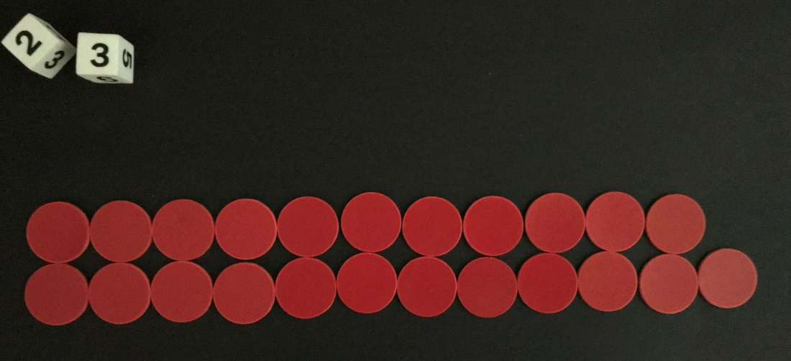
- In pairs, students play the game.
- As a class, discuss what is the same about all the counter collections showing even numbers and then what is the same about all the counter collections showing odd numbers.
This table details assessment opportunities and differentiation ideas.
Assessment opportunities | Too hard? | Too easy?
What to look for:  - Can students represent even numbers with pairs of counters, adding one counter if the number is odd? (MA1-RWN-01)  - Can students state the number is odd or even and then change it by adding or taking away a counter? (MA1-RWN-01)  What to collect:  - observations of pairing and describing odd and even numbers. (MA1-RWN-01) | Students cannot represent the number because it is too big, or they do not understand how to pair counters.  - Repeat the process but with one 6-sided dice.  - Repeat the process but students use the smallest throw for the tens value or throw a 4-sided dice.  - Model a number with paired counters, counting in twos together. | Students can work accurately with numbers created by 6-sided dice.  - Students use 3 × six-sided dice to make three-digit numbers. They can use MAB longs and flats to represent hundreds and tens, then represent the odd or even number of ones with counters.  - Repeat the process but use 2 or 3 10-sided dice.

Superhero powers! – 10 minutes
This activity is adapted from Super Venn Hierarchical Classifier at Learning Trajectories.
- Explain to students that they are going to learn how to organise information. Ask students how they could organise their favourite superheroes into groups, for example, by main colour of clothes. Discuss student ideas. Explain that, today, they are going to think about grouping superheroes by asking questions such as:
- Can the superhero fly?
- Does the superhero use special technology?
Note: If you have any students in your class who do not know what a superhero is, show them some pictures of superheroes or read a book about them.
- Have 5 different coloured counters ready to represent 5 superheroes. Show the students Resource 1: Superpowers Venn diagram and ask them to think about where a superhero with flying powers would belong. Place a counter for the hero into the section that is just for flying. Next, ask students where a superhero with special technology powers would belong and place a different coloured counter into the section that is just for special technology. Think of a superhero who can fly AND use special technology. Explain that the counter for this superhero will go in the middle section of the Venn diagram because the superhero has both powers. See Figure 2.
Figure 2 – Superpowers
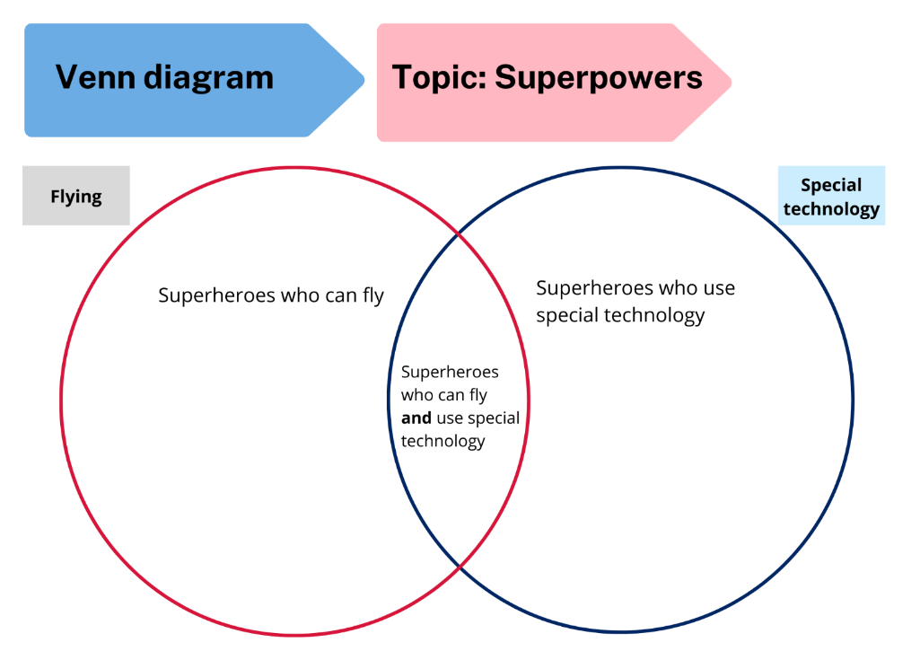
- Ask the students if they know of other superheroes who fly or use special technology or both. Place counters in the appropriate places on the Venn diagram.
Note: For a digital alternative, access Venn diagrams.
- Indicate sections of the Venn diagram and ask students questions to scaffold interpretation of data and use of comparative language:
- How many superheroes can fly?
- How many superheroes use special technology?
- How many superheroes have both superpowers?
- Which categories contain less than 3 superheroes?

Student superpowers! – 10 minutes
Note: Prior to this activity, draw a large two-circle Venn diagram outside with chalk. Label one circle ‘thinking’ and the other ‘talking’.
- Tell students that they are all maths superheroes and ask them to choose whether their biggest maths superpower is thinking about maths or talking about maths. Students choose and stand in a section of the chalk Venn diagram. If some students think they have equal maths superpowers with thinking and talking, explain that they can stand in the middle because that is the section for both superpowers.
- Ask students what other learning superpowers they have. This time, label the Venn diagram with English and science and ask students where they will stand. Check if there is anyone who thinks they have superpowers in both science and English and ask where they will stand. These students stand in the middle section.
- Ask if there is a student with superpowers in another subject, for example, art or sport. Discuss where those students could stand. They might stand outside the Venn diagram, or a third circle could be added to include another subject. Ask students what the middle part of the diagram represents when there are 3 circles. Are there any students who think they have superpowers in all 3 subjects who could stand in this section.

Which hoop are you? – 15 minutes
- In groups of 4-6, students use 2 hula hoops to make a Venn diagram and choose a question with 2 possible answers to investigate and record. Some examples of questions are:
- Where do you like to play most? At the park or at the beach?
- What do you like to eat most for breakfast? Cereal or toast?
- What game do you like to play most? Games with balls or without balls?
- Students choose one investigation to record on Resource 2: Blank Venn diagram, using symbols to represent one-to-one data value. They make 2 statements about their diagram. For example, playing on the beach was more popular than playing at the park, everyone liked playing all kinds of sport so there was not enough room for them in the hula hoops. Ask students, ‘How can you show the answer on paper? Provide spare hoops as needed, so that students can add a category to deepen their investigation.
This table details assessment opportunities and differentiation ideas.
Assessment opportunities | Too hard? | Too easy?
What to look for:  - Can students use symbols to represent data? (MA1-DATA-01)  - Can students use a Venn diagram to sort and describe information, considering items that fit into more than one category? (MAO-WM-01, MA1-DATA-01, MA1-DATA-02)  What to collect:  - work samples of Venn diagrams from student investigations (MAO-WM-01, MA1-DATA-01, MA1-DATA-02) | Students do not understand how to use the part of the Venn diagram which includes all choices.  - Students choose a red or blue building block and stand on the correct side of the Venn diagram.  - Now ask students who likes red and blue building blocks. These students move to the middle section holding red and blue building blocks. | Students understand how to use a two-circle Venn diagram.  - Students add a hula hoop and investigate a question with 3 possible answers. Use Resource 3: Triple Venn diagram to record answers.  - Repeat the process using 4 hula hoops and 4 possible answers.

Consolidation and meaningful practice: Gallery walk – 15 minutes
- Students do a gallery walk in pairs to look at the different investigations and make statements about the data collected.

Lesson 2: Vehicle superpowers!
Core concept: Data can be recorded in many ways.
The table below contains suggested learning intentions and success criteria. These are best co-constructed with students.
Learning intentions | Success criteria
Students are learning that:  - concrete materials can be used to create a data display  - data can be described and interpreted using comparative language  - odd and even numbers have patterns. | Students can:  - use concrete materials to create a one-to-one data display  - create and answer questions about the data  - use comparative language to describe data  - identify patterns in odd and even numeral tracks.

Daily number sense: Odd and even patterns – 10 minutes
- Build student understanding of odd and even numbers by identifying patterns in a numeral track.
- Write the numeral track 50 ? 52 ? 54 ? 56 ? 58 ?
- Ask students if there is anything the same about the numbers. Students share and justify ideas. Revise that they are all even numbers.
- Fill in the gaps using a different colour and ask what comes next. Extend counting to match the ability of your students. Ask students if they know the special name for these numbers. Revise that they are odd numbers and ask why they are odd numbers. In pairs, students use ‘Talk moves’ to identify and discuss patterns in the odd numbers. For example, they always end in 1, 3, 5, 7 or 9, or that odd numbers can never be made into 2 equal groups.
- Call out random two-digit and three-digit numbers and ask students to show a thumbs-up for even and thumbs-down for odd.
This table details assessment opportunities and differentiation ideas.
Assessment opportunities | Too hard? | Too easy?
What to look for:  - Can students identify the missing numbers as odd? (MA1-RWN-01)  - Can students describe patterns in the odd numbers? (MA1-RWN-01)  What to collect:  - observations of students identifying and describing odd numbers. (MA1-RWN-01) | Students do not identify odd and even larger numbers.  - Provide the numeral track 2 ? 4 ? 6 ? 8 ? 10 ? for students to find the missing odd numbers.  - Make each number with pairs of counters for the even number and add one more counter to each to represent the missing odd numbers. | Students work accurately with two-digit numbers.  - Students repeat the process with a three-digit numeral track.  - Students roll 3 × 6-sided or 10-sided dice to find a three-digit number. Use this as the starting number for an odd or even numeral track.

Vehicle superpowers! – 50 minutes
- Explain to students that they are going to explore data by creating their own vehicle with superpowers from a pile of coloured building blocks. They can choose exactly 40 blocks from the pile to make it. Students complete their model and draw it or take a photograph.
- Ask students to predict which blocks they have used the most and the least. Tell the students that they are going to check their predictions by taking their model apart to create a data display. Students choose to categorise the blocks, for example, by colour or number of dots, in a one-to-one data display. Students will also choose how they will record the data, for example, see Figure 3.
Figure 3 – Superpower vehicle and data display
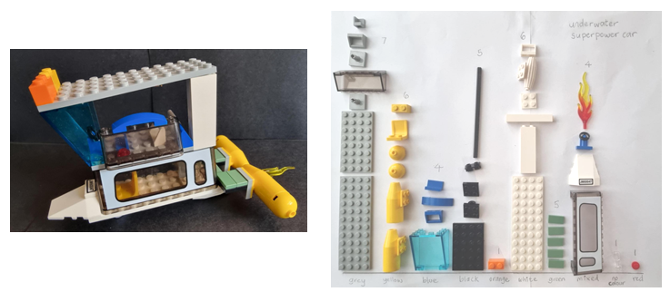
- Ask students:
- How did you organise your blocks? Did you choose colour or dots?
- Choose 2 groups who have used the same category to organise their data and ask them to compare their results.
- Is there anyone you cannot compare your data with? For example, dot graphs cannot be compared with colour graphs.
- Students find a partner to compare their data with and ask:
- Which category has the most pieces?
- Which category has the least pieces?
- Were your predictions correct?
- Were there any blocks that fit into more than one category? How did you solve this problem?
This table details assessment opportunities and differentiation ideas.
Assessment opportunities | Too hard? | Too easy?
What to look for:  - Can students use concrete materials to create a one-to-one data display? (MA1-DATA-01)  - Can students create and answer questions about data? (MAO-WM-01, MA1-DATA-02)  - Do students use comparative language to describe data? (MA1-DATA-02)  What to collect:  - work samples of data displays showing how students have chosen to categorise data (MAO-WM-01, MA1-DATA-01)  - observations of students asking and answering questions using comparative language (MAO-WM-01, MA1-DATA-02) | Students are working towards building with 40 pieces of building blocks.  - Students use 20 pieces to make the model individually.  - Students work in pairs to make a model using 40 pieces.  Students find it challenging to decide how to categorise their pieces.  - Provide students with ideas for how they could sort their building blocks, for example, by colour, or number of dots.  - Model one category as a column and then students complete. | Students organise building blocks using colour or dots.  - Ask students what other categories could be used, for example, transparency.  - Students re-organise their data using 3 or more categories.  - Students consider which pieces of building blocks could now be placed in more than one category and how they will decide this.

Consolidation and meaningful practice: Thinking about categories – 5 minutes
- Discuss a data display that contains 3 or more categories, for example, colour, number of dots, and transparency. Ask students if they would have chosen these categories or different categories and why.
- Ask students what other questions they have about the data.

Lesson 3: Environment superheroes!
Core concept: Data can be recorded in many ways.
The table below contains suggested learning intentions and success criteria. These are best co-constructed with students.
Learning intentions | Success criteria
Students are learning that:  - data can be used to investigate a topic of interest and solve problems  - consistent choice of categories enables interpretation  - place value can be used to find numbers. | Students can:  - select categories to organise and interpret data  - use data to identify and solve everyday problems  - identify how many more to the next 10 from a given two-digit or three-digit number.

Daily number sense: Teacher choice – 10 minutes
- From a class need surfaced through formative assessment data, identify a short, focused activity that targets students’ knowledge, understanding and skills. Example activities may be drawn from the following resources:
- Thinking Mathematically Stage 1
- Universal Resources Hub.

Tricky data – picture graphs – 10 minutes
- Build student understanding of misleading data by exploring a picture graph where symbol size is not consistent.
- Display Resource 4: Holiday bird graph and tell students it is a picture graph of birds that Emily saw on holiday. Ask students:
- How many times did Emily see a stone curlew?
- How many times did she see a robin?
- How many times did she see a lorikeet?
- How is the graph misleading?
- What could you do to make the graph easier to read? Make the pictures the same size so that they can be compared.

What can rubbish tell us? – 50 minutes
- Explain that students are going to be environment superheroes and they are going to pick up rubbish from the playground. Ask students what they might find. Emphasise safety rules, such as not picking up unsafe objects, and telling the teacher where they are.
- Divide the playground into sections and allocate to small groups of students. Provide students with superhero protective gear such as gloves and an evidence bag. Superheroes have 10 minutes to collect rubbish from their allocated area and bring back as evidence to headquarters.
- On a large sheet of plastic divided into sections to reflect the playground allocations, superheroes empty their evidence bags. Ask students:
- What do you notice?
- What do you wonder?
- What can the rubbish tell us?
- Where did the rubbish come from?
- How can you categorise the rubbish?
- Estimate which section has the most rubbish and the least rubbish.
- In small groups, environment superheroes categorise their rubbish. They could choose simple categories such as plastic and paper or consider other possibilities such as rubbish from food wrappers and drink-related items. Students take a photo for a data display to track how much rubbish was in each category. Record 3 statements about the data using comparative language.
Note: The largest volume of rubbish may not equate to the biggest problem. This may lead to a discussion on recycling rubbish.
- As a class, look at the displays and discuss whether they can be compared with each other. This will only be possible if each group chose the same categories. Support students to recognise that this is unlikely. As a class, choose categories and organise the rubbish into one data display. Ask students:
- Which categories of rubbish are the biggest problem? Why?
- How can each problem be solved? Consider classroom and whole school solutions.
Note: This activity could be extended into classroom kindness superpowers, or helpful-at-home superpowers, with data collected over a few days. Students could ask questions to decide on categories and how to collect data, for example, in a tally chart.
This table details assessment opportunities and differentiation ideas.
Assessment opportunities | Too hard? | Too easy?
What to look for:  - Can students choose categories to organise and interpret rubbish from the playground? (MAO-WM-01, MA1-DATA-02)  - Do students use this data to identify and solve rubbish problems? (MAO-WM-01, MA1-DATA-02)  What to collect:  - work samples of data displays with student categories (MAO-WM-01, MA1-DATA-02)  - observations of questions, statements and solutions. (MAO-WM-01, MA1-DATA-02) | Students do not identify categories.  - Provide visual categories for students to sort rubbish.  - Students sort and discuss rubbish in pairs. | Students make data display and record statements.  - Students consider each type of rubbish and brainstorm all possible categories.  - For example, paper could be re-used, recycled, shredded for the compost or used as mulch. Students debate which category best solves the problem of paper rubbish.

Consolidation: How might the time of day affect data collection? – 5 minutes
- Ask students to predict whether the data might be different if the collection took place at a different time of day or on a different day. Consider reasons. Some examples include:
- more rubbish blowing into school when it becomes windy
- less rubbish because one grade is out on an excursion
- less rubbish on a Friday because the older students are at sport for lunch.

Lesson 4: Australian animal superpowers!
Core concept: Data can be recorded in different ways to organise and interpret information.
The table below contains suggested learning intentions and success criteria. These are best co-constructed with students.
Learning intentions | Success criteria
Students are learning that:  - data can be recorded in picture graphs to organise and interpret information  - place value is used to identify the next multiple of 10 for a given number. | Students can:  - organise data with a picture graph and use it to answer questions  - find the next multiple of 10 for a given three-digit number.

Daily number sense: Find the next multiple of 10 – 10 minutes
- Build student understanding of place value by identifying a given number and finding the next multiple of 10.
- Throw three 6-sided dice. Make a three-digit number. State the number and the next multiple of 10.
- Use the same digits to make a different three-digit number. State the number and the next multiple of 10.
- Students repeat in small groups. Record each number and the next multiple of 10.
This table details assessment opportunities and differentiation ideas.
Assessment opportunities | Too hard? | Too easy?
What to look for:  - Can students use place value to make more than one quantity with the same 3 digits? (MA1-RWN-02)  - Can students state the next multiple of 10 for a given number? (MA1-RWN-01)  What to collect:  - work samples showing recognition of the next multiple of 10. (MA1-RWN-01) | Students do not manipulate three-digit numbers.  - Students throw 2 × 6-sided dice, make two-digit numbers and then find the next multiple of 10.  - Students use Resource 5: Number chart to find the next multiple of 10. | Students make three-digit numbers and find the next multiple of 10.  - Students repeat the process with 3 × 10-sided dice.  - Students find the next multiple of 10 and then the next 100.

Possum Magic maths! – 25 minutes
- Explain that students are going to find maths from Australian animal superheroes. Tell students that if animal superheroes had their own Olympics, the medal presentation might look like this:
- The winner of the high jump is the rock wallaby! Rock wallabies can jump 3 metres up rocks in one go, which is about 3 times their height!
- The red kangaroo wins the long jump! If they are hopping away from something in a hurry, kangaroos can jump 9 metres!
- Our number one Australian animal superhero today is the bandicoot with the gold medal for weightlifting! The bandicoot weighs less than 2 kilograms but it can move13 kilograms of soil in a night while it is looking for food. The digging helps to put air into the soil and keeps it healthy so that more plants can grow. That’s why the bandicoot is a real superhero!
- Show the students the cover of Possum Magic and explain that possums have acrobatic superpowers. Tell them that they will be finding maths in the story. Discuss what the book might be about and ask students to predict how many times possums will appear in the story.
- Read the book and each time an animal appears, use Resource 6: Possum Magic animals, to add to a picture graph. Model using a baseline, equal spacing and same-sized symbols. See Figure 4, which shows how the picture graph appears after 3 pages.
Figure 4 – Possum Magic picture graph
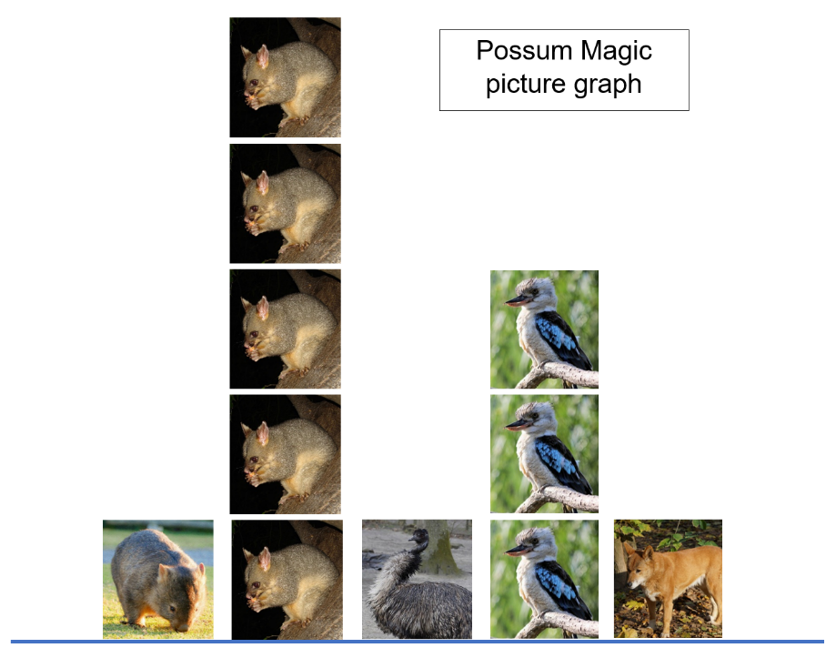
Images sourced from Pixabay and used in accordance with the Pixabay Licence.
- Ask students what questions and answers they can find in the picture graph. Some examples are:
- How many different animals are in the book?
- How many times did possums appear?
- Which animal appears the most?
- Which animal appears the least?
- How many times do animals with fur appear?
- Ask students what other questions they can find the answers to using information from the graph.

Group investigations – 25 minutes
- In groups of 6, students create a picture graph to investigate a question from the book, using images from Resource 6: Possum Magic animals, Resource 7: Possum Magic foods or Resource 8: Possum Magic places. Photocopy these resources as needed. If students choose another question to answer, they will need to draw their own symbols to create a picture graph. Prompt students with questions such as:
- Who has tasted foods from the book? Anzac biscuits, lollies, steak, salad, pumpkin, pavlova and lamingtons.
- Which 3 capital cities would you most like to visit from the book? Adelaide, Melbourne, Sydney, Brisbane, Darwin, Perth, Hobart.
- Who has seen the animals from the book at the zoo or around where they live? Possum, wombat, kangaroo, dingo, kookaburra, emu, koala, snake.
- Move between groups, revising accurate use of a baseline, equal spacing and same-sized symbols as necessary.
- Using the graph, identify and record the most frequent and least frequent outcomes. Choose another category, and identify and record all other categories that contain more and less.
This table details assessment opportunities and differentiation ideas.
Assessment opportunities | Too hard? | Too easy?
What to look for:  - Can students use a baseline, equal spacing and same-sized symbols to create a picture graph? (MAO-WM-01, MA1-DATA-01)  - Do students use comparative language to ask and answer questions about the picture graph? (MAO-WM-01, MA1-DATA-02)  What to collect:  - work samples of picture graphs created to answer a question with comparative statements (MAO-WM-01, MA1-DATA-01, MA1-DATA-02) | Students do not accurately organise data for the group investigation.  - Students investigate which animals they have seen using Resource 6: Possum Magic animals.  - Model how to record symbols for the first 3 students. Then the group records symbols for the next 3 students. | Students use data correctly to ask and answer questions.  - Students use Resource 3: Triple Venn diagram to find out who has tasted a food, visited a city and seen an animal from the book.  - Use the Venn diagram to find out who has experienced 2 of the categories.  - Students research animal superpowers around the world to see what maths they can find. For example, longest, fastest, smallest.

Consolidation and meaningful practice: How can there be more symbols than people in the group? – 10 minutes
- Look at the group picture graph investigations to identify charts that have more symbols than the number of people in the group. Ask students why that might have happened. Explain that this is because students could answer yes to more than one category.

Lesson 5: Australian bird superpowers!
Core concept: Data can be recorded in different ways to organise and interpret information.
The table below contains suggested learning intentions and success criteria. These are best co-constructed with students.
Learning intentions | Success criteria
Students are learning that:  - data can be collected and displayed to answer questions  - data can be used to investigate the chance of everyday events occurring. | Students can:  - organise data with tally marks and use to answer questions  - use data to describe the chance of events being more or less likely to happen.

Daily number sense: Birds I saw at the zoo – 10 minutes
- Build student understanding of number by interpreting a tally chart.
- Neville went to the zoo. He was fascinated by the native Australian birds and decided to make a tally chart to record how many times he saw each kind of bird during the day. Use Resource 9: Zoo birds tally to revise how tally marks are recorded in groups of 5 and answer the questions:
- How many different birds did Neville see? 6.
- How many birds did he see altogether? Count tally groups of fives and then add remaining tally marks.
- Which birds did Neville see an even number of times? Pelican, stone curlew, lorikeet, ibis.
- Which birds did Neville see an odd number of times? Cassowary and robin.
- Which bird did Neville see the least? Cassowary.
- Which bird did Neville see the most? Ibis.
- Which birds did Neville see less than 5 times but more than once? Pelican, robin.
- Which bird did Neville see twice as many times as the lorikeet? Ibis.
- How many times more did Neville see stone curlews compared to cassowaries? 5 more times.
- How many times less did Neville see robins compared to stone curlews? 3 less times.
Note: The Aussie Bird Count is held annually in October through birdlife Australia. It could be used as a resource to support students to connect to real-life maths and revise tally chart skills.

Birds around us – 40 minutes
Note: This activity is split into 3 short timeslots across the day. It requires identification of local bird species.
- Explain that birds have superpowers too! Some of these are:
- The emu, which is the second tallest bird in the world at 2 metres high and it can run at speeds of up to 50 kilometres per hour!
- Australian gannets, which can dive through water at up to 100 kilometres per hour!
- The Green catbird, whose superpower is to imitate a cat meowing. This sound is so realistic that many people living on the east coast of Australia have searched the bush because they think a cat is lost in there.
- The Australian wagtail, which is called Chitty Chitty by the Noongar Aboriginal Peoples of Western Australia because its superpower is to talk without stopping!
- Ask students if they know any bird superpowers and if they have seen birds at school or in their local area.
- Explain that they are going to collect data about birds in and around school using a tally chart. Then they will make predictions about how often they might see each kind of bird. Using Resource 10: Birds seen tally, go outside as a class as early as possible in the morning for 5 minutes to identify and count birds. Repeat this process around noon. Revise how tally marks are made in groups of 5.
Note: Seasons and time of day will impact which birds are observed and could provide opportunities for students to think about the behaviour of birds and how seasons affect their behaviour.
- Use the class tally chart to ask:
- How many birds did you see altogether?
- Which kind of bird was seen most often?
- Which species was seen the least?
- What bird are you most likely to see in school?
- What bird are you least likely to see in school?
- Were any differences between birds seen in the morning and around lunchtime? Why might this be?
- Did you count the same bird twice? If not, how did you know?
- What birds are you more likely to see when you get to school the next day?
- In groups, students choose one bird from the tally chart and identify birds that were seen more often and then birds seen less often.
- Encourage students to keep looking for birds and recording how many they see after school to add to the tally chart the following day.
This table details assessment opportunities and differentiation ideas.
Assessment opportunities | Too hard? | Too easy?
What to look for:  - Do students use the tally chart to identify biggest and smallest values? (MA1-DATA-02)  - Can students use comparative language to describe data from different times of the day? (MAO-WM-01, MA1-DATA-02)  - Can students use data to decide which birds they are more or less likely to see the next morning? (MA1-CHAN-01)  What to collect:  - observations of students using data values to communicate events as being more or less likely to happen (MAO-WM-01, MA1-DATA-02, MA1-CHAN-01) | Students find grouping in fives in a tally chart too challenging.  - Model how to group tally marks with coloured craft sticks, using one colour for the first 5, another colour for the next 5 and so on.  - Students make tally marks with craft sticks first and then draw them.  - Students use counters in groups of 5. | Students accurately identify values and make connections between data and chance.  - Students identify other situations where data could be collected to make connections to chance. For example, when students are more likely or less likely to go to sickbay.  - Students research bird superpowers around the world to see what maths they can find. For example, longest wingspan, fastest, smallest.

Consolidation and meaningful practice: Tally charts – 15 minutes
- Give students Resource 11: Favourite colours. Explain that another class, 2 Rainbow, has collected data on their favourite colours but it is very disorganised. Ask students if they can help by organising the data in a table with tally marks.
- In small groups, students use the tally marks to answer the questions:
- Which colour was the favourite?
- Which colour was the least popular?
- Which colours were liked by more than 5 students?
- Which colour was liked by 3 more students than the students who chose yellow?
- Are there any other questions you could use the tally chart to find the answers to?
This table details assessment opportunities and differentiation ideas.
Assessment opportunities | Too hard? | Too easy?
What to look for:  - Could students create a table and decide on categories? (MAO-WM-01, MA1-DATA-01)  - Did students correctly group tally marks in groups of 5? (MA1-DATA-01, MA1-DATA-02)  - Could students use the tally chart to answer given and created questions? (MAO-WM-01, MA1-DATA-02)  What to collect:  - work samples of correctly organised tally charts (MA1-DATA-01)  - observations of created and given questions and corresponding answers (MAO-WM-01, MA1-DATA-02) | Students find grouping in fives within a tally chart too challenging.  - Model how to group tally marks with coloured craft sticks, using one colour for the first 5, another colour for the next 5 and so on.  - Students make tally marks with craft sticks first and then draw them.  - Students use counters in groups of 5. | Students organise tally marks and answer questions correctly.  - In groups, students use tally marks to collect data on favourite colours from their own class. Identify most and least popular colours.  - Students compare class data to data from 2 Rainbow.  - Students think of other questions that could be answered using their class data.

Lesson 6: What’s the chance? Let’s investigate!
Core concept: Data can be used to predict the likelihood of events.
The table below contains suggested learning intentions and success criteria. These are best co-constructed with students.
Learning intentions | Success criteria
Students are learning that:  - data can be represented in misleading ways  - data can be used to predict the likelihood of events. | Students can:  - understand that a picture graph can be misleading if it does not begin at zero, contains gaps or if the pictures are different sizes  - use data to predict whether an event is more or less likely to happen.

Daily number sense: Teacher choice – 10 minutes
- From a class need surfaced through formative assessment data, identify a short, focused activity that targets students’ knowledge, understanding and skills. Example activities may be drawn from the following resources:
- Thinking Mathematically Stage 1
- Universal Resources Hub

Tricky data – Animals on holiday –10 minutes
- Display Resource 12: Animals on holiday and tell students that Emily made a picture graph of animals she saw on holiday. Ask students:
- How many times did Emily see a wombat?
- How many times did she see a koala?
- How many times did she see a kangaroo?
- How is the graph misleading?
- What could you do to make the graph easier to read? Make the pictures the same size, make sure there are no gaps and make sure all the animals start at the bottom of the picture graph.

What’s the chance? Birds around us (continued) – 10 minutes
- Add data about birds that students saw after school to Resource 10: Birds seen tally. Ask students if there are any changes to the birds most frequently and least frequently seen.
- Use the tally chart to make connections between data and chance by asking:
- What bird are you most likely to see each day?
- What bird are you least likely to see?
- What birds are you more and less likely to see after school?

What’s the chance? Investigate! – 40 minutes
- Identify other events where data could be collected over time with a tally chart to make connections to chance. Some examples are when:
- students are more likely or less likely to go to sickbay
- there is likely to be more or less rubbish in the playground
- students have a higher or lower pulse rate
- ants are more or less likely to be seen at chosen locations.
- In groups, students choose a question to investigate and follow the following steps:
- Create a tally chart template that includes sections to record data in the morning and at noon.
- Ensure there is time in the afternoon to use the data to make connections to chance.
- Collect data for 5 minutes at the chosen times.
- Use the data to make predictions about whether the chosen event is more or less likely at the 2 times during the day.
This table details assessment opportunities and differentiation ideas.
Assessment opportunities | Too hard? | Too easy?
What to look for:  - Can students give reasons why data is misleading? (MA1-DATA-02)  - Do students choose a question which can be investigated over time? (MAO-WM-01, MA1-DATA-01)  - Can students organise data over time into a tally chart to display information clearly? (MAO-WM-01, MA1-DATA-02)  - Can students interpret data to describe an event as more or less likely to happen at chosen times of the day? (MA1-CHAN-01)  What to collect:  - work samples of student data (MAO-WM-01, MA1-DATA-01)  - observations of how students use data to predict the likelihood of an event. (MAO-WM-01, MA1-DATA-01, MA1-CHAN-01) | Students do not yet choose effective questions or display data clearly.  - Students choose one of the 4 example questions.  - Provide students with Resource 13: Tally times to enter tally marks. | Students record and use data over time to make connections to chance.  - Students use Now and Then from NRICH to investigate patterns in data over time for Olympic events.  - Students consider factors and predict what results athletes will be achieving in the future.

Lesson 7: What's the chance? – Everyday events
Core concept: Data can be used to predict the likelihood of events.
The table below contains suggested learning intentions and success criteria. These are best co-constructed with students.
Learning intentions | Success criteria
Students are learning that:  - language can be used to describe chance  - data can be used to predict the likelihood of events  - place value can be used to manipulate three-digit numbers. | Students can:  - correctly use the terms impossible, certain, possible, likely, unlikely, more likely, less likely  - use data to predict the likelihood of an event  - use place value to find highest and lowest values  - find the next multiple of 10 from a given number.

Daily number sense: Highest and lowest – 20 minutes
This activity is adapted from The Thousands Game from NRICH.
- Build student understanding of partitioning and multiples of 10 by using place value to make different quantities from the same digits.
- Explain that you are going to share with students how 2 Rainbow played a number game. The class used a set of digit cards from 0 to 9. These cards were put into a bag and players took it in turns to select 3 and make a number out of them. Every time the cards were used, they were placed back in the bag.
- At first, 2 Rainbow made the highest number they could. Ben took out 3, 8 and 2 and made the number 832. Ask students how many hundreds, tens and ones there are in 832 and what the next multiple of 10 is.
- Using Resource 14: Digit cards, ask a student to select 3 cards from the bag. Make the highest number possible with students and ask them to identify the next multiple of 10.
- Explain that 2 Rainbow then selected another 3 cards from the bag to make the lowest number. Jamie took out 5, 0 and 4 and made 045. His friends said that you can’t put zero at the beginning of a number. Ask students if they agree. 2 Rainbow agreed with Jamie and made 405. Ask students how many hundreds, tens and ones and what the next multiple of 10 is.
- Next, 2 Rainbow drew cards to make the highest even number. Xiang took out 7, 8 and 3. Vincent took out 4, 2 and 9. Ask students who they think found the highest even number. Xiang made 738 and Vincent made the highest with 942. Ask students what is the next multiple of 10 and who got the closest number to 1000.
- For the next round, 2 Rainbow drew cards to make the highest odd number. Raj took out 0, 6 and 9. Ali took out 5, 2 and 7. Ask students who they think found the highest odd number. Raj made 609 and Ali made 527 so Raj was happy that he had made the highest odd number. But then Alan said Ali could make a bigger number with his digits. Ask students what that number could be. Raquelle from 2 Rainbow said that the new number was 725 which meant that Ali had made the highest odd number. Ask your students if they agree and what the next multiple of 10 after 725 and 609 might be. Ask which 2 Rainbow student got the closest number to 1000 and how they worked it out.
- In small groups using Resource 14: Digit cards, students draw 3 cards from the bag and find the following solutions:
- highest number, how many hundreds, tens and ones, find the next multiple of 10
- lowest number, how many hundreds, tens and ones, find the next multiple of 10
- highest even number, find the next multiple of 10, which is closer to 1000?
- highest odd number, find the next multiple of 10, which is closer to 1000?
This table details assessment opportunities and differentiation ideas.
Assessment opportunities | Too hard? | Too easy?
What to look for:  - Can students make highest and lowest three-digit numbers with randomly chosen digits from 0 to 9? (MAO-WM-01, MA1-RWN-01, MA1-RWN-02)  - Can students identify the next multiple of 10 from a given number? (MAO-WM-01, MA1-RWN-02)  What to collect:  - observations of students playing the game. (MAO-WM-01, MA1-RWN-01, MA1-RWN-02) | Students find it too hard to manipulate three-digit numbers.  - Students draw 2 cards each time and follow the process, working out which number is closest to 100.  - Students play with digit cards from 0 to 5.  Students do not understand place value of the zero card and the next multiple of 10.  - Students play the game without the zero card.  - Students use Resource 5: Number chart to find the next multiple of 10. | Students understand all place value skills.  - Students brainstorm how many different strategies they could use to get from a given number to 1000.  - Students repeat the process drawing 4 cards each time.

Everyday events – 50 minutes
Note: Prior to this lesson, draw a line in the playground and mark it as shown in Figure 5. Mark the line long enough for students to stand along the line.
Figure 5 – Possibilities
- Outside, students stand next to the line. Explain that you will ask questions. For each question, students will consider whether the outcome is impossible, unlikely, likely and certain. Students move to that section of the line as you ask:
- Will the sun set tonight?
- Will you be going to the shops this afternoon?
- Will you pet a dog today?
- Will you go to the moon this week?
- If I throw a die, will it land on number 6?
- If I throw it again, will it land on number 6?
- For each question, choose one student to justify why they have chosen that section of the line.
- Back in the classroom, explain to students that they are going to explore everyday events in school. Brainstorm events that take place at school. Students could use Brainstorming from the Digital Learning Selector to record ideas. Record the ideas in a weekly timetable on a large sheet of paper.
- Model statements to predict certain, more likely and less likely events. For each statement, ask for 2 volunteers to share their reasoning. Some examples include:
- it is certain that students will learn about maths or English in the morning
- it is impossible that students will have sport today
- students are more likely to play a ball game on Wednesday.
- In pairs, students use ‘Talk moves’ with the timetable to make statements, predict and justify possibilities about the likelihood of an event.
- Individually, students record things that happen before and after school. Write 3 statements about the likelihood of events in their week using the language of chance. They justify their thinking to a partner.
This table details assessment opportunities and differentiation ideas.
Assessment opportunities | Too hard? | Too easy?
What to look for:  - Do students correctly use the language of chance? (MA1-CHAN-01)  - Can students interpret data to describe the likelihood of a familiar event? (MAO-WM-01, MA1-CHAN-01)  What to collect:  - work samples of student statements using the language of chance (MAO-WM-01, MA1-CHAN-01)  - observations of justifying thinking. (MAO-WM-01, MA1-CHAN-01) | Students do not use the language of chance.  - Give students examples of certain and impossible events to sort.  - Then introduce one more term at a time. | Students accurately use language to describe the likelihood of events.  - Students include weekend events in their timetables.  - Students write 3 statements about likelihood and justify thinking.

Lesson 8: Data superpowers!
Core concept: The type of data determines the choice of display.
The table below contains suggested learning intentions and success criteria. These are best co-constructed with students.
Learning intentions | Success criteria
Students are learning that:  - questions can be investigated through data interpretation  - choices can be made about how data is collected and displayed. | Students can:  - choose a question to investigate a chosen topic and select ways to collect and display data  - describe and justify interpretations of data.

Daily number sense: The 10 tree – 15 minutes
This activity is adapted from The Deca Tree from NRICH.
- Build student understanding of place value by using repeated addition.
- Explain that in the bush there is a deca tree. It is winter and the deca tree has 10 branches coming from its trunk. On each branch there are 10 twigs. Ask students how many branches and twigs there are on the deca tree. The answer is 110.
- Explain that, in spring, the leaves come back. Each twig has 10 leaves. Ask students how many branches, twigs and leaves are on the deca tree now. Use ‘Talk moves’ in pairs with drawings or concrete materials to discuss the solution. Students find the answer 1110 in small groups using strategies of their choice. Observe and ask selected groups to share their strategies.
- Explain that one day, a farmer cut down one branch from the tree. Ask students how many branches, twigs and leaves are on the deca tree now. Students find the answer which is 999 in small groups using strategies of their choice. Observe and ask selected groups to share their strategies.
- Students who find the answer quickly can consider what patterns they can find if the farmer keeps cutting off one branch at a time. The pattern is 999, 888, 777, 666, 555 and so on.
Note: If students find working with tens too challenging, they can draw what the tree would look like if there were 2 branches with 2 twigs on each branch and 2 leaves on each twig. Then they can work out what would happen if one branch was cut off.

Let’s investigate! – 60 minutes
- Explain to students that they are going to use their data superpowers in groups to investigate a topic they are interested in. In small groups, students answer questions to scaffold the process:
- What question do you want to know the answer to?
- What data do you need to collect?
- Do you need to collect data over time? When will you do this?
- How will you collect your data? Tally chart, picture graph or Venn diagram?
- Examples of simple questions to investigate are:
- Birthdays – which month has the most birthdays?
- What’s the favourite? For example, colour, food or sport.
- Examples of more complex questions to investigate are:
- When is it most likely to see an animal during the school day?
- Do more people have brothers or sisters?
- Which pet is the most popular?
- Students collect and display data. Record 3 interpretations about the data and its connections to chance. For example:
- September is the month with most birthdays. I predict that this will be the same in all the other classes.
- Dogs are the most popular pet in our data. But some people have 3 dogs so we can’t say for sure that they are most popular.
- In a data talk each group presents their data and 3 interpretations, communicating their thinking and reasoning clearly. Each time, allow time for peer feedback. This could be to:
- ask questions about the process
- ask new questions about the data
- identify any misleading data and how this could be clarified.
This table details assessment opportunities and differentiation ideas.
Assessment opportunities | Too hard? | Too easy?
What to look for:  - Can students create a suitable question to investigate? (MAO-WM-01, MA1-DATA-01)  - Can students select how to collect and display data? (MAO-WM-01, MA1-DATA-02)  - Do students describe and justify interpretations of data? (MAO-WM-01, MA1-DATA-02)  - Are students able to make connections to chance outcomes? (MAO-WM-01, MA1-CHAN-01)  What to collect:  - work samples of data displays and interpretations (MAO-WM-01, MA1-DATA-01, MA1-DATA-02)  - observations of justifications in data talks. (MAO-WM-01, MA1-DATA-02, MA1-CHAN-01) | Students cannot create a question or method of data collection.  - Give students examples of investigations to choose from.  - Provide a method of collection.  Students do not interpret data or make connections to chance.  - Students present data to peers, who make statements of interpretation.  - Students presenters agree or disagree. | Students can choose a suitable question, collect data, and communicate interpretations including connections to chance.  - Students investigate the same question with another class.  - They then compare the 2 sets of data and think of reasons why data may differ.

Resource 1: Superpowers Venn diagram
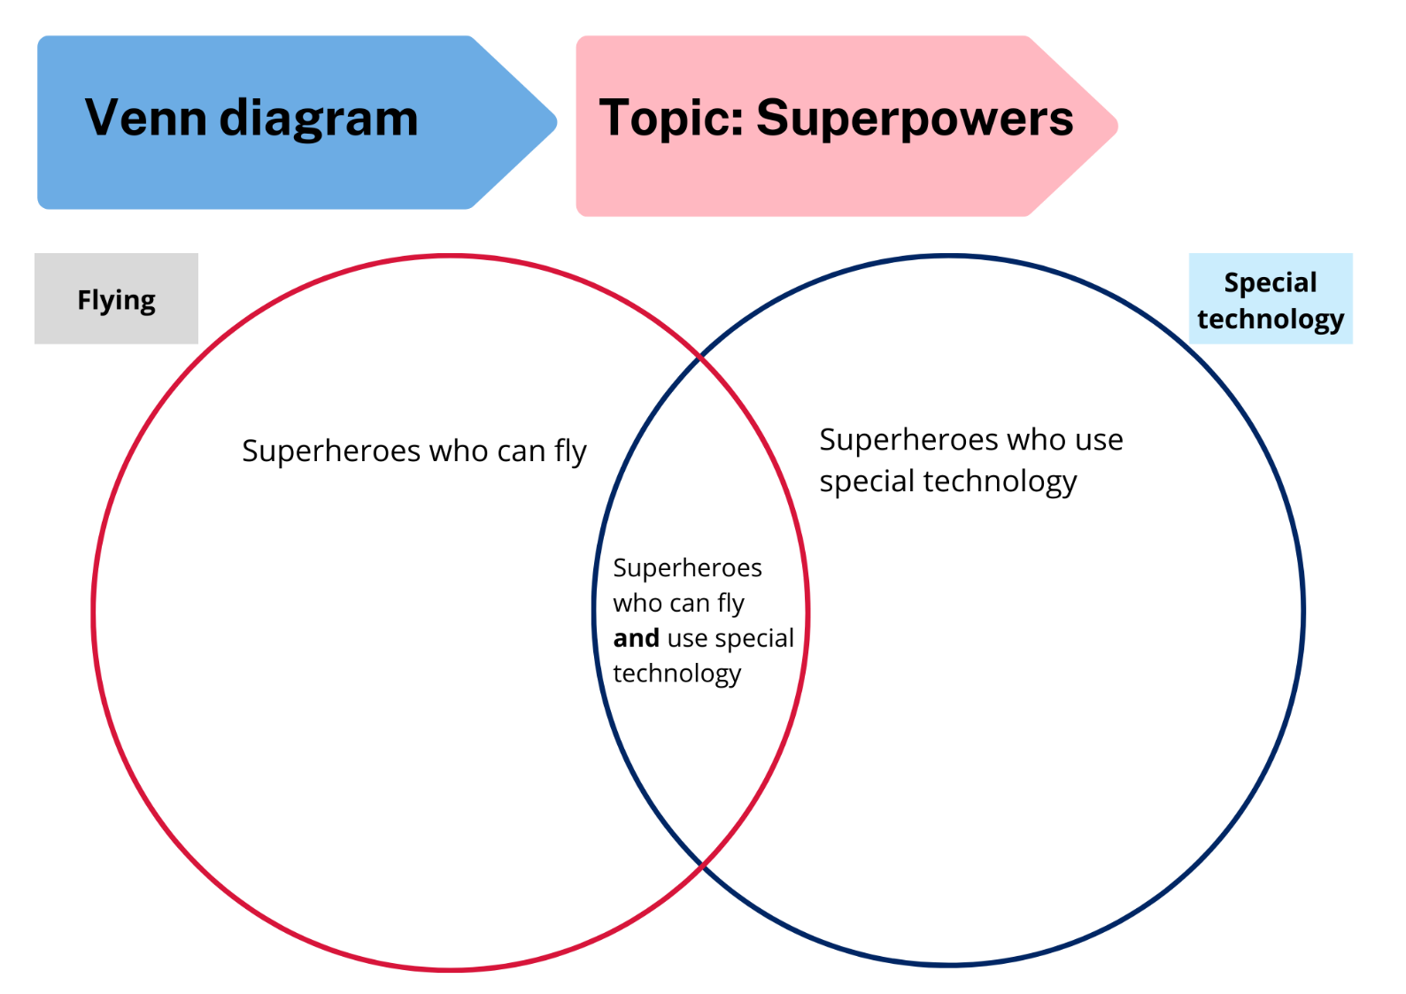

Resource 2: Blank Venn diagram
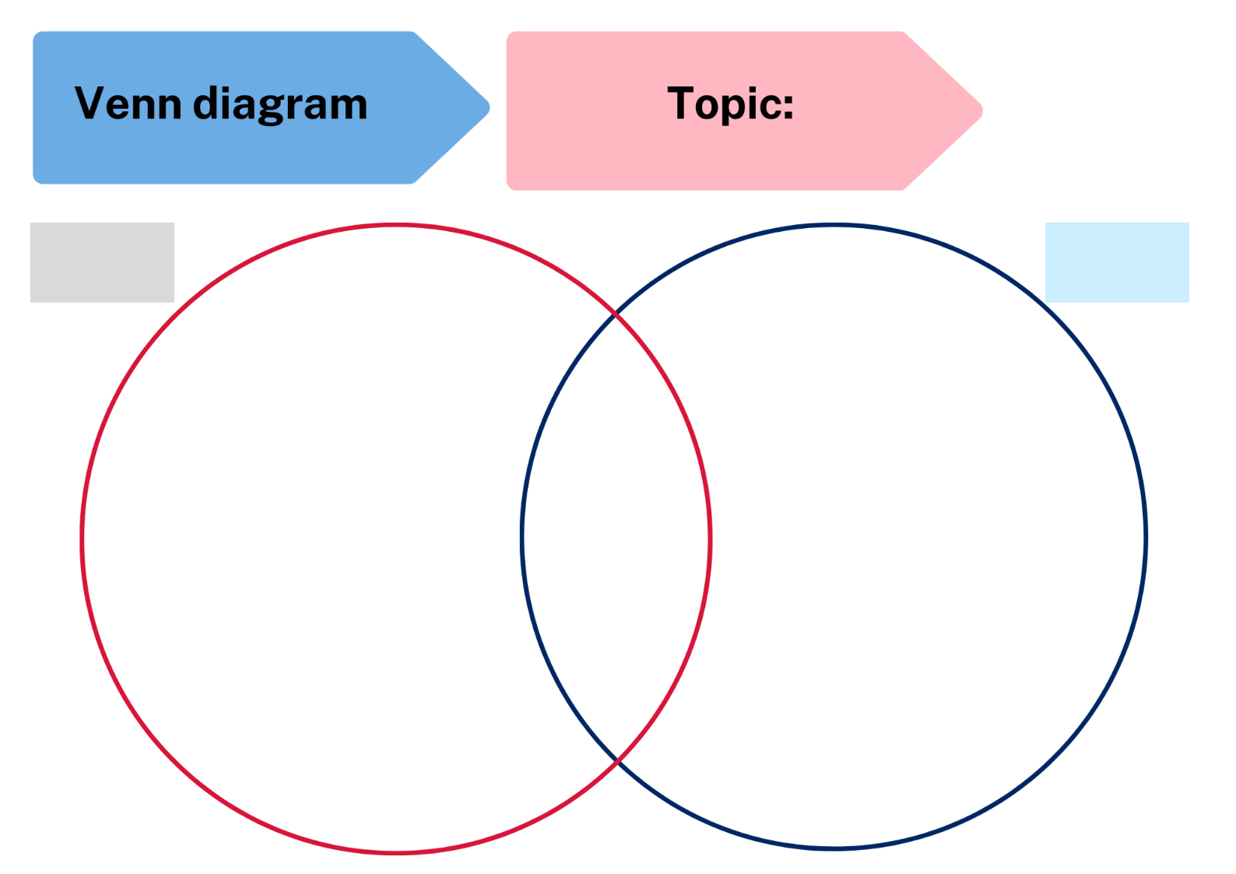

Resource 3: Triple Venn diagram
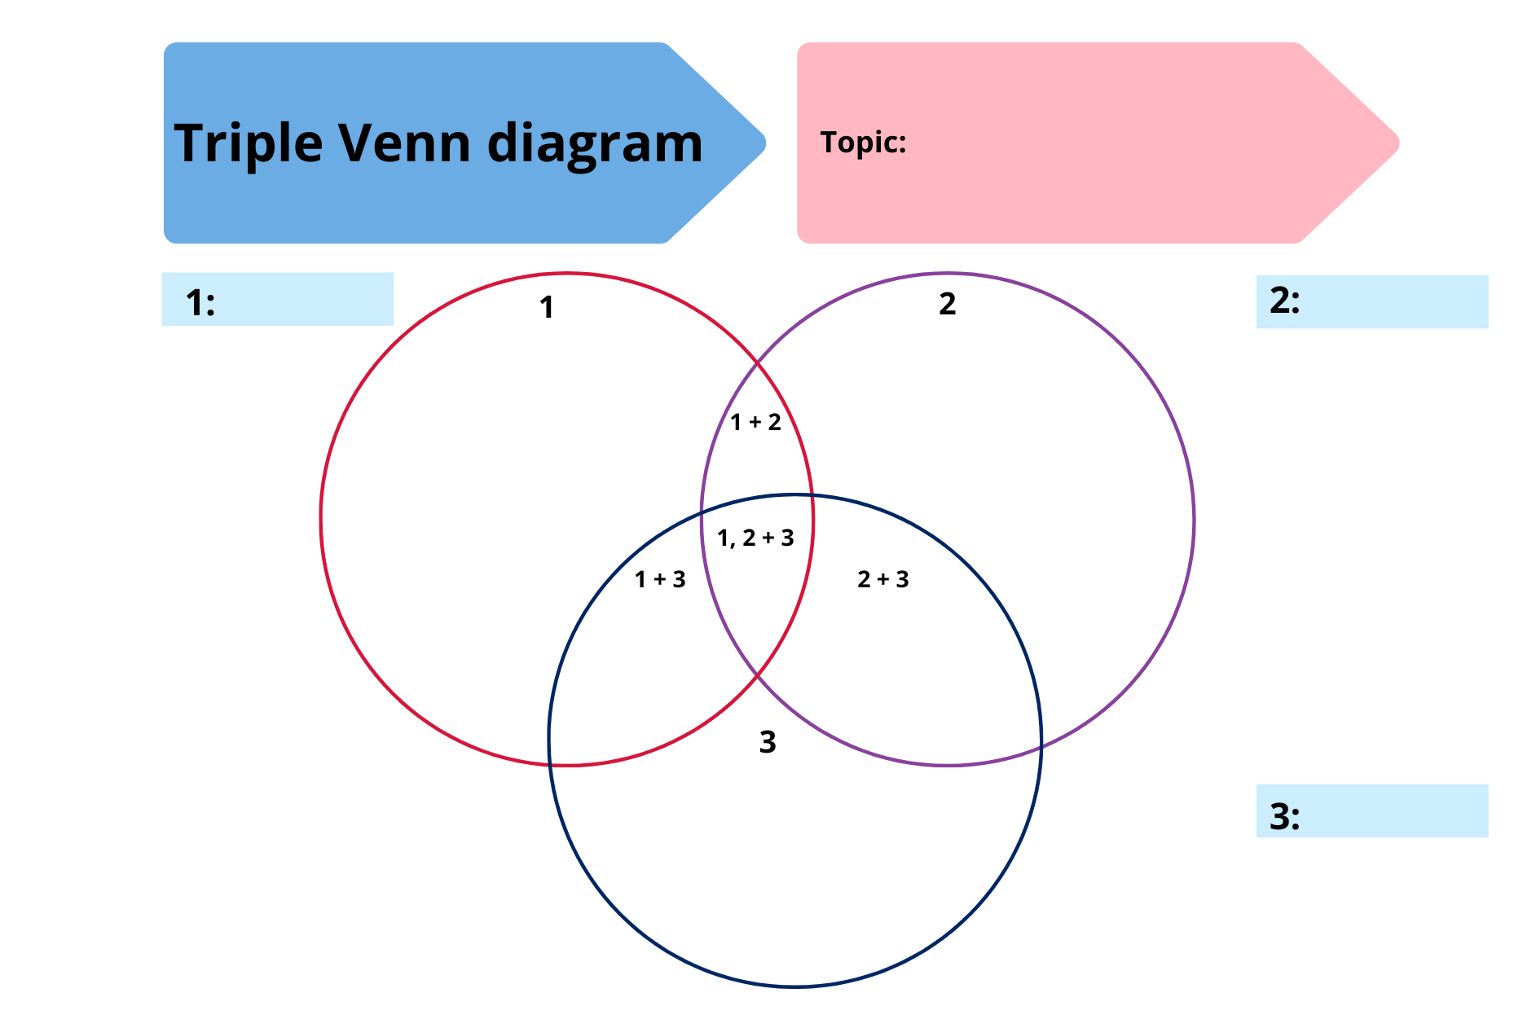

Resource 4: Holiday bird graph
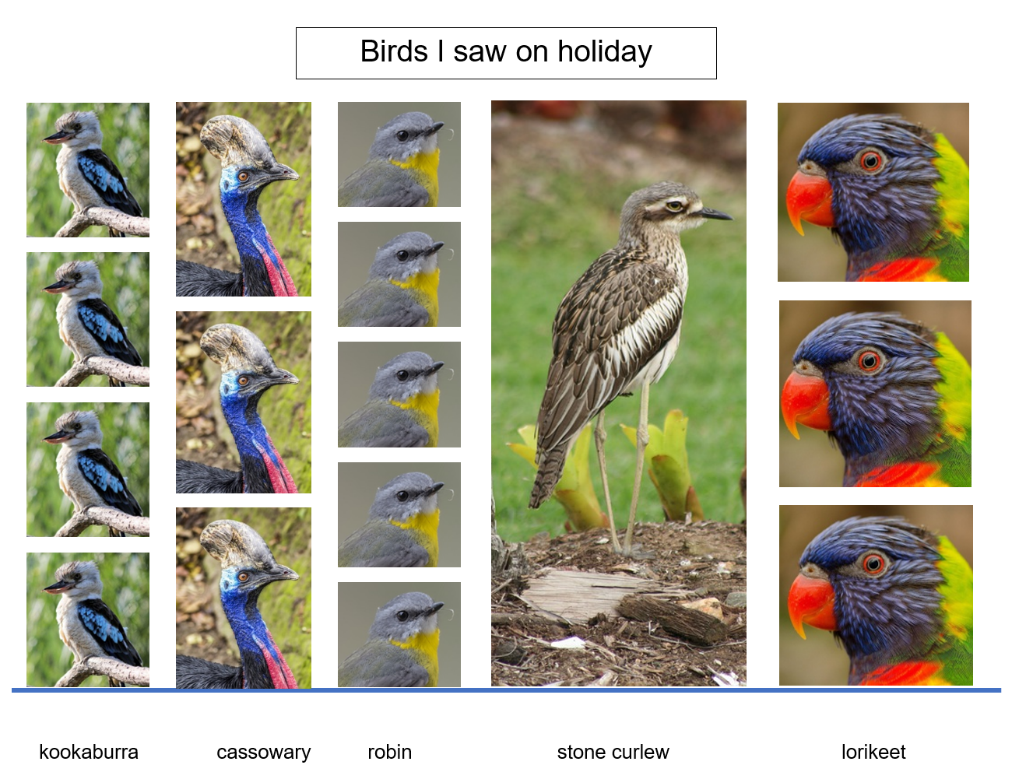
Images sourced from Pixabay and used in accordance with the Pixabay Licence.

Resource 5: Number chart
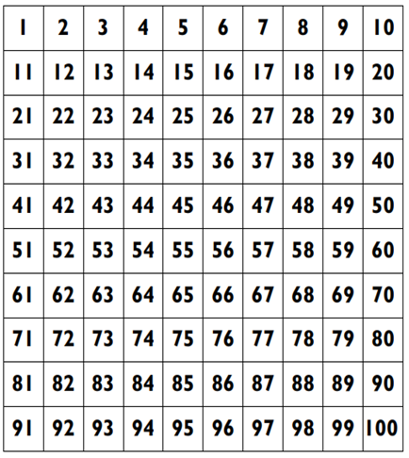

Resource 6: Possum Magic animals
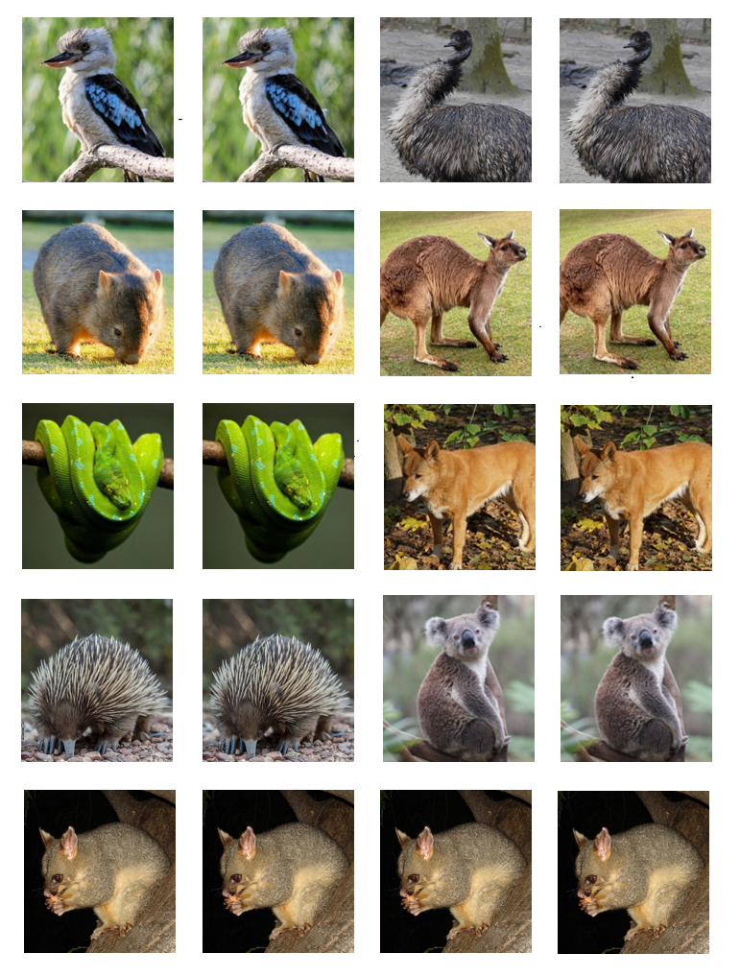
Images sourced from Pixabay and used in accordance with the Pixabay Licence.

Resource 7: Possum Magic foods
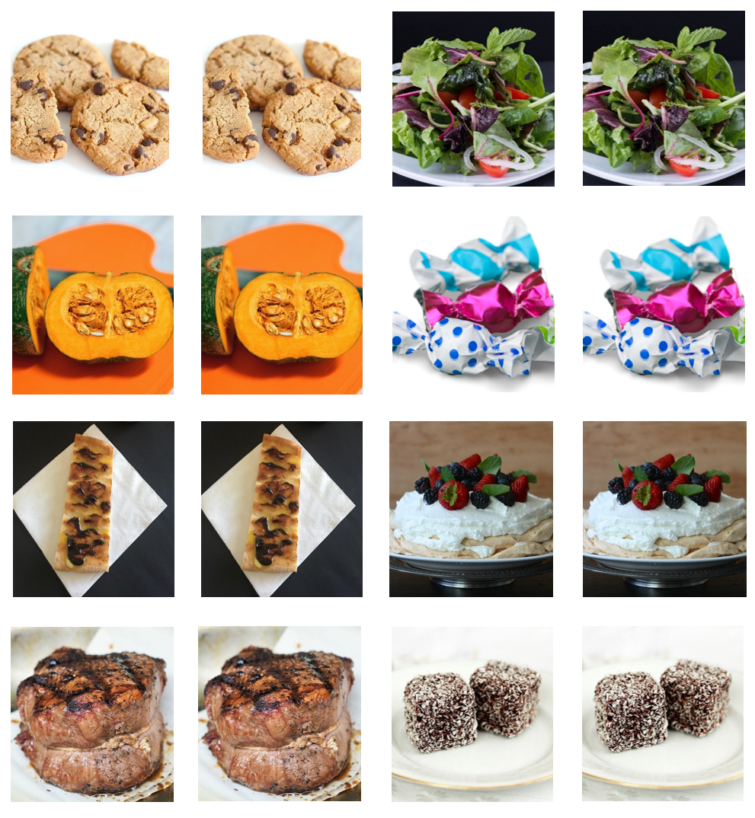
Images sourced from Pixabay and used in accordance with the Pixabay Licence.

Resource 8: Possum Magic places
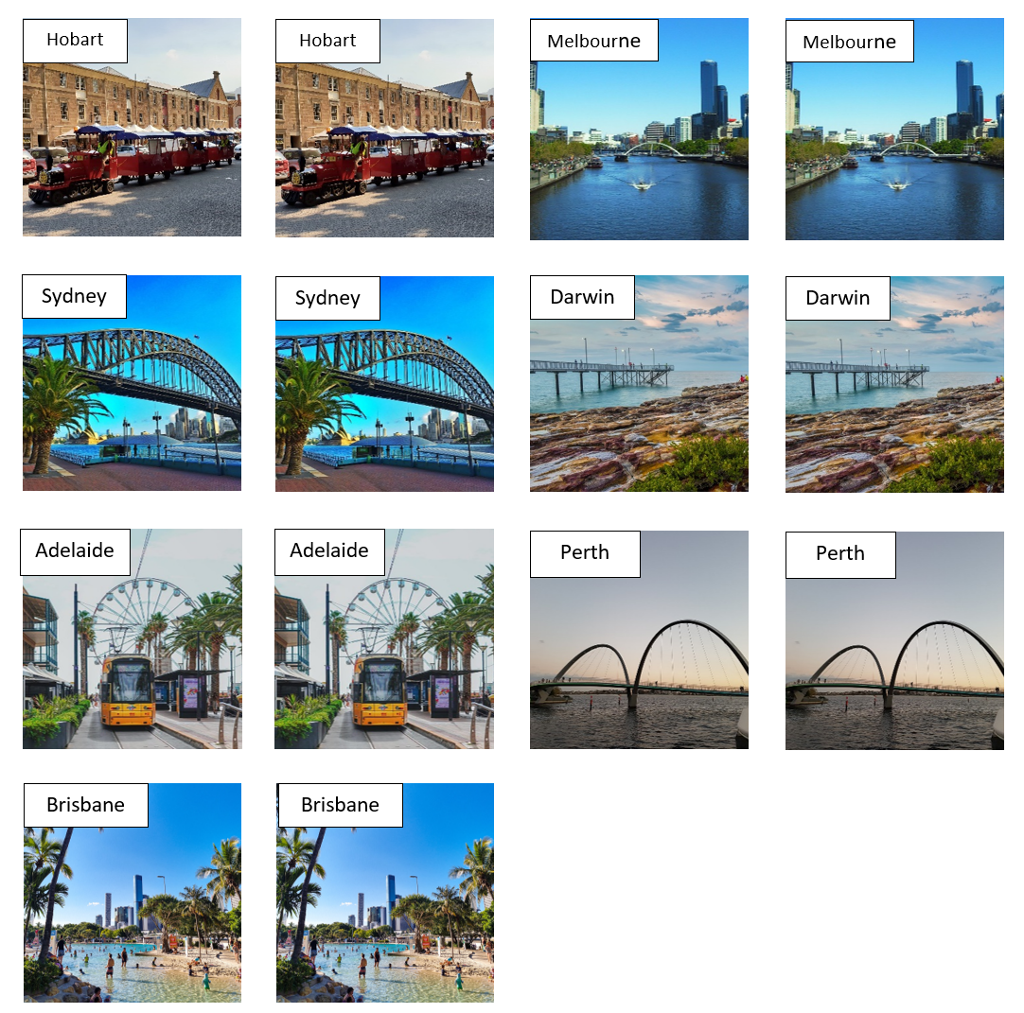
‘Hobart’ by Nico Smit and ‘Brisbane’ by Romain Terpreau are licensed under the Unsplash License. ‘Melbourne’ by DADAs, ‘Sydney’ by GoodGuyPaul, ‘Darwin’ by Patjosse, ‘Adelaide’ by weizhang and ‘Perth’ by juhiking are licensed in accordance with the Pixabay License.

Resource 9: Zoo birds tally
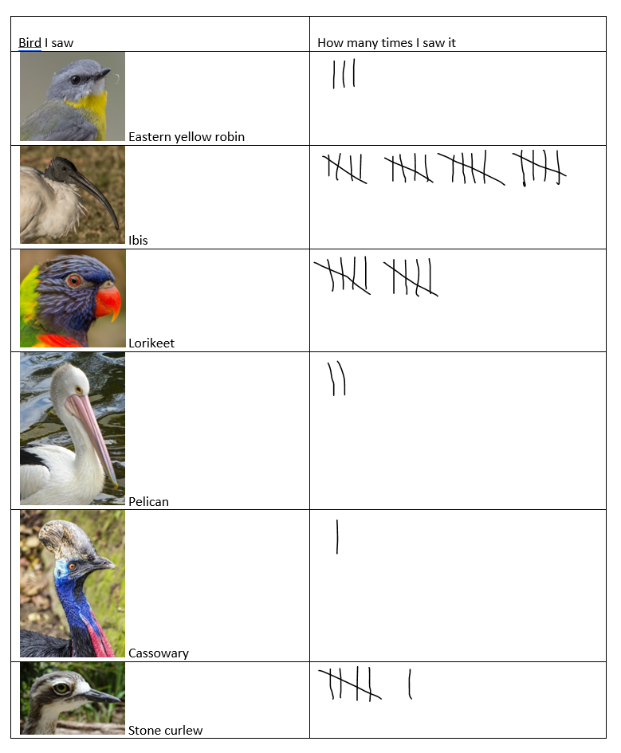
Images sourced from Pixabay and used in accordance with the Pixabay Licence.

Resource 10: Birds seen tally
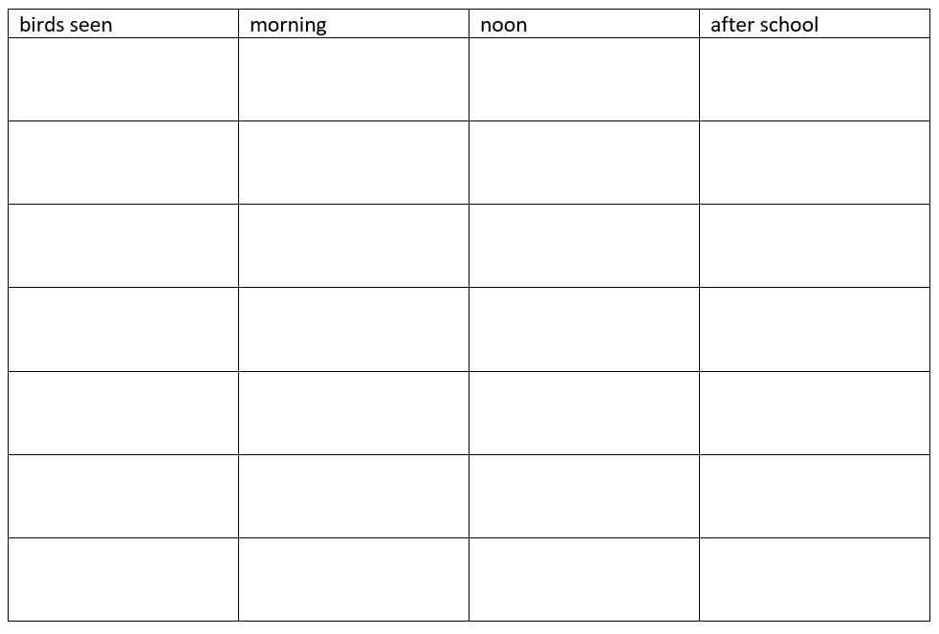

Resource 11: Favourite colours
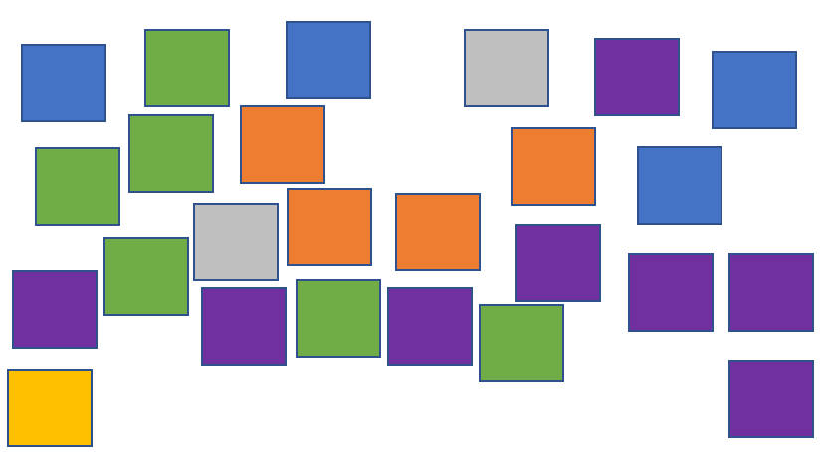

Resource 12: Animals on holiday
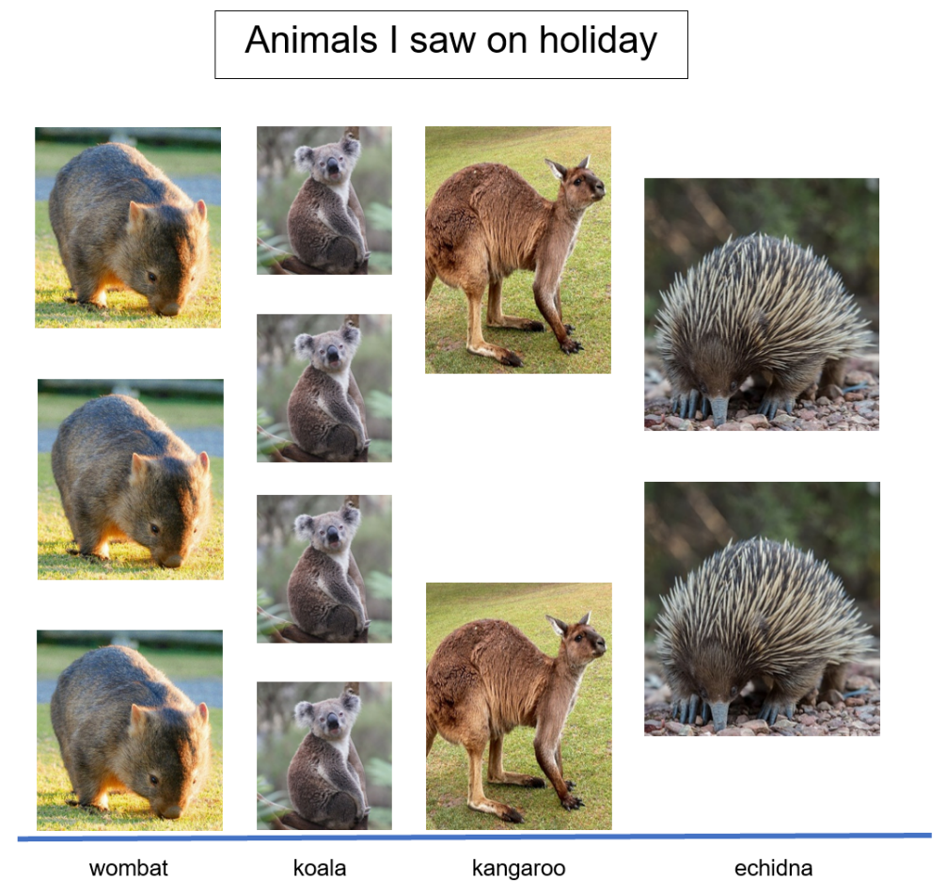
Images sourced from Pixabay and used in accordance with the Pixabay Licence.

Resource 13: Tally times
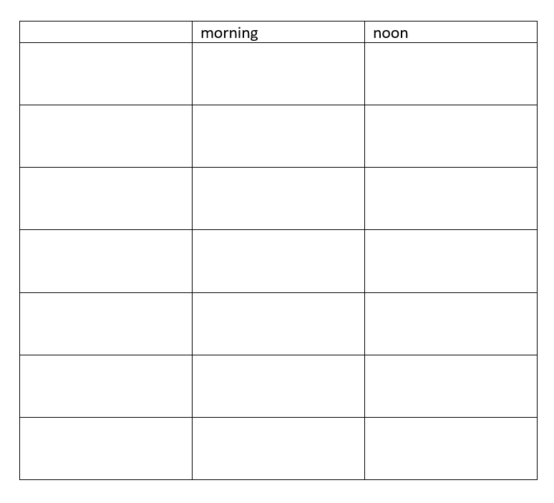

Resource 14: Digit cards
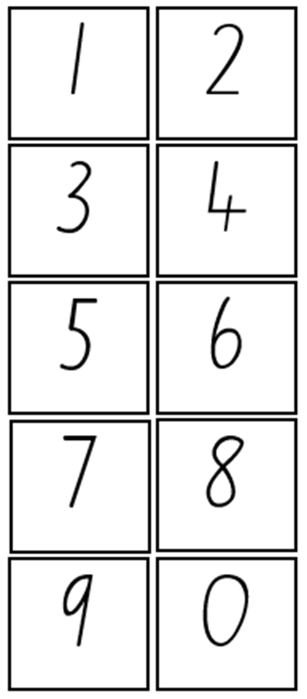

Syllabus outcomes and content
The table below outlines the syllabus outcomes and range of relevant syllabus content covered in this unit. Content is linked to National Numeracy Learning Progression version (3).
Focus area and outcomes | Content groups and content points | Lessons
Representing whole numbers A  MAO-WM-01  MA1-RWN-01  MA1-RWN-02 | Continue and create number patterns  - model and describe ‘odd’ and ‘even’ numbers using items paired in two rows  Represent the structure of groups of ten in whole numbers  - partition two-digit numbers to show quantity values (NPV4) | 1, 2, 4, 7, 8
Representing whole numbers B  MAO-WM-01  MA1-RWN-02 | Use counting sequences of ones and tens flexibly  - identify how many more to the next multiple of ten within two- and three-digit numbers (AdS7)  Form, regroup and rename three-digit numbers  - use place value to partition and rename three-digit numbers in different ways (Reasons about relations) (NPV5) | 1, 2, 4, 7, 8
Combining and separating quantities A  MAO-WM-01  MA1-CSQ-01 | Use advanced count-by-one strategies to solve addition and subtraction problems  - fluently use advanced count-by-one strategies including counting on and counting back to solve addition and subtraction problems involving one- and two-digit numbers (Reasons about relations) (AdS3, AdS4, AdS5) | 5
Data A  MAO-WM-01  MA1-DATA-01  MA1-DATA-02 | Ask questions and gather data  - investigate a topic of interest by choosing suitable questions to obtain appropriate data (IRD2)  - gather data and track what has been counted by using concrete materials, tally marks, lists or symbols (IRD3)  Represent data with objects and drawings and describe the displays  - use concrete materials or pictures of objects as symbols to create data displays where one object or picture represents one data value (IRD2)  - describe information presented in one-to-one data displays (Reasons about relations) (IRD2)  - use comparative language to describe information presented in a display, such as ‘more than’ and ‘less than’  - interpret a data display and identify the biggest or smallest values (IRD2) | 1–6, 8
Data B  MAO-WM-01  MA1-DATA-01  MA1-DATA-02 | Identify a question of interest and gather relevant data  - pose suitable questions where the answers form categories, and predict the likely responses (IRD2)  - collect data on familiar topics IRD2)  - sort data into relevant categories (IRD2)  Create displays of data and interpret them  - organise collected data into lists and tables to display information (IRD2)  - represent data in a picture graph using a baseline, equal spacing and same-sized symbols (IRD2)  - give reasons why some representations of data are misleading (Reasons about relations) (IRD2)  - interpret information presented in tables and picture graphs (Reasons about relations) (IRD2)  record answers to questions using the information in tables and picture graphs (IRD2) | 1–6, 8
Chance A  MAO-WM-01  MA1-CHAN-01 | Identify and describe possible outcomes  - identify possible outcomes of familiar activities and events  - describe the chance of possible outcomes for familiar activities and events (UnC1)  Identify and describe activities that involve chance  - describe possible outcomes in everyday activities and events as being likely or unlikely to happen (UnC2)  - compare familiar activities and events and describe them as being more or less likely to happen (Reasons about relations) (UnC2)  - describe familiar events as being possible (UnC2) | 5–8

References
Links to third-party material and websites
Please note that the provided (reading/viewing material/list/links/texts) are a suggestion only and implies no endorsement, by the New South Wales Department of Education, of any author, publisher, or book title. School principals and teachers are best placed to assess the suitability of resources that would complement the curriculum and reflect the needs and interests of their students.
If you use the links provided in this document to access a third-party's website, you acknowledge that the terms of use, including licence terms set out on the third-party's website apply to the use which may be made of the materials on that third-party website or where permitted by the Copyright Act 1968 (Cth). The department accepts no responsibility for content on third-party websites.
Except as otherwise noted, all material is © State of New South Wales (Department of Education), 2021 and licensed under the Creative Commons Attribution 4.0 International License. All other material (third-party material) is used with permission or under licence. Where the copyright owner of third-party material has not licensed their material under a Creative Commons or similar licence, you should contact them directly for permission to reuse their material.
Mathematics K–10 Syllabus © 2022 NSW Education Standards Authority (NESA) for and on behalf of the Crown in right of the State of New South Wales.
© 2022 NSW Education Standards Authority. This document contains NSW Curriculum and syllabus content. The NSW Curriculum is developed by the NSW Education Standards Authority. This content is prepared by NESA for and on behalf of the Crown in right of the State of New South Wales. The material is protected by Crown copyright.
Please refer to the NESA Copyright Disclaimer for more information.
NESA holds the only official and up-to-date versions of the NSW Curriculum and syllabus documents. Please visit the NSW Education Standards Authority (NESA) website and the NSW Curriculum website.
National Numeracy Learning Progression © Australian Curriculum, Assessment and Reporting Authority (ACARA) 2010 to present, unless otherwise indicated. This material was downloaded from the Australian Curriculum website (National Numeracy Learning Progression) (accessed 13 October 2022) and was not modified. The material is licensed under CC BY 4.0. Version updates are tracked in the ‘Curriculum version history’ section on the 'About the Australian Curriculum' page of the Australian Curriculum website.
ACARA does not endorse any product that uses the Australian Curriculum or make any representations as to the quality of such products. Any product that uses material published on this website should not be taken to be affiliated with ACARA or have the sponsorship or approval of ACARA. It is up to each person to make their own assessment of the product, taking into account matters including, but not limited to, the version number and the degree to which the materials align with the content descriptions and achievement standards (where relevant). Where there is a claim of alignment, it is important to check that the materials align with the content descriptions and achievement standards (endorsed by all education Ministers), not the elaborations (examples provided by ACARA).
This resource contains images and content obtained from Canva, and their use outside of this resource is subject to Canva’s Content License Agreement. If you wish to use them separately from the resource, please go to Canva.
BirdLife Australia (2022) birdlife Australia [website], accessed 17 October 2022.
Clements DH and Sarama J (2019) ‘Super Venn (Hierarchical Classifier)’, Math Activities, Learning and teaching with trajectories website, accessed 14 October 2022.
Fox M (2018) Possum Magic (Vivas J, illus.), Omnibus Books.
Stanford University (n.d.) Data Talks, youcubed website, accessed 14 October 2022.
University of Cambridge (Faculty of Mathematics) (2022) Now and Then, NRICH website, accessed 14 October 2022.
University of Cambridge (Faculty of Mathematics) (2022) The Deca Tree, NRICH website, accessed 14 October 2022.
University of Cambridge (Faculty of Mathematics) (2022) The Thousands Game, NRICH website, accessed 14 October 2022.

