Mathematics – Stage 1 – Unit 25
Contents
Unit description and duration 4
Student prior learning 4
Lesson overview and resources 6
Lesson 1: Reasoning with 2D shapes 12
Daily number sense: Shape talk – 10 minutes 12
Joining triangles – 45 minutes 13
Discuss and connect the mathematics – 5 minutes 17
Lesson 2: Transforming 2D shapes 18
Daily number sense: What’s my number? – 10 minutes 18
The shape transformer – 45 minutes 20
Discuss and connect the mathematics – 5 minutes 23
Lesson 3: Let’s learn about symmetry 24
Daily number sense: Horses and stables – 10 minutes 24
Let’s learn about symmetry – 45 minutes 26
Discuss and connect the mathematics – 5 minutes 30
Lesson 4: Symmetry games 31
Daily number sense: The deal – 10 minutes 32
Symmetry games – 45 minutes 33
Discuss and connect the mathematics – 5 minutes 35
Lesson 5: Looking at leaves 36
Daily number sense: Giant line of tens – 20 minutes 37
Measuring leaves from the garden – 25 minutes 38
Consolidation and meaningful practice: Leaf number line – 15 minutes 40
Lesson 6: Fraction feast 42
Daily number sense: The hopping frog – 20 minutes 42
The fraction picnic – 30 minutes 45
Consolidation and meaningful practice: Making long rolls – 15 minutes 48
Lesson 7: Divide it up! 49
Daily number sense: Place value wrangle – 10 minutes 49
Sharing the sausages – 30 minutes 50
Consolidation and meaningful practice: Dice division – 20 minutes 52
Lesson 8: Shapes all around us 55
Daily number sense: Place value scavenger hunt – 20 minutes 55
3D Venn diagram – 20 minutes 57
Consolidation and meaningful practice: 3D stick structures – 20 minutes 58
Resource 1: Secret garden 60
Resource 2: Isometric triangle paper 61
Resource 3: Arrow 62
Resource 4: Pentagons reflected 63
Resource 5: Shape transformer cards 64
Resource 6: Symmetry puzzles 67
Resource 7: Pentominoes 73
Resource 8: Pentomino grid 74
Resource 9: Random number cards 75
Resource 10: One long roll 77
Resource 11: Half/not half 78
Resource 12: Three long rolls 79
Resource 13: Stick collection 80
Resource 14: Larger stick collection 81
Resource 15: Scavenger hunt template 82
Resource 16: 3D Venn diagram 83
Syllabus outcomes and content 84
References 92

Unit description and duration
This two-week unit develops student knowledge, skills and understanding of how new shapes can be made by joining (combining) and breaking apart (partitioning) existing shapes. Students are provided opportunities to:
- explore how shapes can be made by joining (combining) and breaking apart (partitioning) existing shapes
- create new shapes by adding or removing sides and vertices (corners)
- recognise how two-dimensional (2D) shapes can be classified into different categories according to their features
- create linear patterns with shapes that transform (slide and reflection)
- make designs with symmetry from reflection
- measure areas using uniform informal units
- recognise, sort, and describe the features of three-dimensional (3D) objects
- use concrete materials to model subdividing a whole length into both halves and quarters
- model sharing and grouping collections of objects to represent division.
Mathematics K–10 Syllabus © 2022 NSW Education Standards Authority (NESA) for and on behalf of the Crown in right of the State of New South Wales.

Student prior learning
Before engaging in these teaching and learning activities, students would benefit from prior experience with:
- opportunities to investigate two-dimensional (2D) shapes through playing with pattern blocks, geoboards, paper folding, cutting, and building with solid objects
- distinguishing shapes and objects by their features
- new shapes can be created by adding or removing sides and vertices (corners)
- recognising shapes and objects can be halved in different ways
- using mathematical language in relation to shapes such as sides, equal, vertices and straight
- measure objects using informal units.

Lesson overview and resources
The table below outlines the sequence and approximate timing of lessons; syllabus focus areas and content groups; and resources.
Lesson | Syllabus focus area and content groups | Resources
Lesson 1: Reasoning with 2D shapes  60 minutes  Shapes can be combined and split to form new shapes. | Two-dimensional spatial structure A  - Recognise and classify shapes using obvious features  - Transform shapes using slides and reflections  Two-dimensional spatial structure B  - Represent, combine and separate two-dimensional shapes | - Resource 1: Secret garden  - Resource 2: Isometric triangle paper  - Pattern blocks  - Writing materials
Lesson 2: Transforming 2D shapes  60 minutes  Shapes can be combined and split to form new shapes. | Forming groups A  - Count in multiples using rhythmic and skip counting  Forming groups B  - Represent multiplication and division problems  Two-dimensional spatial structure A  - Recognise and classify shapes using obvious features  - Transform shapes using slides and reflections  Two-dimensional spatial structure B  - Represent, combine and separate two-dimensional shapes  - Identify and describe the orientation of shapes using quarter turns | - Resource 3: Arrow  - Resource 4: Pentagons reflected  - Resource 5: Shape transformer cards  - Concrete materials  - Writing materials
Lesson 3: Let’s learn about symmetry  60 minutes  A symmetrical shape is reflected with the same image. | Representing whole numbers A  - Use counting sequence of ones with two-digit numbers and beyond  Representing whole numbers B  - Use counting sequence of ones and tens flexibly  Two-dimensional spatial structure A  - Recognise and classify shapes using obvious features  - Transform shapes using slides and reflections  Two-dimensional spatial structure B  - Represent, combine and separate two-dimensional shapes | - Masking tape or rulers  - Pattern blocks
Lesson 4: Symmetry games  60 minutes  A symmetrical shape is reflected with the same image. | Combining and separating quantities A  - Use advanced count-by-one strategies to solve addition and subtraction problems  Forming groups A  - Recognise and represent division  Two-dimensional spatial structure A  - Recognise and classify shapes using obvious features  - Transform shapes using obvious features  Two-dimensional spatial structure B  - Represent, combine and separate two-dimensional shapes | - Resource 6: Symmetry puzzles  - Resource 7: Pentominoes  - Resource 8: Pentomino grid  - Masking tape or rulers  - Pattern blocks
Lesson 5: Looking at leaves  60 minutes  Informal units can be used to order, measure and compare areas. | Representing whole numbers A  - Represent numbers on a line  - Represent the structure of groups of ten in whole numbers  Representing whole numbers B  - Use counting sequences of ones and tens flexibly  Two-dimensional spatial structure A  - Area: Measure areas using uniform informal units | - Resource 9: Random number cards  - Chalk  - Leaves  - Wooden pegs  - Wooden unit blocks  - Writing materials
Lesson 6: Fraction feast  65 minutes  Halves and quarters can be created by dividing shapes or objects in different ways. | Representing whole numbers A  - Represent numbers on a line  - Represent the structure of groups of ten in whole numbers  Representing whole numbers B  - Use counting sequences of ones and tens flexibly  Geometric measure A  - Length: Subdivide lengths to find halves and quarters | - Resource 9: Random number cards  - Resource 10: One long roll  - Resource 11: Half/not half  - Resource 12: Three long rolls  - Interactive online random number selector  - Craft sticks  - Modelling clay  - Wooden pegs  - Writing materials
Lesson 7: Divide it up!  60 minutes  Collections of objects can be shared and grouped. | Representing whole numbers B  - Form, regroup, and rename three-digit numbers  Forming groups A  - Recognise and represent division | - Resource 13: Stick collection  - Resource 14: Larger stick collection  - Video: FUSE: Sharing the Sausages (2:06)  - Decks of playing cards  - Dice  - Gumnuts  - Sectional recycled packaging (egg cartons)  - Sticks  - Writing materials
Lesson 8: Shapes all around us  60 minutes  Three-dimensional (3D) objects can be recognised, sorted and described by their features. | Representing whole numbers B  - Form, regroup, and rename three-digit numbers  Three-dimensional spatial structure A  - Recognise familiar three-dimensional objects  - Sort and describe three-dimensional objects  Three-dimensional spatial structure B  - Describe the features of three-dimensional objects | - Resource 15: Scavenger hunt template  - Resource 16: 3D Venn diagram  - Video: The Stickie Gang: Episode 4 Identifying 3D Shapes (1:13)  - Catalogues, magazines, and food packaging  - Everyday 3D objects  - Glue  - Hoops  - Modelling clay  - Scissors  - Sticks  - Writing materials

Lesson 1: Reasoning with 2D shapes
Core concept: Shapes can be combined and split to form new shapes.
The table below contains suggested learning intentions and success criteria. These are best co-constructed with students.
Learning intentions | Success criteria
Students are learning that:  - shapes have features that can be used to name and classify them  - shapes can be joined together to make new shapes  - shapes can be transformed using slides and reflections. | Students can:  - name and describe 2D shapes  - combine and separate triangles to make unique shapes.

Daily number sense: Shape talk – 10 minutes
This lesson has been adapted from Sullivan (2017).
- Build student understanding of 2D shapes and their features by engaging in a shape talk.
- Explain that a friend drew a shape with 4 sides, but they can’t remember what it looked like. Ask students to draw what the shape may have looked like. Students turn and talk to compare their answers.
- Tell students to describe a shape to a partner who draws it from the description. The name of the shape cannot be used. Remind students to use vocabulary such as sides, vertices and two-dimensional.
- Showcase student drawings through a gallery walk and have students name each shape.

Joining triangles – 45 minutes
This lesson has been adapted from Reasoning With 2D Shapes at reSolve (2022).
- Explain that they will be investigating different shapes that can be made by joining sides of triangles. Triangles must be joined by matching full sides together. Joining parts of sides is not allowed. See Figure 1.
Figure 1 – Joining triangles together
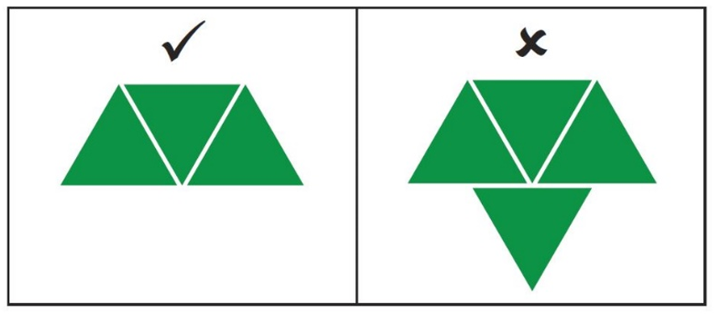
Image adapted from Reasoning with 2D Shapes by reSolve © Australian Government Department of Education 2022 and licensed under CC-BY-NC-SA 4.0
- Provide students with at least 12 triangular pattern blocks each.
- Allowing time for exploration after each question, ask students:
- What are the different ways that you can join 2 triangles together? How do you know?
- What are the different ways that you can join 3 triangles together? How do you know?
- What are the different ways that you can join 4 triangles together? How do you know?
Note: There is only one way that 2 equilateral triangles can be joined. There is only one way that 3 equilateral triangles can be joined. There are only 3 ways that 4 equilateral triangles can be joined. See Figure 2.
Figure 2 – Joining triangles in different ways
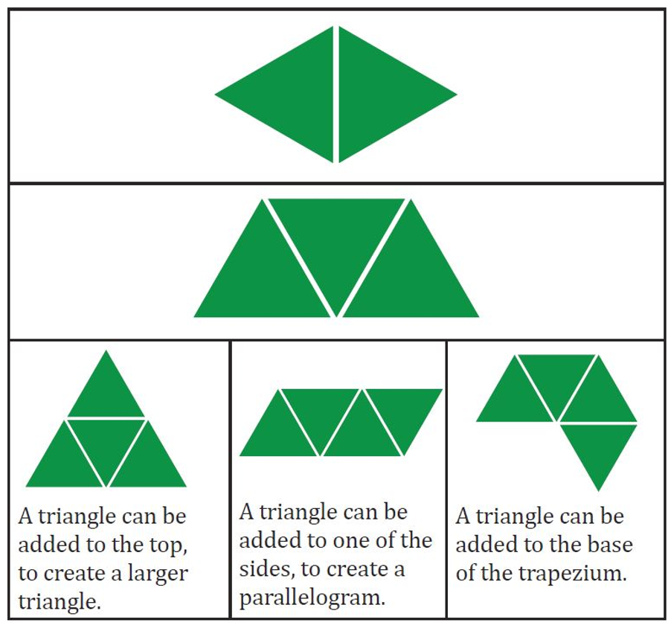
Image adapted from Reasoning with 2D Shapes by reSolve © Australian Government Department of Education 2022 and licensed under CC-BY-NC-SA 4.0
- Display Resource 1: Secret garden as a stimulus and explain that a secret garden requires a special key to open the gate. The key is made up of 5 triangles joined together. Challenge students to find all the possible keys that can be made with 5 triangles. Ask students to record the different options found on Resource 2: Isometric triangle paper.
- Students are likely to collect many different combinations for 5 triangles. Only 4 unique shapes can be found. See Figure 3. Ask students to show which shapes are the same and which are different. Provide students with equilateral triangles that can be cut out and pasted onto paper to allow them to use reflections and turns to show which shapes are unique.
Reflection: A transformation of a shape formed by creating a mirror image on the other side of a given line.
Slide (translation): Sliding a shape without turning it.
Figure 3 – 5 triangles
Image adapted from Reasoning with 2D Shapes by reSolve © Australian Government Department of Education 2022 and licensed under CC-BY-NC-SA 4.0
The table below details assessment opportunities and differentiation ideas.
Assessment opportunities | Too hard? | Too easy?
What to look for:  - Can students combine and separate shapes to make different combinations? (MAO-WM-01, MA1-2DS-01)  What to collect:  - observational records (MAO-WM-01, MA1-2DS-01)  - student cut and paste work samples (MAO-WM-01, MA1-2DS-01) | Students have difficulty making unique shapes.  - Students start with the 3 options made with 4 triangles (see 3rd row of Figure 2) and add an extra triangle to each option.  - Students combine 2 and 3 triangle shapes, as seen in Figure 4. | Students make all the possible unique shapes.  - Ask students how many unique shapes can be made from 6 triangles.  - Students use pattern blocks to find all the possible ways to make a regular hexagon.  - Students create a simple design using pattern blocks and draw what it would look like if it was reflected or turned.
Figure 4 – Triangle shapes
Image adapted from Reasoning with 2D Shapes by reSolve © Australian Government Department of Education 2022 and licensed under CC-BY-NC-SA 4.0

Discuss and connect the mathematics – 5 minutes
- Select students to demonstrate how they used flips, (reflections), turns and slides (translation), to show which shapes were the same and which were different.
- Discuss with the class ways in which the shapes are similar and different. For example, each shape can be made using a trapezium and a rhombus (see Figure 5). Use pattern blocks to demonstrate.
Figure 5 – Trapezium and rhombus
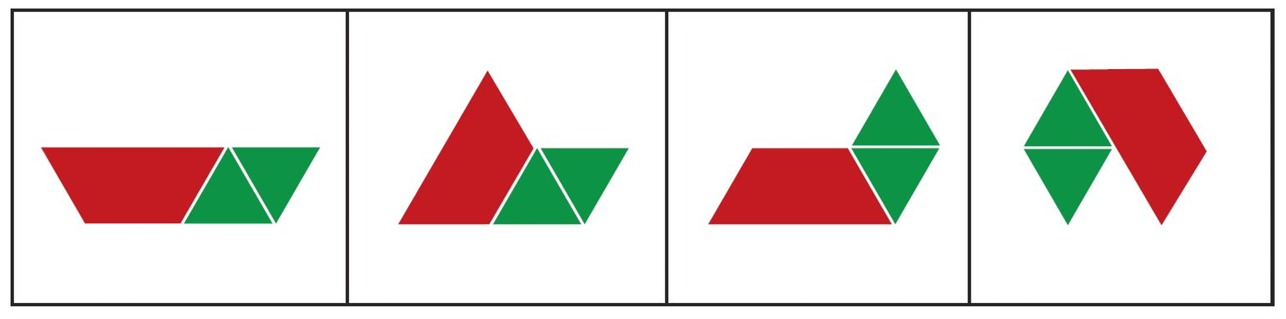
Image adapted from Reasoning with 2D Shapes by reSolve © Australian Government Department of Education 2022 is licensed under CC-BY-NC-SA 4.0

Lesson 2: Transforming 2D shapes
Core concept: Shapes can be combined and split to form new shapes.
The table below contains suggested learning intentions and success criteria. These are best co-constructed with students.
Learning intentions | Success criteria
Students are learning that:  - mathematical problems can be solved in a variety of ways  - common shapes can be composed of smaller shapes  - a shape can be turned using a quarter, half, or full turn in a clockwise or anticlockwise direction. | Students can:  - use skip counting or repeated addition to solve a problem  - identify the shapes within larger shapes  - identify quarter, half, and full turns of shapes in each direction.

Daily number sense: What’s my number? – 10 minutes
This activity has been adapted from What’s my number? at NZ Maths.
- Build student understanding of additive and multiplicative strategies by using knowledge of number operations to find an unknown number.
- Explain that you are thinking of a number and that the students will need to work out the number.
- Students think of a number between 1 and 6. Provide students with clues such as adding 8 to the number or tripling the number will give the same answer. See Figure 6. Ask students what the number could be.
- Provide prompts such as:
- Try your own number. Triple it. What did you get?
- Add 8 to your number. What did you get? Are your answers the same?
- How close was your number? Would it be better to try a bigger number or a smaller number? Explain your thinking.
- Record your thinking in a table.
Figure 6 – Add triple table
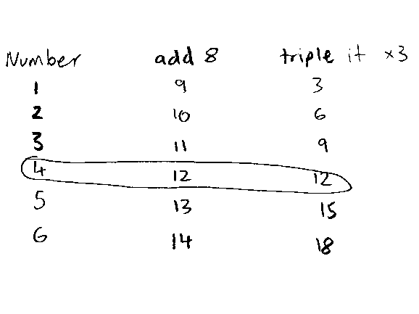
- Ask students to share their thinking and discuss.
The table below details assessment opportunities and differentiation ideas.
Assessment opportunities | Too hard? | Too easy?
What to look for:  - Can students use an appropriate strategy to solve the problem? (MAO-WM-01)  - Can students use skip counting, repeated addition or multiplication to triple a number? (MAO-WM-01, MA1-FG-01)  What to collect:  - observation records from student discussion (MAO-WM-01, MA1-FG-01) | Students have difficulty adding or multiplying.  - Provide a number chart to support learning.  - Provide counters to support learning. | Students solve the problem quickly.  - Ask students to find another method to solve the problem.  - Ask students to create their own problem that requires multiplication to find the solution.

The shape transformer – 45 minutes
This activity has been adapted from Moss (2016).
- Ask students to stand and complete a full turn in a clockwise direction. Repeat the task in an anti-clockwise direction. Remind students that the term clockwise means to turn in the same direction that the hands on a clock turn and that anti-clockwise means to turn in the opposite direction. Repeat with quarter and half turns in both directions, demonstrating if necessary.
- Display Resource 3: Arrow. Explain that the arrow is like a hand on a clock pointing at the 12. Ask students to visualise and draw what the arrow would look like if it was pointing to the 3 on a clock. Explain that this is called a quarter turn in a clockwise direction.
- Display the arrow in the original orientation. Ask students to visualise and draw what the arrow would like after a half turn in a clockwise direction. Display the arrow in the new orientation.
- Ask students to visualise and draw what the arrow would look like after a quarter turn in an anti-clockwise direction. Display the arrow in the new orientation.
- Display the left side shape of Resource 4: Pentagons reflected. Ask the students to describe the shape and what the shape would look like if it was reflected in a mirror. Ask students to visualise and draw their responses. Reveal the shape on the right side and compare it with student responses. Explain that when a shape is flipped in this way, it has been reflected.
- Describe an imaginative shape transformer that has an input and an output slot. See Figure 7. The machine has special powers and once a shape goes into the input slot, the machine transforms the shape into something else. For example, a shape may be reflected or turned.
Figure 7 – Shape transformer
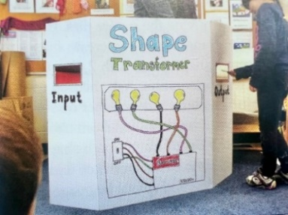
Image adapted from Moss et. al. (2016).
- Bestow upon students the honorary position of ‘shape detectives’ and that they must discover the machine’s transformation rule.
- With students, feed an input card through the machine using Resource 5: Shape transformer cards then take the corresponding output card from the output slot. Display the input and output cards together so that students can see both cards. Ask students to look carefully and think about how the machine has transformed the shape. Ask students to turn and talk to share their explanation.
- Continue using the transformation machine until all cards are used.
- After observing all input and output cards, students are challenged to explain the transformation rule.
- Ask students to use spatial language, for example reflection, turn, quarter, half, clockwise.
The table below details assessment opportunities and differentiation ideas.
Assessment opportunities | Too hard? | Too easy?
What to look for:  - Can students identify shapes presented in different orientations? (MA1-2DS-01)  - Can students identify quarter and half turns? (MA1-2DS-01)  - Can students identify clockwise and anticlockwise or left and right turns? (MA1-2DS-01)  - Can students identify reflections? (MA1-2DS-01)  What to collect:  - recordings of student responses (MAO-WM-01, MA1-2DS-01)  - student drawings (MA1-2DS-01) | Students have difficulty visualising turns and reflections.  - Use concrete materials and have students physically turn and then draw or trace around them.  - Use a mirror to demonstrate reflections of various shapes. | Students easily determine the rule and what each shape looks like after passing through the shape transformer.  - Students create their own set of 3 input and output cards that follow a rule that they create. They can work with a partner who will attempt to determine the rule after observing 3 pairs of cards passing through the shape transformer.  - Students create their own set of 3 input and output cards where only 2 cards follow a rule that they create. They can work with a partner who will be told the rule beforehand. The partner's role is to determine which pair of cards doesn’t follow the rule and to explain why.

Discuss and connect the mathematics – 5 minutes
- Discuss the shape transformer activity. Ask students:
- How were you able to hold in your mind the image of the shapes on the input cards?
- Which transformations were the easiest for you?
- Which transformations were the trickiest for you?
- If you were explaining this activity to other students, what hints would you give to make it easier for them?

Lesson 3: Let’s learn about symmetry
Core concept: A symmetrical shape is reflected with the same image.
The table below contains suggested learning intentions and success criteria. These are best co-constructed with students.
Learning intentions | Success criteria
Students are learning that:  - skip counting can be used to solve multiplication problems  - shapes may have a line of symmetry  - shapes may have more than one line of symmetry. | Students can:  - skip count by tens to solve a problem  - identify a line of symmetry  - create a symmetrical design using pattern blocks.

Daily number sense: Horses and stables – 10 minutes
This activity has been adapted from Skip it to multiply it at NZ Maths.
- Build student understanding of skip counting by solving a word problem.
- Explain that there are 7 horse stables and 10 horses in each stable. Ask how many horses there are altogether.
- Students Think-Pair-Share and record strategies to solve the problem.
- Reflect on strategies used and further the mathematics by asking students:
- How did you calculate the answer?
- Is there a more efficient way of solving the problem?
- Can you show your thinking in a picture or diagram?
- The answer is 70. What is the number before and the number after 70?
- The answer is 70. How many more to 100?
- There are 15 horse stables. There are 4 horses in the first stable. There are 10 horses in all the other stables. How many horses are there altogether?
The table below details assessment opportunities and differentiation ideas.
Assessment opportunities | Too hard? | Too easy?
What to look for:  - Can students use an appropriate strategy to solve the problem? (MAO-WM-01, MA1-RWN-01, MA1-RWN-02)  - Can students demonstrate their thinking? (MAO-WM-01, MA1-RWN-01, MA1-RWN-02)  What to collect:  - student work samples (MAO-WM-01, MA1-RWN-01, MA1-RWN-02) | Students have difficulty skip counting by tens.  - Use concrete materials such as MAB blocks or counters.  - Use a number chart or number line.  - Skip count by fives. | Students skip count by tens and quickly solve the problem.  - Pose a similar problem with an increased number of stables.  - Pose a similar problem with a different number of horses in each stable.  - Explain that there are 90 horses in 10 stables. Ask how many horses might be in each stable.

Let’s learn about symmetry – 45 minutes
This activity has been adapted from Moss et. al. (2016).
- Show students a folded piece of paper that shows half of a heart drawn on one side. Ask students to predict what the shape will look like after it has been cut out and unfolded. Ask students to justify their predictions.
- Cut the outline of the half heart, unfold the paper, and reveal the heart. Ask students what they notice about the heart and what they notice about the 2 sides.
- Focus attention on the fold line. Explain that it’s called the line of symmetry and that it divides the heart in half. Ask students if the 2 sides are the same and how this might be proved. Use scissors to cut down the fold line and superimpose one half onto the other to prove that they are identical. This process may be repeated with other shapes that have a vertical line of symmetry, such as a star, a crown, or a butterfly.
- Place a vertical line, tape, or ruler on a flat surface such as a desk or the floor. Explain to students that they will be playing a symmetry game with pattern blocks. Ask students:
- What might this line be for?
- What is this line called?
- What do you remember about the line of symmetry?
Note: Explain that you will put pattern blocks on one side of the line as shown in Figure 8, and that students will place pattern blocks on the other side to create a symmetrical design. Begin the design by placing the first pattern block on the line. Students mirror your design by placing the pattern blocks on the other side. Continue the design by alternating turns.
Figure 8 – Pattern block game
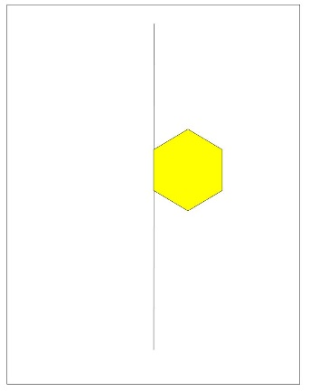
- Model the language of symmetry using words such as distance, mirror, orientation, flip, reflect.
- At times, deliberately misplace the pattern block and ask students to verify if the placement of the shape is correct. Students turn and talk to discuss why the placement is wrong and how to correct it. Students move the pattern block to the correct place and explain why the placement is correct. See Figure 9. Relate it to the folding activity completed in earlier steps. For example, this is a symmetry game so the 2 sides must be the same. If you could fold the board along the line, this design would end up on top of the first one.
Figure 9 – Line of symmetry
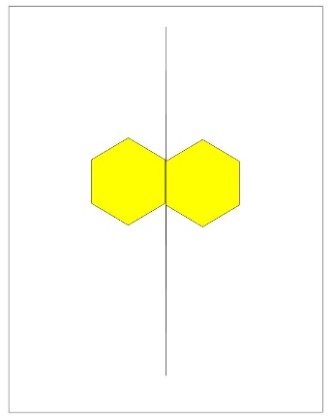
- Continue placing pattern blocks to create symmetrical designs. Review and discuss each placement, ensuring that the design remains symmetrical. Continue for several rounds or until students consistently place pattern blocks in the correct position.
- Students play the same game in pairs or small groups, using their own set of pattern blocks and following the rules used above. Students alternate who goes first to allow all students the opportunity to place the first block.
This table details assessment opportunities and differentiation ideas.
Assessment opportunities | Too hard? | Too easy?
What to look for:  - Can students identify the line of symmetry? (MAO-WM-01, MA1, 2DS-01)  - Can students describe how a 2D-shape or design is symmetrical? (MAO-WM-01, MA1, 2DS-01)  - Can students create a symmetrical design? (MAO-WM-01, MA1, 2DS-01)  What to collect:  - student observations (MAO-WM-01, MA1, 2DS-01)  - discussion answers (MAO-WM-01, MA1, 2DS-01)  - photographs of completed designs. (MAO-WM-01, MA1, 2DS-01) | Students have difficulty making a symmetrical design.  - Demonstrate symmetry patterns and have students determine which patterns have all the blocks placed correctly and which have errors. Ask students to fix the errors.  - Limit the placement of pattern blocks so they must be touching the line of symmetry.  - Limit the number of different types of pattern blocks that can be used. | Students make and describe symmetrical designs.  - Specify that a selected number of pattern blocks must be placed so that they are not touching the line of symmetry or another pattern block.  - Move the line of symmetry so that it is horizontal or diagonal. See Figure 10.  - Introduce an additional line of symmetry, for example, vertical and horizontal. See Figure 11.
Figure 10 – Horizontal symmetry line
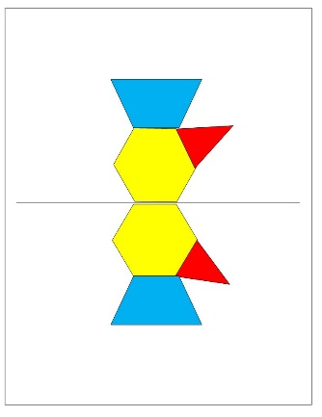
Figure 11 – Horizontal/vertical symmetry line
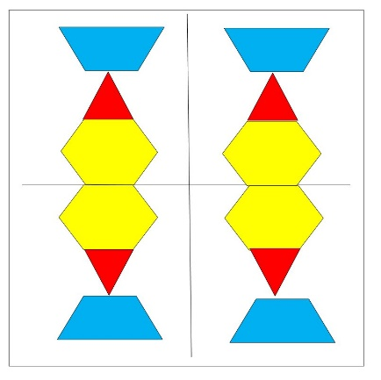

Discuss and connect the mathematics – 5 minutes
- Complete a gallery walk to observe and discuss the completed designs. Ask students:
- When you were placing a block on the design, what were you trying to do?
- How can you tell that your finished design is symmetrical?
- Are there any parts that aren’t symmetrical? What could you do to make them symmetrical?
- What was the most challenging part of the game?
- What is your favourite part of your design?

Lesson 4: Symmetry games
Core concept: A symmetrical shape is reflected with the same image.
The table below contains suggested learning intentions and success criteria. These are best co-constructed with students.
Learning intentions | Success criteria
Students are learning that:  - division problems may have a remainder  - shapes may have a line of symmetry  - a shape can be turned using a quarter, half, or full turn in a clockwise or anti-clockwise direction. | Students can:  - identify the remainder in a division problem  - create a symmetrical design using pattern blocks  - slide, turn and reflect pentominoes.

Daily number sense: The deal – 10 minutes
This activity has been adapted from The Deal at NZ Maths.
- Build student understanding of sharing and grouping by solving a division problem.
- Explain that Alex has 23 collector cards that need to be shared with 3 friends. Alex deals the cards evenly between 4 players and keeps the leftovers. Ask how many cards Alex has after sharing.
- Use ‘Talk moves’ to discuss strategies to solve the problem. Ask questions such as:
- How many people will get the cards?
- How many cards will they get?
- How many cards will be left over?
- How many cards will Alex get?
- Can you show your thinking in a diagram or picture?
The table below details assessment opportunities and differentiation ideas.
Assessment opportunities | Too hard? | Too easy?
What to look for:  - Can students share the cards into equal groups? (MAO-WM-01, MA1-FG-01)  - Can students use a suitable strategy to determine how many cards are leftover? (MAO-WM-01, MA1-CSQ-01)  What to collect:  - student diagrams and pictures. (MAO-WM-01, MA1-CSQ-01, MA1-FG-01) | Students have difficulty sharing into equal groups and determining how many are left over.  - Reword the problem so that there is no remainder. For example, 12 cards shared between Alex and the 3 friends.  - Students practise sharing into equal groups before introducing remainders using smaller numbers. For example, sharing 3 chocolates between 2 people. | Students easily share the cards and determine how many are left over.  - Ask students how many cards each person would get and how many would be left over if there were 47 cards.  - Challenge students to determine how many cards would be needed for each person to get 7 cards with 3 cards left over.

Symmetry games – 45 minutes
This activity has been adapted from Moss et. al. (2016).
- Revise the pattern block symmetry activity from the previous lesson.
- Present each student or pair of students with half a symmetrical pattern block design from Resource 6: Symmetry puzzles.
- Ask students to finish the symmetrical design using pattern blocks, ensuring that each piece they place is symmetric to a piece in the original design.
- During the activity, ask students:
- Where is the line of symmetry?
- What do we know about the line of symmetry?
- Were some designs easier or harder to create symmetry? Why?
- How can you make sure that your side is symmetric to the part that has already been made?
- Introduce the class to pentominoes using Resource 7: Pentominoes. Explain that a pentomino is a special shape formed by joining 5 squares together so that every square has at least one side in common with another square.
- Play the symmetry game using pentominoes, as they did with pattern blocks in the previous lesson. Use a strip of masking tape or a ruler to act as the line of symmetry.
- Students take turns placing a pentomino on their side of the line, ensuring that the design remains symmetrical. Students alternate who goes first.
- Remind students to check that both sides are symmetrical and that their pentominoes are facing the right direction. The game ends when all pentominoes have been used.
Note: Providing each pair of students with 2 sets of pentominoes on different coloured paper will allow for greater contrast between each player’s pentominoes.
- Play the pentomino symmetry game using Resource 8: Pentomino grid as the playing board.
- The rules are the same as the previous game however all pieces must be placed directly on the squares of the game board.
- Be sure to use a vertical line of symmetry. The objective is to place as many pentominoes as possible. The game ends when the board is filled and no more pentominoes fit on the board.
This table details assessment opportunities and differentiation ideas.
Assessment opportunities | Too hard? | Too easy?
What to look for:  - Can students arrange the pattern blocks to create a symmetrical design? (MAO-WM-01, MA1-2DS-01)  - Can students arrange the pentominoes to create a symmetrical design? (MAO-WM-01, MA1, 2DS-01)  - Can students rotate the pentominoes to fit as many of their pieces on the game board as possible? (MAO-WM-01, MA1-2DS-01)  What to collect:  - photographs of completed puzzle designs (MAO-WM-01, MA1-2DS-01)  - photographs of completed pentomino games. (MAO-WM-01, MA1-2DS-01) | Students have difficulty maintaining symmetry with pentominoes.  - Ensure that at least the first move of the game involves placing a pentomino directly against the line of symmetry.  - Limit the number of pentominoes that students use. For example, set a limit of 6 pentominoes on each side of the line of symmetry. | Students easily maintain symmetry with pentominoes.  - Each student plays 2 pentominoes each turn.  - Students are not allowed to watch their partner placing their pentominoes on the game board.  - Change the line of symmetry from vertical to horizontal.

Discuss and connect the mathematics – 5 minutes
- Reflect on and discuss the pentomino symmetry games. Ask students:
- Was it easier or harder using the pentominoes compared to the pattern blocks? Why?
- Were you able to fit all your pentominoes onto the game board or did you run out of space?
- What was your strategy to fit as many of your pentominoes on the game board as possible?
- Did you need to rotate or turn the pentominoes to fit more on your side? Was this effective? Why or why not?

Lesson 5: Looking at leaves
Core concept: Informal units can be used to order, measure, and compare areas.
The table below contains suggested learning intentions and success criteria. These are best co-constructed with students.
Learning intentions | Success criteria
Students are learning that:  - counting by tens develops understanding of place value  - estimating can be used to decide if a measurement of area is reasonable  - the size of a unit and the number of units needed to measure an area are related. | Students can:  - count forwards and backwards by tens and locate the nearest 10 to a number by representing numbers on a line  - estimate which of 2 similar shapes has the larger area and check using an informal unit of measure  - select informal units to measure area and compare areas using drawings, numerals, and words.

Daily number sense: Giant line of tens – 20 minutes
- Build student understanding of counting forwards and backwards by tens by representing numbers on a line.
- Demonstrate a skip counting song (Tune: ‘Skip To My Lou’):
‘Skip count, skip count, count by tens.
Skip count, skip count, count by tens.
Skip count, skip count, count by tens.
We can count to 100.
10, 20, 30, 40, 50, 60, 70, 80, 90, 100!’
- Once students have practised the song, lead them to the playground.
- Draw a number line from zero to 100 by tens using chalk. Demonstrate frog hopping along the number line counting forwards and backwards by tens from zero to 100. Give students the opportunity to practise frog hopping and counting on the number line.
- Regroup and explain that this time students are going to locate the nearest 10 to a number. Explain to students that when rounding to the nearest 10, they should look at the number in the ones place. If the number is 5 or greater, they round the number up. If the number is 4 or less, they round the number down.
- Show Resource 9: Random number cards. Explain to students that they are going to select a random number card and round the number to the nearest 10 by hopping like a frog to a log while counting aloud by tens.
- Provide time for students to locate the nearest 10 to a number by moving like a frog.
This table details assessment opportunities and differentiation ideas.
Assessment opportunities | Too hard? | Too easy?
What to look for:  - Can students count forwards and backwards by tens? (MAO-WM-01, MA1-RWN-01)  - Can students locate the nearest ten to a number by representing numbers on a line? (MAO-WM-01, MA1-RWN-01)  What to collect:  - observations and recordings of student voice (MAO-WM-01, MA1-RWN-01) | Students need further support to count forwards and backwards by tens and locate the nearest 10 to a number by representing numbers on a line.  - Show students an interactive hundreds chart and model rounding the number up when it is 5 or greater. Model rounding the number down if it is 4 or less.  - Provide time for students to use the interactive hundreds chart to practise locating the nearest 10 when selecting a random number. | Students can confidently count forwards and backwards by tens and locate the nearest 10 to a number by representing numbers on a line.  - Select a random number card from Resource 9: Random number cards and continue counting by tens from the nearest 10.  - Select from a random number card from Resource 9: Random number cards and count forwards and backwards by twos.

Measuring leaves from the garden – 25 minutes
- While in the playground, ask students to find a leaf to take back to the classroom.
- Explain that students are going to think about how to measure area.
Area: The amount of space covered by a two-dimensional shape.
Note: A leaf is a three-dimensional object. In this lesson use the outline of a leaf, which is a two-dimensional shape.
- In pairs, students directly compare their leaves and discuss which has the largest area. As a class, students suggest some objects that could be used to measure the area of a leaf. Spend a few minutes discussing advantages and disadvantages of the objects suggested.
- Select 2 uniform informal units of measure that everyone will use, for example, wooden pegs and wooden unit blocks.
- Trace around the leaf on paper. Model estimating how many units of measurement will be needed by making one line of units in the middle of the tracing, discussing how many units are in one row and how many there might be altogether.
- Model measuring part of the area by placing informal units over the leaf with no gaps or overlaps. Prompt students to think about leftover parts. For example, this leaf looks like about a half and a half so they can count as one; here is almost a full unit and here is a tiny bit of unit so that could make one too.
- Students independently estimate, trace, measure and record the area of their leaf. See Figure 12.
Figure 12 – Leaf area
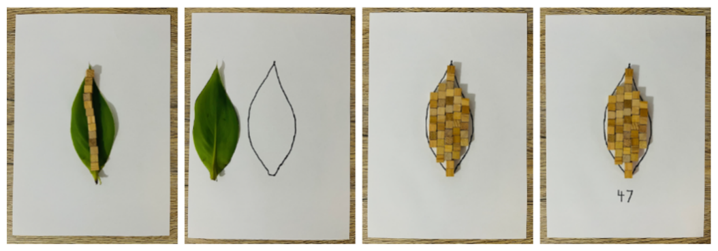
This table details assessment opportunities and differentiation ideas.
Assessment opportunities | Too hard? | Too easy?
What to look for:  - Can students estimate which of 2 similar shapes has the larger area and check using an informal unit of measure? (MAO-WM-01, MA1-2DS-02)  - Can students select informal units to measure area and compare areas using pictures, numerals, and words? (MAO-WM-01, MA1-2DS-02)  What to collect:  - recordings of student voice and observations of students organising and comparing leaf areas (MAO-WM-01, MA1-2DS-02) | Students need further support to estimate, trace, measure and record the area of a leaf.  - Model overlaying 2 leaves using direct comparison.  - Model language of part-part-whole with students to support students to include leftover parts. | Students confidently estimate, trace, measure and record the area of a leaf.  - Using the measurement of their leaf as a unit, for example 20 wooden unit blocks, students estimate areas of larger shapes in the classroom.  - Use their leaf as an informal unit of measure to find the measurement of shapes in the classroom and compare answers to estimates.

Consolidation and meaningful practice: Leaf number line – 15 minutes
- In groups, students organise leaves from the smallest area to the largest area to create a leaf number line.
- Regroup students. Use ‘Talk moves’ to facilitate class discussion.
The table below outlines stimulus prompts to generate conversation about the topic, along with anticipated responses from students.
Prompts | Anticipated student responses
- How do you make sure that you measure area accurately when using uniform informal units?  - What if there are some parts left over when counting uniform informal units to measure area?  - Why is it important to use the same size unit when measuring an object?  - Would you choose a different unit to measure an object if you did it again? | - You need to make rows and columns with no gaps or overlaps.  - Count the parts that look about half as part-part equals a whole.  - If we don’t use the same sized unit to measure, we cannot compare.  - Yes, because a leaf has curved sides, I would try using an object that is round.

Lesson 6: Fraction feast
Core concept: Halves and quarters can be created by dividing shapes/objects in different ways.
The table below contains suggested learning intentions and success criteria. These are best co-constructed with students.
Learning intentions | Success criteria
Students are learning that:  - counting by tens develops understanding of place value  - when a whole has been partitioned (shared) equally in 2, the parts created are called halves  - when a whole has been partitioned (shared) equally in 4, the parts created are called quarters  - recognise when lengths have or have not been divided into halves and quarters. | Students can:  - count forwards and backwards by tens and locate the nearest 10 to a number by representing numbers on a line  - divide lengths into halves and quarters  - recognise when lengths have or have not been divided into halves and quarters.

Daily number sense: The hopping frog – 20 minutes
- Build student understanding of locating the nearest 10 to a number by representing numbers on a line.
- Practise the skip counting song (Tune: ‘Skip To My Lou’)
‘Skip count, skip count, count by tens.
Skip count, skip count, count by tens.
Skip count, skip count, count by tens.
We can count to 100.
10, 20, 30, 40, 50, 60, 70, 80, 90, 100!’
- Model creating a number line from zero to 100 by tens using modelling clay and craft sticks. Write numbers from zero to 100 by tens on the craft sticks. Draw a frog onto a wooden peg to use to jump from log to log along the number line. See Figure 13.
Figure 13 – Frog number line
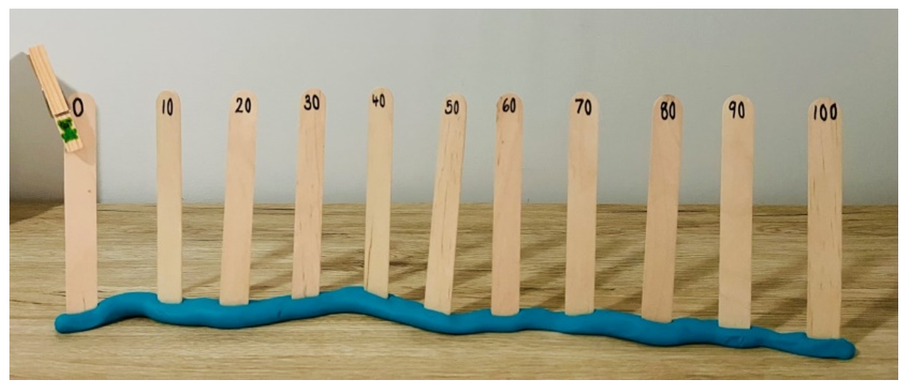
- Show Resource 9: Random number cards or use an interactive online random number selector inputting numbers from zero to 100 in the settings.
- Remind students that, when rounding to the nearest 10, they should look at the number in the ones place. If the number is 5 or greater, students should round the number up. If the number is 4 or less, they should round the number down.
- Explain that students are going to select a random number card or use an interactive random number generator and round the number to the nearest 10 by moving the frog to the log.
- Provide time for individual use of modelling clay and craft sticks to create a number line adding numbers from zero to 100 by tens on the craft sticks and drawing a frog onto a wooden peg.
- Students locate the nearest 10 to a number by moving the frog.
This table details assessment opportunities and differentiation ideas.
Assessment opportunities | Too hard? | Too easy?
What to look for:  - Can students count forwards and backwards by tens? (MAO-WM-01, MA1-RWN-01)  - Can students locate the nearest 10 to a number by representing numbers on a line? (MAO-WM-01, MA1-RWN-01)  What to collect:  - photographs of number line construction and gameplay (MAO-WM-01, MA1-RWN-01) | Students need further support to count forwards and backwards by tens and locate the nearest 10 to a number by representing numbers on a line.  - Show students an interactive hundreds chart and model rounding a number up when it is 5 or greater, and rounding the number down when it is 4 or less.  - Provide time for students to use the interactive hundreds chart to practise locating the nearest 10 when selecting a random number. | Students can confidently count forwards and backwards by tens and locate the nearest 10 to a number by representing numbers on a line.  - Play a game of ‘guess the missing number’ with a peer by removing one of the tens logs from the number line.  - Select a random number card and continue counting by tens from the nearest 10.

The fraction picnic – 30 minutes
This activity has been adapted from The teddy bears’ fraction picnic at NZ Maths.
- Tell a story about 2 frogs going on a picnic. Unfortunately, Frank the frog, who made the lunch, forgot to cut up the long roll equally. The 2 frogs are friends and always share their food equally.
- Display Resource 11: Half/not half. Ask students if they think the long roll is cut into 2 equal lengths. Prompt students to explain why or why not.
- Show students the stimulus Resource 10: One long roll.
- Ask students:
- What does equal lengths mean?
- How could this long roll be cut into 2 equal lengths?
- Students suggest ways to cut the long roll into 2 equal lengths, by drawing a line to indicate where the long roll should be cut, either digitally or by drawing on a copy of Resource 10: One long roll.
- Provide each student with Resource 12: Three long rolls. Ask students what other ways the 2 frogs could fold their long roll into 2 equal lengths, see Figure 14 for suggestions. Provide time for students to fold long rolls into 2 equal lengths in different ways.
- Explain that, when something is divided into 2 equal parts, the parts are called halves. Make a collection of long rolls that have and have not been divided into halves and discuss.
- Explain that paper long rolls can be folded to map one half onto the other by reflection or turning.
- Discuss with students how the 3 rolls can now be shared equally between the 2 frogs.
- Continue telling the story by introducing another 2 frogs to the picnic, making 4 frogs altogether. There is still only one long roll to share between 4 frogs. Ask how students could cut the long roll into 4 equal parts and what the parts would be called.
- Explain that when something is divided into 4 equal parts that these are called quarters.
- Provide time for students to discuss how they think a long roll could be partitioned into 4 equal parts and indicate where the long roll should be cut, either digitally or by drawing on a copy of Resource 10: One long roll.
- Ask students to compare one quarter to one half and ask how many quarters are equal to one half.
- Students now need to share 3 long rolls between the 4 frogs.
- Provide students with Resource 12: Three long rolls. Students fold the 3 long rolls into half and then one half folded in half again to form quarters. See Figure 14.
- Discuss with students how the 3 rolls can now be shared equally between the 4 frogs.
- Students cut out and model how 4 frogs shared the 3 rolls equally at their picnic.
Figure 14 – Quarter folding
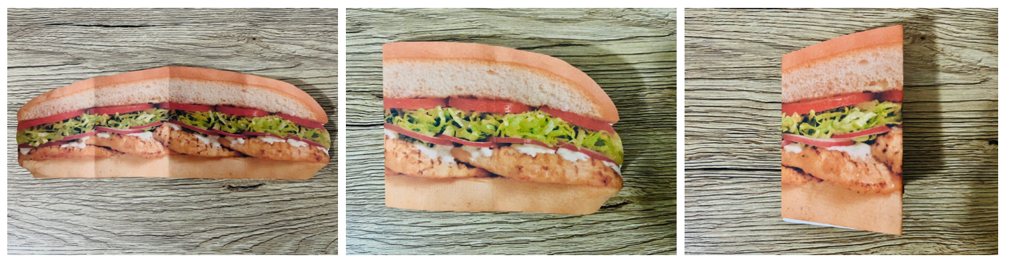
Images sourced from Canva and used in accordance with the Canva Content License Agreement.
This table details assessment opportunities and differentiation ideas.
Assessment opportunities | Too hard? | Too easy?
What to look for:  - Can students divide lengths into halves and quarters? (MAO-WM-01, MA1-GM-03)  - Can students recognise when lengths have or have not been divided into halves and quarters? (MAO-WM-01, MA1-GM-03)  What to collect:  - problem-solving activity to find half/quarters of a long roll (MAO-WM-01, MA1-GM-03)  - photographs of the frog picnic (MAO-WM-01, MA1-GM-03) | Students need further support to divide lengths into halves and quarters and recognise when lengths have not been divided equally.  - Model halves and quarters by dividing sticks into parts to see the relationship between the parts and the whole length (See Figure 15).  - Provide time for students to divide sticks into parts to show halves and quarters. Ask how many halves make a whole and how many quarters make a whole. | Students confidently divide lengths into halves and quarters and recognise when lengths have not been divided equally.  - Introduce 2 more frogs and ask students to share the rolls equally.  - Challenge students to find alternative ways to divide a long roll into 4 pieces so that all frogs still receive the same amount.
Figure 15 – Whole/halves/quarters
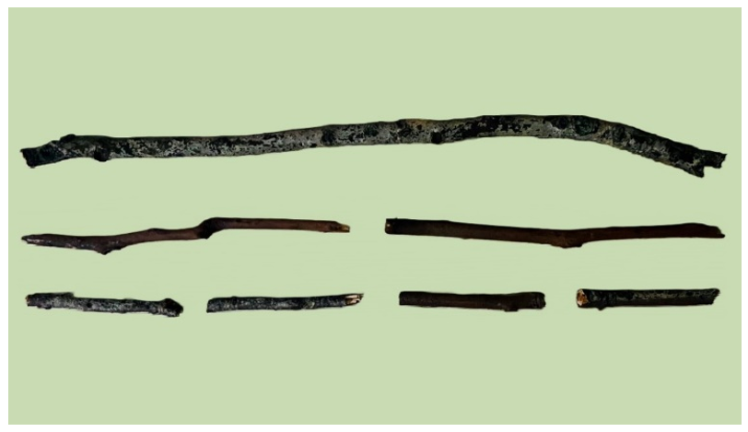

Consolidation and meaningful practice: Making long rolls – 15 minutes
- Provide time for students to make a long roll from modelling clay (see Figure 16). Use a craft stick to cut the long roll into halves and quarters for the frogs.
Figure 16 – Modelling clay roll
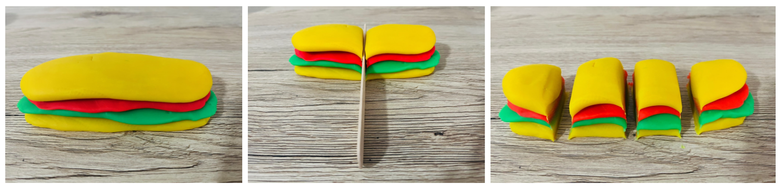

Lesson 7: Divide it up!
Core concept: Collections of objects can be shared and grouped.
The table below contains suggested learning intentions and success criteria. These are best co-constructed with students.
Learning intentions | Success criteria
Students are learning that:  - three-digit numbers are formed, regrouped, and renamed in different ways  - division can be modelled by distributing a collection of objects equally into groups  - grouping division can be modelled by determining the number of groups  - when a collection cannot be distributed equally, they can describe the part left over. | Students can:  - form, regroup, and rename three-digit numbers  - model division by creating equal groups  - model grouping division by sharing the collection equally to determine the number of groups  - describe the part left over when a collection cannot be distributed equally.

Daily number sense: Place value wrangle – 10 minutes
- Build student understanding of place value by forming, regrouping, and renaming three-digit numbers in different ways.
- Students play ‘place value wrangle’ in pairs. Place a deck of playing cards face down with all picture cards removed from the deck except for the joker which can equal any number. Students each turn over 3 cards and form the largest three-digit number. The student with the largest number gets a point which will be recorded using a tally mark.
This table details assessment opportunities and differentiation ideas.
Assessment opportunities | Too hard? | Too easy?
What to look for:  - Can students form, regroup, and rename three-digit numbers? (MAO-WM-01, MA1-RWN-01)  What to collect:  - observations of game-based learning opportunity (MAO-WM-01, MA1-RWN-01) | Students need further support to form, regroup and rename three-digit numbers.  - Model forming a three-digit number, drawing students' attention to ordering the 3 cards from largest to smallest.  - Provide time to practise ordering playing cards from largest to smallest to form three-digit numbers. | Students confidently form, regroup, and rename three-digit numbers.  - Say the number before and after the three-digit number formed.  - Challenge students to form the largest four-digit number by turning over 4 cards.

Sharing the sausages – 30 minutes
This activity is adapted from ‘Sharing the Sausages’ (2022).
- Model division by creating equal groups, sharing collections equally and describing the part left over by viewing Sharing the Sausages (2:06).
- Use a collection of sticks to represent sausages to support students’ responses to questions about the video.
- Ask students:
- How many sausages would Prime have eaten if she didn’t share with the other dogs?
- If Al and Ada only had enough money to buy each dog 2 sausages, how many sausages could they buy?
- If 8 sausages fell out of the bag, how many would be left?
- If 2 more dogs came to dinner and each was given 4 sausages, how many sausages would be needed?
- Use ‘Talk moves’ to facilitate class discussion.
- Tell a story about Al and Ada taking the 4 dogs for a bush walk and collecting sticks along the way. Display Resource 13: Stick collection and explain to students that this photograph is of the 12 sticks that Al and Ada collected.
- Model creating a stick collection. Ask students how many sticks there are in total. Ask how many sticks would be in each group, if Al shared half of the stick collection with Ada. Demonstrate sharing division by distributing the collection equally into 2 groups to determine how many in each group. For example, 12 sticks spilt between 2 groups would be equal to 2 groups of 6 sticks.
- Continue telling the story by explaining that Prime found 3 more sticks on their bush walk. Al and Ada decided to take all sticks home with them to share between the 4 dogs.
- Display Resource 14: Larger stick collection and explain to students that this photograph is of the sticks that Al and Ada collected with the 3 sticks that Prime added to the collection.
- Provide time for students to create a stick collection with a peer. Ask questions such as:
- How many sticks are there in total?
- If Al and Ada share the collection of sticks equally between the 4 dogs, how many will each dog get?
- Will there be any sticks left over? If so, how many?
- Use Think-Pair-Share to discuss. Use this time to listen to student thinking and invite students to share their ideas with the class.

Consolidation and meaningful practice: Dice division – 20 minutes
- Give 20 gumnuts to pairs of students.
- Students play ‘dice division’ with a peer. Students first roll a die to determine the number of groups, then roll a second die to determine the number of objects in each group.
- Once the dice are thrown, students place gumnuts in groups to reflect the numbers rolled. Use of sectional recycled packaging, such as an egg carton, may help students group the objects. Figure 17 shows the dice and 3 groups of 4 gumnuts.
- Students repeat the game several times to practise grouping objects.
Figure 17 – Gumnut groups
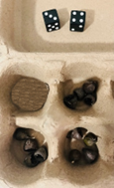
- Alter the game by using only one die. The collection will be divided into groups shown by the number on the die. For example, if a 4 is rolled, then 4 groups of 5 are created. If a 6 is rolled, then 6 groups of 3 and there are 2 left over. (see Figure 18).
- Introduce the language of leftover parts.
Figure 18 – Gumnuts left over
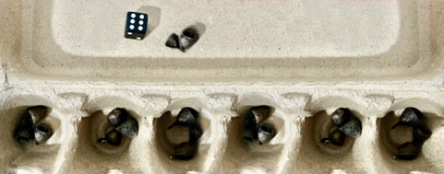
- Provide time for students to play ‘dice division’.
This table details assessment opportunities and differentiation ideas.
Assessment opportunities | Too hard? | Too easy?
What to look for:  - Can students model division by creating equal groups? (MAO-WM-01, MA1-FG-01)  - Can students model grouping division by sharing the collection equally to determine the number of groups? (MAO-WM-01, MA1-FG-01)  - Can students describe the part left over when a collection cannot be distributed equally? (MAO-WM-01, MA1-FG-01)  What to collect:  - photographs of game-based learning opportunities (MAO-WM-01, MA1-FG-01)  - recordings of student voice. (MAO-WM-01, MA1-FG-01) | Students need further support to model division by creating equal groups, share collections equally and describe the part left over.  - Model drawing pictures using tally marks and using one-to-one correspondence to create equal groups.  - Provide time to use hoops and share a collection of bean bags. | Students confidently model division by creating equal groups, share collections equally and describe the part left over.  - Students tell and draw their own story that includes equal groups, sharing collections equally and with a part left over.  - Model the story using a range of different objects.

Lesson 8: Shapes all around us
Core concept: Three-dimensional (3D) objects can be recognised, sorted, and described by their features.
The table below contains suggested learning intentions and success criteria. These are best co-constructed with students.
Learning intentions | Success criteria
Students are learning that:  - three-digit numbers are formed, regrouped, and renamed in different ways  - familiar three-dimensional objects can be recognised, sorted, and described using the terms ‘face’, ‘edge’ and ‘vertex’  - flat surfaces of three-dimensional objects can be recognised and named as two-dimensional shapes  - three-dimensional objects can be represented by making simple models. | Students can:  - form, regroup, and rename three-digit numbers  - recognise, sort, and describe familiar three-dimensional objects  - trace around the flat surfaces of three-dimensional objects to recognise and name two-dimensional shapes  - make simple three-dimensional models using sticks.

Daily number sense: Place value scavenger hunt – 20 minutes
- Build student understanding of place value by stating the quantity value of digits in numbers of up to 3 digits.
- Students play ‘place value scavenger hunt’ by looking for three-digit numbers using catalogues, magazines, and food packaging. See Resource 15: Scavenger hunt template.
- Model an example by using 1-2 numbers from the template. Students will need to look for a three-digit number with a 6 in the tens place, or a zero in the ones place.
- Model cutting a number out and gluing it beside the clue it matches on Resource 15: Scavenger hunt template.
- Provide time for students to find three-digit numbers and cut and paste to match the clues to complete the scavenger hunt.
Assessment opportunities | Too hard? | Too easy?
What to look for:  - Can students identify three-digit numbers that fit the clues? (MAO-WM-01, MA1-RWN-02-01)  - Can students identify the largest number they found and justify their answer? (MAO-WM-01, MA1-RWN-02)  What to collect:  - completed scavenger hunt templates. (MAO-WM-01, MA1-FG-01) | Students need further support to partition and rename three-digit numbers.  - Provide further practise to partition and rename two-digit numbers.  - Model further examples of three-digit numbers. | Students partition and rename three-digit numbers.  - Students name the number before and after each three-digit number they identify.  - Students choose 2 numbers from their scavenger hunt and add them together.

3D Venn diagram – 20 minutes
- Reinforce the names of everyday 3D objects by viewing Identifying 3D Shapes (1:13).
- Demonstrate the game ‘Can you guess the sorting rule?’ by using hoops to create a Venn diagram. Sort everyday 3D objects according to their features, for example, number of faces, edges, and vertices or whether they have a flat or curved surface.
- Explain that a Venn diagram shows the relationship between 2 groups.
- Display Resource 16: 3D Venn diagram showing flat and curved surfaces and ask if students can guess the sorting rule.
- Provide time for students to play ‘Can you guess the sorting rule?’ using a Venn diagram.
- After the game, explain to students that they are going to trace around the flat surface of everyday three-dimensional objects used in the game to recognise and name the two-dimensional shapes revealed.
This table details assessment opportunities and differentiation ideas.
Assessment opportunities | Too hard? | Too easy?
What to look for:  - Students can recognise, sort, and describe familiar three-dimensional objects? (MAO-WM-01, MA1-3DS-01)  - Students can trace around the flat surfaces of three-dimensional objects to recognise and name two-dimensional shapes? (MAO-WM-01, MA1-3DS-01)  What to collect:  - student Venn diagrams and work samples. (MAO-WM-01, MA1-3DS-01) | Students need further support to recognise, sort, describe, and trace three-dimensional objects to recognise and name two-dimensional shapes.  - Go on a shape hunt for 3D objects in the classroom environment and model how to identify the two-dimensional shape of the flat surface.  - Sort the 3D objects found in the classroom environment by their features and explain the similarities and differences. | Students confidently recognise, sort, describe, and trace three-dimensional objects to recognise and name two-dimensional shapes.  - Find and record a 3D object with more than 5 edges.  - Find and record a 3D object with more than 4 vertices.

Consolidation and meaningful practice: 3D stick structures – 20 minutes
- Ask students to select an everyday 3D object used in the previous activity.
- Count the number of sides and collect a corresponding number of sticks.
- Model constructing a simple model of a three-dimensional object by creating the base first. For example, if constructing a cube, (See Figure 19), create a square first then continue to build upwards joining the vertices with modelling clay.
Figure 19 – 3D stick cube
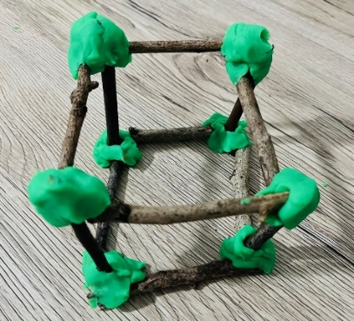
- Provide time to create simple models of 3D objects using sticks.

Resource 1: Secret garden
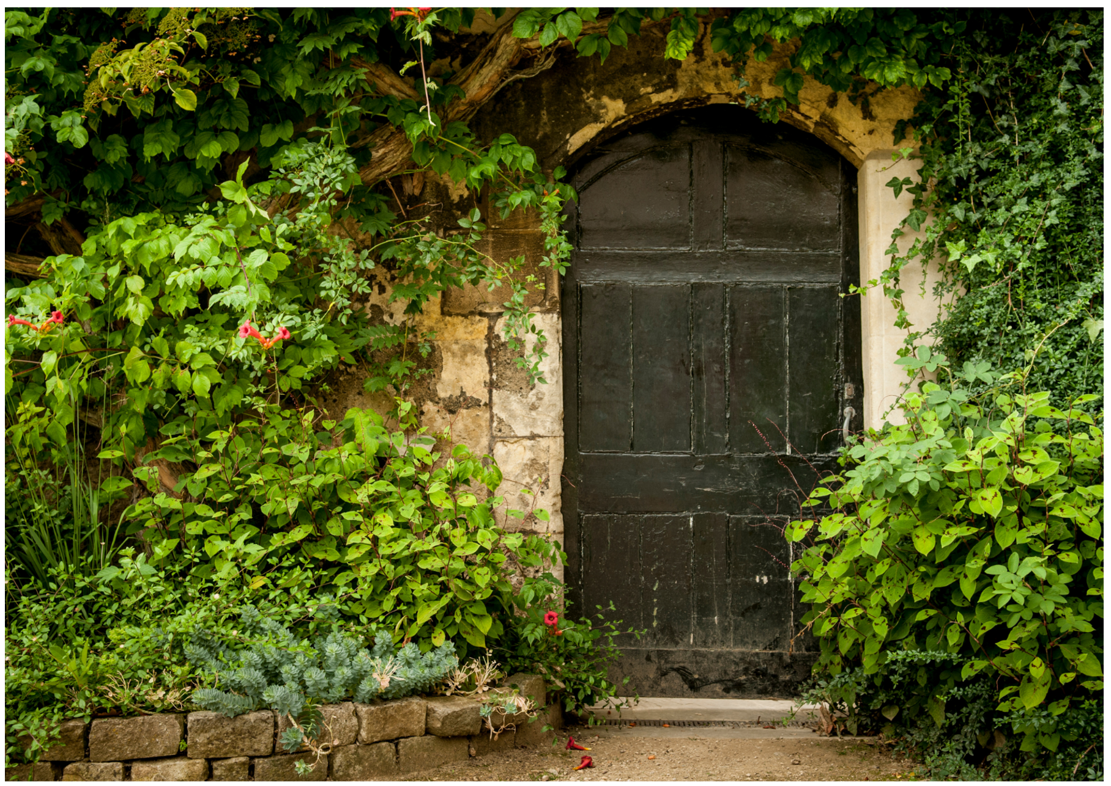
Images sourced from Canva and used in accordance with the Canva Content License Agreement.

Resource 2: Isometric triangle paper

Resource 3: Arrow
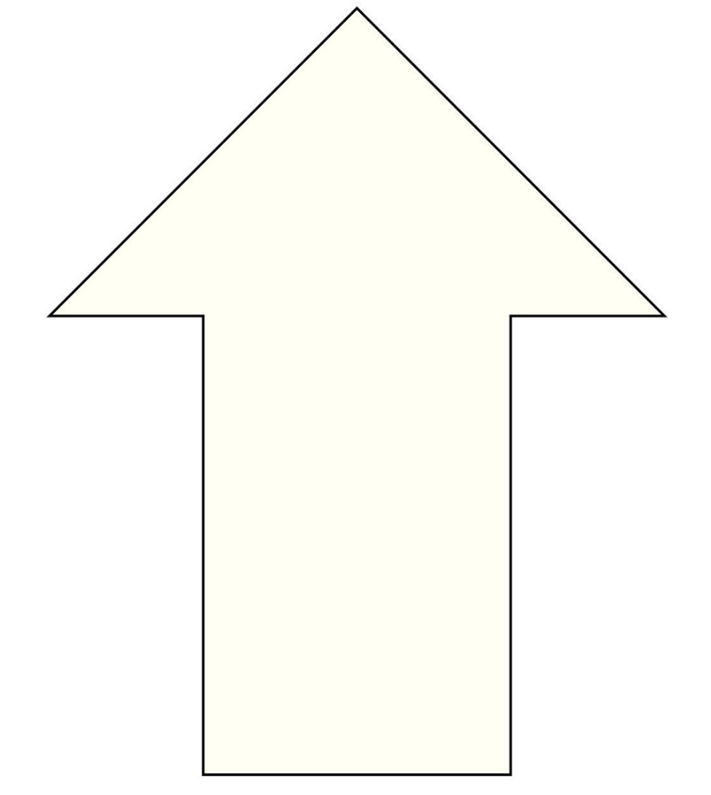

Resource 4: Pentagons reflected
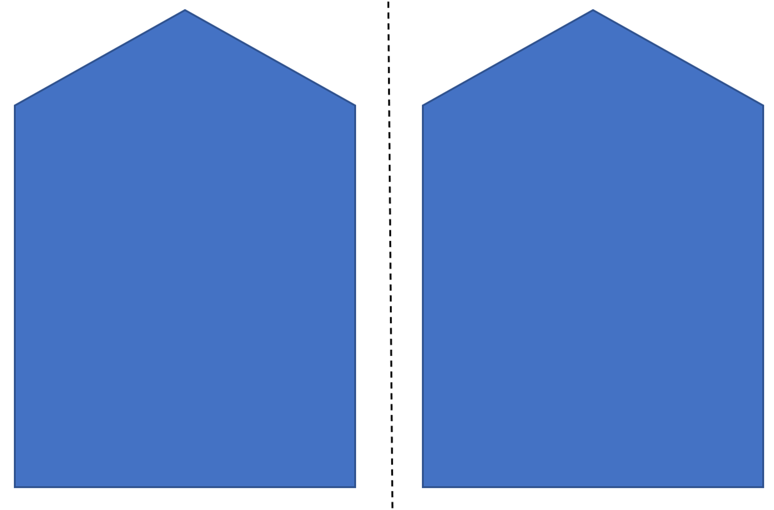

Resource 5: Shape transformer cards
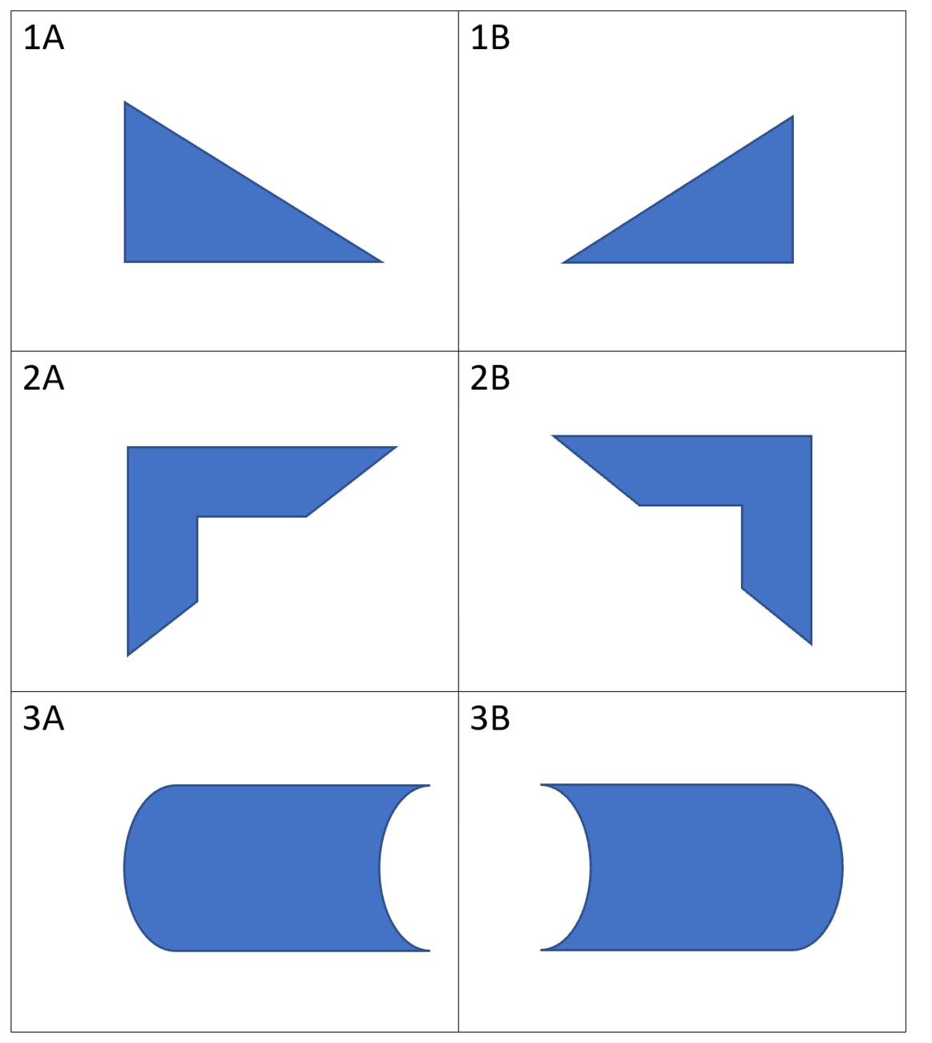
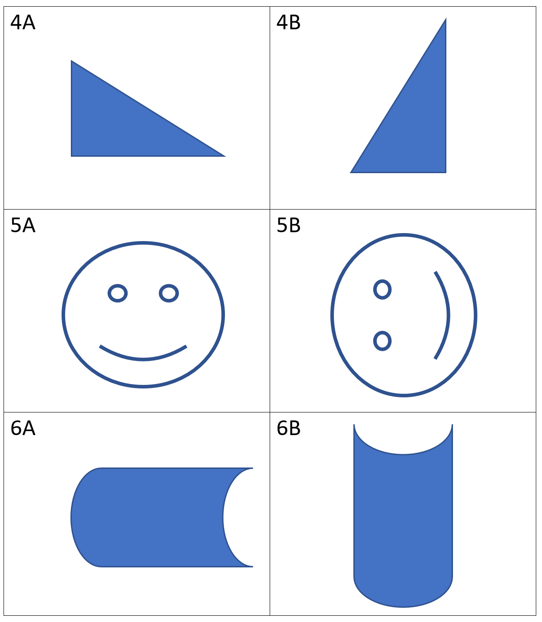
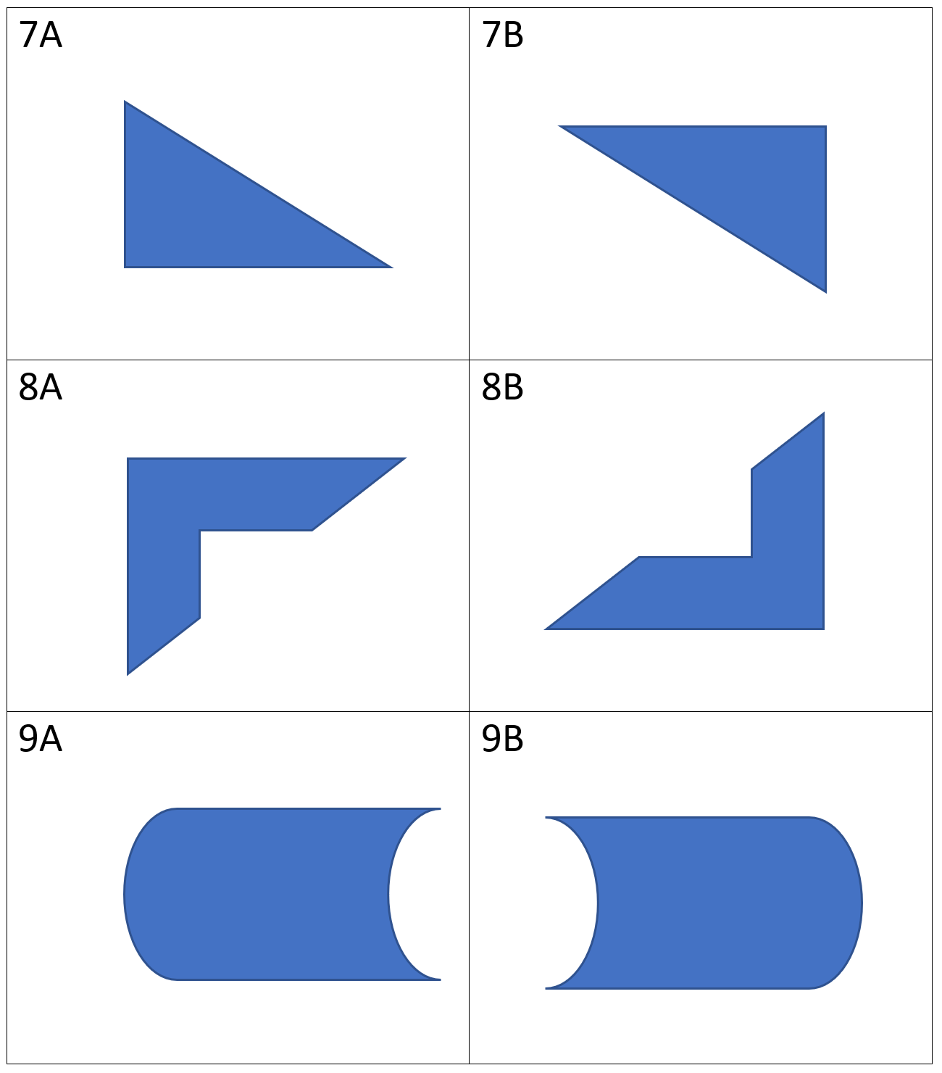

Resource 6: Symmetry puzzles
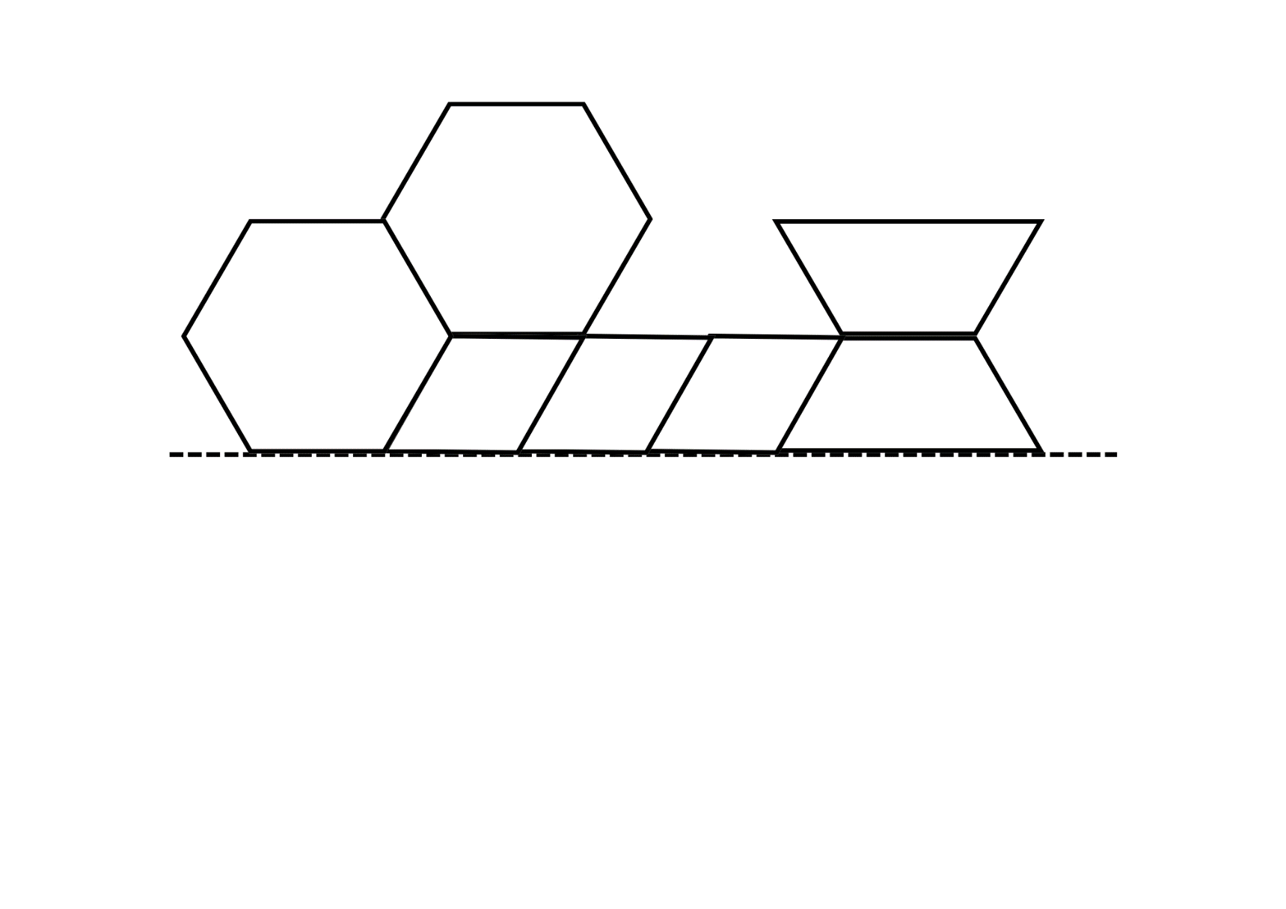
Adapted from Moss et. al. (2016).
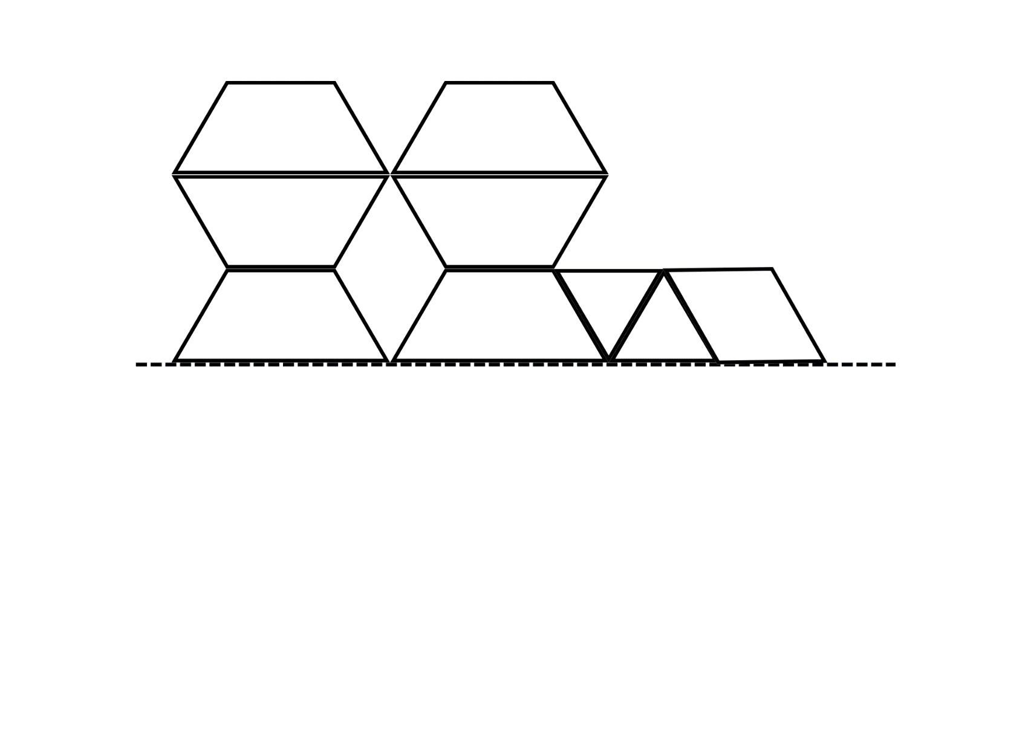
Adapted from Moss et. al. (2016).
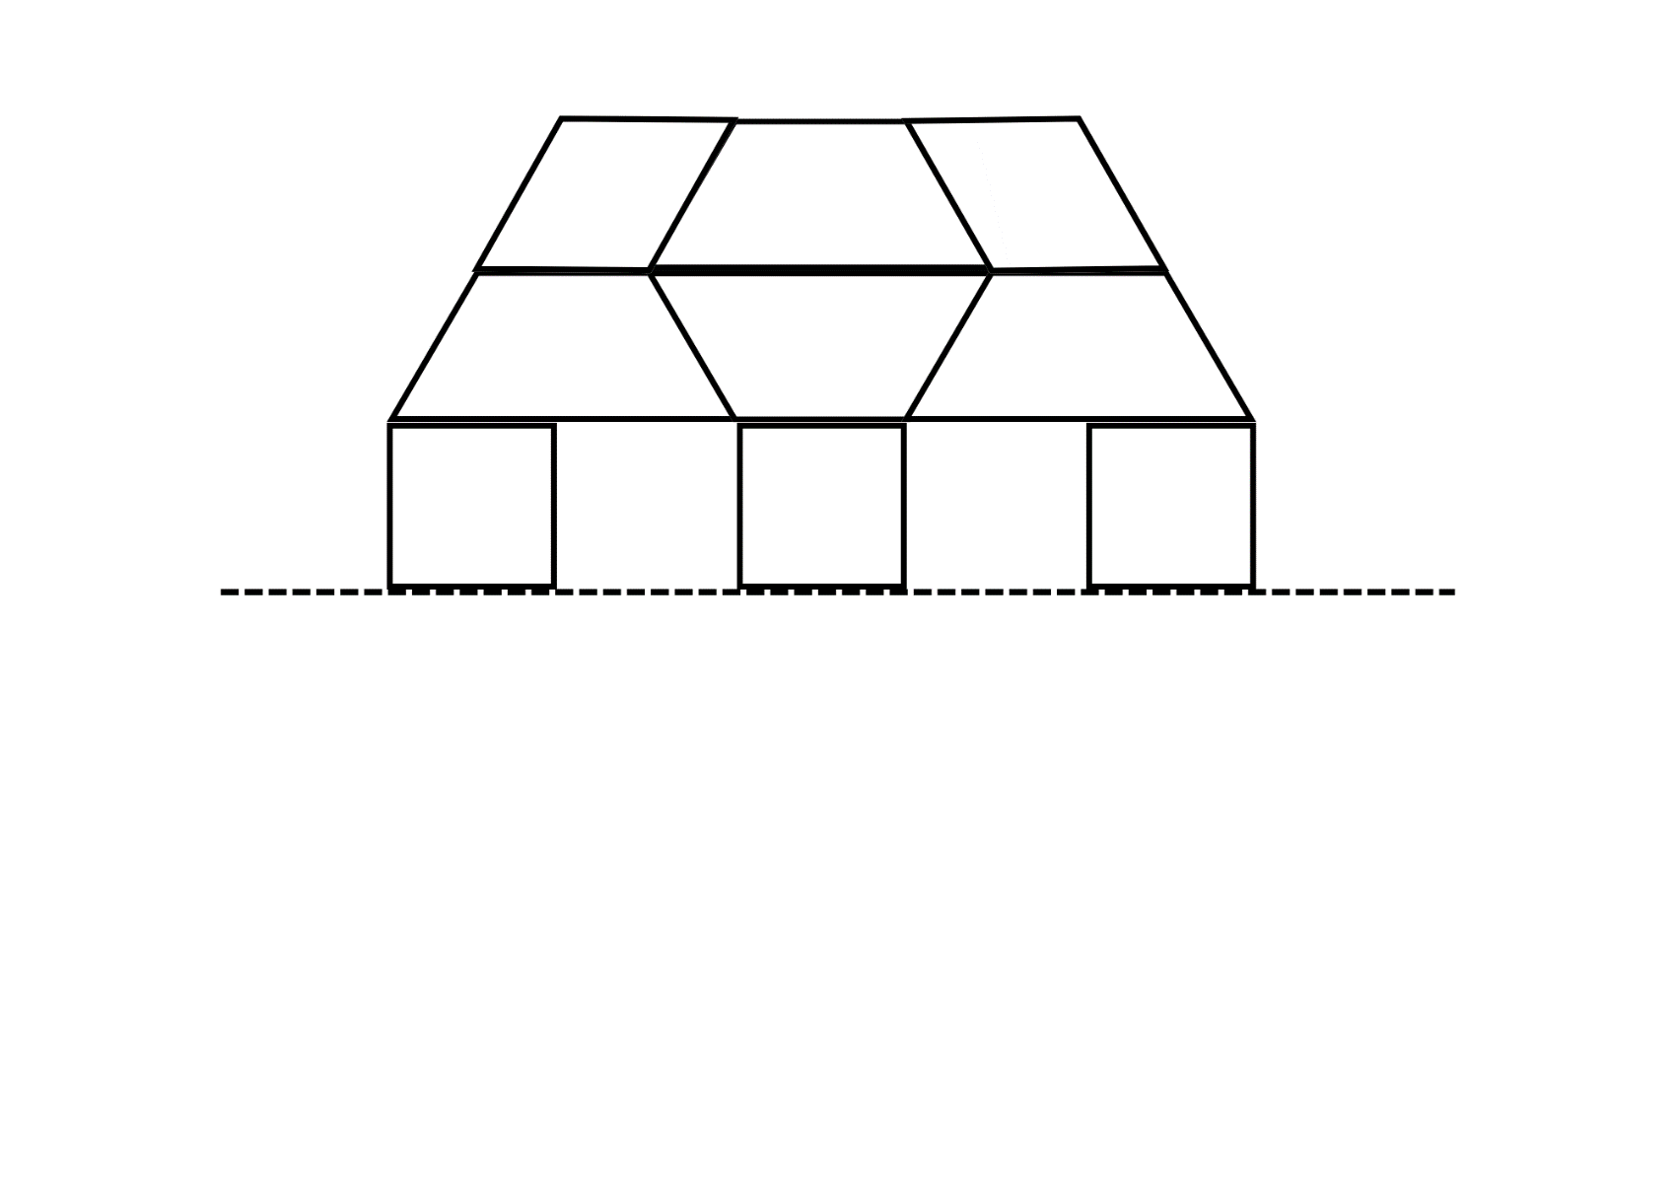
Adapted from Moss et. al. (2016).
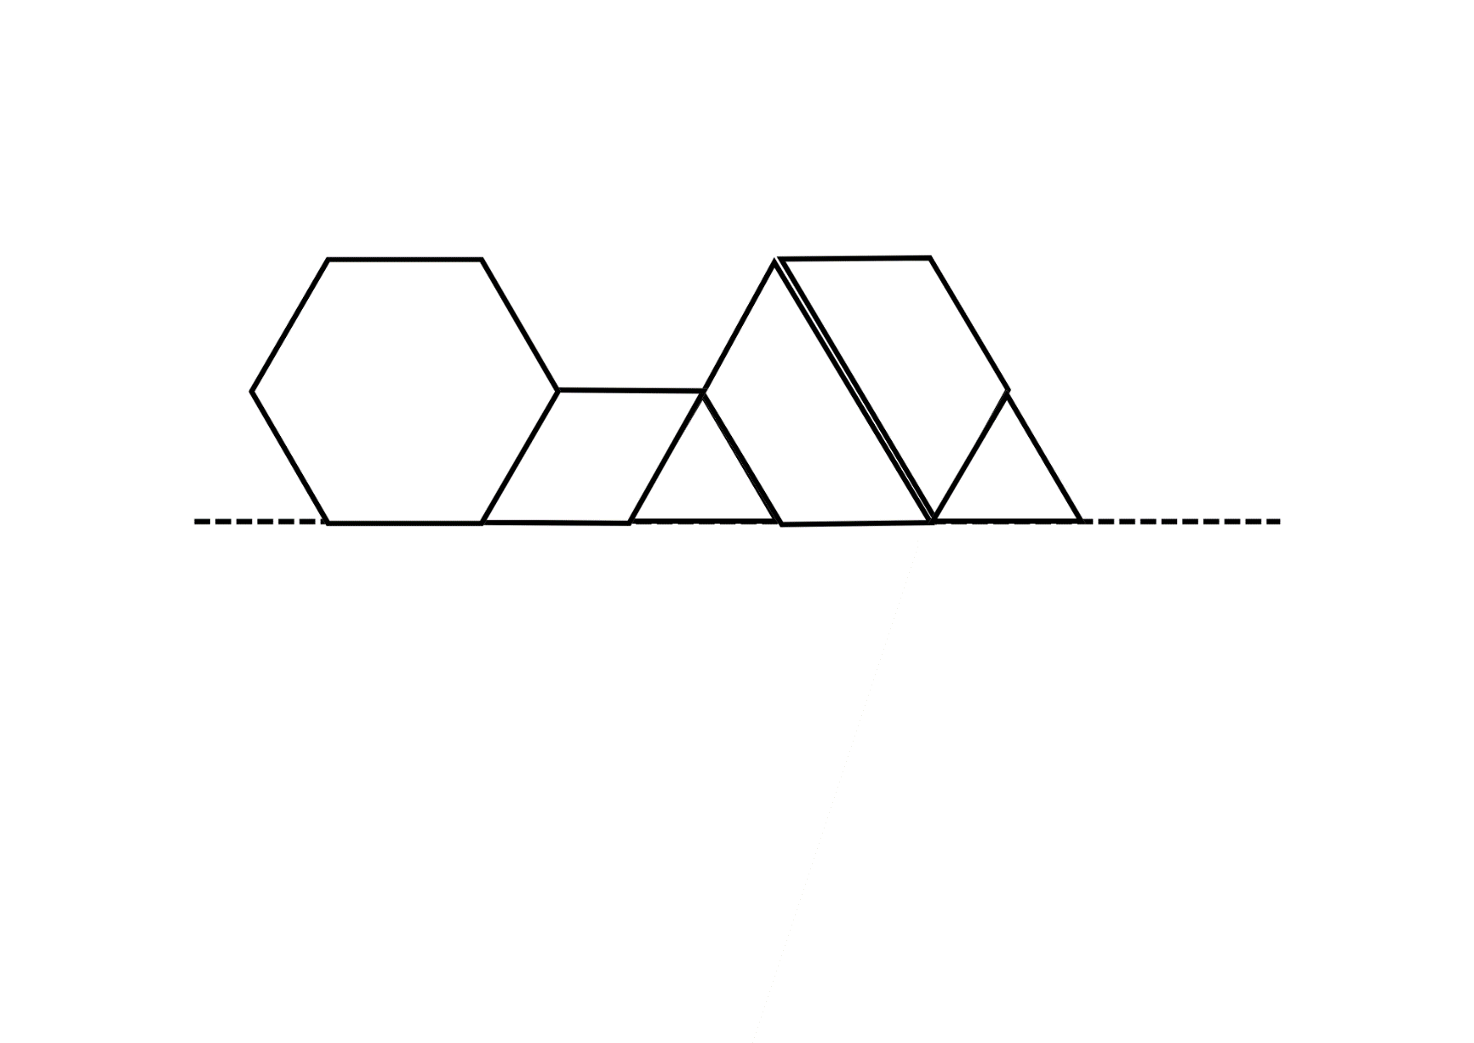
Adapted from Moss et. al. (2016).
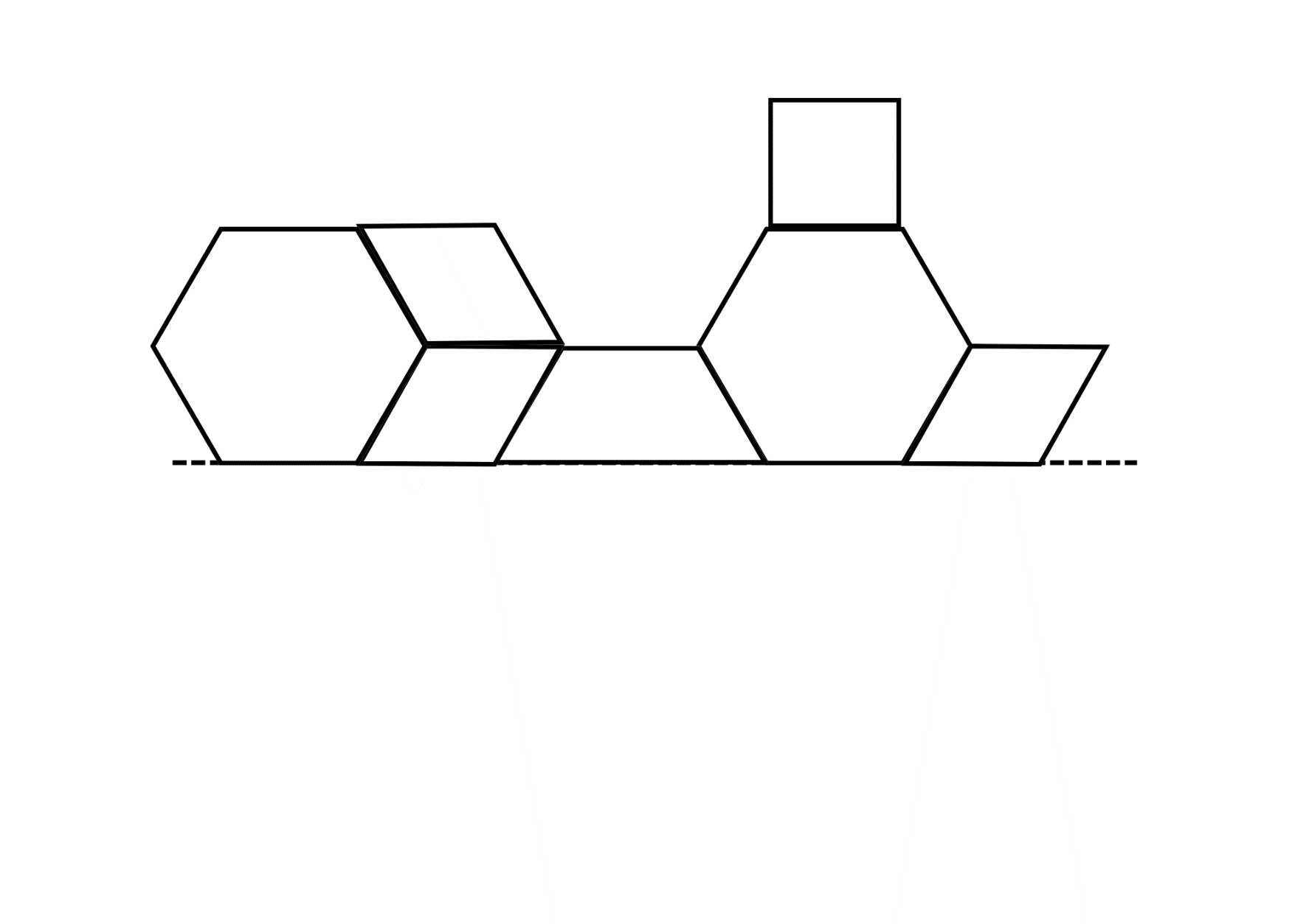
Adapted from Moss et. al. (2016).
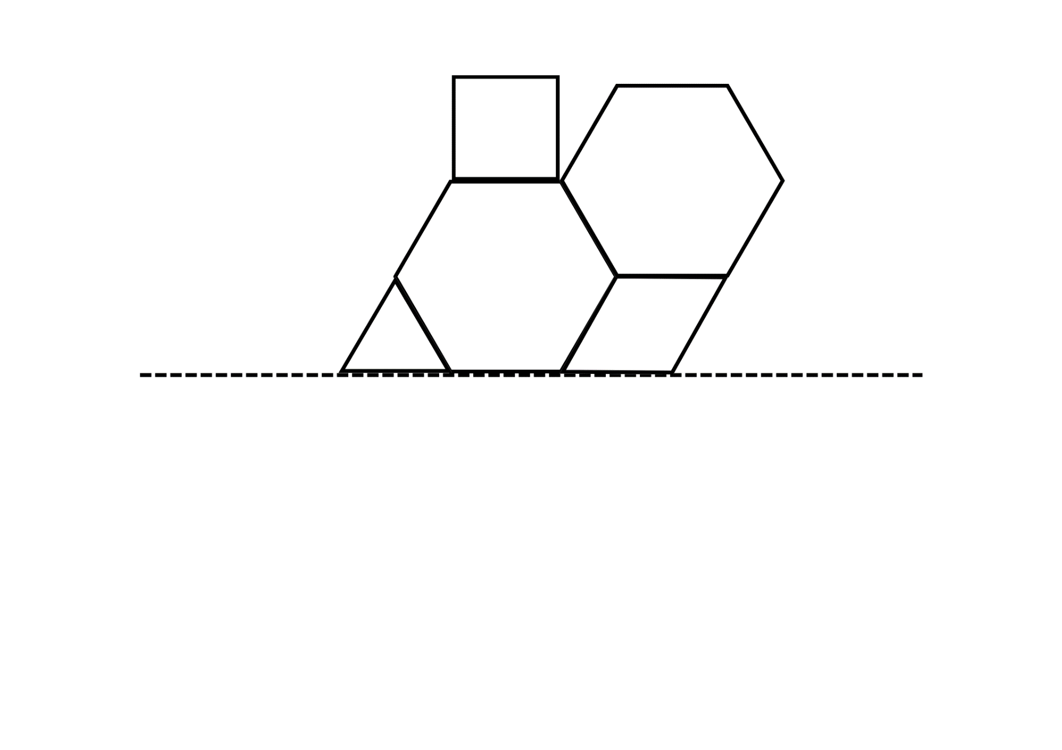
Adapted from Moss et. al. (2016).

Resource 7: Pentominoes
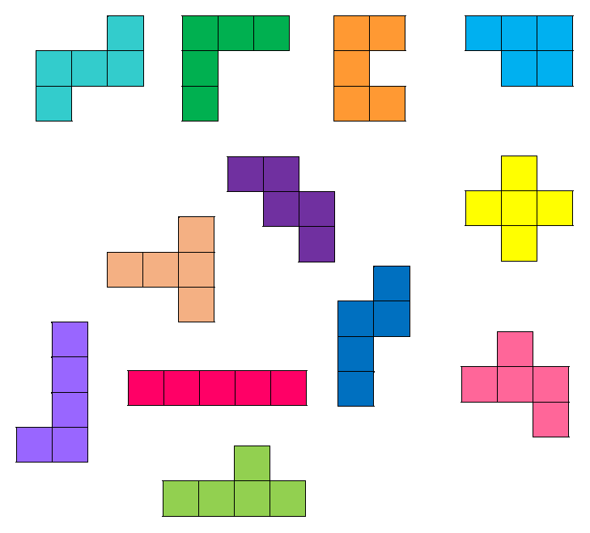

Resource 8: Pentomino grid
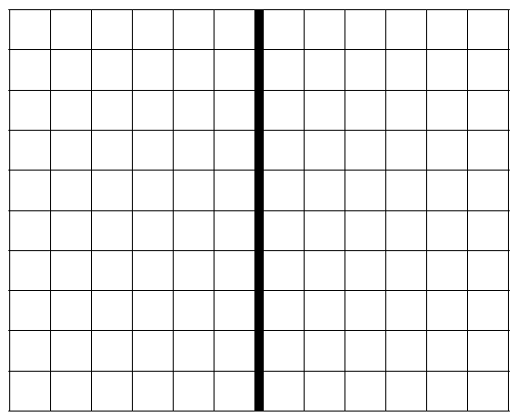

Resource 9: Random number cards
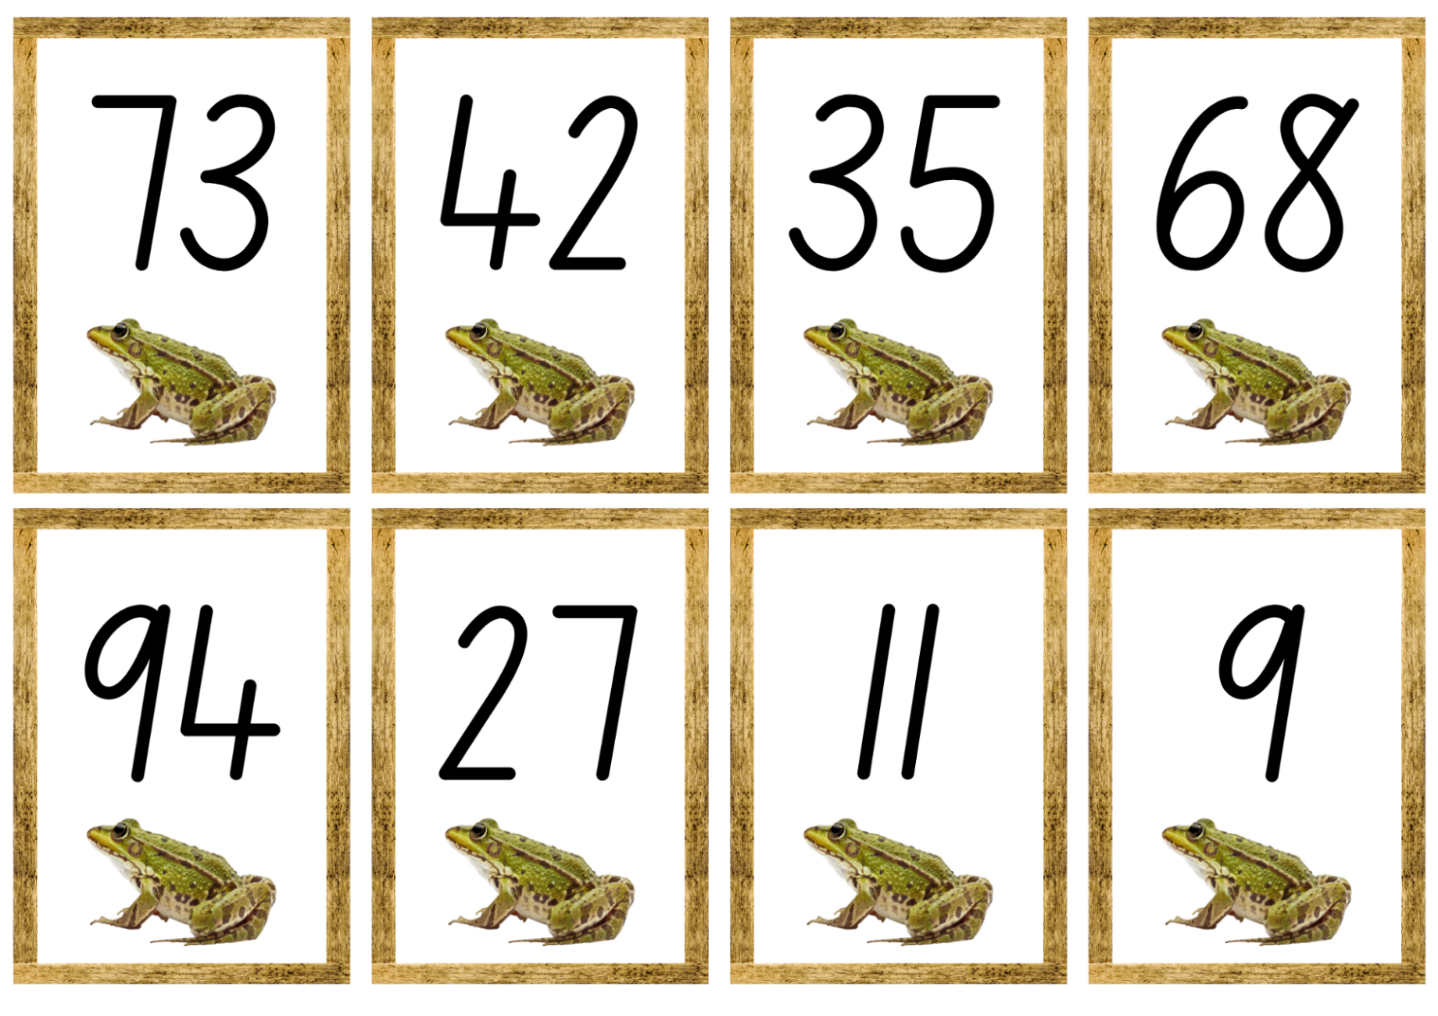
Images sourced from Canva and used in accordance with the Canva Content License Agreement.
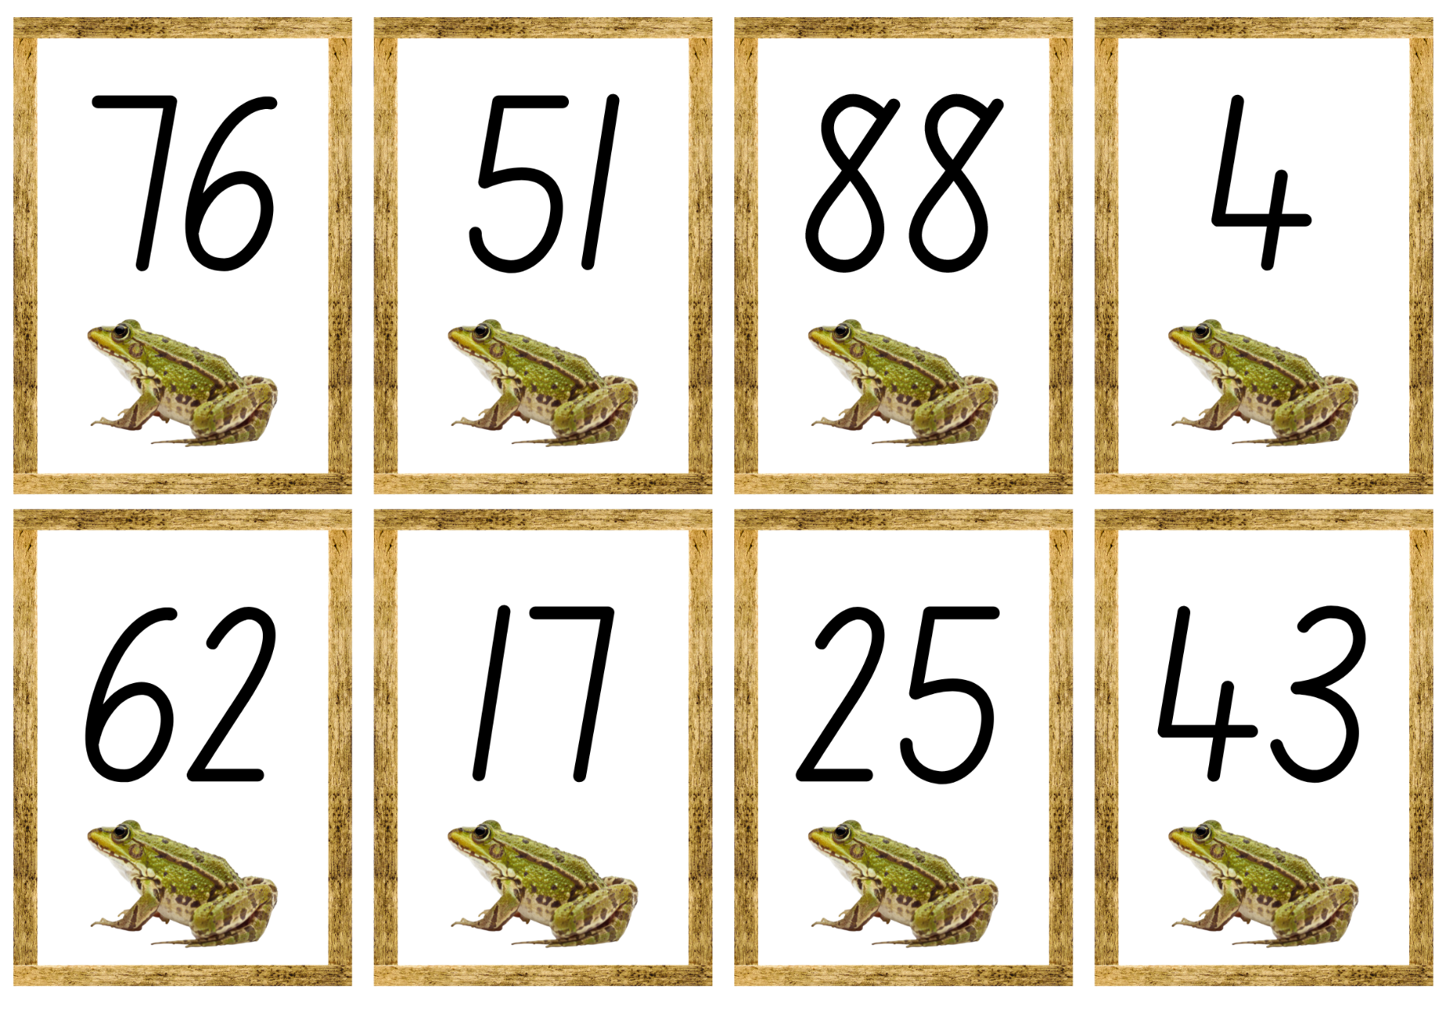
Images sourced from Canva and used in accordance with the Canva Content License Agreement.

Resource 10: One long roll
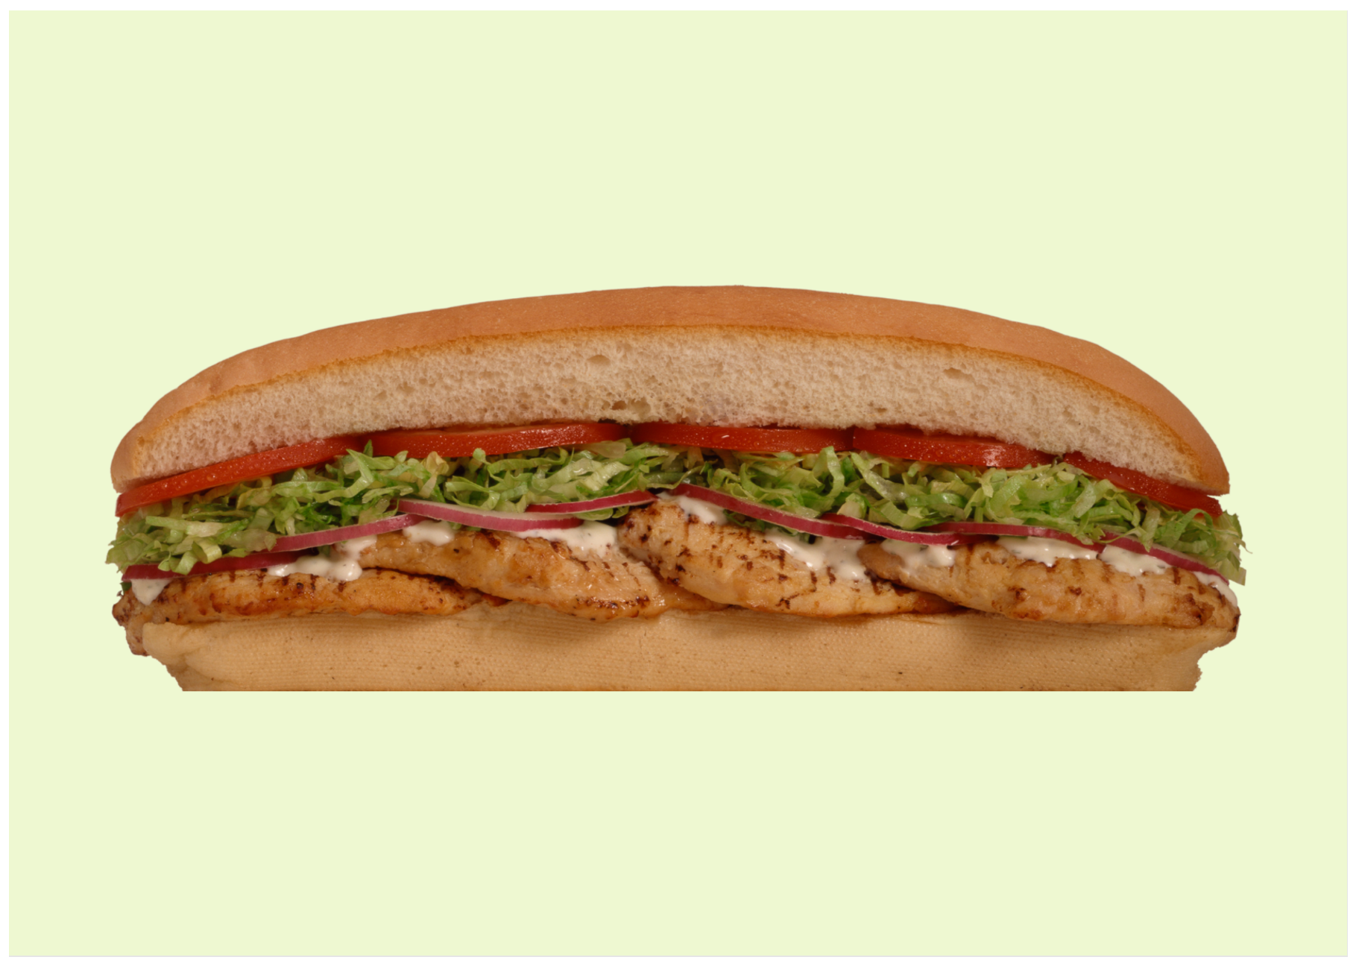
Images sourced from Canva and used in accordance with the Canva Content License Agreement.

Resource 11: Half/not half
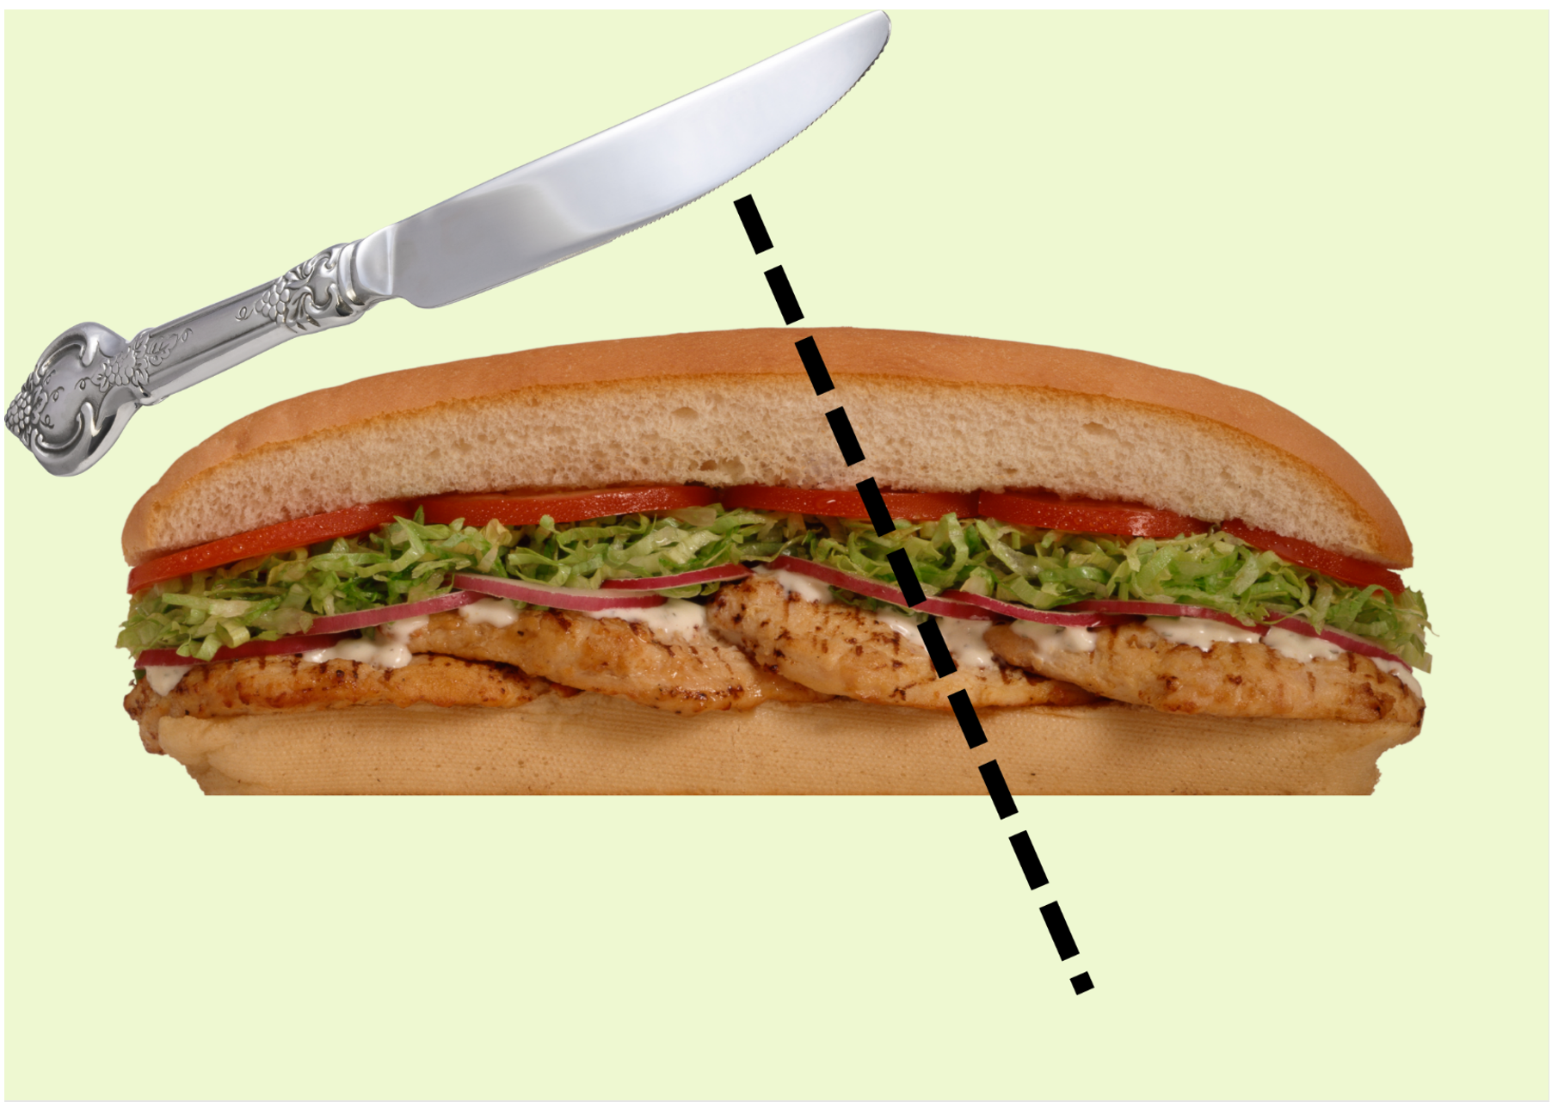
Images sourced from Canva and used in accordance with the Canva Content License Agreement.

Resource 12: Three long rolls
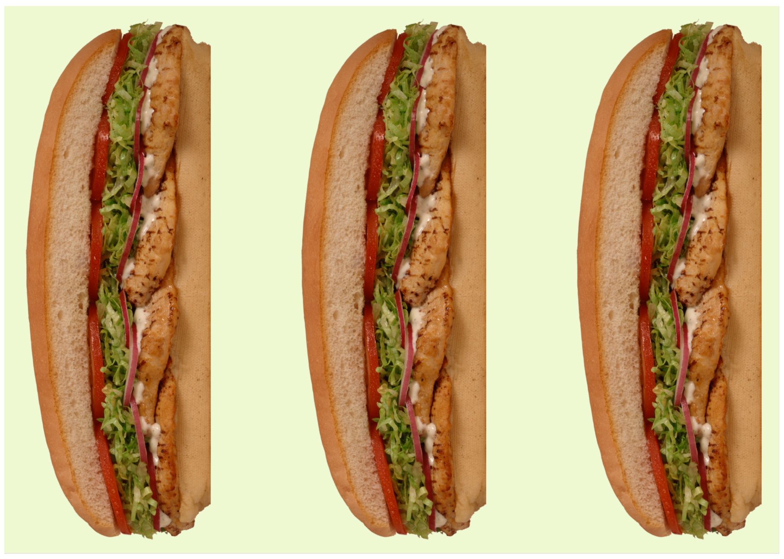
Images sourced from Canva and used in accordance with the Canva Content License Agreement.

Resource 13: Stick collection
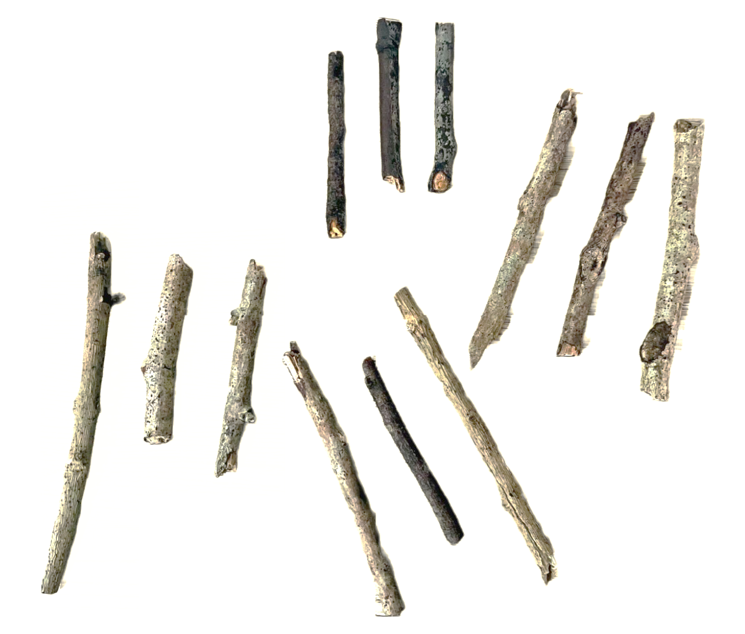

Resource 14: Larger stick collection
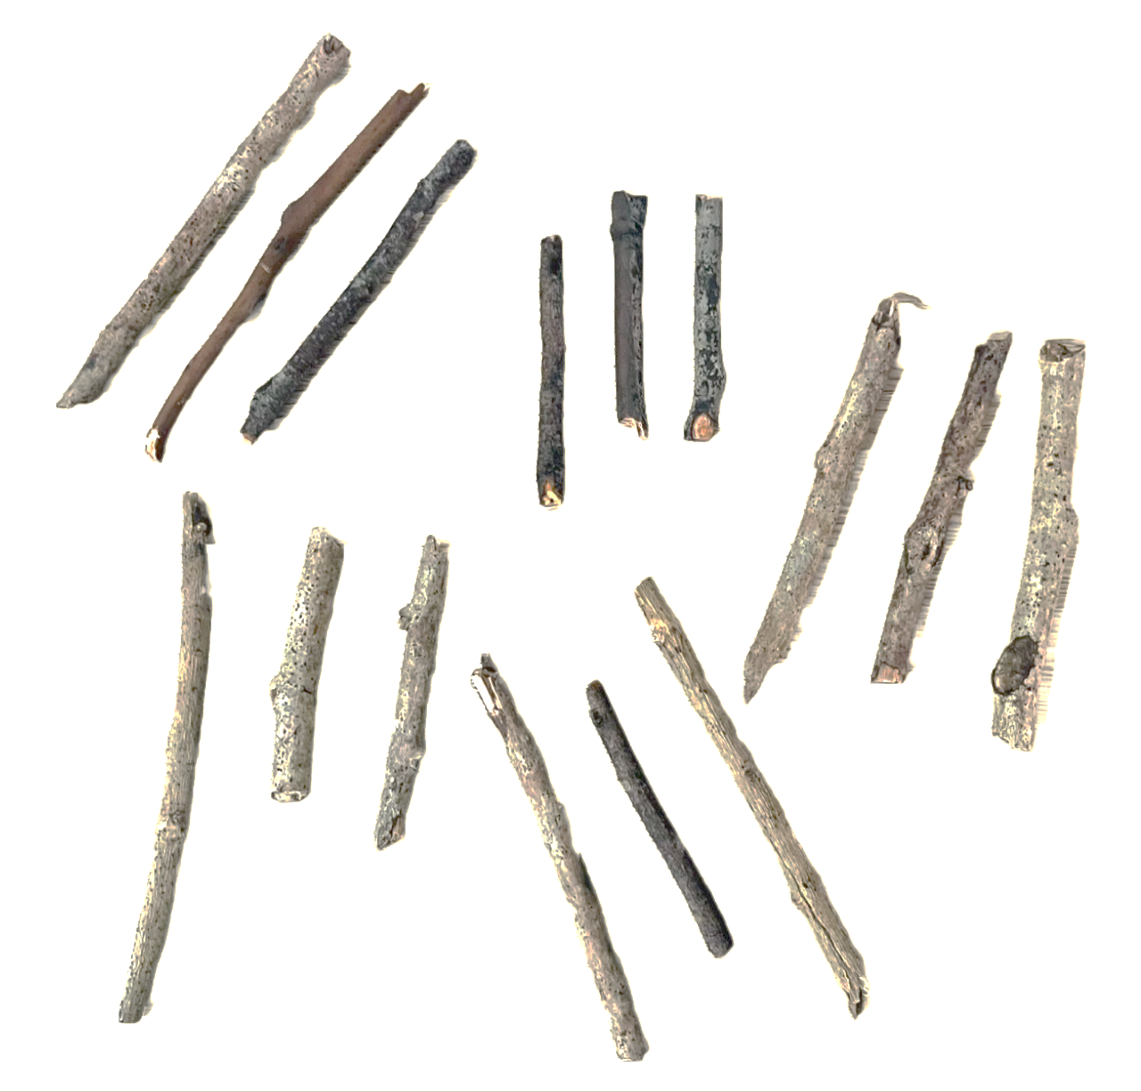

Resource 15: Scavenger hunt template
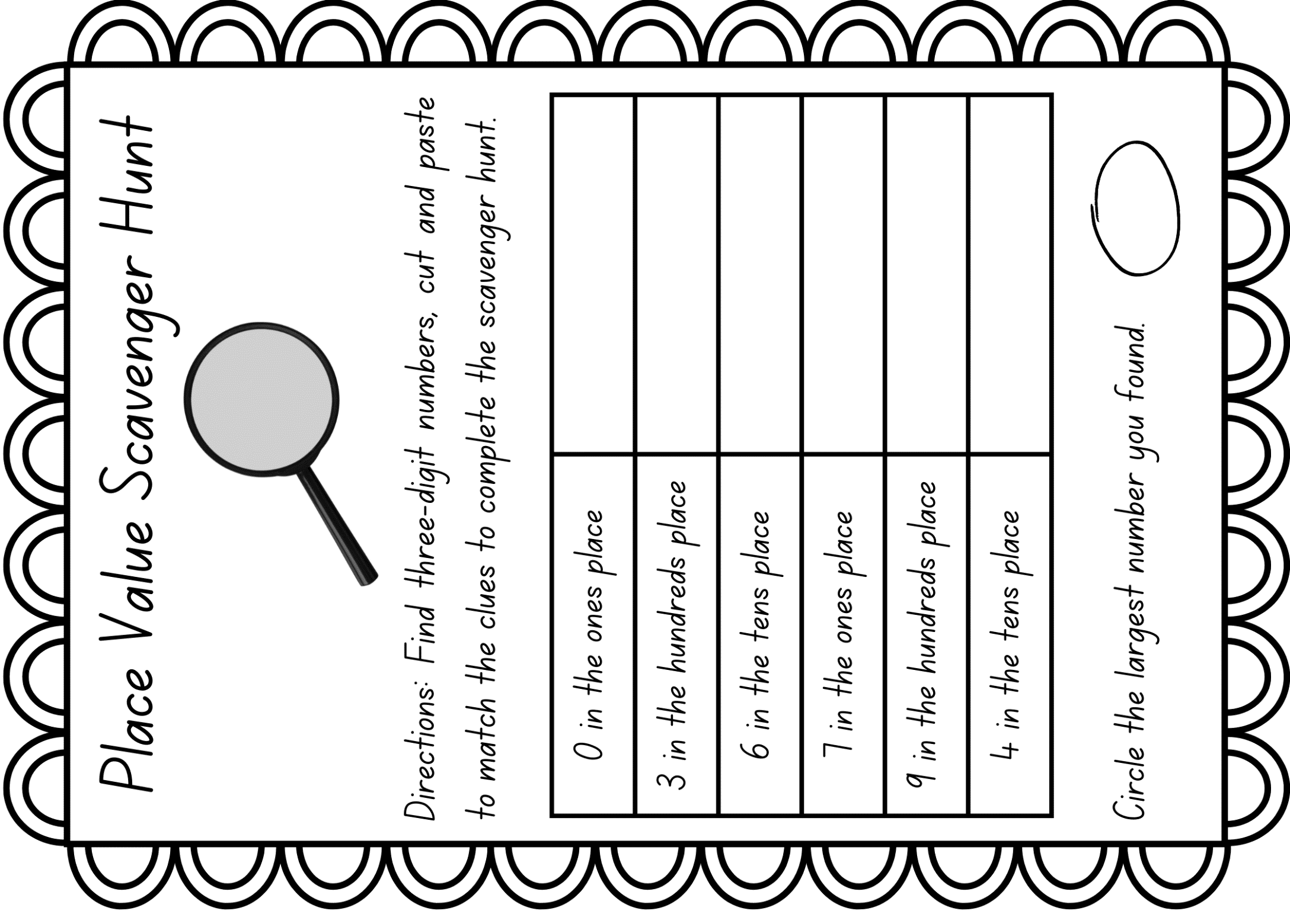
Images sourced from Canva and used in accordance with the Canva Content License Agreement.

Resource 16: 3D Venn diagram
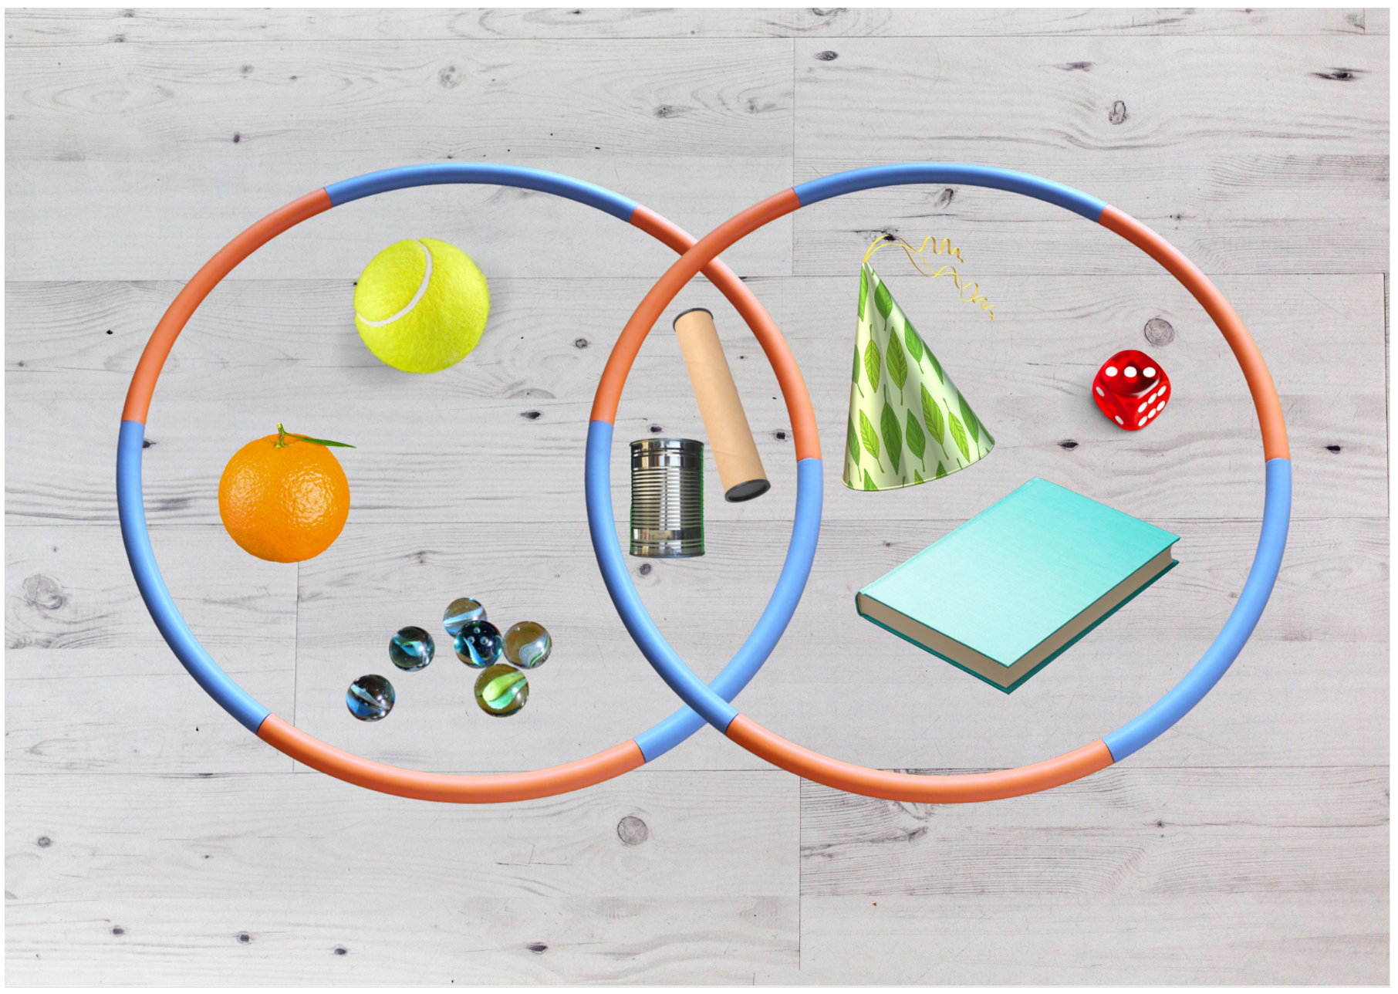
Images sourced from Canva and used in accordance with the Canva Content License Agreement.

Syllabus outcomes and content
The table below outlines the syllabus outcomes and range of relevant syllabus content covered in this unit. Content is linked to National Numeracy Learning Progression version (3).
Focus area and outcomes | Content groups and content points | Lessons
Representing whole numbers A  MAO-WM-01  MA1-RWN-01 | Use counting sequences of ones with two-digit numbers and beyond  - identify the number before and after a given two-digit number (CPr5)  - count forwards and backwards by ones from a given number to at least 120 (CPr6)  Continue and create number patterns  - model and describe 'odd' and 'even' numbers using items paired in two rows  - count forwards and backwards by twos from any starting point (CPr6-CPr7, MuS2)  Represent numbers on a line  - sequence numbers and arrange them on a line by considering the order and size of those numbers (CPr5)  - locate the approximate position of multiples of 10 on a model of a number line from 0 to 100 (CPr5)  Represent the structure of groups of ten in whole numbers  - recognise that ten ones is the same as one ten (NPV2, NPV4)  - use 10 as a reference in forming numbers from 11 to 20 (CPr7)  - count large sets of objects by systematically grouping in tens (CPr7)  - partition two-digit numbers to show quantity values (NPV4)  - use number lines and number charts to assist with locating the nearest ten to a number  - estimate, to the nearest ten, the number of objects in a collection and check by counting in groups of ten (Reasons about quantity) (CPr7, NPV6) | 3, 5, 6
Representing whole numbers B  MAO-WM-01  MA1-RWN-01 | Use counting sequences of ones and tens flexibly  - identify the number before and after a given three-digit number  - count forwards and backwards by tens, on and off the decade, with two- and three-digit numbers (CPr7)  - identify how many more to the next multiple of ten within two- and three-digit numbers (AdS7)  Form, regroup, and rename three-digit numbers  - count and represent large sets of objects by systematically grouping in tens and hundreds (CPr7, NPV5)  - use models such as base 10 material and interlocking cubes to represent and explain grouping (CPr7)  - state the quantity value of digits in numbers of up to three digits (Reasons about quantity) (NPV5)  - identify the nearest hundred to a number  - recognise units of 100 (UnM5, NPV5)  - use place value to partition and rename three-digit numbers in different ways (Reasons about relations) (NPV5)  - estimate, to the nearest hundred, the number of objects in a collection and check by grouping and counting (NPV6) | 3, 5–8
Combining and separating quantities A  MAO-WM-01  MA1-CSQ-01 | Recognise and recall number bonds up to ten  - recognise, recall and record combinations of two numbers that add up or bond to form 10 (AdS2, AdS6)  - model and record patterns for individual numbers up to ten by making all possible whole-number combinations (Reasons about patterns)  - create, recall and recognise combinations of two numbers that add up to numbers less than 10 (AdS2, AdS6)  - describe combinations for numbers using words such as more than, less than and double (Reasons about relations) (AdS6) | 4
Forming groups A  MAO-WM-01  MA1-FG-01 | Recognise and represent division  - use concrete materials to model a half of a collection and show the relation between the half and the whole (InF1)  - model sharing division by distributing a collection of objects equally into a given number of groups to determine how many in each group (InF2, MuS5)  - model grouping division by determining the number of groups of a given size that can be formed (Mus5)  - describe the part left over when a collection cannot be distributed equally using the given group size (MuS6) | 2, 4, 7
Geometric measure A  MAO-WM-01  MA1-GM-03 | Length: Subdivide lengths to find halves and quarters  - use concrete materials to model both half and quarters of a whole length, highlighting the length (InF2)  - identify two equal lengths and the relationship of the parts to the whole length, linking words and images (InF2)  - recognise when lengths have or have not been divided into halves and quarters (InF2) | 6
Two-dimensional spatial structure A  MAO-WM-01  MA1-2DS-01  MA1-2DS-02 | 2D shapes: Recognise and classify shapes using obvious features  - explore, manipulate and describe features of polygons (UGP3)  - use the terms ‘side’, ‘vertex’ and ‘two-dimensional’ to describe plane (flat) shapes (UGP1-UGP2)  - create repeating linear patterns with shapes, including two-shape and three-shape patterns  - compare, sort and classify polygons according to the number of sides or vertices (UGP3-UGP4)  - select and name a shape from a description of its features, identifying triangles, quadrilaterals, pentagons, hexagons and octagons (Reasons about spatial relations)  - recognise that shapes with the same name may have sides of equal or different lengths (Reasons about spatial relations)  - identify shapes presented in different orientations (UGP2)  2D shapes: Transform shapes with slides and reflections  - recognise that sliding or reflecting a shape does not change its size or features (Reasons about spatial relations) (UGP2)  - identify and create a slide (translation) or reflection of a single shape and use the terms ‘slide’ (translation) and ‘reflection’ to describe the movement of the shape (UGP2)  - make designs with symmetry from reflection using paper-folding, mirrors, drawings or paintings (UGP3)  Area: Measure areas using uniform informal units  - explore area using uniform informal units to cover the surface in rows or columns without gaps or overlaps (UuM5)  - measure area by selecting and using appropriate uniform informal units (Reasons about relations)  - explain the relationship between the size of a unit and the number of units needed to measure an area (Reasons about relations)  - explain why the area remains constant when units are rearranged (Reasons about relations)  - record areas by referring to the number and type of uniform informal unit used  - identify any parts of units left over when counting uniform informal units to measure area  - estimate areas by referring to the number and type of uniform informal unit used and check by measuring (UuM3) | 1–5
Three-dimensional spatial structure A  MAO-WM-01  MA1-3DS-01 | 3D objects: Recognise familiar three-dimensional objects  - use the term ‘three-dimensional’ to describe a range of objects (UGP2-UGP3)  - distinguish between objects, which are three-dimensional (3D) and shapes which are two-dimensional (2D)  - identify and name familiar three-dimensional objects, including cubes, cylinders, spheres and rectangular prisms  3D objects: Sort and describe three-dimensional objects  - manipulate and describe familiar three-dimensional objects (UGP2)  - use the term ‘surface' in describing familiar three-dimensional objects  - sort familiar three-dimensional objects according to obvious features  - use the term ‘face’ to describe the flat surfaces of three-dimensional objects with straight (UGP2-UGP3)  - select and name a familiar three-dimensional object from a description of its features | 8
Three-dimensional spatial structure B  MAO-WM-01  MA1-3DS-01 | 3D objects: Describe the features of three-dimensional objects  - describe three-dimensional objects (prisms) using the terms ‘face’, ‘edge’ and ‘vertex’  - represent three-dimensional objects by making simple models  - recognise and name flat surfaces of three-dimensional objects as two-dimensional shapes | 8

References
Links to third-party material and websites
Please note that the provided (reading/viewing material/list/links/texts) are a suggestion only and implies no endorsement, by the New South Wales Department of Education, of any author, publisher, or book title. School principals and teachers are best placed to assess the suitability of resources that would complement the curriculum and reflect the needs and interests of their students.
If you use the links provided in this document to access a third-party's website, you acknowledge that the terms of use, including licence terms set out on the third-party's website apply to the use which may be made of the materials on that third-party website or where permitted by the Copyright Act 1968 (Cth). The department accepts no responsibility for content on third-party websites.
Except as otherwise noted, all material is © State of New South Wales (Department of Education), 2021 and licensed under the Creative Commons Attribution 4.0 International License. All other material (third-party material) is used with permission or under licence. Where the copyright owner of third-party material has not licensed their material under a Creative Commons or similar licence, you should contact them directly for permission to reuse their material.
Mathematics K–10 Syllabus © 2022 NSW Education Standards Authority (NESA) for and on behalf of the Crown in right of the State of New South Wales.
© 2022 NSW Education Standards Authority. This document contains NSW Curriculum and syllabus content. The NSW Curriculum is developed by the NSW Education Standards Authority. This content is prepared by NESA for and on behalf of the Crown in right of the State of New South Wales. The material is protected by Crown copyright.
Please refer to the NESA Copyright Disclaimer for more information.
NESA holds the only official and up-to-date versions of the NSW Curriculum and syllabus documents. Please visit the NSW Education Standards Authority (NESA) website and the NSW Curriculum website.
National Numeracy Learning Progression © Australian Curriculum, Assessment and Reporting Authority (ACARA) 2010 to present, unless otherwise indicated. This material was downloaded from the Australian Curriculum website (National Numeracy Learning Progression) (accessed 7 October 2022) and was not modified. The material is licensed under CC BY 4.0. Version updates are tracked in the ‘Curriculum version history’ section on the 'About the Australian Curriculum' page of the Australian Curriculum website.
ACARA does not endorse any product that uses the Australian Curriculum or make any representations as to the quality of such products. Any product that uses material published on this website should not be taken to be affiliated with ACARA or have the sponsorship or approval of ACARA. It is up to each person to make their own assessment of the product, taking into account matters including, but not limited to, the version number and the degree to which the materials align with the content descriptions and achievement standards (where relevant). Where there is a claim of alignment, it is important to check that the materials align with the content descriptions and achievement standards (endorsed by all education Ministers), not the elaborations (examples provided by ACARA).
This resource contains images and content obtained from Canva, and their use outside of this resource is subject to Canva’s Content License Agreement. If you wish to use them separately from the resource, please go to Canva.
ABC (2022) ‘The Stickie Gang: Episode 4 Identifying 3D Shapes’ [video], ABC iView, ABC website, accessed 7 October 2022.
Australian Government Department of Education (2022) ‘Reasoning with 2D Shapes’, Teaching resources, reSolve: Maths by Inquiry website, accessed 7 October 2022.
Australian Government Department of Education (2022) reSolve: Maths by Inquiry [website], accessed 7 October 2022.
Moss J, Bruce C, Caswell B, Flynn T and Hawes Z (2016) Taking Shape: Activities to Develop Geometric and Spatial Thinking, Pearson Canada Inc, Toronto, Ontario.
New Zealand Ministry of Education (n.d.) ‘Skip it to multiply it’, Resource Finder, nzmaths website, accessed 7 October 2022.
New Zealand Ministry of Education (n.d.) ‘The Deal’, Resource Finder, nzmaths website, accessed 7 October 2022.
New Zealand Ministry of Education (n.d.) ‘The teddy bears’ fraction picnic’, Resource Finder, nzmaths website, accessed 7 October 2022.
New Zealand Ministry of Education (n.d.) ‘What's my number?’, Resource Finder, nzmaths website, accessed 7 October 2022.
New Zealand Ministry of Education (n.d.) nzmaths [website], accessed 7 October 2022.
Online Stopwatch (n.d.) Fun Themed Number Generators for Competitions, Online Stopwatch website, accessed 7 October 2022.
State of Victoria (Department of Education and Training) (2022) ‘Sharing the Sausages’ [video], FUSE, State of Victoria (Department of Education and Training) website, accessed 7 October 2022.
Sullivan P and Lilburn P (2017) Open-Ended Maths Activities: Using good questions to enhance learning mathematics, Oxford University Press, United Kingdom.
Toy Theatre (2022) Interactive Hundreds Chart, Toy Theatre website, accessed 7 October 2022.

