Mathematics – Stage 1 – Unit 24
Contents
Unit description and duration 4
Student prior learning 4
Lesson overview and resources 5
Lesson 1: Counting crayons 12
Daily number sense: Which is more? – 20 minutes 12
How many can we see? – 30 minutes 14
Consolidation and meaningful practice: Estimation station – 15 minutes 17
Lesson 2: Frogs on logs 19
Daily number sense: Which is more? – 15 minutes 19
Frogs on logs – 30 minutes 21
Consolidation and meaningful practice: How many frogs on logs? – 15 minutes 23
Lesson 3: Counting with understanding 25
Daily number sense: Furious frogs! – 20 minutes 25
Counting with understanding – 40 minutes 26
Consolidation and meaningful practice: Noticing and wondering – 10 minutes 28
Lesson 4: Exploring 10 and 100 29
Daily number sense: Let’s count again – 20 minutes 30
2 truths1 lie – 25 minutes 31
Consolidation and meaningful practice: What do we know about 10 and 100? – 15 minutes 34
Lesson 5: Counting the staircase 35
Daily number sense: Finding numbers on a number line – 10 minutes 35
Counting the staircase – 40 minutes 36
Consolidation and meaningful practice: Noticing and wondering – 10 minutes 39
Lesson 6: How close to 25? 40
Daily number sense: Finding numbers on a number line – 15 minutes 40
How close to 25? – 30 minutes 42
Consolidation and meaningful practice: Gallery walk – 15 minutes 44
Lesson 7: Flexible number trains 47
Daily number sense: Hundred-frame filler – 15 minutes 47
Flexible number trains – 45 minutes 49
Consolidation and meaningful practice: Making conjectures – 10 minutes 53
Lesson 8: Dicey addition 55
Daily number sense: Revisiting the hundreds frame filler – 15 minutes 55
Dicey addition – 30 minutes 56
Consolidation and meaningful practice: Summarising the learning – 15 minutes 59
Resource 1: Which is more? 60
Resource 2: Scaffolded observation grid 61
Resource 3: Playing cards 62
Resource 4: Counting crayons 67
Resource 5: 12 frogs 68
Resource 6: Frogs on logs 69
Resource 7: Furious frogs! 70
Resource 8: Ten-frame gameboard 71
Resource 9: Coloured rods 72
Resource 10: 25 gameboard 73
Resource 11: 100 gameboard 74
Resource 12: Completed 25 board 75
Resource 13: Number trains grid 76
Resource 14: Dicey addition gameboard 77
Syllabus outcomes and content 78
References 84

Unit description and duration
This two-week unit develops student knowledge, understanding and skills of place value and how smaller numbers can be found hiding in bigger numbers. Students are provided opportunities to:
- visualise, estimate, and investigate the structure of groups of 10
- sort, create, recognise, and represent numbers and collections up to 100 in different ways
- ask questions, represent ideas, and record thinking using objects and drawings.
Mathematics K–10 Syllabus © 2022 NSW Education Standards Authority (NESA) for and on behalf of the Crown in right of the State of New South Wales.

Student prior learning
Before engaging in these teaching and learning activities, students would benefit from prior experience with:
- noticing, wondering, exploring, and asking questions about objects, collections, and numbers
- collecting and playing informally with objects to investigate and problem solve
- subitising, counting and grouping collections of objects up to 10
- using mathematical language in relation to number.

Lesson overview and resources
The table below outlines the sequence and approximate timing of lessons; syllabus focus areas and content groups; and resources.
Lesson | Syllabus focus area and content groups | Resources
Lesson 1: Counting crayons  65 minutes  Estimation can be used to check the reasonableness of answers. | Representing whole numbers A  - Use counting sequences of ones with two-digit numbers and beyond  - Represent numbers on a line  - Represent the structure of groups of ten in whole numbers | - Resource 1: Which is more?  - Resource 2: Scaffolded observation grid  - Resource 3: Playing cards – a pre-cut set per pair  - Resource 4: Counting crayons  - Which is more?  - Writing materials
Lesson 2: Frogs on logs  60 minutes  Arranging a collection of objects in different ways helps to see the quantity. The quantity always stays the same. | Representing whole numbers A  - Use counting sequences of ones with two-digit numbers and beyond  - Continue and create number patterns  - Represent the structure of groups of ten in whole numbers  Combining and separating quantities A  - Use advanced count-by-one strategies to solve addition and subtraction problems  - Recognise and recall number bonds up to ten | - Resource 5: 12 frogs or objects or figurines to represent frogs (one set of 12 per pair)  - Resource 6: Frogs on logs  - Estimation 180  - A large collection of materials for counting, for example, blocks, counters, twigs, or recycled cardboard  - Writing materials
Lesson 3: Counting with understanding  70 minutes  Familiar structures help to quantify a collection without counting by ones. | Representing whole numbers A  - Use counting sequences of ones with two-digit numbers and beyond  - Represent the structure of groups of ten in whole numbers  Representing whole numbers B  - Form, regroup and rename three-digit numbers  Combining and separating quantities B  - Represent and reason about additive relations | - Resource 7: Furious frogs!  - Video: Counting with understanding up to 100 (16:31)  - A large collection of materials for counting, for example, blocks or counters  - Class set of cups or containers  - Class set of whiteboards  - Ten-frame  - Writing materials
Lesson 4: Exploring 10 and 100  60 minutes  What we know about numbers to 10 helps us with numbers up to 100. | Representing whole numbers A  - Represent the structure of groups of ten in whole numbers  Representing whole numbers B  - Use counting sequences of ones and tens flexibly  Combining and separating quantities A  - Recognise and recall number bonds up to ten  Combining and separating quantities B  - Represent and reason about additive relations | - Resource 8: Ten-frame gameboard  - Video: 2 truths 1 lie (whole numbers) (4:10)  - A large collection of objects, for example, pasta, gumnuts, counters, loose items, paperclips.  - Class set of cups or containers  - Attribute blocks or MABs  - Writing materials
Lesson 5: Counting the staircase  60 minutes  Smaller numbers can be found hiding inside of bigger numbers. | Representing whole numbers A  - Represent the structure of groups of ten in whole numbers  Combining and separating quantities A  - Use advanced count-by-one strategies to solve addition and subtraction problems  - Recognise and recall number bonds up to ten  - Represent equality  Combining and separating quantities B  - Represent and reason about additive relations  - Use knowledge of equality to solve related problems | - Resource 9: Coloured rods pre-cut or sets of coloured rods  - Video: Finding numbers on a number line (5:30)  - Writing materials
Lesson 6: How close to 25?  60 minutes  Bigger numbers can be made by combining smaller numbers. | Representing whole numbers A  - Use counting sequences of ones with two-digit numbers and beyond  - Represent numbers on a line  Combining and separating quantities A  - Recognise and recall number bonds up to ten  Combining and separating quantities B  - Represent and reason about additive relations | - Resource 10: 25 gameboard one per pair  - Resource 11: 100 gameboard one per pair  - Resource 12: Completed 25 board  - Video: Finding numbers on a number line (5:30)  - 2 sets of 20 counters per pair  - Class set of 6-sided dice  - Sticky notes  - Writing materials
Lesson 7: Flexible number trains  70 minutes  Equivalent lengths can be made in different ways. | Representing whole numbers A  - Represent the structure of groups of ten in whole numbers  Combining and separating quantities A  - Use advanced count-by-one strategies to solve addition and subtraction problems  - Recognise and recall number bonds up to ten  - Represent equality  Combining and separating quantities B  - Represent and reason about additive relations  - Use knowledge of equality to solve related problems | - Resource 9: Coloured rods pre-cut or sets of coloured rods  - Resource 11: 100 gameboard  - Resource 12: Completed 25 board  - Resource 13: Number trains grid  - Flexible Number Trains: Day 3 [PDF 548KB]  - Dice for making two-digit numbers  - Writing materials
Lesson 8: Dicey addition  60 minutes  Changing the place value of a number changes its value. | Representing whole numbers A  - Represent the structure of groups of ten in whole numbers  Combining and separating quantities A  - Use advanced count-by-one strategies to solve addition and subtraction problems  - Recognise and recall number bonds up to ten  - Use flexible strategies to solve addition and subtraction problems  - Represent equality  Combining and separating quantities B  - Represent and reason about additive relations  - Form multiples of ten when adding and subtracting two-digit numbers  - Use knowledge of equality to solve related problems | - Resource 11: 100 gameboard  - Resource 14: Dicey addition gameboard  - 10-sided dice or digital dice  - Writing materials

Lesson 1: Counting crayons
Core concept: Estimating the number of objects in a collection can be represented in many different ways.
The table below contains suggested learning intentions and success criteria. These are best co-constructed with students.
Learning intentions | Success criteria
Students are learning that:  - estimation (‘getting your eye in’ or using a known benchmark) can be used to check reasonableness of answers  - quantities can be represented in different ways using words, materials, visuals, and numerals  - smaller numbers can be found hiding inside bigger numbers and bigger numbers can be made by combining smaller numbers. | Students can:  - look at, compare, and estimate the number of objects in a collection without counting each one  - explore, practice, and describe ways to estimate the number of objects in a collection  - use mathematical language to talk about and prove possible answers and methods.

Daily number sense: Which is more? – 20 minutes
- Build student understanding of visual estimation to compare groups using Which is more? from youcubed.
- Display Resource 1: Which is more? which shows sets of dots. Provide time for students to look, think and wonder about which group has more dots and why they think so. Explain this activity will help students to ‘get their eye in’ or become more experienced at accurately estimating the number of objects in a collection.
- Students turn and talk with a partner to discuss what they noticed, which group has more dots and why. Use Resource 2: Scaffolded observation grid to record observations of students throughout the lesson.
- Provide pairs of students with a set of Resource 3: Playing cards. Students each select a card to place side by side where both students can see. They decide which card has more dots by looking at both collections, but not counting them one by one.
- Students take turns to reason mathematically and predict which card has more dots and why. Together they can count which card has more, testing the strategies and mathematical reasoning.
- Students repeat this process by drawing 2 new cards, predicting which card has more dots and developing strategies for proving.
- Ask students:
- How did you know which one has more? How did you prove it?
- What strategies did you come up with for deciding this?
- When you see 2 groups, how can you see which has more?
This table details assessment opportunities and differentiation ideas.
Assessment opportunities | Too hard? | Too easy?
What to look for:  - Are students able to visually estimate the number of objects in a collection? (MA1-RWN-01)  - Can students discuss, explain, justify, and prove different possible answers and methods? (MAO-WM-01)  What to collect:  - observation of student discussions during the activity. (MA1-RWN-01, MAO-WM-01) | Students are not able to visually compare or estimate the number of dots in a collection.  - Provide concrete materials for students to create 2 smaller groups visually estimating which group has more.  - Model ways students can use their eyes to look and see/visually estimate which group has more and why. | Students can visually compare and estimate number of dots in a collection.  - Provide concrete materials for students to create 2 larger groups of objects to estimate and prove.  - Pose questions such as which shelf has more books and which plant has more flowers. Encourage students to explain how they would prove their answer.

How many can we see? – 30 minutes
This lesson has been adapted from the NRICH resource Count the Crayons.
- Explain that, to play this game, students will need their eyes, a partner, and a copy of Resource 4: Counting crayons.
- Provide time for students look at the 2 images in Resource 4: Counting crayons. Using only their eyes, students estimate how many pencils/crayons there are in each image.
- After looking at the images individually, students work with a partner to discuss what they could see, how many crayons and pencils they estimated, the strategies they used and why.
The table below outlines stimulus prompts to generate conversation about the topic, along with anticipated responses from students.
Prompts | Anticipated student responses
- What do you notice about these 2 pictures?  - How did you estimate how many pencils/crayons in each picture? Why did you think this?  - Was this method the same/different to your partner?  - Is there one way you found particularly useful? Why? Why not?  - How else could you do it? | - It was easier to estimate how many crayons in the first picture because they were lined up and not mixed up like the pencils in the second picture.  - The second picture looks like all the pencils fell out of my pencil case. I have about 50 pencils.  - I estimated and counted each crayon to check. I was close with the rows, but it wasn’t easy to estimate or count the number of pencils in the second picture.  - I am wondering if there is a different way to estimate and count the pencils? Maybe I could make smaller groups.  - I could count out the pencils into groups of 10.
This table details assessment opportunities and differentiation ideas.
Assessment opportunities | Too hard? | Too easy?
What to look for:  - Are students able to recognise the number of objects in a collection can be estimated without counting each object? (MA1-RWN-01)  - Can students use their knowledge of numbers up to ten to visually estimate how many objects in a collection? (MA1-RWN-01)  - Are students able to use a known benchmark to check the reasonableness of their estimation? (MA1-RWN-01)  - Can students discuss and prove different possible answers and methods? (MAO-WM-01)  What to collect:  - observation of student participation and discussion during the activity (MA1-RWN-01, MAO-WM-01) | Students are not able to estimate without counting each object by one.  - Provide opportunities for students to practice ‘getting their eye in’ with a smaller collection to estimate visually.  - Model ways to arrange materials, for example create 2 groups, to visually estimate the number of objects in a collection.  - Explain that this can be used as a benchmark to check the reasonableness of their estimations/answers. | Students are able to estimate accurately without counting each object by one.  - Provide students with a larger collection of concrete materials to estimate and check using a known benchmark.  - With a partner, students create their own collections to estimate, check, record and discuss.  - Students go on a ‘visual estimation adventure’ to search for and record collections of objects to estimate, justify, prove, and check using a known benchmark.

Consolidation and meaningful practice: Estimation station – 15 minutes
- As a class, regroup to discuss the lesson and draw out some of the key mathematical ideas. Pose questions for students to contribute their ideas, thinking and observations about the ways groups of objects such as dots and crayons can be estimated. Highlight that there are many ways that we can estimate the amount in a collection.
Note: An anchor chart is a display that ‘holds onto’ students’ ideas and is referred to across lessons. It has a title with images and text to support students’ understanding of the concept taught. An anchor chart summarises concepts, makes connections, and identifies mathematical language. It is added to over the sequence of learning as students learn more about the concept. See Figure 1.
- Create an ‘estimation station’ anchor chart to record student responses, strategies, and mathematical language. Continue to add to the chart throughout the unit of learning.
Figure 1 – Sample anchor chart
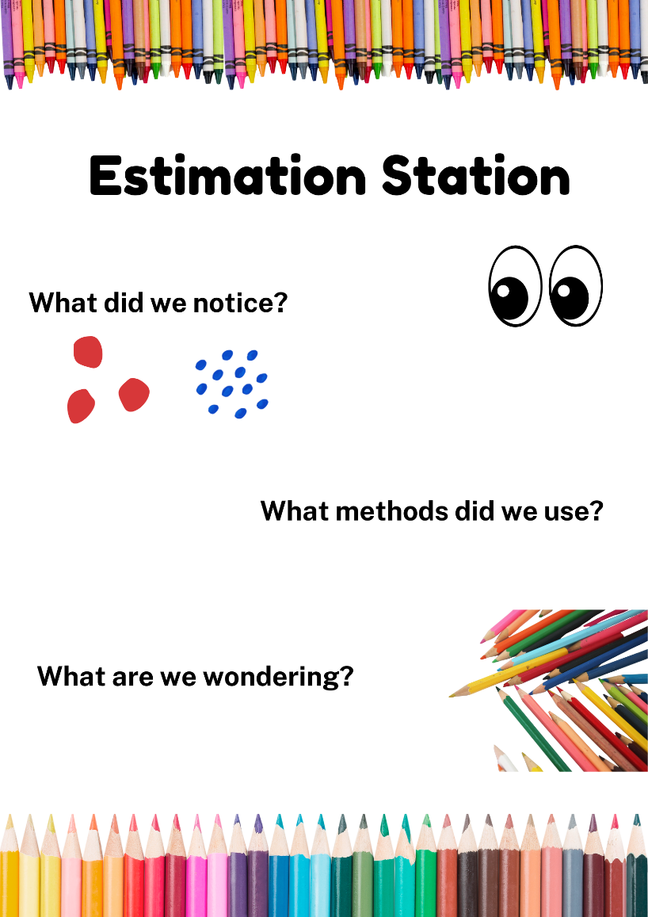
Images sourced from Canva and used in accordance with the Canva Content License Agreement.

Lesson 2: Frogs on logs
Core concept: Arranging a collection of objects in different ways helps to see the quantity. The quantity always stays the same.
The table below contains suggested learning intentions and success criteria. These are best co-constructed with students.
Learning intentions | Success criteria
Students are learning that:  - numbers can be partitioned in different ways  - no matter how a collection is arranged, the quantity remains the same. | Students can:  - organise a collection of objects in different ways  - describe the collection using words, materials, visuals, and numerals  - work with others to solve ‘Frogs on Logs’ using concrete materials  - explain why the quantity remains the same even when objects are arranged differently.

Daily number sense: Which is more? – 15 minutes
- Build student understanding of estimation and counting strategies using the website Estimation 180 created by Andrew Stadel.
- Select a photograph from the website Estimation 180. Explain that students can look at the same photograph and notice different things. Describe what you can see. Invite students to describe what they see in the image.
- After looking at the image, ask students to describe what they can see and how they can compare what they see. For example, explain that you can see a small plant, a fence, and a teacher. The fence is taller than the plant. The teacher is much taller than the fence. Estimate that the teacher is about as tall as our school fence.
- Choose another image and ask students a question about the image. For example, ask what they can tell you about the almonds in this picture. In pairs, students turn and talk about what they can see and how this can be used to estimate an answer to the question.
This table details assessment opportunities and differentiation ideas.
Assessment opportunities | Too hard? | Too easy?
What to look for:  - Can students describe and estimate a collection using words, materials, visuals and numerals? (MAO-WM-01)  What to collect:  - observations of students’ discussions about their mathematical reasoning (MAO-WM-01, MA1-RWN-01) | Students are unable to use words, materials, visuals, and numerals to describe and estimate what they can see.  - Model how to look for benchmarks or clues that may be useful to help students estimate.  - Support students to explain their thinking by providing materials to draw or recreate the collection they are estimating. | Students use words, materials, visuals, and numerals to accurately describe and estimate what they can see.  - Students make their own collection of objects to estimate the quantity with a partner.  - With a partner, students identify clues in an image that support their estimate. They discuss how the clues helped to justify and prove their estimate.

Frogs on logs – 30 minutes
This lesson has been adapted from NZ Maths resource Bears in caves.
- Explain that to play this game students will need a partner, 3 logs (such as twigs, sticks or recycled cardboard) and 12 ‘frogs’ (either figurines, objects to represent the frogs or a copy of Resource 5: 12 frogs).
- Display Resource 6: Frogs on logs and pose the mathematical problem: There are 12 frogs altogether and there are 2 frogs on the first log. How many frogs might be on each of the other logs?
Note: Some students may confuse this with division, that is, by forming equal groups of frogs. Explain that sometimes we need to separate amounts in ways that do not all have the same amounts, or that are shared equally.
- In pairs, students will use the materials to represent this problem and investigate possible solutions. They record all the possible solutions they find. For examples, see Figure 2.
Figure 2 – Representing frogs on logs
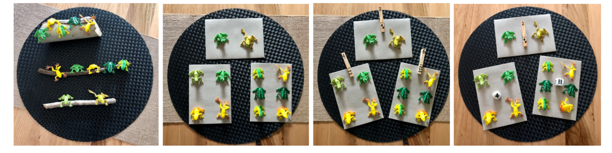
The table below outlines stimulus prompts to generate conversation about the topic, along with anticipated responses from students.
Prompts | Anticipated student responses
- How did you use the materials to help solve the problem?  - How many frogs did you put on the other 2 logs? How did you decide this?  - Did your partner arrange their frogs a different way or the same way? What did you notice?  - What other ways could you sort your frogs? What are you wondering?  - How did you record this?  - Did any ways of arranging the frogs give you a different total? | - I counted out 12 frogs and 3 logs. I put 2 frogs on a log. Then I had 10 frogs left to put on the other logs.  - I put 2 frogs on a log first then I counted 10 more frogs to put on the next 2 logs.  - My partner had 12 frogs. They put 2 on the first log and then 2 and 8. That makes 12 too.  - I put 2 and 3 and 7. That also makes 12.  - I could use photos or drawings to show how I solved the problem.  - The total of frogs was always the same. There were 12.
This table details assessment opportunities and differentiation ideas.
Assessment opportunities | Too hard? | Too easy?
What to look for:  - Can students organise a collection of objects in different ways? (MAO-WM-01, MA1-CSQ-01)  - Are students able to describe the collection using words, materials, visuals and numerals? (MAO-WM-01, MA1-CSQ-01)  - Can students explain why the quantity remains the same even when arranged differently? (MA1-CSQ-01)  What to collect:  - observations, discussions and work samples from the activity. (MAO-WM-01, MA1-RWN-01, MA1-RWN-02, MA1-CSQ-01) | Students are not able to organise a collection of objects in different ways.  - Support students to use the concrete materials and explore ways to solve the problem.  - Use a smaller collection to model different ways of organising a collection. | Students can confidently organise a collection of objects in different ways to solve a problem.  - Provide students with a larger number of frogs to find different solutions for.  - Students create their own number problem for another student to estimate and solve in different ways.

Consolidation and meaningful practice: How many frogs on logs? – 15 minutes
- As a class, revise the problem that students were investigating with a partner by asking:
- What was the problem we were trying to solve?
- How many frogs did we have altogether? (12 frogs)
- How many logs did we have? (3 logs)
- How many frogs were on the first log? (2 on the first log)
- How many frogs could be on the other logs? (12 can the partitioned in different ways, such as 2, 3 and 5 or 2, 3 and 7).
- Draw attention to each pair having had the same problem to solve and the same quantity of frogs and logs. Highlight that there are many different ways to solve the same problem.
- Conduct a gallery walk for students to see other solutions. Select several pairs of students to share how they used the materials to solve the problem. Photographs can be taken to add to a classroom display.
- Use student responses to draw attention to the fact that numbers can be partitioned in different ways, and that no matter how a collection is arranged the quantity remains the same.
- Add to the anchor chart, the mathematical vocabulary used in the lesson. For example, problem solve, investigate, explore, how many, the same as, more than, less than.

Lesson 3: Counting with understanding
Core concept: Familiar structures help to quantify a collection without counting by ones.
The table below contains suggested learning intentions and success criteria. These are best co-constructed with students.
Learning intentions | Success criteria
Students are learning that:  - quantities can be structured to make it easier to find the total  - smaller numbers can be found hiding inside of bigger numbers  - bigger numbers can be made by combining smaller numbers  - no matter how a collection is arranged, the quantity stays the same. | Students can:  - recognise that collections can be shown in ways to make it easier to find the total  - estimate, sort, and count collections by grouping in tens  - recognise that structures such as ten-frames can be used to count larger collections  - recognise that ten ones is the same as one ten.

Daily number sense: Furious frogs! – 20 minutes
This lesson has been adapted from ‘Build it in parts’ by Van De Walle (2019).
- Build student understanding of combinations of 10.
- Give pairs of students 10 connecting cubes or counters. Use Resource 7: Furious frogs! to introduce the story. Ask students how many different combinations of 10 they could make using 2 enclosures, or parts.
- Students make the combinations using counters, recording each combination on a whiteboard with their partner.
- As a class, students share their solutions. Record student responses. Ask what patterns they noticed.
- Show that the total of the frogs can be recorded by using a number sentence for each combination, such as 9 + 1 = 10. Ask students to write a number sentence for each way they separated the frogs.
- Explain that the frogs still aren’t quite happy, but Lucas was given a third frog enclosure for his birthday so now he can separate them across 3 enclosures. For example, he could put 5 frogs in one enclosure, 3 frogs in another and 2 frogs in another. Students work out how many ways there are to separate the frogs now.
- Students make combinations using counters, recording each on their whiteboard. As a class, students share their solutions. Record student responses. Ask what patterns they notice.

Counting with understanding – 40 minutes
- Build student understanding of quantities and numbers to 100 using a mathematical representation, such as a ten-frame structure.
- Revisit the anchor chart from the previous lessons, then watch the video Counting with understanding up to 100 (16:31).
- Pause video at 2:06. Invite students to estimate how many pieces of pasta will fit into the cup.
- Pause at 3:53. Ask students if they would change or revise their estimates.
- Pause at 5:01. Ask students what structures could be used to count the pasta.
- Pause at 6:14. Ask students how many you have already counted if both ten-frames are full.
- Pause at 6:45. Ask students how many you have counted if 3 ten-frames are full.
- Pause at 9:40. Students draw a ten-frame on paper/whiteboard or use their finger to draw a ten-frame on the floor, their arm, or their partners back.
- Pause at 12:42. Ask students if they think more teddy bears will fit into the cup or less.
- Pause at 15:05. Ask students how many teddy bears they think will fit into the cup.
- At the end of the video, recall and discuss the mathematics used, for example:
- ten ones is the same as 1 ten
- using a familiar structure helps us quantify a collection without having to count everything by ones
- groups of 10 can be renamed such as 8 tens and 2 is renamed 82
- you can use structures (for example ten-frames), draw your own, or imagine them.
- Add any new mathematical ideas or vocabulary to the anchor chart.
- Provide pairs of students with a large collection of objects and a cup. They count the number of objects in one cupful, then see how many times they can fill the cup with their objects.
- Using this information, both students estimate how many objects they have in total. They work together to draw ten-frames, then use these to determine the total number of objects in their collection.
- Students compare the result to their estimate to see if it was accurate. They swap their collection with another pair of students, estimate, then determine the total of the new collection using their ten-frames.
This table details assessment opportunities and differentiation ideas.
Assessment opportunities | Too hard? | Too easy?
What to look for:  - Can students estimate, sort and count large sets of objects to 100 by grouping in tens? (MA1-RWN-01)  - Do students draw, imagine or use a familiar structure (ten-frame) to count large collections? (MA1-RWN-01)  - Can students recognise that ten ones is the same as one ten? (MA1-RWN-01)  What to collect:  - observations of students as they engage in the learning activities (MAO-WM-01, MA1-RWN-01) | Students cannot estimate, sort, and count large sets of objects by grouping in tens.  - Support students to estimate how many objects will fit into a cup or handful.  - Model ways a ten-frame structure can be used to group 10 objects, showing that ten ones is the same as one ten. | Students estimate, sort, and count large sets of objects by grouping in tens.  - Students create their own investigation, identifying a large collection of objects to estimate, count and group using ten-frames.  - Students discuss with a partner the strategies they used to estimate, if their estimations were close, how they decided to group their objects and ways groups of 10 can be renamed  - Students discuss ways their thinking and grouping can be recorded.

Consolidation and meaningful practice: Noticing and wondering – 10 minutes
- Ask students:
- What did you notice during this activity?
- Did you see any patterns?
- Is there anything that you are still wondering about?
- Summarise that recognising familiar number patterns helps students to find how many there are, without counting by ones.

Lesson 4: Exploring 10 and 100
Core concept: What we know about numbers to 10 helps us with numbers to 100.
The table below contains suggested learning intentions and success criteria. These are best co-constructed with students.
Learning intentions | Success criteria
Students are learning that:  - a ten-frame is a useful structure because it can help us see smaller parts inside numbers  - numbers can be partitioned in different ways  - what they know about numbers to 10 helps them with numbers up to 100 and beyond  - no matter how you arrange a collection, the quantity stays the same. | Students can:  - use a ten-frame structure to see smaller numbers hidden inside  - record ways two-digit numbers can be partitioned to show quantity values such as 25 is 20 and 5  - use the structure of 10 to investigate numbers to 100. Use words, objects, images, and numbers to represent a quantity  - arrange a collection up to 100 in different ways and recognise the quantity stays the same.

Daily number sense: Let’s count again – 20 minutes
- Build student understanding of quantities and whole numbers up to 100 by estimating and arranging large collections of objects into groups of 10.
- Revise the different strategies used for estimating and counting efficiently in Lesson 3, for example by using a ten-frame structure.
- Explain that to play this activity, students will need a ten-frame gameboard, a cup or container, a collection of up to 100 objects (such as pasta, gumnuts, counters, loose parts, paperclips) and a partner.
- Provide students with a copy of Resource 8: Ten-frame gameboard Students take turns to fill cup or container with the objects and estimate how many will fit inside. One student then empties the objects from the cup onto a surface and their partner asks if they would revise/change their estimate and why.
- Students then use the ten-frame gameboard to arrange the objects into groups of 10. They count and rename groups of tens, for example 6 tens and 5 is renamed 65.
This table details assessment opportunities and differentiation ideas.
Assessment opportunities | Too hard? | Too easy?
What to look for:  - Are students able to estimate, sort and count large sets of objects to 100 by grouping in tens? (MA1-RWN-01)  - Can students draw, imagine or use a ten-frame structure to count up to 100 objects without counting by ones? (MA1-RWN-01)  - Do students recognise ten ones is equal to one ten? (MA1-RWN-01)  What to collect:  - observation of students as they participate in the learning activity. (MAO-WM-01, MA1-RWN-01) | Students cannot estimate, sort, and count the objects by grouping in tens, or recognise that ten ones is the same as one ten.  - Support students to estimate a smaller number of objects and model how to sort objects into groups of 10.  - Model placing 10 objects in a ten-frame to show that ten ones is the same as one ten. | Students estimate, sort, and efficiently count up to 100 objects by grouping in tens.  - Students collect and fill a larger container with objects to estimate, sort and quantify.  - Challenge students to use their mathematical imagination to represent a given number such as 5 tens and 9 ones in different ways.

2 truths1 lie – 25 minutes
This activity has been adapted from the work of Marian Small (2016).
- Watch 2 truths 1 lie (whole numbers) (4:10).
- Explain that to play this game we will need our mathematical brains, our eyes and MABs to investigate and solve 3 statements/problems. 2 are true and one is a lie. Provide students with MABs to recreate examples modelled.
- Pause the video at 1:02. Ask students to pick up a 10 attribute block and a one attribute block as shown in the video.
- Pause at 1:47. Provide time for students to think and wonder about the number 13. Students use MABs to create 13 in different ways such as using 13 ones, and one ten and 3 ones. Ask students to count the number of MABs used to prove 13 can be represented with 4 MABs.
- Pause at 1:55. Provide time for students to think and wonder about how 32 could be represented using 14 MABs. After providing time to explore different ways to represent 32, invite students to share and show their thinking.
- Pause at 3:03 to notice how the MABs were used and then renamed. Students use MABs to represent 32 using 14 MABs. Count the total number of MABs used to solve and prove the problem.
- Pause again at 3:26. Students use MABs to prove the third statement is false, that 25 cannot be represented with 10 MABs. In pairs, students use turn and talk to share their reasoning and explain why the statement is false. Explain that if they do not understand someone else’s thinking, they can ask questions. This will help them explain their ideas and convince others of their thinking.
- As a class, discuss how to record and display the 3 problems solved. Add student reasoning, questions, thinking and mathematical language to the anchor chart.
This table details assessment opportunities and differentiation ideas.
Assessment opportunities | Too hard? | Too easy?
What to look for:  Do students recognise ten ones is the same as one ten? (MA1-RWN-01)  - Can students use 10 as a reference to form groups and partition two-digit numbers to show quantity values, such as representing 25 as 2 tens and 5? (MA1-RWN-01)  - Can students use models such as base 10 materials to solve problems, represent numbers and explain grouping? (MA1-RWN-01, MA1-CSQ-01)  What to collect:  - observations, student responses and photographs of how students represent and explain what they know about 10 (MA1-RWN-01, MAO-WM-01) | Students are not able to recognise ten ones is the same as one ten, or use 10 as a reference to form groups and partition two-digit numbers.  - Use MABs to count out ten ones to line up beside one ten. Model vertically and horizontally to show they are the same.  - Model how 10 can be used as a reference to form groups and partition two-digit numbers, for example, 13. Encourage students to choose another two-digit number to investigate and partition. | Students can represent, explain, and record numbers using base 10 materials.  - Students work with a partner to investigate and estimate how many ways a two-digit number can be represented and recorded.  - Students write their own ‘2 truths 1 lie’ statements for another student to solve.

Consolidation and meaningful practice: What do we know about 10 and 100? – 15 minutes
- Ask students what they know about 10 and 100. Students share their ideas about 10 and 100 and explain, prove, and convince others what they know and why they think this way. Add new ideas to the class anchor chart.
- Ask students:
- How did you use materials, such as MABs, ten-frame structures and objects to represent your ideas?
- Once you organised your materials, how did you count?
- Did you find smaller numbers hiding inside bigger numbers?
- What else are you wondering?

Lesson 5: Counting the staircase
Core concept: Smaller numbers can be found hiding inside of bigger numbers.
The table below contains suggested learning intentions and success criteria. These are best co-constructed with students.
Learning intentions | Success criteria
Students are learning that:  - a quantity can be represented using words, materials, visuals, and numerals  - 2 smaller numbers can be found hiding inside of bigger numbers  - bigger numbers can be made by combining smaller numbers  - no matter how you arrange a collection, the quantity stays the same. | Students can:  - represent amounts in different ways  - find 2 smaller numbers hiding inside bigger numbers  - make bigger numbers by combining smaller numbers  - recognise when different combinations of smaller numbers are equal.

Daily number sense: Finding numbers on a number line – 10 minutes
- Build student understanding of how a quantity can be represented by visuals and numerals with the video Finding numbers on a number line (5:30).
- Pause at 0:55. Ask students where they think the zero will go on the number line and why.
- Continue viewing, then pause at 3:00. Ask students what they think the other 2 numbers will be and why.
- After sharing several responses, draw students’ attention to the strip of paper that was used to find the 5. Ask how they could use the paper to try and find the other missing numbers. Prompt students to look for other clues on the number line to use.
- With a partner, students discuss how they could find the missing numbers on the number line.
- Choose several students to share their thinking, then view the rest of the video, discussing similarities between the strategies that were discussed.

Counting the staircase – 40 minutes
This lesson has been adapted from Math for Love.
Note: If sets of coloured rods are not available, copies of Resource 9: Coloured rods can be used.
- Show students some coloured rods and tell them that they will have some time to build whatever they want.
- Observe what they build and after 5 minutes of play discuss what students have noticed.
- Ask students:
- How do the colours relate?
- Which colours are longer, and which are shorter?
- Can you make the same length of one colour from another? (These responses can be recorded with other student questions as potential ideas to explore later).
- Challenge students to arrange the colours from shortest to longest. Each student should make their own ‘staircase’.
- Once students have built their staircase, ask:
- How many white rods would it take to cover/build a duplicate copy of the red rod?
- What about the light green rod? The purple rod?
- No matter their responses, ask them to defend their answers. Give them time to work on their own to figure out how many white cubes it would take to build a duplicate of any rod.
- Discuss with students what numbers they got for different rods, and what their strategies were to determine the number of cubes:
- Did they need to build every rod using all white cubes?
- Did they use what they had found about smaller rods to build the larger ones? For example, the dark green is a yellow plus a white, and the yellow is 5 white, so the dark green is 5 + 1 = 6 whites.
- Explain that the coloured rods can help find smaller numbers hiding inside bigger numbers. Ask if students have found some smaller ‘numbers’ (represented by the rods) hiding inside larger ‘numbers’ (rods).
- Demonstrate how a way of building coloured rods corresponds to a number sentence, and let students try saying and writing a number sentence that they found.
- Challenge students to build a yellow rod in as many ways as they can. They can record how they did it by recording their combination of rods.
Note: Writing equations is only for students who are conceptually ready. For students who haven’t grasped one to one correspondence, just give them the building task without the added challenge of recording.
This table details assessment opportunities and differentiation ideas.
Assessment opportunities | Too hard? | Too easy?
What to look for:  - Are students able to represent quantities in different ways? (MAO-WM-01, MA1-CSQ-01)  - Can students find 2 smaller numbers hiding inside bigger numbers? (MAO-WM-01, MA1-CSQ-01)  - Do students recognise when different combinations of smaller numbers are equal? (MAO-WM-01, MA1-CSQ-01)  - Can students explain the difference between 2 numbers? (MAO-WM-01, MA1-CSQ-01)  What to collect:  - observations of students’ discussions, photographs and work samples of students finding smaller numbers inside larger numbers (MAO-WM-01, MA1-CSQ-01) | Students are unable to identify the value of the coloured rods.  - Explain that the value of the white rod is ‘one’. Use white rods to match the length of other coloured rods and count them to find the equivalent value.  - Record the value of each coloured rod as they are counted.  Students cannot find 2 smaller numbers hiding inside bigger numbers.  - Support students to find 2 smaller rods that are equal in length to the larger rod.  - Students use the value of the coloured rods to find the value of the 2 smaller rods.  - Support students to create a number sentence, showing how they are added to make the total of the larger coloured rod. | Students confidently identify 2 smaller numbers hiding inside bigger numbers.  - Students create a larger number by combining several coloured rods together, end to end. They swap with a partner and use different coloured rods to create an equivalent length. Students then record the value of both lengths of rods as number sentences.  - In pairs, students take it in turns to write down a ‘secret number’. The other student has 10 attempts to guess the number by representing it in coloured rods. If incorrect, they are told if the secret number is higher or lower. The secret number could be between a certain number range, for example, between 10 and 40.

Consolidation and meaningful practice: Noticing and wondering – 10 minutes
- Ask students:
- What did you notice?
- Did you see any patterns?
- Did you find smaller numbers hiding inside of bigger numbers?
- Is there anything that you are still wondering about?
- Summarise that smaller numbers can be found hiding inside of bigger numbers.

Lesson 6: How close to 25?
Core concept: Bigger numbers can be made by combining smaller numbers.
The table below contains suggested learning intentions and success criteria. These are best co-constructed with students.
Learning intentions | Success criteria
Students are learning that:  - numbers can be sequenced, arranged, and represented on a line  - bigger numbers can be made by combining smaller numbers  - mathematicians look for clues, test ideas and problem solve  - no matter how they arrange a collection, the quantity stays the same. | Students can:  - order numbers on a number line and add missing numbers  - identify when bigger numbers have been made by combining smaller numbers  - communicate their thinking and mathematical reasoning  - recognise that no matter how they arrange a collection, the quantity stays the same.

Daily number sense: Finding numbers on a number line – 15 minutes
- Build student understanding of how a quantity can be represented by visuals and numerals, with Finding numbers on a number line (5:30).
- As a class, revise the Daily number sense activity from Lesson 5: Finding numbers on a number line. Encourage students to recall and describe a number line, how it can be used to organise numbers zero to 10 and look for clues to find missing numbers.
- In pairs, students draw their own number line adding 10 points. Use sticky notes to write numbers zero to 10.
- Ask students to extend their line to include the numbers up to 15, making sure they represent their positions as accurately as possible. Students work with their partner on how to organise the numbers.
- As a class, discuss the number lines to 15 and the strategies students used to represent this accurately.
This table details assessment opportunities and differentiation ideas.
Assessment opportunities | Too hard? | Too easy?
What to look for:  - Do students recognise numbers can be represented on a number line? (MA1-RWN-01)  - Are students able to sequence, arrange and order numbers on a number line? (MA1-RWN-01)  - Can students use mathematical imagination to solve problems and communicate their thinking and reasoning? (MAO-WM-01)  What to collect:  - observations and photographs of how students arrange numbers on a number line (MAO-WM-01, MA1-RWN-01) | Students are not able to represent numbers on a number line.  - Support students to create a number line, explaining the importance of spacing the numbers 0-10 accurately.  - Model how to extend the number line to 15, spacing the numbers evenly along the length of the line. Support students to draw their own representation. | Students can sequence, arrange, order and problem solve to add missing numbers.  - Provide larger numbers for students to arrange on the number line, for example up to 24 or 36.  - Ask students to create a number line with some missing values for another student to solve.

How close to 25? – 30 minutes
This lesson has been adapted from the youcubed resource How close to 25?
- Explain to students that to play this game they will need Resource 10: 25 gameboard (one for each pair), one 6-sided dice and a partner. Each person needs 20 counters of the same colour, but a different colour to their partner’s. Resource 11: 100 gameboard can also be used to extend this game.
- In pairs, student choose their colour counter, roll one die to decide who goes first. The student who rolls the higher number goes first.
- Students take turns to roll the dice then count out a corresponding number of counters and place each one on a different square.
- Students take turns rolling the dice and covering the number of squares with their counters. They should continue to play until the gameboard is covered. For example, see Resource 12: Completed 25 board.
- Explain that bigger numbers can be made by combining smaller numbers. Ask students if they can see any smaller numbers hiding in the 25 dots on Resource 12: Completed 25 board.
- At the end of each game, encourage students to prove which player covered more squares and why. Students rearrange the counters to help them see, or visually prove, which colour has more or less. For an example, see Figure 3.
Figure 3 – A 25 gameboard rearranged
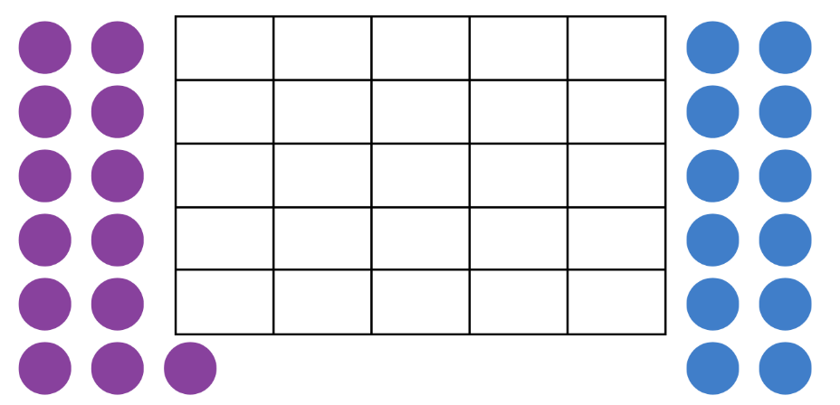
- Students share how they arranged their counters, explaining the arrangements that were most useful for finding the number of counters and who had the most.
- Ask students how they can make both groups the same. Students investigate with their partner how to make both groups equal. Play again, repeat discussion and reflection at end of each game.
This table details assessment opportunities and differentiation ideas.
Assessment opportunities | Too hard? | Too easy?
What to look for:  - Can students communicate their reasoning about how they see and group objects? (MAO-WM-01)  - Can students recognise that no matter how you arrange a collection, the quantity stays the same? (MA1-CSQ-01)  - Are students able to make bigger numbers by combining smaller numbers? (MA1-RWN-01, MA1-CSQ-01)  What to collect:  - observations and student responses showing how they arrange their counters to make a larger number from smaller numbers (MAO-WM-01, MA1-RWN-01) | Students cannot rearrange the counters to support quantifying the total.  - Support students to play the game by identifying the number rolled, counting out the corresponding counters and placing them on the gameboard.  - Model one to one correspondence and counting out aloud when placing counters on the gameboard. | Students efficiently identify the total numbers of counters.  - Students use a 100 gameboard and introduce a second dice to play the game with larger numbers.  - Challenge students to plan ways the counters could be placed on the gameboard while playing to make it easier to visually estimate who has more at the end of game.

Consolidation and meaningful practice: Gallery walk – 15 minutes
- As a class, conduct a gallery walk to view gameboards and notice how the counters have been arranged and rearranged to see which player had more. Highlight the ways counters were arranged to compare the 2 groups.
- Summarise the lesson together, drawing out key mathematical ideas including that bigger numbers can be made by combining smaller numbers. Ask students:
- What did you notice about the way other groups arranged and rearranged their collection?
- Was this similar or different to your arrangement?
- Is there another way you could arrange the counters to help you visually estimate who had more?
- Is there anything you are still wondering?
- As mathematicians, are there any words that can be added to our anchor chart?
- Record student responses and reflections on the anchor chart, including additional mathematical language used (for example, more than, less than, equal, compare, estimate, and prove).
This table details assessment opportunities and differentiation ideas.
Assessment opportunities | Too hard? | Too easy?
What to look for:  - Can students identify when bigger numbers have been made by combining smaller numbers? (MA1-RWN-01, MA1-CSQ-01)  - Are students able to explain their thinking and mathematical reasoning? (MAO-WM-01)  - Can students recognise that no matter how you arrange a collection, the quantity stays the same? (MAO-WM-01, MA1-RWN-01, MA1-CSQ-01)  What to collect:  - observations of student reflections and responses (MAO-WM-01, MA1-RWN-01, MA1-CSQ-01) | Students are not able to explain their thinking and mathematical reasoning.  - Support students to use resources when explaining their thinking, for example, using counters, whiteboards, and their game board.  - Revisit Resource 12: Completed 25 board as an example of bigger numbers being made by combining smaller numbers. | Students confidently explain their thinking and mathematical reasoning.  - Students write a journal, explaining how they found larger numbers that were created by smaller numbers.  - Challenge students to identify how many combinations of smaller numbers they can find hiding inside a larger number, for example, in the number 120.

Lesson 7: Flexible number trains
Core concept: Equivalent lengths can be made in different ways.
The table below contains suggested learning intentions and success criteria. These are best co-constructed with students.
Learning intentions | Success criteria
Students are learning that:  - combining tens and ones help make bigger numbers  - equivalent lengths can be made in different ways  - the same number can be made with different combinations of smaller numbers. | Students can:  - use combinations of tens and ones to make larger numbers  - use different combinations to make the same length  - make, remake, and rename two- and three-digit numbers.

Daily number sense: Hundred-frame filler – 15 minutes
This lesson has been adapted from the work of Siemon et al. 2020.
- Build student understanding of forming and regrouping two- and three-digit numbers by playing a variation of ten-frame filler. Students requiring additional support may prefer to play a game of ten-frame filler from the previous lesson.
- On each turn, a player rolls 2 dice to make a two-digit number. For example, they could roll two 6- or 10-sided dice, then use one of the numbers rolled to represent the ‘tens’, and the other number rolled to represent the ‘ones’.
- After making their two-digit number, the player records it by colouring that number of squares on a copy of Resource 11: 100 gameboard.
- Players take it in turns rolling and filling in their hundred-frame. If there is not enough space remaining on the hundred-frame for the number rolled, that player misses a turn. The player who completes the hundred-frame first is the winner.
This table details assessment opportunities and differentiation ideas.
Assessment opportunities | Too hard? | Too easy?
What to look for:  - Have students used combinations of tens and ones to make 100? (MAO-WM-01, MA1-RWN-01, MA1-RWN-02)  - Are students able to make, remake and rename two and three-digit numbers? (MAO-WM-01, MA1-RWN-01, MA1-RWN-02)  What to collect:  - work samples and observations of discussions that show conceptual understanding of number combinations (MAO-WM-01, MA1-RWN-01, MA1-RWN-02) | Students have difficulty making two-digit numbers with the dice or recording their results on the hundred filler grid.  - Support students by recording the 2 numbers they rolled. Show how one of these can represent the ‘tens’ and the other number the ‘ones’ place value in a two-digit number, then colour the corresponding number of squares on Resource 11: 100 gameboard.  - Students can play the game using one die to fill the hundred-frame, using smaller numbers to build one hundred. | Students confidently make two-digit numbers with the dice to complete the hundred filler grid.  - Challenge students to fill the hundred-frame in as few turns as possible, keeping track of the numbers rolled each turn. This will require students to use the 2 numbers they rolled strategically, to create the biggest numbers that will fit on the board each turn.  - Students can use several gameboards to make a larger target number, such as 200 or 300.

Flexible number trains – 45 minutes
Note: If access to sets of coloured rods is limited, an alternative can be provided using Resource 9: Coloured rods.
- Build student understanding of how an equivalent length can be made in different ways by playing Flexible Number Trains: Day 3 [PDF 548KB] by youcubed.
- Pass out sets of coloured rods. Allow students to play and explore for several minutes to familiarise themselves with them. Invite students to share what they noticed about the coloured rods and if they have any questions about them.
- Introduce the activity, Flexible Number Trains: Day 3 [PDF 548KB]. Choose 3 or 4 different rods and build a train. For example, a train of a length of 8 made from 4 different coloured rods can be built in 4 different ways using rods of the same colour (see Figure 4). Using a ruler can keep the different block trains in line.
Figure 4 – A length of 8 made in 4 different ways
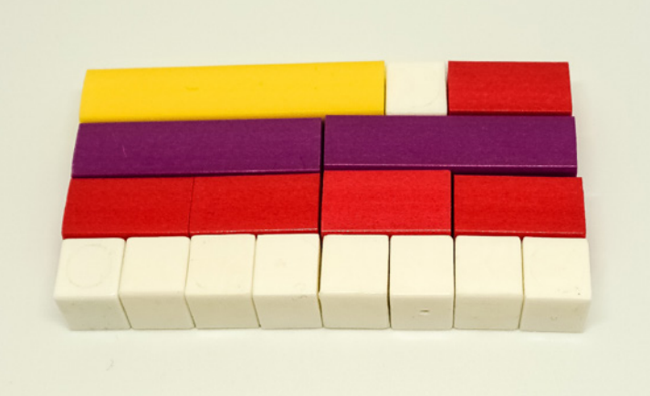
Image adapted from ‘Flexible Number Trains: Day 3 [PDF 548KB]’ by youcubed and is licensed under CC BY 4.0.
- Students build a train that is the same as the teacher’s example. Then they create a second train parallel to the first, but only using white unit cubes.
- Students talk about something they noticed about the 2 trains with a partner. Ask students to share what they discussed.
- Tell students they are going to investigate these number trains by choosing 3 or 4 different coloured rods and building their own. They will then build as many different trains as they can that are equal to their first but are built using only one colour of rod (see Figure 4). Provide encouragement as students explore and make mistakes.
Note: If students need more support while they are working, pause the task and ask some students to share their thinking. Facilitating a discussion before anyone has finished the task is a good way to build a maths learning community. If students are struggling and making mistakes, remind them that making mistakes and struggling is the best time for brain growth in mathematics.
- While students are building new trains, watch and listen to how they are checking that their new trains are the same length as their first. Some students may create trains to match their original train by mixing different coloured rods. Remind them that the focus is on making equivalent trains that are built with the same-coloured rods.
- After students have made several trains ask them to record them on Resource 13: Number trains grid. Their trains should accurately show the length of each rod and include a number sentence that represents each of their trains. They should use the colours to connect each number in the number sentence to the coloured rod in their picture of their number train (see Figure 5).
Figure 5 – Recording number trains on grid paper
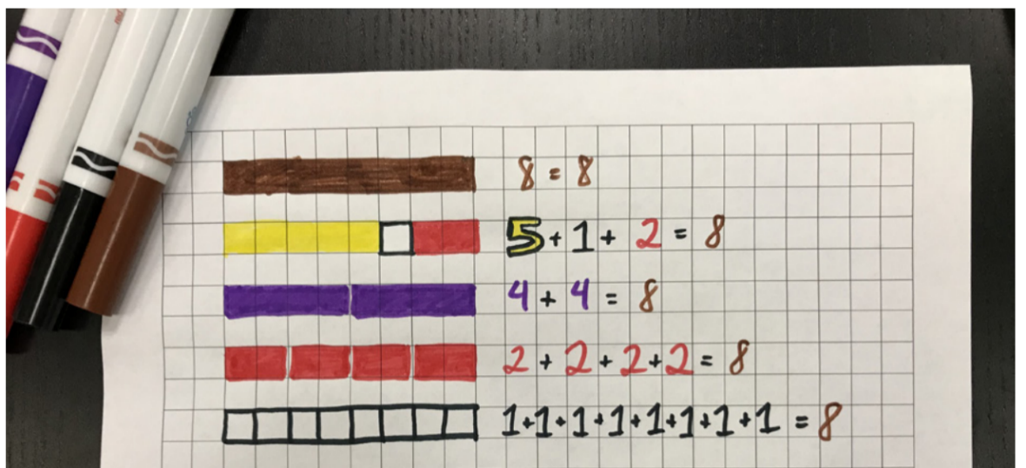
Image adapted from ‘Flexible Number Trains: Day 3 [PDF 548KB]’ by youcubed and is licensed under CC BY 4.0.
- After students have built and recorded some flexible number trains, bring them together for a discussion. Invite students to share their trains and the work they have done to record their findings. Since students were asked to choose 3-4 different coloured rods to make their train, the smallest train that is possible has a length of 6.
- Organise the trains they have produced in order from shortest to longest. Ask students to look at the trains and what they notice and what they are wondering.
- If this isn’t identified by students, explain that the trains show that equivalent lengths can be made in different ways. They also show that the same number can be made with different combinations of smaller numbers.
This table details assessment opportunities and differentiation ideas.
Assessment opportunities | Too hard? | Too easy?
What to look for:  - Can students use different combinations to make the same number? (MAO-WM-01, MA1-RWN-01, MA1-RWN-02)  - Have students explained that equivalent lengths can be made in different ways? (MAO-WM-01, MA1-RWN-01, MA1-RWN-02)  What to collect:  - students work samples – number trains (MAO-WM-01, MA1-RWN-01, MA1-RWN-02)  - observations of discussions and photographs of the use of rods to show conceptual understanding of number combinations (MAO-WM-01, MA1-RWN-01, MA1-RWN-02) | Students have difficulty making different combinations of blocks for the equivalent number trains.  - Support students to line up their blocks to make a clear comparison.  - Model how to repeatedly use a different coloured block to make an equivalent sized number train.  - Demonstrate how to count and record the number of blocks used to create the equivalent number trains. | Students confidently make several equivalent number trains.  Ask students:  - What if the train is made up of 8 light green rods, how many trains of equivalent length can you make with one colour?  - Which train lengths have the least number of equivalent rod trains made with the same-coloured rods?  - Which train lengths have the greatest number of equivalent rod trains made with the same-coloured rods?

Consolidation and meaningful practice: Making conjectures – 10 minutes
Note: A conjecture is an idea based on a pattern you have noticed that you would like to prove. It is like a hypothesis in science. One example of a conjecture that students may make is that all the even number train lengths can be made with the red, two-unit rods.
- Introduce the word ‘conjecture’ and explain that mathematicians study patterns and make conjectures. Point out that there are many patterns in the number trains to discuss.
- Students turn and talk with a partner to discuss any patterns they identified. Once they have identified a pattern, ask them to develop a conjecture that explains why this pattern happens. Explain that mathematicians work to prove their conjectures and encourage students to try and prove theirs.
- Ask students if they have a conjecture about the patterns they would like to share.
The table below outlines stimulus prompts to generate conversation about the topic, along with anticipated responses from students.
Prompts | Anticipated student responses
- What is a conjecture that you would like to share?  - Do you think that the conjecture is correct?  - What did you notice?  - What are you wondering? | - Trains with smaller number blocks/carriages will need more of them to make the same length.  - I think this conjecture is correct because we needed 8 white blocks to make the same length as one long block.  - I noticed that there are lots of number combinations that add up to 8. They are all equivalent.  - Are there any other number combinations that add up to 8?
- Explain that, just as coloured rods can create equivalent lengths in different ways, different combinations of numbers can be used to make the same number.

Lesson 8: Dicey addition
Core concept: Changing the place value of a number changes its value.
The table below contains suggested learning intentions and success criteria. These are best co-constructed with students.
Learning intentions | Success criteria
Students are learning that:  - smaller numbers can be found hiding inside of bigger numbers  - bigger numbers can be made by combining smaller numbers  - what we know about numbers to 10 helps us with numbers up to 100 and beyond. | Students can:  - use counting sequences of ones and tens flexibly  - represent the structure of groups of 10 in whole numbers  - use flexible strategies to solve addition and subtraction problems.

Daily number sense: Revisiting the hundreds frame filler – 15 minutes
This lesson has been adapted from the work of Siemon et al. 2020.
- Build student understanding of forming and regrouping two and three-digit numbers with a variation of ten-frame filler.
- Students replay the game Hundred-frame filler from the previous lesson using a copy of Resource 11: 100 gameboard.
- Provide a few minutes to reflect on the mathematics involved in the game.
- Ask students:
- Was there a strategy that helped you to win the game?
- What numbers do you think were the best to roll? Why?
- What was the shortest combinations for 100? What were the longest?
- What might happen if you had a third player? Would it make it easier or harder to win?

Dicey addition – 30 minutes
This lesson has been adapted from the NRICH resource Dicey addition.
- Explain that, to play this game, students need a partner, a 10-sided dice, and a copy of Resource 14: Dicey addition gameboard. Dice from the Digital Learning Selector can also be used.
- Students use the addition grids on Resource 14: Dicey addition gameboard or draw their own, as in Figure 6.
Figure 6 – Addition grid
- Students take turns to roll the dice once. After each roll, they decide which of the 4 addition cells to put that number in. Students continue rolling the dice 4 times until all their cells are full.
- The two-digit numbers that were made are then added to make each student’s final number for that game. Whoever has the sum closer to 100 wins.
- There are 2 possible scoring systems:
- A point for a win. The first person to reach 10 points wins the game.
- Each player keeps a running total of their ‘penalty points’, the difference between their result and 100 after each round. The first to reach 500 penalty points loses. This target can be adjusted to make it easier or more difficult.
- After students have played several rounds, pause the game and ask students to think about the strategies they are using to play the game.
The table below outlines stimulus prompts to generate conversation about the topic, along with anticipated responses from students.
Prompts | Anticipated student responses
- What do you notice when you are playing the game?  - What strategies are you using to make the total closest to 100?  - Is there anything you are wondering about or finding challenging? | - I noticed that if I always make the biggest numbers I can, they go over 100.  - I thought about whether I need my second number to be bigger or smaller to get close to 100.  - After making my first number, I use the place value columns to make my second number bigger or smaller.  - I found it challenging to add the two-digit numbers.
- As students continue to play the game, observe their progress and support as required.
This table details assessment opportunities and differentiation ideas.
Assessment opportunities | Too hard? | Too easy?
What to look for:  - Do students make bigger numbers by combining smaller numbers? (MAO-WM-01, MA1-RWN-01, MA1-RWN-02)  - Can students use counting sequences of ones and tens flexibly during the game? (MAO-WM-01, MA1-RWN-01, MA1-RWN-02)  - Do students recognise that changing the place value of a number changes its value? (MAO-WM-01, MA1-RWN-01, MA1-RWN-02)  What to collect:  - students work samples and observations that indicate conceptual understanding of place value. (MAO-WM-01, MA1-RWN-01, MA1-RWN-02) | Students have difficulty making different combinations of blocks for the equivalent number trains.  - Support students to line up their blocks to make a clear comparison.  - Model how to repeatedly use a different coloured block to make an equivalent sized number train.  - Demonstrate how to count and record the number of blocks used to create the equivalent number trains. | Students confidently make several equivalent number trains.  Ask students:  - What if the train is made up of 8 light green rods, how many trains of equivalent length can you make with one colour?  - Which train lengths have the least number of equivalent rod trains made with the same-coloured rods?  - Which train lengths have the greatest number of equivalent rod trains made with the same-coloured rods?

Consolidation and meaningful practice: Summarising the learning – 15 minutes
- Summarise the lesson together, drawing out key mathematical ideas including that changing the place value of a number changes its value. Ask questions such as:
- What did you notice about the game now?
- Why was it so important to be able to change the place values of the numbers you rolled?
- Is there anything you are still wondering?
- Are there any words that can be added to our anchor chart?
- Record student responses and reflections on the anchor chart. Celebrate the students’ learning by recapping all the ways that smaller numbers were found hiding in bigger numbers.

Resource 1: Which is more?
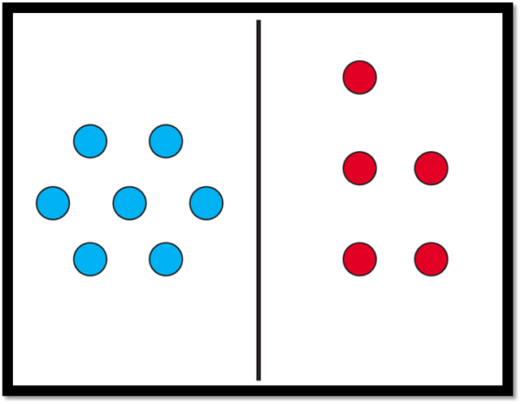
Image adapted from ‘Which is more?’ by youcubed and is licensed under CC BY 4.0.

Resource 2: Scaffolded observation grid
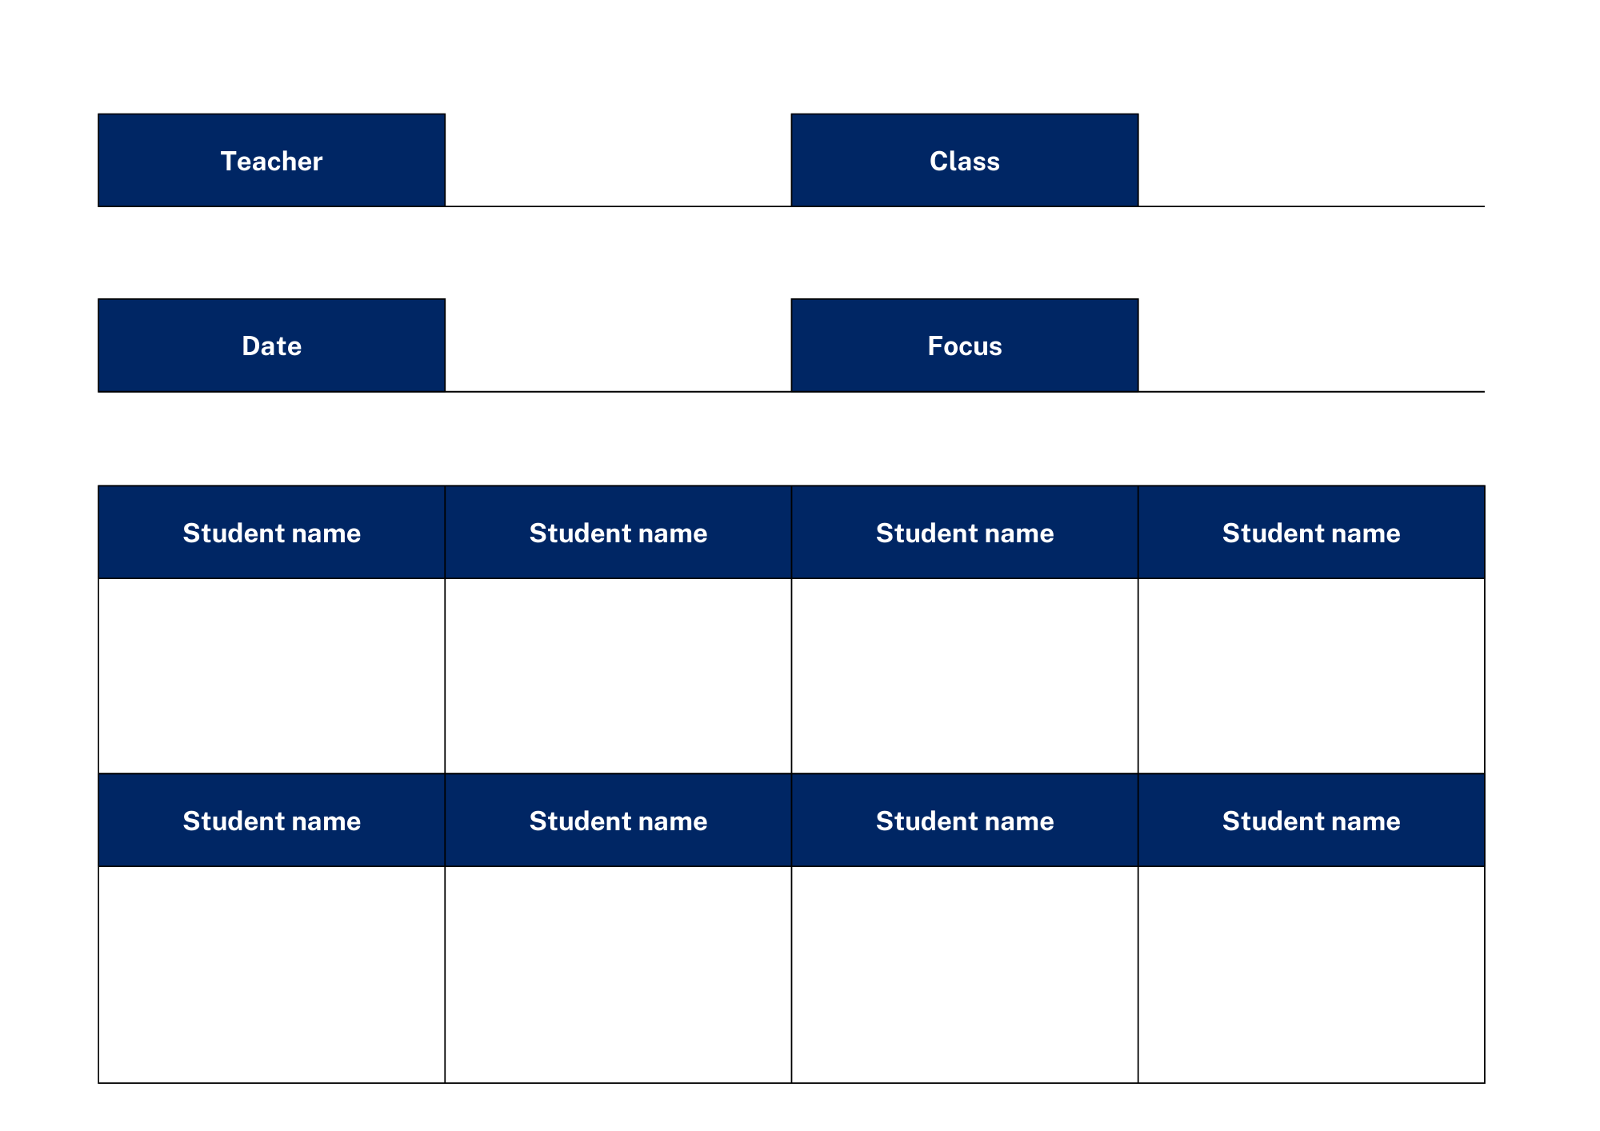

Resource 3: Playing cards
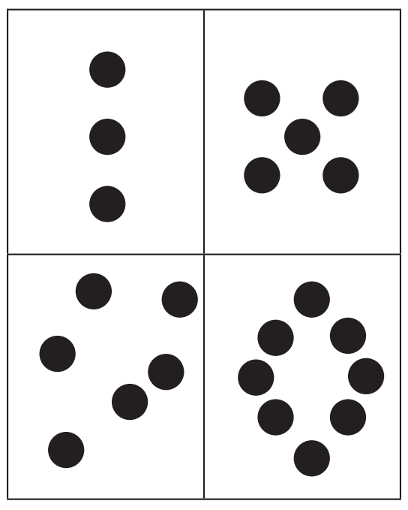
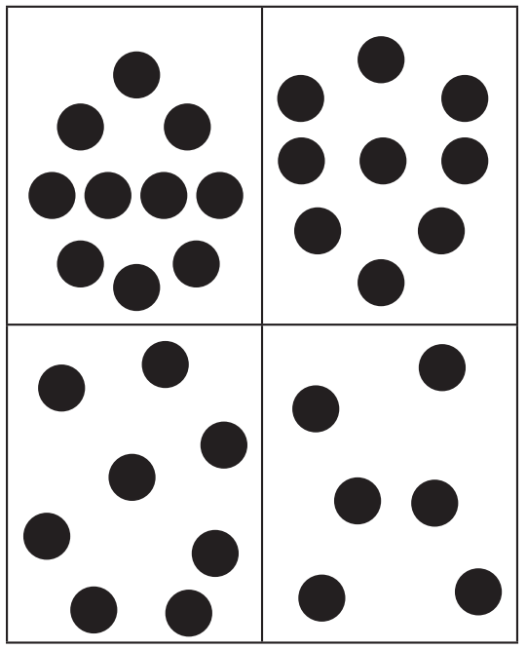
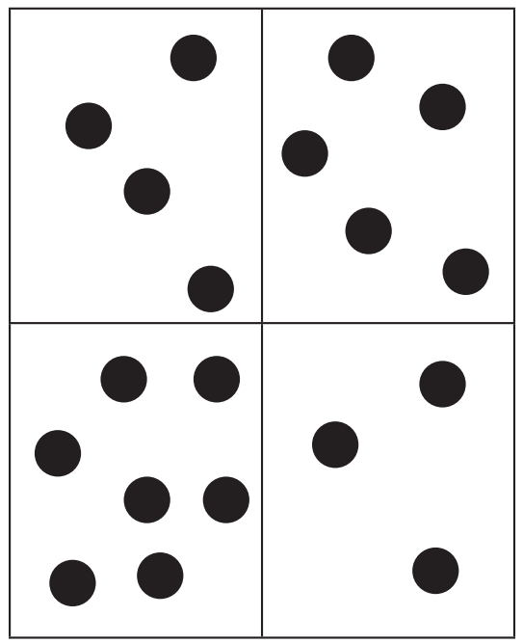
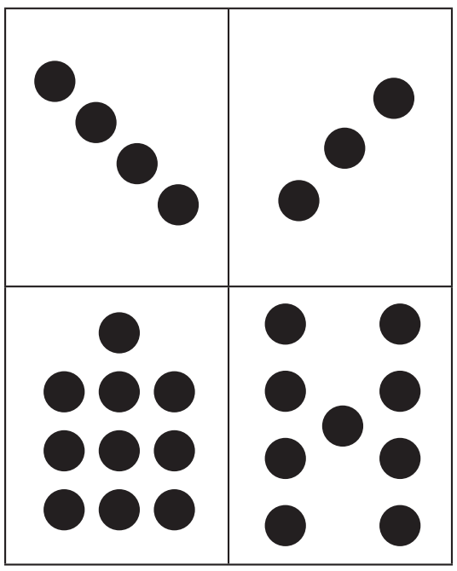
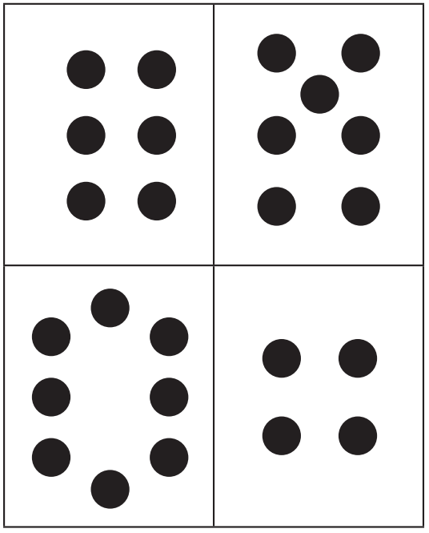
Images sourced from ‘Which is more? Deck of cards [PDF 14.8 KB]’ by youcubed and is licensed under CC BY 4.0.

Resource 4: Counting crayons
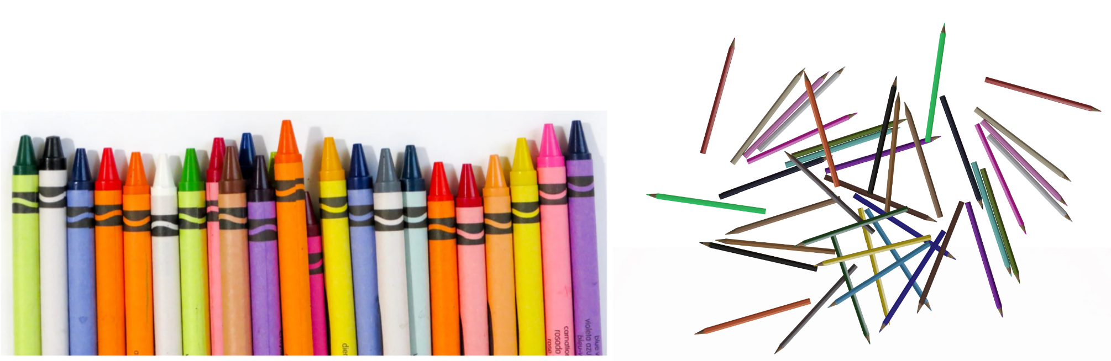
‘Crayon Lot’ by Miesha Renae Maiden is used in accordance with the Canva Pro Content Licence and ‘Scattered Coloring Pencils’ by JarkkoManty is used in accordance with the Pixabay Licence.

Resource 5: 12 frogs
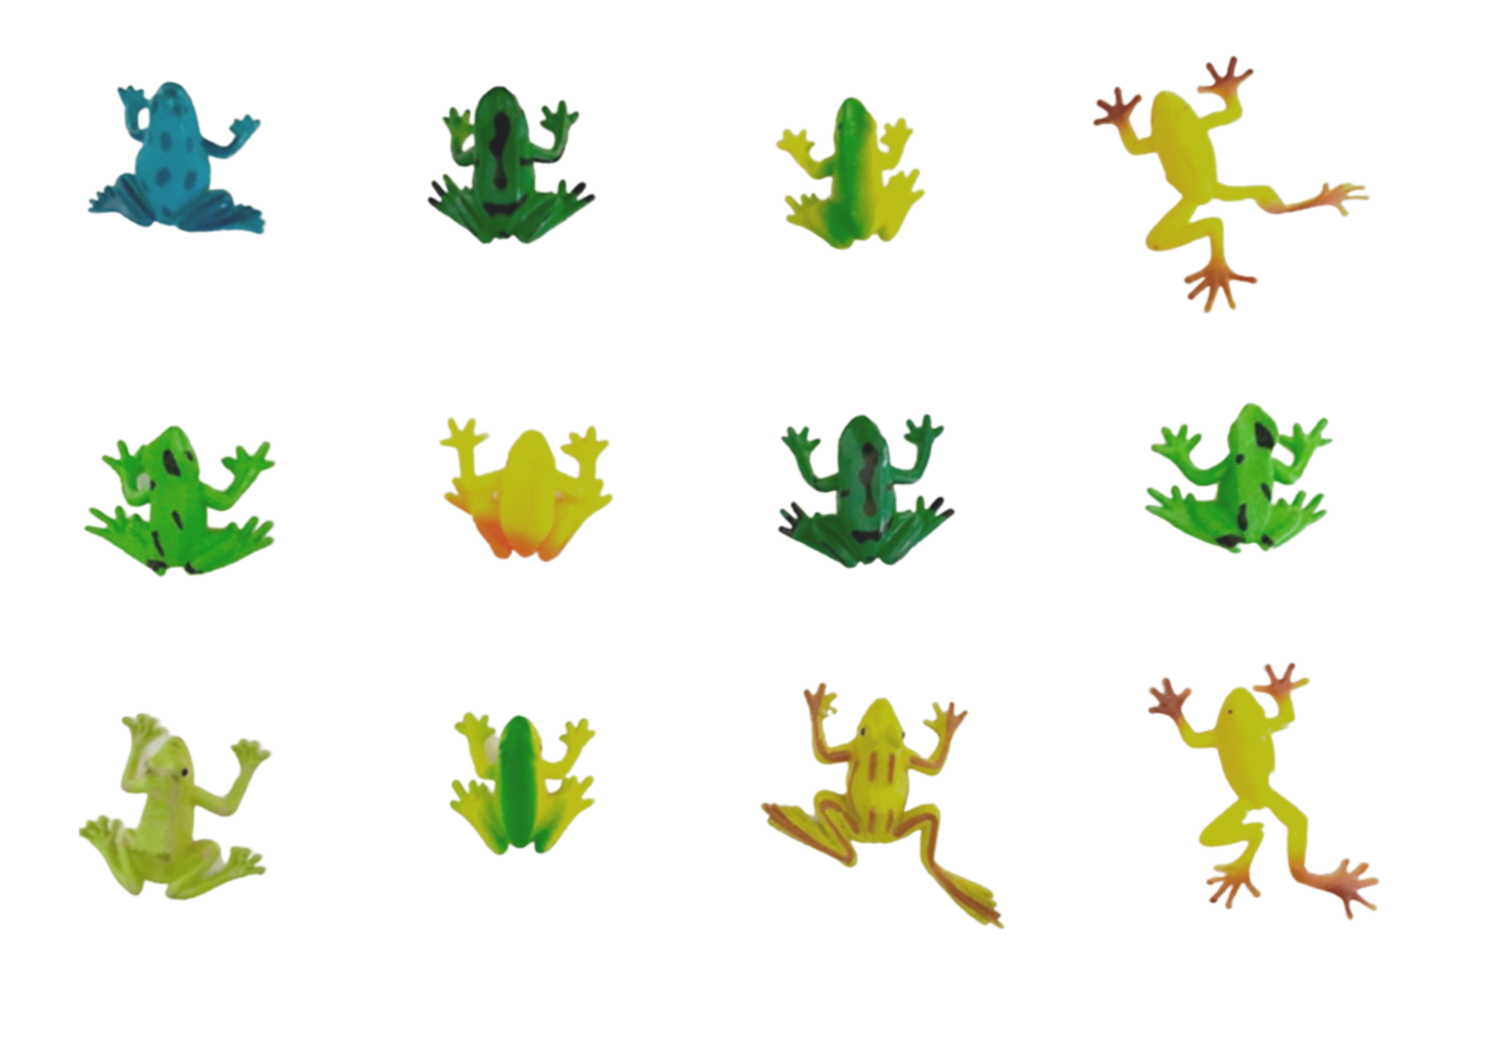

Resource 6: Frogs on logs
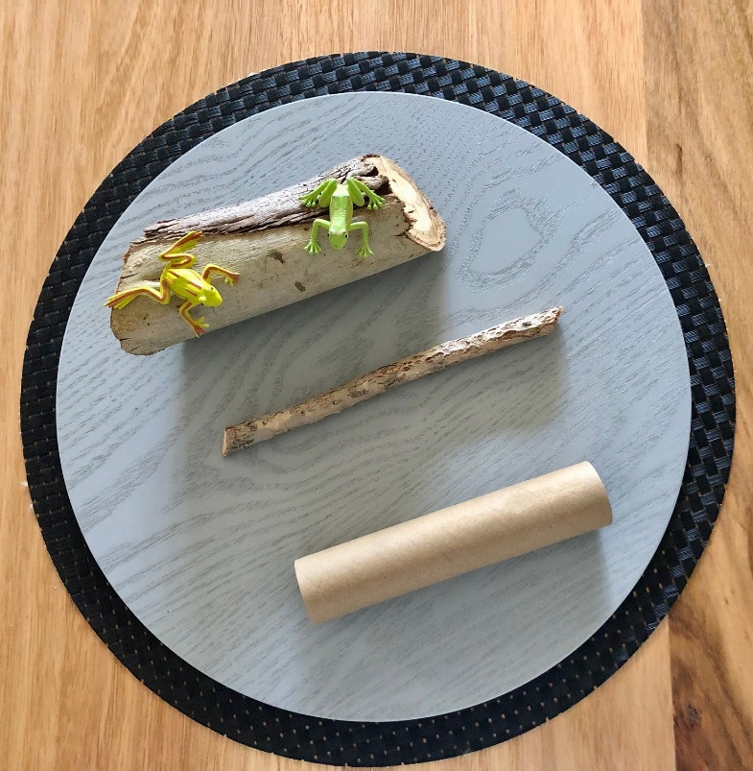

Resource 7: Furious frogs!
Lucas has ten pet frogs. When they are all kept in the same enclosure it is crowded and they argue with each other. Lucas has two frog enclosures to share them between, but he isn’t sure of the best way to separate the frogs to keep them happy. He wants to try different combinations he can share his 10 frogs between two enclosures. For example, he could put nine frogs in one enclosure and leave one frog on its own.
Can you work out how many different number combinations there are for separating the frogs?
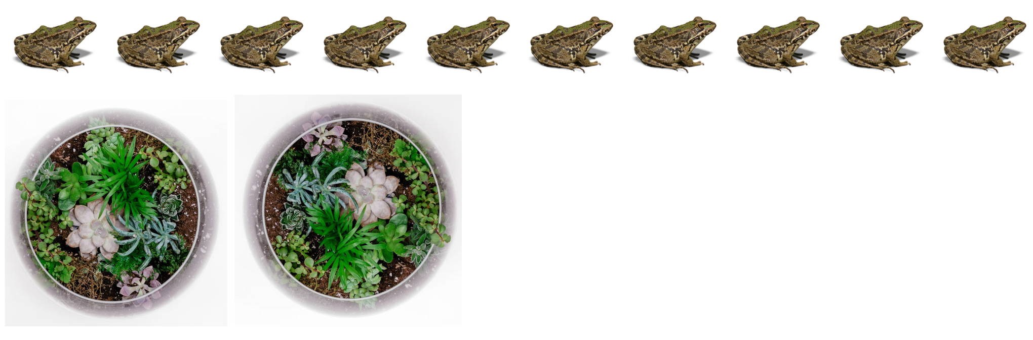
Images sourced from Canva and used in accordance with the Canva Content License Agreement.

Resource 8: Ten-frame gameboard
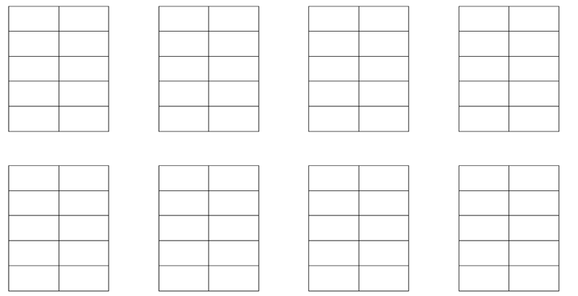

Resource 9: Coloured rods
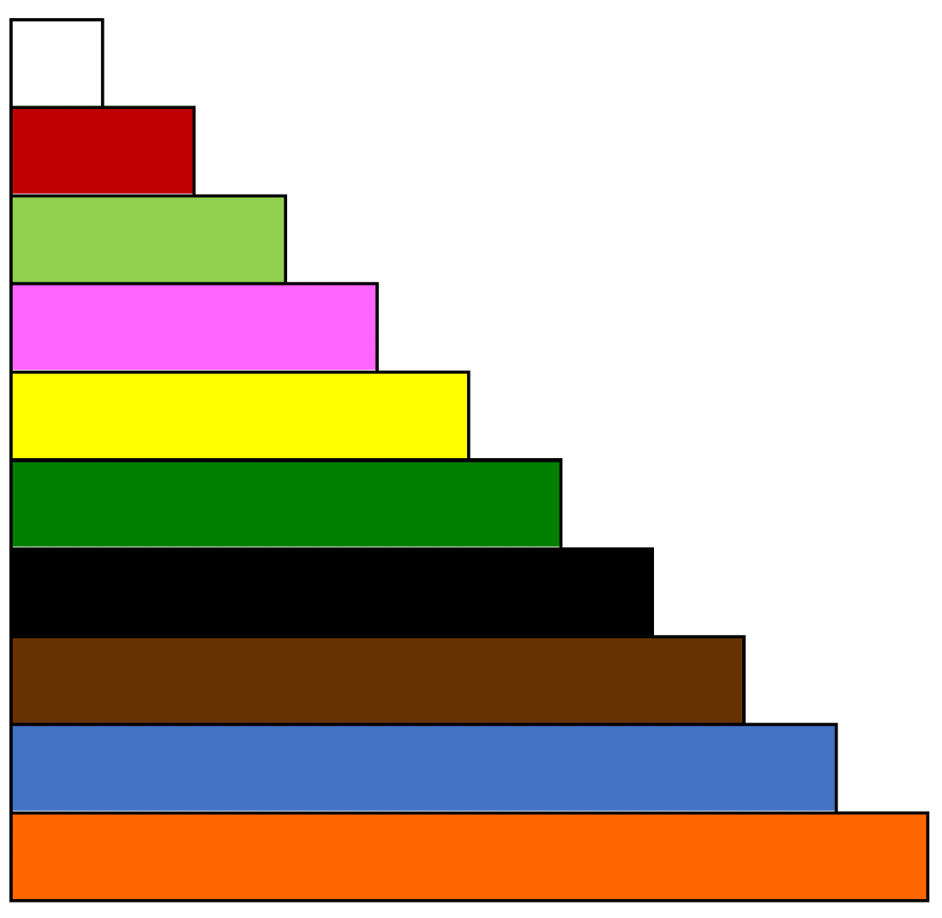

Resource 10: 25 gameboard
Image sourced from ‘How close to 25?’ by youcubed and is licensed under CC BY 4.0.

Resource 11: 100 gameboard

Resource 12: Completed 25 board
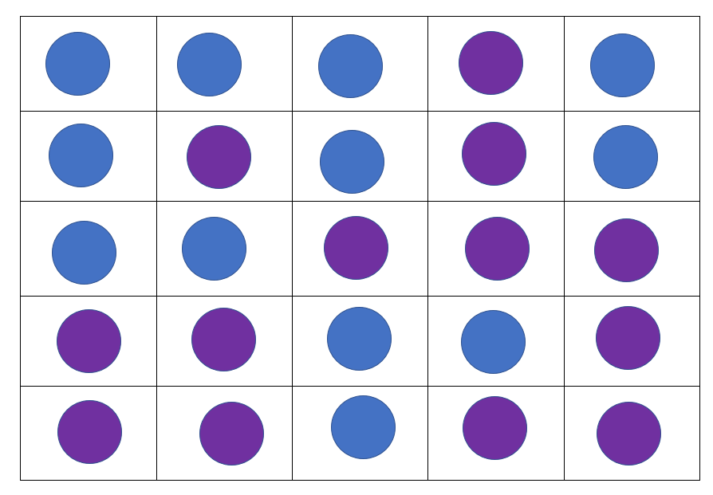

Resource 13: Number trains grid

Resource 14: Dicey addition gameboard
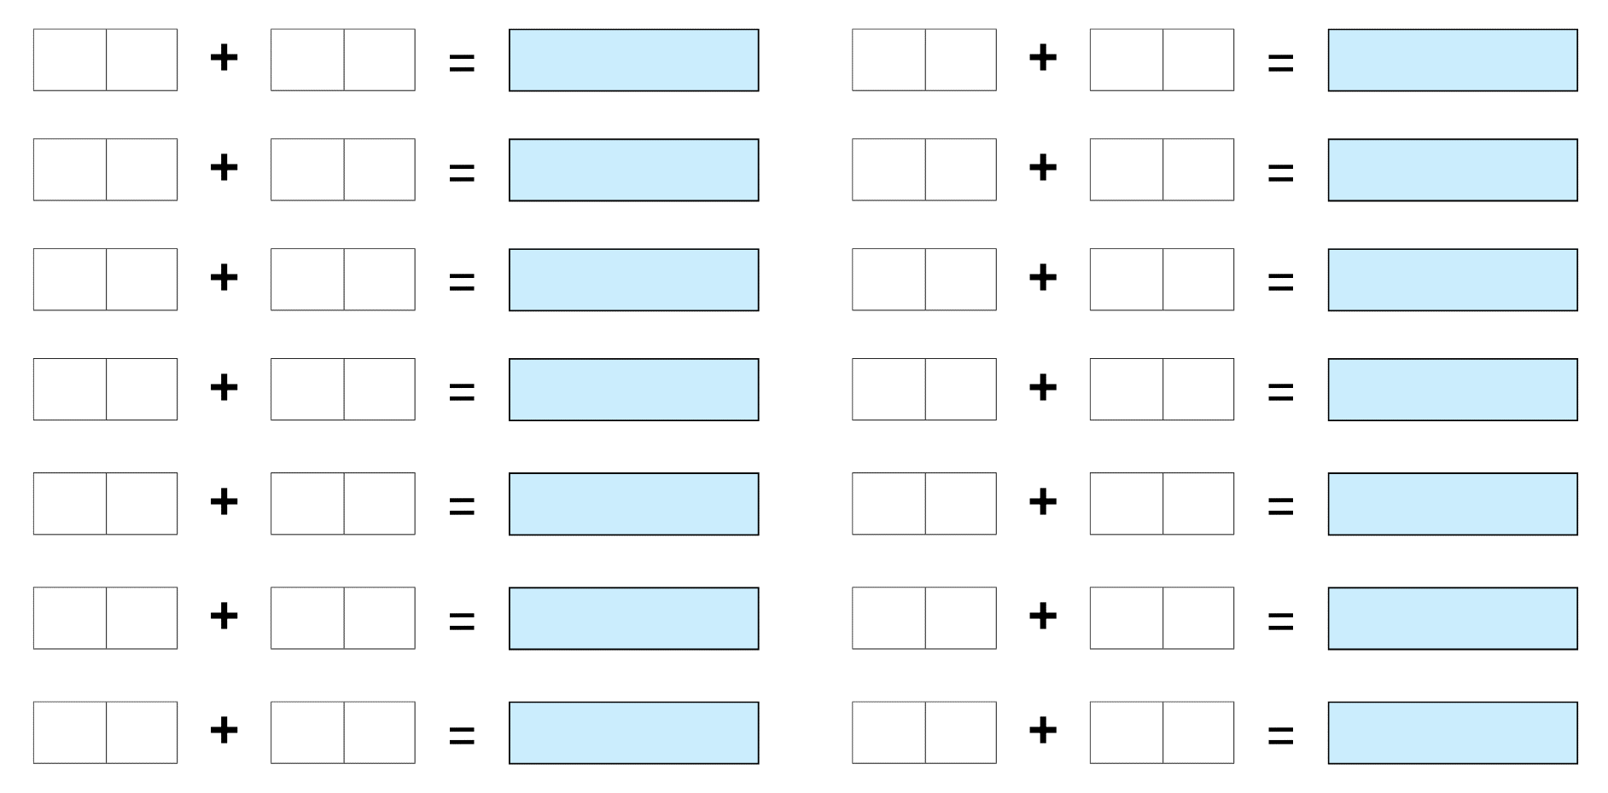

Syllabus outcomes and content
The table below outlines the syllabus outcomes and range of relevant syllabus content covered in this unit. Content is linked to National Numeracy Learning Progression version (3).
Focus area and outcomes | Content groups and content points | Lessons
Representing whole numbers  MAO-WM-01  MA1-RWN-01  MA1-RWN-02 | Part A: Use counting sequences of ones with two-digit numbers and beyond  - identify the number before and after a given two-digit number (CPr5)  Represent numbers on a line  - sequence numbers and arrange them on a line by considering the order and size of those numbers (CPr5)  Represent the structure of groups of ten in whole numbers  - recognise that ten ones is the same as one ten (NPV2, NPV4)  - use 10 as a reference in forming numbers from 11 to 20 (CPr7)  - count large sets of objects by systematically grouping in tens (CPr7)  - partition two-digit numbers to show quantity values (NPV4)  - use number lines and number charts to assist with locating the nearest ten to a number  - estimate, to the nearest ten, the number of objects in a collection and check by counting in groups of ten (Reasons about quantity) (CPr7 NPV6)  Part B: Use counting sequences of ones and tens flexibly  - count forwards and backwards by tens, on and off the decade, with two- and three-digit numbers (CPr7)  - identify how many more to the next multiple of ten within two- and three-digit numbers  Form, regroup, and rename three-digit numbers  - count and represent large sets of objects by systematically grouping in tens and hundreds (CPr7, NPV5)  - use models such as base 10 material and interlocking cubes to represent and explain grouping (CPr7) | 1–8
Combining and separating quantities  MAO-WM-01  MA1-CSQ-01 | Part A: Use advanced count-by one strategies to solve addition and subtraction problems  - apply the terms ‘add’, ‘plus’, ‘equals’, ‘is equal to’, ‘is the same as’, ‘take away’, ‘minus’ and ‘the difference between’ to describe combining and separating quantities (AdS1, AdS6)  - recognise and use the symbols for plus (+), minus (–) and equals (=)  - record number sentences in a variety of ways using drawings, words, numerals and symbols (AdS6)  - fluently use advanced count-by-one strategies including counting on and counting back to solve addition and subtraction problems involving one- and two-digit numbers (Reasons about relations) (AdS3, AdS4, AdS5)  Recognise and recall number bonds up to ten  - recognise, recall and record combinations of two numbers that add up or bond to form 10 (AdS2, AdS6)  - model and record patterns for individual numbers up to ten by making all possible whole-number combinations (Reasons about patterns)  - create, recall and recognise combinations of two numbers that add up to numbers less than 10 (AdS2, AdS6)  - describe combinations for numbers using words such as more than, less than and double (Reasons about relations) (AdS6)  Use flexible strategies to solve addition and subtraction problems  - represent addition and subtraction using structured materials such as a bead string or similar model (AdS6, AdS7)  - select and apply strategies using number bonds to solve addition and subtraction problems with one- and two-digit numbers by partitioning numbers using quantity value and bridging to 10 (Reasons about relations) (AdS6, AdS7)  Represent equality  - use the equals sign to record equivalent number sentences involving addition, and to mean 'is the same as', rather than as an indication to perform an operation (Reasons about relations) (NPA3)  - model the commutative property for addition and apply it to aid the recall of addition facts (Reasons about relations) (AdS7)  - recall related addition and subtraction facts for numbers to at least 10 (Reasons about relations) (AdS6)  Part B: Represent and reason about additive relations  - create, record and recognise combinations of two numbers that add to numbers from 11 up to and including 20 (AdS7)  - create, model and solve word problems, using number sentences  - represent the difference between two numbers using concrete materials and diagrams (AdS6)  - recall and use related addition and subtraction number facts to at least 20 (AdS7)  Form multiples of ten when adding and subtracting two-digit numbers  - add two-digit numbers by building to multiples of ten (AdS7)  Use knowledge of equality to solve related problems  - use number bonds to determine a missing number (AdS6, NPA3, NPA4)  - use number knowledge to solve related problems (Reasons about relations) (AdS7, NPA4)  - use a variety of ways of writing number sentences (NPA3, NPA4)  - use number bonds to solve equality problems (NPA3, NPA4) | 3–8

References
Links to third-party material and websites
Please note that the provided (reading/viewing material/list/links/texts) are a suggestion only and implies no endorsement, by the New South Wales Department of Education, of any author, publisher, or book title. School principals and teachers are best placed to assess the suitability of resources that would complement the curriculum and reflect the needs and interests of their students.
If you use the links provided in this document to access a third-party's website, you acknowledge that the terms of use, including licence terms set out on the third-party's website apply to the use which may be made of the materials on that third-party website or where permitted by the Copyright Act 1968 (Cth). The department accepts no responsibility for content on third-party websites.
Except as otherwise noted, all material is © State of New South Wales (Department of Education), 2021 and licensed under the Creative Commons Attribution 4.0 International License. All other material (third-party material) is used with permission or under licence. Where the copyright owner of third-party material has not licensed their material under a Creative Commons or similar licence, you should contact them directly for permission to reuse their material.
Mathematics K–10 Syllabus © 2022 NSW Education Standards Authority (NESA) for and on behalf of the Crown in right of the State of New South Wales.
© 2022 NSW Education Standards Authority. This document contains NSW Curriculum and syllabus content. The NSW Curriculum is developed by the NSW Education Standards Authority. This content is prepared by NESA for and on behalf of the Crown in right of the State of New South Wales. The material is protected by Crown copyright.
Please refer to the NESA Copyright Disclaimer for more information.
NESA holds the only official and up-to-date versions of the NSW Curriculum and syllabus documents. Please visit the NSW Education Standards Authority (NESA) website and the NSW Curriculum website.
National Numeracy Learning Progression © Australian Curriculum, Assessment and Reporting Authority (ACARA) 2010 to present, unless otherwise indicated. This material was downloaded from the Australian Curriculum website (National Numeracy Learning Progression) (accessed 27 September 2022) and was not modified. The material is licensed under CC BY 4.0. Version updates are tracked in the ‘Curriculum version history’ section on the 'About the Australian Curriculum' page of the Australian Curriculum website.
ACARA does not endorse any product that uses the Australian Curriculum or make any representations as to the quality of such products. Any product that uses material published on this website should not be taken to be affiliated with ACARA or have the sponsorship or approval of ACARA. It is up to each person to make their own assessment of the product, taking into account matters including, but not limited to, the version number and the degree to which the materials align with the content descriptions and achievement standards (where relevant). Where there is a claim of alignment, it is important to check that the materials align with the content descriptions and achievement standards (endorsed by all education Ministers), not the elaborations (examples provided by ACARA).
This resource contains images and content obtained from Canva, and their use outside of this resource is subject to Canva’s Content License Agreement. If you wish to use them separately from the resource, please go to Canva.
Finkel D (2015) ‘Cuisenaire Rod Lessons’, Free Lesson Library, Math for Love website, accessed 27 September 2022.
New Zealand Ministry of Education (n.d.) ‘Bears in caves’, Resource, nzmaths website, accessed 27 September 2022.
Siemon D, Warren E, Beswick K, Faragher R, Miller J, Horne M, Jazby D, Breed M, Clark J and Brady K (2020) Teaching Mathematics: Foundations to Middle Years, 3rd edn, Oxford University Press Australia and New Zealand.
Small M (2016) What should K-8 math look like? [PDF 1.86MB], One, Two ... Infinity, accessed 27 September 2022.
Stadel A (2022) Days 1-20, Estimation 180 website, accessed 27 September 2022.
Stanford University (n.d.) ‘Which is More? (K-1)’, Week of Inspirational Math(s), youcubed website, accessed 27 September 2022.
Stanford University (n.d.) ‘How Close to 25 (K-2)’, Week of Inspirational Math(s), youcubed website, accessed 27 September 2022.
Stanford University (n.d.) youcubed [website], accessed 27 September 2022.
Stanford University (2018) Flexible Number Trains: Day 3 [PDF 548.14KB], youcubed, Stanford University, accessed 27 September 2022.
University of Cambridge (Faculty of Mathematics) (2022) Count the crayons, NRICH website, accessed 27 September 2022.
University of Cambridge (Faculty of Mathematics) (2022) Dicey Addition, NRICH website, accessed 27 September 2022.
Van de Walle J, Karp K, Bay-Williams JM, Brass A, Bentley B, Ferguson S, Goff W, Livy S, Marshman M, Martin D, Pearn C, Prodromou T, Symons D and Wilkie K (2019) Primary and Middle Years Mathematics: Teaching Developmentally, 1st Australian edn, Pearson Australia, Melbourne.

