Mathematics – Stage 1 – Unit 23
Contents
Unit description and duration 4
Student prior learning 4
Lesson overview and resources 5
Lesson 1: Measurement Matey 14
Daily number sense: Guess what – 10 minutes 15
Math is everywhere! – 40 minutes 15
Consolidation and meaningful practice – 10 minutes 20
Lesson 2: Captain Beard’s treasure chest 21
Daily number sense: Walk the plank counting – 10 minutes 21
Captain Beard’s investigation – 50 minutes 22
Lesson 3: Cannon ball maths 27
Daily number sense: X marks the spot – 20 minutes 27
Fire the cannon – 40 minutes 28
Lesson 4: Pirate Bonny’s flag 30
Daily number sense: Number talk – 10 minutes 31
Which flag has a larger area? Part 1 – 30 minutes 32
Consolidation and meaningful practice: Which flag has a larger area? Part 2 – 20 minutes 37
Lesson 5: Pirate Bonny’s new treasure chest 40
Daily number sense: Pirate Bonny’s fort – 15 minutes 41
Pirate Bonny’s treasure chest – 30 minutes 41
Consolidation and meaningful practice – 15 minutes 44
Lesson 6: Heave the cargo 45
Daily number sense: Fingers and hands – 10 minutes 45
Heave the cargo – 50 minutes 46
Consolidation and meaningful practice: Mystery item – 10 minutes 50
Lesson 7: Pirate Bonny’s measurement challenge (Part 1) 51
Daily number sense: – 10 minutes 52
Jump the plank and treasure chest mass – 50 minutes 52
Lesson 8: Pirate Bonny’s measurement challenge (Part 2) 57
Daily number sense – 10 minutes 58
Area Ahoy and Pirate Bonny’s lunch – 50 minutes 58
Consolidation and meaningful practice: Pirate ceremony – 15 minutes 62
Resource 1: Captain Beard’s ship 63
Resource 2: Pirate crew 64
Resource 3: Pirate Bonny’s bucket 65
Resource 4: Bucket recording sheet 66
Resource 5: Estimating and recording 67
Resource 6: Bingo card 68
Resource 7: Fire the cannon 69
Resource 8: Number tiles 70
Resource 9: Sample flags 71
Resource 10: Cubes 72
Resource 11: Estimating volume 73
Resource 12: Recording volume 74
Resource 13: Counting hands 75
Resource 14: Counting fingers 76
Resource 15: Jump the plank 77
Resource 16: Crew certificate 78
Syllabus outcomes and content 79
References 87

Unit description and duration
This two-week unit develops student knowledge, understanding and skills of measurement. Students are provided opportunities to:
- measure, record, compare and estimate a variety of attributes including length, area, volume, and mass using informal and formal units
- explore and connect mathematical measurement concepts
- apply mathematical measurement techniques to solve problems and communicate their thinking.
Mathematics K–10 Syllabus © 2022 NSW Education Standards Authority (NESA) for and on behalf of the Crown in right of the State of New South Wales.

Student prior learning
Before engaging in these teaching and learning activities, students would benefit from prior experience with:
- measuring the length of objects around the house and backyard using informal units of measurement
- comparing the sizes of shapes or objects by direct comparison
- filling different size and shape containers with water, marbles, rice, or sand to compare which can hold the most
- hefting (holding 2 items in each hand and lifting to test the weight) to order a variety of household items from lightest to heaviest.

Lesson overview and resources
The table below outlines the sequence and approximate timing of lessons; syllabus focus areas and content groups; and resources.
Lesson | Syllabus focus area and content groups | Resources
Lesson 1: Measurement Matey  60 minutes  Objects have common attributes that can be measured in different ways. | Representing whole numbers A  - Use counting sequences of ones with two-digit numbers and beyond  - Represent the structure of groups of ten in whole numbers  Geometric measure A  - Length: Compare lengths using uniform informal units  Geometric measure B  - Length: Compare and order lengths, using appropriate uniform informal units  Two-dimensional spatial structure A  - Area: Indirectly compare area  - Area: Measure areas using uniform informal units  Two-dimensional spatial structure B  - Area: Compare rectangular areas using uniform square units of an appropriate size in rows and columns  Three-dimensional spatial structure A  - Volume: Measure and compare the internal volumes (capacities) of containers by filling  Three-dimensional spatial structure B  - Volume: Compare containers based on internal volume (capacity) by filling and packing  Non-spatial measure A  - Mass: Investigate mass using an equal-arm balance | - Resource 1: Captain Beard’s ship  - Resource 2: Pirate crew  - Resource 3: Pirate Bonny’s bucket  - Resource 4: Bucket recording sheet  - Bucket or container (1 per each group of students)  - Counters  - Selection of informal units of measurement  - Ten-frame (1 per student)  - Writing materials
Lesson 2: Captain Beard’s Treasure Chest  60 minutes  We can measure lengths using informal and formal units. | Representing whole numbers A  - Use counting sequences of ones with two-digit numbers and beyond  - Represent numbers on a line  Representing whole numbers B  - Use counting sequences of ones and tens flexibly  Geometric measure A  - Length: Compare lengths using uniform informal units  Geometric measure B  - Length: Compare and order lengths, using appropriate uniform informal units  - Length: Recognise and use formal units to measure lengths of objects | - Resource 1: Captain Beard’s ship  - Resource 5: Estimating and recording  - Chalk  - Metre ruler  - Metre strip of ribbon or cardboard (one per pair of students)  - Number chart  - Paper for anchor chart  - Writing materials
Lesson 3: Cannon ball maths  60 minutes  Measuring and comparing the lengths and distances using formal units. | Representing whole numbers A  - Use counting sequences of ones with two-digit numbers and beyond  Representing whole numbers B  - use counting sequences of ones and tens flexibly  Geometric measure A  - Length: Compare lengths using uniform informal units  Geometric measure B  - Length: Compare and order lengths, using appropriate uniform informal units  - Length: Recognise and use formal units to measure lengths of objects | - Resource 6: Bingo card  - Resource 7: Fire the cannon  - Beanbags  - Metre ruler  - Writing materials
Lesson 4: Pirate Bonny’s Flag  60 minutes  Area can be measured using uniform square units in rows and columns. | Representing whole numbers A  - Use counting sequences of ones with two-digit numbers and beyond  - Represent the structure of groups of ten in whole numbers  Forming groups B  - Represent and explain multiplication as the combining of equal groups  Two-dimensional spatial structure A  - Area: Indirectly compare area  - Area: Measure areas using uniform informal units  Two-dimensional spatial structure B  - Area: Compare rectangular areas using uniform square units of an appropriate size in rows and columns | - Resource 8: Number tiles  - Resource 9: Sample flags  - Paper for anchor chart  - Selection of informal units for measuring (paper clips, connecting blocks, square tiles, sticky notes, string)  - Square tiles  - Writing materials
Lesson 5: Pirate Bonny’s new treasure chest  60 minutes  Volume can be measured by filling and packing with informal unit. | Three-dimensional spatial structure A  - Volume: Measure and compare the internal volumes (capacities) of containers by filling  Three-dimensional spatial structure B  - Volume: Compare containers based on internal volume (capacity) by filling and packing | - Resource 10: Cubes (one per student)  - Resource 11: Estimating volume (one per student)  - Resource 12: Recording volume  - 3 different size containers  - Blocks  - Interlocking cubes (12 per student)  - Paper for anchor chart  - Selection of informal units for measuring  - Writing materials
Lesson 6: Heave the cargo  70 minutes  Mass can be measured and compared using an equal arm balance. | Representing whole numbers A  - Continue and create number patterns  Forming groups A  - Count in multiples using rhythmic and split counting  - Use skip counting patterns  - Model and use equal groups of objects to represent multiplication  Non-spatial measure A  - Mass: Investigate mass using an equal-arm balance | - Resource 1: Captain Beard’s ship  - Resource 13: Counting hands  - Resource 14: Counting fingers  - 2 shopping bags to support hefting (one set per pair of students)  - Equal-arm balance (one per pair of students)  - Variety of objects with different mass (for example, a pirate book, a ball, a toy, a box a hat or a map)  - Writing materials
Lesson 7: Pirate Bonny’s Measurement Challenge Part 1  60 minutes  Mathematicians use units of measure to solve mathematical problems. | Forming groups B  - Represent and explain multiplication as the combining of equal groups  Geometric measure A  - Length: Compare lengths using uniform informal units.  Geometric measure B  - Length: Compare and order lengths, using appropriate uniform informal units  - Length: Recognise and use formal units to measure lengths of objects  Non-spatial measure A  - Mass: Investigate mass using an equal-arm balance | - Resource 15: Jump the plank (one per student)  - 4 ‘treasures’ with varying mass  - Cardboard (rectangular shape)  - Chalk  - Equal-arm balance (one per pair of students)  - Length and mass anchor chart from previous lessons  - Metre ruler (one per pair of students)  - Writing materials
Lesson 8: Pirate Bonny Measurement Challenge Part 2  75 minutes  Mathematicians use units of measure to solve mathematical problems. | Forming groups B  - Represent and explain multiplication as the combining of equal groups  Three-dimensional spatial structure A  - Volume: Measure and compare the internal volumes (capacities) of containers by filling  Three-dimensional spatial structure B  - Volume: Compare containers based on internal volume (capacity) by filling and packing  Two-dimensional spatial structure A  - Area: Indirectly compare area  - Area: Measure areas using uniform informal units  Two-dimensional spatial structure B  - Area: Compare rectangular areas using uniform square units of an appropriate size in rows and columns | - Resource 16: Crew certificate per student  - 3 treasure chests (various sizes)  - Blocks  - Chalk  - Single square or tile as unit of measure  - Volume and area anchor chart from previous lessons  - Writing materials

Lesson 1: Measurement Matey
Core concept: Objects have common attributes that can be measured in different ways.
The table below contains suggested learning intentions and success criteria. These are best co-constructed with students.
Learning intentions | Success criteria
Students are learning that:  - objects have common attributes (length, volume, mass and area) that can be measured  - the attribute being measured determines the unit used to measure  - mathematics-specific language helps convey meaning about measurement  - mathematicians estimate, compare and record using pictures, numbers, and words, and by referring to the uniform informal unit used. | Students can:  - identify that Pirate Bonny’s bucket has attributes that can be measured, including length, area, internal volume and mass  - choose an informal unit to measure attributes of Pirate Bonny’s bucket  - estimate the number of units to measure each attribute of Pirate Bonny’s bucket  - use mathematical words to describe the measurement attribute  - record their thinking using pictures, numbers, and words.

Daily number sense: Guess what – 10 minutes
This activity has been adapted from A Sense of 'ten' and Place Value by the University of Cambridge (NRICH 2022).
- Build students understanding of a strong ‘sense of 10’ as a foundation for both place value and mental calculations and visualising by playing the ten-frame game ‘Guess What’.
- Player 1 secretly arranges some counters on a ten-frame. Player 2 asks questions that can be answered yes or no, trying to gain enough clues to work out the arrangement of counters. For example:
- Is the top row full?
- Are there 8 counters?
- Is there an empty box in the bottom row?
Variations: As players become more skilled, start counting the number of questions players ask. The player who asks the fewest questions, wins. More-ten frames can be used to provide additional challenge.

Math is everywhere! – 40 minutes
This activity has been adapted from Van de Walle et al. (2019).
- Display Resource 1: Captain Beard’s ship on the board. Give students time to review the image. Ask students:
- What do you notice about the image?
- What items or objects could you count in this image?
- What could you measure in this image?
- As a class, make a list of the mathematics in the image. For example, the number of portholes, area of the ship’s deck, volume of the treasure chest, weight of the pirate or length of the masts.
- Draw students’ attention to the mathematics that exists all around, including the different measurements visible in Resource 1: Captain Beard’s ship. Explain that, during this unit, students will explore and investigate mathematics through a pirate adventure with Captain Beard and Pirate Bonny.
- Display Resource 2: Pirate crew. As a class, connect prior learning regarding measurement, including what measurement is, why it is used and how to measure.
- Display Resource 3: Pirate Bonny’s bucket and explain that Pirate Bonny wants to measure her bucket.
The table below outlines stimulus prompts to generate conversation about the topic, along with anticipated responses from students.
Prompts | Anticipated student responses
- What could she measure? Is there more than one thing she can measure?  - What unit of measure could she use to measure her bucket?  - Could she use the same unit to measure everything? Why/Why not? | - We could measure the capacity using cups of water to find out how many units will fill the bucket.  - We could measure the mass using a balance scale.  - We could measure how tall the bucket is using blocks.  - We could measure the area of the bucket using tiles.  - We can’t measure length with the same unit as volume because the water would go everywhere.  - We could measure the length and the mass with the same unit, blocks.
Note: Students need to understand that to measure something, they must perform the following steps: decide on the attribute to be measured, select a unit that has that attribute, and compare the units (by filling, covering, matching or using another method) with the attribute being measured. The number of units required to match the object is the measure (Van de Walle et al. 2019:458).
- Explain to students that they need to know what is being measured – this is the attribute. The measurement attributes of the bucket include length, area, internal volume, and mass.
- Revise these measurement attributes and connect prior learning regarding the use of formal and informal units of measurement.
- Divide students into groups of 3 or 4. Give each group a container or bucket and Resource 4: Bucket recording sheet.
- Students are given a selection of informal units to choose from to measure each attribute. Invite students to share their choice of informal unit and their reasoning for that selection.
- Discuss the importance of estimation when investigating measurement. Tell students that estimation helps them focus on the attribute being measured and the measurement process and helps develop familiarity with the units of measure.
Estimation: The process of using mental and visual information to measure or make comparisons without using measuring instruments (Van de Walle et al. 2019:462). Estimating is often based on visualising a known unit or benchmark.
- Students measure all the attributes using their chosen informal units and record their measurements.
- Select some students to present their results to the class. Ask students:
- Why did you choose a particular unit of measure for a certain attribute?
- How did you visualise your estimation?
- Did your estimation come close to your measurement? Why or why not?
- Would you choose a different unit of measure if you were to do this again? Explain your reasons.
- Did you have any challenges measuring with your chosen unit? How did you solve these challenges?
This table details assessment opportunities and differentiation ideas.
Assessment opportunities | Too hard? | Too easy?
What to look for:  - Can students identify the attributes of the bucket including length, area, volume/capacity and mass? (MAO-WM-01, MA1-GM-02, MA1-2DS-02, MA1-3DS-02, MA1-NSM-01)  - Are students able to estimate the number of informal units needed to measure different attributes? (MAO-WM-01, MA1-GM-02, MA1-2DS-02, MA1-3DS-02, MA1-NSM-01)  - Can students select an appropriate unit of measurement? (MAO-WM-01, MA1-GM-02, MA1-2DS-02, MA1-3DS-02, MA1-NSM-01)  - Do students use appropriate mathematical language to describe the attributes of the bucket? (MAO-WM-01)  - Can students record their thinking using pictures, numbers, and words? (MAO-WM-01, MA1-GM-02, MA1-2DS-02, MA1-3DS-02, MA1-NSM-01)  What to collect:  - observations of students estimating and measuring (MAO-WM-01, MA1-GM-02, MA1-2DS-02, MA1-3DS-02, MA1-NSM-01)  - student work sample – Pirate Bonny’s recording sheet. (MAO-WM-01, MA1-GM-02, MA1-2DS-02, MA1-3DS-02, MA1-NSM-01) | Students are unable to estimate the number of informal units needed.  - Support students to count units by marking off single units mentally or physically. For example, if measuring length, have students use their hands to mark their place or make a mark on the container to keep track of their place.  - In a small group, revise that estimation is visualising a known benchmark.  Students are unable to use appropriate mathematical language to describe the attributes of the bucket.  - Modelling the mathematical specific language during measurement activities.  - Create a word wall with students to refer to using the mathematical language. | Students can estimate the number of informal units needed.  - Ask students to choose a different unit of measurement. Ask how this changed their estimation.  - Students remeasure using a different unit. Ask if this was a more accurate measurement. Prompt students to explain their thinking.

Consolidation and meaningful practice – 10 minutes
- Give students the opportunity to repeat the activity using different informal units of measurement.
- As a class, discuss the differences between the units of measurement. For example, the smaller the units of measurement the more we needed.

Lesson 2: Captain Beard’s treasure chest
Core concept: We can measure lengths using informal and formal units.
The table below contains suggested learning intentions and success criteria. These are best co-constructed with students.
Learning intentions | Success criteria
Students are learning that:  - mathematicians can use informal and formal units to estimate and measure lengths  - metres can be abbreviated to ‘m’  - mathematicians communicate their thinking and reasoning coherently and clearly. | Students can:  - estimate and measure items in the classroom using a metre  - use a formal unit of measurement  - record metres using the abbreviation for metres (m)  - reason and explain their thinking about Captain Beard’s problem.

Daily number sense: Walk the plank counting – 10 minutes
- Build student understanding of whole numbers by counting forwards and backwards by tens to at least 120.
- Draw an empty number line 0 to 120. Call out a number the students need to start from. Students will stand on the number line where they think this number would be. Ask students what information they used to work out where the number would be.
- Lead the students in oral counting by tens to walk the plank forward and backwards. Use a number chart to support students by pointing to the multiples of tens. Vary the activity by using other counting patterns such as twos and fives, forwards and backwards from any starting point.
This table details assessment opportunities and differentiation ideas.
Assessment opportunities | Too hard? | Too easy?
What to look for:  - Can students count forwards and backwards by tens, twos and fives from any starting point? (MA1-FG-01)  - Are students able to locate the approximate position of multiples of 10, 2 and 5 on a model of a number line from 0 to 120? (MA1-FG-01) | Students are unable to count forwards and backwards by tens, twos and fives.  - Students look at a number chart to prompt skip counting.  - Scaffold students counting with concrete materials such as connecting blocks. | Students can count forwards and backwards by tens, twos and fives.  - Students count by tens, twos, fives off the decade.  - Students count by sixes, sevens or eights.  - Increase the number range from 120 to 250.

Captain Beard’s investigation – 50 minutes
This activity has been adapted from Can You Do it Too? by the University of Cambridge (NRICH 2022).
- As a class, discuss what students already know about length. Create a class anchor chart with a focus on a definition, vocabulary, units of measurement and how to measure (see Figure 1).
Figure 1 – Example measurement anchor chart
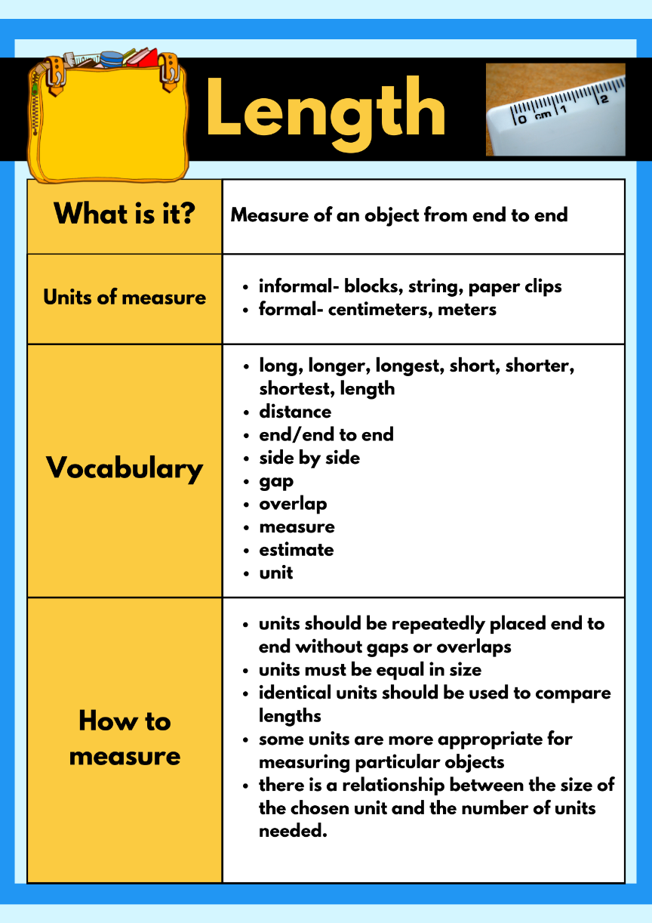
Images sourced from Canva and used in accordance with the Canva Content License Agreement.
- Display Resource 1: Captain Beard’s ship. Explain the problem, that Captain Beard wants to bury his treasure chest on the island and record where it is on his treasure map. He draws the palm tree on his map then counts 14 steps from the palm tree to the treasure chest and writes this on his map. He asks Pirate Bonny to check if his counting is correct, but she counts 20 steps.
- Ask students why they think Captain Beard has counted less steps to the treasure chest than Pirate Bonny.
- Take students outside and have them line up behind a marked line. Mark another line 3 to 4 metres away and have students silently count how many steps it takes from one line to the other. Discuss how many steps it took each student and why the number varies.
- Ask students:
- Why do you think Captain Beard counted 14 steps and Pirate Bonny counted 20 steps to the treasure chest?
- Why are the measurements different? Why is this a problem for Captain Beard?
- Is there a better way to measure the distance? Explain your reasoning.
- Draw students’ attention to the importance of uniform, accurate, and precise measurements, and the need for a formal unit of measurement.
- Show students a metre ruler. Ask students what they notice and wonder.
- Investigate the metre ruler. Discuss with students that the distances between marks on a ruler represent unit lengths and that the marks indicate the endpoints of each unit. Model estimating and measuring length using a metre ruler.
Note: Using the phrase ‘make, mark and move’ assists students in understanding the concept of repeated units. By placing a unit on a flat surface, marking where it ends, moving it along and continuing the process, students identify that the unit of measurement is the space between the marks on a measuring device and not the marks themselves. When recording measurements, a space should be left between the number and the abbreviated unit of measurement, for example, 1 m.
- Explain to students that Captain Beard has set them a challenge to find items in the ship (classroom) that are more than one metre long. Provide students with a one metre length strip cut from ribbon or cardboard and a copy of Resource 5: Estimating and recording.
- In pairs, students select classroom items to estimate and measure using the metre length. Students record their estimates and measurements in the worksheet.
- Invite students to share their findings with the class. Ask the students the following questions to guide a class discussion:
- Why did you choose a particular classroom item to measure?
- What was the strategy you used to estimate? How accurate was your estimate?
- What did you notice? What surprised you?
- Were there any challenges when measuring? How did you solve them?
- What items in the classroom were about a metre long?
- What items were more than a metre long?
This table details assessment opportunities and differentiation ideas.
Assessment opportunities | Too hard? | Too easy?
What to look for:  - Can the students give reasons and explanations about the problem and their thinking? (MAO-WM-01, MA1-GM-02)  - Can students estimate length to the nearest metre? (MAO-WM-01, MA1-GM-02)  - Do students measure using a metre ruler/strip? (MA1-GM-02)  - Are students able to record lengths with the abbreviation (m)? (MA1-GM-02)  What to collect:  - observations of students estimating, comparing and measuring (MAO-WM-01, MA1-GM-02)  - student work sample Resource 5: Estimating and recording (MAO-WM-01, MA1-GM-02) | Students are unable to estimate and measure a metre length.  - Students continue to use non-standard units, for example, hand spans to measure.  - Explicitly model the correct use of a metre ruler, making sure there are no gaps or overlaps between measure.  - Work with small groups of students to measure accurately, reinforcing the correct use of the metre ruler/ metre strip.  - Ask students to identify something in the room that is about 1 m long and measure to check. | Students can estimate and measure a metre length.  - Ask students if they need a smaller unit of measure than a metre. Prompt students to explain their thinking.  - Ask students if they would ever need a unit bigger than a metre. Students make a list of things they would need to measure with a unit bigger than a metre.

Lesson 3: Cannon ball maths
Core concept: Measuring and comparing lengths using formal units.
The table below contains suggested learning intentions and success criteria. These are best co-constructed with students.
Learning intentions | Success criteria
Students are learning that:  - mathematicians can use formal units to estimate, compare and measure lengths  - metres can be abbreviated to (m)  - mathematicians communicate their thinking and reasoning coherently and clearly. | Students can:  - recognise a metre length  - estimate, measure, and record to the nearest metre  - record metres with abbreviated (m)  - answer the question ‘How far can the cannon ball go?’  - organise results (data) to answer the question ‘How far can the cannon ball go?’

Daily number sense: X marks the spot – 20 minutes
- Build students understanding of three-digit numbers by playing bingo.
- Print Resource 6: Bingo card.
- Students write 15 three-digit numbers between 100 and 200 to cover their bingo card.
- Teacher chooses a three-digit number and writes it on the board.
- Students mark an X on a number that is before or after the number written on the board.
- The winner is the student to cover all their numbers on their bingo card first.
This table details assessment opportunities and differentiation ideas.
Assessment opportunities | Too hard? | Too easy?
What to look for:  - Can the students identify numbers before and after three-digit numbers? (MA1-RWN-01, MA1-RWN-02)  What to collect:  - student observations. (MA1-RWN-01, MA1-RWN-02) | Students are unable to identify the three-digit number before or after.  - Scaffold students’ identification of three-digit numbers with a visual, for example a number chart.  - Scaffold students with a smaller bingo card or two-digit numbers | Students can identify the three-digit numbers before or after.  - Ask students to find numbers that are 5 more or 5 less than the number called.  - Ask students to find numbers that are 7 more or 7 less than the number called.

Fire the cannon – 40 minutes
- Explain the problem that Captain Beard needs to protect his treasure. He wants the pirate crew to fire the cannon if anyone comes near the treasure chest. Captain Beard needs to work out how far the cannon ball can go. He wants the students to fire the cannon and record the distance it can travel and report back to him.
- Give each student a copy of Resource 7: Fire the cannon and take them outside to an open space. Line the students up behind a marked line.
- Explain to students they will have 3 chances to fire the cannon. Show students the cannon ball (beanbag). Students will record an estimate in metres and then fire the cannon (throw the beanbag).
- After they have fired the cannon, students check how far the cannon ball travelled using a metre ruler. Remind students to use the phrase ‘make, mark and move’ to assist them in understanding the concept of repeated units.
- As a class, add any additional information about length to the anchor chart.
This table details assessment opportunities and differentiation ideas.
Assessment opportunities | Too hard? | Too easy?
What to look for:  - Can students estimate length to the nearest metre? (MAO-WM-01, MA1-GM-02)  - Do students measure lengths using a metre unit? (MA1-GM-02)  - Are students able to record lengths with the abbreviation (m)? (MA1-GM-02)  What to collect:  - student work sample Resource 5: Estimating and recording. (MAO-WM-01, MA1-GM-02) | Students are unable to estimate and measure distances in metres.  - Support students to count units by marking off single units mentally or physically.  - Hold the metre ruler for students to use as a visual benchmark.  - Model the make, mark and move process. | Students can measure distances in metres.  - Provide opportunity for students to use centimetres (cm) to provide a more accurate measure.  - Ask students how they would measure a larger length, for example a swimming pool or football field. Ask if a metre would be an appropriate unit of measure. Prompt students to explain their thinking.

Lesson 4: Pirate Bonny’s flag
Core concept: Area can be measured using uniform square units in rows and columns.
The table below contains suggested learning intentions and success criteria. These are best co-constructed with students.
Learning intentions | Success criteria
Students are learning that:  - mathematicians estimate, compare and order area to determine the largest surface  - area can be measured by selecting and using square uniform informal units of an appropriate size  - the array structure of rows and columns can be used to find the area of an object  - mathematicians record comparisons of area using pictures, numbers, and words. | Students can:  - estimate which pirate flag has the largest area  - compare and order the pirate flags by area size  - measure the pirate flags area using uniform informal units  - use the structure of rows and columns (array) to find the total area  - use skip counting or repeated addition to find the total area  - record their thinking using pictures, numbers, and words.

Daily number sense: Number talk – 10 minutes
This activity has been adapted from Wyborney (2017).
- Build students understanding of part whole relationships and number combinations to 10 by using a number tiles activity.
- Display Resource 8: Number tiles on the board. Give students time to think and wonder about the image. Make a chart of what students notice. For example, I can see different shapes, or I can see 4 green squares would fit in one blue square.
- Explain to students that a green square has a value of one, a yellow rectangle in any orientation has a value of 2, a red rectangle in any orientation has a value of 3 and the blue square has a value of 4. Variation: These numbers can be made larger for additional challenge.
- In pairs give students a copy of Resource 8: Number tiles. Students record the value of each section on the image (see Figure 2).
Figure 2 – Example of annotated number tile
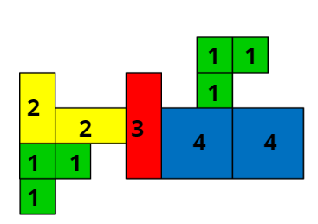
- Using their knowledge of part whole relationships, students find combination of numbers to find the total value of the shape.
- Students record their thinking on the image. Encourage students to find the most efficient combinations to determine the total quantity.

Which flag has a larger area? Part 1 – 30 minutes
- As a class, discuss what students already know about area. Create a class anchor chart with a focus on a definition, vocabulary, units of measurement and how to measure area. Explain that using their knowledge of length will help students determine the area of a surface.
Area: The measure of the amount of surface within a two-dimensional shape.
- Explain to students that Pirate Bonny has a mathematical pirate problem to solve. She wants to get a new flag made for her pirate ship. Pirate Bonny has been sent 2 sample flags from the pirate shop. She wants to choose the flag with the largest area.
- Mark 2 rectangular shapes with differing lengths and widths on the classroom floor. Make sure it is not easy to determine by looking at the shapes which rectangle has the larger area (see Figure 3).
Figure 3 – Example of rectangular shapes
- Ask the students to turn and talk to a partner and estimate which flag has the largest area.
- Share some of the student’s estimations and thinking. Remind students that mathematicians check their thinking and estimations by measuring. Ask students what units are appropriate to measure area and why.
- Provide a selection of informal units that can be used to measure. For example, paper clips, connecting block, square tiles, sticky notes and string.
- In small groups, give students time to discuss which is the most appropriate unit to measure the area of the flags. Discuss why some uniform informal units are more appropriate to measure area than others. For example, paper clips leave gaps which will not give us an accurate measure.
Note: Covering surfaces with a range of informal units should assist students in understanding that some units tessellate (fit together without gaps or overlaps) and are therefore more suitable for measuring area.
- Students estimate the number of units needed to cover each flag. Students record their estimations in their workbook.
- Students measure the area of both flags using their chosen unit of measure. During the activity, observe student’s strategies for measuring. Remind students to have no gaps or overlays of units and emphasise the use of the array structure of rows and columns.
Array: One of several different arrangements that can be used to model multiplicative situations involving whole numbers. An array is made by arranging a set of objects into columns and rows. Each column must contain the same number of items as the other columns. Each row must contain the same number of items as the other rows.
- Ask students:
- How does the structure of rows and columns help measure area?
- How can you count the total area? For example, use repeated addition or skip counting.
- Were there parts leftover when measuring the area? How did you count these? For example, folding a sticky note to fit.
- Which rectangle was larger? How do you know?
Note: In covering activities, rectangular shapes are used so that students develop an understanding of the structure of the unit covering (array) in area. Knowledge of array structure is important for an understanding of area measurement. It enables the area of a rectangle to be linked to the lengths of its sides.
- Students record their strategy for measuring area and the total area of each flag next to their estimates using pictures, numbers, and words. Ask students:
- How did your answer compare to your estimate?
- Why do you think your estimate was close to, or far away, from the actual answer?
- What strategies could you use to help you estimate more accurately next time?
- Which flag would you tell Pirate Bonny to choose? Why?
Note: Drawing the array structure for the tessellation of area units helps students to understand the rows (and columns) as composite units. This enables them to connect side length and area. If students have drawn and talked about the structure of an array, they may grasp the structure of three-dimensional stacking more easily.
This table details assessment opportunities and differentiation ideas.
Assessment opportunities | Too hard? | Too easy?
What to look for:  - Can students make a reasonable estimate about area? (MAO-WM-01, MA1-2DS-02)  - Are students able to use the structure of rows and columns with uninform informal units? (MA1-FG-01 MA1-2DS-02)  - Can students find the total area? (MA1-FG-01, MA1-2DS-02)  - Are students able to compare the area of 2 rectangles and determine which has the larger area? (MAO-WM-01, MA1-2DS-02)  - Can students record comparisons of area using drawing, words and numbers? (MAO-WM-01, MA-2DS-02)  What to collect:  - student observations (MAO-WM-01, MA1-FG-01, MA1-2DS-02)  - student's recordings of area. (MAO-WM-01, MA1-FG-01, MA1-2DS-02) | Students are unable to use the structure of rows and columns with uniform informal units to find the total area.  - Model creating one row and one column using the informal units. Students use this initial structure as a scaffold to complete.  - Support students to group informal units. Model skip counting on a number chart to find the total. | Students can use the structure of rows and columns with uniform informal units to find the total area.  - Ask students what difference would it make if they used much smaller or bigger informal units for measuring? Students explain their thinking.  - Students to measure the area of a non-rectangular surface within the classroom. Ask them what challenges this has. Challenge students to find a solution and record their findings.

Consolidation and meaningful practice: Which flag has a larger area? Part 2 – 20 minutes
- Display Resource 9: Sample flags on the board. Explain to students that Pirate Bonny has been given another 2 flags to choose from. This time she only has one square tile to measure the area.
- Give each student a copy of Resource 9: Sample flags and one square tile.
- Ask students:
- Is it possible to measure and compare the areas using only one tile? How?
- What will you need to show in your recording?
- Which flag would you tell Pirate Bonny to choose? Why?
Note: To help students develop an appreciation for the structure of repeated units in measuring area, progress teaching from providing multiple squares to cover an area, to providing only one square. Having only one square requires students to create the pattern or structure of the units by drawing or visualising.
- In pairs, have students explain to their partner how they would measure with only one tile.
- Students measure the area using only one tile, encourage students to ‘make, mark and move’ to iterate units accurately.
- As a class, add any additional information they have learned about area to the anchor chart.
This table details assessment opportunities and differentiation ideas.
Assessment opportunities | Too hard? | Too easy?
What to look for:  - Are students able to use the structure of rows and columns with a single square? (MA1-FG-01, MA1-2DS-02)  - Can students find the total area using a single square? (MA1-FG-01, MA1-2DS-02)  - Are students able to compare the area of 2 rectangles and determine which has the larger area? (MAO-WM-01, MA1-2DS-02)  - Can students record comparisons of area using drawing, words and numbers? (MAO-WM-01, MA-2DS-02)  What to collect:  - student observations (MAO-WM-01, MA1-FG-01, MA1-2DS-02)  - student's recordings of area. (MAO-WM-01, MA1-FG-01, MA1-2DS-02) | Students are unable to use the structure of rows and columns with a single square.  - Support students by providing a grid structure to overlay onto the flags.  - Scaffold the rows and columns by creating pencil marks on image to demonstrate rows and columns. | Students are able to use the structure of rows and columns with a single square.  - Ask students how measuring the length and width of the rectangle helps to determine the total area.  - Ask students if they can think of other informal units that would be appropriate to measure area. Students make a list.

Lesson 5: Pirate Bonny’s new treasure chest
Core concept: Volume can be measured by filling and packing with informal units.
The table below contains suggested learning intentions and success criteria. These are best co-constructed with students.
Learning intentions | Success criteria
Students are learning that:  - mathematicians estimate, compare and order internal volume by counting the number of blocks used in models  - mathematicians are precise when measuring internal volume, making sure they fill right to the top of the container  - objects can look different but still have the same internal volume  - mathematicians record comparisons of volume using pictures, numbers, and words. | Students can:  - estimate which container has the larger internal volume  - compare and order the internal volume of the containers  - measure the internal volume of the containers using cubes filled to the brim  - recognise models that look different may have the same volumes  - record their thinking using pictures, numbers, and words.

Daily number sense: Pirate Bonny’s fort – 15 minutes
This activity has been adapted from Sullivan and Lilburn (2004).
- Build student understanding of volume by comparing structures. Display Resource 10: Cubes on the board. Ask students to turn and talk to a partner and discuss the following questions:
- How many cubes are in the stack? Why do you think this way?
- How many cubes cannot be seen in each stack? How do you know?
- Explain that Pirate Bonny used 12 blocks to make a fort on her island. Ask students what her fort might look like.
- Invite students to use 12 interlocking cubes to build a model. Encourage students to build more than one object using 12 interlocking cubes.
- Students gallery walk to view other results. Ask students:
- What did you notice?
- What can you tell me about the different objects with the same volume?

Pirate Bonny’s treasure chest – 30 minutes
- As a class, discuss what students already know about volume. Create a class anchor chart with a focus on a definition, vocabulary, units of measurement and how to measure volume. Explain to students that using their knowledge of the array structure will help to determine internal volume.
- Explain that Pirate Bonny’s treasure chest has broken – she needs to find the perfect container that will hold as much treasure as possible.
- Display 3 different size containers and one block. Ask students to estimate which container would hold the most blocks, and therefore would make the best treasure chest. Prompt students to explain how they will know.
- Students complete Resource 11: Estimating volume to record their estimations.
- Ask students how they could work out how many blocks the containers can hold.
- In pairs, students measure using blocks to fill and order 3 containers from the container that the holds the least to most.
- Students record measurement by completing Resource 12: Recording volume. Use ‘Talk moves’ to support discussion, ask students:
- Why did you put the containers in that order?
- What do we need to remember when we are fitting the blocks inside the containers? Why?
- What is the same or different about the containers measured?
- What do you notice when you compare your estimation and actual results?
- What was the most accurate method for filling the containers? Why?
- How do we ensure accurate measuring of volume?
This table details assessment opportunities and differentiation ideas.
Assessment opportunities | Too hard? | Too easy?
What to look for:  - Can students estimate internal volume? (MAO-WM-01, MA1-3DS-02)  - Are students able to use informal units to measure volume? (MAO-WM-01, MA1-3DS-02)  - Are students able to compare, order and record the volume of 2 or more containers? (MAO-WM-01, MA1-3DS-02)  - Are students able to recognise and explain why containers of different shapes may have the same internal volume? (MAO-WM-01, MA1-3DS-02)  - Are students able to estimate how much a container holds by referring to the number and type of uniform informal unit used and check by measuring? (MAO-WM-01, MA1-3DS-02)  What to collect:  - student observations (MAO-WM-01, MA1-3DS-02)  - student recordings. (MAO-WM-01, MA1-3DS-02) | Students are unable to use informal units to measure volume.  - Explore the language of volume and capacity such as full, empty, estimate, gap.  - Provide further experiences in filling containers with continuous materials such as water, and discrete objects such as marbles to the brim.  - Model the use of informal units and the structure of rows and arrays, noticing the lack of gaps. | Students can use informal units to measure volume.  - Students fill the containers with 2 different materials, such as water and marbles, and compare differences.  - Students fill the container halfway and use mathematical reasoning to estimate the remaining blocks needed.  - Give students containers that look different but holds the same amount. Have students estimate which container has the greatest volume.

Consolidation and meaningful practice – 15 minutes
- Students are given the opportunity to complete the activity again, using different informal units of measurement.
- As a class, discuss the differences between the units of measurement. For example, the smaller the units of measurement the more is needed to fill the container. Add any new information to the anchor chart on volume.

Lesson 6: Heave the cargo
Core concept: Mass can be measured and compared using an equal-arm balance.
The table below contains suggested learning intentions and success criteria. These are best co-constructed with students.
Learning intentions | Success criteria
Students are learning that:  - mathematicians estimate, compare and order mass to determine which object is heaviest or lightest  - mass can be measured using an equal arm balance  - mathematicians record comparisons of area using pictures, numbers, and words. | Students can:  - estimate, compare and order the mass of cargo (objects)  - compare and order the mass of cargo (objects)  - measure the mass of objects by using an equal arm balance  - record thinking using pictures, numbers, and words.

Daily number sense: Fingers and hands – 10 minutes
This activity has been adapted from Fingers and Hands by the University of Cambridge (NRICH 2022).
- Build student understanding of counting sequences and number patterns by counting large groups.
- Display Resource 13: Counting hands. Ask students:
- What do you notice?
- How many fingers (including thumbs) are there in the picture? How do you know?
- How many fingers (including thumbs) would there be if another person joined the group?
- As a group, students share how they came to their total and compare their way with other people’s ways.
- Display Resource 14: Counting fingers. Ask students:
- What do you notice?
- How many fingers are there in the picture? How do you know?
- Did you change the way you worked it out?
- Are there some ways that were more popular to count than others? Why do you think this is?

Heave the cargo – 50 minutes
- Display Resource 1: Captain Beard’s ship on the board. Ask students to identify 2 objects that could have the same mass in the image. Students turn and talk to explain their thinking to a partner. Guide student discussions with the following questions:
- Is it possible to determine mass by looking? Why/why not?
- Does the size of an object determine the mass? Why/why not?
- How can we measure mass? Is there another way?
- If I needed to compare mass quickly, how could I do this?
- As a class, discuss what students already know about mass. Create a class anchor chart with a focus on a definition, vocabulary, units of measurement and how to measure mass.
- Ask students to stretch out arms and imagine an elephant in one hand and mouse in the other. Ask students to describe what would happen to their arms.
- Display 2 shopping bags, for example, one filled with a full drink bottle and the other bag with a small book. Ask students to estimate:
- Which object will be heavier?
- Why do you think this way?
- How can I work out which shopping bag is the heaviest?
- Ask students to close their eyes and heft each bag. Check their estimation of which object is heavier.
Hefting: Testing the weight of an object by lifting and balancing it. Where possible, students can compare the weights of 2 objects by using their bodies to balance each object.
- Ask students to find objects in the classroom with the same size, first estimate and then check estimation by hefting.
- Ask students:
- Is hefting an accurate way to measure? Why or why not?
- What challenges did you have? How did you solve them?
- How could you measure mass accurately?
- Display an equal-arm balance and 5 objects that could be found as cargo on a pirate ship. For example, a pirate book, a ball, a toy, a box, a hat, or a map.
Note: The equal-arm balance can have 2 functions including comparing the masses of 2 objects and measuring the mass of an object by using multiple identical units.
- Display 2 of the objects. Ask students:
- What do you notice about these objects?
- Which item will be the heaviest? How could you find out?
- Can you predict what will happen if one object sits in one bucket, and the other object sits in the other bucket?
- When will you know the mass is the same?
- When is it hard to predict which items will be heavier?
- Place the objects on either side of an equal-arm balance. Ask students:
- Can you see any objects that may have the same mass? What makes you think that?
- When will know the mass is the same?
- Place the objects on either side of an equal-arm balance to obtain a level balance.
- Explain that Captain Beard must ensure that all the cargo on his ship is ordered from heaviest to lightest mass, so the boat can sail safely across the seas. Students need to order the items from heaviest to lightest mass.
- In pairs, students compare and order objects by first hefting and then using an equal-arm balance to check. Students predict the action of the equal-arm balance before placing objects in each bucket. Use ‘Talk moves’ to support student reasoning about relations.
- Ask students to create a drawing to record their thinking.
The table below details assessment opportunities and differentiation ideas.
Assessment opportunities | Too hard? | Too easy?
What to look for:  - Can students make a reasonable estimate about mass? (MAO-WM-01, MA1-NSM-01)  - Are students able to use an equal-arm balance to measure, compare, record mass of 2 items? (MAO-WM-01, MA1-NSM-01)  - Are students able to compare and order mass by hefting and check using and equal-arm balance? (MAO-WM-01, MA1-NSM-01)  What to collect:  - student observations (MAO-WM-01, MA1-NSM-01)  - student recording. (MAO-WM-01, MA1-NSM-01) | Students are unable to compare mass by hefting.  - Explore the language of mass such as heavy, light, big, small, balance.  - Further experiences in hefting. Manipulate their body appropriately in order to feel the mass of an object.  Students are unable to use an equal-arm balance to measure and record mass.  - Reduce the number of objects being compared.  - Model how to use the equal-arm balance to support accuracy. | Students can compare mass by hefting.  - Extend responses through logic of indirect comparison.  - Students turn and talk to compare reasoning and communicate about what they are learning. Students give feedback to peers on their learning.  Students can use an equal-arm balance to measure and record mass.  - Students compare mass systematically and explain why it fits in a particular order.  - Students further explore the spatial structure of items and relation to mass.

Consolidation and meaningful practice: Mystery item – 10 minutes
- Explain that Pirate Bonny has found a mystery item that has the same mass as 10 pencils. Ask students what it could it be. Students use an equal-arm balance to discover items around the room with the same mass as pencils.
- As a class, discuss the differences between an object’s attributes, and the effect on its mass.
- As a class, add any additional information they have learned about mass to the anchor chart.

Lesson 7: Pirate Bonny’s measurement challenge (Part 1)
Core concept: Mathematicians use units of measure to solve mathematical problems.
The table below contains suggested learning intentions and success criteria. These are best co-constructed with students.
Learning intentions | Success criteria
Students are learning that:  - length can be measured using formal units of measure  - mass can be measured using an equal-arm balance  - mathematicians use units of measurement to solve mathematical problems  - mathematicians record estimations, comparisons and results using pictures, numbers, and words, and by referring to the unit used. | Students can:  - estimate the length of jumps to the nearest metre and check by measuring  - record lengths of jumps using (m)  - recognise the need for a formal unit smaller than a metre  - compare and order the masses of treasure by hefting and checking using an equal-arm balance  - place objects on either side of an equal-arm balance to obtain a level balance for objects with the same mass  - record their thinking using pictures, numbers, and words.

Daily number sense: – 10 minutes
- From a class need surfaced through formative assessment data, identify a short, focused activity that targets students’ knowledge, understanding and skills. Example activities may be drawn from the following resources:
- Thinking Mathematically Stage 1
- Universal Resources Hub

Jump the plank and treasure chest mass – 50 minutes
Note: These activities can be completed as 2 separate rotations.
- Revise that students have been exploring measurement in different ways. Explain that Pirate Bonny is very impressed with their mathematical skills and would like to invite them to be part of her crew. However, to be part of Pirate Bonny’s crew, they will need to complete some final pirate measurement challenges.
- Explain that the first pirate challenge is called ‘jump the plank’. Pirate Bonny wants to know how far her pirates can jump from the plank on her ship.
- Ask the students what measurement attribute is being measured in this challenge and how they know.
- Review the anchor chart on length and draw a pirate plank on the ground using chalk or a piece of rectangular cardboard.
- Revise the importance of estimating by visualising the unit of measurement. Students estimate how far in formal units (metres) they will jump. Students can record their estimate using the abbreviation (m). See Resource 15: Jump the plank for an example table to be drawn to record student data.
- In pairs, one student places both feet together on the plank and jumps as far as they can. Using chalk, the other student marks how far the first student jumped. Students use a metre ruler to record the length of the jump using metres. Each student records 3 estimates and 3 jumps.
- Ask students:
- How did you visualise or think about your estimate?
- Was your estimate close to the actual measurement? Why do you think that happened?
- How accurate was your measurement? How do you know?
- Is there a way you could check your measurements?
- Which jump was your furthest? How do you know?
- Did you use the ‘make, mark, move’ process? How did it help you measure more accurately?
- Do we need a unit of measure smaller than the metre? Explain why.
- Explain that the second pirate challenge is ‘Treasure chest mass’. Find 4 objects of varying mass to represent 4 treasures. Tell students that Pirate Bonny has 4 pieces of treasure and she wants to find out which treasure has the greatest mass. Students must find one object in the classroom with the same mass as the heaviest treasure.
- Review the anchor chart on mass.
- Divide students into groups of 3 or 4. Give students the opportunity to explore the 4 objects (treasure) using hefting. Students estimate the order of the treasure from lightest to heaviest. Students record their estimations in their workbook using a line model (see Figure 4).
Figure 4 – Example of line model for mass
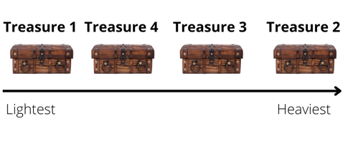
Images sourced from Canva and used in accordance with the Canva Content License Agreement.
- Give each group an equal-arm balance to measure and compare their treasure. Students measure and record their comparisons in their workbook using a line model.
- Students identify objects in the classroom that could be the same mass as the heaviest treasure. Students investigate by comparing objects mass using the equal-arm balance. In their workbooks, students record an object that has the same mass as the heaviest treasure.
- Select some groups to share their strategies for comparing the treasures’ mass and identifying an object with the same mass. Ask the following questions to stimulate a class discussion:
- What did you notice about the mass of the treasure when hefting?
- How did you compare the 4 treasures? Is there a different way you would do this next time?
- Did the size of the treasure affect the mass? Explain your thinking.
This table details assessment opportunities and differentiation ideas.
Assessment opportunities | Too hard? | Too easy?
What to look for:  - Can students estimate length to the nearest metre? (MAO-WM-01, MA1-GM-02)  - Do students measure jumps using a metre unit? (MA1-GM-02)  - Are students able to record lengths with the abbreviation (m)? (MA1-GM-02)  - Can students compare and order the masses of the treasure by hefting, and check using an equal-arm balance? (MAO-WM-01, MA1-NSM-01)  - Can students use an equal-arm balance to compare the masses of the treasure and record which is heavier or lighter? (MAO-WM-01, MA1-NSM-01)  - Are students able to record their thinking using pictures, numbers, and words? (MAO-WM-01, MA1-GM-02, MA1-NSM-01)  What to collect:  - observations of students when estimating, comparing and measuring (MAO-WM-01, MA1-GM-02, MA1-NSM-01)  - workbook displaying recording. (MAO-WM-01, MA1-GM-02, MA1-NSM-01) | Students are unable to measure jumps using a metre unit.  - Support students to mark a starting point and to line up the unit correctly.  - Mark one unit to help the student understand where to begin the next measurement.  Students are unable to compare the mass of the 4 treasures:  - Allow students to compare 2 treasures. Demonstrate hefting and provide an opportunity for the student to heft 2 items.  - Model how to use the equal-arm balance to support accuracy. | Students can measure jumps using a metre unit.  - Ask if the metre is the most accurate unit of measure. Prompt students to explain their thinking.  - Ask if the student can think of a smaller unit of measure that would be more accurate. Support students to use centimetres for a more accurate measurement.  Students can compare the mass of the 4 treasures.  - Ask students if the equal-arm balance is an accurate measure of mass. Prompt students to explain why/why not.  - Explain that the equal-arm balance helps to compare mass. Ask how students could measure mass using a formal unit of measure.

Lesson 8: Pirate Bonny’s measurement challenge (Part 2)
Core concept: Mathematicians use units of measure to solve mathematical problems.
The table below contains suggested learning intentions and success criteria. These are best co-constructed with students.
Learning intentions | Success criteria
Students are learning that:  - mathematicians estimate, compare and order area to determine the largest surface  - mathematicians estimate, compare and order volume to determine which container holds the most  - mathematicians use units of measurement to solve mathematical problems  - mathematicians record estimations, comparisons and results using pictures, numbers, and words, and by referring to the unit used. | Students can:  - estimate which pirate ship has the larger area  - measure the pirate ships area using uniform informal  - compare and order the pirate ships by area size  - use the structure of rows and columns to find the total area  - estimate which treasure chest holds the most  - measure the internal volume of the treasure chests by packing cubic units using an array model  - compare the internal volume of the treasure chests  - record mathematical thinking using pictures, numbers, and words.

Daily number sense – 10 minutes
- From a class need surfaced through formative assessment data, identify a short, focused activity that targets students’ knowledge, understanding and skills. Example activities may be drawn from the following resources:
- Thinking Mathematically Stage 1
- Universal Resources Hub

Area Ahoy and Pirate Bonny’s lunch – 50 minutes
- Revise that students have been exploring measurement in different ways. Explain that Pirate Bonny is very impressed with their mathematical skills and would like to invite them to be part of her crew. To be part of Pirate Bonny’s crew they will need to complete the final 2 pirate measurement challenges.
- Explain that the first pirate challenge is called ‘Area Ahoy’. Students need to find out how many new square planks would be needed to replace the deck on the pirate ships.
- Review the anchor chart on area and draw 3 large rectangle pirate ship decks on the ground using chalk. Ask students:
- What do you need to remember when measuring area?
- How would you measure the area? What could you use in the classroom?
- Could we use the same unit of measure that we used in Lesson 4 (sticky notes) to measure the area of the pirate ship? Why or why not?
- Display a single square. Ask, when finding the area of a ship:
- What pattern would the tiles make? How could you draw this?
- How can you count the total area? For example, how could you use repeated addition or skip counting?
- Is it possible to measure and compare area using only one square? How will you do this?
- Revise the importance of estimating by visualising the unit of measure. Ask students to estimate the area of the chalk pirate ship deck and record their estimations by drawing in their workbook.
- Students work in groups of 3 or 4 to measure the area of the pirate ships deck by covering the surface with single squares in rows and columns without gaps. Students use the ‘make, mark, move’ process and record measurements.
- Students order the decks from smallest to largest area using a line model.
- Select some groups to share their strategies for comparing the area. To stimulate a class discussion, ask students:
- How did you visualise or think about your estimate?
- Can you explain your drawing? How did you work out the area?
- Was your estimate close to the actual measurement? Why do you think that happened?
- How accurate was your measurement? How do you know?
- How do the structure of rows and columns help measure area?
- Which pirate ship had the biggest area? How do you know?
- Explain that the second pirate challenge is called ‘Pirate Bonny’s Lunch’. Show students 3 varying sized treasure chests. Pirate Bonny wants to know which treasure chest is best for holding the most amount of gold.
- Review the anchor chart on volume. Ask students:
- What do you need to remember when measuring volume?
- Why is it important to fill to the brim with no gaps?
- What materials could you use to work out the volume? Why?
- If I want to measure the internal volume of this container with blocks, how should I put them in? Explain your reasoning.
- How might finding the area of a shape help you to find the volume of an object?
- With a partner, students pack containers with blocks to measure the internal volume, then count the units. Students record the structure of their packing in their workbooks by drawing a picture.
- Bring students back together. Ask students:
- How did you count the blocks? Was there an easy way to draw the pattern of layers?
- How accurate was your measurement? How do you know?
- Which treasure box was the biggest? How do you know?
This table details assessment opportunities and differentiation ideas.
Assessment opportunities | Too hard? | Too easy?
What to look for:  - Can students make a reasonable estimate about area? (MAO-WM-01, MA1-2DS-02)  - Are students able to use the structure of rows and columns with uniform informal units? (MA1-FG-01 MA1-2DS-02)  - Can students find the total area? (MA1-FG-01, MA1-2DS-02)  - Are students able to compare the area of 2 or more rectangles and determine which has the larger area? (MAO-WM-01, MA1-2DS-02)  - Can students record comparisons of area using drawing, words and numbers? (MAO-WM-01, MA-2DS-02)  - Can students make a reasonable estimate about volume? (MAO-WM-01, MA1-3DS-02)  - Are students able to use informal units to measure volume? (MAO-WM-01, MA1-3DS-02)  - Are students able to compare, order and record the volume of 2 or more containers? (MAO-WM-01, MA1-3DS-02)  What to collect:  - observations of students when estimating, comparing and measuring (MAO-WM-01, MA1-2DS-02, MA1-3DS-02, MA1-FG-01)  - workbook displaying recording (MAO-WM-01, MA1-3DS-02) | Students are unable to use rows and column structure to measure area.  - Draw the structure of rows and arrays for the students and ask what they notice.  - Model creating one row and one column using the informal units. Students use initial structure as a scaffold to complete.  Students are unable to measure volume using units.  - Further experiences in filling containers with continuous materials such as water, and discrete objects such as marbles  - Model creating one layer for the students and supporting them to replicate the first layer on top. | Students can use rows and columns to measure area.  - Ask students to measure the area of a non-rectangular surface within the classroom. Ask what challenges this has and prompt students to find a solution.  - Ask students to record their findings.  Students can measure volume using units.  - Ask why students think blocks would not be the most accurate way of measuring volume. Encourage students to suggest alternatives.  - Ask students to draw a diagram of how they have organised their blocks and describe their thinking.

Consolidation and meaningful practice: Pirate ceremony – 15 minutes
- Congratulate students on their mathematical skills and explain that they have exceeded all of Pirate Bonny expectations. Hand out Resource 16: Crew certificate to all students and explain that Pirate Bonny has invited them to be part of the crew.
- Explain that Captain Beard would like a record of students’ challenges and successes during their investigations. Students draw a picture of what they have learnt during this investigation. Ask students:
- What did you enjoy most about being measuring mathematicians? Why?
- How did the challenge make you feel?
- What group work skills did you use in this unit?

Resource 1: Captain Beard’s ship
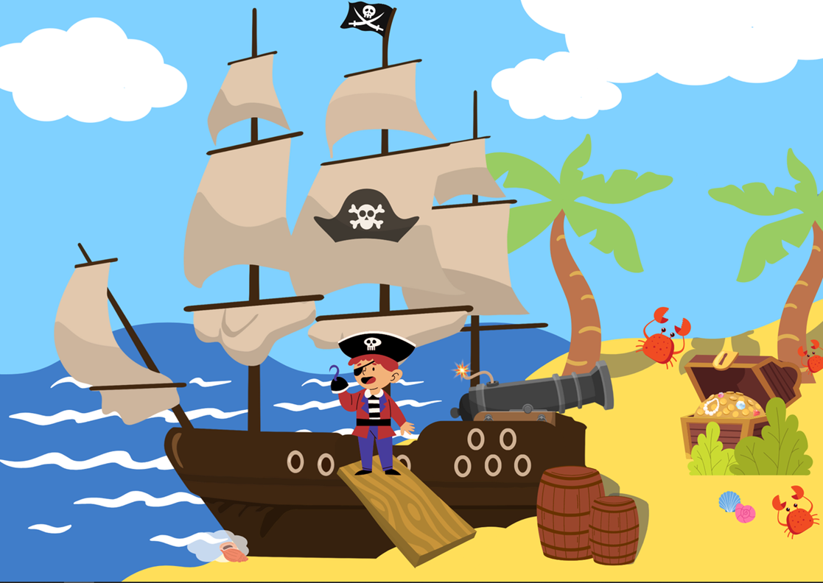
This image contains content obtained from Canva, and its use outside of this resource is subject to Canva’s Content License Agreement. If you wish to use it separately from the resource, please go to Canva.

Resource 2: Pirate crew
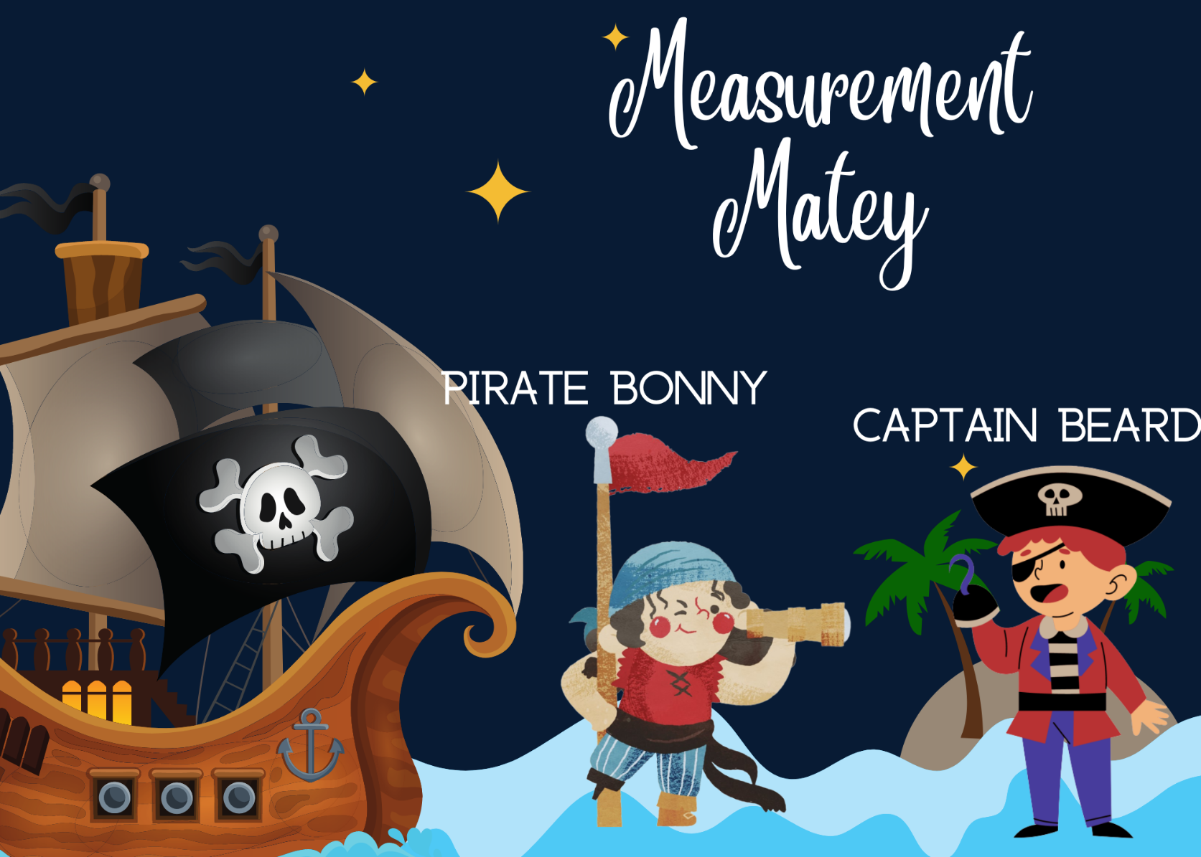
Images sourced from Canva and used in accordance with the Canva Content License Agreement.

Resource 3: Pirate Bonny’s bucket
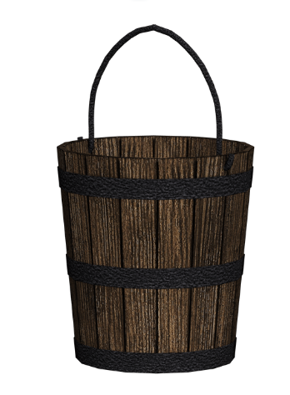
‘Wooden bucket’ by susannp4 is used in accordance with the Pixabay License.

Resource 4: Bucket recording sheet
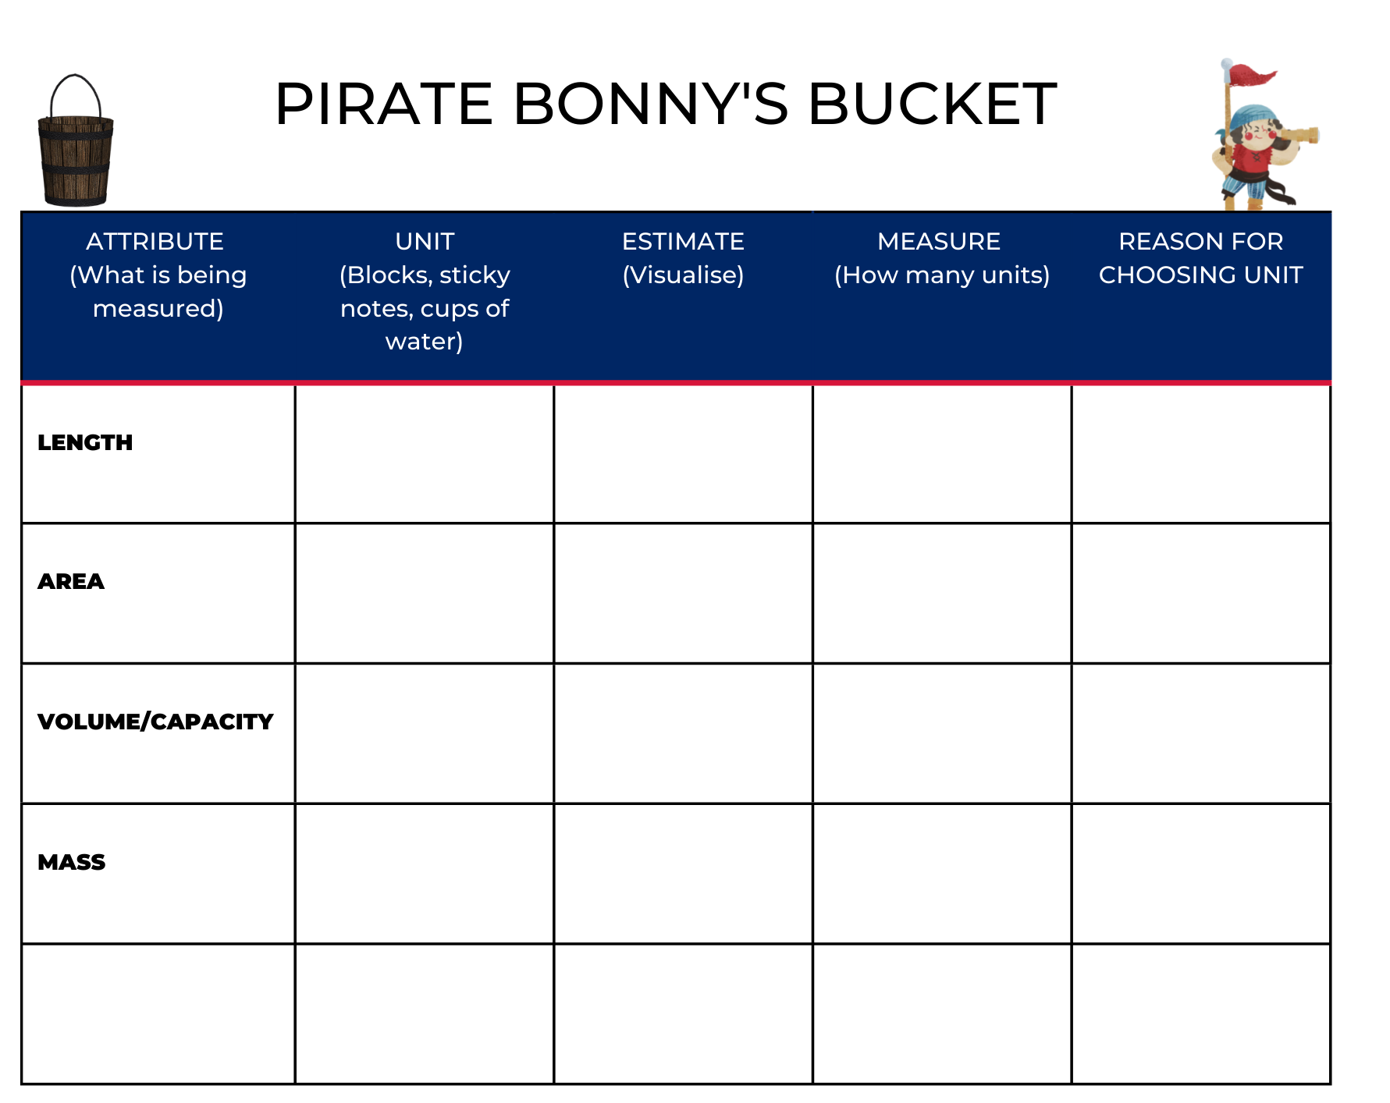
Images sourced from Canva and used in accordance with the Canva Content License Agreement.

Resource 5: Estimating and recording
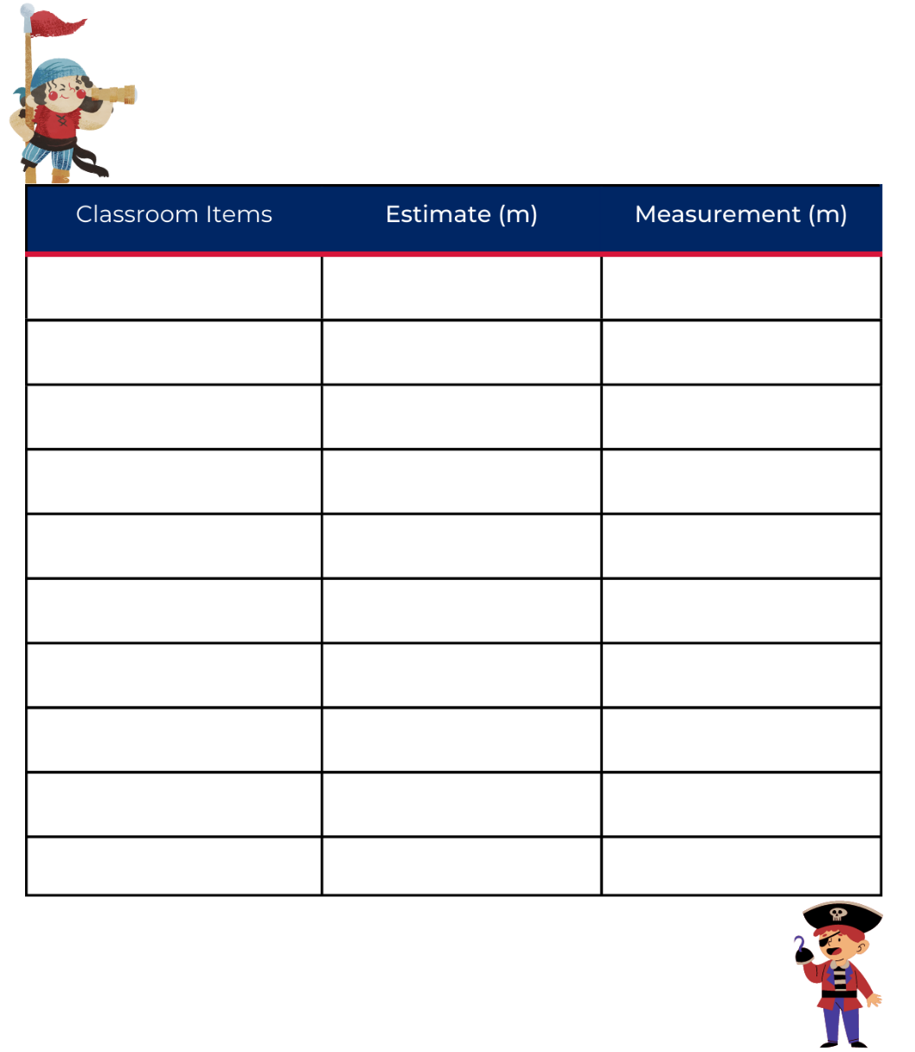
Images sourced from Canva and used in accordance with the Canva Content License Agreement.

Resource 6: Bingo card
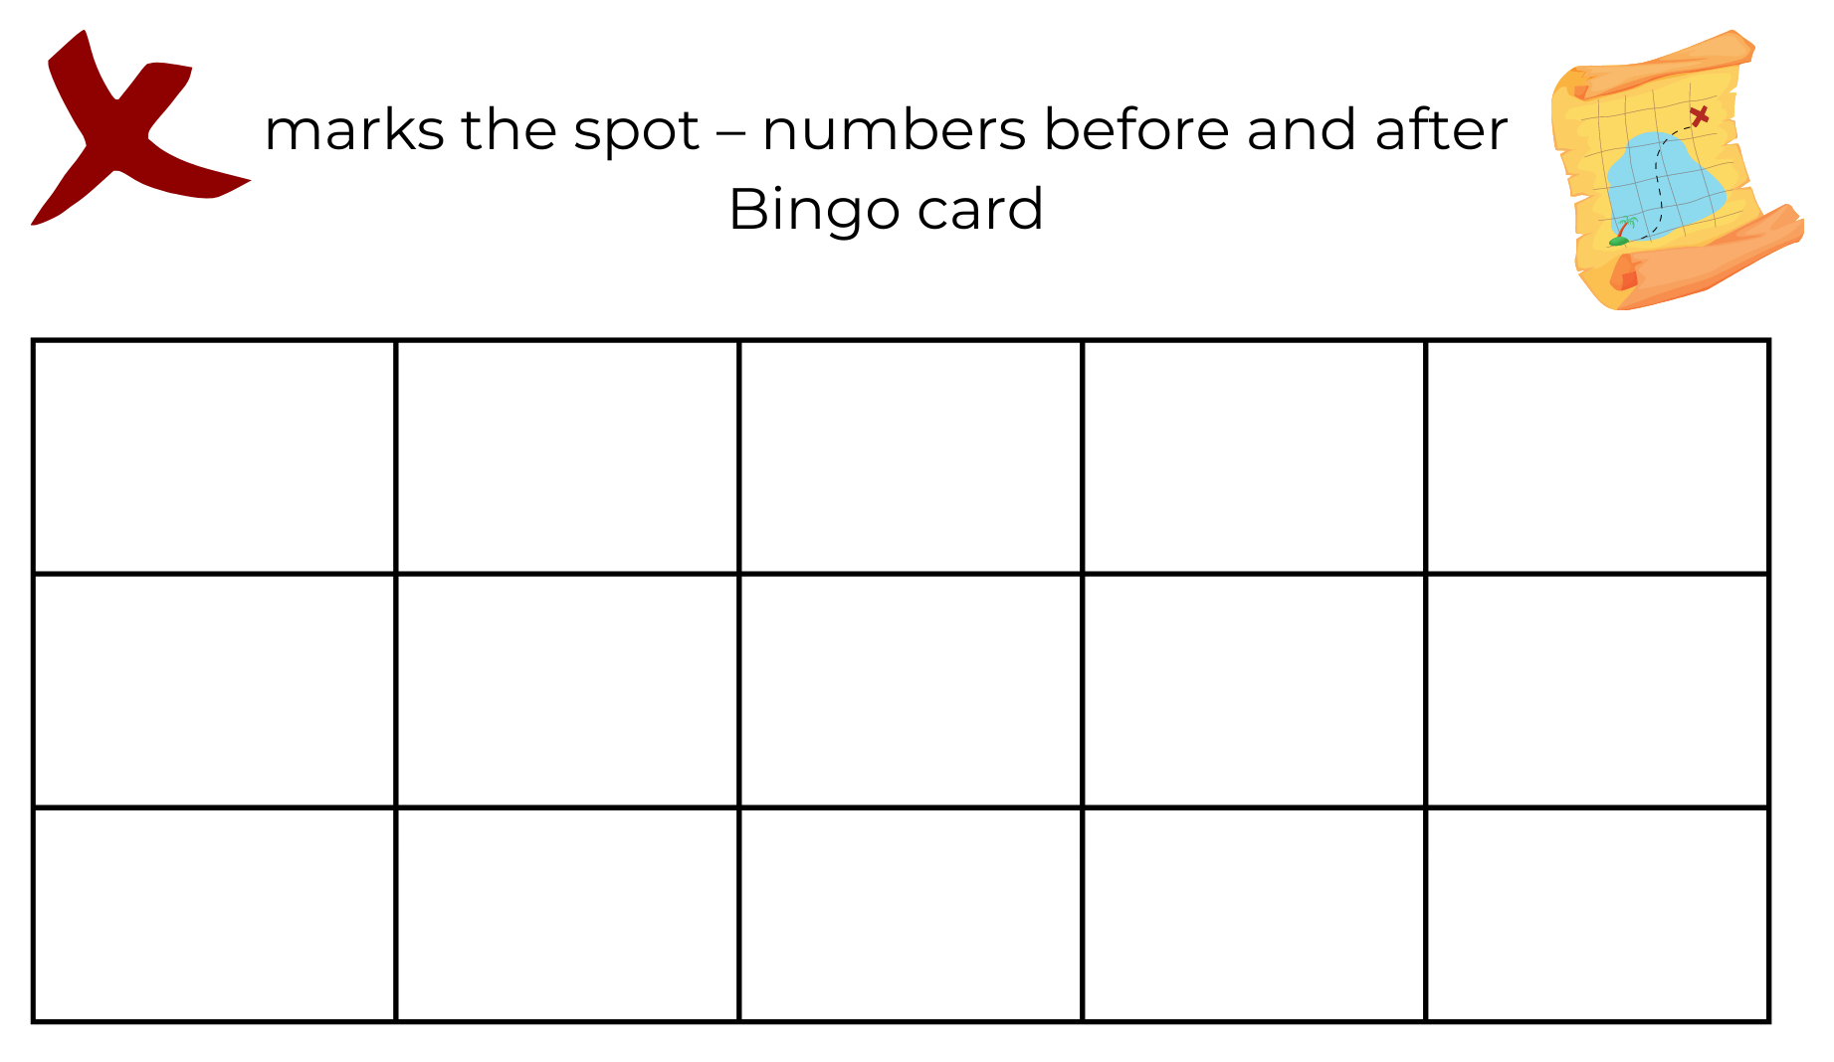
Images sourced from Canva and used in accordance with the Canva Content License Agreement.

Resource 7: Fire the cannon
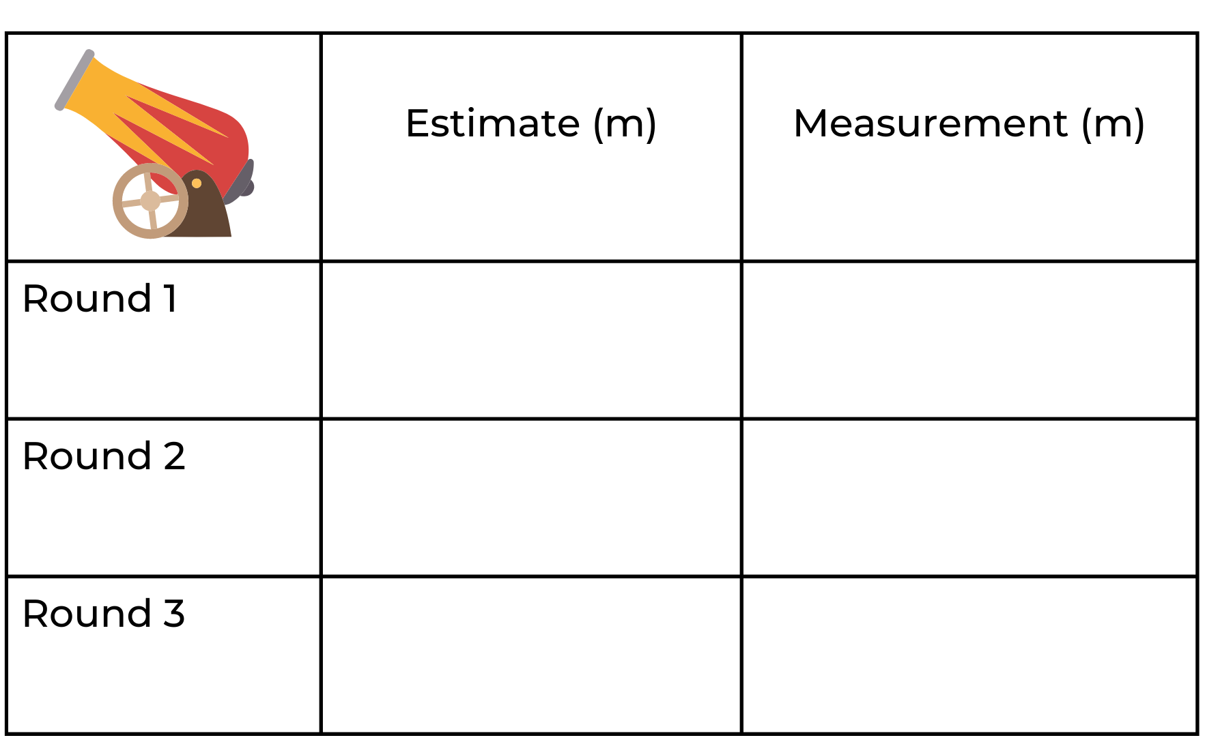
Images sourced from Canva and used in accordance with the Canva Content License Agreement.

Resource 8: Number tiles
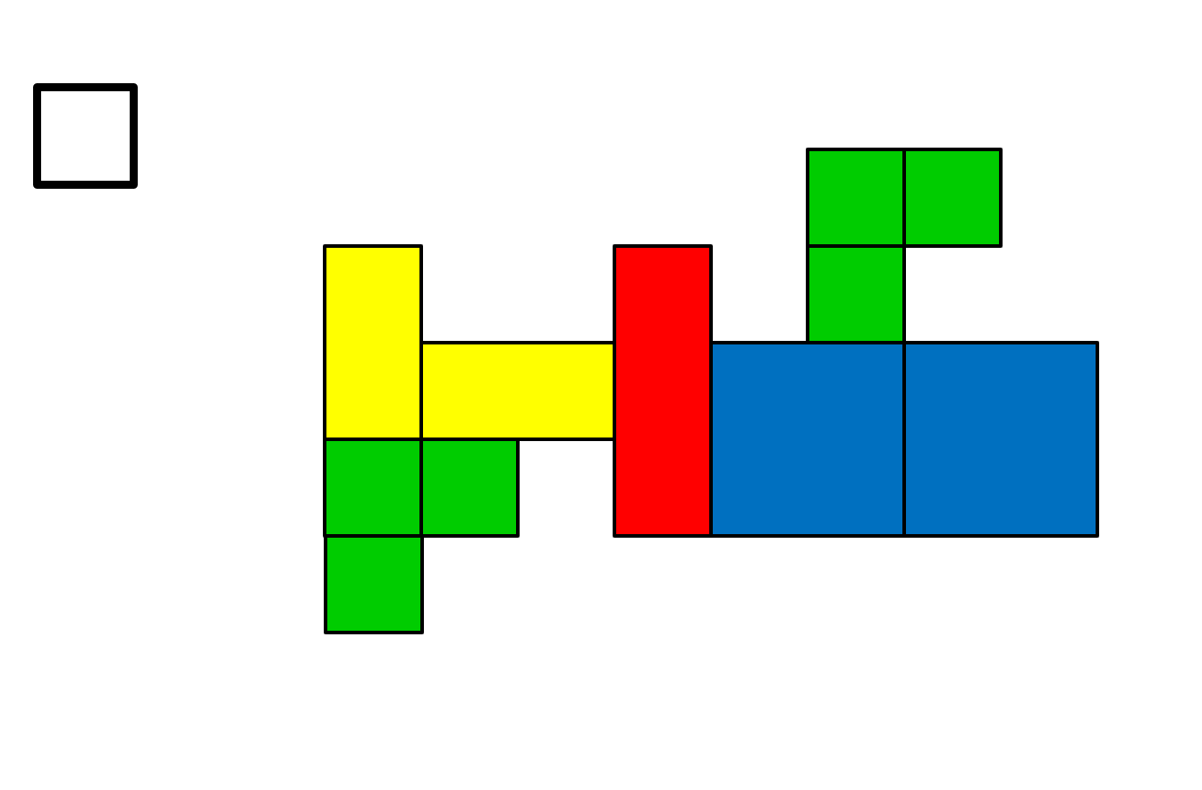

Resource 9: Sample flags
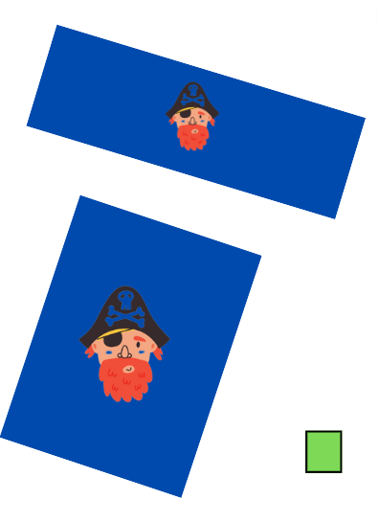
Images sourced from Canva and used in accordance with the Canva Content License Agreement.

Resource 10: Cubes
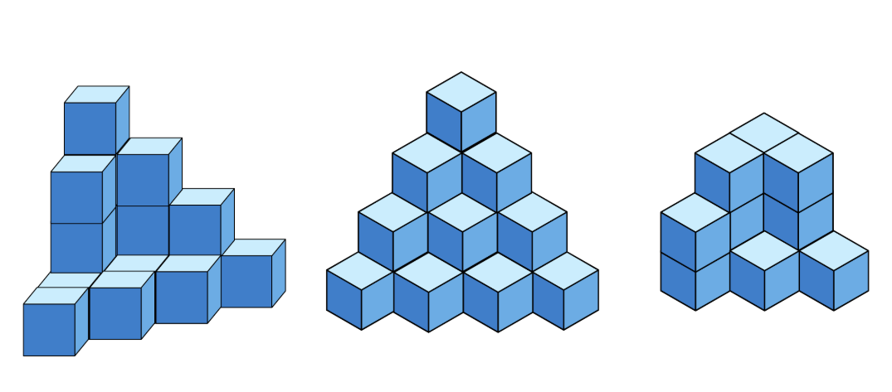

Resource 11: Estimating volume
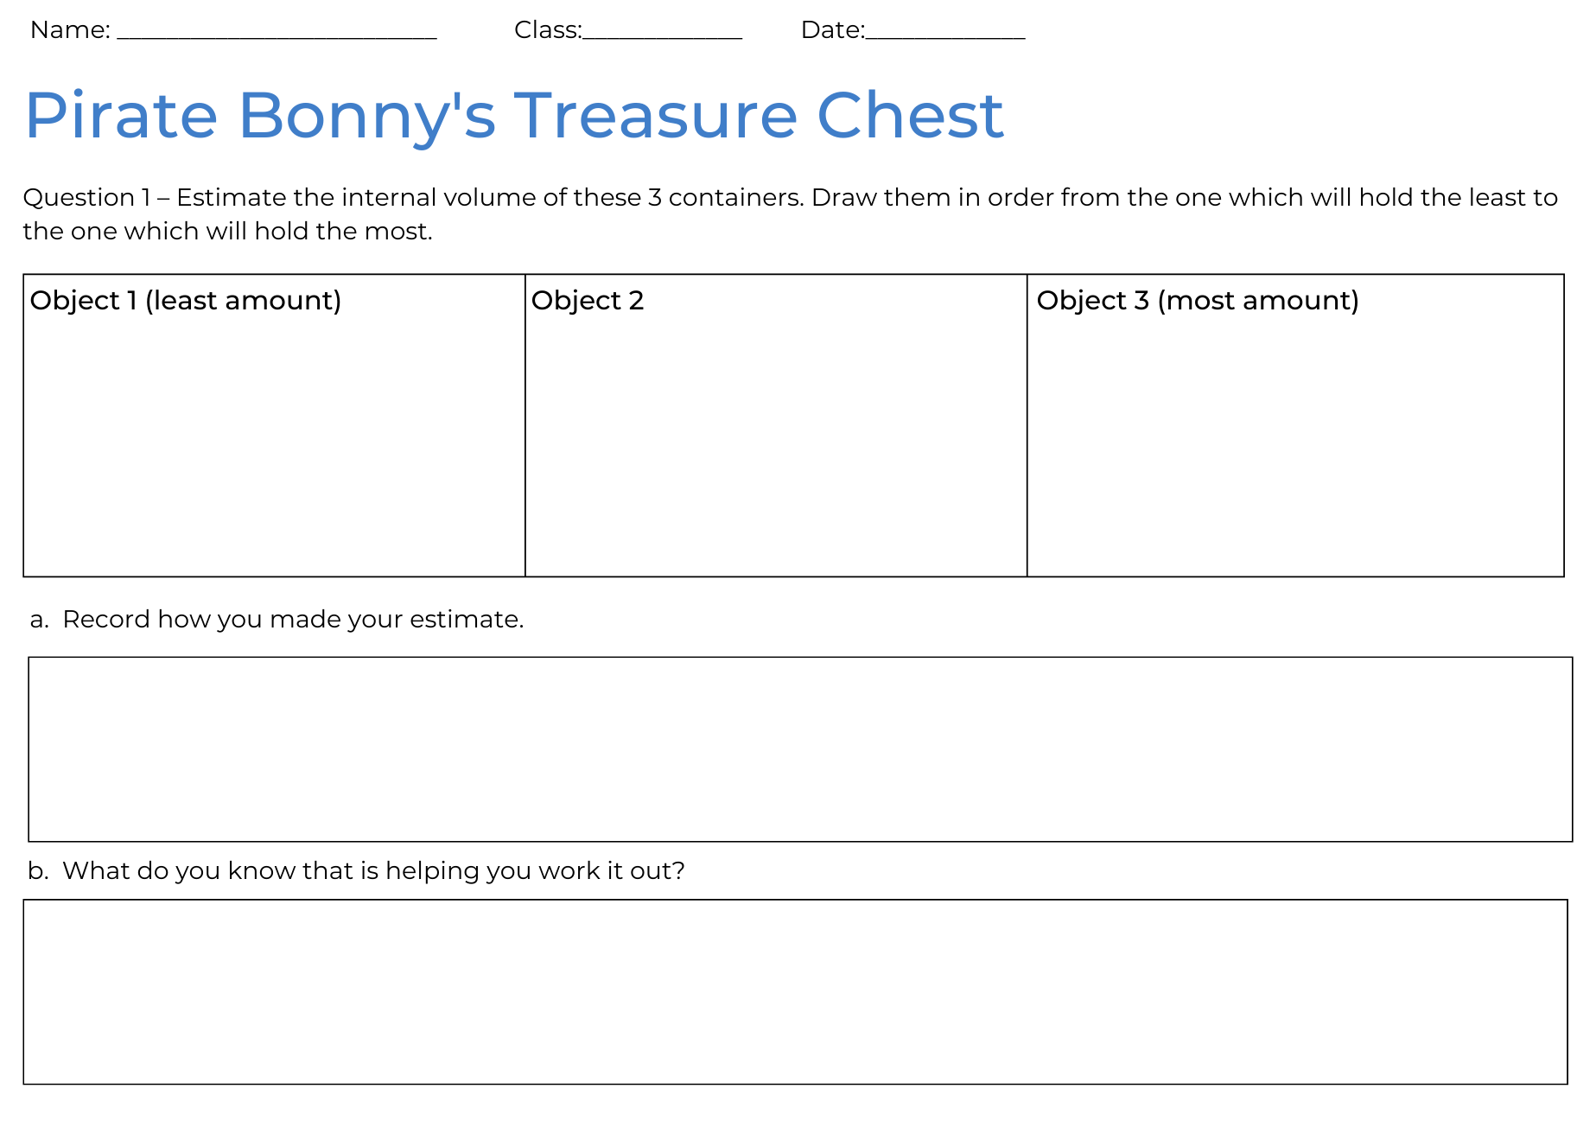

Resource 12: Recording volume
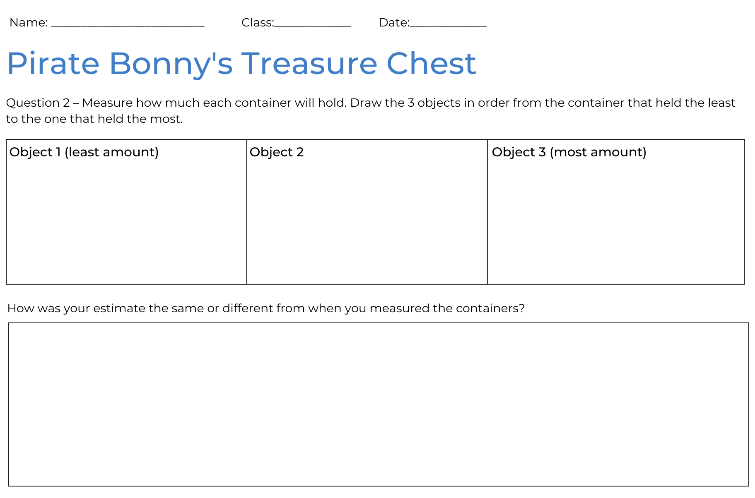

Resource 13: Counting hands
‘Human Hand’ by Billion Photos is used in accordance with the Canva Content License Agreement.

Resource 14: Counting fingers
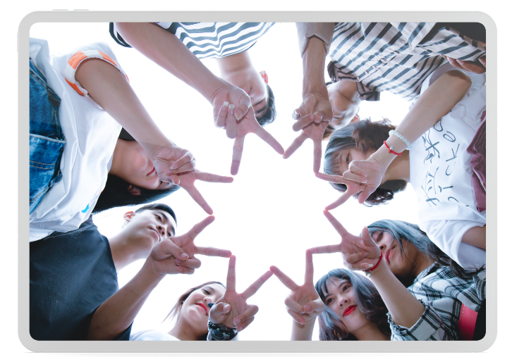
‘Group of People Forming Star Using Their Hands’ by Zun Zun is used in accordance with the Canva Content License Agreement.

Resource 15: Jump the plank
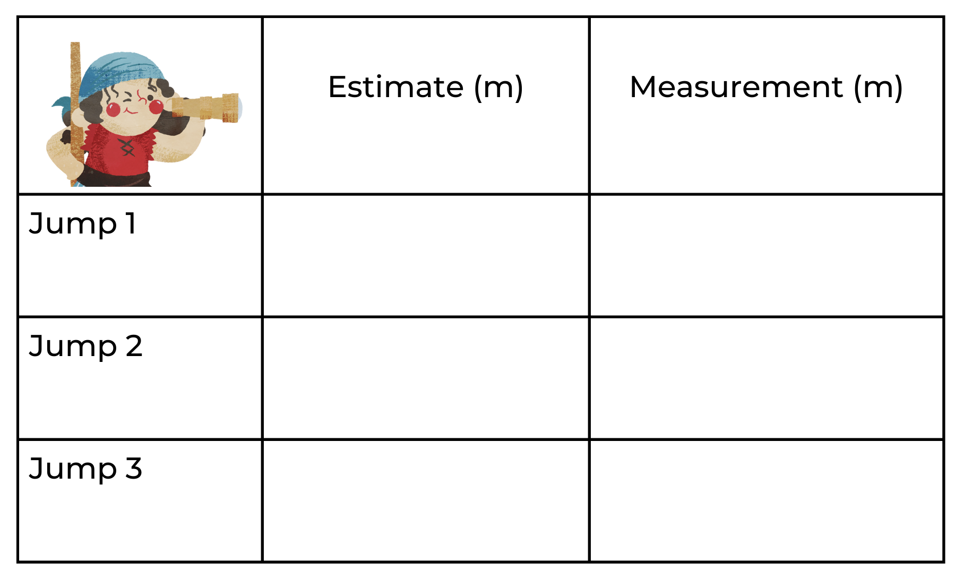
Images sourced from Canva and used in accordance with the Canva Content License Agreement.

Resource 16: Crew certificate
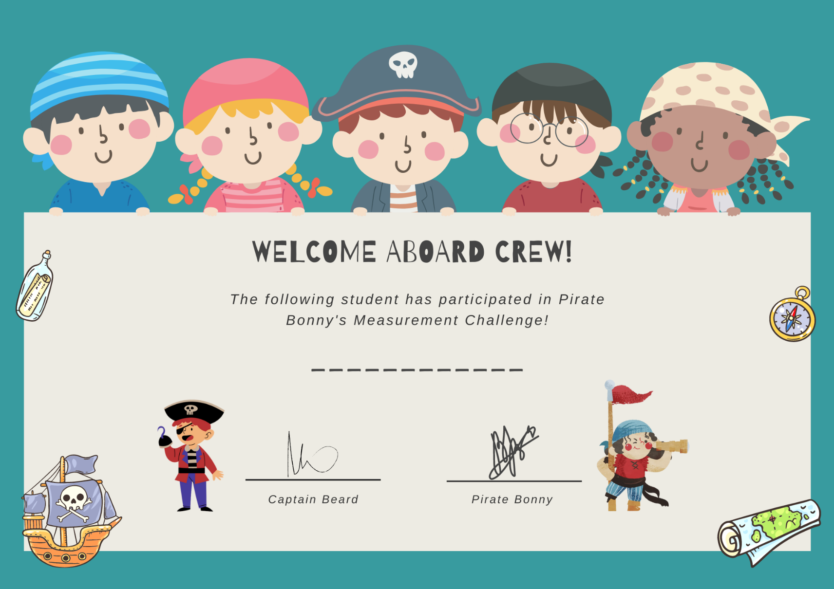
Images sourced from Canva and used in accordance with the Canva Content License Agreement.

Syllabus outcomes and content
The table below outlines the syllabus outcomes and range of relevant syllabus content covered in this unit. Content is linked to National Numeracy Learning Progression (3).
Focus area and outcomes | Content groups and content points | Lessons
Representing whole numbers A  MAO-WM-01  MA1-RWN-01  MA1-RWN-02 | Use counting sequences of ones with two-digit numbers and beyond  - identify the number before and after a given two-digit number (CPr5)  Continue and create number patterns  - count forwards and backwards by twos from any starting point (CPr6-CPr7, MuS2)  Represent numbers on a line  - sequence numbers and arrange them on a line by considering the order and size of those numbers (CPr5)  - locate the approximate position of multiples of 10 on a model of a number line from 0 to 100 (CPr5)  Represent the structure of groups of ten in whole numbers  - recognise that ten ones is the same as one ten (NPV2, NPV4)  - use 10 as a reference in forming numbers from 11 to 20 (CPr7)  - count large sets of objects by systematically grouping in tens (CPr7)  - estimate, to the nearest ten, the number of objects in a collection and check by counting in groups of ten (Reasons about quantity) (CPr7, NPV6) | 1–4, 6
Representing whole numbers B  MAO-WM-01  MA1-RWN-01  MA1-RWN-02 | Use counting sequences of ones and tens flexibly  - identify the number before and after a given three-digit number | 2–3
Forming groups B  MAO-WM-01  MA1-FG-01 | Represent and explain multiplication as the combining of equal groups  - use objects, diagrams, images or actions to model multiplication as accumulating equal groups (MuS4)  - solve multiplication problems using repeated addition (MuS4)  - form arrays of equal rows and equal columns (MuS5)  - determine and distinguish between the number of rows/columns and the number in each row/column when describing collections of objects (MuS5) | 4, 6–8
Geometric measure A  MAO-WM-01  MA1-GM-01  MA1-GM-02  MA1-GM-03 | Length: Compare lengths using uniform informal units  - estimate lengths, indicating the number and type of unit used and check by measuring (UuM3) | 1–3, 7
Geometric measure B  MAO-WM-01  MA1-GM-01  MA1-GM-02  MA1-GM-03 | Length: Compare and order lengths, using appropriate uniform informal units  - compare the lengths of two or more objects that cannot be moved or aligned (Reasons about relations)  - record length comparisons using pictures, numbers, and words, and by referring to the uniform informal unit used  Length: Recognise and use formal units to measure the lengths of objects  - recognise the need for formal units to measure lengths and distances (UuM6)  - use the metre as a unit to measure lengths and distances to the nearest metre or half-metre  - record lengths and distances using the abbreviation for metres (m)  - estimate lengths and distances to the nearest metre and check by measuring (UuM6) | 1–3, 7
Two-dimensional spatial structure A  MAO-WM-01  MA1-2DS-01  MA1-2DS-02 | Area: Indirectly compare area  - indirectly compare the areas of two surfaces that cannot be moved or superimposed (UuM4)  - predict which of two similar shapes has the larger area and check by covering (UuM4)  Area: Measure areas using uniform informal units  - explore area using uniform informal units to cover the surface in rows or columns without gaps or overlaps (UuM5)  - measure area by selecting and using appropriate uniform informal units (Reasons about relations)  - explain why the area remains constant when units are rearranged (Reasons about relations)  - record areas by referring to the number and type of uniform informal unit used  - identify any parts of units left over when counting uniform informal units to measure area  - estimate areas by referring to the number and type of uniform informal unit used and check by measuring (UuM3) | 1, 4, and 8
Two-dimensional spatial structure B  MAO-WM-01  MA1-2DS-01  MA1-2DS-02 | Area: Compare rectangular areas using uniform square units of an appropriate size in rows and columns  - cover rectangular surfaces by creating repeated rows of square tiles (UuM5)  - use a single square to create the array structure of area in rows and columns (UuM5)  - use the structure of repeated units to find the area of a rectangle (UuM5)  - explain how the grid structure of rows and columns helps to find the area  - compare the areas of two or more surfaces that cannot be moved, or superimposed, by measuring in uniform informal units (UuM4)  - record comparisons of area using pictures, numbers, and words, and by referring to the uniform informal unit used | 1, 4, and 8
Three-dimensional spatial structure A  MAO-WM-01  MA1-3DS-01  MA1-3DS-02 | Volume: Measure and compare the internal volumes (capacities) of containers by filling  - use uniform informal units to measure how much a container will hold by counting the number of times a smaller container can be filled and emptied into the container being measured (UuM3)  - select appropriate informal units to measure the capacities of containers  - recognise and explain the relationship between the size of a unit and the number of units needed (Reasons about relations)  - compare the internal volumes of two or more containers using appropriate uniform informal units (UuM3)  - recognise and explain why containers of different shapes may have the same internal volume (Reasons about relations)  - estimate how much a container holds by referring to the number and type of uniform informal unit used and check by measuring (UuM3-UuM4) | 1, 5, and 8
Three-dimensional spatial structure B  MAO-WM-01  MA1-3DS-01  MA1-3DS-02 | Volume: Compare containers based on internal volume (capacity) by filling and packing  - make and use a device for measuring internal volume (capacity) calibrated in uniform informal unit (UuM3-UuM4)  - compare, order and record the internal volumes (capacities) of two or more containers by measuring each container in uniform informal units (UuM3-UuM4)  - estimate internal volume (capacity) by referring to the number and type of uniform informal unit used (UuM3) | 1, 5, and 8
Non-spatial measure A  MAO-WM-01  MA1-NSM-01  MA1-NSM-02 | Mass: Investigate mass using an equal-arm balance  - place objects on either side of an equal-arm balance to obtain a level balance  - use an equal-arm balance to compare the masses of two objects and record, which is heavier or lighter (UuM2)  - predict the action of an equal-arm balance before placing particular objects in each pan (Reasons about relations)  - use a balance to find two collections of objects that have the same mass (UuM2)  - compare and order the masses of two or more objects by hefting, and check using an equal-arm balance (UuM2) | 1, 6, and 7

References
Links to third-party material and websites
Please note that the provided (reading/viewing material/list/links/texts) are a suggestion only and implies no endorsement, by the New South Wales Department of Education, of any author, publisher, or book title. School principals and teachers are best placed to assess the suitability of resources that would complement the curriculum and reflect the needs and interests of their students.
If you use the links provided in this document to access a third-party's website, you acknowledge that the terms of use, including licence terms set out on the third-party's website apply to the use which may be made of the materials on that third-party website or where permitted by the Copyright Act 1968 (Cth). The department accepts no responsibility for content on third-party websites.
Except as otherwise noted, all material is © State of New South Wales (Department of Education), 2021 and licensed under the Creative Commons Attribution 4.0 International License. All other material (third-party material) is used with permission or under licence. Where the copyright owner of third-party material has not licensed their material under a Creative Commons or similar licence, you should contact them directly for permission to reuse their material.
Mathematics K–10 Syllabus © 2022 NSW Education Standards Authority (NESA) for and on behalf of the Crown in right of the State of New South Wales.
© 2022 NSW Education Standards Authority. This document contains NSW Curriculum and syllabus content. The NSW Curriculum is developed by the NSW Education Standards Authority. This content is prepared by NESA for and on behalf of the Crown in right of the State of New South Wales. The material is protected by Crown copyright.
Please refer to the NESA Copyright Disclaimer for more information.
NESA holds the only official and up-to-date versions of the NSW Curriculum and syllabus documents. Please visit the NSW Education Standards Authority (NESA) website and the NSW Curriculum website.
National Numeracy Learning Progression © Australian Curriculum, Assessment and Reporting Authority (ACARA) 2010 to present, unless otherwise indicated. This material was downloaded from the Australian Curriculum website (National Numeracy Learning Progression) (accessed 12 September 2022) and was not modified. The material is licensed under CC BY 4.0. Version updates are tracked in the ‘Curriculum version history’ section on the 'About the Australian Curriculum' page of the Australian Curriculum website.
ACARA does not endorse any product that uses the Australian Curriculum or make any representations as to the quality of such products. Any product that uses material published on this website should not be taken to be affiliated with ACARA or have the sponsorship or approval of ACARA. It is up to each person to make their own assessment of the product, taking into account matters including, but not limited to, the version number and the degree to which the materials align with the content descriptions and achievement standards (where relevant). Where there is a claim of alignment, it is important to check that the materials align with the content descriptions and achievement standards (endorsed by all education Ministers), not the elaborations (examples provided by ACARA).
This resource contains images and content obtained from Canva, and their use outside of this resource is subject to Canva’s Content License Agreement. If you wish to use them separately from the resource, please go to Canva.
Sullivan P and Lilburn P (2004) Open-ended Maths Activities: Using ‘good’ questions to enhance learning in Mathematics, 2nd edn, OUP (Oxford University Press) Australia and New Zealand, Melbourne.
University of Cambridge (Faculty of Mathematics) (2022) Can You Do it Too?, NRICH website, accessed 12 September 2022.
University of Cambridge (Faculty of Mathematics) (2022) Fingers and Hands, NRICH website, accessed 12 September 2022.
Van de Walle J, Karp K, Bay-Williams JM, Brass A, Bentley B, Ferguson S, Goff W, Livy S, Marshman M, Martin D, Pearn C, Prodromou T, Symons D and Wilkie K (2019) Primary and Middle Years Mathematics: Teaching Developmentally, 1st Australian edn, Pearson Australia, Melbourne.
Way J (2011) ‘A Sense of “ten” and Place Value’, Number Sense, University of Cambridge NRICH website, accessed 12 September 2022.
Wyborney S (16 January 2017) ‘Primary Tile Questions’, Steve Wyborney's Blog, accessed 12 September 2022.

